
Date: ________________________
Series: Jesus is God’s Son (Dec-Mar)
Year 2, Lesson 36

The Calling of

the First

Disciples

Take Home Point: *JESUS IS GOD’S SON—I follow Jesus every day.
*Repeat this phrase throughout the lesson. The leader will say the first part of the phrase (CAPS). The children respond with the second part of the phrase (italics).

Bible Event: Matthew 4:18-22
Jesus Link: Jesus is the perfect leader to follow.

We will help children know:
- The story of Jesus calling Peter, Andrew, James and John to be His disciples.
- Jesus calls us to follow Him and fish for people.
- Just as the disciples followed Jesus in their everyday lives so we, too, can follow Jesus in our everyday lives.

We will help the children feel:
- Eager to follow Jesus.
- Committed to serving Jesus in their lives.
- Self-esteem knowing that they are important members of God’s kingdom.

We will help the children do:
- Echo pantomime to tell the story of Jesus calling the disciples.
- Make and eat a “Banana Boat” to review the Bible event.
- Play a “Fishing Game.”

THIS LESSON’S ROADMAP

DESTINATION | PAGE # | DISCOVERIES ON YOUR JOURNEY | SUPPLIES NEEDED
Large Group Opening   | 3  3-5 | Puppet Presentation  Bible Event | - Xiao Hung puppet  - puppet-sized fishing pole (Can be made from a dowl rod and fishing line.)
Small Group Application   | 6  7  7-8  8 | Activity 1: “Paper Bag Fish” Craft  Activity 2: “”Banana Boats” Snack  Activity 3: ”Fishing” Game  Activity 4: “Fish Out the Verse”  Prayer Time | Activity 1:  - brown paper lunch bags  - newspapers  - masking tape  - markers  - googly eyes or blue dot stickers  - label that says, “We are fishers of men.”  Activity 2:  - ½ a pisang emas per child  - three finger biscuits per child  - plastic knife  - serviettes  - cups  - water or juice  Activity 3:  - blanket (preferably blue)  - three buckets with prizes in each bucket:  Bucket 1: small toys  Bucket 2: stickers  Bucket 3: small snacks  Label the buckets 1, 2 and 3.  - child-sized fishing rod  - individual fishes cut from reproducible  Activity 4:  - child-sized fishing rod  - 8 fishes trace from Activity3 then write words of the memory verse on them  - blanket (preferably blue)
Large Group Wrap-up   | 8  8 | Singing (Optional)  Lesson Review with Puppet Skit | - optional music for the lesson  - Xiao Er puppet

Pre-Session Singing: (10 minutes)
Purpose: When all children are in one group singing, it is easy for new children to join the group and immediately get involved. When the music can be correlated, it introduces the theme for the day. Choose two to three songs and list them here.

Large Group Opening: (15 minutes)
Purpose: The puppet demonstrates the need that will be met in today’s lesson. The scripts are not written verbatim, but give a story line in which the group leader can interact with the puppet. The children are introduced to the take home point and then interact with God’s Word as they experience the Bible event.

Supplies needed: Xiao Hung puppet; puppet-sized fishing pole

Puppet Presentation:
Xiao Hung comes on stage carrying a fishing pole. He is really excited because he went on a fishing trip with his dad and his grandpa. It was a guy’s day out. He tells the presenter that they caught 500 million fish.

The presenter asks Xiao Hung if he can count to 500 million. Xiao Hung says yes. He then counts to 13 then skips to 500 million.

The presenter tells Xiao Hung that he is excited that Xiao Hung went fishing and caught a lot of fish. It reminds him of today’s Bible event. In today’s Bible event the children are going to learn about something that we catch that is even more important than fish. The children are going to learn that we can catch people.

Xiao Hung exclaims, “What?! Catch people?! That sounds crazy!” The presenter agrees that it does sound crazy but in the Bible event Jesus calls four fishermen to leave their boats, follow Jesus and become fishers of people. We, too, can follow Jesus and become fishers of people, catching people for Jesus. That means we tell people about Jesus and they learn how to become followers of Jesus, too.

The presenter teaches Xiao Hung the take home point. *JESUS IS GOD’S SON—I follow Jesus every day. The presenter says the first part; Xiao Hung responds with the second part. After practicing it with Xiao Hung several times, the presenter teaches it to the children.

Bible Event: Echo Pantomime

Explain to the children that for today’s Bible event, you will be doing an echo pantomime. You will say a line and do an action and they need to repeat the line and action after you. Begin:

Becoming Fishers of Men

One day Jesus was walking (Walk in place.)

Along the Sea of Galilee. (Make waves with hands.)

He saw two brothers. (Make a visor over eyes with hand.)

One brother was Simon Peter. (Hold up one finger.)

The other was Andrew. (Hold up a second finger.)

They were throwing a net (Throw hands out from body.)

Into the sea. (Make waves with hands.)

They were fishermen. (Cast an imaginary fishing rod.)

Jesus said to them, (Cup hands over mouth.)

“Come follow me.” (Make a beckoning motion with arm.)

The brothers left their nets. (Throw hands out from body.)

They followed Jesus. (Walk in place.)

The group walked on (Continue walking in place.)

Along the Sea of Galilee. (Make waves with hands.)

They saw two brothers. (Make a visor over eyes with hand.)

One brother was James. (Hold up one finger.)

The other brother was John. (Hold up a second finger.)

They were in a boat. (Pretend to row with arms.)

They were fixing a fishing net. (Pretend to spread out a net with hands.)

They were fishermen. (Cast an imaginary fishing rod.)

Jesus said to them, (Cups hands over mouth.)

“Come follow me.” (Make a beckoning motion with arm.)

The brothers left their nets. (Throw hands out from body.)

They followed Jesus. (Walk in place.)

Now there were four men. (Hold up 4 fingers.)

They were Jesus’ helpers. (Spread out arms in front of body.)

They would fish for people. (Cast an imaginary fishing rod.)

They would tell people about Jesus. (Cups hands around mouth.)

They would bring people to Jesus. (Make a beckoning motion with hand.)

We, too, can tell people about Jesus. (Cup hands around mouth.)

We, too, can fish for people. (Cast an imaginary fishing rod.)

Say:

In the Bible event, Peter, Andrew, James and John left their fishing to follow Jesus, but they were still fishermen. They continued to fish for a living, but now they also fished for people by telling people about Jesus. We, too can fish for people by following Jesus every day—in our work, in our play, at home, at school, all the time—and by telling people about Jesus. We want to follow Jesus and fish for men because Jesus is God’s Son. He loves us and He died for us. Jesus fills us with excitement about that good news and we want to follow Jesus and share the news with others.

Practice the take home point. You say the first part; the children respond with the second part. *JESUS IS GOD’S SON—I follow Jesus every day.

End with the following prayer:

Dear God,
Thank You for the best gifts.
Thank You for sending Jesus.
He’s our Savior and Your Son.
Help me follow Jesus every day.
Thank You! Thank You! Thank You!
Amen.
Small Group Application: (30 minutes)
Purpose: Smaller groups enable children to develop closer relationships with adults and peers in the church. As you reinforce the take home point with a fun hands-on activity, discuss the Bible event. Be sure to repeat the take home point several times. Say the first part and have the children respond with the second phrase. Application questions help kids apply the take home point to their daily lives. Close this session by gathering your small group for prayer. Let the kids pray!

During small group application time, discuss the following questions and points:

What were Peter, Andrew, James and John doing when Jesus saw them? (They were fishing.)

What did Jesus ask them to do? (To follow Him and become fishers of men.)

How can we follow Jesus and be fishers of people? (Answers will vary but may include telling others about Jesus, loving others, obeying Jesus, learning about Jesus, etc.)

Why do we want to follow Jesus and be fishers of people? (Jesus loves us and died for us. He fills us with excitement at that wonderful news.)

Activity 1: “Paper Bag Fish” Craft
Supplies needed: brown paper lunch bags; newspapers; masking tape; markers;
googly eyes or blue dot stickers; label that says, “We are fishers of men.”

To make:
- Stuff a brown paper lunch bag 2/3 full with newspaper.
- Twist the open end of the lunch bag closed at the point where there is not newspaper.
- Put masking tape around the twisted end to secure it closed.
- Fan out the excess paper at the end of the lunch bag to make a “fish tail.”
- At the stuffed end of the paper bag put googly eyes or blue, dot stickers on each side of the bag to make fish eyes.
- Decorate the fish with markers.
- Attach the label to the fish.

To discuss:
As the children make their fish, review the Bible event. Brainstorm ways to follow Jesus and be fishers of people.

Practice the take home point. You say the first part; the children respond with the second part. *JESUS IS GOD’S SON—I follow Jesus every day.

Activity 2: “Banana Boat” Snack
Supplies needed: ½ a pisang emas per child; three finger biscuits per child; plastic knife; serviettes; cups; water or juice

To make:
- Cut the bananas into half, lengthwise.
- Lay the banana on a serviette so that they are curved upward like a boat.
- Stick several finger biscuits in the “boat” to represent people.

To discuss:
Review the Bible event. Say: After Peter, Andrew, James and John left their boats to follow Jesus and become fishers of people, they also continued to fish for fish. That was their job. That was how they earned their livings. We also have a daily life. We go to school, play with friends, do our chores and live with a family. We can follow Jesus in everything we do and in every part of our lives. We follow Jesus by loving Him, obeying Him, worshipping Him and by telling others about Jesus.

Practice the take home point. You say the first part; the children respond with the second part. *JESUS IS GOD’S SON—I follow Jesus every day.

Activity 3: “Fishing” Game
Supplies needed: blanket (preferably blue); three buckets with prizes in each bucket:
Bucket 1: small toys, Bucket 2: stickers’ Bucket 3: small snacks, Label the buckets 1, 2 and 3.; child-sized fishing rod ; individual fishes cut from reproducible

To play:
- Have two children hold up a blanket.
- Scatter the fish on the floor behind the blanket.
- A third child sits on the floor behind the blanket.
- A fourth child is the fisherman. He/she “casts” the “fishing pole” over the blanket and into the “water.”
- The child behind the blanket puts a fish on the fishing pole.
- The fisher pulls the line back over the blanket and follows the directions on the fish. (Have an adult read the directions.) The fisher gets a prize out of the bucket with the number that corresponds to the fish.
- The children switch roles and continue playing.
- Keep playing until all the children have gotten several prizes or as time and interest allows. Hint: Make sure the children are carrying out the directions on all the children in the group, not just one or two.)

To discuss:
We can fish for people in many ways: by telling them about Jesus, by being kind to them, and showing them Jesus’ love. When we played this game, we were practicing ways to be fishers of people. The most important thing is to share the love of Jesus with other people so they can learn about His love, just as we have learned that Jesus loves us.

Practice the take home point. You say the first part; the children respond with the second part. *JESUS IS GOD’S SON—I follow Jesus every day.

Activity 4: “Fish Out the Verse”
Supplies needed: child-sized fishing rod ; 8 fishes trace from Activity3 then write words of the memory verse on them; blanket (preferably blue)

Memory Verse: Luke 3:22 ~ “You are my Son, whom I love; with You I am well pleased.”

MV Presentation:
This activity continues from Activity 3. Spread out the blanket this time and scatter the memory verse fishes on the blanket. Get the children to take turns to fish out a fish. When all 8 fishes are fished out, read and arrange it for the children to hear and see. Have them repeat several times with you.

Prayer Time:
Thank Jesus for loving you and calling you to follow Him. Ask him to help you follow Him and be a fisher of people.

Large Group Wrap-Up: (10 minutes)
Purpose: The crazy bird puppet, Xiao Er, struggles with learning the take home point. The leader shows an example of each small group application activity from this lesson and says the first phrase of the take home point. The kids respond with their phrase. They try to teach the puppet the take home point, but each time he confuses words or concepts. After three attempts, he finally gets it right and sings the correct take home point in a silly opera-like voice.

Singing: (Optional)

Lesson Review with Puppet Skit:
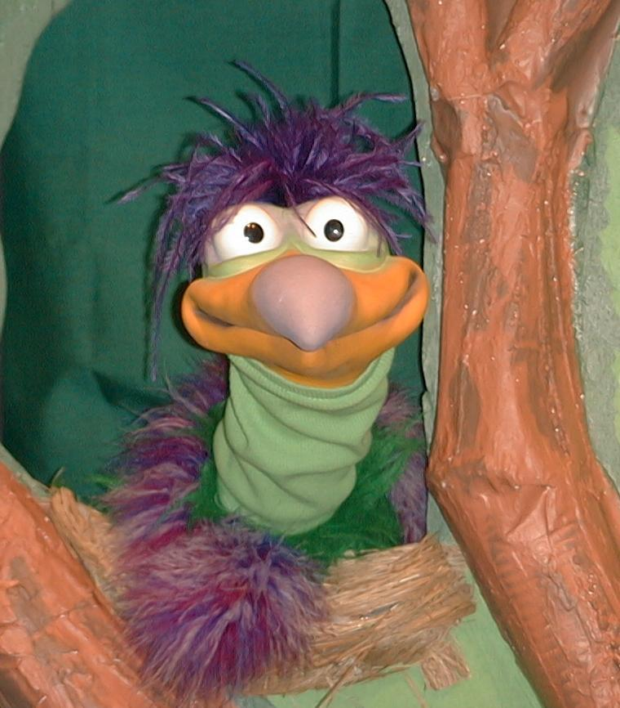
Presenter shows Xiao Er a craft made in Activity 1. Then the kids attempt to teach Xiaon Er the take home point.

Presenter says to kids: “Jesus Is God’s Son…”
Kids say: “…I follow Jesus every day.”
Presenter says to Xiao Er: “Jesus Is God’s Son…”
Xiao Er says: “…I followed a dog once… and he went over a hill… and through the woods… and then he went into the store”

Presenter shows an example of the next activity done in small group and repeats first phrase to kids. The kids say the correct response trying to teach Xiao Er the take home point. Continue in this manner with Presenter showing example of each activity. Here are Xiao Er’s responses:

Xian Er’s response to Activity 2 sample: “…I follow where my nose takes me.
Where’s my snack?”
Xiao Er’s response to Activity 3 sample: “…I followed a whale into the ocean”

Presenter says: “Xiao Er, listen one last time.
Jesus Is God’s Son…”
Kids response: “…I follow Jesus every day.”
Presenter says to Xiao Er: “Jesus Is God’s Son…”
Xiao Er’s response: (Warms up his singing voice with “Mee, mee, mee,
mee, mee…” and sings in a silly dramatic opera-like
voice) “Jesus Is God’s Son – I follow Jesus
every day.”

Welcome guests and thank them for attending.

Lesson 36

Large Group Opening:
- Xiao Hung puppet
- puppet-sized fishing pole (Can be made from a dowl rod and fishing line.)

Small Group Application:
Activity 1:
- brown paper lunch bags
- newspapers
- masking tape
- markers
- googly eyes or blue dot stickers
- label that says, “We are fishers of men.”
Activity 2:
- ½ a pisang emas per child
- three finger biscuits per child
- plastic knife
- serviettes
- cups
- water or juice
Activity 3:
- blanket (preferably blue)
- three buckets with prizes in each bucket:
Bucket 1: small toys
Bucket 2: stickers
Bucket 3: small snacks
Label the buckets 1, 2 and 3.
- child-sized fishing rod
- individual fishes cut from reproducible
Activity 4:
- child-sized fishing rod
- 8 fishes trace from Activity3 then write words of the memory verse on them
- blanket (preferably blue)

Large Group Wrap-up
- optional music for the lesson
- Xiao Er puppet
