
Date: ________________________
Series: We Are God’s Church (Apr-May)
Year 2, Lesson 49

The Road to Emmaus

Take Home Point: *JESUS IS ALIVE—I can’t wait to tell others.
*Repeat this phrase throughout the lesson. The leader will say the first part of the phrase (CAPS). The children respond with the second part of the phrase (italics).

Bible Event: Luke 24:13-35
Jesus Link: Jesus died and rose for everyone—share the good news!

We will help children know:
- The story of Jesus appearing to two of His followers on the road to Emmaus.
- Jesus died and rose for everyone.
- The news of Jesus’ death and resurrection is good news to be shared with everyone.

We will help the children feel:
- Excited that Jesus is alive.
- Joy-filled knowing Jesus died for them.
- Eager to share the news that Jesus is alive with others.

We will help the children do:
- Hear the Bible event being told through tandem storytelling.
- Review the Bible event while eating bread and jam for snack and learn a prayer song, “Come Lord Jesus.”
- Practice sharing the good news that Jesus is alive while playing “Good News Megaphone Relay.”

THIS LESSON’S ROADMAP

DESTINATION | PAGE # | DISCOVERIES ON YOUR JOURNEY | SUPPLIES NEEDED
Large Group Opening   | 3  3 | Puppet Presentation  Bible Event | - Xiao Hung puppet  - Bible  - two adult-sized disciple costumes  - tandem-storytelling scripts
Small Group Application   | 7  8  8  9 | Activity 1: “Jesus is Alive Cards” Craft  Activity 2: “Bread and Jam” Snack  Activity 3: ”Good News Megaphone Relay” Game  Activity 4: “Tandem-Memory Verse”  Prayer Time | Activity 1:  - Reproducible copied for each child on a sheet of hard card  - cross stickers (enough for children to put one on each hard card)  - one plastic bag per child  - crayons or markers  Activity 2:  - bread  - jam  - plastic knives  - serviettes  - cups  - hand wipes  - water or juice  Activity 3:  - masking tape  Activity 4:  - tandem-memory verse cards done in two colours
Large Group Wrap-up   | 9  9 | Singing (Optional)  Lesson Review with Puppet Skit | - optional music for the lesson  - Xiao Er Puppet

Pre-Session Singing: (10 minutes)
Purpose: When all children are in one group singing, it is easy for new children to join the group and immediately get involved. When the music can be correlated, it introduces the theme for the day. Choose two to three songs and list them here.

Large Group Opening: (15 minutes)
Purpose: The puppet demonstrates the need that will be met in today’s lesson. The scripts are not written verbatim; but give a storyline in which the group leader can interact with the puppet. The children are introduced to the take home point and then interact with God’s word, as they experience the Bible event.

Supplies needed: Xiao Hung puppet; Bible; two adult-sized disciple costumes; tandem-storytelling scripts

Puppet Presentation:
Xiao Hung comes out very excited. He has some good news to share, and he can’t wait to tell it! His best friend, Jonathan, moved away, and he misses him. But now Jonathan is coming back to visit, and he is going to spend the night at Xiao Hung’s house. Xiao Hung has all kinds of fun plans for when Jonathan spends the night. They are going to eat McDs, watch a movie and have a pillow fight.

The presenter rejoices with Xiao Hung over his good news. (Although he does wonder if Xiao Hung’s mom will want them to have a pillow fight!)

Then the presenter says that Xiao Hung’s good news reminds him of today’s Bible event. In the Bible event, two of Jesus’ followers were sad that He had died. They had lost their best friend, Jesus. But, as they were walking along a road to a town called Emmaus, they met Jesus. After they realized who Jesus was, He disappeared. The two disciples were so excited they couldn’t wait to share the good news that they saw Jesus with His other followers, just as Xiao Hung couldn’t wait to share with others the news that he was going to see Jonathan.

The presenter teaches Xiao Hung the take home point: *JESUS IS ALIVE– I can’t wait to tell others! The presenter says the first line; Xiao Hung responds with the second line. After practicing it with Xiao Hung a few times, the presenter practices it with the children.

Bible Event: Tandem Storytelling
In tandem storytelling, two storytellers stand on opposite sides of the stage and tell the Bible event back and forth in short sentences or phrases. The storytellers act as if they do not realize the other person is there. They may or may not be dressed in costumes. Ideally, the storytellers have the script memorized. But if that is not possible it is also okay for them to read the script. The key to tandem storytelling is to keep each character’s phrases short and keep the energy level high. At the end of the skit, the storytellers will sometimes discover each other and the skit will end with them conversing together. Before beginning each skit, have the children put on their imagination hats. They will be meeting two actors who are pretending to be characters from today’s Bible event.

“The Road to Emmaus”
If possible, dim the lights to give the appearance of the early morning hours. A storyteller dressed as a disciple stands on each side of the stage. Before beginning the tandem story, the large group presenter should point out the characters to the children and explain that they are actors pretending to be Jesus’ followers. One is named Cleopus. The Bible does not tell the others name, but let’s pretend his name is Titus. :

Cleopus: I was so sad.

Titus: I was sadder than can be.

Cleopus: They hung Jesus on the cross.

Titus: They left Jesus on the cross to die.

Cleopus: When He died, I felt as if I had lost my life.

Titus: I lost my best friend.

Together: My heart was filled with sorrow.

Cleopus: But that morning I heard some good news.

Titus: Some women were now saying they had seen Jesus—alive.

Together: Jesus was alive!

Cleopus: Alive!

Titus: Alive!

Together: Did we dare believe the good news? Did we dare hope?

Cleopus: Now I was traveling.

Titus: Walking along the road…

Cleopus: Going to Emmaus…

Titus: With my friend Cleopus…

Cleopus: As we walked, a man appeared.

Titus: A man came out of nowhere.

Cleopus: “What are you talking about?” the man asked.

Titus: Cleopus told him all that had happened: that Jesus died, was buried and now some women were claiming they saw Him alive.

Cleopus: Could it be true that Jesus was alive?

Titus: Could it be true that Jesus came out of the grave?

Together: Could it be true?

Cleopus: The man walked with us along the road.
Titus: He walked with us to Emmaus.

Together: And as he walked, he talked.

Cleopus: He explained to us who Jesus was.

Titus: The man told us why Jesus had to rise and die.

Cleopus: He explained that Jesus came to take the punishment for our sins.

Titus: He helped us understand God’s word.

Together: Then we were told that Jesus did rise from the dead.

Cleopus: Could it be true that Jesus was alive?

Titus: Could it be true that Jesus came out of the grave?

Together: Could what this man said be true?

Cleopus: We arrived at the house and invited our new friend in.

Titus: We asked the man to stay for dinner.

Cleopus: When he took the bread, he gave thanks.

Titus: When he broke the bread…

Cleopus: Our eyes were opened!

Titus: We saw that the man was Jesus!

Together: Jesus really was alive!

Cleopus: Jesus is alive!

Titus: He is alive!

Cleopus: Jesus is risen from the dead!

Titus: He came out of the grave.

Cleopus: He visited us!

Titus: He comforted us.

Cleopus: He explained God’s word to us.

Titus: And then Jesus disappeared.

Cleopus: Jesus broke the bread and then left us.

Titus: Jesus was no longer with us.

Cleopus: But we weren’t sad.

Titus: We were still happy.

Together: Jesus is alive!

Cleopus: We hurried to share the good news.

Titus: We ran to tell the others.

Cleopus: Jesus is alive!

The disciples walk off stage.

The large group presenter comes back on stage and says:

In the Bible event, the disciples were lonely for Jesus. Then they learned that Jesus was alive. They learned that Jesus had to die so all of our sins can be forgiven. They were so excited to hear the good news that they hurried back to Jerusalem to share that news with the others. We, too, can be excited about the good news that Jesus is alive. We, too, can share that good news with others.

Practice the take home point. You say the first part; the children respond with the second part. *JESUS IS ALIVE—I can’t wait to tell others.

End with the following prayer:

Dear God,
Thank You for the best gifts.
Thank You for sending Jesus.
He’s our Savior and Your Son.
Help me tell others, “Jesus is alive.”
Thank You! Thank You! Thank You!
Amen.

Small Group Application: (30 minutes)
Purpose: Smaller groups enable children to develop closer relationships with adults and peers in the church. As you reinforce the take home point with a fun hands-on activity, discuss the Bible event. Be sure to repeat the take home point several times. Say the first part and have the children respond with the second phrase. Application questions help kids apply the take home point to their daily lives. Close this session by gathering your small group for prayer. Let the kids pray!

During small group application time, discuss the following questions and points:

Why were the two men in the Bible event sad? (Jesus had died on the cross.)

As the men were walking on the road to Emmaus, Jesus appeared to them but they did not know it was Jesus. He explained to them why He had to die on the cross. Why did Jesus have to die on the cross? (He had to take the punishment for everyone’s sins so we who trust in Him will be forgiven and made children of God.)

When Jesus broke the bread and gave thanks, the men knew it was Jesus. How do you think they felt? (Answers will vary but may include surprised, happy, and excited.)

The men returned at once to Jerusalem to tell the others Jesus is alive. What are some ways we can share the news with others that Jesus is alive? (Answers will vary but may include telling them, bringing them to Sunday school and watching videos about Jesus with them.)
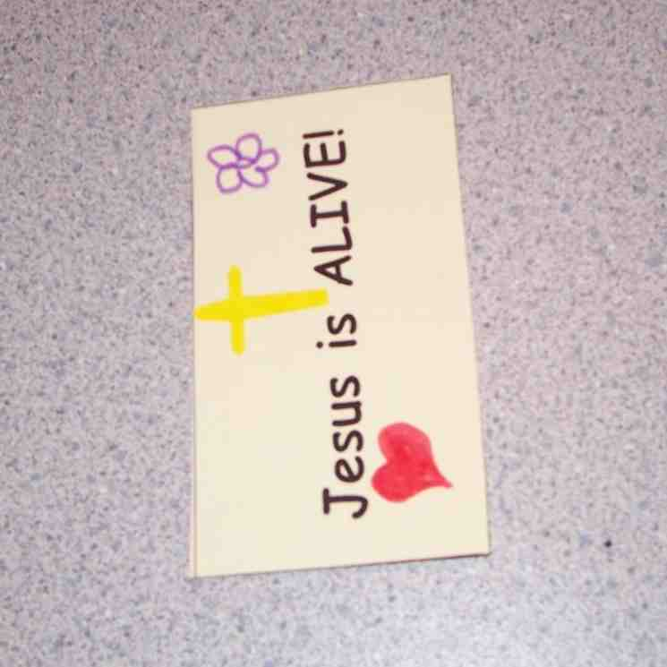

Activity 1: “Jesus is Alive! Cards” Craft
Supplies needed: Reproducible copied for each child on a sheet of hard card; cross stickers (enough for children to put one on each hard card); one plastic bag per child; crayons or markers

Instructions:
- Read the words on the cards from the reproducible and put a cross sticker on each card.
- Decorate the cards with crayons or markers.
- Cut the cards apart and put them in a plastic bag.
- Encourage the children to hand out the cards to friends, relatives and neighbors who need to hear the good new that Jesus is alive.

Discussion:

Jesus is alive! That is the best news of all. Jesus died to take the punishment for our sins and He rose from the grave to share the news that all who trust in Him are forgiven and are now children of God. I wonder how we can share that news with others…

Practice the take home point. You say the first part; the children respond with the second part. *JESUS IS ALIVE—I can’t wait to tell others.

Activity 2: “Bread and Jam” Snack
Supplies needed: bread; jam; plastic knives; serviettes; cups; hand wipes; water or juice

Instructions:
- Spread jam on bread.
- Before eating sing the following echo prayer song:

Come Lord Jesus (Tune: Are You Sleeping?)

Come Lord Jesus (Come Lord Jesus)
Be our guest (Be our guest)
Let these gifts to us be blessed (Let these gifts to us be blessed)
A-a-men (A-a-men)

3. As the children eat, review the Bible event.

To discuss:
Review the Bible event, comparing the bread and jam snack to the bread Jesus broke.

We need bread to feed our bodies, but we also need Jesus to feed our hearts. When He was walking along the road with two of His followers, He was explaining God’s word and why He had to die. He was feeding their hearts. When the men returned to Jerusalem to share the good news that they had seen Jesus, they were feeding the hearts of other followers of Jesus. How can we feed the hearts of others and share the good news that Jesus is alive?

Practice the take home point. You say the first part; the children respond with the second part. *JESUS IS ALIVE—I can’t wait to tell others.

Activity 3: “Good News Megaphone Relay” Game
Supplies needed: masking tape

Instructions:
- Tape to the floor two parallel strips of masking tape as far apart as possible for each team.
- Divide the teams in half and have one group stand in a line behind each masking tape line.
- On the word “Go!” the first child from each team runs to the other line, cups his hands around his mouth to make a megaphone and shouts “Jesus is alive!”
- The first child in that line now runs back down to the next child and repeats the process.
- Play continues until the last child has had a turn to run and shout, “Jesus is alive!”
- The first team to finish wins.
- Repeat this game with different messages: “Jesus is God’s Son!” “Jesus died for you!” and “Jesus forgives our sins!”

To discuss:

We have some important messages to share: “Jesus is alive!” “Jesus is God’s Son!” “Jesus died for you!” and “Jesus forgives our sins!” I wonder who we can share those messages with…

Practice the take home point. You say the first part; the children respond with the second part. *JESUS IS ALIVE—I can’t wait to tell others.

Activity 4: “Tandem-Memory Verse”
Purpose: Help kids to memorize and keep scriptures at heart. Using creative ways to help kids enjoy learning the key verse and in small group setting.

Supplies needed: tandem-memory verse cards done in two colours

Memory Verse: Acts 2:44 ~ “All the believers kept meeting together, and they shared everything with each other.” (GW)

Memory Verse Learning:
Divide the children into two groups and have them line up facing one another. Give each member of one group one set of cards and the other group another set of cards.
Just like tandem storytelling above, two groups of children stand on opposite sides and tell the memory verse back and forth in short phrases. But some children may not recognize some words so it is best for shepherd to go through the cards with the children before leaving them to do the tandem memory verse several times.

Prayer Time:
Pray for someone who does not know the good news that Jesus is alive. Ask Jesus to help you share the good news with others.

Large Group Wrap-Up: (10 minutes)
Purpose: The crazy bird puppet, Xiao Er, struggles with learning the take home point. The leader shows an example of the each small group application activity from this lesson and says the first phrase of the take home point. The kids respond with their phrase. They try to teach the puppet the take home point, but each time he confuses words or concepts. After three attempts, he finally gets it right and sings the correct take home point in a silly opera-like voice.

Singing: (Optional)

Lesson Review with Puppet Skit:
Xiao Er’s confused responses:

Activity 1: “I can’t wait to tie my shoes.”
Activity 2: “I can’t wait to eat that snack.”
Activity 3: “I can’t wait to sell cookies.”

Welcome guests and thank them for attending.

Lesson 49

Large Group Opening:
- Xiao Hung puppet
- Bible
- two adult-sized disciple costumes
    - tandem-storytelling scripts

Small Group Application
Activity 1:
- reproducible copied for each child on a sheet of hard cards
- cross stickers (enough for children to put one on each hard card)
- one plastic bag per child
- crayons or markers
Activity 2:
- bread
- jam
- plastic knives
- paper towel
- cups
- hand wipes
- water or juice
Activity 3:
- masking tape
Activity 4:
- tandem-memory verse cards done in two colours.

Acts 2:44 | believers | together | shared | with each
All the | kept meeting | and they | everything | other

Large Group Closing:
- Xiao Er puppet
- sample materials from small group activities

Optional Music for the Lesson:
- Choose 2 or 3 songs and list them here
Jesus is ALIVE! | Jesus is ALIVE!
Jesus is ALIVE! | Jesus is ALIVE!
Jesus is ALIVE! | Jesus is ALIVE!
Jesus is ALIVE! | Jesus is ALIVE!

