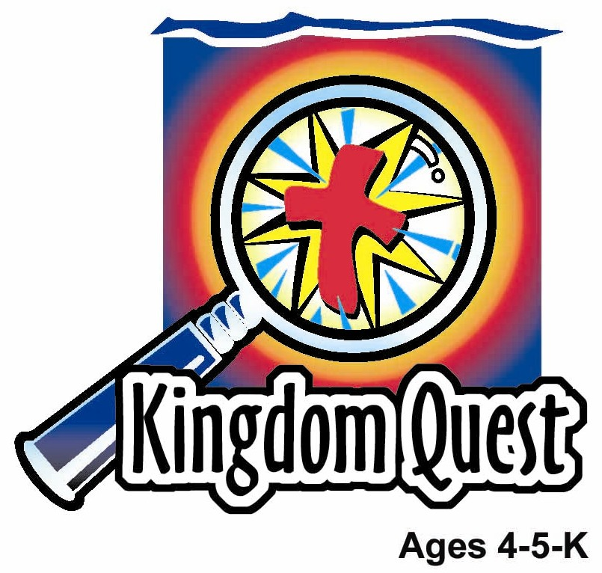
Date: ________________________
Series: We Are God’s Church (Apr-May)
Year 2, Lesson 53

An Ethiopian Believes

Take Home Point: *WE ARE GOD’S CHURCH—We teach about Jesus.
*Repeat this phrase throughout the lesson. The leader will say the first part of the phrase (CAPS). The children respond with the second part of the phrase (italics).

Bible Event: Acts 8:26-40
Jesus Link: All God’s word teaches us Jesus is the Savior.

We will help children know:
- The story of The Ethiopian learning about and believing in Jesus.
- We, like Philip, as members of God’s family, the church, are to teach others about Jesus.
- All of God’s word, the Bible, teaches that Jesus is the Savior.

We will help the children feel:
- Eager to share the story of Jesus with others.
- Empowered to teach others about Jesus.
- Excited about others coming to faith.

We will help the children do:
- Listen to a dramatized Ethiopian retell the story of when he first learned about Jesus and believed that he is the Savior.
- Make and eat a chee cheong fun scroll as a review of the Bible event.
- Make and play a concentration game that teaches a way of sharing the story of Jesus with others.
THIS LESSON’S ROADMAP

DESTINATION | PAGE # | DISCOVERIES ON YOUR JOURNEY | SUPPLIES NEEDED
Large Group Opening  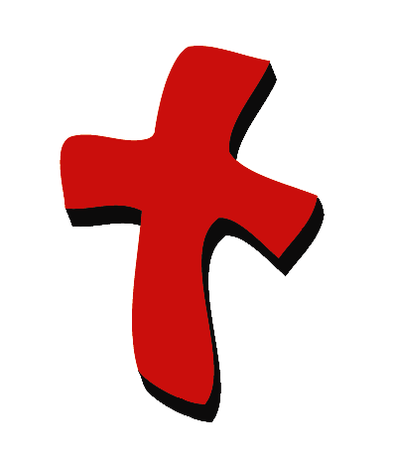 | 3  3 | Puppet Presentation  Bible Event | - Ting Ting puppet  - puppet-sized teaching item such as a chalk board, flash cards, workbook, or bookbag  - adult-sized costume for Ethiopian eunuch  - Bible  - scroll  - two chairs
Small Group Application   | 6  7  7  8  8 | Activity 1: “Concentration Game” Craft  Activity 2: “Chee cheong Fun Scroll” Snack  Activity 3: ”Gospel Concentration” Game  Activity 4: “Show & Say”  Prayer Time | Activity 1:  - two copies of the reproducible per child—copied on manila card  - scissors  - crayons  - one plastic bag per child  Activity 2:  - half a piece of flat chee cheong fun per child  - small sausages sliced into quarter – 2 per child  - plate and fork  - cups  - water  Activity 3:  - concentration cards from  activity 1  Activity 4:  - a silhouette of a church  - a silhouette figure for each child  - a 2”X3” card with Acts 2:44 written
Large Group Wrap-up   | 8  8 | Singing (Optional)  Lesson Review with Puppet Skit | - optional music for the lesson  - Xiao Er Puppet

Pre-Session Singing: (10 minutes)
Purpose: When all children are in one group singing, it is easy for new children to join the group and immediately get involved. When the music can be correlated, it introduces the theme for the day. Choose two to three songs and list them here.

Large Group Opening: (15 minutes)
Purpose: The puppet demonstrates the need that will be met in today’s lesson. The scripts are not written verbatim, but give a story line in which the group leader can interact with the puppet. The children are introduced to the take home point and then interact with God’s word, as they experience the Bible event.

Supplies needed: Ting Ting puppet; puppet-sized teaching item such as a chalk board, flash cards, workbook, or book bag; adult-sized costume for Ethiopian eunuch; Bible; scroll; two chairs

Puppet Presentation:
Ting Ting comes on stage carrying a teacher item such as a chalkboard, flashcards, workbook, or book bag. She shares that she can’t wait until she grows up because she wants to be a teacher. She’s going to teach the children their “abc’s,” how to count, and all about the weather. She’s going to take them on field trips, play games like “Duck, Duck, Goose” with them, and she’s going to do lots of art projects in her classroom. Her students are going to give her hugs, bring her coffee cups (even though she doesn’t like coffee) and flowers for teacher gifts, and they’re all going to love her. She can’t wait to be a teacher.

The presenter asks Ting Ting if she knows she can be a teacher right now. Ting Ting is surprised. The presenter explains that Ting Ting can teach her family, friends and other people she knows that Jesus is the Savior. He saved us from our sins by dying on the cross and taking our punishment so we can be forgiven.

The presenter shares that in today’s Bible event a man, named Philip, teaches another man, a traveler, that Jesus is the Savior. Because of Philip’s teaching, the Ethiopian traveler believes in Jesus and is baptized.

The presenter teaches Ting Ting the take home point: *WE ARE GOD’S CHURCH–We teach about Jesus. The presenter says the first line; Ting Ting responds with the second line. After practicing it with Ting Ting a few times, the presenter practices it with the children.

Bible Event: A Visit from a Dramatized Character
A costumed adult presents the Bible event, telling it from first person point of view. This person should be introduced by asking the children to put on their imagination hats and imagine that this really is the person in the Bible story.
The large group presenter takes out the Bible and says:

Today’s Bible event comes from a book of the Bible called Acts. It is the story of a traveler from the country of Ethiopia who, as he traveled was reading God’s word. But he didn’t understand what he was reading until a man named Philip helped him. We will have a visitor, someone dressed as the Ethiopian, help tell the Bible event. Let’s find out what happened.

Large group presenter leaves stage and someone dressed as the Ethiopian comes on stage. He begins:

Good morning, boys and girls. I am excited to tell you my story of how I came to know and love Jesus. I am from the African country of Ethiopia. One day as I was traveling, the most incredible thing happened. Let me tell you about that day.

I had an important job in my country, Ethiopia. I was in charge of all the money of Queen Candace. But as much as I knew about money, I did not know much about God’s word. I believed in the God of the Jews and I looked forward to the coming of the promised Savior. I didn’t know that He had already come, that Jesus was the Savior.

On that day, I was traveling back to my country in a chariot (sit on one of the two chairs which are set side by side) after worshipping God in the city of Jerusalem. I was reading a scroll that was God’s word. (Hold up scroll.) I didn’t understand what it said. It was confusing.

That’s when I saw a man running alongside of my chariot. “Do you understand what you are reading?” he asked me. “How can I,” I answered, “unless someone explains it to me?”

I invited the man to sit next to me. (Pat empty chair.) I learned that the man’s name was Philip. An angel told him to travel on this road and the Spirit of God, the Holy Spirit, told Philip to come to me.

As we traveled along the road, (bump up and down) Philip explained to me the meaning of the Scriptures. I was reading from the book of Isaiah, which talked about a lamb being sacrificed. Philip explained that Isaiah was talking about Jesus. Like a lamb, Jesus was sacrificed. He died on a cross to take the punishment for my sins and your sins. Sins are the things we do that are wrong. Because Jesus died on the cross and came alive again on Easter, we can be forgiven and be a part of Jesus’ family. Everyone who is a part of Jesus’ family will someday be with Him in heaven.

I was so excited to hear and learn the Good News. I wanted to be baptized right away. So we stopped the chariot along the road and I was baptized in a river nearby. (Get up and pantomime being baptized.) Immediately after I was baptized, the Spirit took Philip away. (Sit back on the chair.) I went back to my chariot and rode away, praising God for His goodness. Philip taught me the Good News of Jesus and I wanted to share that Good News with others.

You too can teach others the Good News.

I am off now to share my story with others, so they can hear the Good News.

Ethiopian leaves stage and large group presenter returns. Large group presenter says:

Wow! Because Philip listened to the Spirit and taught the Ethiopian about Jesus he came to love and trust Jesus and became a part of Jesus’ family. Because we, too, are a part of Jesus’ family, we want to teach others about Jesus.

Practice the take home point. You say the first part; the children respond with the second part. *WE ARE GOD’S CHURCH—We teach others about Jesus.
End with the following prayer:
Dear God,
Thank You for the best gifts.
Thank You for sending Jesus.
He’s our Savior and Your Son.
Help me teach others about Jesus.
Thank You! Thank You! Thank You!
Amen.

Small Group Application: (30 minutes)
Purpose: Smaller groups enable children to develop closer relationships with adults and peers in the church. As you reinforce the take home point with a fun hands-on activity, discuss the Bible event. Be sure to repeat the take home point several times. Say the first part and have the children respond with the second phrase. Application questions help kids apply the take home point to their daily lives. Close this session by gathering your small group for prayer. Let the kids pray!

During small group application time, discuss the following questions and points:

Why was the Ethiopian confused? (He wanted to understand God’s word but he didn’t know what it meant.)

How did Philip help the Ethiopian? (He taught him that the words were talking about Jesus. He told him the Good News—Jesus is that Savior. He died for our sins. All who trust in Him can be a part of His family. The Ethiopian believed and was baptized.)

What can we teach others about Jesus? (Answers will vary but will include that He’s the Savior, Jesus died and rose to forgive their sins. Jesus loves them, and if they believe, they can belong to Jesus’ family, etc.)

Who can you tell about Jesus? (Answers will vary but may include family, friends, etc.)

Activity 1: “Concentration Game” Craft
Supplies needed: two copies of the reproducible per child—copied on manila card; scissors; crayons; one plastic bag per child

Instructions:
- Color two reproducible pages.
- Cut the pictures apart to make cards.
- Take the cards home in a plastic bag.

To discuss:

Teach the children the meaning of each card as follows:
- Heart: God loves us very much. God loves us enough that He came up with a plan to forgive our sins.
- Manger: He sent His Son, Jesus to the earth as a baby. Jesus was laid in a manger for a crib.
- Cross: Jesus grew up, did many miracles like healing people from their sins and then died on a cross.
- Tomb: Jesus was laid in a tomb. But on the third day the tomb was empty. Jesus had risen from the dead!
- Crown: Because Jesus died on the cross and rose from the grave, our sins can be forgiven if we trust in Jesus. Someday those who trust in Jesus will receive a crown of life and live forever with Him in heaven.
- Praying hands: Now, even though we can’t see Jesus, He is with us. We can talk to Him in prayer. He will hear us. Jesus loves us very much.

Encourage the children to take their cards home. Play them with friends and teach their friends the meaning of the cards.

Practice the take home point. You say the first part; the children respond with the second part. *WE ARE GOD’S CHURCH—We teach about Jesus.
Activity 2: “Chee Cheong Fun Scroll” Snack
Supplies needed: half a piece of flat chee cheong fun per child; small sausages sliced into quarter – 2 per child; plate; cups; water

Instructions:
- Spread the half piece of chee cheong fun on plate.
- Give each child two of the sliced sausages.
- Use one sliced sausage to roll chee cheong fun into a scroll shape at one end.
- Do the other end also.
- Put some sauce and eat!

To discuss:

As the children eat, review the Bible event. Say: God’s word teaches us that Jesus is the Savior. We can teach that to other people.

Practice the take home point. You say the first part; the children respond with the second part. *WE ARE GOD’S CHURCH—We teach about Jesus.

Activity 3: “Gospel Concentration” Game
Supplies needed: concentration cards from activity 1

To play:
- Divide into smaller groups of 2-4 children and give each group its own playing space.
- Lay out one or more decks of cards, depending on group size, on the playing area.
- Take turns turning two cards face up.
- If the cards match, the one who turned them up keeps the pair.
- Play until all the cards are gone.
- The child with the most matches wins.

To discuss:

As the children turn over the cards, have them explain each picture, using the guidelines in the craft activity above.

Practice the take home point. You say the first part; the children respond with the second part. *WE ARE GOD’S CHURCH—We teach about Jesus.

Activity 4: “Show & Say”
Purpose: Help kids to memorize and keep scriptures at heart. Using creative ways to help kids enjoy learning the key verse and in small group setting.

Supplies needed: a silhouette of a church; a silhouette figure for each child; a 2”X3” card with Acts 2:44 written

Memory Verse: Acts 2:44 ~ “All the believers kept meeting together, and they shared everything with each other.” (GW)

Memory Verse Learning:
Using the same method of review as lesson 51, have
the children volunteer to recite the verse by using the
silhouette figures. Get every child to recite.
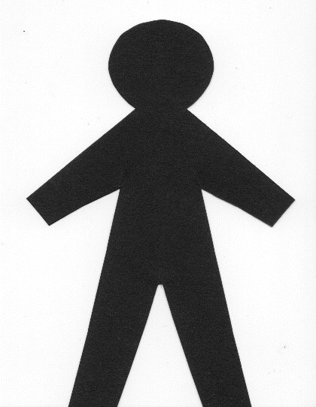
- 2”X3” card say, “Acts 2:44.”
- Silhouette figure say, “All the believers.”
- Put silhouette figure on the church and say, “…kept meeting together…”
- Child takes a figure and hand to the person on his right saying “…and they shared everything with each other.”

Prayer Time:
Ask God to help you teach others that Jesus is the Savior.

Large Group Wrap-Up: (10 minutes)
Purpose: The crazy bird puppet, Xiao Er, struggles with learning the take home point. The leader shows an example of the each small group application activity from this lesson and says the first phrase of the take home point. The kids respond with their phrase. They try to teach the puppet the take home point, but each time he confuses words or concepts. After three attempts, he finally gets it right and sings the correct take home point in a silly opera-like voice.

Singing: (Optional)

Lesson Review with Puppet Skit:

Xiao Er’s confused responses:
Activity 1: “We teach kids to make games.”
Activity 2: “We teach others about making chee cheong fun.”
Activity 3: “We teach kids how to concentrate.”
Welcome guests and thank them for attending.

Lesson 53

Large Group Opening:
- Ting Ting puppet
- puppet-sized teaching item such as a chalk board, flash cards, workbook, or bookbag
- adult-sized costume for Ethiopian eunich
- Bible
- scroll
    - two chairs

Small Group Application
Activity 1:
- two copies of the reproducible per child—copied on manila card
- scissors
- crayons
- one plastic bag per child
Activity 2:
- half a piece of flat chee cheong fun per child
- small sausages sliced into quarter – 2 per child
- plate and fork
- cups
- water
Activity 3:
- concentration cards from activity 1
Activity 4:
- a silhouette of a church
- a silhouette figure for each child
- a 2”X3” card with Acts 2:44 written

Large Group Closing:
- Xiao Er puppet
- sample materials from small group activities

Optional Music for the Lesson:
- Choose 2 or 3 songs and list them here
Concentration Game template
