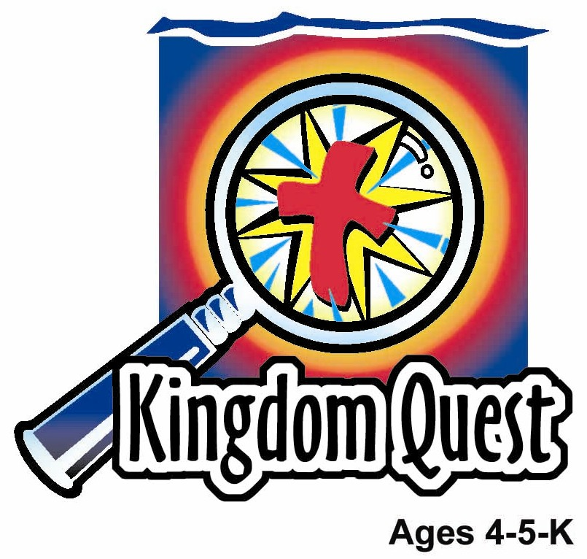
Date: ________________________
Series: Mother’s Day (Apr-May)
Year 2, Lesson 55

Mother’s Day Special

Take Home Point: *OUR MOTHERS CARE FOR US—Jesus cares for us too.
*Repeat this phrase throughout the lesson. The leader will say the first part of the phrase (CAPS). The children respond with the second part of the phrase (italics).

Bible Event: Isaiah 66:13
Jesus Link: Jesus gives us families to care for us.

We will help children know:
- The ways in which our mothers and families care for us.
- Jesus also cares for us.
- One way Jesus shows us His care is by giving us mothers and families to care for us.

We will help the children feel:
- Thankful for the care of mothers and families.
- Thankful for the care of Jesus.
- Desire to show care back to their mothers and families.

We will help the children do:
- Participate in a mystery theater by guessing how a mother is demonstrating care for her child.
- Draw cross on a cookie and eat it to teach the concept, “Jesus’ love blooms in our hearts.”
- Play a relay game, “Stuff Mom’s Bag,” to teach appreciation for all the things mothers do for their children.
THIS LESSON’S ROADMAP

DESTINATION | PAGE # | DISCOVERIES ON YOUR JOURNEY | SUPPLIES NEEDED
Large Group Opening   | 3  3 | Puppet Presentation  Bible Event | - Xiao Hung puppet  - flower  - Bible  - microphone  - a woman to play the role of the mother (Give her the script in advance.)
Small Group Application   | 6  6  7  7 | Activity 1: Mother’s Day Card” Craft  Activity 2: “Painted Cross Cookie” Snack  Activity 3: ”Stuff Mom’s Bag” Game  Prayer Time | Activity 1:  - reproducible card  - crayons  - finger paint  - small paper plates  - newspaper  - hand wipes  Activity 2:  - flower shaped biscuits (round will also work)  - several tubes of decorator’s frosting  - serviettes  - hand wipes  - cups  - water or juice  Activity 3:  - masking tape  - canvas bag or large purse  - one of the following per child (or your own ideas): comb, Band-Aid, plastic cup, tissue paper, stir spoon, wash cloth, keys, picture book, wallet, cleaning spray and rag  - several chairs  - box or basket  - Optional: sand timer, stopwatch
Large Group Wrap-up   | 8  8 | Singing (Optional)  Lesson Review with Puppet Skit | - optional music for the lesson  - Xiao Er Puppet

Pre-Session Singing: (10 minutes)
Purpose: When all children are in one group singing, it is easy for new children to join the group and immediately get involved. When the music can be correlated, it introduces the theme for the day. Choose two to three songs and list them here.

Large Group Opening: (15 minutes)
Purpose: The puppet demonstrates the need that will be met in today’s lesson. The scripts are not written verbatim, but give a story line in which the group leader can interact with the puppet. The children are introduced to the take home point and then interact with God’s word, as they experience the Bible event.

Supplies needed: Xiao Hung puppet; flower; Bible; microphone; a woman to play the role of the mother (Give her the script in advance.)

Puppet Presentation:
Xiao Hung comes on stage carrying a flower. He says it is to give his mother for Mother’s Day. The presenter asks Xiao Hung why he is giving his mother a flower for Mother’s Day. Xiao Hung wants to show his mom he loves her but, other than that, he’s not sure why we give flowers to mothers on Mother’s Day.

The presenter explains to Xiao Hung that mothers remind us of flowers. Just as a flower grows and blooms, so too a mother’s love grows and blooms in our hearts.

Today, in the Bible event the children will be learning that Jesus loves us and cares for us. One way He cares for us is by giving us mothers and other people to love us and take care of us.

The presenter teaches Xiao Hung the take home point: *OUR MOTHERS CARE FOR US—Jesus cares for us too. The presenter says the first line; Xiao Hung responds with the second line. After practicing it with Xiao Hung a few times, the presenter practices it with the children.

Bible Event: Mystery Theater
Mystery Theater is a drama in which the Bible event is communicated creatively and children are invited to give their input by guessing the answers to mysteries. In this case, different scenarios are acted out and children guess what is happening in each pantomime.

The large group presenter and a mom come on stage. The presenter opens the Bible and says:

Today, to celebrate Mother’s Day, I want to read you a very special passage from God’s word, the Bible, which talks about mothers. The passage is taken from a book in the Bible called Isaiah. (Read Isaiah 66:13.)

In that passage, we learn that God cares for us in the same way a mother cares for us. Today, for our Bible event, we are going to have a mystery theater. I have a mother with me who is going to act out different ways mothers help care for their children. After the mother is done acting out the event, you will have a chance to guess what she is doing.

Pick out three or four of the following six events for the mother to pantomime. Have her pantomime each event for 10-15 seconds. Then have the children guess what she is doing.

Event 1: Rocking a Baby
Have the mother cross her arms and pantomime rocking an infant while mouthing a song.

Event 2: Fixing Food
The mother pantomimes pouring ingredients into a bowl, stirring it, scooping it onto a baking sheet and putting it in the oven.

Event 3: Fixing a Wound
With a concerned look on her face, the mother pantomimes washing off a child’s arm, putting a Band-Aid on it and then kissing it.

Event 4: Tucking a Child in at Night
The mother pantomimes pulling covers up over a child, praying, stroking the child’s face and kissing him good night.

Event 5: Reading to a Child
Act out sitting next to a child, reading, pointing to pictures and turning pages.

Event 6: Helping a Child Get Dressed
Pantomime picking clothes out of a closet and helping a child get dressed in the clothes.

After the mother pantomimes the different situations and the children guess what the mother is doing, say:

Mothers, and people who are like mothers to us, do a lot to take care of children. They feed them, make sure they have clean clothes to wear, keep the house clean, tuck them into bed at night, help them with baths, hair cuts, homework and give them lots of love. They talk to their children, laugh with their children, do special activities, and kiss and hug them.

All moms are different. Some like to read. Others like to jog. Some moms like to eat pizza. Others like to eat broccoli. Some moms are short. Others are tall.

And sometimes a person who isn’t a mom may be just like a mom because of the love she gives a child.

We can thank Jesus for giving us our moms or for giving us someone who loves us like a mom. That’s the way Jesus is. He loves us and cares for us, so He gives us a mom and our families to love us and care for us. Thank you, Jesus, for love!

Practice the take home point. You say the first part; the children respond with the second part. *OUR MOTHERS CARE FOR US—Jesus cares for us too.

End with the following prayer:

Dear God,
Thank You for the best gifts.
Thank You for sending Jesus.
He’s our Savior and Your Son.
He cares for us by giving us our mothers.
Thank You! Thank You! Thank You!
Amen.

Small Group Application: (30 minutes)
Purpose: Smaller groups enable children to develop closer relationships with adults and peers in the church. As you reinforce the take home point with a fun hands-on activity, discuss the Bible event. Be sure to repeat the take home point several times. Say the first part and have the children respond with the second phrase. Application questions help kids apply the take home point to their daily lives. Close this session by gathering your small group for prayer. Let the kids pray!

*This may be a difficult lesson for children who do not have a loving mother. Be sensitive to these children by saying “mother or someone who is like a mother to us.”

During small group application time, discuss the following questions and points:

How does Jesus care for us? (Answers will vary but may include: by giving us mothers, by dying on the cross for us, by listening to our prayers, etc.)

How do our mothers or other family member care for us? (Answers will vary but may include: by cooking meals, helping a hurt child, tucking children into bed at night, etc.)

I wonder how we show Jesus we care for Him? (Answers will vary but may include: by obeying Jesus, praying to Him and showing His love to others, etc.)

I wonder how can we show our mothers or other family members we care for them? (Answers will vary but may include: By telling them, giving them gifts and cards on special days and by doing nice things for them, etc.)

Activity 1: “Mother’s Day Card” Craft
Supplies needed: reproducible card; crayons; finger paint; small paper plates; newspaper; hand wipes

Instructions:
- Have the children write their names inside the card and decorate the inside with crayons.
- Cover the table with newspapers and pour a small amount of various colored finger paint on the paper plates.
- Have the children make flowers above the vase on the outside of the card using finger paint thumbprints.
- Use crayons to draw stems down to the pot.
- Add crayon leaves if time permits.
- Allow to dry.

To discuss:
Read the card to the children and say: Because our moms love us and care for us, we are happy inside, happy like the color of a blooming flower. In what ways do your moms or other special people that love you like a mom care for you? (Answers will vary.) We can thank Jesus for giving us moms to care for us.

Practice the take home point. You say the first part; the children respond with the second part. *OUR MOTHERS CARE FOR US—Jesus cares for us too.

Activity 2: “Painted Cross Cookie” Snack
Supplies needed: flower shaped biscuits(round will also work); several tubes of decorator’s frosting; serviettes; hand wipes; cups; water or juice

Instructions:
Use tubes of cake decorating gel to draw crosses on the cookies.

To discuss:
Just as a mom’s love makes us bloom, Jesus’ love blooms in our hearts. The best way Jesus showed us His love was by dying on the cross and coming alive again to take the punishment for our sins so we can be forgiven. When we sin, it is like the mud. But, because Jesus died for us, God looks at everyone who loves Jesus and doesn’t see muddy hearts. Instead, our hearts are as beautiful to Him as a spring flower. We are forgiven!

Practice the take home point. You say the first part; the children respond with the second part. *OUR MOTHERS CARE FOR US—Jesus cares for us too.

Activity 3: “Stuff Mom’s Bag” Game
Supplies needed: masking tape; canvas bag or large purse; one of the following per child (or your own ideas): comb, Band-Aid, plastic cup, tissue paper, stir spoon, wash cloth, keys, picture book, wallet, cleaning spray and rag; several chairs; box or basket;
Optional: sand timer, stopwatch

To set up:
- Use masking tape to create a start line at one end of the playing area.
- Set the box or basket behind the line and put all the items in it.
- Put the canvas bag or purse on the other end of the playing area.
- Set up several chairs along the path to make an obstacle course the children must go around.
- Have the children line up behind the masking tape.

To play:
- Set the timer or stop watch for 30 seconds to one minute depending on class size or begin counting slowly to 30.
- The first child in the line picks an object from the box, runs through the obstacle course to the bag and stuffs it in the bag.
- The child runs back through the obstacle course to the line and taps the next child, who repeats the process.
- Continue playing until every child has had a turn.
- The team wins if they beat the clock.

Option: Have one group of kids compete against another group.

To discuss:
Pick up an object and have the child who stuffed it in the bag come forward. Say: I wonder how a mom uses this… Can you help me? After all the children have had a turn, say: Mothers sure take care of us in a lot of ways. I am very thankful that Jesus gave us mothers.

Practice the take home point. You say the first part; the children respond with the second part. *OUR MOTHERS CARE FOR US—Jesus cares for us too.

Prayer Time:
Thank Jesus for your mother and/or other family members who care for you. Name specific reasons why you are thankful.

Large Group Wrap-Up: (10 minutes)
Purpose: The crazy bird puppet, Xiao Er, struggles with learning the take home point. The leader shows an example of the each small group application activity from this lesson and says the first phrase of the take home point. The kids respond with their phrase. They try to teach the puppet the take home point, but each time he confuses words or concepts. After three attempts, he finally gets it right and sings the correct take home point in a silly opera-like voice.

Singing: (Optional)

Lesson Review with Puppet Skit:

Xiao Er’s confused responses:
Activity 1: “I love my mommy.”
Activity 2: “I care for that cookie.”
Activity 3: “Don’t stuff your mom in a bag.”

Welcome guests and thank them for attending.

LESSON 55

Large Group Opening:
- Xiao Er puppet
- flower
- Bible
- microphone
    - a woman to play the role of the mother (Give her the script in advance.)

Small Group Application
Activity 1:
- reproducible card
- crayons
- finger paint
- small paper plates
- newspaper
- hand wipes
Activity 2:
- flower shaped biscuits (round will also work)
- several tubes of decorator’s frosting
- serviettes
- hand wipes
- paper cups
- water or juice
Activity 3:
- masking tape
- canvas bag or large purese
- one of the following items per child (or use your own ideas): comb, Band-Aid, plastic cup, tissue paper, stir spoon, wash cloth, keys, picture book, wallet, and cleaning spray and rag
- several chairs
- box or basket
- Optional: sand timer or stopwatch

Large Group Closing:
- Xiao Er puppet
- sample materials from small group activities

Optional Music for the Lesson:
- Choose 2 or 3 songs and list them here

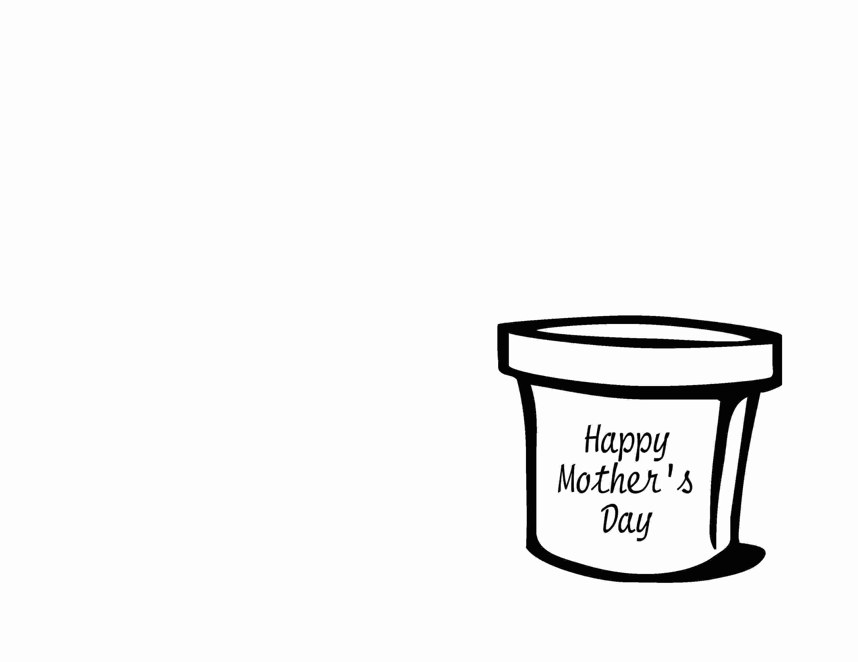

Your love
makes me
b l o o m !

Love,
____________
“I thank my God for all the memories I have of you.” Philippians 1:3

