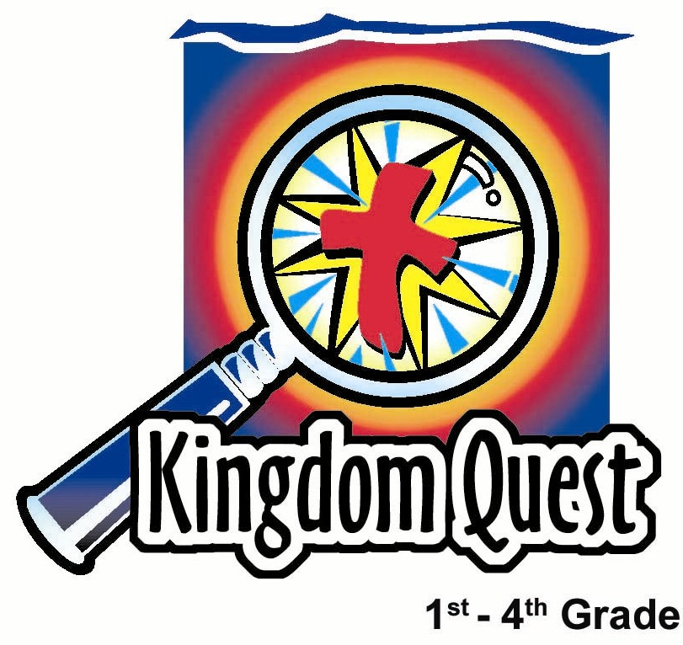
Date: ____________________
Series: Discover the Design (Jun-Aug)
Year 1, Lesson 1

Merdeka Weekend

Take Home Point: *Remember your blessings and be thankful.
*Repeat this phrase throughout the lesson.

Bible Event: Psalm 77:11-12, Psalm 111:1-5

Key Verse: Psalm 107:1: “Thank the Lord because He is good. His love continues forever.”

We will help kids know:
- For our country’s Merdeka Day, we remember those who have died in war for our country.
- The greatest victory we can remember is Jesus giving His life in spiritual battle for our salvation.
- God wants us to remember our blessings—spiritual blessings, people blessings, and material blessings.

We will help kids feel:
- Convicted that they too often fail to remember their blessings because they are thinking of what they don’t have.
- Surprised at how many important blessings they do have.
- Rich because of the great love God has for us.

We will help kids do:
- Remember their blessings and be thankful by making a memory chain.
- Pray a prayer of thanksgiving for their many blessings, both in class and during the week.
- Instead of complaining about something they don’t have, be thankful for that which they do.
THIS LESSON’S ROADMAP

DESTINATION | PAGE # | DISCOVERIES ON YOUR JOURNEY | SUPPLIES NEEDED
Small Group Warm-Up  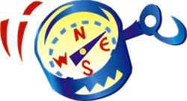 | 3-4 | Do we have a memory problem when it comes to remembering God’s blessings? Play a memory game to see how good your memory is. | - small jelly for each child  - super-size jelly for each group
Large Group   | 5  7-9  10  11 | Overview  Puppet Presentation:  “Dao Dao Remembers His Blessings”  Audience Interaction:  “Memory Test for Maximum Blessings”  Puppet Presentation:  “Dao Dao Remembers His Blessings” Conclusion | - Dao Dao puppet with a super-size jelly taped to his hand  - table  - a red, a white, and a blue poster board creased in the center and stood upright like a large card.  - Bible  - cross  - glass of water  - photo album  - school yearbook  - Malaysian flag  - banana  - soccer ball  - socks  - sweat band  - doll  - paint brush
Small Group Application   | 5-6 | Make a thanksgiving chain to remember your spiritual, people, and material blessings.  Memory Verse Learning: “Discovering Through the Maze” | - piece of paper or whiteboard with marker  - 1-inch strips of red, white, and blue paper cut 8½ inches long  - stapler for each group  - markers, pens, or crayons  - Mahjong paper with Bible  verse written  - Worksheet found on p.14
Small Group Warm-Up: 15 minutes
Purpose: Get pointed in the right direction! Build relationships and help guests feel at ease. Do the learning readiness activity that will point your group in the right direction for the lesson.

Supplies needed: small jelly for each child; super-size jelly for each group

Start by saying:

Today we are going to talk about two things. One thing is memory and the other thing is being thankful. Whose memory is good enough to remember what we are going to talk about this morning? (Memory and being thankful.)

Let’s first play a memory game. I am going to read a shopping list. Listen carefully. See how many items you can remember from the list. Here are ten things on the shopping list.

Popcorn Oatmeal
Flour Paper Towels
Ketchup Bananas
Crackers Syrup
Milk Bread

Begin with one child and see how many items he can name. When he runs out, the next child continues. When that child runs out, the next continues until they are finished.

Play the game again quickly. This time the list is taken from items that could be found in a closet.
Backpack Bible
Football shirt Yo-yo
Water bottle Magnifying glass
Book Camera
Coat hanger Teddy bear

Option: To help kids remember, use visuals. Shepherds can bring items from home that are similar to the lists. Have separate bags for each of the different categories.

Set all the items from a category out so everyone can see and then pack them into a sack one at a time. Ask the kids how many of the items they could remember.

We have talked a little bit about memory. Now let’s talk about saying thank you.

I am passing out a jelly to every child. You have one minute to give your jelly to someone else. When you receive a jelly from another person you are to say thank you. The object of the game is to have no jelly in your hand at the end. You can only give one jelly to a person at a time. Remember to say thank you each time you receive a jelly. You may begin.

After the activity, gather the children. Redistribute the jellies so everyone has one and let them eat.

How many of you remembered to say thank you each time you received a jelly?

How did it feel when you had so many people thank you? (Good inside, appreciated.)

How do you think God feels when we say thank you to him? (Happy that we are thankful.)

A blessing is like a present that God gives us. It can be something that is either big or it can be something small.

Who can remember a big blessing or a present from God that you received a long time ago? For example, maybe you had a big blessing when you were five years old but it is still something you are thankful for today.

Give whoever answers the question a super-size jelly and tell him, “Well done.” When the other kids see this, they will no doubt say, “Not fair!”

Let the children complain for a while. Then point out how quickly they can change from being thankful (as they were earlier when they had a small Tootsie Roll) to complaining (when they saw there was a larger Tootsie Roll they did not have). Is this a memory problem? Say:

Just a few minutes ago you were thanking people for your Tootsie Rolls, now you are complaining! Did you forget something?

Today we are going to see it is important for us to not have that memory problem. We will learn to *remember your blessings and be thankful.

Large Group: 20-30 minutes
Purpose: Help kids observe what the Bible says. Present the Bible event in creative fashion. Help kids begin to interpret what it means.

Overview

Supplies needed: Dao Dao puppet with a super-size jelly taped to his hand; table; a red, a white, yellow and a blue poster board creased in the center and stood upright like a large card; Bible; cross; glass of water; photo album; school yearbook; Malaysian flag; banana; soccer ball; socks; sweat band; doll; paint brush.

Puppet Presentation: “Dao Dao Remembers His Blessings”
The teacher explains to Dao Dao the significance of Merdeka Day and remembering those who gave their lives for our country. We are to also remember and give thanks to Jesus who gave His life for us in the spiritual war for our salvation.

Audience Interaction: “Memory Test For Maximum Blessings”
A volunteer is asked to play a memory game that teaches about the different categories – spiritual blessings, people blessings, and material blessings – for which to be thankful.

Puppet Presentation: “Dao Dao Remembers His Blessings” Conclusion

Small Group Application: 20-25 minutes
Purpose: Help kids map out the meaning of the Bible event in their lives. Use the questions to stimulate discussion but don't feel tied to them. Allow the Holy Spirit to guide you. Include personal examples from your own faith journey. The example of Christ at work in your life will leave lasting impressions of how Christ can work in the children's lives.

Use your Bibles! Children need to learn how to look up references and follow along when scripture is read aloud. Allow for quality time of prayer at the close of the lesson.

Observation Questions: What happened?
Read Psalm 77:11-12 and Psalm 111:1-5. Let the children look in their Bibles and find some of the things they should give thanks to God for. Record on a piece of paper or white board the blessings kids found in the scripture passages.

Interpretation Questions: What does this mean?

When you give thanks to God, is it just speaking words to Him? Or is there feeling behind it as well? If so, what kind of feelings?

Application Questions: What does this mean to me?

Supplies needed: piece of paper or whiteboard with marker; 1-inch strips of red, white, and blue paper cut 8½ inches long; stapler for each group; markers, pens, or crayons

Application Activity:
Make a thanksgiving chain using red, white, and blue paper. The paper should be cut into 1-inch strips that are 8½ inches long. On these strips children will write a word according to the category they are listing as an area of thanksgiving. Categories are as follows.
Red: Spiritual blessings
White: People blessings

Blue: Material blessings

Yellow: Physical blessings

To help children think of spiritual blessings, ask the following.

What characteristics or qualities of God can you thank Him for? What has God done for you that you can thank Him for?

Have the children look for phrases or words in Psalm 111:1-5.

For people blessings ask the following questions.

Think of people who have helped you come to know God better and better. Think of friends to give thanks for. Think of people you don’t know but who have helped you anyway. (Government officials, police, firemen.) Think about groups of war veterans who have given their lives to protect our country.

For material blessings ask the following.

Think of the things you need to live. (Food, water, air, clothing, shelter.) Think of the luxuries you enjoy. (Toys, vacations, television.) Think of the different talents and abilities you have. (Being smart, playing sports, singing.)

For material blessings ask the following.

Think of the strength you have to be able to walk, run, climb and etc.

After a child has thought of a blessing and shared it with the group, have him make a link by stapling the ends of the paper strip together. The next person then attaches his own link to that link after he shares, until a paper chain for the group is made.

If possible, connect the chain together in red, white, and blue sequence.
This will encourage everyone to think of a wider variety of blessings.

The group’s paper chain can then be attached to other groups’ chains to decorate the room. Or the group’s paper chain can be left as a reminder of the group’s thanksgivings.

Memory Verse Learning: 5 minutes
Purpose: Help kids to memorize and keep scriptures at heart. Using creative ways to help kids enjoy learning the key verse and in small group setting.

Supplies needed: Mahjong paper with Bible verse written; Worksheet found on page 14

Memory Verse: Psalm 107:1~ “Thank the Lord because He is good. His love continues forever.” (NCV)

MV Presentation: “Discovering Through the Maze”
Hand worksheet out to the children. Instruct them to work on it to discover the Bible verse for today’s learning. They are to take every third letter of the maze to form the Bible verse. Reward every child with a sticker for having complete their worksheet.

When every child have completed their worksheet, take out the mahjong paper with Bible verse written to memorize with the children.

Prayer Time:
Spend plenty of time praying today. *Remember your blessings and be thankful. Pray and give thanks for all or part of the items on the paper chain your group has created.

Large Group Presentation

“Dao Dao Remembers His Blessings”
Puppet Presentation

Take Home Point: *Remember your blessings and be thankful.

Dao Dao: (Appears with a super-sized jelly taped to his hand.) Hi, Teacher! Hi, kids! Is this great or what?

Teacher: You’re in a good mood, Dao Dao. What’s up?

Dao Dao: It’s because we are having a holiday this weekend. And finally, I got this extra big jelly in my small group. What a great day to be Dao Dao!

Teacher: Dao Dao, I hope you remember your blessings and are thankful. Do you know why you have a holiday this coming Friday?

Dao Dao: Ya! It’s Merdeka! Merdeka!

Teacher: That’s right.

Dao Dao: Teacher? Doesn’t that have to do with remembering?

Teacher: Yes.

Dao Dao: Oops. I’m going to be in trouble.

Teacher: Why?

Dao Dao: I have a terrible memory.

Teacher: What’s wrong with your memory?

Dao Dao: My mom says I always forget to turn off the lights when I leave the room. And I forget to pick up my clothes.

Teacher: But do you ever forget when your birthday is?

Dao Dao: Don’t be silly, Teacher. I never forget that!

Teacher: Maybe your memory is in better shape than you think. Today we are learning to remember our blessings and be thankful.

Dao Dao: Is that why people have name it memorial day?

Teacher: In a way. Memorial day or Merdeka Day is for us to remember one special blessing that we have. We remember soldiers who fought in wars and gave their lives to protect our country.

Dao Dao: That sounds important!

Teacher: It is. And it’s very touching when you consider what a great cost some men and women gave when they were killed in a war.

Dao Dao: I don’t know of anyone who ever died in a war for our country.

Teacher: Let’s see if any of these kids do. Boys, girls, and shepherds, if you have a relative who fought and died in World War II, would you stand up. How about if you had a relative who had been in a war?

Option: Instead of the previous questions, have any veterans or military servicemen from your church come and briefly describe their military branch and where they served (or serve). It would be even more special if they could wear their uniforms.

Dao Dao: Wow! That’s something to think about. People who gave their lives. Just remembering that makes me thankful.

Teacher: Yes. I had a brother who died in a very important war. As a matter of fact, he died to save me.

Dao Dao: Were you in a war, Teacher?

Teacher: All of us are in a war. It’s a fight against Satan, sin, and death.

Dao Dao: Who are you talking about, Teacher?

Teacher: Jesus. He’s my brother in a way. He’s the brother of all because He came from heaven to live here as one of us.

Dao Dao: And He died in a war?

Teacher: It was a spiritual war. Don’t you remember when He died on the cross? He didn’t stay dead though; He rose again. And now anyone who trusts in what He has done for them has victory over Satan, sin, and death!

Dao Dao: Teacher, when I remember that, it’s even better than a giant jelly and a holiday.

Teacher: Today we are going to *remember our blessings from God and be thankful. That includes remembering on Merdeka Day those who gave their lives and remembering many other blessings.

Dao Dao: What are we going to do?

Teacher: Watch this,Dao Dao. I have a little memory game for some volunteers from the audience.

“Memory Test For Maximum Blessings”
Audience Interaction

Have on a table four groups of items hidden behind four poster boards. The poster boards can be freestanding if folded in half and stood upright like a large card.

The first poster board is red and has written on its side facing the audience, “Spiritual Blessings.” Behind it is concealed a Bible, a cross, and a glass of water.

The second poster board is white and on it is written, “People Blessings.” Behind it is concealed a photo album, a school yearbook, and an flag.

The third poster board is blue and on it is written, “Material Blessings.” Behind it is a banana, a doll, and socks.

The fourth poster board is yellow and on it is written, “Physical Blessings.” Behind it is a soccer ball, a paint brush and a sweat band.

Invite one contestant forward. Explain that there are three different categories of blessings: spiritual blessings, people blessings, and material blessings. Say that behind each of the poster boards are three objects that remind us of those blessings.

Lift the poster board and count for five seconds before concealing the objects again. After doing this with all four groups, challenge the child to remember all twelve objects. If the child cannot do so, he can call on a friend to help him.

Next, explain the meaning behind the different objects. If time allows, ask a child to guess what each item symbolizes. However, do not use too much time guessing and taking time away from the small group application. The groups need to feel unhurried during their small group application today.

The items symbolism is as follows.
Bible: God’s Word
Cross: The gift of Jesus to us
Glass of water: Holy Spirit
Photo album: Family
School yearbook: Friends
Malaysian flag: Country or the people who died to protect it
Banana: Food
Doll: Toys

Socks: Clothes
Soccer ball: Physical abilities
Paint brush: talents and abilities God has given us
Sweat band: Strength

After a review of the meanings of these objects, the puppet presentation continues.

“Dao Dao Remembers His Blessings”
Conclusion

Dao Dao: Teacher, I don’t know if I could remember all thirteen of those things.

Teacher: There’s only twelve, Dao Dao.

Dao Dao: See, I must have already forgotten!

Teacher: Dao Dao, it’s not as bad as all that. The most important thing is to remember your blessings every day and give thanks to God for them. The Bible says, “Thank the Lord because He is good. His love continues forever.” (Psalm 107:1).

Dao Dao: Why is that such a big deal?

Teacher: When you remember your blessings and give thanks, it helps take away your worry or your sadness or whatever is bothering you. When you remember your blessings and give thanks, you realize you are a rich person. Just do it and find out. It really works.

Dao Dao: But I don’t have a good memory for those kinds of things.

Teacher: Then let’s help you get one. In our small groups we all will practice *remembering our blessings and giving thanks. Your memory will improve as you practice remembering. And the more you do this every day, the richer you will feel. So before we go to small group, why don’t we have a closing prayer?

Dao Dao: I forgot how la.

Teacher: Dao Dao, stop teasing. Let’s pray.
Dear God, we need some help remembering all our blessings. Would You help us? We want to thank You for our spiritual blessings, like Jesus dying on the cross for us. Thank You for our people blessings, like the people You put in our lives that help us and love us. Thank You for our material blessings, like the many great toys we get to own. And thank You for…thank You for…Dao Dao, what was the fourth type of blessing?

Kids: Thank you for our material blessings.

Teacher: Yeah! God, thank you for physical strength and our talents and abilities. In Jesus’ name we pray. Amen.
Supplies:

Quantity ()

Small Group Warm-Up:
  - small jelly for each child
  - super-size jelly for each group

Large Group:
- Dao Dao puppet with a super-size jelly taped to his hand
- table
- a red, a white, a yellow, and a blue poster board creased in the center and stood upright like a large card. The red poster board has written on its side facing the audience “Spiritual Blessings.” The white poster board has written on it “People Blessings.” The blue poster board has written on it “Material Blessings.” The yellow poster board has written on it “Physical Blessings.”
- Bible
- cross
- glass of water
- photo album
- school yearbook
- Malaysian flag
- banana
- soccer ball
- socks
- sweat band
- doll
- paint brush

Small Group Application:
- 1-inch strips of red, white, yellow, and blue paper cut 8½ inches long
- stapler for each group
- markers, pens, or crayons
- piece of paper or whiteboard with marker

