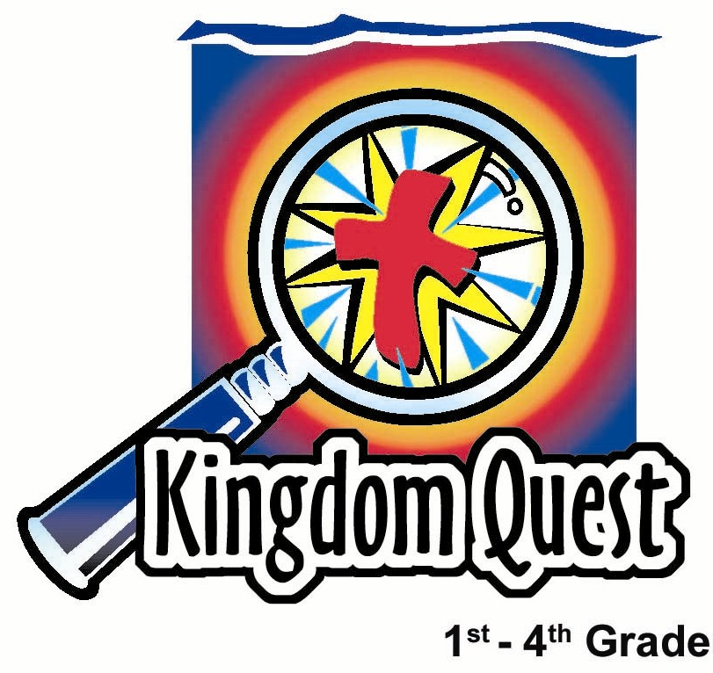

Date: ____________________
Series: Discover the Design (Jun-Aug)
Year 1, Lesson 2

Creation-Yes!; Evolution-No!

Take Home Point: *God made everything.
*Repeat this phrase throughout the lesson.

Bible Event: Genesis 1:1, Psalm 19:1, Revelation 4:11 – Creation

Key Verse: Genesis 1:1: “In the beginning God created the sky and the earth.” (NCV)

We will help kids know:
- God created all things.
- The world did not happen by accident; humans did not evolve from other animals.

We will help kids feel:
- Responsible and thankful to God, who has created them.
- Special because God has created them.

We will help kids do:
- Experience what God might feel like if someone took credit for what He made.
- Make a puzzle picture of something they are thankful God created.

THIS LESSON’S ROADMAP

DESTINATION | PAGE # | DISCOVERIES ON YOUR JOURNEY | SUPPLIES NEEDED
Small Group Warm-Up   | 3-4 | How does it feel when someone doesn’t believe you? How do you think God feels when people don’t believe he created the world? Have your group design a puzzle. God’s creation fits together perfectly like the puzzle’s pieces. | - 4 x 5-inch puzzle for each group  - Magic pens or colour pencils
Large Group   | 4  7-12  13 | Overview  Drama and Puppet Presentation: “Dr. Seow Seow and the Theory of Evolution”  Object Lesson: “Discover the Design: God Made Everything” | - costume for Dr. Seow Seow that might include a lab coat, crazy glasses, an oversized pen and clipboard, and wild hair  - Xiao Er, a crazy looking bird puppet  - jigsaw puzzle  - large tupperware  - stuffed toy monkey (or other animal)  - two boards to slam together for a noise effect  - one of the puzzles from small group warm-up with group members’ names on it  - large blank puzzle that is in pieces
Small Group Application   | 5-6 | *God made everything! Show your thankfulness for what God has created by making a puzzle that celebrates on of his creations.  Memory Verse Learning:  “Memory Verse Puzzle”  1 Cor. 10:26 will be emphasized for lessons 2-4 to encourage children to honour God’s creation by taking care of His world. | Option 1  - permanent marker per group (optional for groups with younger children)  - colour pencils  - 4 x 5-inch puzzle for each child  Option 2  - supply of magazines with pictures  - piece of construction paper for each child  - scissors  - markers or colour pencils  - glue  - the puzzle done by each child during option 1 or 2
Small Group Warm-Up: 15 minutes
Purpose: Get pointed in the right direction! Build relationships and help guests feel at ease. Do the learning readiness activity that will point your group in the right direction for the lesson.

Supplies needed: 4 x 5-inch puzzle for each group; magic pens or colour pencils

Gather your group around the puzzle. Have a variety of colored permanent markers available but caution children about getting any permanent marks on their clothing. (Colour pencils will work as well, though the colors will not be as bright.)
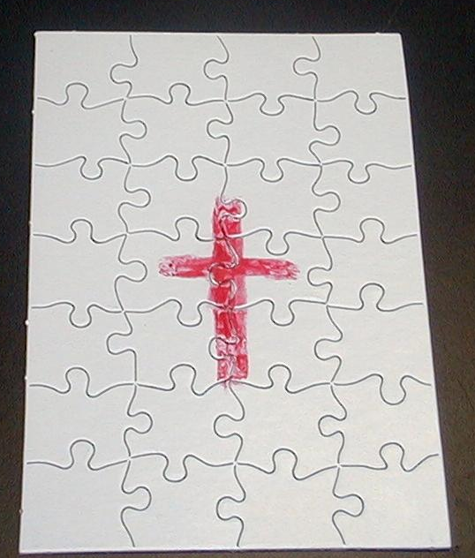
As you talk, draw a cross in the center of the puzzle.

Today we are going to make a puzzle with all of our names on it. The puzzle will remind us of how God designed the whole world and how he fit it together like a beautiful puzzle. Some of the very best creations God has created are all of you!

As kids take turns signing their names on the puzzle, have them tell the group about something they have made.
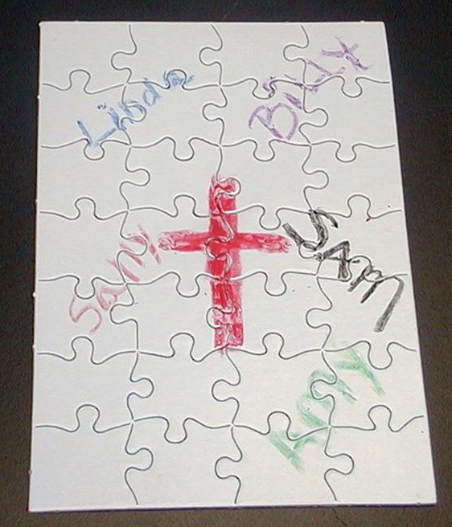
Can you think of something you made that you are proud of? It doesn’t need to be a big thing. It could be a Lego project, a picture you drew, a craft you made, or something you built.

Go first and write your name on the puzzle. Tell about something you have made. Then pass the puzzle around so each child may sign his name and tell about what he has made.

As the kids are sharing what they have made, give each child the experience of being doubted. Act as though you don’t believe the child could make the thing he describes making. This needs to be done sensitively. Perhaps this could be done with the kids knowing that you are teasing. For example:

Johnny, I can’t believe you could put together a model airplane. How could an eight-year-old do that? That doesn’t seem possible.

After the puzzle has been signed by all of the children and you have doubted everyone’s story, continue.

How did you feel when I didn’t believe that you really made what you said you did? (Surprised, a little upset, confused.)

How do you think God might feel when people don’t believe that he made the world and everything in it?

Allow the children to respond.

Today we are going to learn this important truth: *God made everything!

Large Group: 20-30 minutes
Purpose: Help kids observe what the Bible says. Present the Bible event in creative fashion. Help kids begin to interpret what it means.

Overview

Supplies needed: costume for Dr. Seow Seow that might include a lab coat, crazy glasses, an oversized pen and clipboard, and wild hair; Xiao Er, a crazy looking bird puppet; jigsaw puzzle; large tupperware; stuffed toy monkey (or other animal); two boards to slam together for a noise effect; one of the puzzles from small group warm-up with group members’ names on it; large blank puzzle that is in pieces

Drama and Puppet Presentation: “Dr. Seow Seow and the Theory of Evolution”
Dr. Seow tries to explain how the world and its inhabitants evolved into being. Instead, Dr. Seow shows how the theory of evolution with all of its missing links and improbabilities, requires more faith to accept than to believe in the truth of God.

Object Lesson: “Discover the Design: God Made Everything”
Covers Bible readings Genesis 1:1, Psalm 19:1, and Revelation 4:11. Using a puzzle, the large group presenter will explain how God designed and created everything.

Small Group Application: 20-25 minutes
Purpose: Help kids map out the meaning of the Bible event in their lives. Use the questions to stimulate discussion but don't feel tied to them. Allow the Holy Spirit to guide you. Include personal examples from your own faith journey. The example of Christ at work in your life will leave lasting impressions of how Christ can work in the children's lives.

Use your Bibles! Children need to learn how to look up references and follow along when scripture is read aloud. Allow for quality time of prayer at the close of the lesson.

Observation Questions: What happened?

How did Professor Seow think the world evolved or came into being? (It started with the Big Bang and everything else evolved over zillions of years.)

Could Professor Seow prove this? (No.)

Read aloud Genesis 1:1, Psalm 19:1, and Revelation 4:11.

Who does the Bible say made the world? (God made it.)

Interpretation Questions: What does this mean?

Is there any proof that God made the world? (The orderly and complicated design of the world points to a powerful force that created it—God. See Romans 1:19-20: “What can be known about God is clear to them because he has made it clear to them. From the creation of the world, God’s invisible qualities, his eternal power and divine nature, have been clearly observed in what he made.”)

Application Questions: What does this mean to me?

Application Activity:

Option 1:
Supplies needed: permanent marker per group (optional for groups with younger children); colour pencils; 4 x 5-inch puzzle for each child

Give each child a blank puzzle.
It may be time-consuming for younger kids to write out “God made.” You could write this for them using a quick-drying permanent marker.
Today we are going to remember that *God made everything! Each of you has a small puzzle of your own to decorate. I would like you to write, “God made. . .” and finish the sentence with what it is that you are thankful that God made. But on the very top of the puzzle, write Genesis 1:1. Then draw a picture of the thing you are thankful for.
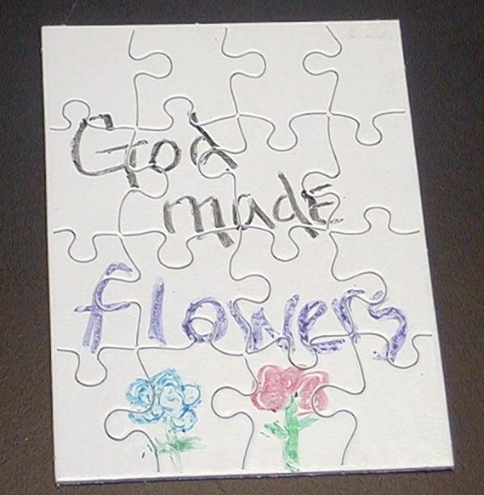
You could write on your puzzle, “God made butterflies” or “God made anteaters.” Think of all the possibilities. God made 4th graders, volcanoes, stars, or your family. You could even write your own name.

As you are doing this, I would like us to talk about how it makes you feel that God made these things.

Choose from the following questions for your group’s discussion.

When would be a good time to stop and thank God for what he has created?

How does it make you feel knowing there has never been anyone like you nor will there ever be anyone like you because God made you so unique?

Would you feel differently about yourself if you thought God did not make you but you happened by chance? Why or why not?

Just like the puzzle pieces fit together in a special design, what do you think God has designed you to do?

Wrap up the discussion, reinforcing the take home point, *God made everything! Also point out the best part of God’s design is not only creating the world, but also giving his son to the world so we might be part of God’s plan forever.

Option 2:
Supplies needed: supply of magazines with pictures; piece of construction paper for each child; scissors; markers or colour pencils; glue

If blank puzzles are not available, let the children make their own puzzles. Supply magazines with pictures. Have the children paste a picture on a piece of construction paper. Then use markers or crayons to write, “God made…”

Then have the children turn over their construction paper and draw lines in the shape of puzzle pieces. When they cut along these lines, the completed project will be a self-made puzzle.

Memory Verse Learning: 5 minutes
Purpose: Help kids to memorize and keep scriptures at heart. Using creative ways to help kids enjoy learning the key verse and in small group setting.

Supplies needed: the puzzle done by each child during option 1/2

Memory Verse: 1 Corinthians 10:26 - “[Certainly,] because the earth and everything on it belong to the Lord.”

MV Presentation: “Memory Verse Puzzle”
Have the children bring out their puzzle that was done during option 1/2. The Bible verse that they have written at the top of the puzzle should be repeated several times to
keep it into memory. If any child have not written the verse, be sure that he/she does so before the shepherd leads them to memory verse learning. After memorizing, the children can complete designing and colouring their puzzle if they had not completed theirs.

Prayer Time:
Go through the alphabet and think of the different things God has created, each beginning with one of the letters. As you think of these, thank God for how wonderful He is to create these things. One child will begin with the letter “A” and the next will take the letter “B.” Go around the circle as you continue through the alphabet.
Large Group Presentation

“Dr. Seow Seow and the Theory of Evolution”

Drama and Puppet Presentation

This is the first in a series of five utilizing a costumed character, Dr.Seow Seow. The name is adopted from Hokkien meaning “crazy” and this character brings out challenges as he learns the truth of God’s creation.

The actor playing the part of Dr. Seow can have lots of fun creating the character. The costume might involve a lab coat, crazy glasses, an oversized pen and clipboard, and wildly spruced hair. He would also do well to speak with an accent. The script is written with some accent changes such as turning the word “the” into the word “ze” and “where” into “vere.”

Accompanying the crazy scientist is his puppet, Xiao Er, who is a crazy looking bird that over-exaggerates the ridiculous.

The large group presenter, Teacher, is present to provide the serious questions and correct answers.

A few props are needed:
- a jigsaw puzzle
- a large tupperware
- a stuffed toy monkey (or other animal)
- two boards to slam together for a noise effect
Improvise with these supplies according to your own imagination.

The script is written with the main point of every paragraph in bold and capitalized. This might help with grasping the main idea and help the actors memorize their parts. Immediately after the presentation, the large group presenter wraps up with an object lesson.

Introduction
Teacher: Boys and girls, please welcome our guest speaker, Dr. Seow Seow.

(Dr. Seow enters as the children clap.)

Teacher: Dr. Seow Seow . . . Are you Hokkien?

Dr. Seow: Yez, my father is Hokkien; my grandfather is Hokkien; so I am
Hokkien.

Teacher: Wait a minute. You mean, you’re… (do the action of turning one finger at the side of head denoting “crazy”)

Dr. Seow: No, no. My name is Seow Seow.

Teacher: So you are not “seow”, la.

Dr. Seow: Zat is correct.

Teacher: I’ll just call you Dr. Seow. What are you here to do today, Dr. Seow Seow?

Dr. Seow: I’m here to tell you all about ze world. I am so brilliant. I know all about ze sun and ze moon and even ze stars, which go “twinkle, twinkle, twinkle.”

Xiao Er: Did someone say, “Twiggies, Twiggies, Twiggies”?

Dr. Seow: No I said, “twinkle, twinkle, twinkle.” Oh, excuse me. Zis is my not-so-brilliant assistant, Xiao Er.

Xiao Er: Hi everyone! I’ll be happy to assist you…in eating those Twiggies.

Dr. Seow: Zere are no Twiggies!

Xiao Er: Okay. Then just Bon Bons.

Dr. Seow: You are ze ding-dong!

Teacher: (Steps in.) Wait a minute. I’m the host here.

Xiao Er: Oh good, Hostess. I love Hostess! Cupcakes are my favorite.

Teacher: Wait a minute. We need to get to work.

Xiao Er: Eating?

Teacher: No, discovering.

Dr. Seow: Zat is vat I am trying to do! I vill tell you about ze whole universe. I vill tell you about ze animals and how zey changed over zillions and zillions of years, and finally zey become brilliant like me!

Xiao Er: Ha! I think you mean like a big ding-dong!

Dr. Seow: Quiet bird! Ve vill proceed.
It All Happened By Chance
Props:
- jigsaw puzzle
- large tupperware

Dr. Seow: You see, zis vorld and ze sun and ze moon and ze stars. . . All zese things just came together. And ven everything was just right, life just began on ze earth with itty-bitty animals that began to change and become more and more bigger animals.

Teacher: Can you show us how that worked, Doctor?

Dr. Seow: Certainly! It is like zis jigsaw puzzle. You see how it is put together nicely. Vell, if I take it apart and I put it into my special machine here (plastic tub) and I shake it up and pour it out, it vill come out perfectly together. Should I demonstrate?

(The doctor tries this once and then continues to try as the dialogue proceeds.)

Teacher: It’s not working, Doctor.

Xiao Er: Maybe you should fill it up with some Twiggies!

Dr. Seow: Xiao Er, don’t be ridiculous!

Xiao Er: Okay. Use Bon Bons!

Dr. Seow: No, the secret is zis. I must do this for zillions and zillions of years. Zen it will finally vork.

Teacher: I don’t know, Doctor. Do we have zillions and zillions of years to wait, boys and girls?

(“No!”)

Dr. Seow: Vell, it vill vork. It is the truth of evolution.

Teacher: It that the truth or is that a theory?

Xiao Er: Or is it a Bon Bon?

Dr. Seow: Quiet bird! Theory or truth. Vat is the difference?

Teacher: Truth is something God says. He says He made everything!

Dr. Seow: Vell, I know nothing about zat. But I know zese experiments vill vork if I just do it long enough.

Xiao Er: Or if you feed your assistant some Bon Bons!

Teacher: Dr. Seow, let’s go on to the next one. I don’t think we have zillions and zillions of years.

Animals Changed and Finally Became Humans
Props:
- stuffed toy monkey
- large tupperware

Dr.Seow: Here is ze other truth of evolution. People come from ze monkeys, which come from ze other animals.

Teacher: How did that happen?

Dr. Seow: Vell, I vill show you. I have ze monkey here and I put it into my special machine. I shake it up and out vill come ze doll of ze person. Do you want a Barbie doll or a Ken doll?

Xiao Er: Or a chocolate-covered dinosaur?

Dr. Seow: Xiao Er, now is not ze time. Vell, vat do you vant?

Teacher: I don’t think the monkey will change into anything. I think it will stay a monkey.

Dr. Seow: Here, I vill show you. (Shakes stuffed animal in tupperware and opens it to reveal the stuffed animal is the same.) Oops. I vill try again. (Tries again.)

Teacher: I don’t think it’s working, Dr. Seow.

Dr. Seow: Vell, I vill tell you vat ve vill do. Ve vill do zis for zillions and zillions of years until finally ze monkeys change into ze people.

Teacher: Boys and girls, do you want to wait zillions and zillions of years?

(“No!”)

Teacher: I don’t think they do, Dr. Seow.

Xiao Er: Uh, Dr. Seow…

Dr. Seow: Yes, Xiao Er?

Xiao Er: I think you are making a monkey of yourself.

Dr. Seow: Quiet, cuckoo bird! Zey vill just have to have faith in me and believe zis will work.

Teacher: That’s a lot of faith! I think I would rather believe that God made us as people, each one of us special.

Dr. Seow: But zat is not ze theory of evolution.

Teacher: I guess not. It’s just in the Bible. Tell me, Dr. Seow, if you don’t believe that God made everything, then where does it come from?

The Universe Started by Itself With a Big Bang
Prop:
- two boards to slam together for a noise effect

Dr. Seow: Vell, I vill show you. You see, at the very beginning of ze whole vorld there vas all zis stuff together in one big super-sized glob. Zen suddenly (*BANG* sound effect with the two boards) it all exploded out and spun out zillions and zillions of stars and ze sun and ze earth and ze moon. It just happened (*BANG*) just like zat.

Xiao Er: The stars and the suns and the earth and the moon…Bang! Just like that, right?

Dr. Seow: Zat is right, Xiao Er.

Xiao Er: Can you go “Bang!” and make me a moon cake?

Dr. Seow: No, I am just explaining how ze universe started.

Teacher: Well, I have one question.

Dr. Seow: Vat is your question?

Teacher: Who made the big glob that exploded and made all the stars and planets?

Dr. Seow: Who said anybody had to make it? It vas just zere.

Teacher: How did it get there?

Dr. Seow: I am just ze brilliant scientist. How do you expect me to know?

Teacher: Oh! Then I have a good book for you to read that explains it all.

Dr. Seow: Vat is zat?

Teacher: The Bible. It says in Genesis 1:1, “In the beginning God created the sky and the earth.”

Dr. Seow: Vell, who wrote zat?

Teacher: God did. He wanted us to know that He made everything!

Dr. Seow: Is zis a theory or ze truth?

Teacher: God says that it is the truth. Maybe you should find out for yourself.

Dr. Seow: Vell, vell, vell! Maybe even brilliant scientists can learn some of zese things. I think I vill come back next week and see vat else you have to say about zis matter. Vat do you say, Xiao Er? Ve come back next veek?

Xiao Er: Sure thing, Doctor Ding Dong—I mean, Fritz.

Dr. Seow: Let’s go. We have to practice a zillion, zillion times vith my special machine to see if it vorks. Bye, boys and girls.

Xiao Er: Bye, kids!

“Discover the Design: God Made Everything”

Object Lesson

Props needed:
- one of the puzzles from small group warm-up with group members’
names on it
- large blank puzzle that is in pieces

While pointing to the blank puzzle pieces say:

Teacher: These puzzle pieces scattered about are kind of like the way evolutionists see how everything came into being. Scientists learn and study these pieces to come up with a theory about how the world was made and how we ended up as people. All of these pieces don’t fit together very well, though.

Show the assembled puzzle with children’s names on it and read Genesis 1:1, Psalm 19:1, and Revelation 4:11.

Teacher: Look at this next puzzle.

See the design on this puzzle? This puzzle didn’t just happen by chance. There is a design here. Someone designed how each puzzle piece would be shaped and how it all fits together. A design is like the plan of how it should be after it is made.

God also has a design. His design is much bigger than this puzzle. *God made everything. He made the entire world and all the people. He fit them together so we would know He made us and we could give thanks to Him.

Since God made us, we want to listen to Him to understand His design and plan for our lives. Then all the pieces, like this puzzle, will fit together.

Together we are giving thanks and glory to God for His wonderful creation. The best part of his design is in the middle of it. There He placed His own son, Jesus, to give His life for us so that our lives would fit together with Him.

All can repeat the take home point.

*God made everything!
Supplies:

Quantity ()

Small Group Warm-Up:
- 5½ x 8-inch blank puzzle for each group (puzzles can purchased from www.discountschoolsupply.com) A sample is also available to you on page 16 and 17. Photocopy master copy and then mount onto a heavy paper.
- magic pens or colour pencils

Large Group:
  - costume for Dr. Seow Seow that might include a lab coat, crazy glasses, an oversized pen and clipboard, and wildly spruced hair
  - Xiao Er, a crazy looking bird puppet
  - jigsaw puzzle
  - large tupperware
  - stuffed toy monkey (or other animal)
  - two boards to slam together for a noise effect
  - one of the puzzles from small group warm-up with group members’ names on it
  - large blank puzzle that is in pieces

Small Group Application:

Option 1
- permanent marker per group (optional for groups with younger children)
- colour pencils
- 4 x 5-inch puzzle for each child

Option 2
- supply of magazines with pictures
- piece of construction paper for each child
- scissors
- markers or crayons
- glue

Memory Verse Learning:
- the puzzle done by each child during option 1 or 2

