
Date: ____________________
Series: Discover the Design (Jun-Aug)
Year 1, Lesson 6

God Designs the Family

Take Home Point: *God fits us together in families.
*Repeat this phrase throughout the lesson.

Bible Event: Genesis 2:18-25

Key Verse: Genesis 2:18: “Then the Lord God said, ‘It is not good for the man to be alone. I will make a helper who is right for him.’” (NCV)

We will help kids know:
- God designed the family beginning with a husband and a wife.
- The reason God designed families, was not only so people would populate the world. He also wanted the family to care for one another with God’s love.

We will help kids feel:
- God’s love for them as they receive His love through their families.
- A desire to share God’s love in their families.

We will help kids do:
- Speak openly about their families.
- Play a game that reminds them of how God has blessed their families.

THIS LESSON’S ROADMAP

DESTINATION | PAGE # | DISCOVERIES ON YOUR JOURNEY | SUPPLIES NEEDED
Small Group Warm-Up   | 3 | Talk about families and how God can help us in our families and feel connected with one another. | - no supplies are needed
Large Group   | 4  7-11 | Overview  Drama and Puppet Presentation:  “Dr. Seow and Ze Family Machine” | - costume for Dr. Seow Seow that might include a lab coat, crazy glasses, an oversized pen and clipboard, and wildly spruced hair  - Xiao Er, a crazy looking bird puppet  - The Family Machine  - sound effects to indicate the wrong ingredients have been added to the machine (buzzing, crashing) and the right ingredients have been added (ringing or siren)  - a child, a grandpa, a husband and wife, and a man volunteer.  - pisang goreng (enough so each child gets one)
Small Group Application   | 4-5  6-7 | Memory Verse Learning:  “Connected Together”  Genesis 3:15b tells us that when God made man, He already have in mind salvation. This verse is recommended to be learnt for lessons 5-7.  Play the memory game and understand how and why God adopted us into his family. | - a 5X8 size of the paper for each group  - scissors  - marker  - copies for each group of the game cards for “The Family Match Game”  - scissors
Small Group Warm-Up: 15 minutes
Purpose: Get pointed in the right direction! Build relationships and help guests feel at ease. Do the learning readiness activity that will point your group in the right direction for the lesson.

Supplies needed: no supplies are needed

When the kids arrive, play the kinesthetic learning game, “Knots.” The game works best when there are five to ten people in the group.

One child is the “Problem Solver” and steps away from the group. The other children come together in a close circle. Each child puts a hand in the circle and grabs the hand of someone not standing next to him. Then each child in the circle puts his other hand in the circle and grabs the hand of someone else not standing next to him. The group is now in a “knot.”

The Problem Solver’s role is to give the group directions to get “unknotted.” For example, he may say, “Step over these hands” or “Spin around and go underneath those arms.”

Can all the children remain connected together in those handgrips while they are “unknotted?” The unknotting happens as children shift around to create a circle. It is also possible for two circles to be formed.

After the children have been unknotted, have the group clap in celebration for solving the puzzle.

Gather the group back to together to discuss:

When we hold hands we can see how we are connected together. Today we are talking about families. How are families like this circle? (They are connected together, they feel close to each other, they work out problems together.)

Do you ever feel like your family gets all knotted up? Do you ever feel like family problems are hard to work out, like it was hard to unknot this circle? Can you give some examples?

We will talk about our families and how God can help us in our families. The first thing we need to remember is that God designed the family. *God fits us together in families.
Large Group: 20-30 minutes
Purpose: Help kids observe what the Bible says. Present the Bible event in creative fashion. Help kids begin to interpret what it means.

Supplies needed: costume for Dr. Seow Seow that might include a lab coat, crazy glasses, an oversized pen and clipboard, and wildly spruced hair; Xiao Er, a crazy looking bird puppet; The Family Machine; sound effects to indicate the wrong ingredients have been added to the machine (buzzing, crashing) and the right ingredients have been added (ringing or siren); a child, a grandpa, a husband and wife, and a man volunteer; pisang goreng (enough so each child gets one)

Overview

Drama and Puppet Presentation: “Dr. Seow and Ze Family Machine”
Today Dr. Seow will be using a machine to see if he can create a family. Dr. Seow will make mistakes in producing a family by putting the wrong ingredients in the family machine. With Teacher’s help, Dr. Seow gets it right.

Small Group Application: 20-25 minutes
Purpose: Help kids map out the meaning of the Bible event in their lives. Use the questions to stimulate discussion but don't feel tied to them. Allow the Holy Spirit to guide you. Include personal examples from your own faith journey. The example of Christ at work in your life will leave lasting impressions of how Christ can work in the children's lives.

Use your Bibles! Children need to learn how to look up references and follow along when scripture is read aloud. Allow for quality time of prayer at the close of the lesson.

Memory Verse Learning: 5 minutes
Purpose: Help kids to memorize and keep scriptures at heart. Using creative ways to help kids enjoy learning the key verse and in small group setting.

Supplies needed: a 5X8 size of the paper for each group; scissors; marker

Memory Verse: Genesis 3:15b - “…Her child will crush your head. And you will bite his heel.”

MV Presentation: “Connected Together”
The method of teaching this memory verse is like cut and clip. Take the prepared 5”X8” strip of pleated paper and cut the side that has a boy outline. Then cut the side that has the girl outline. While cutting, review the points below:-

- God designed the family beginning with a husband and a wife.
- The reason God designed families, was not only so people would populate the world. He also wanted the family to care for one another with God’s love.
- Then Man chose to sin against God but God said in Genesis 3:15b that He will provided a Saviour, who would crush Satan’s head and the power of sin.

Open out your cutting. Paste to a board or wall. With a marker, write out the memory verse like the diagram.

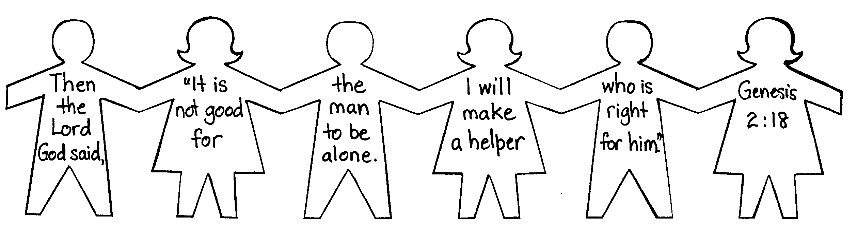

Supplies needed: copies for each group of the game cards for “The Family Match Game;” scissors

Play the memory game, “The Family Match Game.” You will have two pages with eight pairs of questions. Cut the cards out and lay them face down on the table. It would be helpful to arrange the squares in columns.

Divide the group into two teams. The object of the game is to find the cards that match. Alternate between each team turning over two cards. If the team finds a match, the question on the card is read to that team. One or more people can answer the question. After a team answers the question, they keep the two matching cards.

Determine how much time you take for each discussion question. This will depend on the needs of the group. If one team seems to be answering all of the questions, ask the other team the very same questions. The purpose of this activity is discussion.

These questions include the categories of observation, interpretation, and application. Note that some of the questions demand sensitivity and some call for insight. For example, question seven asks what you say to someone who says, “Two men can get married to each other and be a family.” Children today are commonly exposed to the concept that homosexuality is an alternative lifestyle for a family. God’s word speaks against this in Romans 1:27. Yet, God’s word says we are to love people and help them if they have broken lives or broken families.

Question six asks, “How did God adopt you into his family?” The answer to that is found in Ephesians 1:5: “And before the world was made, God decided to make us His own children through Jesus Christ. That was what He wanted and what pleases Him.” It was through his Son, Jesus, that we are adopted into God’s family. It can be pointed out, as well, that baptism is like the official adoption papers. (See Galatians 3:26-4:7.)

Use the game as a time for kids to share about their own families. Take time for questions that arise during the game. Again, make the link that God has adopted us into His family by sending His Son, Jesus, into the world.

If your group is answering the questions quickly and you would like to take more time, the game can be repeated with an entirely different outcome. Remember to conclude with the take home point:

*God fits us together in families.

Prayer Time:
Close with a prayer thanking God for fitting us together in families. Also thank God for adopting us into his family through our Savior, Jesus Christ.

Large Group Presentation

“Dr. Seow and Ze Family Machine”

Drama and Puppet Presentation

This is the first in a series of five utilizing a costumed character, Dr.Seow Seow. The name is adopted from Hokkien meaning “crazy” and this character brings out challenges as he learns the truth of God’s creation.

The actor playing the part of Dr. Seow can have lots of fun creating the character. The costume might involve a lab coat, crazy glasses, an oversized pen and clipboard, and wildly spruced hair. He would also do well to speak with an accent. The script is written with some accent changes such as turning the word “the” into the word “ze” and “where” into “vere.”

Accompanying the crazy scientist is his puppet, Xiao Er, who is a crazy looking bird that over-exaggerates the ridiculous.

The large group presenter, Teacher, is present to provide the correct answers and the serious questions.

Today Dr. Seow will be using a machine to see if he can create a family. This machine could be either a pedestal upon which people can stand or a large refrigerator box in which people can stand in. (Sound effects and lighting would make the machine extra special.)

Dr. Seow will make mistakes in producing a family by putting the wrong ingredients in the family machine. With Teacher’s help, Dr. Seow gets it right.

Note that the question here is, “How has God designed families to begin?” The answer is “with a husband and a wife.” Though families today are blended and headed by single parents, God’s design for families is a husband and wife in marriage together. We want to be sensitive about children who may not have both parents living with them. This is an example of how families can sometimes be broken, but God can still put plenty of love in those families. We believe the Bible also says that the homosexual lifestyle differs from God’s design for the family.

Teacher: Let’s discover today how *God fits us together in families. Please welcome Dr. Seow Seow and his not-quite-so amazing bird, Xiao Er.

Dr. Seow: Hello, boys and girls.

Teacher: Welcome, Dr. Seow. Let me give you our question for today.

Xiao Er: I know! I know! I know!

Dr. Seow: You know vat, silly bird?

Xiao Er: I know the answer!

Dr. Seow: He hasn’t even given ze question yet.

Xiao Er: But I still know the answer.

Dr. Seow: Vat is it?

Xiao Er: A five-foot pisang goreng!

Dr. Seow: Vat kind of answer is zat?

Xiao Er: An answer to any problem we might have…like “I’m hungry.”

Teacher: Xiao Er, please forget the five-foot pisang goreng.

Dr. Seow: Silly bird!

Teacher: I want to discover how God designs the family.

Dr Seow: (interrupting) I know! I know! I know!

Teacher: I have the answer right here in the Bible.

Dr. Seow: But I have ze answer right here in my newest invention.
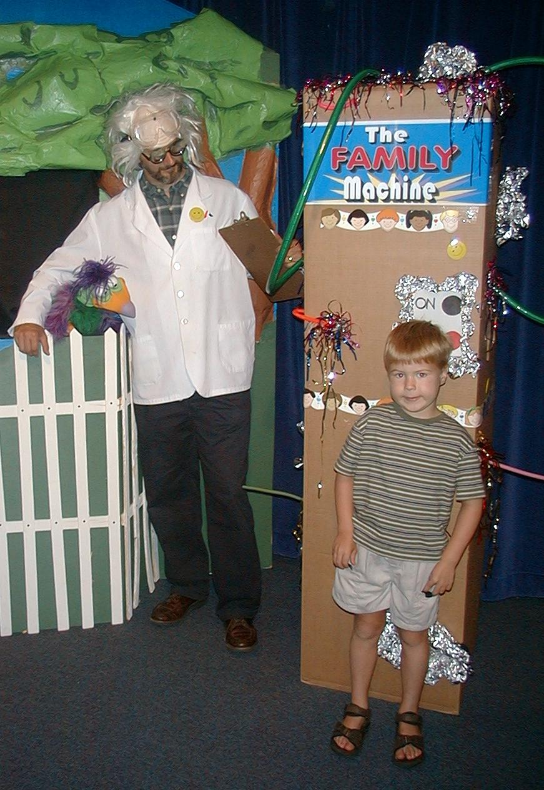
Xiao Er: Is it a five-foot pisang goreng maker machine?

Dr. Seow: No, silly bird.

Xiao Er: A three-foot pisang goreng maker machine?

Dr. Seow: No. Zis is Ze Family Machine. It vill create ze family.

Teacher: But, Dr. Seow, God created the family. I was just going to read about it right here in the Bible.

Dr. Seow: (interrupting) But, Teacher, I have ze machine to prove how ze family is made. Let me show you how it vorks.

Xiao Er: And if it doesn’t make a family, maybe we can get a five-foot pisang goreng out of it.

Dr. Seow: It vill vork fine, okay?

First, I need a volunteer from ze audience. I vill put in ze right ingredients and ve vill have ze family. (Places the volunteer in the “machine” and turns the machine on. A buzzer sounds a negative response.)

Vait a minute…Vat has gone
wrong?

Teacher: Dr. Seow, maybe I can help.

Dr. Seow: Vell, it seems to not be vorking. I put zis child into Ze Family Machine and it is kaput!

Teacher: That’s because families do not begin with just a kid. (Nothing personal, kids.)

Dr. Seow: But can ze kids be part of ze family?

Teacher: Of course! But God designed the family a different way.

Dr. Seow: Ah, I know vat vay. Vait one more minute. (Excuses the child and brings up a grandpa.)

Now I have ze grandpa who vill begin ze family. (Turns on machine and it crashes.)

Teacher: Doctor, I want to read from the Bible. It has God’s design for the family. In Genesis 2:18 it says, “Then the Lord God said, ‘It is not good for the man to be alone. I will make a...’”

Dr. Seow: (interrupting) Vait! I zink I understand. Let me get someone else. (Dismisses the grandpa and brings up a man whose wife is also in the audience.)

Here is ze man. I vill put him in ze machine. Vill it vork now? (He tries the machine and nothing happens.)

Teacher: Please, Dr. Seow. I was reading from God’s word. God said “It is not good for the man to be alone…”

Dr. Seow: Vait! Of course! Ze man cannot make ze family alone. I must find him a companion. (He brings another man to put in the machine.) Now zis vill make ze family.

Teacher: I don’t think so! Guys can be great friends, but guys can never be married to each other according to God’s design.

Dr. Seow: Ah yes, married! (He dismisses the second man.)

Teacher: Let me explain it from God’s word. God said, “It is not good for the man to be alone. I will make a helper who is right for him.” So God caused the man to sleep, took a rib from him, and formed the woman from the rib. God brought the man and woman together. When they are married, the man and woman leave their parents and start their new family.

Dr. Seow: I zink I understand. Let see if ze machine vorks. (He brings forward the wife of the man in the machine. When the husband and wife are together in the machine, the sound effects indicate success.)

Ah, success at last. I have created Ze Family Machine.

Teacher: Well, you have created a machine that tells you when you have the right ingredients to start a family.

(Teacher brings forward the child of the married couple and the dialogue continues. The child also stands in the machine.)

Dr. Seow: Can ze children be part of ze family?

Teacher: Of course they can! That’s one of the reasons God made marriage. He made marriage so husbands and wives could have kids.

Dr. Seow: But vat if ze mom and dad do not live together anymore? Can zey still be a family?

Teacher: Sometimes families break. Even though God designed families for everyone to stay together, sometimes they don’t.

Dr. Seow: So can zey still be a family?

Teacher: Of course they can. Families are places where people love and care for each other. God can still help that happen even when families have had problems. *God fits us together in families!

Dr. Seow: Vell, I have ze machine zat fixes the problem of ze families,
right?

Xiao Er: Good! I have a problem.

Dr. Seow: Vat is zat?

Xiao Er: I need a five-foot pisang goreng.

Dr. Seow: You need a five-foot kick in ze feathers, silly bird! I’m telling you…

Teacher: (Interrupting) Wait a minute! Maybe that’s not such a bad idea.

Xiao Er: Really?

Teacher: Sure. Families are supposed to not only be there to have kids, but they are also there to care for one another. Pisang goreng remind me of that. When I was a little boy I loved it when my mom gave me barley foo cok and pisang goreng. It was a way that she showed she cared for me.

Xiao Er: Well, what do you know? Finally someone is talking some sense!

Dr. Seow: Vat? Are you going cuckoo too?

Teacher: No, look here. Let’s adjust these knobs and see what happens.

(Noise sounds and lights flash. Teacher goes behind the machine and pulls out some pisang goreng. )

Dr. Seow: Vell, vat do you know. My machine has done something.

Xiao Er: But where’s the five-foot pisang?

Teacher: I think this is the best we can do. We’ll pass out a pisang to everyone in small group as we think about how God made the family—making marriage for man and wife to be together and to have children. Every family is to be a place to show God’s love. It’s kind of like pisang goreng and barley foo cok.

Xiao Er: Good! Let’s eat.

Teacher: No, let’s pray. Dear God, thank you for designing the family beginning with a husband and wife and making it a place of love. Thank you that *you fit us together in families. Help all of our families be filled with your love. Thank you that because of Jesus, we’re part of your family. Through Him, you give us enough love to go around for everyone. In Jesus’ name. Amen.
Supplies:

Quantity ()

Small Group Warm-Up:
- no supplies are needed

Large Group:
- costume for Dr. Seow Seow
- Xiao Er, a crazy looking bird puppet
- “The Family Machine” (a pedestal upon which people can stand or a large refrigerator box in which people can stand)
- sound effects to indicate the wrong ingredients have been added to the machine (buzzing, crashing) and the right ingredients have been added ringing or siren)
- a child, a grandpa, a husband and wife, and a man will be pulled from the audience
- pisang goreng (enough so each child gets a pisang)

Small Group Application:
- copies for each group of the game cards for “The Family Match Game” (attached to lesson)
- scissors
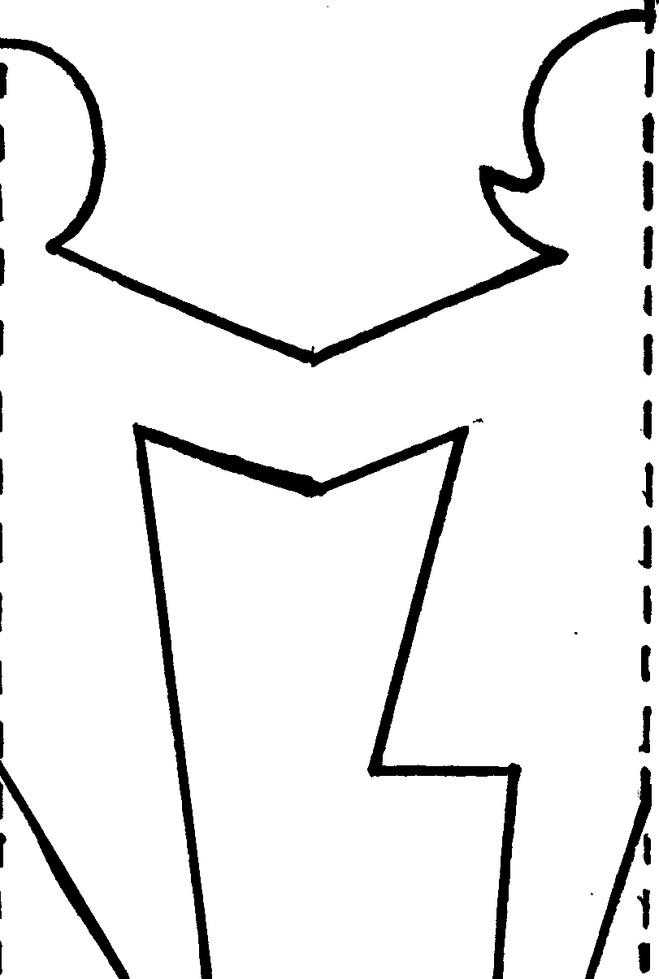

Memory Verse Learning:
- a 5X8 Size of the paper for each group
- scissors
- marker

1  Tell about a time you helped someone in your family. | 1  Tell about a time you helped someone in your family.
2  How many reasons can your team give for the following question: Why did God create families? | 2  How many reasons can your team give for the following question: Why did God create families?
3  Pretend you are a parent and your child acted so badly in school that the teacher called you. What would you do or say to your child? | 3  Pretend you are a parent and your child acted so badly in school that the teacher called you. What would you do or say to your child?
4  What will be the best thing about starting your own family some day? | 4  What will be the best thing about starting your own family some day?
5  Who in your family is best at showing God’s love to others? | 5  Who in your family is best at showing God’s love to others?
6  How did God adopt you into his family? | 6  How did God adopt you into his family?
7  What do you say to someone who says, “Two men can get married to each other and be a family”? | 7  What do you say to someone who says, “Two men can get married to each other and be a family”?
8  What do you say to someone who is sad because his mom and dad got divorced? | 8  What do you say to someone who is sad because his mom and dad got divorced?

