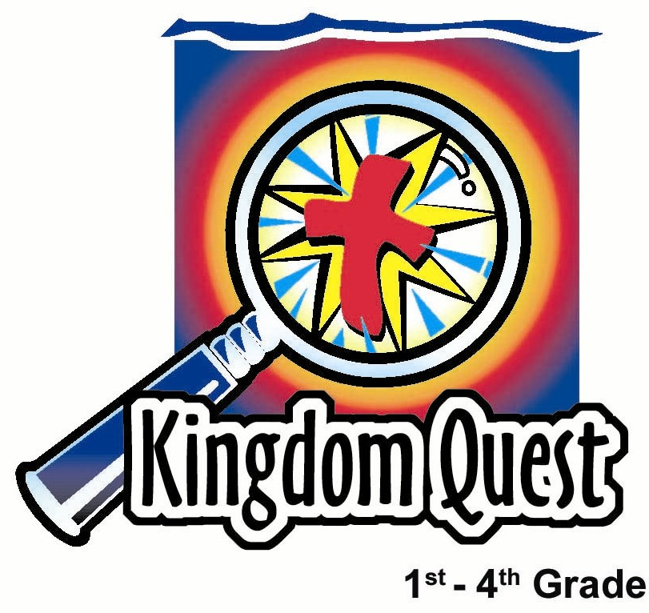
Date: __________________
Series: Jesus Is the King (Dec-Mar)
Year 1, Lesson 34

God Announces
the King

Take Home Point: *God tells us in baptism, “I am your God, and you are my child whom I love.”
*Repeat this phrase throughout the lesson.

Bible Event: Matthew 3
Key Verse: Matthew 3:17: “And a voice spoke from heaven. The voice said, ‘This is my Son and I love Him. I am very pleased with Him.’”

We will help kids know:
- God’s covenant message in the Old Testament was primarily “I am your God and you are My people.”
- God’s message to us in baptism is much the same, “I am your God, and you are My child.” In baptism, we are adopted into God’s family.
- Jesus is God’s true son. When He was baptized God said, “This is My Son and I love Him. I am very pleased with Him.”

We will help kids feel:
- Empowered because God is pleased with them and calls them to be His children.
- Challenged that their ministry begins right now. God calls them in baptism to be His sons and daughters and to live for Him.

We will help kids do:
- Make a reminder of what it means to be baptized and hear God say, “You are My child and I love you. I am very pleased with you.”
- Receive baptism for those who are not yet baptized but in faith desire it.
THIS LESSON’S ROADMAP

DESTINATION | PAGE # | DISCOVERIES ON YOUR JOURNEY | SUPPLIES NEEDED
Small Group Warm-Up   | 3-4 | Kids will use flour, water, strips or paper, and a heart to learn how are all connected to God in baptism and how we are connected to each other. When we become God’s child, we become a part of God’s family. We also become brothers and sisters in Christ. | - flour  - water  - bowl  - eight to ten different colored strips paper sheets  - wet hand towel  - plastic sheet to cover the floor  - clear plastic sheet with a heart outline drawn on it
Large Group   | 4  9  10-11  12-13  13-14 | Overview  Pass the Promise Interaction  Puppet Presentation: “Dao Dao Adopts Rocky”  Interview with John the Baptist  Puppet Presentation: “Dao Dao Adopts Rocky” Conclusion | - Bible with a cross on it  - football with the cross  - Dao Dao in sunglasses and disguise  - Rocky (dog puppet) in sunglasses and disguise  - actor dressed as John the Baptist or the video, The Visual Bible: Matthew (3:1-17) (Visual International and Visual Entertainment, Inc., 1984)
Small Group Application   | 5-7  8 | Make an origami dove to help talk about what baptism means. The dove will remind the kids of the words God spoke over Jesus and says to us through baptism: *I am your God and you are my child whom I love.  Memory Verse Learning:  “Flour Paste Competition”  Psalm 147:3 is reinforced to highlight the reason of Jesus coming into the world to fix our broken world. | - dove worksheet (page 17)  - pens or pencils  - scissors  - two bowls of flour paste;  - strips of paper with the  words of Bible verse  prewritten for each team  - plastic sheet to cover the  floor  - two pieces of clear plastic of  A3 size  - wet hand towels
Small Group Warm-Up: 15 minutes
Purpose: Get pointed in the right direction! Build relationships and help guests feel at ease. Do the learning readiness activity that will point your group in the right direction for the lesson.

Supplies needed: flour; water; bowl; eight to ten different colored strips paper sheets; wet hand towel; plastic sheet to cover the floor; clear plastic sheet with a heart outline drawn on it

At Jesus’ baptism God declared, “This is my Son, whom I love—my Son with whom I am pleased.” In our baptism God calls us to be His children. Because of Jesus, God says to us, “This is my child, whom I love; with him/her I am well pleased.”

This hands-on warm-up activity involves the children mixing a small amount of water into flour to make a flour paste. Each child will then write his name on a colored strip of paper, dip the paper strip into the paste mixture, and apply the strip to a large piece of clear plastic. As children apply their strips to the clear plastic, they will fill in a heart outline that was drawn on the clear plastic before class.

While making the flour paste say:
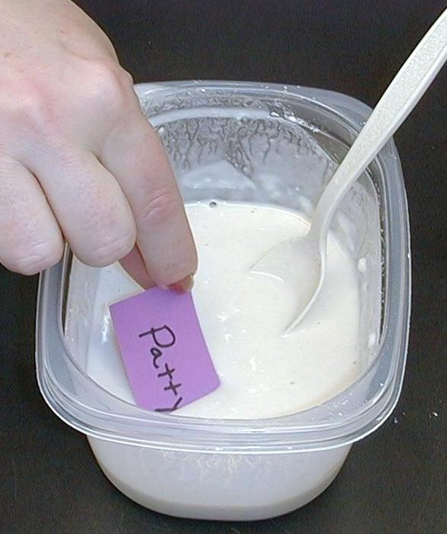
Today we are talking about baptism. We are going to use some flour and water to show you what God is telling us when we get baptized. In baptism, God takes water (hold up the cup of water) and mixes it with His powerful word. (Hold up the bowl of flour and then mix the water and flour together.) He then spreads that on us. (Spread paste on a strip of paper with your name on it.) In doing this, God unites Himself with us. (Stick your name onto the plastic sheet heart.) *God tells us in baptism, “I am your God, and you are My child whom I love.”

Pass out the strips of paper and have the children write their names on them.

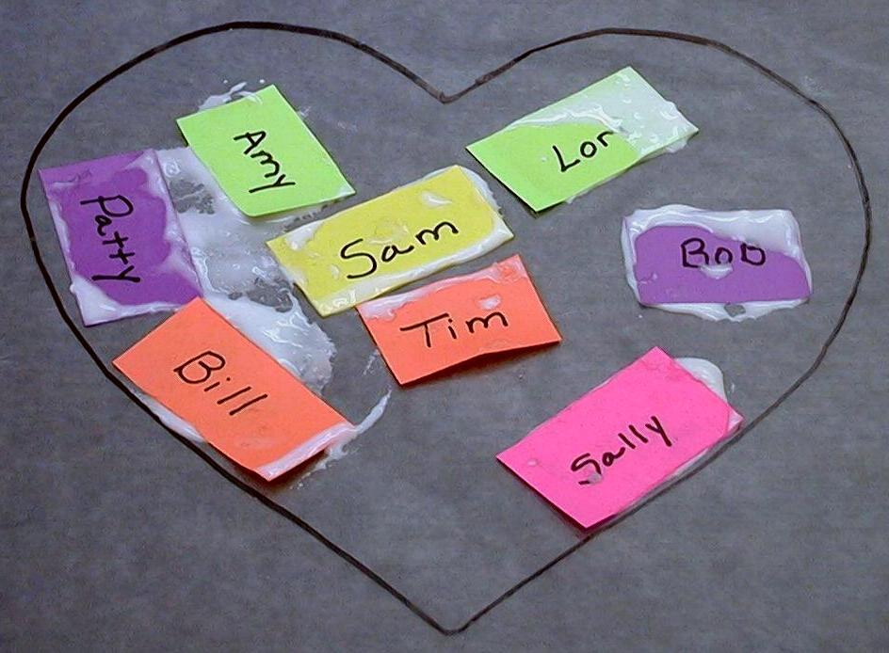
Your strip of paper will remind you of yourself as a child of God. Now dip your strip into the paste we made and apply it to the plastic sheet to help fill in the heart outline. Together we will make a heart. The heart reminds us of God’s love for us.

While we are “connecting” our strips to make a heart, share how you are unique from anyone else. Notice how each one of the strips of paper is different. God wants you to feel special for the unique way He made you and called you to be His
child.
Just like our strips of paper are connected together to make this heart, we are all connected to God in baptism and we are connected to each other. When we become His child, we become a part of God’s family. We also become brothers and sisters in Christ.

Today we will learn *God tells us in baptism, “I am your God and you are My child whom I love.”

Large Group: 20-30 minutes
Purpose: Help kids observe what the Bible says. Present the Bible Event in creative fashion. Help kids begin to interpret what it means.

Supplies needed: Bible with a cross on it; football with the cross; Dao Dao in sunglasses and disguise; Rocky (dog puppet) in sunglasses and disguise; actor dressed as John the Baptist or the video, The Visual Bible: Matthew (3:1-17) (Visual International and Visual Entertainment, Inc., 1984)

Overview

Pass the Promise Interaction: Teacher uses the Pass the Promise football to show how God passes us His promise through baptism.

Puppet Presentation: “Dao Dao Adopts Rocky”
Just as Dao Dao needs adoption papers as proof that Rocky is his dog, baptism makes official our adoption as God’s children.

Interview with John the Baptist: In this Bible event from Matthew 3, John preaches repentance and baptism to the people of Jordan. As John baptizes Jesus, God makes known to the world that Jesus is His true son.

Puppet Presentation: “Dao Dao Adopts Rocky” Conclusion

Small Group Application: 20-25 minutes
Purpose: Help kids map out the meaning of the Bible event in their lives. Use the questions to stimulate discussion, but don't feel tied to them. Allow the Holy Spirit to guide you. Include personal examples from your own faith journey. The example of Christ at work in your life will leave lasting impressions of how Christ can work in the children's lives.

Use your Bibles! Children need to learn how to look up references and follow along when scripture is read aloud. Allow for quality time of prayer at the close of the lesson.

Supplies needed: dove worksheet (page 17); pens or pencils; scissors

Have the children turn to Matthew 3 in their Bibles while reviewing today’s event.

Observation Questions: What happened?

What message was John the Baptist preaching? (Matthew 3:2-3. Repent and prepare the way for the Lord, Jesus.)

Who came and heard John and what did they then do? (Verses 5-6. People from Jerusalem, Judea, and the whole region of Jordan. They confessed their sins and were then baptized by John.)

Jesus also came to John to be baptized. But John knew Jesus had never sinned. How did John feel about baptizing Jesus? (Verse 14. He felt unworthy.)

Why did Jesus say He must be baptized? (Verse 15. To fulfill all righteousness. To do all God wanted Him to do as an example for us.)

What miraculous thing happened as soon as Jesus was baptized? (Verses 16-17. Heaven opened and the Spirit of God descended like a dove on Jesus and God’s voice was heard saying, “This is my Son and I love Him. I am very pleased with Him.”)

Interpretation Questions: What does this mean?

Why was God pleased with His Son? (He loved Jesus and was saying to the world that this was His true son. He was pleased that Jesus obeyed Him.)

Application Questions: What does this mean to me?

Application Activity:
To help us talk about what water baptism means to us, we are going to make an origami, or paper, dove. On the top part of the dove is our main Bible point, “I am your God, and you are My child and I love you.” That reminds us of what God says to us in our water baptism.

On the backside of your paper, we’re going to write some special things about ourselves. Write several things you like about how God has made you. You might write about your appearance or your personality. (Pause for the kids to write and have them share out loud some of what they are writing. This helps them feel special.)

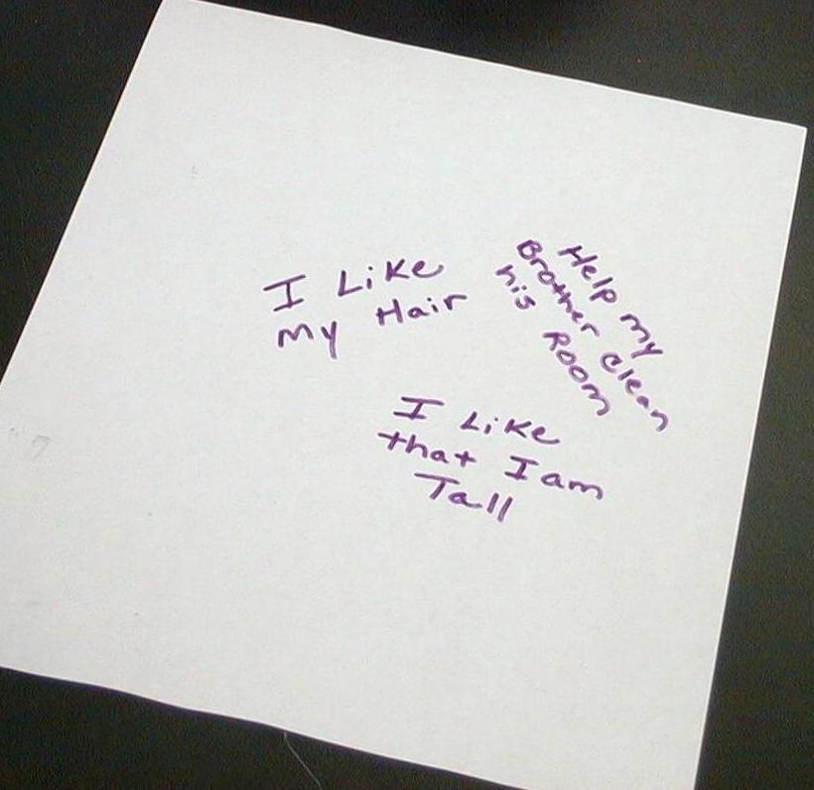
Then write things you might do to show you are God’s special child. These might be things you can do this week to show God’s love to someone else. (Have kids share some specific examples and then give them a short time to write down ideas.)

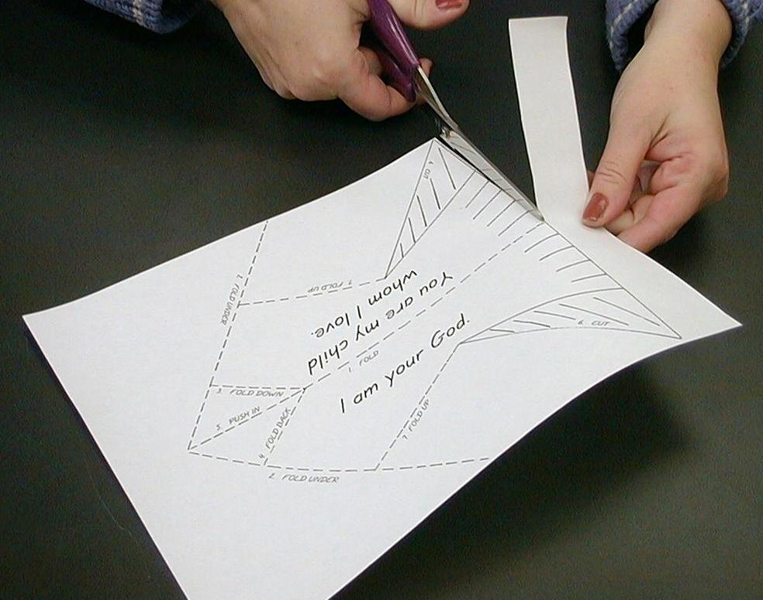
After the children have written on the backside of their papers, they can cut along the solid line at the bottom of the page to cut off the excess paper. With this done, the children are now ready to fold their paper doves.

- Fold under side flaps (Line 1) to make a point.
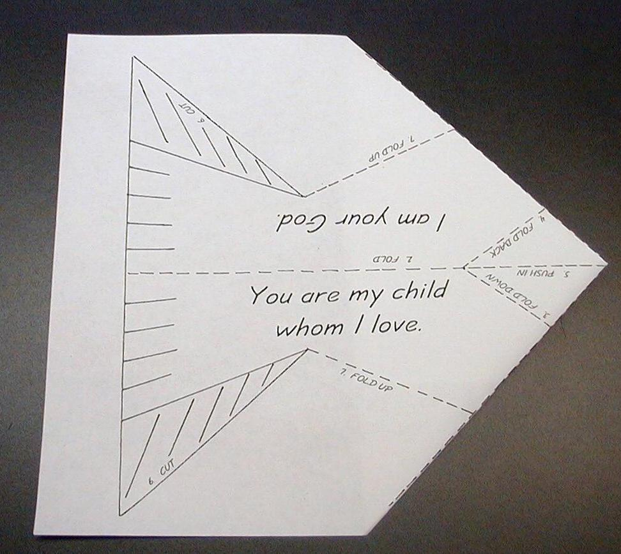
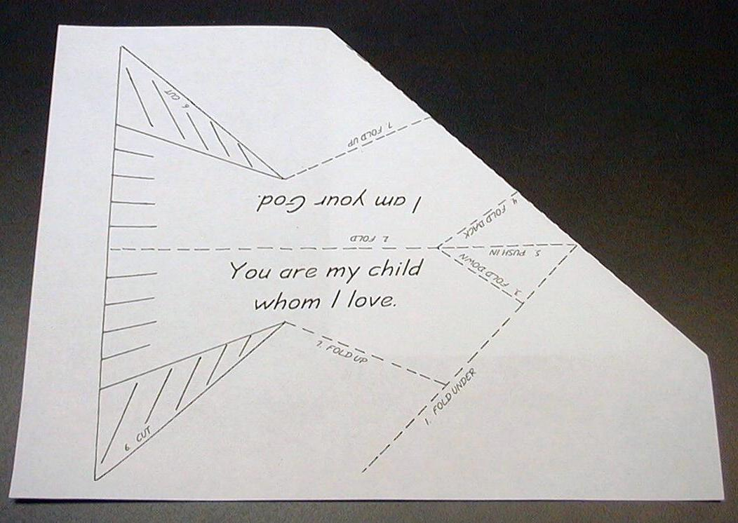

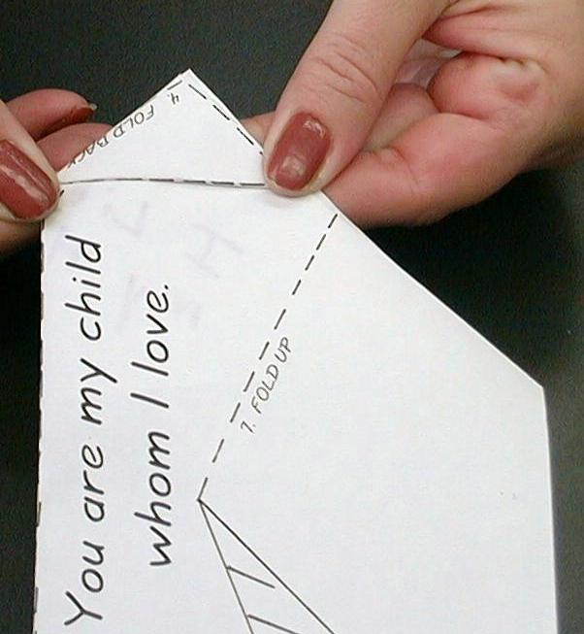

- Fold in half along Line 2.
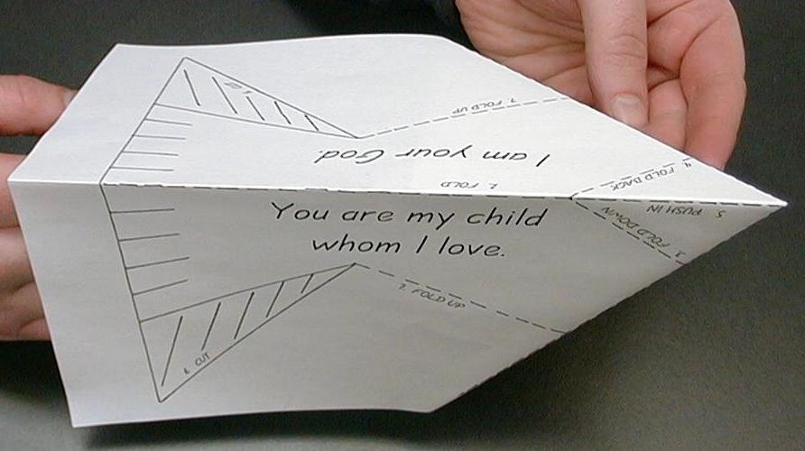

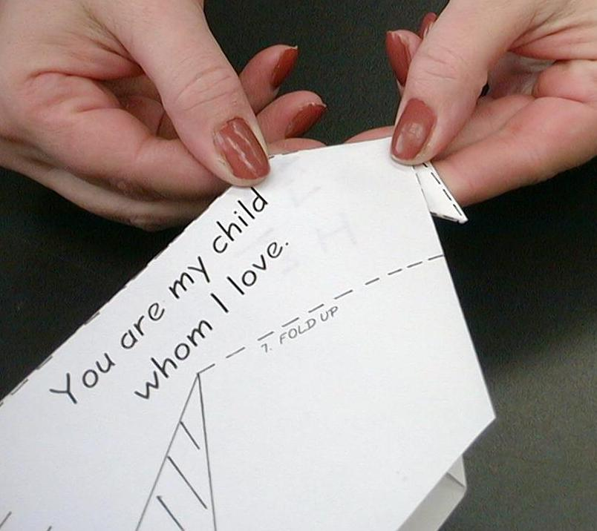
- Fold down along Line 3 to crease.

- Fold back along Line 4 to crease.

- Push in along Line 5 to create the beak of the bird.
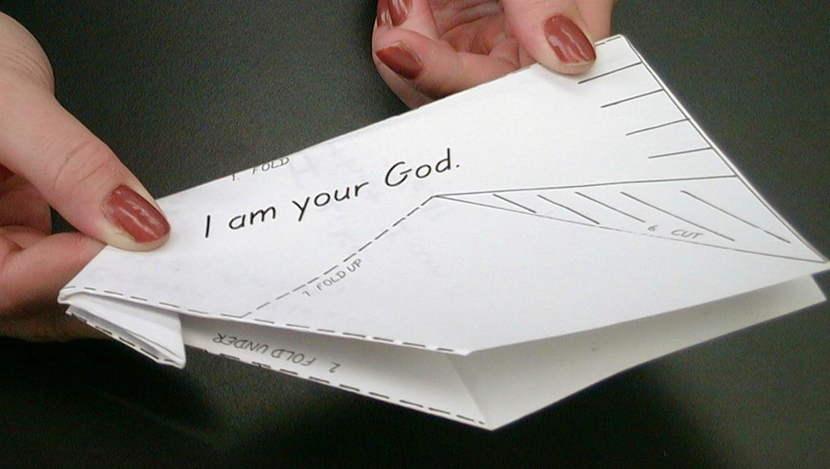
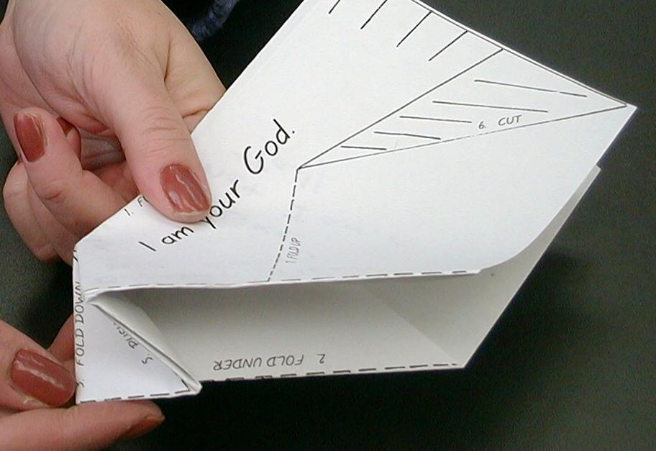

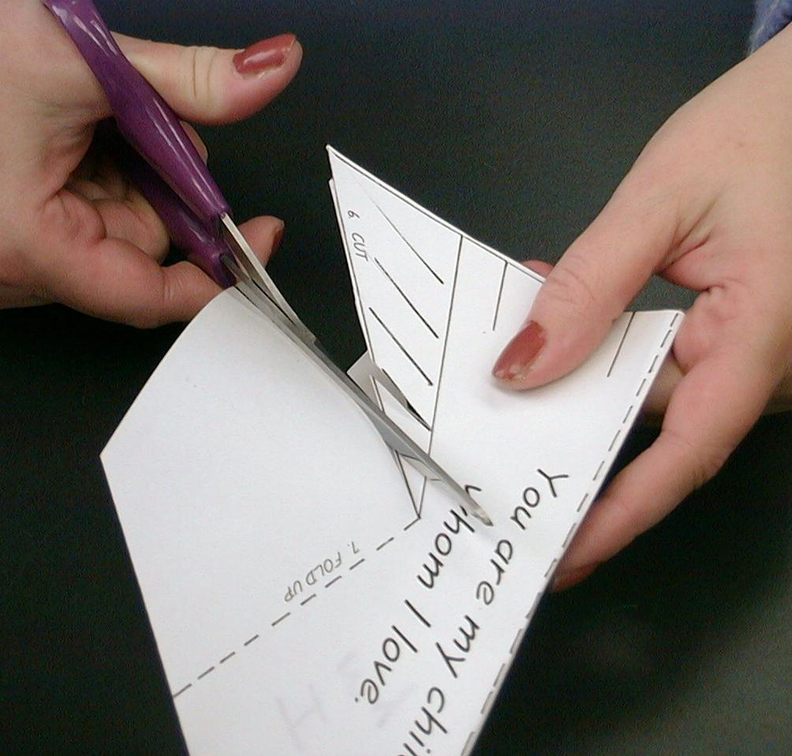
- Cut along solid Line 6 to create tail wings. Also, cut along short solid lines to create feathers.
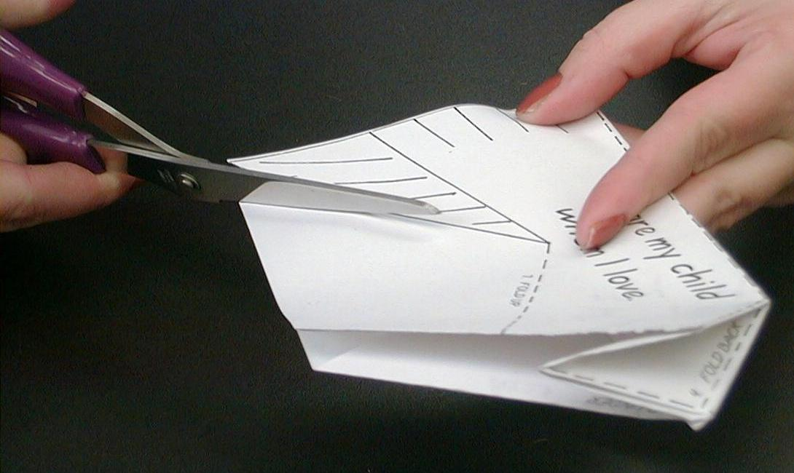

- Fold up flaps on both sides (Lines 7) to create the wings of the dove.
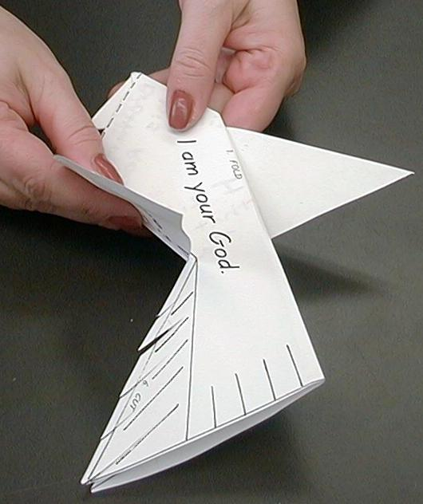

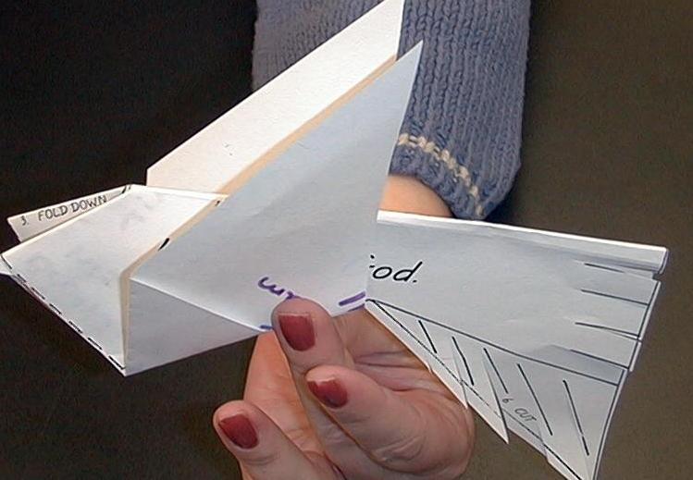

Look at the dove and remember what God spoke over Jesus and says to you through baptism. Let’s read it together. *I am your God and you are My child and I love you.

Memory Verse Learning: 5 minutes
Purpose: Help kids to memorize and keep scriptures at heart. Using creative ways to help kids enjoy learning the key verse and in small group setting.

Supplies needed: two bowls of flour paste; strips of paper with the words of Bible verse prewritten for each team; plastic sheet to cover the floor; two pieces of clear plastic of A3 size; wet hand towels

Memory Verse: Psalm 147:3 “He heals the brokenhearted. He bandages their wounds.”

MV Presentation: “Flour Paste Competition”
Lay the plastic sheet on the floor to be the game track. At one end, paste the clear plastic for each team. In the middle, set one bowl of flour paste and strips of paper, also for each team. Divide the children into two teams and give the following instructions:-
- The team is to complete in forming the memory verse.
- The first team to complete is the winner.
- One has to run and pick a word to the Bible verse.
- Dip some flour paste at the back of the strip of paper.
- Run to plastic sheet and stick paper onto the plastic sheet.
- Runs back and touch the next person.

Prayer Time:
Ask if every child knows Jesus as his Savior. Ask if all have been baptized. Minister to children accordingly. You might want to lead a child to a prayer of receiving Christ as Savior if that child desires. Such a prayer has these essential elements:
- praying to God;
- being sorry for my sins;
- thanking God for sending Jesus to die on the cross to pay for the punishment for my sins; and
- receiving Jesus as Savior and asking Him to take control of my life.

Close your eyes. I want you to imagine God is right next to you and He is saying this to you. “(Name of child), I am your God, and you are My child and I love you. What would you like to thank Me for or ask Me?”

Repeat with each student. If a child has not been baptized and is a believer, pass that child’s name on to your pastor.

Pass the Promise Interaction

The large group presenter uses a Bible with a cross on it to review the Old Testament covenant message, “I am your God, and you are My people.”

Teacher: In the Old Testament God was always saying to the people, “I am your God and you are My people.” Today we are going to hear Him say something to us that’s very similar but it’s not in the old covenant. It’s in the new covenant. It’s a new way God says it.

(Picks up the football with a cross on it.) This is a reminder of the promise that was passed on to the people in the Old Testament. God said that He was going to send a savior. He has—He sent Jesus. In water baptism, that message comes to us. It’s the promise of forgiveness and new life in Him. How do we receive it? With hands of faith.

Remember how in previous lessons God passed the promise of Jesus to His people? God also passes the promise of Jesus to us. In water baptism God says, “I am your God and you are My child.” We can become God’s children through the forgiveness that Jesus bought for us. Water baptism is just like this football being passed to you. You can catch it by trusting in the promise. You have the hands of faith.

(Tosses the football to a child.) When you catch it, you say, “I trust in whatever you say! I am your child through believing in what Jesus has done for me.” (Asks for the football back and does this again with another child.)

“Dao Dao Adopts Rocky”

Puppet Presentation

This episode introduces a new character, Rocky. Rocky, a dog, does not talk to the audience but whispers into Dao Dao’s ear. The Rocky character must be very alert to interrupt characters non-verbally and give lots of non-verbal feedback.

Dao Dao: (Enters wearing sunglass disguises and looking around cautiously.) Hi, Teacher. Umm...er…you don’t happen to see any dogcatchers out there do you?

Teacher: No, I don’t think so. Kids, have you seen any dogcatchers out here? No, Dao Dao, there’s not. But what’s with the sunglasses? Are you in disguise again?

Dao Dao: Maybe. (Looking down.) Come on up, Rocky. The coast is clear.

(Rocky enters wearing a disguise like Dao Dao.)

Teacher: Whom do we have here? Or is it a secret?

Dao Dao: This is my dog, Rocky. Isn’t that right, Rocky?

(Rocky shakes his head “no” and whispers into Dao Dao’s ear.)

Teacher: What did he say?

Dao Dao: He said that he isn’t my dog. Instead, I’m his child.

Teacher: Oh? Well, who belongs to whom? Is he your dog or are you his child?

(Rocky whispers to Dao Dao.)

Dao Dao: (To Rocky.) I am not your child. You are my dog. And if we don’t watch out, you might not even be my dog unless we get you adopted or something.

Teacher: What’s up, Dao Dao? Why the disguises?

Dao Dao: Teacher, I really want Bowser to be my very own dog. I’ve always wanted a dog, someone I could talk to and play with. And Rocky’s great. He’s a friend, especially when I’m lonely.

Teacher: So what’s the problem?

Dao Dao: Well, I just found Rocky and I always...

(Rocky nudges Dao Dao)

Dao Dao: What is it, Rocky?

(Rocky whispers.)

Dao Dao: Oh, Rocky says I didn’t find him. He found me. Anyway, I want a dog.

Teacher: But doesn’t he belong to someone else?

Dao Dao: I don’t think so. He says he once lived at a house, but they were mean to him and he ran away a long time ago. He’s been looking for a new boy to adopt. But how does a boy adopt a dog?

(Rocky interrupts and whispers.)

Dao Dao: I mean, how does a dog adopt a boy?

Teacher: That reminds me a little bit about what we’re talking about in Sunday school today.

Dao Dao: What do you mean?

Teacher: What you need is adoption papers for dogs. Something official that says, “I am Dao Dao and this is my dog and I love him!”

(Rocky shakes his head agreeably.)

Dao Dao: But how are you talking about that in Sunday school?

Teacher: We are talking about baptism, and baptism is our adoption paper from God. Here. Why don’t you listen to John the Baptist. He’s the one who baptized Jesus. Maybe he can tell you more about what it means.

Interview with John the Baptist

This interview can be adlibbed but it is built around the following central questions. The skit begins with John the Baptist calling from offstage. The presenter invites John the Baptist onstage.

Instead of doing the following interview, the video The Visual Bible: Matthew (3:1-17) could be shown.

John: (Shouting from offstage.) Repent, repent, for the Kingdom of God is near!

Teacher: John? John the Baptist? Please join us today.
(John enters.)

Teacher: Your name is John the Baptist. Can I call you Johnny or what do you prefer?

John: Actually, I was known as John the Baptizer. And I really don’t care about what I am called. I just care about whom I’m pointing to.

Teacher: Tell us about that. Who are you pointing to?

John: I am pointing to the Messiah, the Anointed One, the King of Kings, the Savior of the World—Jesus! I came to help people get ready for His coming and to tell them to repent. To repent means to turn our hearts to God and to trust God.

Teacher: Tell us what happened the day you baptized Jesus.

John: Well, there I was baptizing people in the Jordan River. Jesus came and said, “I should be baptized by you.” He also said, “I do this to give a perfect example for people.” And when I baptized Him, guess what happened. God said, “This is My Son and I love Him. I am very pleased with Him.” A dove, the Spirit of God, hovered over us and heaven had opened.

Teacher: What do you think all of this meant?

John: God was announcing that Jesus truly was His Son and this was the beginning of His Son’s ministry. This was the beginning of Jesus being a perfect example for us and living His life to die on the cross for our sins.

Teacher: Does Jesus want us to be baptized?

John: Yes! He told us to go and make disciples by baptizing all people, even children. When we are baptized, it’s like God saying to us, “I am your God; you are My child whom I love.” Then we, too, start our ministry just like Jesus started His.

Teacher: So where do you go from here?

John: Back to the wilderness. I’ll keep telling people to get ready for Jesus.

Teacher: How do you survive out there in those rugged places?

John: God takes great care of me. I have all the locust and honey I want! I’m off now. (Walks offstage and shouts from offstage.) Prepare the way of the Lord. Repent!

“Dao Dao Adopts Rocky”

Puppet Presentation

Teacher: Dao Dao, did you hear what God said over His Son in baptism?

Dao Dao: Yeah. He said, “This is My Son and I love Him. I am very pleased with Him.”

Teacher: Do you know God says that to you?

Dao Dao: To me?! But I’m just Dao Dao.

Teacher: No. To God you are His adopted son and He is very pleased with you.

Dao Dao: Adopted?

Teacher: Yes. Do you trust in Jesus as your Savior?

Dao Dao: Sure.

Teacher: Have you been baptized?

Dao Dao: Sure.

Teacher: In baptism God says, “I am your God and you are My child and I love you.”

Dao Dao: Wow! That’s great!

(Rocky whispers in Dao Dao’s ear.)

Dao Dao: Oh! And that’s what Rocky wants to hear too. He wants to hear me say, “You are my dog and I am very pleased with him.”

(Rocky whispers in Dao Dao’s ear again.)

Dao Dao: (Shakes his head.) Rocky wants to say, “I am your dog, and you are my child, Dao Dao.”

Teacher: Well, however it is. Let’s go get your dog tags and license so we can make the adoption official.

Dao Dao: That’s great! Come on, Rocky.

(Rocky whispers in Dao Dao’s ear.)

Dao Dao: No, I won’t make you eat locust and honey. That was just for John the Baptist. You get dog food.

Teacher: Okay, Dao Dao. But we should first have a closing prayer.

Dao Dao That’s right!

Teacher: Dear God, thank You that You choose us to be Your children. Just like You said about Jesus, “This is My Son and I love Him. I am very pleased Him,” you say to us, “I am your God, and you are My child and I love you.” Thank You for water baptism that is kind of like adoption papers. In Jesus’ name. Amen.

Lesson 34

Small Group Warm-Up:
- flour
- water
- bowl
- 8-10 different colored strips paper sheets
- hand wipes
- something to cover the floor
- clear plastic sheet with a heart outline drawn on it

Large Group:
- Bible with a cross on it
- football with the cross
- Dao Dao in sunglasses and disguise
- Rocky (dog puppet) in suglasses and disguise
- actor dressed as John the Baptist or the video, The Visual Bible: Matthew (Visual International and Visual Entertainment, Inc., 1984) Cue video to Matthew 3:1-17.

Small Group Application:
- dove worksheet (page 16)
- pens or markers
- scissors

Memory Verse Learning:
- two bowls of flour paste;
- strips of paper with the words of Bible verse prewritten for each team
- plastic sheet to cover the floor;
- two pieces of clear plastic of A3 size
- wet hand towels

You are My child
and I love you.
I am your God
