
Date: _______________ __
Series: Jesus Is the King (Dec-Mar)
Year 1, Lesson 35

God Trains the King

Take Home Point: *God’s word helps us fight Satan.
*Repeat this phrase throughout the lesson.

Bible Event: Matthew 4:1-11
Key Verse: Hebrews 4:12: “God’s word is alive and working. It is sharper than a sword sharpened on both sides.”

We will help kids know:
- Jesus was tempted like any other human but He overcame the temptation by using God’s Word.
- We have the weapon of God’s Word available to us.

We will help kids feel:
- Confident of the power they have over the devil.
- Armed and ready to go!

We will help kids do:
- Memorize scripture as a weapon against the devil.
- Make a bookmark as a tool to help remind them that God’s Word is a sword.

THIS LESSON’S ROADMAP

DESTINATION | PAGE # | DISCOVERIES ON YOUR JOURNEY | SUPPLIES NEEDED
Small Group Warm-Up   | 3-4 | Play a game called “Temptation” to see what it takes to tempt another person to smile. Today the kids will learn how Jesus was in training with God so he knew exactly what to do when he was tempted. We can learn to do the same. *God’s word helps us fight Satan. | - no supplies are needed
Large Group   | 4  7-9  9  10 | Overview  Puppet Presentation: “Dao Dao Goes for the Light Saber”  Video: The Visual Bible: Matthew  Puppet Presentation: “Dao Dao Goes for the Light Saber” Conclusion | - Star Wars VCD (optional)  - trick balloon, flashlight, and duct tape or wide masking tape to make a light saber  - memory verse cards (Page : 14)  - James 2:1  - Ephesians 5:4  - Colossians 3:9-10  - Ephesians 4:32  Ephesians 6:1  - video, The Visual Bible: Matthew (4:1-11) (Visual  International and Visual Entertainment, Inc., 1984)
Small Group Application   | 5-6  6 | “God’s word is living and active. It is sharper than any two-edged sword.” The kids will make a sword bookmark to help remind them of this. Then play a game that helps the kids memorize this scripture.  Memory Verse Learning:  “Two-Edged Sword Test”  To be certain that the kids be instilled with the take-home memory verses, for the next six weeks the concentration is to learn these verses with them. | - sword copied on manila card for each child  - aluminum foil  - scissors  - tape  - small stickers  - two sets of the Hebrews 4:12 memory sword game cards for each group  - copy of the memory verses from large group for each child to take home  - poster board with hooks attached
Small Group Warm-Up: 15 minutes
Purpose: Get pointed in the right direction! Build relationships and help guests feel at ease. Do the learning readiness activity that will point your group in the right direction for the lesson.

Supplies needed: no supplies needed

“Temptation Game”
Since we are talking about temptation today, remember to use the word “temptation” as you refer to the actions of the game.

Today we are going to play a game called “Temptation.” One child will be “it.” He will make faces, do silly actions, or do whatever it takes to tempt another person to smile. Try not to smile. If anyone smiles while they are being tempted or even while watching another person getting tempted, that person becomes a tempter as well. So several of you might end up tempting others to smile.

Who do you think will be the last person to keep from smiling? The winner is the person who can keep a straight face until everyone else is out!

After you have played this game once, ask the winner these questions:

Was it always easy to keep a straight face? Did you have a trick that helped you keep from laughing that you can share with the rest of us? Would you train us to do that?

Allow the child to teach his technique to the group. Then play the game again with the winner starting as “it.” Then ask:

Did it help to have training? Did it seem easier to resist the temptation of laughing?

In our last lesson about Jesus’ baptism, God said, “This is My son, and I love Him.” Jesus knew that when something very special happens to us (like baptism), the devil will attack because he does not like to see us grow. So, Jesus went into training. He went into the desert for 40 days and 40 nights. While He was there, He was tempted by the devil.

Think about the game we just played. Who was the tempter? What was he/she trying to get us to do? What were we trying not to do? Can anyone describe what it means to be tempted? (When we have thoughts suggesting that we do something we know is wrong.) In the game we played, how did we get training? Today we will hear how Jesus was in training with God so he knew exactly what to do when He was tempted. We can be in training, too. Today we will see what the King did to resist temptation. Then we can learn to do the same. *God’s word helps us fight Satan.

If time allows, you might consider this discussion question.

What are some things that tempt you? (Give some examples to get kids started. For example disobeying parents, saying mean things about someone else, telling or listening to a dirty joke, using bad words, lying not to get in trouble, etc.)

Large Group: 20-30 minutes
Purpose: Help kids observe what the Bible says. Present the Bible Event in creative fashion. Help kids begin to interpret what it means.

Supplies needed: Star Wars video (optional); trick balloon, flashlight, and duct tape or wide masking tape to make a light saber; memory verse cards (Page 14) - James 2:1, Ephesians 5:4,Colossians 3:9-10, Ephesians 4:32, Ephesians 6:1; video, The Visual Bible: Matthew (4:1-11) (Visual International and Visual Entertainment, Inc., 1984)

Overview

Puppet Presentation: “Dao Dao Goes for the Light Saber”
Dao Dao gave in when tempted and stole a Star Wars video. Now he learns how Satan is behind the many temptations that we face. God’s word is the sword that is our protection. Teacher makes a light saber with trick balloon, flashlight, and tape. The lights are turned out for special effect. Then five temptations are mentioned. After each temptation, a child volunteer from the audience who has been tempted in such a way comes forward to read the verse and wield the sword.

Video: The Visual Bible: Matthew
Show Matthew 4:1-11. Let the children review the Bible event in small group application.

Puppet Presentation: “Dao Dao Goes for the Light Saber” Conclusion

Small Group Application: 20-25 minutes
Purpose: Help kids map out the meaning of the Bible event in their lives. Use the questions to stimulate discussion, but don't feel tied to them. Allow the Holy Spirit to guide you. Include personal examples from your own faith journey. The example of Christ at work in your life will leave lasting impressions of how Christ can work in the children's lives.

Use your Bibles! Children need to learn how to look up references and follow along when scripture is read aloud. Allow for quality time of prayer at the close of the lesson.

Supplies needed: sword copied on manila card for each child; aluminum foil; scissors; tape; small stickers; two sets of the Hebrews 4:12 memory sword game cards for each group; copy of the memory verses from large group for each child to take home; poster board with hooks attached

Observation Questions: What happened?

What did Jesus do immediately after He was baptized? (Matthew

4:1-2. He went out into the desert and fasted for 40 days and 40 nights.)

What three ways did the devil tempt Jesus and how did Jesus respond? (Matthew 4:1-11.)

Interpretation Questions: What does this mean?

Why do you think Jesus went to the desert for 40 days? Do you think He guessed that Satan would try to tempt Him? What do you think He was doing during the 40 days? Why do you think it was important for Jesus to fast and pray?

Do you think it was easier for Jesus to resist temptation than it is for you? (Allow time for the children to respond, but make sure by the end of this discussion they understand that Jesus was a human being just as we are. His temptation would have been just as great as our temptations are. In fact, when we grow stronger in the Lord it seems the devil works that much harder on us.)

Jesus always referred back to scripture to fight the devil. (See Matthew 4:4, 7, 10.) How do you think Jesus learned that much scripture? Did He have time to go and look up a verse when the devil was tempting Him? (No, He probably had to study and memorize just like we do.)

Application Questions: What does this mean to me?

Jesus did some specific things to resist Satan’s temptations. Let’s make a list of what He did. Looking at the list we made for Jesus, what could you use to resist temptation when Satan comes to you?

When you are tempted to sin, what could you do to tell Satan to take a hike? (Just tell him to get lost. Memorize scripture and use it to fight him.)

What would you do right now if Satan was bothering you? (Talk with the children about any reasonable response.)

Application Activity:
Today we are going to make a sword to help remind you that God’s word acts like a sword sharpened on both sides.

Have each child cut out his sword following the design already printed on manila card. Then have the children wrap the sword with aluminum foil.

This sword will be a bookmark for your Bible. It will help you remember that God’s word is like a two-edged sword. In fact, let’s memorize that verse now. Hebrews 4:12 says, “God’s word is alive and working. It is sharper than a sword sharpened on both sides.”

Memory Verse Learning: 5 minutes
Purpose: Help kids to memorize and keep scriptures at heart. Using creative ways to help kids enjoy learning the key verse and in small group setting.
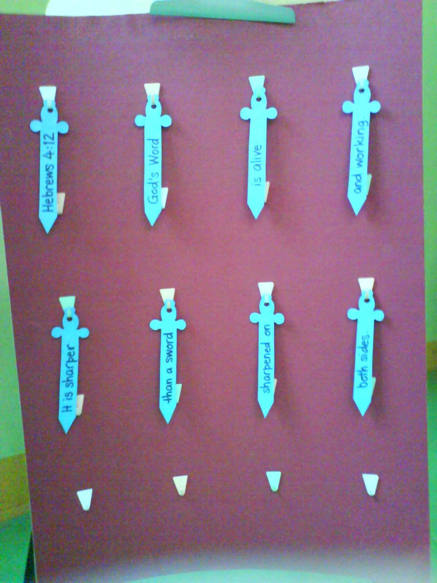

MV Presentation: “Two-Edged Sword Test”
Let’s memorize this verse in a fun way. See these two
stacks of “sword.” They are the words for our Bible
verse. I am going to split our group into two teams
and each team with get a stack of swords. When I
tell you to start, each team will hang the swords on
poster board to the order of the Bible verse. When you
have the verse in order, everyone in your group reads it
together. The first team to finish wins.

Play the game a couple more times changing people in the group each time. Afterward, each child who can say the Bible verse gets a small sticker on his sword.

Your sword is a bookmark for your Bible. Every Sunday you bring it, I will give you a sticker for every new Bible verse you can say to me for that week. Let’s see if we can fill the sword up with stickers.

Hand out a copy of the Bible verses used in large group for the children to learn at home and report back to you.

Remember that we learned today *God’s word helps us fight Satan.

Prayer Time:
Close with prayer taking time to talk to the children about their needs and thanking God for the weapons he gives us against Satan.

“Dao Dao Goes for the Light Saber”

Puppet Presentation

The following script calls for volunteers from the audience and flash cards with Bible verses written on them. Also needed is a light saber, which is made by taping a trick balloon (a long thin balloon used for tying animals) to a bright long-handled flashlight. (The best tape for this is duct tape or wide masking tape.) You might be able to purchase a toy light saber.

Teacher: Hi, Dao Dao! How are you?

Dao Dao: (Sadly and slowly.) Oh…Hi, Teacher…

Teacher: Dao Dao, what’s wrong?

Dao Dao: Well, I made a bad mistake.

Teacher: What did you do?

Dao Dao:: I’m afraid I stole a Star Wars video and my mom caught me.

Teacher: No wonder you’re sad. What happened?

Dao Dao: Chan Weng Keong and I were at the store and he showed me how easy it was to put a video in my backpack. I could walk out and no one would know.

Teacher: Is that what you did, Dao Dao?

Dao Dao: Yeah. When I got home my mom checked for my homework. She found the video in my backpack. But I’m kinda glad she found it. I felt so bad about taking it.

Teacher: What are you going to do?

Dao Dao: Well, I’ll return it and I’ll write an apology letter. I promised my mom I wouldn’t steal anything again. Oh yeah. I had to ask God for His forgiveness.

Teacher: It sounds like things are getting better.

Dao Dao: Yeah, but I don’t understand something. I don’t understand why I did it! I know better than that.

Teacher: Dao Dao, you were tempted and you gave in to temptation.

Dao Dao: Was that when Chan Weng Keong showed me how to sneak the video in my backpack?

Teacher: Yes, it was. But it wasn’t just Chan Weng Keong. Did you know that Satan has power to put those thoughts in your mind and tempt you? Satan even uses people like Weng Keong to help suggest temptations.

Dao Dao: Oh, that sounds spooky. Is that how Satan works?

Teacher: Yes, Satan can use people to suggest what is wrong. Sometimes he can just use thoughts.

Dao Dao: Thoughts like, “Hmm…That Star Wars VCD looks great. I bet I could watch it a hundred times. I sure wish I had it. I think I could take it so easily…” I guess I know what you mean, Teacher. Do you ever get tempted to do wrong?

Teacher: Every day. I just want to be ready to answer temptation by knowing God’s word. God’s word is like a sword.

Dao Dao: A sword? Cool! Maybe it’s like a light saber from Star Wars.

Teacher: The Bible calls God’s word a double-edged sword. (That means it’s sharp on both sides.) I think you could probably call it a light saber.

Dao Dao: How does it work?

Teacher: Well, let’s just make a light saber and find out.

Dao Dao: No way! Cool!

Teacher: I’m going to take this flashlight and balloon to make a pretend light saber. (Makes the light saber and continues.) Now can I have someone turn off all the lights? Let’s see if it works. (Waves light saber in dark as sound effects are made.)

Dao Dao: Way cool, Teacher! But how is that like God’s word?

Teacher: God’s word is like the light that cuts through the power of darkness and temptation, just like this light saber cuts through the darkness. And I’ll show you how some kids can use God’s word. I’ll need a volunteer. This volunteer will have to be able to remember a time when he was tempted to disobey his parents. Please come on up.

(To the child.) Can you tell us quickly about a time you were tempted to disobey your parents. Maybe you even did disobey them.
Dao Dao, this is how God’s word works like a light saber. I’m giving to this child this Bible verse card with Ephesians 6:1 on it. He can read the verse out loud. (If the child cannot read the words, he can repeat them as Teacher reads them.)

(Teacher continues the interview process by calling up other children and asking the following questions. Bible verses found in the supply list correspond with the questions and are read by a child after he answers a question.)

Teacher: Has anyone here ever been tempted to say bad things about another person or just been mean to another person? (James 2:1)

Has anyone been tempted to tell or listen to a dirty joke? (Ephesians 5:4)

Has anyone been tempted to lie? (Colossians 3:9-10)

Has anyone been tempted to hold a grudge against someone and not forgive him or her? (Ephesians 4:32)

Dao Dao: That’s really cool. I like how God’s word helps us not fall for Satan’s temptations.

Teacher: In fact, Jesus used God’s word to fight Satan.

Dao Dao: Did Jesus get tempted?

Teacher: Yes, he did. Satan tempted Jesus. But Jesus used God’s word and did what God wanted, and Satan couldn’t trick Him. It happened at the very beginning of Jesus’ ministry, and it was the way God trained Jesus before He started His ministry.

Dao Dao: Did Jesus use a light saber?

Teacher: No, just God’s word. Here. Let’s watch the story in today’s Bible video. This is from Matthew 4:1-11.

Show the video, The Visual Bible: Matthew (4:1-11).

“Dao Dao Goes for the Light Saber”

Puppet Presentation Conclusion

Dao Dao: Wow! Satan was really trying to get Jesus wasn’t he?

Teacher: He sure was. But most of all Satan wants to have the power to keep us from God.

Dao Dao: He can’t do that can he?

Teacher: Not if we trust in Jesus as our rescuer. Remember, that Jesus defeated the devil by giving His life for us on the cross. Because of that, we can be forgiven and be friends with God no matter what!

Dao Dao: Oh yeah. And when we hear Satan telling us how easy it is to do stuff that God doesn’t want and how we won’t get caught…well then we can use God’s word to fight Satan.

Teacher: Now you’ve got it, Dao Dao. Let’s close in prayer.

Dear God, we know that You will forgave us whenever we say sorry for the wrong we have done. But we know that you forgave us. Thanks for doing that and still being our friend. Help all of us to use God’s word to fight the devil when he tempts us. We will remember what You said in the Bible, that we can know that You forgive us and love us no matter what. In Jesus’ name. Amen.

Ephesians 6:1 (Obeying parents)
(For large group leader)
“Children, obey your parents the way the Lord wants. This is the right thing to do.”

James 2:1 (Being mean to another person)
“My dear brothers, you are believers in our glorious Lord Jesus Christ. So never think that some people are more important than other.”

Ephesians 5:4 (Dirty jokes)
“Also, there must be no evil talk among you. You must not speak foolishly or tell evil jokes. These things are not right for you. But you should be giving thanks to God.”

Colossians 3:9-10 (Lying)
“Do not lie to each other. You have left your old sinful life and the things you did before. You begun to live the new life.”

Ephesians 4:32 (Not forgiving others)
“Be kind and loving to each other. Forgive each other just as God forgave you in Christ.”

Lesson 35

Small Group Warm-Up:
- no supplies needed

Large Group:
- Star Wars VCD (optional)

trick balloon, flashlight, and duct tape or wide masking tape to make a light saber. Or you might be able to purchase a toy light saber.
- memory sword verse cards (page 14, 15)
- video, The Visual Bible: Matthew (Visual International and Visual Entertainment, Inc., 1984) Cue video to Matthew 4:1-11.

Small Group Application:
- sword copied on manila card for each child (page 14, 15)
- aluminum foil
- scissors
- tape
- small stickers
- two sets of the Hebrews 4:12 memory sword game cards for each group (page 14, 15)
- copy of the memory verses from large group for each child to take home (page 13)
Memory Verse Learning:
- two sets of the Hebrews 4:12 memory sword game
cards for each group
- copy of the memory verses from large group for each
child to take home
- poster board with hooks attached

Ephesians 6:1
Lesson 35, Large Group and
Small Group Appllication
Children, obey your parents the way the Lord wants. This is the right thing to do.”

Colossians 3:9-10
“Do not lie to each other. You have left your old sinful life and the things you did before. You begun to live the new life.”

Ephesians 4:32
“Be kind and loving to each other. Forgive each other just as God forgave you in Christ.”

Ephesians 5:4
“Also, there must be no evil talk among you. You must not speak foolishly or tell evil jokes. These things are not right for you. But you should be giving thanks to God.”

James 2:1
“My dear brothers, you are believers in our glorious Lord Jesus Christ. So never think that some people are more important than other.”


Hebrews 4:12
God’s word
is alive
and working.
Lesson 35, Small Group Application
It is sharper

than a sword
sharpened on
Lesson 35, Small Group Application

both sides.

