
Date: _________________
Series: Jesus Is the King (Dec-Mar)
Year 1, Lesson 37

The King Is a Prophet

Take Home Point: *We are called to penetrate the world with Jesus’ love.
*Repeat this phrase throughout the lesson.

Bible Event: Matthew 5:13-16
Key Verse: Matthew 5:16 : “...You should be a light for other people. Live so that they will see the good things you do. Live so that they will praise your Father in heaven.” (NCV)

We will help kids know:
- Jesus is the Prophet. He challenges us to penetrate this world with His love.
- Jesus calls us to live out our lives in a way that is radically different from the ways of the rest of the world.
- “To penetrate” means “to go into something.” Jesus calls us to go into the world as his witnesses. Like salt and light, we penetrate the world to give it flavor and light.

We will help kids feel:
- Energized to penetrate their world with Jesus.
- Empowered by the Holy Spirit working in them.

We will help kids do:
- Experience through various activities what it means to penetrate the world.
- Identify those people in their lives whom God is asking them to go and reach for the kingdom.

THIS LESSON’S ROADMAP

DESTINATION | PAGE # | DISCOVERIES ON YOUR JOURNEY | SUPPLIES NEEDED
Small Group Warm-Up   | 3-4 | Challenge the children to see themselves as salt and light. They can share the message of Jesus! Use french fries and salt and/or a lit candle to talk about what it means to penetrate. | Option 1:  - two containers for each group, one salted and one unsalted  - regular salt  Option 2:  - birthday candle for each child with 4-inch square of aluminum foil to prevent the wax from dripping  - matches
Large Group   | 5  9-11  12-13  13 | Overview  Video: The Visual Bible:Matthew. Show Matthew 5:13-16.  Puppet Presentation: “Dao Dao and the Catering Church”  Story Telling: “Rachel, Salt and Light”  Puppet Presentation: “Dao Dao and the Catering Church” Conclusion | - video, The Visual Bible: Matthew (5:13-16 and 38-48) (Visual International and Visual Entertainment, Inc., 1984)  - Styrofoam box with a large chicken thigh inside  - Styrofoam boxes for every group with chicken flavoured biscuits inside
Small Group Application   | 5-7  7-8 | Do a simple craft that reminds the children that God wants us to penetrate the world with his love. You will use water in the craft to help the children understand how the Holy Spirit (often symbolized by water in the Bible) can work through us to reach others.  Memory Verse Learning:  “Two-Edged Sword Test”  To continue teaching the kids the take-home memory verses given out during lesson 35. | - dinner-size plate for each child  - small dessert-size plate for each child  - coffee filter for each child  - spray bottle with water per group  - two or three different colors of powdered gelatin per group (with spoons for serving)  - crayons  - newspaper or paper towels  - a set of memory sword cards on Eph. 5:4 and last week’s set on Jm. 2:1 and Heb. 4:12  - stickers
Small Group Warm-Up: 15 minutes
Purpose: Get pointed in the right direction! Build relationships and help guests feel at ease. Do the learning readiness activity that will point your group in the right direction for the lesson.

Supplies needed: Option 1 - two containers french fries for each group, one salted and one unsalted; regular salt; Option 2 - birthday candle for each child with 4-inch square of aluminum foil to prevent the wax from dripping; matches

Today we are challenging the children to see themselves as salt and light. Like salt, they can penetrate the world to bring flavor and preservation. Like light, they can dispel the darkness. These children can share the message of Jesus to their friends and family. They can even help those who don’t know Jesus, meet him as their Savior and Lord.
Small group warm-up will be slightly longer today if both activities are done. To compensate, large group can be made slightly shorter.

You have options to do the salt activity, the light activity, or both.

Have two containers of french fries for your group. (Coffee filters make good containers and will be used later in the lesson.) One container of french fries will be salted and the other will be unsalted.
Option 1: Salt
Ask kids:

Where is your favorite place to eat french fries? Do you like eating french fries while at McDonald? How about at home while watching TV? What about having french fries while you do your homework?

Boys and girls, we have been chosen by a very distinguished group of people to have a french fries taste test. You will get a few pieces of french fries out of each container and decide which one is better.

Optional: You could have kids fill out an evaluation form like they were real “taste-testers.”

Which french fries do you like better? Why?

The children will like the salty kind better, but make sure they identify the salt as the reason.

If I sprinkled a little salt on the top of the unsalted french fries, would that help? (Yes.) But the salt needs to penetrate to be able to be tasted. The word “penetrate” means “to go into something.” If the salt is simply sprinkled over one area and can’t adequately penetrate the container of french fries, it doesn’t really help.

The large group leader will announce that the lights are coming down. If you are not finished with the above activity, finish quickly and move on to this activity.
Option 2: Light

In this activity, each child will be given a small birthday candle and a four-inch square of aluminum foil. Wrap the candle base in foil to protect fingers from dripping wax.

Wow! This room is pretty dark. But I have a solution. I have a candle for each of you.
It is very important that you tell the children your expectations up front about the use of the candles when lit. If a child misbehaves, he will blow out his candle and
not participate.
Do not allow for any exceptions!

Show the children how to light a candle by tipping the unlit candle toward the flame of the lit candle. The lit candle remains still and upright.

As the first candle is lit, notice how it helps light the room to some degree. Also notice how after many candles are lit, the room becomes brighter and brighter. After the candles are lit, say:

See how the light penetrates the darkness. Another way to say this is that the lights pierce through or enter into the darkness. God asks us to be salt and light to our world. He wants us to penetrate the world. In Matthew 5:13-16 Jesus says:

“You are salt of the earth. But if salt loses its salty taste, it cannot be made salty again. It is good for nothing. It must be thrown out for people to walk on. You are the light that gives light to the world. A city that is built on a hill cannot be hidden. And people don’t hide a light under a bowl. They put the light on a lampstand. Then the light shines for all the people in the house. In the same way, you should be a light for other people. Live so that they will see the good things you do. Live so that they will praise your Father in heaven.”

Today we will learn that *we are called to penetrate the world with Jesus’ love.

Large Group: 20-30 minutes
Purpose: Help kids observe what the Bible says. Present the Bible Event in creative fashion. Help kids begin to interpret what it means.

Supplies needed: video, The Visual Bible: Matthew (5:1-16 and 38-48); Visual International and Visual Entertainment, Inc., 1984); Styrofoam box with a large chicken thigh inside; Styrofoam boxes for every group with chicken flavoured biscuits inside

Overview

Video: The Visual Bible:Matthew. Show Matthew 5:13-16.

Puppet Presentation: “Dao Dao and the Catering Church”

The audience participates in this script as Teacher uses the analogy of delivering home-cook meal to teach Dao Dao how we, the church, take the “good news” to others.

Story Telling: “Rachel, Salt and Light”

Puppet Presentation: “Dao Dao and the Catering Church” Conclusion

Small Group Application: 20-25 minutes
Purpose: Help kids map out the meaning of the Bible event in their lives. Use the questions to stimulate discussion, but don't feel tied to them. Allow the Holy Spirit to guide you. Include personal examples from your own faith journey. The example of Christ at work in your life will leave lasting impressions of how Christ can work in the children's lives.

Use your Bibles! Children need to learn how to look up references and follow along when scripture is read aloud. Allow for quality time of prayer at the close of the lesson.

Supplies needed: dinner-size plate for each child; small dessert-size plate for each child; coffee filter for each child; spray bottle with water per group; two or three different colors of powdered gelatin per group (with spoons for serving); crayons; newspaper or paper towels

Look at Matthew 5:13-16. Have the children participate either by reading aloud or following along as you read.

Observation Questions: What happened?

Jesus says that we are like what two things? (Salt and light.)

What happens to salt when it loses its saltiness? (It is thrown out.)

What do you not do when you light a lamp? (You do not put it under a basket.)

What are we a light to? (The world.)

Interpretation Questions: What does this mean?

How are we like salt and light to our friends? (Salt and light penetrate. One adds flavor and preserves and the other gets rid of the darkness. *We can penetrate the world with Jesus’ love. We add flavor to people's lives and shine with our lives to get rid of spiritual darkness.)

How do people let their lights shine in front of others? (By showing acts of love to others in Jesus’ name. Telling others about Jesus.)

Application Questions: What does this mean to me?

Discuss these questions while doing the following activity.

Who will you be salt and light to by sharing God’s love and sharing the good news of Jesus? What specific things will you do?

Application Activity:
Give each child a coffee filter and have him flatten the filter and write his name in crayon in the center. Ask the children to then write names of friends, people who might be going through a difficult time, or people who might not be very close to God around the edge of the filter. Explain that this symbolizes the “circle” of people we have in our lives

Then give each child a 8” Styrofoam plate (to catch any excess water) and a 6” paper plate (to create a rounded surface). Place the smaller plate upside down inside the larger plate. Invert the coffee filter and cover the small paper plate with it.
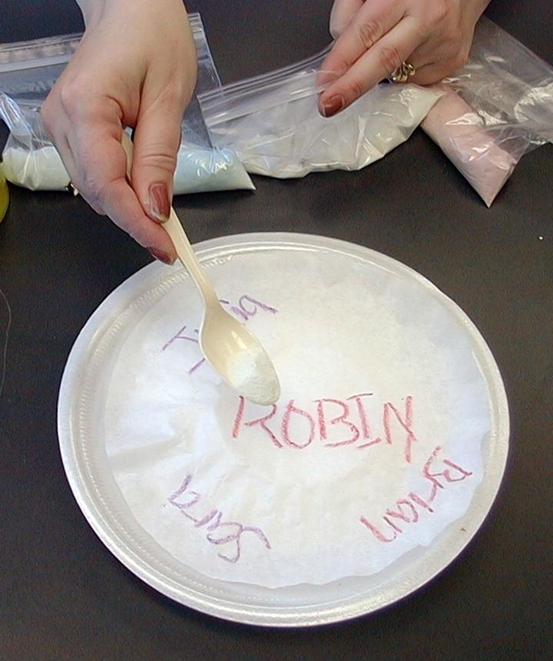
God wants you to penetrate the world and give his love to others. When you do this, you are like salt. You are adding flavor to people’s lives. Remember how Jesus said that you are salt of the earth.

I have some special granules (gelatin powder) that look like salt. This isn’t really salt, but it will remind us that we are to be the salt of the world. After you have finished writing your names with crayon and placed your coffee filter “circle” over the small paper plate, you can spoon some of the “salt” sprinkles over your name.

As you are doing that, tell one way that you can show Jesus’ love to one of the other people named on your circle. You might even tell us a little about those people. If you tell us a little how you can help be salt to another person, you can even take some sprinkles from another bag.

After the children have applied their sprinkles, they are ready to spritz the art project with water from the spray bottle. Apply enough water so the sprinkles change colors and soak to the fringes, penetrating the names. Don’t overspray!
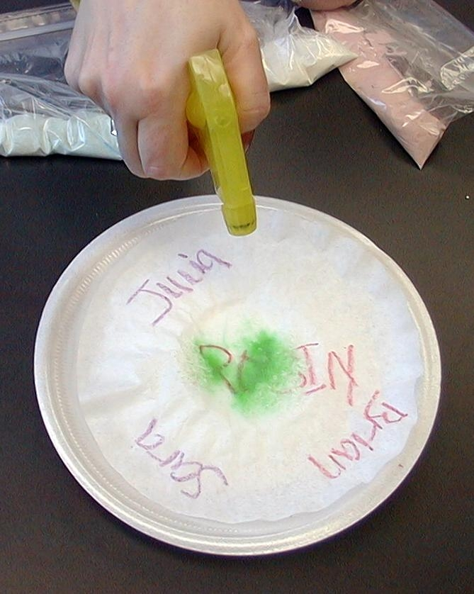
In the Bible, water is often a symbol of the Holy Spirit. Let’s lightly spray our circles. Think of how the Holy Spirit can work through you to reach others.

When you see how these sprinkles change colors and penetrate to the edge of your circle, does it remind you of how God will use you to penetrate another’s world? What do these colors remind you of when you think about the message that you will tell others?

Accept any answer, but let the children discuss. Some discussion starters for the colors are:
Red: The blood of Jesus cleanses us from sin.
Blue: The color of faith and hope. (If someone is “true blue” they are faithful.)
Green: The color of everlasting life.

Remember: *We are called to penetrate the world with Jesus’ love.

After the art projects are finished, set them aside to dry. The following week, they can be displayed on a poster board or kept in your tub as prayer reminders.

Memory Verse Learning: 5 minutes
Purpose: Help kids to memorize and keep scriptures at heart. Using creative ways to help kids enjoy learning the key verse and in small group setting.

Supplies needed: a set of memory sword cards on Eph. 5:4 and previous sets on James 2:1 and Heb. 4:12; stickers

Memory Verse: Hebrews 4:12, James 2:1, Ephesians 5:4, Colossians 3:9-10, Ephesians 4:32, Ephesians 6:1

MV Presentation: “Two-Edged Sword Test”
Have the children take out their sword bookmark so stickers can be given to those who can say some memory verse. (Have some spare for those who are new or have lost theirs.) Take out the set of memory sword cards on Ephesians 5:4 to help children review or learn the verse. Each person will hook the words on the poster board in order of the Bible verse and reads it out loud when completed. It will be timed and the person with the fastest time wins. The previous sets of memory sword cards can also be taken out for challenges.

Your sword is a bookmark for your Bible.
for three more Sundays, I will give you a sticker for every new Bible verse you can say to me for that week. Let’s see if we can fill the sword up with stickers.

Prayer Time:
Ask the children to pray specifically for people that God is calling them to penetrate their world with Jesus. Ask the Holy Spirit to give them the opportunity and courage this week to follow through.
“Dao Dao and the Catering Church”

Puppet Presentation

The puppet script begins after watching the video.

Dao Dao: Aww…It can’t be over already! I want to watch more of the video.

Teacher: That’s all for the Bible reading today. But did you hear Jesus the prophet?

Dao Dao: You mean Jesus was a prophet?

Teacher: Sure. He spoke words of truth that challenge us to do something very important.

Dao Dao: What’s that?

Teacher: Jesus wants us to be like salt and light. He wants us to penetrate the world.

Dao Dao: Penetrate? I know what that means.

Teacher: What does “penetrate” mean, Dao Dao?

Dao Dao: Penetrate is when you trade pens with someone!

Teacher: Dao Dao, you’re being silly. “Penetrate” means that you “go into something.” Salt goes into food and preserves it and gives it flavor. Light goes into darkness and let’s people see. And we’re supposed to penetrate the world.

(Dao Dao is thinking.)

Teacher: Do you understand, Dao Dao?

Dao Dao: Yeah, except for one thing. What are you talking about?

Teacher: We, believers in Christ, are the church and the church is supposed to penetrate the world and give people the good news of Jesus.

Dao Dao: Let me see if I’ve got it. The church—that’s us—is supposed to penetrate the world.

Teacher: Let me give you an example. Use your imagination. Pretend that the church is like a home-cook catering business If a home-cook caterer serves dishes to its customers, what do we, the church, serve to the people?

Dao Dao: Gummy worms!?

Teacher: Dao Dao!

Dao Dao: Gummy worm rice?

Teacher: Dao Dao!

Dao Dao: Okay, Teacher. What does the church serve to its people?

Teacher: The church serves spiritual food.

Dao Dao: What’s spiritual food?

Teacher: It’s food for your soul. We are hungry in our hearts to know God and His love for us. The good news of Jesus is spiritual food that satisfies. When we trust Jesus as our Savior and Lord, we will be friends with Him forever.

Dao Dao: So instead of rice, we serve spiritual food. But how do people get it? Do they just come in and order it?

Teacher: Most think so, but that’s not all there is. Let me show you by having some volunteers come up. Do you want to volunteer, Dao Dao?

Dao Dao: No, someone needs to stay back and be cool.

Teacher: Okay. (Selects five volunteers.) Here are my five volunteers. (Speaking to the volunteers.) Let’s just say that you are in the home-cook catering business and here is your giant chicken thigh. Enjoy! (Teacher hands them a Styrofoam box with a giant chicken thigh inside.)

Dao Dao: Hey, no fair. I want some!

Teacher: But you’re not up here in the church…er, I mean…the home-cook catering.

Dao Dao: But I didn’t know that I’d get a chicken thigh if I’d be there. No fair. I want a thigh. I want a thigh. Hey kids, c’mon. Join me. (Chanting.) We wanna chicken thigh. We wanna chicken thigh. We wanna chicken thigh.

Teacher: Okay. Everyone quiet down. I get the message. How about this? I have a Styrofoam box with chicken thigh that needs to go out to you. In fact, I have one box for every group. But how shall I get it to you?

Dao Dao: I know. How about we phone for delivery?!

Teacher: Great idea, Dao Dao! So, let me find some delivery people to take the product out to the customers who are away from the catering place. Who shall I send? Well, how about these five customers? They would make great delivery people. Here each of you take one Styrofoam boxes and deliver to every group.

Dao Dao: Teacher, do you realize that the customers of your catering are the ones who are now delivering food to people? What kind of catering works that way?

Teacher: The church does! The church is just like this type of catering business. The church is made of people who come to a place and enjoy the spiritual food.

Dao Dao: Like the people here eating chicken thigh?

Teacher: Yes. Then they become the delivery people to bring spiritual food to others in the world.

Dao Dao: You mean people like us screaming for rice?

Teacher: Exactly. People who are spiritually hungry. The church penetrates the world and brings spiritual food.

Dao Dao: And that’s what we’re supposed to do?

(If time allows, Teacher continues with the script and reads the story, “Rachel, Salt and Light.” If you do not have time, go directly to closing prayer in the puppet presentation conclusion. )

Teacher: It sure is, Dao Dao. Here let me tell a story of how that happens.

“Rachel, Salt and Light”

Teacher: Do you know what a privilege it is for God to call you one of His representatives? Think of what a difference you can make when you penetrate your world with His love. To penetrate also means to make a way. You can make a way for others to know Jesus, as you are salt and light to the world. Consider the story of a girl named Rachel and the difference she made at her school.

Rachel went to a public school that had much spiritual darkness. Many students there used drugs, and some were members of gangs. Making a stand for God was not a very popular thing to do.

Rachel had a special relationship with God. Every day she spent time praying and reading the Bible. She was willing to be used by God for whatever He wanted.

Her faith was soon tested. When she was just thirteen, Rachel was diagnosed with leukemia, cancer of the blood. She was told that she might not have long to live.

What would you do if you knew you might die in just a few months or years? Would you stay in your room and be sad? Would you try to visit as many amusement parks as you could? Would you stop going to school?

This is what Rachel did. She wanted to make her life count. She knew God could choose to heal her. If He didn’t, she wanted to bring as many people with her into a friendship with Jesus as she could. Rachel wanted every day to count for Jesus.

Rachel asked her parents to pray for her every day that God would give her a chance to share the love of Jesus with a school mate.

When Rachel was at school it seemed as though everyone was watching her. The word had spread that she had cancer and that she did not have long to live. The kids could not understand that even though she was dying, she was so concerned about others. Rachel shared the love of Christ with everyone. She really was making a differene.

Rachel was penetrating her world with the love of Jesus. She was salt and light in her school.

On her sixteenth birthday, Rachel was weak. She knew the end would be soon. She was ready to go home and be with the Lord. Still she just wanted to see all her high school friends in heaven with her some day.

Rachel wrote a letter to her school, but she did not have a chance to read it to them. A few weeks later she died and went to heaven with Jesus.

When it was time for Rachel’s funeral, hundreds of students requested permission to go. Several school buses carried them from the campus to the funeral. At Rachel’s graveside, her letter was read.

“Dear Classmates,

I told my parents that I was willing to die and to go home into eternity if I could bring all of you with me. My Savior made a way for you to go to the other side…”

After the letter was finished, an invitation was given for those who wanted to begin a friendship with Jesus Christ and some day be with Him and Rachel in heaven. Almost every student surged forward to receive this promise.

Jesus is the king and has given each of us a royal call to share His love with others every day of our lives. I am sure Rachel is glad that Jesus chose to use her sickness so she could be salt and light to her school and her friends.

Jesus is giving you the same opportunity in whatever place He sends you. He said it Himself, “You are the salt of the world. You are the light of the world. Let your light shine for Jesus.”

Based on the story “Rachel” by Sheri Rose Shepherd. Taken from LIFE IS NOT A DRESS REHEARSAL by Sheri Rose Shepherd (Multnomah Publishers, Inc., 2000)

“Dao Dao and the Catering Church”

Puppet Presentation Conclusion

Dao Dao: Wow, Teacher! That was a great story.

Teacher: It sure is. It can be our story too. We can penetrate our world by sharing Jesus’ love. It’s good to pray now... Dear God, thank You that You want us to go into the world and give others good spiritual food like Jesus’ love. Jesus’ love is even better than chicken thigh. Show each one of us how we can do that and help us to do it. In Jesus’ name. Amen.

Lesson 37
Small Group Warm-Up:
Option 1
- two containers (or coffee filters) of french fries for each group, one salted and one unsalted
- salt

Option 2
- birthday candle for each child with four-inch square of aluminum foil to prevent the wax from dripping on the child (Emergency candles can be used as well. Though these candles are more expensive, they can be used whn candles are required for future lessons.)
- matches

Large Group:
- video, The Visual Bible: Matthew (Visual International and Visual Entertainment, Inc., 1984) Cue video to Matthew 5:13-16 and 38-48.
- Styrofoam box with a large chicken thigh inside
- Styrofoam boxes for every group with chicken flavoured biscuits inside

Small Group Application:
- 8” Styrofoam plate for each child
- 6” paper plate for each child
- coffee filter for each child
- spray bottle with water per group
- two or three different colors of powdered gelatin mix per group (with spoons for serving)
- crayons
- newspaper or paper towels

Memory Verse Learning:
- a set of memory sword cards on Eph. 5:4 and last week’s set on Jm. 2:1 and Heb. 4:12 . You can use the template below to cut out a number of “swords” from manila cards to write out the verse for learning.

- stickers

thanks to God.

