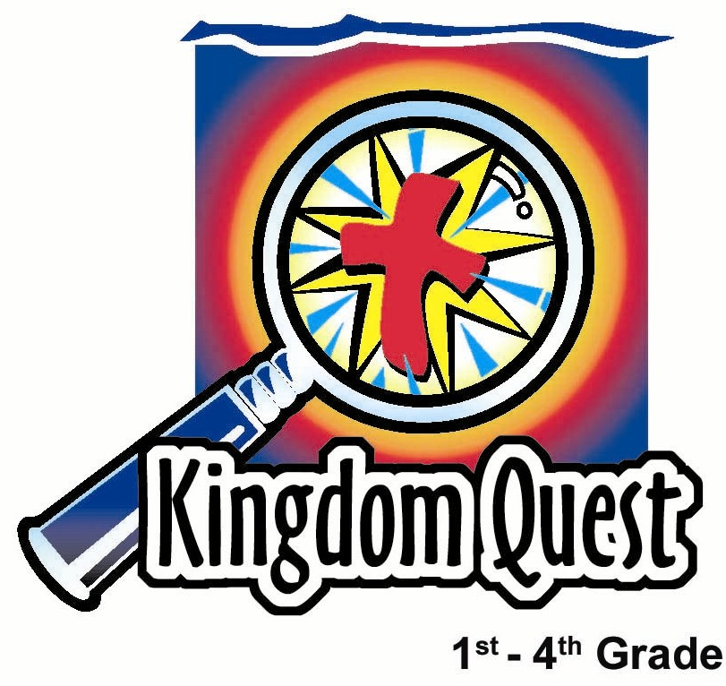
Date: _________________
Series: Jesus Is the King (Dec-Mar)
Year 1, Lesson 38

The King Is
a Priest

Take Home Point: *Jesus is our priest. He is our bridge builder to God.
*Repeat this phrase throughout the lesson.

Bible Event: Matthew 6:9-13, The Lord’s Prayer
Key Verse: Hebrews 4:14, 16: “We have a great high priest who has gone into heaven. He is Jesus the Son of God. Let us, then, feel free to come before God’s throne. Here there is grace. And we can receive mercy and grace to help us when we need it.” (NCV)

We will help kids know:
- Because of Jesus, we have a “bridge builder” or a connection with the Father.
- The master of prayer, Jesus, taught us how to pray.
- The Lord’s Prayer is a model of prayer for our lives.

We will help kids feel:
- Reassured that they can go straight to the throne of God with their prayers.
- Confident in their ability to pray as Jesus has taught us.
- Peace knowing that God cares about them and listens to each of their prayers.

We will help kids do:
- Pray the Lord’s Prayer both by memory and with understanding.
- Keep a prayer journal.

THIS LESSON’S ROADMAP

DESTINATION | PAGE # | DISCOVERIES ON YOUR JOURNEY | SUPPLIES NEEDED
Small Group Warm-Up  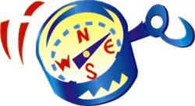 | 4-5 | Have the kids work together to solve a puzzle. How can one child standing on a chair get a ball to another child standing on a chair six feet away without throwing the ball? Use a bridge (or another child)! | - small plastic ball for each group  - two chairs for each group
Large Group   | 4-5  9-10  10  11-12  13 | Overview  Puppet Presentation: “Dao Dao Gets Plugged In”  Video: Visual Bible: Matthew  Lord’s Prayer Presentation  Puppet Presentation: “Dao Dao Gets Plugged In” Conclusion | - yield signs for the Lord’s Prayer:  - KING’S PRAISE: “Our Father who are in heaven, hallowed by Thy name.”  - KING’S KINGDOM: “Thy kingdom come, Thy will be done on earth as it is in heaven.”  - KING’S GIFTS: “Give us this day our daily bread…”  - KING’S FORGIVENESS: “And forgive us our trespasses as we forgive those who trespass against us…”  - KING’S PROTECTION: “And lead us not into temptation, but deliver us from evil. For Thine is the kingdom and the power and the glory forever and ever.  - VCR, TV, and video camera  - video, The Visual Bible: Matthew (Visual International and Visual Entertainment, Inc., 1984) cued to Matthew 6:5-15  - cable to connect video camera and VCR  - five chairs
Small Group Application   | 6-8 | Each child will get a prayer journal and you will help them begin their “Prayer Journey to the King” as they begin to discuss with you and write in their booklet their various prayer needs.  Memory Verse Learning:  Instead of memorizing a verse, encourage the children to memorize the Lord’s Prayer by using the yield signs from large group presentation. | - prayer journal for each child  - pencils  - yield signs for the Lord’s Prayer
Small Group Warm-Up: 15 minutes
Purpose: Get pointed in the right direction! Build relationships and help guests feel at ease. Do the learning readiness activity that will point your group in the right direction for the lesson.

Supplies needed: small plastic ball for each group ; two chairs for each group

One ball and two chairs are needed to do this activity. Set the two chairs about six to seven feet apart. Have two children come up and stand one on each of the chairs. Have another two children come up and each stand behind a chair and hold the other child’s right hand acting as anchors. (This is to help keep the kids from falling off.) See the diagram below.
C |  |  |  | C
h |  |  |  | h
i | Child |  | Child | i
l |  |  |  | l
d |  |  |  | d

Kids, I have a puzzle for you to work out. I will need everyone to work and think together to be able to solve this puzzle. Are you up for the challenge?

I am going to give the ball to one of the children on a chair. The object is for that child to hand the ball to the child on the other chair. They cannot throw the ball. They cannot toss the ball. The ball can only travel from hand to hand.

The rest of you in the class can help come up with a solution to this puzzle. Remember, you cannot throw or toss the ball. All you can do is hand the ball off.

Let the children problem solve for a while and see if they can come up with the solution. Notice that the above diagram looks somewhat like a bridge with the middle section missing. Point this out by using leading questions such as:

What kind of structure do these kids on and behind the chairs look like? What kind of structure do we need to get something across from one place to another?

The solution for this activity is to have one child come and stand between the two children on the chairs. He would have his arms outstretched and the first child would be able to hand the ball to him and he could hand it on to the other child. See below.

C |  | C |  | C
h |  | h |  | h
i | Child | i | Child | i
l |  | l |  | l
d |  | d |  | d
After kids have come up with the solution, ask:

What was the only way you could get the ball across that big gap? (By building a bridge.) Today we will learn that our prayers are like the ball that needs to be passed up to God. We need someone who can be a bridge builder, someone who can hand our prayers up to God. Who do you think that is? (Jesus.)

In the Old Testament, the priest went into the temple to offer sacrifices for the sins of the people and to pray for them. The people couldn’t go into the temple or stand directly before God, only the priest could. He was like a bridge builder, someone who filled in the gap between God and people.

When Jesus came and died for us, things changed. Listen to Hebrews 4:14 and 16. “We have a great high priest who has gone into heaven. He is Jesus the Son of God. Let us, then, feel free to come before God’s throne. Here there is grace. And we can receive mercy and grace to help us when we need it.”

What did Jesus do for us? Jesus is now our great high priest, our bridge builder. What does that mean for us? Can we go straight to God now? (Yes, because Jesus has bridged the gap.)

Today, we are going to learn how to pray because the master of prayer, Jesus himself, taught us. We will learn that *Jesus is our priest. He is our bridge builder to God.

Large Group: 20-30 minutes
Purpose: Help kids observe what the Bible says. Present the Bible Event in creative fashion. Help kids begin to interpret what it means.

Supplies needed: yield signs for the Lord’s Prayer - KING’S PRAISE: “Our Father who are in heaven, hallowed by Thy name.” KING’S KINGDOM: “Thy kingdom come, Thy will be done on earth as it is in heaven.”KING’S GIFTS: “Give us this day our daily bread…”KING’S FORGIVENESS: “And forgive us our trespasses as we forgive those who trespass against us…” KING’S PROTECTION: “And lead us not into temptation, but deliver us from evil. For Thine is the kingdom and the power and the glory forever and ever.” ; VCR, TV, and video camera; video, The Visual Bible: Matthew (Visual International and Visual Entertainment, Inc., 1984) cued to Matthew 6:5-15; cable to connect video camera and VCR; five chairs

Overview

Puppet Presentation: “Dao Dao Gets Plugged In”
A camera will be tuned into Dao Dao to film his prayers to God. The television is symbolic of God’s throne and what he receives from us in prayer. The filming of Dao Dao’s prayer request does not get to God because there is no cable between the camera and the TV. The cable then becomes a picture of Jesus, the bridge builder or priest. When Teacher connects the cable, it illustrates Jesus taking our prayers to the Father. He sees and hears our prayers because they are prayed in Jesus’ name, through faith in him.

Video: Visual Bible: Matthew (6:5-15, The Lord’s Prayer)

Lord’s Prayer Presentation: At different stations, different sections of the Lord’s Prayer are taught and children volunteers then pray that theme.

Puppet Presentation: “Dao Dao Gets Plugged In” Conclusion
Dao Dao learns how to pray in Jesus’ name.

Small Group Application: 20-25 minutes
Purpose: Help kids map out the meaning of the Bible event in their lives. Use the questions to stimulate discussion, but don't feel tied to them. Allow the Holy Spirit to guide you. Include personal examples from your own faith journey. The example of Christ at work in your life will leave lasting impressions of how Christ can work in the children's lives.

Use your Bibles! Children need to learn how to look up references and follow along when scripture is read aloud. Allow for quality time of prayer at the close of the lesson.

Supplies needed: prayer journal for each child; pencils

Look at Matthew 6:5-15. Have the children participate either by reading aloud or following along as you read.

Observation Questions: What happened?

Read Hebrews 10:19-21 to the children, or have someone who is a good reader read.

What did Jesus do for us so that we can “now go confidently into the holy place”? (He shed his blood as a sacrifice, or He died for us.)

How did this make Jesus like the high priest? (Jesus is our great high priest because He made the ultimate sacrifice for sins.)

Interpretation Questions: What does this mean?

What is this “holy place”? (Through prayer, we can approach the throne of God in heaven.)

Because Jesus became the bridge or intercessor for us, what difference does that make as people approach the throne of God when they pray? (We know God will hear us and listen because Jesus made the connection.)

Now, how can we come to God? Why?

Application Questions: What does this mean to me?

Why do we pray in Jesus’ name? (We are acknowledging that Jesus is interceding or praying for us to the Father.)

How does this make you feel when you pray in this way? (Confident that God hears me and will answer my prayer.)

How do we know God hears our prayers?

How does Jesus help us pray? (He gave us the Lord’s Prayer.)

*Jesus is our priest. He is our bridge builder to God.

Application Activity:
Use the following activity to apply God’s word to the children. Ask questions and help lead them to understand what they can pray for.

Today we are going to work on a prayer journal. Each child will get a prayer journal and you will help them begin their “Prayer Journey to the King” as they begin to discuss with you and write in their booklet their various prayer needs. Help them start writing in it today and they can take it home to use this week. In each section of the journal is a description of how to pray.

Memory Verse Learning:
Instead of memorizing a verse, encourage the children to memorize the Lord’s Prayer by using the yield signs from large group presentation.

Prayer Time:

Now I want you to think about a prayer you would like to pray in Jesus’ name. Remember, this will be just like Jesus handing this request to the Father.

I will begin the prayer and then I would like each of you to pray something you wrote in your journal. After everyone has had a chance to pray we will close with the Lord’s Prayer.

Dear God, we thank You that You gave us a bridge builder, a priest named Jesus. Because of Him, You hear and answer all our prayers. Today we ask that You would better teach us how to pray. We need your power in our lives and the power of prayer… (Let the children pray some of the requests in their journal.)

We pray all of these things in Jesus’ name as we pray together: Our Father who art in heaven., hallowed by Thy name. Thy kingdom come, Thy will be done on earth as it is in heaven. Give us this day our daily bread; and forgive us our trepasses as we forgive those who trespass against us; and lead us not into temptation, but deliver us from evil. For Thine is the kingdom and the power and the glory forever and ever. Amen.

“Dao Dao Gets Plugged In”

Puppet Presentation

This puppet presentation requires some special video effects. A video camera will be aimed at Dao Dao and turned on during the puppet presentation. This camera can be handheld but is preferably on a tripod. Likewise, a television will be turned on some distance away. The missing link is the cable between the two.

(Teacher sets the camera in place, aiming it at the place where Dao Dao will appear.)

Teacher: Dao Dao, are you there? I need your help.

(A crashing sound is heard behind the puppet stage. Dao Dao emerges, a bit shaken up.)

Teacher: Dao Dao, are you all right? What happened?

Dao Dao: Ooh! I fell down, Teacher. I was trying to do that thing where you pass the ball from one chair to the other and well…I guess I slipped.

Teacher: Dao Dao, all the kids did that, but they learned that they needed a bridge builder. A bridge builder would be someone who could hand the ball across for them.

Dao Dao Well, I thought I had a pretty long reach by myself. But I found out that I don’t bounce so well. Ouch! (Rubbing his head or shoulder.) Hey, what’s this camera about? (Acting excited.) Am I going to be on TV?

Teacher: Yes, Dao Dao. This is what is going to happen. I will ask you to think of some prayers and I’ll turn on this video camera and film you.

Dao Dao: Cool! Can I say any kind of prayers?

Teacher: Yes, any kind of prayers. Then this television over here will be turned on. This will remind us of the throne of God, the Father, and what prayers he sees and hears from us.

Dao Dao: So when I pray God sees it and hears it, right?

Teacher: That’s the way it’s supposed to work. Are you ready to give it a try?

Dao Dao: Sure. Turn on the camera.

Teacher: Okay. I’m turning on the camera and the TV. Now Dao Dao, give me a prayer.

Dao Dao: Dear God, I’m praying to you now. Thank You for hearing me. I want to (looks at TV)…Hey, wait a minute! Am I getting through? Dear God, please give Teacher enough sense to set up this camera so I can be seen on your TV.

Teacher: Okay. Cut! We seem to be having a technical difficulty here. The camera is on and the TV works. What’s wrong?

Dao Dao: Teacher, I may only be in Std. 3, but everyone knows that you need a cable or wire or something running from the camera to the TV.

Teacher: Oh, you’re right. Just like a cable is needed to connect the camera to the television, so we need a bridge builder, or a priest, to connect us to God.

Dao Dao: I still say we need a cable.

Teacher: Dao Dao, you’re right. We need a cable but that cable is like Jesus, our priest. He is a bridge builder to God. “Priest” means “bridge builder.” Only when we have faith in Jesus, our priest, can we be connected to God in prayer.

Dao Dao: Do you have a cable?

Teacher: Here it is. I’ll connect you. I will act as Jesus, who is like this cable connecting our prayers to God. (Connects the cable and holds it with outstretched arms, a picture of Jesus’ out stretched arms on the cross.) Okay, Dao Dao. Go ahead and pray.

Dao Dao: Dear God, once again I pray to You…Hey look, I’m on TV! Oh, I mean thank You, God, for hearing my prayers. I think it’s really cool that Jesus is the bridge builder or priest or the cable guy that connects us together with You. So please help me learn how to pray to You and even pray more and better prayers. In Jesus’ name. Amen.

Teacher: Great stuff, Dao Dao! Let me show you how God is already answering your prayer. He has given us the Lord’s Prayer as a model for prayer. Let’s listen to today’s Bible event on video.

Show the video, The Visual Bible: Matthew (6:5-15).

Lord’s Prayer Presentation

Have the five yield signs of the Lord’s Prayer hung on free standing poles spread out across the front. If more convenient, the signs can be taped up on a wall or simply held by volunteer students sitting in chairs.

Select a child to sit at a chair, beneath or alongside each of these signs. Let the children know ahead of time you will be asking them to pray out loud. It will be best to get spiritually mature children who can think quickly.

Teacher: Sometimes even when we know that we can go straight to the throne of God because of Jesus, we still find it difficult to pray. Sometimes we aren’t quite sure how to pray or what words to use.

Jesus was so good to us. He gave us a prayer and said, “Here is how you should pray.” Does anyone know what we call this prayer? You’re right. It is the Lord’s Prayer. Today we will learn about that prayer and then say it together.

The Lord’s prayer is divided into five parts for this lesson, which are represented by the yield signs hung on the five poles. Each yield sign is like a stopping place on the journey of powerful prayer.

Have the entire group recite the section of the Lord’s Prayer that you are discussing at each sign. Then explain the prayer and have the child at the station pray an example of that type of prayer.

The different yield signs or stations should be as follows:


KING’S PRAISE: “Our Father who art in heaven, hallowed be Thy name…”

Teacher: Praise means telling God who He is or what He has done that makes Him so great. Think of things about God that you can praise Him for. You might want to praise Him for being powerful and creating the world. You could praise Him for giving us His son. You could praise Jesus for giving His life for you. You could praise the Holy Spirit for being with you and showing you about God.

Child prays this petition in his own words.

KING’S KINGDOM: “…Thy kingdom come, Thy will be done on earth as it is in heaven.”

Teacher: Think of some ways God could act in people’s lives. This is His kingdom coming to our lives. You could pray for people who are hurting or need understanding. You could pray for people who don’t know God’s love or people who don’t trust in Jesus. You could pray for yourself, and that God would show you what His will is for you.

Child prays this petition in his own words.

KING’S GIFTS: “Give us this day our daily bread…”

Teacher: Pray for what you need everyday. You could pray for food and health. You could pray for other people’s needs, others who don’t have enough to eat. Are you worried about anything? Pray for that. God wants us to not worry about the future but pray that God would take care of us one day at a time.

Child prays this petition in his own words.

KING’S FORGIVENESS: “…And forgive us our trespasses as we forgive those who trespass against us…”

Teacher: Think of anything that you might be doing that would not be pleasing to God. Pray for forgiveness. Know that since Jesus gave His life for you on the cross, your sins are forgiven. Think about anyone who has done something against you. Give that person’s actions to God by forgiving that person. Then ask God to take care of that person and to help him stop doing that bad thing.

Child prays this petition in his own words.

KING’S PROTECTION: “…And lead us not into temptation, but deliver us from evil. For Thine is the kingdom and the power and the glory forever and ever.”

Teacher: Pray that God would protect you from doing what the devil would want you to do. This is spiritual protection. Pray for faith to believe God’s promises. Pray for the power of God’s word to be used in you.

Child prays this petition in his own words.

Teacher: Remember, kids, that *Jesus is our priest. He is our bridge-builder to God. Whenever we come before God asking in Jesus’ name, we can be sure that Jesus is connecting us to our Father in heaven.

“Dao Dao Gets Plugged In”
Puppet Presentation Conclusion

Dao Dao: Wow, Teacher! That sure is a lot of praying!

Teacher: Yes, Dao Dao, but praying is one of the most important things we can do. Remember: with every prayer we pray, Jesus is the bridge builder. He’s the one who brings our prayers right there before God. Let us pray.

Dear God, thank You for Jesus, who is a bridge builder or priest or something like that. Help us to pray more and to talk to You a lot. We pray it in Jesus’ name. Amen.

Lesson 38
Small Group Warm-Up:
- small plastic ball for each group
- two chairs for each group

Large Group:
- yield signs for the Lord’s Prayer:
- KING’S PRAISE: “Our Father who are in heaven, hallowed by Thy name.”
- KING’S KINGDOM: “Thy kingdom come, Thy will be done on earth as it is in heaven.”
- KING’S GIFTS: “Give us this day our daily bread…”
- KING’S FORGIVENESS: “And forgive us our trespasses as we forgive those who trespass against us…”
- KING’S PROTECTION: “And lead us not into temptation, but deliver us from evil. For Thine is the kingdom and the power and the glory forever and ever.
- VCR, TV, and video camera
- video, The Visual Bible: Matthew (Visual International and Visual Entertainment, Inc., 1984) cued to Matthew 6:5-15
- cable to connect video camera and VCR
- five chairs

Small Group Application:
- prayer journal for each child (pages 15-21)
- pencils

Memory Verse Learning:
- yield signs for the Lord’s Prayer
thanks to God.

