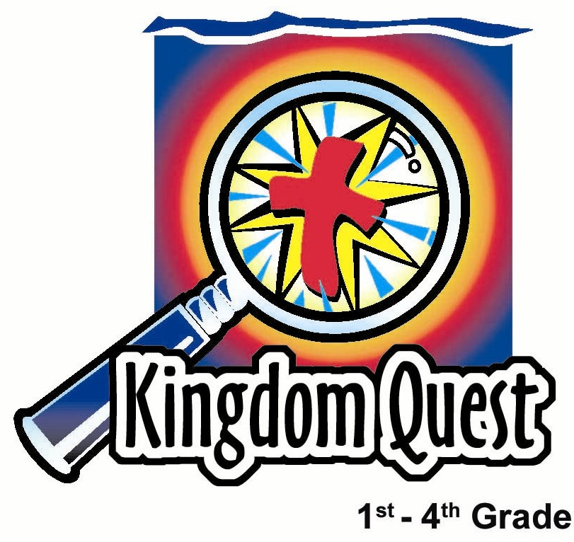
Date: __________________
Series: Jesus Is the King (Dec-Mar)
Year 1, Lesson 39

The King Is
a King

Take Home Point: *Jesus is the King and has power to help you.
*Repeat this phrase throughout the lesson.

Bible Event: Matthew 7:28-8:17, Jesus had the power and authority to heal.
Key Verse: John 17:2: “You gave the Son power over all people so that the Son could give eternal life to all those people you have given to Him.” (NCV)

We will help kids know:
- Jesus is the King and has the power to help you.
- God the Father had given Jesus the authority to heal us and save us.
- We are subjects of King Jesus through faith.
- We have Jesus’ authority to help others.

We will help kids feel:
- Delighted to be subjects of the King, Jesus.
- Confident that Jesus has the power to help them in whatever they need.

We will help kids do:
- Say with confidence, “I believe that Jesus is the King.”
- Use their authority as His subjects to share the kingdom with others.

THIS LESSON’S ROADMAP

DESTINATION | PAGE # | DISCOVERIES ON YOUR JOURNEY | SUPPLIES NEEDED
Small Group Warm-Up   | 3-4 | Have thumb wars to determine who is the king of your group. That child will then be given the authority to make up commands for the group. Jesus came to this earth to be king. In the kingdom of God, Jesus rules over our hearts and lives. | - one paper crown for each group (to be worn)
Large Group   | 4  8-9  9  10 | Overview  Puppet Presentation: “Dao Dao Meets the King”  Video: The Visual Bible: Matthew  Puppet Presentation: “Dao Dao Meets the King” Conclusion | - crown  - cape or coat with a string of sweets taped inside.  - piece of sweets for each child  - scepter  - video, The Visual Bible: Matthew (Visual International and Visual Entertainment, Inc., 1984) cued to Mathew 7:28-8:17
Small Group Application   | 5-7 | Jesus has the power to do whatever it takes in your life. The devil has power too. Do a special trick to show the kids to help them remember that because of the cross, the devil has no more power over them. We have the victory through our King.  Memory Verse Learning:  “A Newspaper Verse”  John 17:2 is reinforced for lessons 39-42 to highlight that Jesus has the power to help us and we can share that to others. | - yardstick for each group  - two pieces of newspaper with an outline of a cross drawn on it for each group  - red, purple, and black marker for each group  - one colour A4 paper per group  - for each group, words of John 17:2 are cut out from the newspaper  - glue
Small Group Warm-Up: 15 minutes
Purpose: Get pointed in the right direction! Build relationships and help guests feel at ease. Do the learning readiness activity that will point your group in the right direction for the lesson.

Supplies needed: one paper crown for each group (to be worn)

In this activity we will investigate power and authority. Power is the might or influence one has over another. Authority is the power that has been given to another so they can use it. Jesus was truly God here on earth, yet He received the power and authority for His ministry from His Father.

Hold up a crown and ask:

What do you know about kings or queens? What is their job? What do the subjects of their kingdom have to do?

Place the crown on your head and say:

I am the king of this group. I have the power to make the rules. But today I am going to give the crown up to someone who has a different kind of power. It’s the power of thumb wrestling.

We are going to have thumb wars to determine whom I will make king or queen of the thumb wrestle. He or she would then have the authority to make up the rules for the group.

Facing another player and extending your right hand toward them play thumb wars or thumb wrestling. Curl the four fingers of your hand and hook them with the person facing you. Then while moving the thumb back and forth in rhythm from left to right say, “1,2,3,4. I declare a thumb war.” Each child then battles to see whose thumb can end up on top of the opponent’s thumb.

Explain the directions for the game. As you finish each round, let the winners go on to compete against other winners until you have one winner left.

It is now my privilege to give the crown to the winner. I now give (child’s name) authority to act as king of this group.

Have the child put on the crown and wear it into large group.

When we say someone has authority, it means that someone else has given him a special right or power. I have given (child’s name) the right to be king since he won the thumb war. This person now has authority to act as king. What new edicts or commands would you like to make for this group?

See whether the new king will exercise his authority in a good way or a bad way. You have the right to take back the authority you have given him if something too ridiculous is mentioned. Discuss with the group what rules the others would like to set up if they were king of the group, or better yet, king of the world. Finally point out:

When Jesus was on earth He had great power since He was God. But God the Father gave Jesus the right to use that authority to be King over a special kingdom.

Jesus came to this earth to be king. He could have been King of the world but He cared more about a different kingdom than any He could have in this world. It is a spiritual kingdom that has to do with our hearts and minds. In the kingdom of God, Jesus rules over our hearts and lives. We follow Him because we are His subjects. Because we are His subjects He takes care of us.

Are you a subject of Jesus? Do you want to follow Him and serve Him? What are some benefits of having Jesus as your King? Today we will learn that *Jesus is the King and has power to help you.

Tell the “King of the Thumb Wars” that his authority ends now so he doesn’t think he is in charge for the morning.

Large Group: 20-30 minutes
Purpose: Help kids observe what the Bible says. Present the Bible Event in creative fashion. Help kids begin to interpret what it means.

Supplies needed: crown; cape or coat with a string of sweets taped inside; piece of sweets for each child; scepter; video, The Visual Bible: Matthew (Visual International and Visual Entertainment, Inc., 1984) cued to Mathew 7:28-8:17

Overview

Puppet Presentation: “Dao Dao Meets the King”
Teacher tries to convince Dao Dao that he is a king that can give his subjects whatever they need. Dao Dao isn’t easily convinced but learns that Jesus is the real King who has the power and authority from God the Father to provide for our needs.

Video: The Visual Bible: Matthew (7:28-8:18)

Puppet Presentation: “Dao Dao Meets the King” Conclusion

Small Group Application: 20-25 minutes
Purpose: Help kids map out the meaning of the Bible event in their lives. Use the questions to stimulate discussion, but don't feel tied to them. Allow the Holy Spirit to guide you. Include personal examples from your own faith journey. The example of Christ at work in your life will leave lasting impressions of how Christ can work in the children's lives.

Use your Bibles! Children need to learn how to look up references and follow along when scripture is read aloud. Allow for quality time of prayer at the close of the lesson.

Supplies needed: yardstick for each group; two pieces of newspaper with an outline of a cross drawn on it for each group; red, purple, and black marker for each group

Your group will need a yardstick and a large, unfolded sheet of newspaper (double layered with an extra sheet of newspaper to make thicker). Draw a large outline of a cross in purple (the color of royalty) and write “King of Kings” inside the cross.
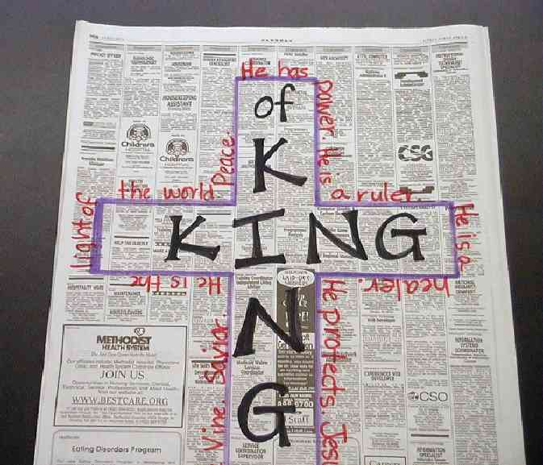
Along the outside border of the cross write words or phrases the children use to tell you about what they know of Jesus the King. Write these words in red. Prompt the children with questions like:

What are qualities or characteristics Jesus has as a King? (He has power. He is a ruler. ) Give me words that describe Jesus as a king? What kinds of things can He do?

Observation Questions: What happened?
Read to the children or have them read Matthew 7:28-8:17.

What are ways that Jesus healed the people? (Sometimes with touch, sometimes with no touch, He spoke.)

Write the children’s words or ideas in red in the top left hand corner of the newspaper.

Who did Jesus heal? (Everyone who was a subject of the king from the social outcast like the leper, to the Roman officer who was the enemy of the Jew, to Peter’s mother-in-law, one of His dear friends. Because we are all subjects of the king, Jesus makes no distinction in His care for us.)

Interpretation Questions: What does this mean?

Why did Jesus heal the people? (Because of His great love for His people.)
Write some more words in red in the top left hand corner to describe why and whom Jesus healed.
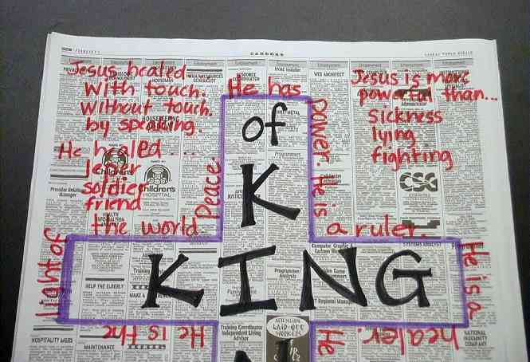

What is Jesus more powerful than? (Sickness, lying, fighting, etc.)

Write some of these words in red (the color of love) in the top right hand corner of the paper.

Application Questions: What does this mean to me?

Why are you valuable or important to the King? (Because we are His faithful subjects. He paid for us with a price. God loved us so much He sent His only Son to die for sins in our place.) Let’s write our names in the bottom left hand corner of the paper.

Jesus has the power to do whatever it takes in your life. Do you believe that? What are some of the things that you need Jesus to do for you? (Discuss.) Let’s write these things in the bottom right hand corner.

The devil has power too. Who has more power, the devil or Jesus?

And because we live under the grace of the cross, we have power and authority. Jesus says to us in Luke 10:19, “Listen! I gave you power to walk on snakes and scorpions. I gave you more power than the Enemy has. Nothing will hurt you.”

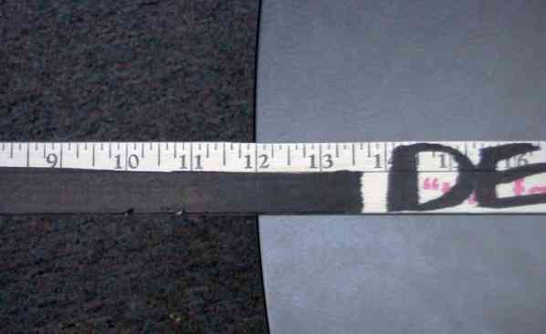
I have a special trick to show you to help you remember that because of the cross, the devil has no more power over you. We have the victory through our King. Let’s write, “devil” on this yardstick in black.

Lay the yardstick on the table with about 12 inches sticking over the end.

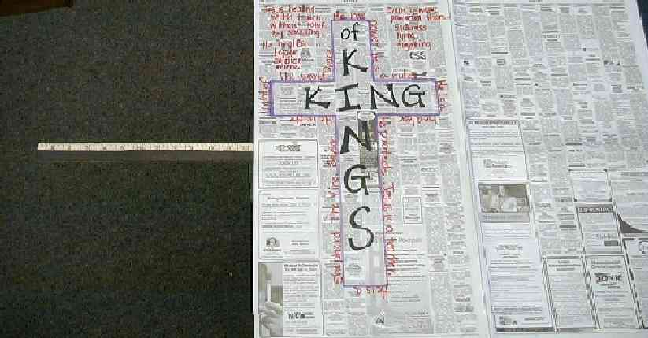
If I hit the end of this yardstick, it would flip up and could actually hurt me just like the devil would want to hurt me. But if I take the newspaper and lay it on top of the yardstick, I have covered it with the power of the King and the cross.

Open the newspaper and cover the yardstick, leaving the 12 inches that are hanging off the table uncovered. (The more area the newspaper covers, the better the trick will work.)

Now hit the stick as close to the table as possible. Instead of the yardstick flipping up, it will snap in half. The scientific reason behind this has to do with air pressure coming down on the paper.
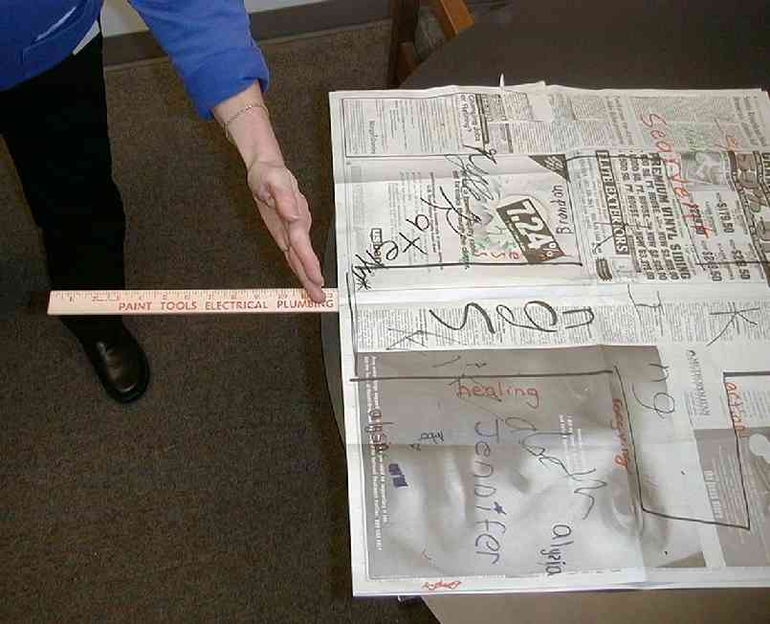

Just like this newspaper protected me from the yardstick popping up and hitting me in the face, so Jesus protects me from anything Satan could do to me. From what we have learned about Jesus today, why do you know this is true?

*Jesus has power to help you. Jesus has power over the devil and gives you authority over him, too.

Memory Verse Learning: 5 minutes
Purpose: Help kids to memorize and keep scriptures at heart. Using creative ways to help kids enjoy learning the key verse and in small group setting.

Supplies needed: one colour A4 paper per group; for each group, words of John 17:2 are cut out from the newspaper; glue

Memory Verse: John 17:2 - “You gave the Son power over all people so that the Son could give eternal life...”

MV Presentation: “A Newspaper Verse”
Tell the children that you will be reading a scripture verse to them but they have to pay close attention to the reading because they have to piece the verse together after the reading. Have the children close their eyes and listen intently while you read the scripture verse twice. Then pass out a few newspaper words to each child. Tell the children that at your indication, they have to come together and paste the whole scripture verse on the coloured A4 paper. As a shepherd, you will time them to see how fast they can do it. (Keep the paper that they had glued for next week.)
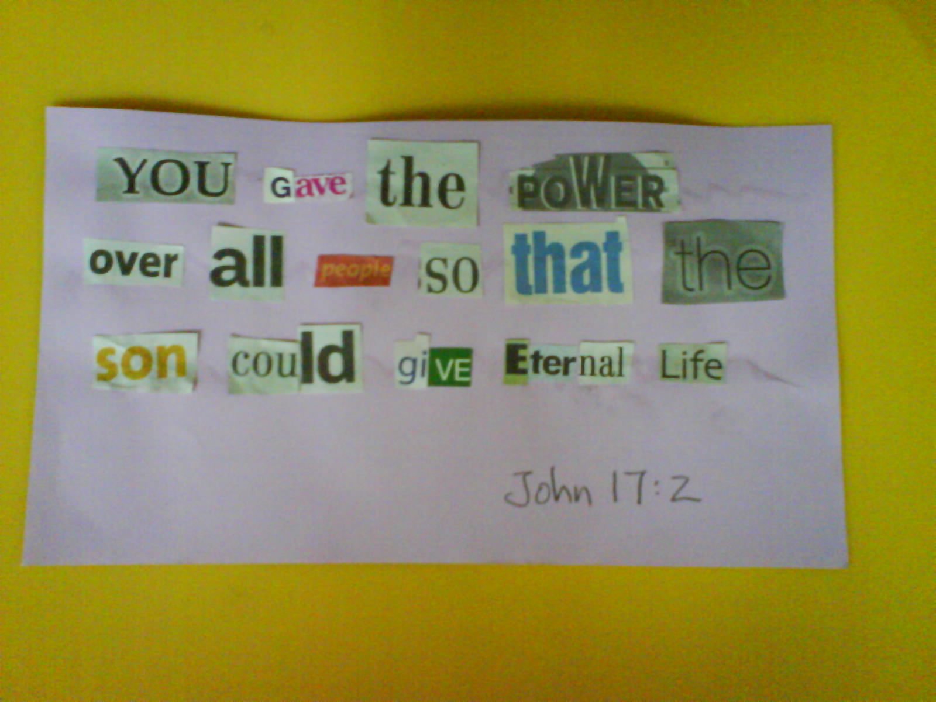

Prayer Time:
Pray that all would remember the power of
Jesus in difficult times. Pray for specific times
of difficulty that children have spoken about today.

“Dao Dao Meets the King”
Puppet Presentation

Dao Dao: One, two, three, four. I declare a thumb war! Hey, Teacher, that was fun! And guess what. My shepherd said I could be king of my group since I won.

Teacher: Well, that’s fine Dao Dao. But I’m king of this room.

Dao Dao: But you didn’t win any thumb war.

Teacher: It doesn’t matter. Pastor Lim said I could be king of this room.

Dao Dao: Yeah, but that doesn’t make you king.

(Teacher puts on crown, cape (or coat), and scepter. Note that the cape is lined with strings of sweets, which must be concealed when Teacher puts on the coat.)

Teacher: Yep, I am king of this room.

Dao Dao: No way.

Teacher: Way! I’ll tell you what. Kids, how many of you think I am king of this room? If you do, stand up.

Dao Dao: Well, I’m sitting down. I’m sorry but you just don’t look like a king. Does he, kids?

Teacher: Let me see if I can do some things to show you that I am king. I have much power. (Tapping the coat with the scepter.) I command this coat to be made of sweets.

Dao Dao: Yeah, right. And I command my baseball cap to be made of Oreos. It won’t work, Teacher.

Teacher: But I have the authority here to be king. That gives me special power. So everyone who believes that I am king and can make this coat turn to sweets, please stand up.

Dao Dao: We’re sitting down, Teacher. It looks like all the kids are sitting down. (Dao Dao can make observations about any kids still standing.)

Teacher: (Opening his coat to reveal the strings of sweets.) Well, what do you know? I was right, and you didn’t believe me.

Dao Dao: Not fair, Teacher! You didn’t change the coat into sweets! You had it hidden all along.

Teacher: You’re right, Dao Dao. But you didn’t believe me. Here’s the point…

Dao Dao: The point is do we get any of that sweets in your coat?

Teacher: You’ll get some if you can remember the lesson point.

Dao Dao: What’s that?

Teacher: I had the power as king of this room. Pastor Lim gave the power to me. That means I have authority here.

Dao Dao: Yeah. So?

Teacher: Jesus came as King. He was already God in heaven before He was born. When he lived here, He was King of an invisible kingdom. It was the kingdom of God. And He can become King of our lives. God had given Him the right to be King. God the Father gave Jesus authority to be the King and He is able to give us just what we need.

Dao Dao: Like you have the authority as king here to give us the sweets that we need.

Teacher: I’m not sure you need it but, yes, I have the authority to give it to you.

Dao Dao: What did Jesus the King give us?

Teacher: He gave us salvation. That means He took away the punishment for our sins. The Bible says in John 17:2 that God has given Jesus authority over all human race so He can give eternal life to all those God gave to Him.

Dao Dao: That might even be better than sweets.

Teacher: And to show that He had authority to give us just what we needed and to show that He was King of God’s kingdom, Jesus healed the sick and did many miracles.

Dao Dao: Like what?

Teacher: Let me show you. Watch this video. It’s the exact words out of the Bible, and it shows what Jesus did. It begins in Matthew 7:28 and ends at 8:17.

(Show the video, The Visual Bible: Matthew.)
“Dao Dao Meets the King”
Puppet Presentation Conclusion

Teacher: Dao Dao, now do you see how Jesus had authority and power to act as King? He had the authority to heal. He also had authority to forgive sins and save us. But you didn’t see that part on the video. So the point of the lesson for today is *Jesus is the King and has power to help you.

Dao Dao: I think I get it. And are you still king of this room?

Teacher: Yeah, in my own little pretend way.

Dao Dao: Then can I have one of those pretend sweets because now I believe you?

Teacher: You bet. And I’ll take these out of my coat and make sure the shepherds have some for their kids. But we’ll say a closing prayer before we leave.

Dear Heavenly Father, thank You for sending Jesus and giving Him the authority to be our King. Jesus, thank You for your saving power that You used for us. Holy Spirit, give us just what we need. We pray this all in Jesus’ name. Amen.

(As the children leave, they are given a piece of sweets.)

Lesson 39
Small Group Warm-Up:
- one paper crown for each group (to be worn)

Large Group:
- crown
- cape or coat with a string of sweets taped inside.
- piece of sweets for each child
- scepter
- video, The Visual Bible: Matthew (Visual International and Visual Entertainment, Inc., 1984) cued to Mathew 7:28-8:17

Small Group Application:
- yardstick for each group
- two pieces of newspaper with an outline of a cross drawn on it for each group
- red, purple, and black marker for each group

Memory Verse Learning:
- one colour A4 paper per group
- for each group, words of John 17:2 are cut out from the newspaper
- glue

