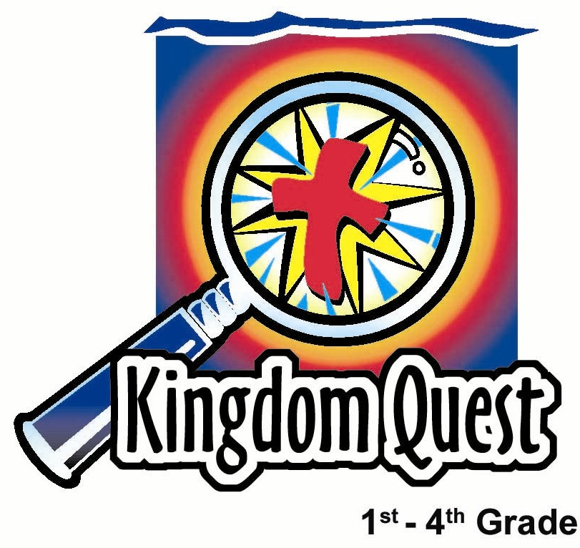
Date: _________________
Series: Jesus Is the King (Dec-Mar)
Year 1, Lesson 42

The King Calls for Everything

Take Home Point: *Salvation is only through Jesus. You can’t get to heaven on your own.
*Repeat this phrase throughout the lesson.

Bible Event: Matthew 19:16-26
Key Verse: Matthew 19:26: “It is impossible for people to save themselves, but everything is possible for God.”

We will help kids know:
- We can’t keep the commandments perfectly so we can’t earn our way to heaven.
- The only way to heaven is through faith in Jesus Christ.
- Because Jesus gave up everything for us, we want to give up everything for him.

We will help kids feel:
- Comforted that the only way to heaven is through Jesus.
- Convicted of those things that are more important than serving Jesus or others.

We will help kids do:
- Help them to see that they haven’t lived a perfect life and need Jesus to save them.
- Using the object lesson of threading a needle, show them that like it is impossible for a camel to go through the eye of a needle, it is impossible for anyone to earn heaven on their own.
- Trust in Jesus as their Savior.
- Create an offering envelope that reflects giving their best to Jesus.

THIS LESSON’S ROADMAP

DESTINATION | PAGE # | DISCOVERIES ON YOUR JOURNEY | SUPPLIES NEEDED
Small Group Warm-Up   | 3-4 | Start a special club and ask the kids if they want to join. They probably will, except when you tell them the increasingly more difficult requirements to be in your club. Today the kids will learn about a rich young man and how difficult it was for him to give up things that were important to him. | - variety of snacks for each group
Large Group   | 4  7-10  10  10-11 | Overview  Puppet Presentation with Audience Interaction: “Dao Dao and the Highway to Heaven Club”  Video: The Visual Bible: Matthew  Puppet Presentation: “Dao Dao and the Highway to Heaven Club” Conclusion | - one or two eight or ten-foot ladders  - two ropes with loops with their ends suspended from ceiling or ladders  - three-foot by four-foot cross made of two by fours  - video, The Visual Bible: Matthew (Visual International and Visual Entertainment, Inc., 1984) cued to Matthew 19:16-26
Small Group Application   | 5-6  7 | Because Jesus made the way for us to get to heaven by giving His very life, we want to give our very best back to Him. Kids will make an offering envelope to take home and put in a place they will look at every day as a reminder of Jesus’ sacrifice and what they can give Him in return.  Memory Verse Learning:  “Surprise Score”  John 17:2 is reinforced for lessons 39-42 to highlight that Jesus has the power to help us and we can share that to others. | - needle and thread for each group  - offering envelope for each child  - markers, crayons, or colored pencils  - large plain white sticker (name tag) for each child  - label for each child that reads, “You’ve given all to me. I give my best to you!”  - 10 boxes of various sizes  that is able to contain one  after another  - ten pieces of 5X5cm cards  - marker
Small Group Warm-Up: 15 minutes
Purpose: Get pointed in the right direction! Build relationships and help guests feel at ease. Do the learning readiness activity that will point your group in the right direction for the lesson.

Supplies needed: variety of snacks for each group

I am starting a special club. It is the (name of your group) Club. You have a few requirements to join. How many of you would like to be a member?

The first thing you must do is tell me something you did good today.

Have the kids share their “good” thing and praise them for wanting to join your club. Let them pick out a piece of snack from a variety you have available. Then say:

Here is a piece of snack for you because I am excited about you wanting to be part of my club. Pick your favorite kind but don’t open it yet. Another requirement to be part of my club is to share the snack with a friend. Do you still want to be part of my club?

Have the kids exchange their snack with one another.

While you are eating your snack, I want you to think about this question and share your answer with the group: what is your favorite possession in the whole wide world?

Be sure all the children who took snacks share in the discussion.

Next requirement is to tell who your worst enemy is. Who is the one person you like the least?

Again, let all the children share.

The final requirement to belong to my club is to take your most favorite thing and give it to your worst enemy. I would like you to do that today. It will no longer belong to you. How many of you think that you want to join my club?

The children will not be very excited about joining the club at this point. The following discussion will help set the lesson for the day.

Think back to the first question. It was pretty easy to join the club when all you had to do was tell about one good thing you have done. When did it start getting harder? (When you asked me to share my snack with a friend.)

Why was that harder than just telling me about something that you did that was good today? (Because I was giving away a snack I really liked and I wasn’t sure if I would like the kind that I got back.)

When did it get to be very difficult and why?

Most of us wouldn’t make good members of the (name of group) Club. It is hard to do good to everybody and we often fail. I’m glad today we will find out that we don’t get to heaven by being part of a “Be Good Club.”

Today, in large group, we will hear about a rich young man and how difficult it was for him to give up things that were important to him. This Bible event will also teach us that *salvation is only through Jesus. You can’t get you to heaven on your own.

Large Group: 20-30 minutes
Purpose: Help kids observe what the Bible says. Present the Bible Event in creative fashion. Help kids begin to interpret what it means.

Supplies needed: one or two eight or ten-foot ladders; two ropes with loops with their ends suspended from ceiling or ladders; three-foot by four-foot cross made of two by fours; video, The Visual Bible: Matthew (Visual International and Visual Entertainment, Inc., 1984) cued to Matthew 19:16-26

Overview

Puppet Presentation with Audience Interaction: “Dao Dao and the Highway to Heaven Club”
Dao Dao wants to make a club with the membership requirement to do enough good things to earn heaven. A child volunteer will be a visual representation of the audience and their ability to do enough good deeds to climb each rung of a ladder. Ultimately, Teacher proves that it is impossible to do enough good deeds to get to heaven. Instead, a child hanging onto a cross is the physical reminder of hanging onto the cross of Christ.

The loops the cross is held up by remind us of Jesus’ words about a camel passing through the eye of a needle. What is impossible for man is possible for God.

Video: The Visual Bible: Matthew (19:16-26)

Puppet Presentation: “Dao Dao and the Highway to Heaven Club” Conclusion

Small Group Application: 20-25 minutes
Purpose: Help kids map out the meaning of the Bible event in their lives. Use the questions to stimulate discussion, but don't feel tied to them. Allow the Holy Spirit to guide you. Include personal examples from your own faith journey. The example of Christ at work in your life will leave lasting impressions of how Christ can work in the children's lives.

Use your Bibles! Children need to learn how to look up references and follow along when scripture is read aloud. Allow for quality time of prayer at the close of the lesson.

Supplies needed: needle and thread for each group; offering envelope for each child; markers, crayons, or colored pencils; large plain white sticker (name tag) for each child;
label for each child that reads, “You’ve given all to me. I give my best to you!”

Observation Questions: What happened?

When the rich young man came to Jesus, what did he say he had done? (Matthew 19:16-20. He had kept all the commandments.)

What did Jesus ask him to do? (Verse 21. Get rid of everything he had of value.)

What did Jesus say about rich people? (Verse 23 and 24. It is easier for a camel to go through the eye of a needle than for a rich man to enter the kingdom of God.)

Ask for a volunteer to try and thread a needle.

If it’s hard to get a piece of thread through the eye of a needle, then how much more a whole camel?

Interpretation Questions: What does this mean?

How did the rich young man feel and why? (Verse 22. He was sad because he knew he could never give up everything he had.)

We do not want children to become judgmental about rich or poor people in asking the following questions. If children become sensitive about their economic status, remind them that God has his reasons for giving financially to some people more than others. Being rich does not necessarily mean having more money. God gives many gifts that can also include family and God given abilities. He wants us to use whatever blessings He has given us to serve Him and others. Also remind the kids that compared to many countries in Asia, we in Malaysia are quite rich. Jesus is talking about us as well.

Why do you think Jesus used the illustration of rich people?

Do you think it is harder for rich people or for poor people to get to heaven? This question could be stated another way. Is it harder for rich people or poor people to accept the free gift of Jesus? Why do you think so? (Accept any answer. Let them think. The real issue is not just how much money one has, but how much one depends on God rather than other things. The rich young ruler was depending on his own religious goodness to get him to heaven. We must see our need and helplessness before we will be ready to trust in Jesus to save us.)

Application Questions: What does this mean to me?

Do you have things that seem very important to you that you would find difficult to give up for others or Jesus? Share some things that you might struggle with giving up. Being open and honest helps kids share openly and gives them ideas to relate to.

Do you think if you could give these things up, then you could earn heaven? (No.) How did Jesus tell us we get to heaven? Since Jesus gave His life for you, what do you think you should do for Him? (Give up our lives to Him.)

Application Activity:
As a reminder that we need to give our lives up to God, we are going to make a special offering envelope.

Give to each child an offering envelope, a sticker with the words: “You have given all to me. I give my best to You.” and a mailing label. On the mailing label, have the children draw a simple picture of themselves and write their names next to or beneath it in marker. Then have them affix both stickers to the offering envelope.

Talk about the point of the lesson by saying:

Today we learned that *salvation is only through Jesus. You can’t get to heaven on your own. Because Jesus made the way for us to get to heaven by giving His very life, we want to give our very best back to Him. Romans 12:1 says, “Offer your lives as a living sacrifice to Him. Your offering must be only for God and pleasing to Him.”

Take these offering envelopes home and put them in a place that you will look at every day as a reminder of Jesus’ sacrifice and what you can give Him in return.

Memory Verse Learning: 5 minutes
Purpose: Help kids to memorize and keep scriptures at heart. Using creative ways to help kids enjoy learning the key verse and in small group setting.

Supplies needed: 10 boxes of various sizes that is able to contain one after another; ten pieces of 5X5cm cards; marker

Memory Verse: John 17:2 - “You gave the Son power over all people so that the Son could give eternal life...”

MV Presentation: “Surprise Score”
Before class, write scores for each 5X5cm cards; example 1,000 or 200. Randomly put the first score into the smallest box as you put them one after another into many layers. Review John 17:2 verbally with the children. Then divide the class into two teams and have the children sit in a circle. Explain to the children that when the music is being played, the box is passed around (something like musical chair game). When the music stops, the child that is holding the box can open it to find out a score. If he wants to receive this score for his team, he must be able to recite John 17:2 without mistakes. The game continues until all the boxes are opened and scores are revealed; or as time permit.

Prayer Time:
Have the children think about people that need Jesus in their life. Pray that the Holy Spirit would soften their hearts so they would see the need for Jesus. Also have the children think and pray about one area in their own lives that they feel conviction to turn over to the Lord.
“Dao Dao’s Highway to Heaven Club”
Puppet Presentation with Audience Interaction

Prop1: Suspended Cross

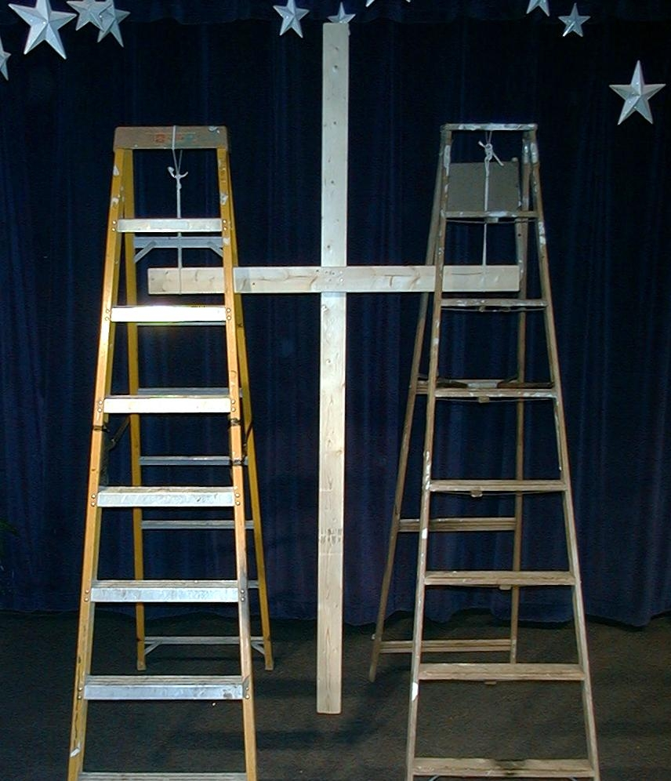
Option 1: Have two loops of rope suspended from the ceiling or from something sturdy enough to support the weight of a child. These loops should be about two feet apart and about five or six feet above ground so a cross made of two by fours with the height of four feet and width of three feet can be suspended through the loops. The bottom of the cross is off the floor. The crossbeam going between the two loops should be strong enough to hold a child who hangs on.

Option 2: If it is impossible to hang two loops from the ceiling that will support the weight of a child, use two stepladders of equal height with loops suspended from each top step.

Prop 2: Eight to Ten-Foot Ladder

Dao Dao: Hey, Teacher, that was a neat club we just made in our small group.

Teacher: Yeah, but wasn’t it pretty hard to think about giving your favorite toy to your worst enemy.

Dao Dao: Sort of. But I just imagined that you could pretend to be my worst enemy. ‘Cause I know that if I had to give you my skateboard and you used it, you’d fall and break into a thousand pieces. You’d probably give it right back, so I liked the game.

Teacher: I think you might have missed the point, Dao Dao.

Dao Dao: No, I got the point. As a matter of fact, I am ready to start a new club right now.

Teacher: What’s that?

Dao Dao: It’s the Highway to Heaven Club. Will you help me?

Teacher: Okay, Dao Dao. But I still think you don’t quite understand.

Dao Dao: I understand fine. Now, Teacher, grab that ladder over there and place it right there in the middle. (Teacher moves the ladder.) Good. Every time you take a step up that ladder you move a step closer to heaven. When you get to the top, then you’ve done enough stuff to get to heaven.

Teacher: Dao Dao, I don’t think…

Dao Dao: (Interrupts.) Teacher, your job was just to move the ladder. Just leave the club to me. Okay, which of you kids out there want to join my Highway to Heaven Club?

Teacher: Looks like about everyone. Can they all join?

Dao Dao: No. We have to see who qualifies. I’ll read a question and then, kids, if you can answer yes, then stand up in your place.

Teacher: What do you want me to do with the ladder?

Dao Dao: Well, why don’t you pick a volunteer who will represent all the people who can answer yes to the questions on the highway to heaven?

Teacher: Okay. (Picks a volunteer from the audience.) Here is my volunteer. If (name of person) climbs up four steps, then he has made it, right?

Dao Dao: Right. Here we go. Step one. All of you kids who have been here at Sunday school for the last four Sundays, stand up.

Teacher: There are lots of kids. That means our special volunteer can take one step up.

Dao Dao: Step two. Of the kids standing, how many of you have not told one single lie in the last four weeks? If you qualify, stay standing.

Teacher: It still looks like several are standing. Highway to Heaven Club, let’s have our volunteer take one more step.

Dao Dao: This is easy. Step three. Which of you in the last four weeks haven’t complained at all when your parents asked you to do your jobs like clearing the table, making your bed, or picking up your room? Look, there are some still standing!

(If you have an honest group and all are seated at this question, skip the next section. Ask the volunteer to step down from the ladder.)

Teacher: I wonder if we should ask the question again about lying? You mean to tell me that you did no complaining when asked to do your jobs? That is wonderful. Let’s have our volunteer step up one more time on the Highway to Heaven. And we have only one more step to make. But I have one last question.

Dao Dao: And then we have done enough good things to get to heaven, right?

Teacher: We’ll see. Here’s the question. How many have taken all your toys and sold them so you could give the money to poor people who need food? Okay then, everyone sit down and our volunteer needs to climb down the ladder and have a seat.

Dao Dao: It’s not fair, Teacher. That is too hard! No one can get to heaven if we do that.

Teacher: Dao Dao, you just have the wrong highway to heaven. It’s impossible to get to heaven by doing enough good stuff yourself. *Salvation is only through Jesus. You can’t get you to heaven on your own.

Dao Dao: What do you mean?

Teacher: Let me show you. See these loops here? They remind us of an eye of a needle only much bigger.

Dao Dao: Do you mean that really small opening in a needle that you try to put the thread through?

Teacher: That’s right. Jesus said it is harder for a rich man to enter the kingdom of heaven than for a camel to go through the eye of a needle.

Dao Dao: It’s impossible for a camel to go through an eye of a needle.

Teacher: Right. That’s just what the disciples said. Then they said, “Who can be saved?”

Dao Dao: I guess it won’t be the rich people.

Teacher: No, Dao Dao. It won’t be the people who try to earn heaven on their own good works.

Dao Dao: But then who can be saved?

Teacher: Jesus said, “It is impossible for people to save themselves, but everything is possible for God.” Watch this. I am going to take this cross and put it into the two loops of rope. This will remind us of what Jesus said about the eye of a needle. See how the cross is hanging here? Can I have our volunteer back?

Dao Dao: What are you going to do?

Teacher: I’m going to lift this person up to the cross and let him hang onto it for a few seconds.

Dao Dao: Why are you doing that?

Teacher: Dao Dao, this is the way Jesus made it possible for us to be saved. Jesus gave everything he had for us. Though He was very rich in heaven, He came to earth to live a perfect life in our place. He then died on the cross to take away our sins. This makes it possible for us to be forgiven and go to heaven. (Lifts child up to hang on the cross.)

Dao Dao: Wow! He is hanging on to the cross and His feet are off the ground.

Teacher: That’s how we do it. To hang onto the cross means we have faith in Jesus to save us. It’s how we get to heaven.

Dao Dao: That looks like fun, can I do it?

Teacher: We don’t have time to let everyone hang on this cross with his hands. But you can trust in the cross of Jesus and that is better yet. Why don’t you listen to today’s Bible event on video? Listen to the part about the eye of a needle and remember how God makes it possible for everyone to be saved.

(Show Matthew 19:16-26 from The Visual Bible: Matthew.)

“Dao Dao’s Highway to Heaven Club”
Puppet Presentation Conclusion

Dao Dao: Hey, Teacher. I think I want to make a new way of getting into my Highway to Heaven Club.

Teacher: What’s that?

Dao Dao: You simply hang on to the cross of Jesus.

Teacher: Great, Dao Dao!

Dao Dao: And then you give me all your money. Because I’m poor and Jesus said…

Teacher: (Interrupts.) Dao Dao! That’s enough kidding around. Let’s say our closing prayer.

Dear God. Thank You that Jesus is the only way to heaven because we can’t get there on our own. Help each one of us believe this and have faith in Jesus. Let us hang on to the cross. And if there is anything we won’t give up to follow You, help us to remember what You gave up to save us. Help us give up whatever we would hold back from You. In Jesus’ name. Amen.

Lesson 42
Small Group Warm-Up:
- variety of snacks for each group

Large Group:
- one or two eight or ten-foot ladders
- two ropes with loops with their ends suspended from ceiling or ladders
- three-foot by four-foot cross made of two by fours
- video, The Visual Bible: Matthew (Visual International and Visual Entertainment, Inc., 1984) cued to Matthew 19:16-26

Small Group Application:
- needle and thread for each group
- offering envelope for each child
- markers, crayons, or colored pencils
- large plain white sticker (name tag) for each child
- label for each child that reads, “You’ve given all to me. I give my best to you!”

Memory Verse Learning:
- 10 boxes of various sizes that is able to contain one after another
- ten pieces of 5X5cm cards
- marker

thanks to God.

