
Date: _________________
Series: Jesus Is the King (Dec-Mar)
Year 1, Lesson 46

The King’s Table

Take Home Point: *Jesus wants to live in us.
*Repeat this phrase throughout the lesson.

Bible Event: Matthew 26:26-35
Key Verse: 1 Corinthians 11:24-25: “This is my body; it is for you. Do this to remember me…This cup shows the new agreement from God to His people. This new agreement begins with the blood of my death. When you drink it, do it to remember me.”

We will help kids know:
- Jesus gives His life to live in ours through the Lord’s Supper.
- Jesus said, “Remember me when you eat this bread and drink from this cup.”

We will help kids feel:
- Totally loved by Jesus.
- Reassured of the forgiveness of their sins.

We will help kids do:
- Encouraged to go and tell others about Jesus until He comes back.
- Decorate and eat a cream cracker snack reminding them of Jesus’ life given for us.
THIS LESSON’S ROADMAP

DESTINATION | PAGE # | DISCOVERIES ON YOUR JOURNEY | SUPPLIES NEEDED
Small Group Warm-Up   | 3-4 | Can you eat an M&M with your eyes closed and know what color it is? Jesus gave the church a special food that when tasted it, it tasted like forgiveness. Forgiveness seems as hard to taste as the color of M&Ms. But this meal tasted like Jesus himself living right in people’s lives! | - M&Ms  - popcorn  - serviettes  - small whiteboard or mahjong paper and a marker (optional)
Large Group   | 4  8-9  10  10-12  12-13 | Overview  Puppet Presentation: “Reporter Dao Dao and Eyewitness News Reporting The King’s Table”  Video: The Visual Bible: Matthew  Optional Activity: “Eyewitness Special Report”  Puppet Presentation: “Reporter Dao Dao and Eyewitness News Reporting The King’s Table” Conclusion | - Dao Dao dressed as a news reporter (possibly with glasses and a tie)  - Jewish innkeeper puppet or actor  - news desk with a sign on the front that reads, “Passover Week 30 A.D.”  - banner that reads, “News Center K-I-N-G”  - video, The Visual Bible: Matthew (Visual International and Visual Entertainment, Inc., 1984) cued to Matthew 26:26-35  For optional activity:  - reporter (could be the large group presenter or an actor)  - video camera  - TV or imager  - cord to connect the video camera and imager  - microphone  - loaf of bread  - chalice or cup
Small Group Application   | 5-7  7 | Frost cream crackers and lay them in the shape of the cross. The dark icing will remind the kids of the sin Jesus took on Himself on the cross. Then sprinkle powdered sugar over the cross to remind the kids that our sins are covered white as snow with Jesus’ forgiveness.  Memory Verse Learning:  “Make Some Symbols”  2 Corinthians 5:21 is reinforced for lessons 44-47 to emphasize that Jesus traded places with us to win us eternal life. | - a cream cracker for each child  - chocolate frosting  - plastic knives  - large sheet of aluminum foil for each group  - four red M&Ms for each group (saved from small group warm-up)  - powdered sugar  - half a A4 paper; magic markers
Small Group Warm-Up: 15 minutes
Purpose: Get pointed in the right direction! Build relationships and help guests feel at ease. Do the learning readiness activity that will point your group in the right direction for the lesson.

Supplies needed: M&Ms; popcorn; serviettes; small whiteboard or mahjong paper and a marker (optional)

Today we are going to play some food games. To begin with, let’s have some popcorn. When you eat popcorn, what does it remind you of? (Going to the movies, special snack at home, etc.)

Let kids eat popcorn while you continue with discussion.

What other foods remind you of something special? What do you think of when you have mooncakes? (Lantern festival)

What special occasion does cake and ice cream remind you of? (Birthdays.) Turkey? (Christmas)

Can you think of other foods that have special significance?

Optional: Use a small white board or mahjong paper to brainstorm and write down kids’ answers.

Today we will explore how Jesus gave a special meal to His followers to remind them of Him. Does anyone know what it is? (The Lord’s Supper, Holy Communion.)

I wonder why Jesus would tell us that we should eat a special meal if He wants us to remember what He’s done for us? Any ideas? (This higher reasoning question may not have a quick answer but it challenges kids to think in a deeper way.)

Let’s play a game. I want to see how good you are at guessing what flavor something is without being able to see it. Would anyone like to have some M&Ms with your popcorn? To get some, you have to close your eyes and eat one M&M. You can’t see the color. But if you can guess the color you have eaten, I will give you three more.

Have the kids close their eyes as you pass each one an M&M to eat. (Save four red M&M’s for small group application.) As the kids participate in the contest, talk about how hard or easy it is to recognize food by its taste. Then say:

Remember how we said Jesus gave a special meal to help us remember what He did for us? Did you know He made it even more special? Jesus gave to the church a special food that when they tasted it, it tasted like forgiveness. Forgiveness seems as hard to taste as the color of M&Ms. But this meal tasted like Jesus Himself living right in people’s lives! That’s what we will discover in large group today. *Jesus wants to live in us.

Listen very carefully to the Bible event today and see if you can figure out how Jesus can live in us!

The Lord’s Supper delivers a message of Jesus wanting to live in our lives and to give us his forgiveness.

Large Group: 20-30 minutes
Purpose: Help kids observe what the Bible says. Present the Bible Event in creative fashion. Help kids begin to interpret what it means.

Supplies needed: Dao Dao dressed as a news reporter (possibly with glasses and a tie); Jewish innkeeper puppet or actor; news desk with a sign on the front that reads, “Passover Week 30 A.D.”; banner that reads, “News Center K-I-N-G”; video, The Visual Bible: Matthew (Visual International and Visual Entertainment, Inc., 1984) cued to Matthew 26:26-35; For optional activity:reporter (could be the large group presenter or an actor); video camera; TV or imager; cord to connect the video camera and imager; microphone ; loaf of bread; chalice or cup

Overview

Puppet Presentation: “Reporter Dao Dao and Eyewitness News Reporting The King’s Table”
Dao Dao interviews an innkeeper who provided the room for Jesus’ last supper. Dao Dao learns that the bread and wine from the Passover meal are now given as Jesus’ body and blood for the forgiveness of sins.

Video: The Visual Bible: Matthew (26:26-35)

Optional Activity: “Eyewitness Special Report”

Puppet Presentation: “Reporter Dao Dao and Eyewitness News Reporting The King’s Table” Conclusion

Small Group Application: 20-25 minutes
Purpose: Help kids map out the meaning of the Bible event in their lives. Use the questions to stimulate discussion, but don't feel tied to them. Allow the Holy Spirit to guide you. Include personal examples from your own faith journey. The example of Christ at work in your life will leave lasting impressions of how Christ can work in the children's lives.

Use your Bibles! Children need to learn how to look up references and follow along when scripture is read aloud. Allow for quality time of prayer at the close of the lesson.

Supplies needed: a cream cracker for each child; chocolate frosting; plastic knives; large sheet of aluminum foil for each group; four red M&Ms for each group (saved from small group warm-up); powdered sugar

Observation Questions: What happened?

What special foods did Jesus give the disciples at their last supper together? (Matthew 26:26-28. He gave them bread and wine.)

What did He say the bread and wine were? (Verses 26 and 28. His body and blood.)

Which disciple was the biggest talker when it came to claiming to be strong for Jesus? (Verses 33 and 35. Peter said he would never abandon Jesus.)

What did Jesus say Peter would do? (Matthew 26:34. Jesus said that before the rooster crowed that night, Peter would deny Jesus three times.)

Interpretation Questions: What does this mean?

Whenever people eat the bread and drink the wine, what are they celebrating? (They are celebrating that Jesus gave His body and His blood on the cross for their sins.)

When we take this special meal into our body we are reminded that *Jesus wants to live in us.

Look at 1 Corinthians 11:23-26. Jesus said to remember him. What does the Bible mean when it says, “you show others about the Lord’s death until He comes”? (The Lord’s Supper will be a constant reminder of Jesus dying on the cross and that He loves you so very much. We need to keep eating the Lord’s Supper until Jesus comes back again.)

How could have Peter “needsomma helpinlately?”

Application Questions: What does this mean to me?

What does God give us through this special meal? (Matthew 26:28, Romans 6:8-11, and 1 Peter 2:24. Forgiveness of sin, life, victory over the devil, a life freed from sin.)

Jesus asks us to remember His sacrifice for us. When is it important to remember this? (Whenever we think of our sins, we need to remember that Jesus died in our place as the consequence of sin.)

This is a very special event, kind of like your birthday or another kind of big celebration. What makes this special event different than other special events? (We receive forgiveness, and Jesus living in us through the power of the Holy Spirit.)

*Jesus wants to live in us. That is what communion or the Lord’s Supper is all about. He comes to us in a very real way. Forgiveness of sins, life, and salvation are given to us. What does this great gift encourage us to do? (See 1 Corinthians 11:26 again. We will tell about Christ’s death until He comes back.)

Application Activity:
Even though you may not yet be quite old enough to take communion, you can still remember what Jesus did for you when He died on the cross and how very much He loves you.

As a group, make a sculpture that tastes of forgiveness. Give every child one cream cracker. Let each child use a plastic knife to frost his cracker with chocolate icing. (If you have younger children in your group, you may want to frost the cream crackers for them as your group talks.)

As the crackers are being frosted, have the children tell about something they did wrong for which they got in trouble. This could be an experience from home or school. How did they feel after they had done something wrong? After they had gotten in trouble?

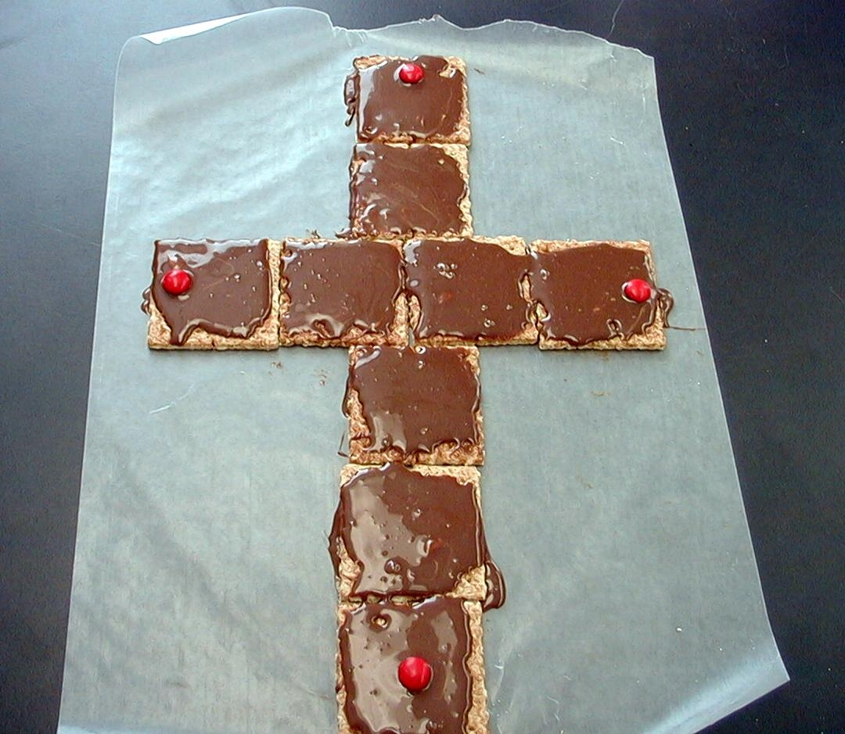
After the cream crackers have been frosted, have the children put their crackers together on aluminum foil in the shape of a cross.

Our cream crackers in the shape of a cross remind us of the cross of Jesus. The dark icing reminds us of how Jesus took our sin upon himself. Second Corinthians 5:21 says, “Christ had no sin. But God made Him become sin. God did this for us so that in Christ we could become right with God.”

Place four red M&Ms at the four corners of the cross and say:

These M&Ms remind us of Jesus shedding His blood for our forgiveness. Because of that, our sins are covered white as snow with His forgiveness.

Sprinkle white powdered sugar over the cream crackers and the picture is complete.

What does it feel like to be forgiven?

As the children eat their cream crackers, ask if they taste as sweet as forgiveness.

Though these cream crackers may be good, they certainly are not better than the spiritual food of God’s forgiveness through Jesus. Through the Lord’s Supper, God gives us the spiritual food of His forgiveness.

Memory Verse Learning: 5 minutes
Purpose: Help kids to memorize and keep scriptures at heart. Using creative ways to help kids enjoy learning the key verse and in small group setting.

Supplies needed: half a A4 paper; magic markers

Memory Verse: 2 Corinthians 5:21- “Christ had no sin. But God made Him become sin. God did this for us so that in Christ we could become right with God.”

MV Presentation: “Make Some Symbols”
Show the manila card worksheet of lesson 44 once again to the class. Since for the pass two week 2 Corinthians 5:21 have been emphasized and sealed in their hearts, tell the children that this week they are to rewrite the Bible verse in symbol form. For example, to replace “Christ” with the symbol of a cross. Give the children some time to work on their verse and then to take turn to share it with the group.

Prayer Time:
Thank Jesus for the sweet taste of forgiveness and for the gift he gave us of His life on the cross.

“Reporter Dao Dao and Eyewitness

News Reporting the King’s Table”

Puppet Presentation

Setting:
A desk is at the center of News Studio K-I-N-G. A banner is hung above the desk that reads “News Center K-I-N-G.” On the front of the desk should be a sign that reads “Passover Week 30 A.D."

Characters:

Dao Dao: dressed as a news reporter, possibly wearing a tie and glasses

Ben Helpinlately: actor or puppet as the owner of the home the Jesus celebrated the Passover dressed in period costume (If this character is played by an actor, he should be seated at the news desk.)
Teacher: large group presenter, sitting at the news desk

Dao Dao: Good morning you wonderful looking people out there in TV land. And you too, Teacher. Welcome to Eyewitness News K-I-N-G. This is news anchor Dao Dao reporting here in Jerusalem, Passover week 30 A.D. And with me today is Benjamin Helpinlately. How are you Benjamin?

Ben: You can call me Ben. I’m Ben Helpinlately.

Dao Dao: That’s what I understand. You have been helpin’ lately. Can you tell us more?

Ben: Well, it all started when my wife, Needsomma, tells me that we never have any friends over for dinner.

Dao Dao: Let me see if I have that right. Your wife, Needsomma Helpinlately, says she wants company.

Ben: Sure, I tell her. But oi vey! It’s Passover week and there’s so much to get ready for us to have that special Passover meal. So I says to her, “Okay already. Unless God tells me otherwise, we’ll have someone over after Passover.”

Dao Dao: So when’s the dinner planned? After Passover?

Ben: Oi vey! That’s the strange thing. God did tell me to have someone over for the Passover meal. You see, this Rabbi Jesus, sent some of His disciples to me to say He’s coming to a Passover meal at my house.

Dao Dao: Wow! I bet Needsomma was excited.

Ben: Yes and no. Yes, she was excited that her house—I mean our house—would be used for Jesus and His 12 disciples’ Passover meal. But it was their special time together so they wanted to be alone. And my! my wife, Needsomma Helpinlatey, really did need some helpin’ lately getting used to not having Passover with the famous Jesus. So, we gave them an upper room where they could celebrate Passover just by themselves.

Dao Dao: What do you think is going to be so special about Jesus celebrating the Passover meal with His disciples?

Ben: Well, they will be remembering how God was with our people and brought them out of the land of slavery.

Teacher: Land of slavery?

Ben: O Ya! I am talking about the land of slavery, Egypt! Passover is about remembering how God was with us and freed our people. But now listen to Rabbi Jesus talk about how He wants to be part of our lives and free us from our own land of slavery.

Teacher: Egypt?

Ben: No No! He was talking about slavery to sin. We don’t live in Egypt anymore.

Dao Dao: Say some more, Teacher. This is getting good.

Teacher: You say something.

Dao Dao: So, Mr. Helpinlately, is this freedom-from-sin thing what he is talking about in the Passover meal?

Ben: Well, when I left there was some talk about Him giving Himself as a new kind of Passover, His body and His blood. But, my my, I didn’t understand what He was talking about. I figure I’ll get Needsoma Helpinlately and she can explain it to me.

Dao Dao: And folks there you have it. Something special happening at Passover meal as Jesus wants to be part of His disciples’ lives by making a new Passover. Let’s go to live coverage on the scene. This is Dao Dao and Ben Helpinlately and Teacher—reporting for K-I-N-G Eyewitness News.

(Show Matthew 26:26-35 from the video, The Visual Bible: Matthew.)

“Eyewitness Special Report”

Optional Activity

The following is an optional activity that might supplement the puppet presentation or even replace it. It can be abbreviated easily since you can determine the number of questions asked to the audience. A K-I-N-G reporter (the large group presenter or an actor) goes into the audience with another person shooting video of the interviews. If a video camera is hooked up to a television with a cable, the kids interviewed will be “live” on the newscast.

Following the Matthew 26:26-35 video, the screen flashes "Special Report" and then goes to K-I-N-G reporter.

Hello, I'm ________, K-I-N-G's Eyewitness Reporter. I'm still in Jerusalem, hot on the trail of Jesus. Today is the feast of Passover and I'm standing outside this ordinary-looking building. From what I understand, something extraordinary has just taken place inside. Let me see if I can talk to some of the "eyewitnesses" and find out exactly what just took place.

The reporter then goes into the "crowd" and begins to ask questions. Some sample questions may be as follows. Asking all the questions may take too much time. The reporter will have to judge that.


Why is everybody standing around here? Who is inside there that everyone wants to see? (Jesus and his disciples.)

What are Jesus and the disciples doing in there? (Celebrating the Passover feast with a meal.)

You know I'm looking for furniture for my dining room. What were the table and chairs in there like? (Low table, Jesus and disciples sat on the floor.)

I heard that Jesus did something amazing with the bread they were serving. What did Jesus do? (He gave thanks, broke bread, and said, "Take and eat; this is My body.")
What do you think Jesus meant by that? (The bread is His body and would be broken on the cross for our sins.)
Wait! I just heard someone say something about the cup. Can you tell me what Jesus did with the cup? (He gave thanks and gave to them saying, "This is My blood which is poured for the forgiveness of sins.”)

Does anyone know what Jesus meant by that? (By dying on the cross and shedding His blood, we would have forgiveness for our sins.)

Were you close enough to hear Jesus talking to His disciples? What did He tell them? (Jesus said they would leave Him that very night.)

Why would the disciples leave Jesus? They loved Him and were always with Him. What did the disciples say to Jesus? (They said they would never leave Him.)

Wait a minute. What about Peter? What did Jesus say to Peter? (Jesus told Peter that he would deny Him three times before the rooster crowed.)

I bet that kind of hurt Peter’s feelings. What did Peter say? (“Even if I have to die with you, I will never disown you.”)

Wow, Peter must love Jesus very much. Thanks to the help of these great "eyewitnesses," I think we have a good idea of what happened inside this building today.

Use a loaf of bread and a cup to show what Jesus did as He broke the bread and help up the cup.

Jesus and his disciples celebrated the feast of Passover together upstairs. While they were eating, Jesus did something incredible. He took the bread, gave thanks, and then broke it. He told the disciples it was His body that was going to be broken on the cross.

Then He took the cup, He gave thanks, and then gave it to His disciples. He told them it was His blood that was going to be shed for the forgiveness of their sins.

Amazing! Jesus not only shared the Passover meal with His disciples, He shared Himself and the plan for salvation. It was at the table that Jesus told the disciples He was going to die for our sins and we would have everlasting life through His death. You know, I've been to a lot of fancy dinner parties but none were ever as awesome as the King's table.

That's all for now. I'm going to find Jesus—no matter what it takes. Stay tuned as we continue to follow this amazing story. This is ________, K-I-N-G's Eyewitness Reporter.

“Reporter Dao Dao and Eyewitness

News Reporting the King’s Table”

Puppet Presentation Conclusion

Dao Dao: Reporter Dao Dao back from live coverage. We’ve seen something special.

Teacher: We sure have. Jesus has just given His disciples a new meal to celebrate. It will be for all believers who need some “helpin’ lately.”

Ben: Hey, are you talking about my wife, Needsomma?

Teacher: No, we’re talking about all people who need some help. That’s all of us.

Dao Dao: What kind of help does Jesus give us?

Teacher: Jesus wants to live in us. This meal shows us that. He says that when we eat this meal, we remember that His body and blood we’re given for us on the cross. We then remember that Jesus lives inside us!

Dao Dao: That means Jesus is living right here in my life?

Teacher: It sure does. And what better helpin’ could we have lately?!

Dao Dao: This is Reporter Dao Dao signing off and happy to have been helpin’ lately!

Ben: Hey, that’s my name.

Teacher: But it’s time to sign off anyway. Say good-bye, Ben.

Ben: Bye!

Dao Dao: And good-bye from K-I-N-G Eyewitness News Reporting.

Teacher: Let’s pray. Dear Lord, thank You that we can be served at the King’s table. What an honor! Thank You that You invite us to be part of that meal because You want to be real in our lives. You gave Your body and blood on the cross for each one of us because You love us so much. Thank You that we can be certain in our hearts that You died especially for each one of us. Thank You for working faith in our hearts as we pray.

Lesson 46
Small Group Warm-Up:
- M&Ms
- popcorn
- serviettes
- small whiteboard or mahjong paper and a marker (optional)

Large Group:
- Dao Dao dressed as a news reporter (possibly with glasses and a tie)
- Jewish innkeeper puppet or actor
- news desk with a sign on the front that reads, “Passover Week 30 A.D.”
- banner that reads, “News Center K-I-N-G”
- video, The Visual Bible: Matthew (Visual International and Visual Entertainment, Inc., 1984) cued to Matthew 26:26-35
For optional activity:
- reporter (could be the large group presenter or an actor)
- video camera
- TV or imager
- cord to connect the video camera and imager
- microphone
- loaf of bread
- chalice or cup

Small Group Application:
- a cream cracker for each child
- chocolate frosting
- plastic knives
- large sheet of aluminum foil for each group
- four red M&Ms for each group (saved from small group warm-up)
- powdered sugar

Memory Verse Learning:
- half a A4 paper; magic markers

thanks to God.

