
Date: ____________________
Series: Pass The Promise (Jun-Aug)
Year 1, Lesson 9

Noah Obeys God

Take Home Point: *Go against the flow—stand for God.
*Repeat this phrase throughout the lesson.

Bible Event: Genesis 6:9-22

Key Verse: 2 Peter 2:5b: “…Noah was a man who preached about being right with God.” (NCV)

We will help kids know:
- It is important to stand up against negative peer pressure and to stand for God.
- God passed the promise of protection to Noah. Through Noah, the Savior was born.
- God keeps His promises to us.

We will help kids feel:
- Confident that God will protect them as they stand for Him.
- Conviction that it is worth resisting the pressures of this world for the sake of standing for God.

We will help kids do:
- Trust in God’s promises.
- Identify forces in their world that attempt to push them away from God.
- Give thanks to God for how He has passed the promise of Jesus so they might stand firm.
THIS LESSON’S ROADMAP

DESTINATION | PAGE # | DISCOVERIES ON YOUR JOURNEY | SUPPLIES NEEDED
Small Group Warm-Up   | 3-4 | As Christians, we can’t always go along with a group and do as they do if it is something that is wrong in God’s sight. Children will play the game “Simon Says” and get squirted with water if they don’t do the correct action. | - squirt gun for each shepherd
Large Group   | 4  7-9  10-12 | Overview  Puppet Presentation:  “Dao Dao Goes With the Flow”  Bible Event:  “An Interview With Noah” | - Dao Dao  - a football with a cross drawn on it with masking tape  - Noah puppet or an actor dressed like Noah
Small Group Application   | 4-6  6 | Sometimes Satan uses people in this world to try to push you away from God. He also uses television, music, and movies. Play a game by trying to push a child off the cross taped on the floor.  Memory Verse Learning: “Fill in the Blank”  Genesis 4:7b is emphasized again to highlight that Jesus gives us power to master over sin | - masking tape for each group  - 8 ½- x 11-inch piece of paper for each group  - paper cross about the size of a shoe  - poster board with Bible verse prepared  - word strip answers  Noah puppet

Small Group Warm-Up: 15 minutes
Purpose: Get pointed in the right direction! Build relationships and help guests feel at ease. Do the learning readiness activity that will point your group in the right direction for the lesson.

Supplies needed: squirt gun for each shepherd

You will need a squirt gun and a bit of silliness to help the warm-up activity be successful.

Invite the children to play a game of “Simon Says.” One child will be Simon and give commands to the others. If the leader saying "Simon says" precedes the command, everyone is to do the command. If the leader does not say “Simon says” with the command, any child who does the command has made a mistake. Usually the player who has made a mistake steps out of the game. In this case, however, the player will be squirted with the squirt gun. (Shoot at the child’s shoes or peripheral clothing so the child’s feelings are not hurt.)

This game can be lots of fun. The point of the game is that if you don’t go along with the crowd, you may experience some repercussion.

After playing the game for ten minutes and others have gotten a chance to be the leader, gather the children together.

In this game, everyone was going along with the leader. When the leader said, “Simon says,” everyone did what Simon said. If you didn’t, you got the squirt gun treatment. If the leader didn’t say “Simon says,” then you were not to do the action. But if you did, you got the squirt gun treatment.

Have you ever been part of a group where the leader or several people wanted to do something that was wrong? If you didn’t do what they did, you might have gotten the “squirt gun treatment” or been treated badly. Maybe they made fun of you or didn’t talk to you because you didn’t do what they did. Does anyone here have a story to share about a time when something like this happened?

Listen to the children’s stories.

How was your story like being squirted with the squirt gun? How did what happened to you in your story feel similar to getting squirted by the squirt gun?

Today when we go to large group we will meet a man who went against the flow. That means everyone was doing what was wrong in God’s sight. However, this man said he would obey God. Because of that, God rescued him.

In the Bible event we’re going to hear about a lot of water. Maybe you can guess what the Bible event is about. Right! Our story today is about Noah. Today we will learn how to *go against the flow and take a stand for God.

Large Group: 20-30 minutes
Purpose: Help kids observe what the Bible says. Present the Bible Event in creative fashion. Help kids begin to interpret what it means.

Supplies needed: Dao Dao; a football with a cross drawn on it with masking tape; Noah puppet or an actor dressed like Noah

Overview

Puppet Presentation: “Gordy Goes With the Flow”
Gordy tries to prove he doesn’t follow the crowd. Instead, he is actually the instigator.

Bible Event: “An Interview With Noah”

Bible event from Genesis 6-9.

Small Group Application: 20-25 minutes
Purpose: Help kids map out the meaning of the Bible event in their lives. Use the questions to stimulate discussion but don't feel tied to them. Allow the Holy Spirit to guide you. Include personal examples from your own faith journey. The example of Christ at work in your life will leave lasting impressions of how Christ can work in the children's lives.

Use your Bibles! Children need to learn how to look up references and follow along when scripture is read aloud. Allow for quality time of prayer at the close of the lesson.

Read Genesis 6:9-22:

Observation Questions: What happened?

Why did God want to destroy all people on earth? (Verses 11-12. The world was corrupt because the people lived evil lives.)

Why did God spare Noah and his family? (Verse 9. Noah had God’s approval and was a man of integrity among the people of his time. He walked with God.)

What did God tell Noah? (Verses 13-21. God told Noah to build a ship and fill it with two of every kind of animal. Verse 18. God said, “But I will make my promise to you.”)

Interpretation Questions: What does this mean?

What do you think some of the people might have said to Noah when they saw him building the ark?

What do you think the people might have said to tease him or make fun of him for following God?

After God had destroyed the earth and Noah and his family were saved, God made a promise to him and all people after that. Read this promise in Genesis 9:12-17. What did God promise?

Application Questions: What does this mean to me?

Supplies needed: masking tape for each group; 8 ½- x 11-inch piece of paper for each group ; paper cross about the size of a shoe

Read Luke 3:36 to see Noah’s name in the New Testament. What is special about this? (God passed his promise to send Jesus into the world. Jesus was born a descendent of Noah. Note how this is God’s way of passing the promise of a Savior to the world through Noah.)

As a visual illustration of the learning point, do the following. Tape a cross about the size of a shoe on the floor. Approximately two feet behind the cross, tape to the floor a piece of 8 ½- x 11-inch paper.
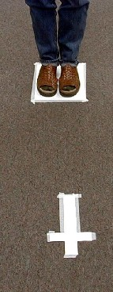
Have a child stand with both feet together on top of the paper facing the cross. Using one finger, gently push the child from the front, and try to make him step off the paper. (Most shepherds should be able to easily do this.)

After doing this activity with a couple children, gather the group for discussion.

Sometimes Satan uses people in this world to try to push you away from God. What are some wrong things Satan might tell you in messages on television? What about in movies? What about in music? Are there any heroes that aren’t good examples? Have you ever had a friend tempt you or try to push you away from God without realizing it?

After discussing these questions, return to the paper and cross and show the children the secret to winning every time. Instead of keeping both feet together on the paper, one foot should step forward and be placed on the cross. Have a child demonstrate and again attempt to push him. It won’t be so easy this time.
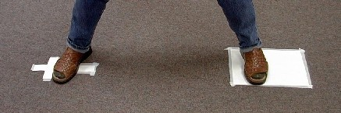

PUSH

Putting our foot on the cross like this reminds us of the spiritual truth that we can stand on Jesus’ power as we trust in Him. Ephesians 6:12 tells us we are fighting with spiritual powers of darkness, but we will be able to take a stand during those evil days through the power we receive from the Lord.

Is this the same power Noah received? How do you receive this power? (Prayer, reading God’s word, doing what God says.)

Memory Verse Learning: 5 minutes
Purpose: Help kids to memorize and keep scriptures at heart. Using creative ways to help kids enjoy learning the key verse and in small group setting.

Supplies needed: poster board with Bible verse prepared; word strip answers

Memory Verse: Genesis 4:7b - “Sin is ready to attack you. Sin wants you. But you must rule over it.”
Genesis ___: ___b
______ is ready
to ___________
you. _______ wants
you. But you must ________
over it.

MV Presentation: “Fill in the Blanks”
Paste memory verse poster board onto wall. At its side,
randomly turn over and paste the word strip answers so
that the children can pick one and place it on the correct
“blank.” Let this be a challenge between girls and boys
with a score of 100 for the right answer. But there is a
catch, there are two extra word strip that says “FLOOD.”
If that is picked, the team looses all their score. When
verse is completed, memorize with the children.

Prayer Time:
Pray for special protection and the ability to
*go against the flow and take a stand for God.
Large Group Presentation

“Dao Dao Goes With the Flow”

Puppet Presentation

Take Home Point: *Go against the flow—stand for God.

Teacher: Kids, it seems as if some kind of Gordy fan club has been started here, is that right? Well, let’s just hope Dao Dao doesn’t get too big of a head about that. For now, let’s give him a call. (Starts as a whisper.) Dao Dao… Dao Dao… Dao Dao…

(Children chant, “Dao Dao! Dao Dao! Dao Dao!)

Dao Dao: Thank you. Thank you very much. Ah, the power of fame! I think we kids are taking over, Teacher.

I’ve been on vacation. It was a lot of fun. But since when have you guys started playing with squirt guns at Sunday school?

Teacher: Since we’ve been talking about going with the flow.

Dao Dao: Well, I want to play with the squirt guns. How do I get to do that?

Teacher: We are learning something using the squirt guns, Dao Dao. Only those who were going against the flow got squirted. “Going against the flow,” means those in the game who were not doing what everyone else was.

Dao Dao: What does that teach?

Teacher: Sometimes people want us to go along with what is wrong. If we don’t go along with them, we might get laughed at or made fun of, just like getting squirted with a squirt gun.

Dao Dao: Oh, I would never do something just because everyone else does. For example, watch this. Kids, I want all of you to point to Teacher and laugh. Go ahead.

(The children point and laugh at Teacher.)

Dao Dao: See, Teacher? I didn’t point and laugh. Can I have the squirt gun now?

Teacher: I don’t think you understand, Dao Dao.

Dao Dao: Okay. Let me try again. Turn around, Teacher. Okay. (Whispering.) Kids, stick your tongue out at Teacher just for a second.

(Teacher turns around and looks behind himself as the kids stick their tongues out at him.)

Dao Dao: See, Teacher? I didn’t stick out my tongue.

Teacher: Yes, Dao Dao, but you are the one who asked them to. I’m not sure if you’re going against the flow or if you are starting the flow.

Dao Dao: Wait a minute, Teacher. Kids, put your hands over your ears and whistle so you don’t have to listen to Teacher.

Teacher: Dao Dao, that’s enough.

Dao Dao: (With hands over his ears.) What did you say? I can’t hear you.

Teacher: (Removes Dao Dao’s hands from his ears.) Okay, kids, that’s enough of just going along with the flow and doing something that you really shouldn’t be doing just because everyone else is.

Dao Dao: Oh, Teacher, we were just clowning around.

Teacher: I know you were, Dao Dao. But can you also see how easy it is for everyone to go along with the flow, even if some of the things you are doing are…well, not very nice?

I want to tell you about some people in Noah’s day who were disobeying God in a very serious way. They were going with the flow and doing things that were not very nice toward God.

Dao Dao: You mean, like laughing and pointing at him?

Teacher: They were laughing at Noah who warned them about their wicked ways.

Dao Dao: You mean they were sticking their tongues out at God?

Teacher: In a way.

Dao Dao: They had their hands over their ears and wouldn’t listen?

Teacher: That’s true. Noah was trying to tell them their world would be destroyed because they were just going along with the flow and weren’t following God,

Dao Dao: Did Noah go along with the flow, too?

Teacher: No, he didn’t. Noah went against the flow and took a stand for God. But I’ll let Noah tell his story because he is our special guest today. Dao Dao, why don’t you step back for a while and I’ll introduce our special guest.

Dao Dao: Okay, Teacher. Just as long as I don’t have to go along with the flow. See ya! Bye, kids!

Teacher: Bye, Dao Dao. Now, introducing Noah…come on up. Let’s welcome Mr. Noah to Sunday school.

“An Interview With Noah”
Bible Event

From week to week a football with a cross, made from masking tape, will be the visual reminder that God is passing the promise throughout the Old Testament. The promise is ultimately fulfilled in Jesus. The “Pass the Promise Football is needed for this drama sketch.

The Bible event is written for a puppet. However, if that is not possible in your setting, an actor dressed as Noah can be used.

(Noah enters.)

Teacher: Noah, we are very happy to have you with us. Your story is recorded here in Genesis 6:9-22.

Noah: Yes, that’s me all right!

Teacher: Noah, you look rather old. Tell me, how old are you?

Noah: I’m 600 years old.

Teacher: Wow! You don’t look a day over 500. You have had quite an adventure.

Noah: Yes, I just got off the boat.

Teacher: You must be quite an experienced sailor to be chosen by God to ride out this flood.

Noah: Nope. I wasn’t a sailor at all. I lived in a desert.

Teacher: You must be an expert boat builder then.

Noah: No.

Teacher: An experienced zookeeper?

Noah: No.

Teacher: If you weren’t an experienced sailor, an expert boat builder, or an experienced zookeeper, how did you manage?

Noah: God provided. He gave me everything I needed.

Teacher: Tell us your story. Why did God choose you?

Noah: The whole earth was evil. All day long people’s thoughts were nothing but evil. They didn’t listen to God. They didn’t do what God said. They didn’t care about Him at all.

Teacher: What about you, Noah? Did you “go along with the flow” and join in with them?

Noah: Oh no. I warned them God would destroy the world but He would save anyone who trusted in Him.

Teacher: What did the people say when you told them that?

Noah: They laughed.

Teacher: But this is no joking matter.

Noah: Still, they laughed when they saw me building the boat. I told them it would soon rain and there would be a big flood.

Teacher: How long did it take for that to happen?

Noah: Years.

Teacher: Where were you building the boat?

Noah: In the desert.

Teacher: And what did you put in the boat?

Noah: Different animals.

Teacher: How did the animals get there?

Noah: God said He would send them.

Teacher: How long did all of this take?

Noah: Years and years.

Teacher: What did the people say to you about all of this?

Noah: They said I was stupid. But I think God was giving them a chance to repent.

Teacher: Did the people repent?

Noah: They didn’t. So just my wife, my three boys (Shem, Ham, and Japheth), and their wives got on the boat with the animals and me and off we went.

Teacher: How long was your voyage?

Noah: One hundred fifty days!

Teacher: Wow! That’s almost as long as a whole school year.

Noah: One hundred fifty days because it rained forty days and forty nights.

Teacher: That must have been a long time to be cooped up in a boat.

Noah: It was a long time to be cooped up with those animals! We were actually in the ark for 1 year and 17 days. Man, we were ready for some fresh air! Finally, it was over and I came out of the ship with my wife and kids, and we let the animals go. We were so thankful because God had spared all the animals and us.

Teacher: What did you do?

Noah: We made a sacrifice to God and he painted a rainbow in the sky. He passed a promise to us. Wait a minute. Where’s my football. God passed a promise that he would never destroy the world with water again. He passed a promise to my family and me that someday through our descendents a Savior would come into the world. Now I understand that Savior, Jesus, washes away our sins.

Teacher: He sure does, Noah. Thank you for going against the flow and taking a stand for God. Thanks for building an ark even when people laughed at you. Let’s close with prayer.

Dear God, thank You for Noah who went against the flow and took a stand for God. Help us to also go against the flow and take a stand for God. Thank You that you passed the promise along that You would never again destroy the world with water. Thank You that You passed Your promise along that through Noah’s descendants, Jesus was born. Jesus, be our Savior and be with us always. In Jesus’ name we pray. Amen.
Supplies:

Quantity ()
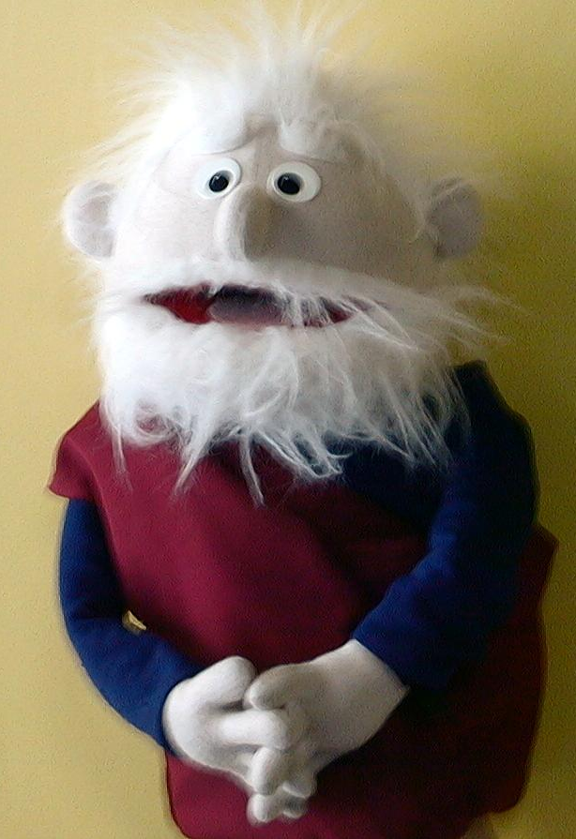
Small Group Warm-Up:
- squirt gun for each shepherd

Large Group:
- Dao Dao
- football with a cross drawn on it with masking tape
- Noah puppet or an actor dressed like Noah

Small Group Application:
- masking tape for each group
Noah Puppet
- 8 ½ x 11-inch piece of paper for each group
- paper cross about the size of a shoe

Memory Verse Learning:
- poster board with Bible verse prepared
- word strip answers
Genesis ___: ___b
______ is ready
to ___________
you. _______ wants
you. But you must ________
over it.

4
7
Sin
attack
Sin
rule
FLOOD
FLOOD

