
Date: ____________________
Series: Pass The Promise (Jun-Aug)
Year 1, Lesson 10

Tower of Babel

Take Home Point: *God opposes the arrogant but favors the humble.
*Repeat this phrase throughout the lesson.

Bible Event: Genesis 11:1-9

Key Verse: 1 Peter 5:5b: “God is against the proud, but He gives grace to the humble.” (NCV)

We will help kids know:
- God opposes the arrogant but favors the humble.
- The Bible event of the Tower of Babel. God confused language and scattered people at Babel, and God brought many languages together at Pentecost.

We will help kids feel:
- Challenged with the feelings of arrogance or envy in a simulation game.
- Humbled because God’s love and power are so wonderful.

We will help kids do:
- Build card towers and discuss attitudes of arrogance or envy.
- Think of ways they could put others first.

THIS LESSON’S ROADMAP

DESTINATION | PAGE # | DISCOVERIES ON YOUR JOURNEY | SUPPLIES NEEDED
Small Group Warm-Up   | 3-4 | The children will learn about being too proud through a game of building towers with cards and the story of the tower of Babel. | - 2 deck of cards for each group.  - 2 scissors for every two children  - local snacks for each group
Large Group   | 5  9-10  11  12 | Overview  Puppet Presentation:  “Dao Dao’s Tower of Cards”  Interactive Drama:  “Lee and Cheong, the Babbling builders”  Puppet Presentation:  “Dao Dao’s Tower of Cards” Conclusion | - Dao Dao  - a football with a cross drawn on it with masking tape  - a seemingly indestructible tower of cards  - table  - two actors dressed in period costume. One should know some words from another language. The other needs to be able to speak dialect or another foreign language. Both need to be able to improvised and interact with each other and the audience.
Small Group Application   | 5-7  8 | Make a thanksgiving chain to remember your spiritual, people, and material blessings.  Memory Verse Learning: “Putting in Symbol and Words”  Genesis 4:7b is learnt to emphasize that Jesus gives us power to master over sin. | - deck of cards  - rules for game printed on 81/2- x 11-inch paper for each group (see p. 13)  - poster board with Bible verse prepared
Small Group Warm-Up: 15 minutes
Purpose: Get pointed in the right direction! Build relationships and help guests feel at ease. Do the learning readiness activity that will point your group in the right direction for the lesson.

Supplies needed: 2 deck of cards for each group; 2 scissors for every two children; local snacks for each group

This activity is a contest to see which pair of children can build the tallest card tower. Group the children into pairs and evenly pass out a deck of cards. (If more decks of cards are available, pass them out also.) You will instruct the children how to cut the cards so they might more easily make a tower. Explain the rules of the game to the children.

We are going to have a contest to see which team can build the tallest card tower. Here is a trick to building tall card towers. You can take a card and cut two slits in it on one or more of the sides. Then when you put another card with slits into it, it helps the cards stand up straight.

Demonstrate how this is done.

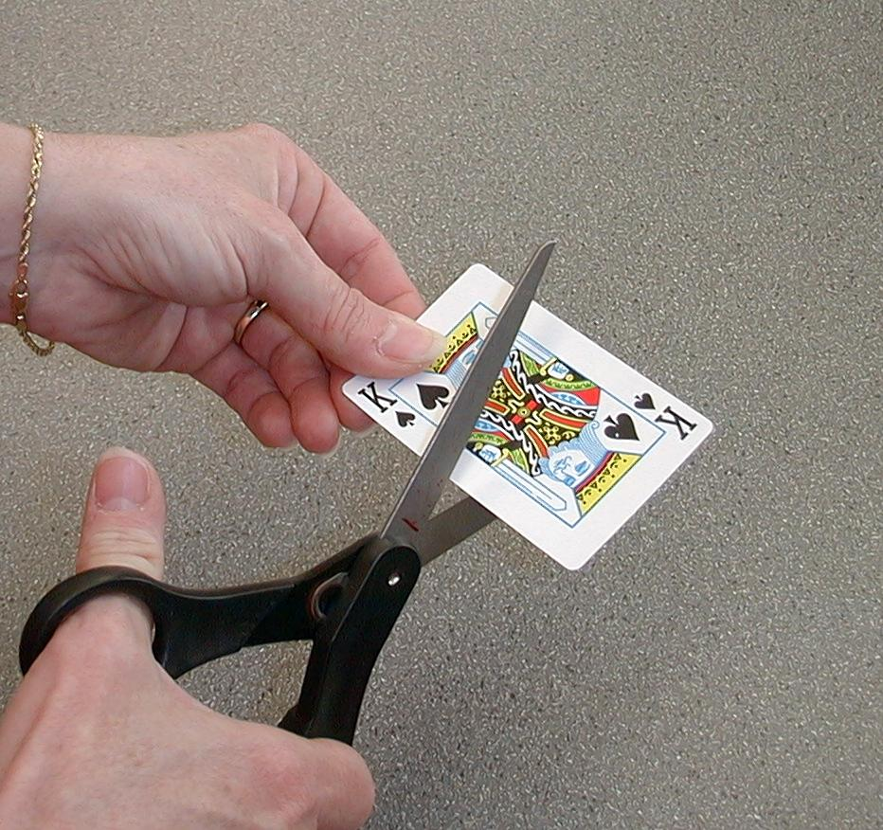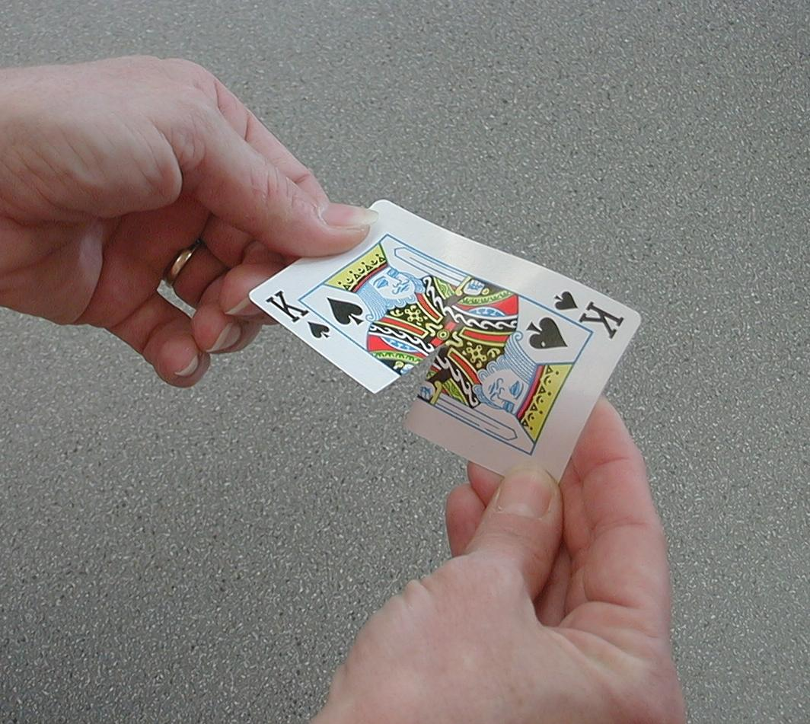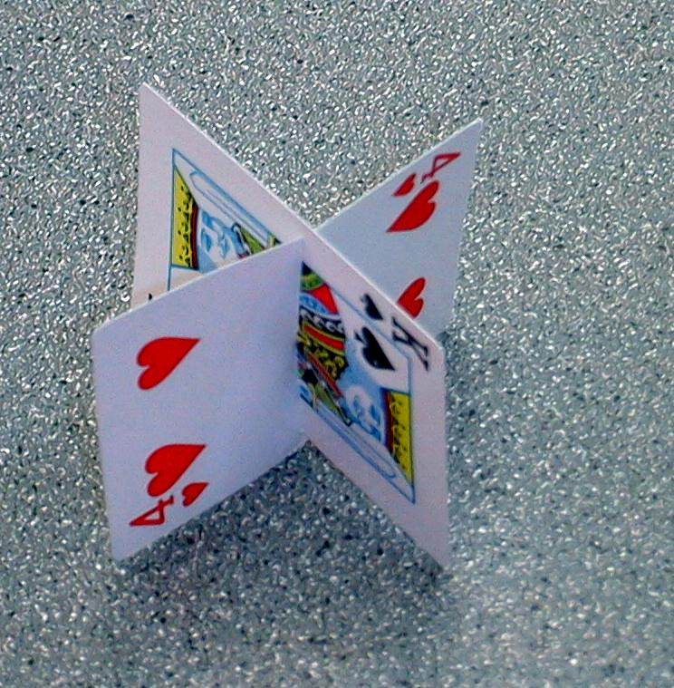

Once we begin the game, you can cut any type of slits in the cards you want. Or you don’t have to cut any slits at all. At the end of five minutes, your time will be up and we will see who has the tallest card tower.

At the end of five minutes, have the children stop building and note the tallest tower.

Here are our winners. Look how much taller and better their tower is than anyone else’s. I bet you feel very proud.

I didn’t tell you before but since you won that means you are the best. I have a snack for you, but this is what you must do to get it. Repeat after me. “As you can see…I’m the best…so I don’t care…about the rest.”

Now you can knock down the other towers.

Expect a bit of protesting from the others at this point, but allow the winning team to knock over the other towers. Give the winners a snack. Then regroup the children and talk about how they felt during this activity.

Winners, how did you feel when you won the snack? (Proud, happy.) How did you feel when you repeated the proud words I told you? (Awkward. It was mean to say. Extra proud because I was the best.) How did you feel when you got to knock over the other towers? (Confused because I know it’s not nice. Happy. Tough.)

How did the rest of you feel when you watched the winner get snacks and you didn’t? (Disappointed, envious.) How did you feel when the winner knocked over your card tower? (Angry. It wasn’t fair.)

I need everyone to understand that I was the one who asked the winner to knock over the tower. And it’s not a nice thing to do. I was the one who told you to repeat those proud words. It is also not a nice thing to be so interested in winning that you don’t care about anyone else.

What we were playing was a game that helped us experience some of those feelings. It helps us understand what happens when we are too proud. Being too proud means that we might be arrogant.

An arrogant person thinks, “I’m the best so I don’t care about the rest!” Let’s repeat that. “I’m the best so I don’t care about the rest!”

Is that the attitude God wants us to have? Of course not! Today we are going to discover that *God opposes the arrogant but favors the humble. Let’s repeat that.

In the Bible, there were some people who tried to build a tower. They thought they could be more important than God. They were arrogant, and God did something to them that made them stop building the tower. Listen carefully in today’s large group so you can discover what God did.

Large Group: 20-30 minutes
Purpose: Help kids observe what the Bible says. Present the Bible Event in creative fashion. Help kids begin to interpret what it means.

Supplies needed: Dao Dao; a football with a cross drawn on it with masking tape; a seemingly indestructible tower of cards; table; two actors dressed in period costume. One should know some words from another language. The other needs to be able to speak Pig Latin or another foreign language. Both need to be able to improvised and interact with each other and the audience.

Overview

Puppet Presentation: “Dao Dao’s Tower of Cards”
Dao Dao is very arrogant about his ability to build card towers.

Interactive Drama: “Moe and Joe, the Babbling Builders”

The Bible event from Genesis 11:1-9 is dramatized with the help of construction workers Moe and Joe.

Puppet Presentation: “Dao Dao’s Tower of Cards” Conclusion

Dao Dao is humbled after hearing the Bible event.

Small Group Application: 20-25 minutes
Purpose: Help kids map out the meaning of the Bible event in their lives. Use the questions to stimulate discussion but don't feel tied to them. Allow the Holy Spirit to guide you. Include personal examples from your own faith journey. The example of Christ at work in your life will leave lasting impressions of how Christ can work in the children's lives.

Use your Bibles! Children need to learn how to look up references and follow along when scripture is read aloud. Allow for quality time of prayer at the close of the lesson.

Supplies needed: deck of cards; rules for game printed on 81/2- x 11-inch paper for each group (see p. 13)

Observation Questions: What happened?
Read 1 Peter 5:6b.

“Furthermore, all of you must serve each other with humility, because God opposes the arrogant but favors the humble.”

Who does God oppose? Who does God favor?

Read Genesis 11:1-9.

Why did the people want to build a tower? (Verse 4. To make a name for themselves.)

What did God do to stop them. (Verse 7. He mixed up their language so they wouldn’t understand each other.)

Interpretation Questions: What does this mean?

Why do you think God did not want them to build a tower? What’s wrong with a tower anyway? (There is nothing wrong with a tower or building tall buildings. The problem is being arrogant and thinking they don’t need God. God wanted to stop them from thinking they could do everything on their own. That is an attitude of rebellion.)

What do you think it was like when the people were trying to build but could not understand each other? (Confusing, funny, frustrating.)

Play a game to help kids understand how the people might have felt with their languages mixed up. Divide the children into four groups. Tell them they will be assigned to Team 1, Team 2, Team 3, or Team 4.

Explain the object of the game is for every person to help build a tower together. But no one can talk during the game. Then say:

I will pass out the cards on the table, and you will take them to use in building. However, you can only touch certain cards.

Team 1 – Can only touch red cards.
Team 2 – Can only touch black cards.
Team 3 – Can only touch face cards.
Team 4 – Can only touch numbered cards.

Lay out these printed rules for a reminder of what cards each team can pick up.

As you turn over the cards one at a time, more than one child will probably reach for the same card. The children will have to resolve their difficulty without speaking. This activity works well only if that rule is insisted upon. Do not wait for the conflict to be resolved. Rather, deal the next card.

After the game has lasted long enough to make the point, take the cards from the children and discuss the activity.

How did you feel when someone else took a card you wanted?

What was it like when you couldn’t say anything about it or explain that you wanted the same card?

Why is it hard to work together when you cannot talk to each other? Did you feel angry towards anyone else?

Application Questions: What does this mean to me?

Sometimes people today hate others that have different languages or look differently. If someone is arrogant or prideful, does it make it easier for that person to hate someone who talks in a different language? Why or why not?

Are there people today who speak different languages and are at war with each other?

Do some people not like others because they look differently or have different colored skin?

Tell about a time in your school in which someone picked on someone else because they were different in the way they looked or in the way they spoke. What happened?

How does God want us to treat other people that are different from us?

Special Bonus!
If time allows, tell the children about Acts 2:6-11. This is Pentecost, which is the Tower of Babel in reverse.

God had scattered all the people into different languages and nations when they tried to build a tower to their own glory.

But after Jesus came, God brought all the people who spoke different languages together to hear one language. It was God’s message of the good news of Jesus. It happened on Pentecost when he poured out the Holy Spirit on his disciples. They spoke in different languages so all the different people could hear the good news of Jesus. Jesus brought the people together, though they spoke many different languages. The result was the people of the church were built together for God’s glory.

Today much work is done learning other peoples’ languages so the Bible can be written to hear the good news of Jesus. Jesus wants us to bring people together by bringing them to meet him.

Memory Verse Learning: 5 minutes
Purpose: Help kids to memorize and keep scriptures at heart. Using creative ways to help kids enjoy learning the key verse and in small group setting.

Supplies needed: poster board with Bible verse prepared

Memory Verse: Genesis 4:7b - “Sin is ready to attack you. Sin wants you. But you must rule over it.”

MV Presentation: “Putting in Symbol and Words”
Display poster board and memorize with the children:-


Genesis : b

is to . wants

. But must it.
Genesis : b

is to . wants

. But must it.

Repeat the point for the day:

*God opposes the arrogant but favors the humble.

Prayer Time:
Close with prayer admitting any times we have been arrogant and have tried to build a tower to our own glory. Ask that we could become like Jesus, who humbled himself to serve others by giving his life for us. Ask that he would help us serve others by being kind to them. Also pray for people that speak or look differently than us.
Large Group Presentation

“Dao Dao’s Tower of Cards”

Puppet Presentation

Take Home Point: *God opposes the arrogant but favors the humble.

A tower of cards that is six stories high will be Dao Dao’s prop. What makes this tower unique is that it is taped together and seems to be indestructible. The tower will, however, be destroyed during the interactive drama.

Teacher: Good morning, kids! (Shows the kids the “Pass the Promise” football.) We continue our series “Pass the Promise” as we see how God passes His promise to send a Savior to people, even people who are proud and arrogant.

Dao Dao: (Enters next to his tower of cards.) Yo, Teacher! Check this out!

Teacher: Dao Dao, look at your tower of cards!

Dao Dao: Yeah, I just won the contest. I’m good!

Teacher: Wow! You are good. How tall is your tower?

Dao Dao: It’s six stories high. I’m very good!

Teacher: Okay, you’re very good.

Dao Dao: I’m the best!

Teacher: Well, maybe. It looks to me like you taped some of these cards together.

Dao Dao: So? Who cares? I’m the best in the whole world!

Teacher: I don’t know about that.

Dao Dao: I do. If I wanted, I could build a card tower to the ceiling.

Teacher: Where do you think you would get enough cards for that?

Dao Dao: Well, I would just take them from the other groups.

Teacher: Then they wouldn’t have any cards.

Dao Dao: I don’t care. I’m the best so I don’t care about the rest.

Teacher: That sounds arrogant to me.

Dao Dao: What’s arrogant?

Teacher: It is when you are full of pride or you are so full of yourself that you don’t think about others.

Dao Dao: Huh? Did you say something? I wasn’t listening. I was daydreaming about my picture in the Malaysian Book of World Records for the world’s greatest card tower builder.

Teacher: Watch out, Dao Dao. The Bible says *God opposes the arrogant but favors the humble.

Dao Dao: Do you think I’m arrogant?

Teacher: Maybe you better check. An arrogant person says (in a rhyming tone): “I’m number one because of what I can do. I’m more important than God. I guess he’s number two.”

Dao Dao: I may be the best…but I don’t know if I want to say that. No one can say God is number two!

Teacher: That’s right. As a matter of fact, why don’t you listen to a lesson from the Bible about how *God opposes the arrogant but favors the humble.

Dao Dao: I don’t really want to listen to anyone right now. I want to keep on building my card tower.

Teacher: Well, this Bible event is about some guys who said they were the greatest builders in the world.

Dao Dao: What?! The nerve! Just who do they think they are?

Teacher: Why don’t you meet them and find out what happened to their tower.

Dao Dao: Okay, Teacher. Just leave my card tower right there so I can admire it in case I get bored.

“Lee and Cheong, the Babbling Builders”
Interactive Drama

The names of the characters can be changed to fit the gender of those acting out the parts. One of these actors should know some words from another language. The other actor needs to be able to speak Pig Latin** or another foreign language. Both of the actors need to be able to adlib and interact with each other and the audience.

**Pig Latin moves the first consonant of every word to the end of the word and adds “ay” sound. For example, the word “tower” becomes “ower-tay” and “build” becomes “uild-bay.”

The actors, Lee and Cheong, enter wearing construction hats and tool belts.

Teacher: Many years after Noah and his family had landed, the earth began to be populated again. From Genesis 11:1-4, it says…. (Reads from Bible.)

And now to comment on this building project, are Lee and Cheong fresh from the construction site. Lee and Cheong, I understand you are construction workers on a new site. Can you tell us a few things about it.

Lee and Cheong begin to brag about their building project. Using the following facts, they can make exaggerated claims about how wonderful their tower is. Here are some facts.

- The tower is made of baked bricks and tar for cement.
- The tower’s top will go into the sky.
- All people will be impressed and gather to the monument.
- “This is to our glory. We don’t need God anymore. We can do it all on our own, just as long as we work together.”

Teacher: And from Genesis 11:5-7... (Reads from the Bible.)

Lee and Cheong begin to speak in different languages (even if one is a dialect). They try to communicate with each other, Teacher, and the audience. They become more and more frustrated. In their frustration, they smash Dao Dao’s card tower and leave to different sides of the room.

Teacher: Genesis 11:8-9 says…(Reads from the Bible.)

“Dao Dao’s Tower of Cards”
Puppet Presentation Conclusion

Dao Dao: Teacher, this is not fair. My tower got smashed.
Teacher: I’m sorry, Dao Dao, but maybe it was a good lesson to learn.
Dao Dao: You mean not to leave my card tower out when people are having an argument?
Teacher: No. The lesson was not to be arrogant. *God opposes the arrogant but favors the humble.
Dao Dao: Oh yeah. Well, how can I be humble?
Teacher: First of all, don’t try to just build a tower to your own glory.
Dao Dao: You mean like a card tower? But I’m good at it!
Teacher: There’s nothing wrong with building card towers. God wants you to use your gifts and be good at many things. But anytime you think that you getting glory is more important than God getting glory, it is wrong.
Dao Dao: Yeah, God opposes the arrogant...
Teacher: … but He favors the humble.
Dao Dao: And what do humble people do?
Teacher: They feel good about the things they can do but they always give credit to God, who gave them the gifts to make it possible. Being humble means giving glory to God and not just thinking about ourselves. Remember that Jesus, God’s own Son, was humble. He humbled Himself to become a person who gave His life for us on the cross.
Dao Dao: You mean I could still build my tower?
Teacher: Sure. And you can still be the best at it. But remember that is not more important than giving glory to God. Maybe we should pray about it.
Dear God, thank You for the ability to build towers and to do other cool stuff. But help us not be arrogant. Help us not be full of ourselves. Help us give glory to You. You gave us our gifts and You even gave us the gift of Your son, Jesus. In His name we pray. Amen.

Dao Dao: Bye,Teacher! Bye, kids!
Supplies:

Quantity ()

Small Group Warm-Up:
- deck of cards for each group. The deck does not need to be a complete set but, if possible, it is best to have more than one deck available.
- one scissors for every two children (or at least one scissors per group)
- small piece of candy for each group

Large Group:
- Dao Dap
- football with a cross drawn on it with masking tape
- tower of cards that is six stories high. The tower should be taped together and seem indestructible.
- table
- two actors dressed in period costume. One of these actors should know some words from another language. The other actor needs to be able to speak Pig Latin or another foreign language. Both of the actors need to be able to adlib and interact with each other and the audience.

Small Group Application:
- deck of cards
- rules for game printed on 81/2 x 11-inch paper for each group (Rules are attached here and also attached to the lesson):

Memory Verse Learning:
- poster board done on carton box or manila card similar to diagram below
Genesis : b

is to . wants

. But must it.
Team 1 – Red cards

Team 2 – Black cards

Team 3 – Face cards

Team 4 – Numbered cards

