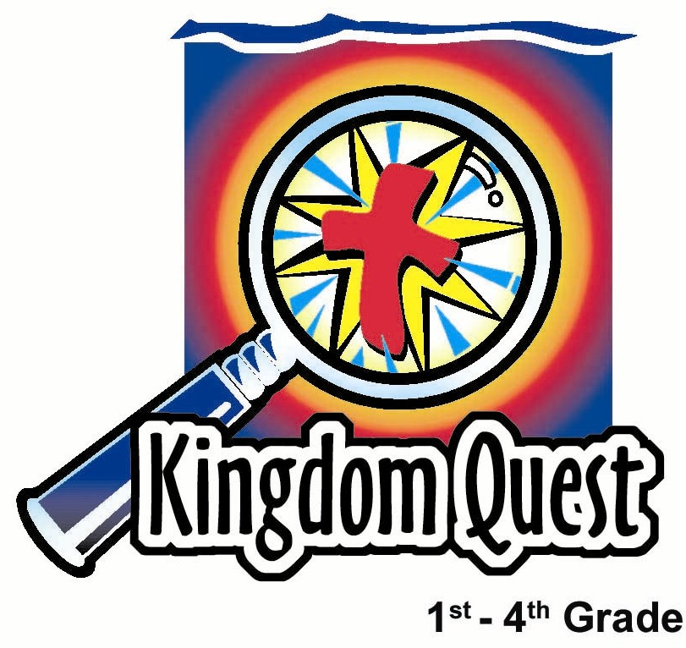
Date: ___________________
Series: Pass the Promise (Sept-Nov)
Year 1, Lesson 16

Rebekah,
a Wife
for Isaac

Take Home Point: *God provides for our families.
*Repeat this phrase throughout the lesson.

Bible Event: Genesis 24
Key Verse: Psalm 118:1, “Thank the LORD because he is good. His love continues forever.” (NCV)

We will help kids know:
- Abraham and his servant trusted God to answer their prayer to provide a wife for Isaac.
- God provides for all the needs in our lives.
- God’s ultimate provision for our lives is Jesus, our Savior. Through Jesus, we become part of God’s family.

We will help kids feel:
- Secure in God’s care for their families.
- Thankful for God’s blessings.

We will help kids do:
- Identify those things God provides in their lives.
- Pray and ask God to provide in all areas of their lives.

THIS LESSON’S ROADMAP

DESTINATION | PAGE # | DISCOVERIES ON YOUR JOURNEY | SUPPLIES NEEDED
Small Group Warm-Up   | 3-4 | Help the children begin to understand how God provides for them personally. Each child will receive a balloon and guess who ultimately provided this gift for them—God! | - a bag filled with balloons  for each group
Large Group   | 4  8-10  10-12 | Overview  Dramatic Presentation:  “Rebekah, A Wife For Isaac”  Puppet Presentation:  “Rebekah, Dao Dao, and a Bucket of Blessings” | - costumes for Abraham (adult), Esau and Jacob (children)  - two actors to pantomime (optional)  - Dao Dao with a bucket over his head
Small Group Application   | 4-6  6 | Thank God for blessings using M&Ms. Make a “bucket of blessings” and fill it with M&Ms. Each color of M&M will represent a type of blessing to thank God for.  Memory Verse Learning:  “Memory Verse Walk”  Gen. 28:15 is recommended for lessons 16-20 to feel confident that God will be with them in their times of trouble. | - colourful biscuits for each group  - paper cup for each child  - pipe cleaner or ribbon for each child  - label for each child that reads, “Psalm 118:1, ‘Thank the LORD because he is good. His love continues forever.’”  - small alphabets flashcards in bag  - masking tape  - Bible verse pre-written on whiteboard
Small Group Warm-Up: 15 minutes
Purpose: Get pointed in the right direction! Build relationships and help guests feel at ease. Do the learning readiness activity that will point your group in the right direction for the lesson.

Supplies needed: bag filled with balloons for each group

We want the children to discover how provisions are blessings that come from God. It is easy for children to understand that God makes all things, but we want them to see His personal provisions in their lives. There also is an element of anticipation and surprise in this warm-up activity. The Bible event of Isaac receiving the blessing of a wife had elements of surprise and anticipation, as well.

Today we are going to hear about a big surprise that Isaac got! We are going to start with an activity that lets you feel surprise too, just like Isaac.

Hold up the bag for the kids to see.

This is my surprise blessing bag. I would like you to reach into the bag and pull out one object. You can feel that there are several things in my bag, but you can only pull out one. The item you pull out is yours to take home.

After all the children have received their gift, ask:

Can you guess who provided this gift?

Let the children freely guess. Agree with answers such as “you,” “the church,” and “the store.” Ultimately, all of the gifts came from God. Help the children make the link that, though God did not manufacture the toy or sweet, He gave all the resources and materials for them to be produced. Indirectly, God provided those gifts to the children.

God gave you this blessing. A blessing is a surprise gift God gives us that we don’t deserve.

So children might discuss events from their world, ask the following question.

Can you tell me one new thing God provided for your family in the last week?

After children have shared, prepare them for large group with the following.

Remember how God is passing the promise to people who lived a long time ago in Old Testament times? Through them, God promised He would send His Son, Jesus, into the world. A couple of weeks ago we learned about Abraham who had a son, Isaac. Today we are finding out how God provided a wife for Isaac. It reminds us that *God provides for our families even today.

Optional Warm-Up Activity: Divide kids into groups of three or four. Have the children write “provides” vertically down the side of a paper. Then they can write an acrostic prayer. Have children think of things God provides for them personally that begin with each letter of the word “provides.” Have them write those things on the paper. End your warm-up time with a prayer thanking God for what He provides.

Large Group: 20-30 minutes
Purpose: Help kids observe what the Bible says. Present the Bible event in creative fashion. Help kids begin to interpret what it means.

Supplies needed: costumes for Abraham (adult), Esau and Jacob (children);
two actors to pantomime (optional); Dao Dao with a bucket over his head

Overview:

Dramatic Presentation: “Rebekah, a Wife for Isaac”
Grandpa Abraham tells the story to his grandsons, Jacob and Esau, how God provided their father, Isaac, with the blessing of his wife, Rebekah.

Puppet Presentation: “Rebekah, Dao Dao, and a Bucket of Blessings”
Dao Dao uses a bucket to give his sister a drink, which she doesn’t appreciate. He also learns how God gives us buckets of blessings.

Small Group Application: 20-25 minutes
Purpose: Help kids map out the meaning of the Bible event in their lives. Use the questions to stimulate discussion but don't feel tied to them. Allow the Holy Spirit to guide you. Include personal examples from your own faith journey. The example of Christ at work in your life will leave lasting impressions of how Christ can work in the children's lives.

Use your Bibles! Children need to learn how to look up references and follow along when scripture is read aloud. Allow for quality time of prayer at the close of the lesson.

Supplies needed: colourful biscuits for each group; paper cup for each child
pipe cleaner or ribbon for each child; label for each child that reads, “Psalm 118:1, ‘Thank the LORD because he is good. His love continues forever.’”
Observation Questions: What happened?
What did Abraham ask his servant to do? (Genesis 24:4. He asked him to go to his relatives’ country and find a wife for Isaac.)

Why Abraham did not want a wife for his son that lived in his country? (Genesis 24:3. Because the Canaanites did not worship the true God.)

How did the servant know Rebekah was the one? (Genesis 24:14. He prayed for a sign that a girl giving him water would also offer to water his camels.)

What was the servant’s reaction when he saw God’s answer in providing this wonderful blessing? (Genesis 24:26-27. He bowed down to God and praised Him for His faithfulness.)

Interpretation Questions: What does this mean?
Do you think it was always easy for the servant to trust God to provide a wife for Isaac?

What did Abraham have to do to get God’s blessings for his family? (He had to seek and follow God’s will.)

Application Questions: What does this mean to me?
If you could ask God to provide you with anything right now, what would you ask Him?

Do you really believe God will provide you with the very best of just what you need?

What must we do so that God’s will is done in our lives? (We should seek and follow God and ask for His will to be done. We must follow God like Abraham if we want God’s blessings.)

Application Activity:
Today we are going to ask or thank God for blessings using biscuits. Remember, a blessing is a surprise gift God gives us that we don’t deserve.

First, we need to make a bucket for our biscuits. We will call it a “bucket of blessings” because it reminds us of the bucket Rebekah used.

Give each child a small paper cup and a pipe cleaner/ribbon. Have kids poke a hole on each side of the cup and attach the pipe cleaner as the handle to the bucket.

Pour the biscuits onto the table. Ask the children not to touch the sweets or pick them up until they are told to do so. To collect blessings for the buckets, the children take turns talking to God about the following blessings as they pick up a biscuits according to its color. (This is also the prayer time.)

- Each child can pick an orange biscuits as he thanks God for a blessing he has had in his family.
- Each child can pick up a pink icing biscuits as he asks God to provide for a special need in his family.
- Each child can take a yellow biscuits and place it in his bucket as he thanks God for the blessing of his faith and that he can have God as a friend because of what Jesus has done for him.
- Each child can take a brown biscuits as he asks God to help him with one thing he needs for his faith to continue to grow.
- Each child can take a green biscuits as he thanks God for the blessings of fun with friends.
- Each child can take a white icing biscuits as he asks God to help him encourage his friends to grow in faith.

By now, buckets should be filled. Give each child a label with today’s Bible passage on it and let him place it on the front of his bucket. Read the Bible passage together. Then remind the kids again: *God provides for our families.

Memory Verse Learning: 5 minutes
Purpose: Help kids to memorize and keep scriptures at heart. Using creative ways to help kids enjoy learning the key verse and in small group setting.

Supplies needed: small alphabets flashcards in bag; masking tape; Bible verse pre-written on whiteboard

Memory Verse: Genesis 28:15 ~ “I am with you, and I will protect you everywhere you go.” (NCV)

MV Presentation: “Memory Verse Walk”
Use the masking tape to make two parallel lines, ten feet apart before class. During class, display whiteboard and let the children learn the Bible verse. Emphasize to students that no matter what our families go through, God is with those who full trust in Him. Then line the small group behind one of the lines. Tell them when they hear the shepherd calling out an alphabet, which is in their name, they should take a giant step forward and say the memory verse. Now the shepherd starts out by drawing out an alphabet from the bag and say, “God says He is with someone whose name has the letter A.”

God is the one who provides for every need of our family.
Let us trust God for what we need and remember this:
*God provides for our families.

Prayer Time:
Have the children pray about a need that their family might have. At the end of the prayer, reassure them God will provide at the appropriate timing as well as give what would truly bless them as a family.
Large Group Presentation

Rebekah, a Wife for Isaac

Dramatic Presentation

Grandpa Abraham and his grandsons, Esau and Jacob, enter the room. Abraham, now very old walks slowly while the two boys hold his hands and try to pull him along faster.

Esau: Come on, Grandpa! Just a little further.

Jacob: Yeah, Grandpa, hurry up! We want to show you our secret hiding place.

Grandpa: Not so fast, Esau and Jacob! Your grandpa can’t walk as fast as he used to.

Esau: Here it is, Grandpa. Isn’t it great?

Grandpa: What a fine hiding place, boys. It is shady and cool among the olive trees. Your old grandpa must sit and rest for a while.

Jacob: Tell us a story, Grandpa! You always tell the best stories!

Esau: Yeah! Like the story about the way God told you and Grandma that you were going to have a baby even though you were 99 years old and Grandma was 89!

Grandpa: Okay, boys. What story shall I tell you?

Jacob: I know! I know! Tell us about how our father met our mother.

Grandpa: Well, it was after your grandmother, Sarah, had died and your father, Isaac, started noticing girls.

Esau: Girls? YUCK!

Jacob: DISGUSTING!

Grandpa: (Laughs.) Soon enough, my grandsons, your opinion on girls will change. Anyway, I knew God had a special plan for our family. Remember, *God provides for our family, just as He had promised me long ago.

Esau: I remember! God had you look up at the stars and said that one day our family would be sooooo big it would be impossible to count us. Just like the stars.

Grandpa: That’s right, Esau. I will tell you how our God provided for our family. He found just the right wife for my son Isaac to marry. You see, I did not want Isaac to marry any of the Canaanite girls that lived around us. I wanted Isaac to marry someone who worshipped God. So I sent my servant to a far away country where I was born. I told him an angel would help him find just the right girl to bring back as a bride for Isaac.

Jacob: How did he find her?

(Two actors can be seen off center stage pantomiming the interaction between the servant and Rebekah as told by Abraham.)

Grandpa: My servant arrived at Nahor just as the sun was going down. He stopped by a well just outside of town to give the camels a drink of water. Then he prayed and said, “God, show me who should be Isaac’s wife. When I ask a girl for a drink, if she is the right one for Isaac, have her give me a drink and offer to water my camels as well.”

Jacob: Is that what happened, Grandpa?

Grandpa: It was amazing how God answered the prayer. Before my servant had even finished praying, a young girl, Rebekah, came with a jar on her shoulder. My servant hurried to meet her and asked if she would give him a drink. Rebekah quickly lowered her jar and gave the servant a drink. Then she said, “May I please give a drink to your camels, as well.” He knew for sure that this was God’s choice for Isaac’s bride.

Esau: So that was our mom! I bet she was pretty.

Grandpa: Not only that, your mother was one who followed the true God. It just so happened that her grandfather was my brother. I was sure then that God had chosen Rebekah to be Isaac’s wife.

Jacob: Wow! I guess you’d say theirs was a match made in heaven.

Grandpa: That’s exactly right, Jacob. Just as God has always been Jehovah-Jireh (“the Lord who provides”), it was He who provided the perfect wife for your father.

Esau: Well, that might be okay for mother and father, but I am NEVER getting married.

Jacob: Me either!

Grandpa: I don’t know. God provides for our family. That might mean He will even provide wives for you two someday. Remember, God made the promise to us that all the nations of the world would be blessed through our descendants.

Jacob: Tell us another story, Grandpa.

Grandpa: I will wait until next week. Then I will tell you how God is passing the promise of the coming Messiah to our family. Now, off you go, boys.

Jacob: Thank you, Grandpa! Bye!

Esau: Girls? Yuck! I’m going hunting. Bye, Grandpa!

Rebekah, Dao Dao, and a Bucket of Blessings

Puppet Presentation

Teacher: Wow! Kids, wasn’t that great to listen to Grandpa Abraham and his grandsons, Jacob and Esau? Let’s see if Dao Dao listened.

(Kids chant, “Dao-Dao! Dao-Dao! Dao-Dao!”)

Dao Dao: (Wearing a bucket as a hat.) Hi, Teacher! Hi, kids!

Teacher: Dao Dao, what is that on your head?

Dao Dao: It’s a bucket, can’t you tell?

Teacher: Well, it’s awfully silly.

Dao Dao: Not as silly as today’s story. Why didn’t Rebekah just turn on the hose and let him take a drink from that?

Teacher: What are you talking about? Today’s story was about how God provided a wife for Isaac. Her name was Rebekah.

Dao Dao: Yeah, she carried all that water in buckets. Boy, was that ever silly!

Teacher: What do you mean that was silly?

Dao Dao: Well, why didn’t she just turn on the hose and let them take a drink from that?

Teacher: Dao Dao, they didn’t have water faucets or hoses back then. They had to get their water from a spring or well. But that’s not the point.

Dao Dao: What’s the point?

Teacher: The point is that God provides for our families. And He provided a wife for Isaac. She was the one who took the jar or bucket she was carrying and gave the servant a drink and watered the camels.

Dao Dao: Yeah, I was listening. That was the sign the servant had prayed for. He knew right away that she was the girl he should take back to be Isaac’s wife.

Teacher: So you were listening, even with a bucket on your head. By the way, why is that bucket on your head?

Dao Dao: Oh, I just used it like in the story.

Teacher: How is that?

Dao Dao: I poured a glass of water from it and gave it to my sister.

Teacher: That was nice.

Dao Dao: Sure. Then I asked her if she liked the water.

Teacher: That was nice. Did she?

Dao Dao: She said, “Yes.” Then I said, “Good! Because the camel who just drank from this bucket of water before you, liked it, too!”

Teacher: Dao Dao!

Dao Dao: Then she insisted I wear the bucket on my head. She helped do that.

Teacher: That’s what you get for playing tricks.

Dao Dao: But I didn’t have a camel anyway.

Teacher: There’s one thing you do have, Dao Dao, and you can remember it today.

Dao Dao: What’s that?

Teacher: God has buckets of blessings for you. When you trust Him, He provides for your family. The best blessing He could possibly provide is the gift of his Son, Jesus.

Dao Dao: Yeah, Jesus really is the best.

Teacher: Did you know that since God gave Isaac the right wife, Rebekah, their great, great, great grandkids were the family that Jesus was born into. Through Jesus, all the families of the world are blessed.

Dao Dao: That is a blessing.

Teacher: It’s buckets of blessings.

Dao Dao: Which is better than buckets of camel water!

Teacher: Sure is, Dao Dao. Let’s close our time with prayer.

Dear God, thank You for providing for our families with buckets of blessings. Thank You, too, for running water from hoses so we don’t have to water our camels by carrying jars of water. Thank You most of all for the greatest blessing, Jesus, who came to die for our sins in our place. We love You, Lord. In Jesus’ name. Amen.

Lesson 16

Small Group Warm-Up:
- bag for each group filled with balloons for each child

Large Group:
- costumes for Abraham (adult), Esau and Jacob (children)
- two people to pantomime off center stage (optional)
- Dao Dao with a bucket over his head

Small Group Application:
- two types of colourful biscuits purchased at “pasar malam” for each group
- paper cup for each child
- pipe cleaner or ribbon for each child
- label for each child that reads: Psalm 118:1,
“Thank the LORD because he is good. His love
continues forever.”

MV Learning:
- small alphabets flashcards in bag
(provided on page 13)
- masking tape
- Bible verse pre-written on whiteboard

A | B | C | D | E
F | G | H | I | J
K | L | M | N | O
P | Q | R | S | T
U | V | W | X | Y
Z

