
Date: ____________________
Series: Pass the Promise (Sept-Nov)
Year 1, Lesson 19

Laban Tricks
Jacob

Take Home Point: *God can make good even out of family messes.
*Repeat this phrase throughout the lesson.

Bible Event: Genesis 29:1-35
Key Verse: Psalm 145:18: “The LORD is close to everyone who prays to him.” (NCV)

We will help kids know:
- Laban tricked Jacob.
- Jacob married two wives.
- Through Leah’s son, Judah, God would send His Son, Jesus, to save the world.

We will help kids feel:
- Sad about lies and deceitfulness.
- Confident to go to God for forgiveness and that He will work it out.

We will help kids do:
- Commit to behave in an honest manner.
- Pray for God’s help in their family messes.

THIS LESSON’S ROADMAP

DESTINATION | PAGE # | DISCOVERIES ON YOUR JOURNEY | SUPPLIES NEEDED
Small Group Warm-Up   | 3-4 | While studying Esau and Jacob, we see that lies and deceit are at the heart of their problems. | - no supplies are needed
Large Group   | 4-5  10  10-13  14-15 | Overview  Puppet Presentation:  “Laban Tricks Jacob”  Interactive Drama:  “Laban Tricks Jacob”  Puppet Presentation:  “Laban Tricks Jacob” Conclusion | - Dao Dao  - Mun Mun, Dao Dao’s sister  - football with a cross drawn on it with masking tape  - costumes for Leah, Rachel, and Jacob  - shepherd’s crook for Jacob
Small Group Application   | 5-6  7 | When families trick or lie to one another, it can tear their relationships apart. God wants our families to be put back together. The way he does that is by sending part of his own family, Jesus, into the world.  Memory Verse Learning:  “Tic-Tac-Toe Challenge”  Gen. 28:15 is recommended for lessons 16-20 to feel confident that God will be with them in their times of trouble. | - one tangram for each child (see page 8)  - copy of the cross tangram for each shepherd (see page 9)  - scissors  - envelopes or paper clips for puzzles  - whiteboard  - marker
Small Group Warm-Up: 15 minutes
Purpose: Get pointed in the right direction! Build relationships and help guests feel at ease. Do the learning readiness activity that will point your group in the right direction for the lesson.

Supplies needed: no supplies needed

Family problems seem to be a reoccurring theme as we have studied Jacob and Esau. In fact, lies and deceit seem to be right at the heart of these problems. It is a theme that our children can understand. Today’s warm-up activity may seem like a fun harmless game, but it will lead you right into a discussion on lies and deceit.

Today we are going to play a game called “To Tell the Truth.” I am going to pick one child to leave the room. When he comes back he will have to decide who is lying and who is telling the truth.

Pick one child to leave the room. Look at the topics below for Round 1. Pick one of the following statements and ask the children to raise a hand if they have done what the statement says. (For example, “Raise your hand if you have been to the circus.”) Pick two children who have raised hands to come forward. Also pick two children who did not raise their hands to come forward.

All four of these contestants will try to convince the child when he returns that they have done what the statement says they have (i.e. they have all gone to the circus). The two children who have not done what the statement says need to pretend that they have.

Have the child who left, comes back into the room. He will try to guess which kid is lying. (He only needs to pick one that is untruthful, not both.) He does this by asking three questions. In our example, questions could include: “What kind of animals did you see at the circus?” or “What was the funniest thing you saw at the circus?”

Play three rounds of the game if possible. Pick a different child to leave the room for each round. Choose one of these topics for each round:

Round 1: I have been to Sunway Lagoon.
or
I have been to the circus.

Round 2: I have all my homework done.
or
My room is clean and my bed is made.

Round 3: I have spoken about Jesus to a friend this week.
or
Yesterday I said my own prayer to God.
After the game ask:

Was it always easy to tell who was lying in our game? How did it make you feel when you weren’t sure if someone was lying or telling the truth?

How do you feel when you find out someone lied to you? Have you ever lied to someone in your family? How do you think they felt?

Allow time for sharing. Ask :

Did any of you find a way to work it out without getting angry with the other person?

What have we learned so far in our lessons about what we are to do when someone tricks us or lets us down?

Today we are going to learn more about Jacob. You would think Jacob would have learned after all the trouble he had with tricking his brother, Esau, and having to run away, but he didn’t. We will learn that *God can make good even out of family messes.

Large Group: 20-30 minutes
Purpose: Help kids observe what the Bible says. Present the Bible Event in creative fashion. Help kids begin to interpret what it means.

Supplies needed: Dao Dao; Mun Mun, Dao Dao’s sister; football with a cross drawn on it with masking tape; costumes for Leah, Rachel, and Jacob
shepherd’s crook for Jacob

Songs

Offering

Prayer Introducing Take Home Point: *God can make good even out of family messes.

Puppet Presentation: “Laban Tricks Jacob”

Mun Mun is very hurt and angry with Dao Dao for tricking her.

Dramatic Presentation: “Laban Tricks Jacob”
Jacob shares how his father-in-law Laban tricked him and how this caused problems in his family (Genesis 29:1-35).

Puppet Presentation: “Laban Tricks Jacob” Conclusion
Dao Dao and Mun Mun learn how the promise of Jesus is passed to them. They then have the power to confess their mistakes and forgive each other.

Small Group Application: 20-25 minutes
Purpose: Help kids map out the meaning of the Bible event in their lives. Use the questions to stimulate discussion but don't feel tied to them. Allow the Holy Spirit to guide you. Include personal examples from your own faith journey. The example of Christ at work in your life will leave lasting impressions of how Christ can work in the children's lives.

Use your Bibles! Children need to learn how to look up references and follow along when scripture is read aloud. Allow for quality time of prayer at the close of the lesson.

Supplies needed: one tangram for each child (see page 8); copy of the cross tangram for each shepherd (see page 9); scissors; envelopes or paper clips for puzzles

Observation Questions: What happened?
In the Bible event today, where was Jacob going and who was he looking for? (Genesis 28:5. He was going to live with his uncle Laban.)

Jacob worked for his uncle so that he could get what? (Genesis 29:18. Jacob worked seven years for Rachel to become his wife.)

How was Jacob tricked? (Genesis 29:16-28. Laban tricked Jacob by giving him Leah instead of Rachel.)

Can you describe what Jacob’s family was like with two wives? (Genesis 29:31-35. There was a lot of fighting and jealousy.)

Can anyone remember how Jacob had tricked someone else before this? (Genesis 25:29-34. Jacob tricked Esau out of his birthright.)

Interpretation Questions: What does this mean?
Jacob’s family was divided because of lying. Jacob had to run away from home not see his mother again. Jacob and his brother were divided as well, and he was afraid of him. Now that his uncle Laban had lied to him, do you think Jacob was tired of lies and saw how they hurt people? Explain.

Application Questions: What does this mean to me?
Can you think of a time when you told a lie and it hurt a relationship with someone else?

What happens when people in a family lie to each other? (It tears the family apart.)

Application Activity:
Hand each child a paper tangram puzzle. Pass out scissors.

This special puzzle is called a tangram. It is going to remind us of our families. When families trick or lie to one another, it can tear their relationships apart, just like cutting these puzzle pieces out does to the puzzle.

I would like everyone to cut out the puzzle pieces. As you do, I would like you to think of a time when you have tricked someone or told a harmful lie that might have hurt your family or separated people from each other.

After the kids share, challenge them to see if they can put their tangram back together in the original square. As they are trying that say,

God wants our families to be put back together. The solution He gave us was to send part of His own family, Jesus, into the world. Jesus gave His life for us when He died on the cross. When we trust Jesus, He lives in our heart and helps us tell the truth and forgive others who might have lied to us.

After the kids have made their “family” squares, give them the challenge to make a cross out of their puzzle pieces. Have the kids discuss ways they can help maintain the family peace, i.e. remembering not to lie to family members, asking forgiveness if they hurt someone’s feelings, talk about Jesus, have devotions, show love to one another.
If children are having trouble making a cross with their pieces, you can show them the solution that is attached. The kids may have other variations to the cross also. As the puzzle is transformed into a cross say:

*God can make good even out of family messes. He promises in the Bible to hear our prayers when we ask for His help. Psalm 145:18 says, “The LORD is close to everyone who prays to Him.” We can always trust God’s promises.

Give kids envelopes or paper clips to keep their tangram pieces together.

Memory Verse Learning: 5 minutes
Purpose: Help kids to memorize and keep scriptures at heart. Using creative ways to help kids enjoy learning the key verse and in small group setting.

Supplies needed: whiteboard; marker

Memory Verse: Genesis 28:15 ~ “I am with you, and I will protect you everywhere you go.” (NCV)

MV Presentation: “Tic-Tac-Toe Challenge”
Use a whiteboard for this challenge. Divide the children into two groups. Announce to the children that each time a team wins the Tic-Tac-Toe challenge, they gain 1,500 points for their group. In order to have the opportunity to do the tic-tac-toe for the team, one has to be able to recite Genesis 28:15. Everybody has to take turn to play for their team. No team member will be able to play for another round unless all team members have played.

Prayer Time:
Kids can hold the tangram in their hands during prayer time as a physical reminder that *God can make good even out of family messes. Pray for any family concerns mentioned today and any other prayer needs. Please be using your prayer journal with the kids.

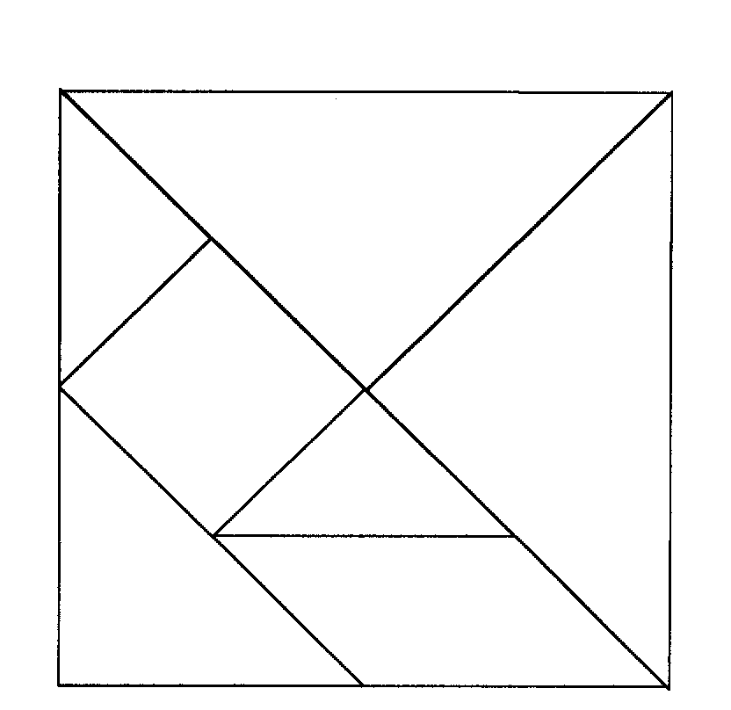
Small Group Application: Tangram
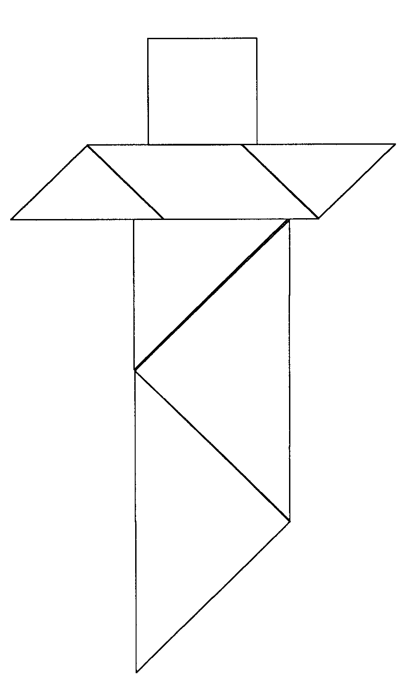
Small Group Application: Cross Tangram Solution

Large Group Presentation

Laban Tricks Jacob

Puppet Presentation

Mun Mun: I am never going to speak to you again.

Dao Dao: Aw, come on! It was just a joke.

Mun Mun: I didn’t think it was very funny. You told me it was canteen day at school. You know I enjoy canteen day. I even took extra money along to buy ice kacang. But it wasn’t canteen day I am so disappointed that it makes me sick to think about it. I’m never going to talk to you again.

Dao Dao: I just meant it as a joke.

Mun Mun: Well, it’s not very funny. And I want you to know the next time you need to borrow money from me, you can forget about it.

Dao Dao: Aw, come on! Get a sense of humor.

Teacher: Wait a minute, Dao Dao. Can’t you see you really hurt Mun Mun’s feelings?

Dao Dao: But it’s just canteen day.

Teacher: No, it’s not just canteen day. It’s playing tricks or not telling the truth. And it can make a mess not just out of your dessert. It can make a mess out of families.

Dao Dao: Oh yeah, that’s just like we learned about Jacob. He used some food to trick his brother, Esau. Jacob’s family got in a big mess.

Teacher: Yes, but not only that. Jacob himself got tricked.

Dao Dao: You mean Esau got even with him?

Teacher: No, it wasn’t Esau. It was a man named Laban. Laban had two daughters. Jacob loved one of the daughters and wanted to marry her. But Laban tricked Jacob into marrying both daughters.

Dao Dao: No way! I didn’t think that was legal!

Teacher: Well, it was legal back then. But it sure made a mess out of their family. Let’s hear from Jacob himself.
Laban Tricks Jacob

Dramatic Presentation

(Offstage the voices of the two sisters are heard.)

Rachel: Tonight I’m going to make Jacob his favorite dinner—figs and bread.

Leah: That’s not fair! You made dinner last night.

Rachel: No, dear sister, you made dinner last night.

Leah: Did not!

Rachel: Did too!

Leah: (Fading.) Did not!

Rachel: (Fading.) Did too!

(Jacob enters the room with a shepherd’s crook as if tending a flock of sheep and goats. As he makes his way to the stage, he is mumbling.)

Jacob: Two sheep are better than one, two tents are better than one, two camels are better than one—but two wives! Oh, excuse me! Do you mind if my sheep and goats graze here a moment? To be honest, they’re not my sheep and goats. They are my Uncle (and now father-in-law) Laban’s.
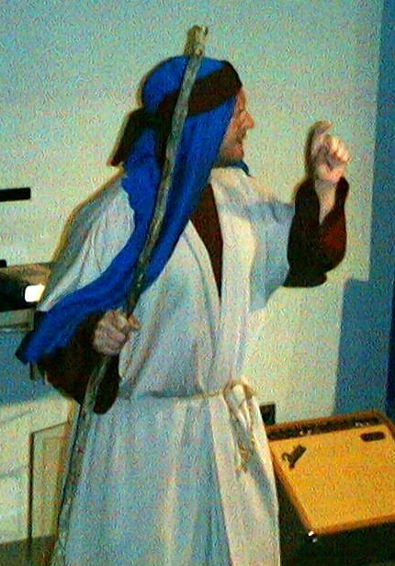
(Looking around.) It’s so quiet out here among the hills with only an occasional bleat from a lamb or goat. This is nothing like what awaits me at home—the sound of two wives! That’s right! And it’s all because my father-in-law tricked me! Let me tell you what happened.

You probably remember my brother Esau and I lived with our parents, Isaac and Rebekah. Well, after I tricked Esau out of his birthright and got our father’s blessing, I had to get out of town quick! Esau was pretty mad. He was so mad that I was afraid he might kill me.

My mother sent me to the house of her brother Laban in Haran to find a wife. She promised she would send for me once Esau cooled off.

So I headed to Haran as fast as I could. When I arrived, I saw a group of shepherds watering their flocks and asked if they knew of my Uncle Laban. “Sure,” they said. “In fact, here comes his daughter, Rachel, with the sheep.”

That was the first time I saw her. (Sighs.) Rachel, beautiful Rachel. I rolled the stone away from the well so she could water the flock. Then I kissed her, and told her that I was her cousin, the son of her Aunt Rebekah. She was so happy to see me that she started to cry!

In the meantime, my Uncle Laban heard that I had arrived in Haran and he came to meet me. Like Rachel, he was happy to see me and welcomed me to his home. At home, I met my uncle’s other daughter, Leah.

I stayed with my uncle helping tend his flocks. After I had been there for about a month, he told me he wanted to pay me for working and he asked me what I wanted for wages. Well, it wasn’t money or sheep or goats that I wanted. It was Rachel, beautiful Rachel I wanted for my wife. I told my uncle that I would work for him for seven years in return for Rachel, and my uncle agreed. Let me tell you those seven years seemed just like a few days because all I could think about was Rachel, beautiful Rachel.

After the seven years were up, my uncle invited all kinds of people and threw a huge wedding feast! It was wonderful! There was music, food, dancing, and best of all Rachel, beautiful Rachel. She looked so beautiful that night—well, what I could see of her. You see, the wedding veil she wore covered her face. But I was so happy! At last Rachel would be my wife or so I thought! Little did I know that my uncle had a trick up his sleeve!

The next morning I woke up and found out that it wasn’t Rachel who wore the wedding veil that night. It was Leah, her older sister! Now Leah was a nice girl but she wasn’t Rachel. I wanted Rachel.

Needless to say, I marched out of the tent, found my Uncle Laban (now my father-in-law), and said to him. “Listen buddy! For seven years I’ve worked my fingers to the bone and did I mind? No, I worked gladly because at the end of the seven years I knew I would have Rachel for my wife. And what do I find this morning? I find that instead of giving me Rachel for my wife you tricked me and gave me Leah! I WANT RACHEL!”

Well, good old Uncle Laban gave me some flimsy excuse about the older daughter having to be married first. Right! Anyway, to cool me down he made another bargain. He promised if I stayed and worked another seven years I could marry Rachel. Two wives! What was I going to do with two wives! My father had only had one, but what else could I do? I wanted Rachel so I agreed.

For another seven years I worked for my uncle and I had beautiful Rachel. Now don’t get me wrong. Leah is a good wife. In fact, she has given me many sons. But it is Rachel I love and Leah knows it. Sometimes that causes problems. You know how sister’s can be always bickering at each other about who is the best wife for me. So that’s why I like it here among the sheep and goats.

You know, sometimes I wish Uncle Laban hadn’t tricked me. Things would be so much simpler.

(Offstage the voices of the two sisters are heard.)

Rachel & Leah: (Sweetly in unison.) Jacob, time for dinner.

Rachel: (Not so sweetly.) No, dear sister, we agreed I would call him. You called him for lunch.

Leah: (Not so sweetly.) No, dear sister, we agreed I would call him. You called him for lunch.

Rachel: Did not!

Leah: Did too!

Rachel: Well, I’m his favorite wife!

Leah: Well, I’m his first wife!

Jacob: (Cups hands and calls.) Coming, Rachel. Coming, Leah. (Exits.)

Laban Tricks Jacob
Puppet Presentation Conclusion

Teacher: Jacob was a person who made lots of mistakes but God still used him as part of his plan to bring the Savior into the world. God passed the promise of the Messiah. (The football with the cross on it should be used to demonstrate this concept.)

What a wonderful God we have that can take the messes that we make and make good things happen. You can see how lies and deceit caused a lot of anger and jealousy in Jacob’s family. Look at Leah and Rachel, They weren’t happy at all. Lies and deceit do the same thing to our families. It makes us feel like we are torn apart.

Dao Dao: Just like Jacob had messes in his family, there are messes in our families even today.

Mun Mun: You can say that again!

Dao Dao: There are messes in our families even today!

Teacher: Okay, that’s enough with the messes. God has a way to help us with our family messes. God heals families with forgiveness. When we do something wrong, we need to ask God for forgiveness. Since Jesus gave His life for us, God will forgive us and help clean up our families’ messes.

Dao Dao: Did God forgive Jacob for all of his messes?

Teacher: Yes, he did. God even turned the mess Jacob had with two wives into a blessing.

Mun Mun: Yeah, because even then God still passed the promise. Through Jacob’s family, God gave a blessing to the entire world. Through their family, Jesus was born.

Teacher: Through Jesus, families today are healed with forgiveness. For example, when one brother apologizes to his sister…

Dao Dao: No way!

Teacher: Yes way.

Dao Dao: I guess you’re right. I’m sorry, Mun Mun.

Teacher: And ask for Jesus’ power to do better and not lie or hurt other people with tricks. *God can make good even out of family messes.
Let’s prayer together.

Dear Jesus, thank You for dying on the cross for us. We know that You have forgiven us when we made big messes in our life. Help us forgive others who hurt us. Heal our family with Your forgiveness. We know You have the power to do that. We pray all these in Jesus’ name. Amen.

Dao Dao: Teacher, we have to go now and get along with each other.

Mun Mun: Ya. Bye teacher.

Teacher: Bye, you both.

SUPPLY LIST

Lesson 19
Small Group Warm-Up:
- no supplies are needed

Large Group:
- Dao Dao
- Mun Mun, Dao Dao’s sister
- football with a cross marked on it with masking tape
- costumes for Leah, Rachel, and Jacob
- shepherd’s crook for Jacob

Small Group Application:
- one tangram for each child (seepage 8)
- one envelope or paper clip for each child
- copy of the cross tangram for each shepherd (see age 9)
- scissors

Memory Verse Learning:
- no supplies are needed

