
Date: ____________________
Series: Pass the Promise (Sept=Nov)
Year 1, Lesson 21

Joseph and His Brothers

Take Home Point: *Jealousy “jails us,” but God can free us.
*Repeat this phrase throughout the lesson.

Bible Event: Genesis 37
Key Verse: John 8:36, “So if the Son makes you free, then you will be truly free.” (NCV)

We will help kids know:
- Joseph and his brothers had many problems in their family due to jealousy.
- God can change our hearts to help us overcome jealousy.

We will help kids feel:
- Sadness over the areas in their lives where they are jealous of others.
- Comfort in knowing that Jesus has freed us from the areas where jealousy used to control us.

We will help kids do:
- Identify a person they are jealous of and see the “jail” it puts them in.
- Turn the person over to Jesus in prayer.
- Thank God that he is the one who overcomes our jealousy.
- Identify times in their families when jealousy damages relationships and pray for those times.

THIS LESSON’S ROADMAP

DESTINATION | PAGE # | DISCOVERIES ON YOUR JOURNEY | SUPPLIES NEEDED
Small Group Warm-Up   | 3 | Children will experience jealousy when someone in their group gets something better. Have they ever felt jealous of a brother, sister, or friend? Today they will learn about 12 brothers who had a jealousy problem. | - three small “Sang Cha Peng” for each child  - one large “Sang Cha Peng” for each group
Large Group   | 4  7  8-16  17 | Overview  Puppet Presentation: “Joseph and His Brothers”  Radio Drama:  “Joseph and His Brothers”  Puppet Presentation: “Joseph and His Brothers” Conclusion | - Dao Dao  - costumes for Joseph and Jacob  - various signs and sound effects  - football with a cross on it
Small Group Application   | 4-6  6 | When we get jealous, we become so busy trying to hurt the other person that we forget we are the ones who become very unhappy. We become “jailed.” Jesus frees us from sin and jail.  Memory Verse Learning: “Toothpick Verse”  James 4:7 is recommended for lessons 21-23 to be reminded that in times of temptation one should act out in God’s ways. | - 12 toothpicks for each child  - 3x3-inch piece of cardboard or Styrofoam board  - glue  - 8X11 inch carton board or Styrofoam board  - a box of toothpicks  - pre-arranged Bible verse display board
Small Group Warm-Up: 15 minutes
Purpose: Get pointed in the right direction! Build relationships and help guests feel at ease. Do the learning readiness activity that will point your group in the right direction for the lesson.

Supplies needed: three small “Sang Cha Peng” for each child; a large “Sang Cha Peng” for each group

Today we will be starting with an activity that will set the stage for our lesson. Each group will have a large “Sang Cha Peng” and a plate of smaller “Sang Cha Peng.”

I am so glad you are here today. I brought each one of you a special treat.

Give each child a small ”Sang Cha Peng”, saving the large “Sang Cha Peng” for the last child. Say to this child as you give him the large “Sang Cha Peng”,

I am so glad you are here. I saved this special piece of tit bits for you because you are so special to me.

Amidst the groans and complaints of the other children, you may tell the children they can eat their tit bits. Then ask them some questions to explore their feelings.

How are you feeling right now? How did it make you feel when I gave one of you an extra special “Sang Cha Peng”? What do we call the feeling you felt when I gave you a small tit bits and (insert name of student) a large tit bits? (Jealousy) Jealousy is when someone gets something better than you and it makes you mad.

After allowing time for children to respond, assure them of your love for them and give two “Sang Cha Peng” to each of the kids who got a small one.

Have you ever felt like a brother, sister, or friend got better treatment than you? Would you share about a time? How did it make you feel? What did it make you want to do?

Today in our story we will learn about 12 brothers who had a major jealousy problem. The brothers were always worried that their brother, Joseph, was getting more than they were. They got so upset with him that they tried to get rid of him. Today we will learn that *jealousy “jails us,” but God can free us by changing our hearts. What do you think that means?

Let’s find out in our story today how jealousy jailed a bunch of brothers.
Large Group: 20-30 minutes
Purpose: Help kids observe what the Bible says. Present the Bible event in creative fashion. Help kids begin to interpret what it means.

Supplies needed: Dao Dao; costumes for Joseph and Jacob; various signs and sound effects; football with a cross on it

Overview:

Puppet Presentation: “Joseph and His Brothers”
The Bible event in Genesis 37 is personated as a radio drama about Joseph and his brothers. The brothers are jealous of Joseph’s special treatment from their father. They become enraged with Joseph’s dreams that imply they would bow to him. The brothers want to kill Joseph but are instead satisfied to imprison him and later sell him into slavery.

Radio Drama: “Joseph and His Brothers”
Dao Dao learns that becoming jealous actually will “jail us” on the inside.

Puppet Presentation: “Joseph and His Brothers” Conclusion

Small Group Application: 20-25 minutes
Purpose: Help kids map out the meaning of the Bible event in their lives. Use the questions to stimulate discussion but don't feel tied to them. Allow the Holy Spirit to guide you. Include personal examples from your own faith journey. The example of Christ at work in your life will leave lasting impressions of how Christ can work in the children's lives.

Use your Bibles! Children need to learn how to look up references and follow along when scripture is read aloud. Allow for quality time of prayer at the close of the lesson.

Supplies needed: 12 toothpicks for each child; 3x3-inch piece of carton box or foam core; glue

Observation Questions: What happened?
Why did Joseph’s brothers dislike him so much? (Genesis 37:3-11. Joseph’s father loved Joseph more and he gave him a beautiful coat of many colors. Joseph had dreams that made the brothers mad.)

What did the brothers decide to do with Joseph? Why? (Genesis 37:18-19. Joseph’s brothers were very jealous of him and threw him in a well.)
What happened to Joseph after they threw him in the well? (Genesis 37:25-28. His brothers sold him as a slave to some traveling merchants on their way to Egypt.)

Interpretation Questions: What does this mean?
If you had been one of Joseph’s brothers, would you have been jealous of him? Why or why not?

Do you think it was easy being Joseph’s brothers? Why or why not?

Application Questions: What does this mean to me?
Have you ever been jealous of someone? Explain.

How are we able to change those horrible jealousy feelings that make us feel so bad? (First, we need to pray and ask God to step into our lives through the Holy Spirit and change our heart. Then we need to change in how we treat the other person of whom we are jealous.)

Application Activity:
Each child will have approximately 12 toothpicks and a 3x3-inch piece of cardboard or foam core.

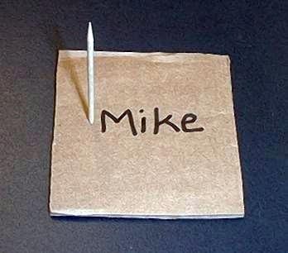
I would like you to take your piece of cardboard and write your name in the center of it. Now I want you to think of a person of whom you are jealous. When you are jealous of the person, do you want to invite him to your roller skating birthday party? No, I didn’t think so.

Take one of the toothpicks and poke in the cardboard by your name. As you put it in, think about the person you didn’t want to invite.

Would you want to send him a Christmas card? Now poke in another toothpick on the other side of your name.

Would you want him on your baseball team? Poke another toothpick on another side of your name.
Lead the kids to think of other ways they might get even with someone they are jealous of until their names are encircled with toothpicks.
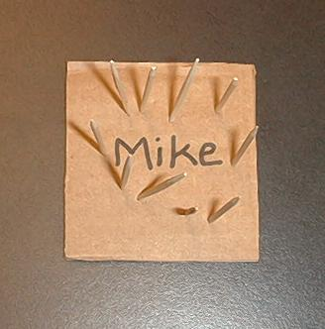
Look, it appears you have made a jail. Who is inside the jail? (Me.) That’s the way jealousy is in our lives. We get so busy trying to hurt the other person that we forget we are the ones who become very unhappy. It’s like we put ourselves in jail.

Who has freed us from all sin that jails us? (Jesus.) Our Bible verse for today says, “So if the Son sets you free, you will be absolutely free.”

If you truly believe Jesus has freed us, I want you to take out those toothpicks and make a cross with them on your cardboard. Glue them on your cardboard.

Let’s review our Bible verse, *Jealousy “jails us,” but God can free us. Because of Jesus’ death for the forgiveness of our sins, we can forgive others. Just ask God for forgiveness and let His Holy Spirit work a miracle in your heart. Let’s do that right now.

Dear Jesus, I am so sorry for all the times I have been jealous of someone else. Please make those changes in my heart so I will not be in jail anymore. Thank You, my most precious Jesus. Amen.

Memory Verse Learning: 5 minutes
Purpose: Help kids to memorize and keep scriptures at heart. Using creative ways to help kids enjoy learning the key verse and in small group setting.

Supplies needed: 8X11 inch carton board or foam board; a box of toothpicks; pre-arranged Bible verse display board

Memory Verse: James 4:7, “Stand against the devil, and the devil will run away from you.”

MV Presentation: “Toothpick Verse”
Pre-arrange the Bible verse with toothpicks on a carton board. Display it to teach the children the Bible verse for memorizing. Then give each child a piece of the carton board and some toothpicks so that they can arrange the verse by poking the toothpick on the carton board.

Prayer Time:
Take time for prayer journals and any concerns your children may have. This is a wonderful time for you to grow in your relationship with your children.
Large Group Presentation

Joseph and His Brothers

Puppet Presentation

Dao Dao: Teacher, it isn’t fair! I got ripped off. I got a small “Sang Cha Peng.”

Teacher: That’s because we were learning about jealousy.

Dao Dao: I don’t care about jealousy. I care about ”Sang Cha Peng.” Why does everyone get a big one and I get a small one?

Teacher: Are you feeling jealous?

Dao Dao: No, I’m feeling hungry. I think I’ll just borrow a big “Sang Cha Peng” from my sister Mun Mun. Her teacher gave her the special one. That’s just like her. She’s always the teacher’s favorite. She’s Mom and Dad’s favorite, too!

Teacher: It still sounds to me like you are jealous. You’re just like (says names in a sing-song way) Reuben, Simeon, Levi, Judah, Dan, Naphtali, Gad, Asher, Issachar, and Zebulun.

Dao Dao: Say what?

Teacher: These are Joseph’s brothers. They were so jealous of Joseph they wanted to hurt him.

Dao Dao: I bet that’s because he got the big “Sang Cha Peng.”

Teacher: Not a “Sang Cha Peng.” But he did get something else that was special because he was his dad’s favorite.

Dao Dao: What was that?

Teacher: Well, Dao Dao, why don’t you stay and listen to today’s radio drama and find out what it was. And maybe you’ll find out about jealousy and what it does to us.

Dao Dao: Okay. Do you have a “Sang Cha Peng” I can munch on while I listen?

Joseph and His Brothers

Radio Drama

Characters:

- Host
- Sound technician (Shows cues and makes sounds. Might also serve as “Voice 1.”)
- Voice 1 (Does several voices.)
- Voice 2 (Does several voices.)
- Joseph
- Jacob

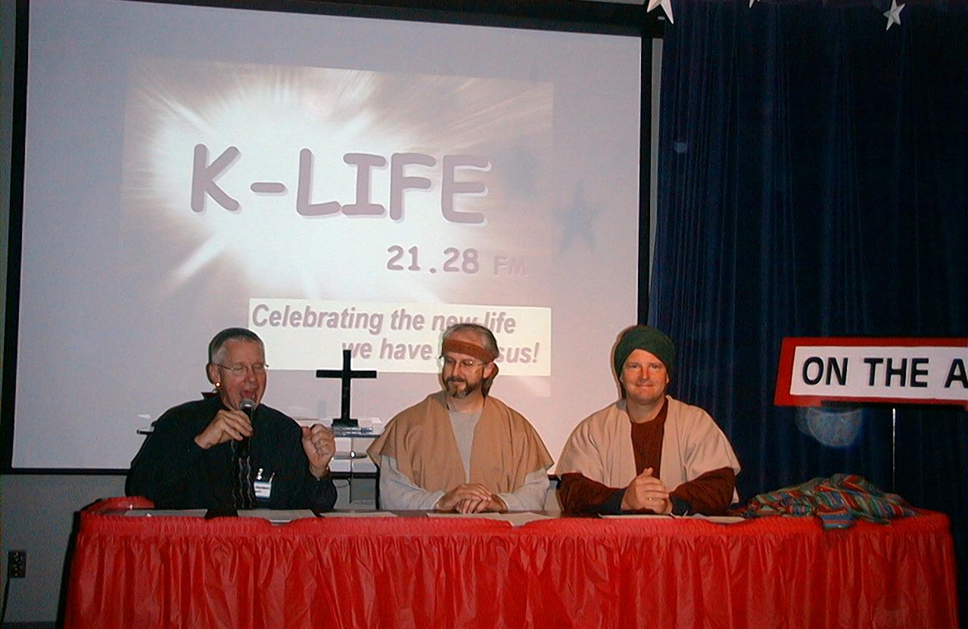
The stage is set with a table for the host, Jacob, and Joseph as the main radio voices. Jacob and Joseph are in costume to help the kids better picture the main characters. Voice 1, Voice 2, and sound effects would best be done behind a screen. Adults who can change voice inflection are recommended. A table behind the screen is also needed for the sound effects props. The sound effects, when hidden, better capture the imagination of the audience.

There is another option for doing the voices. If desired, all the brothers could be assigned parts instead of simply Voice 1 and Voice 2. This format could lend itself to a large number of kids participating but requires the parts to be spoken quickly and clearly.

Towards the middle of the presentation, you may want to insert a short commercial. This commercial could be quickly acted out by the sound tech and the host or by children who were previously instructed. The commercial could pertain to your church’s current mission project.

The sound technician holds up the cue signs APPLAUSE, WOW, and OOH above the visual screen so the kids can read them. The host can remind the audience that they play a part in the drama by making the appropriate sounds when he holds up the cue signs. This should be practiced once before beginning.
IT IS VITALLY IMPORTANT NOT TO LET THIS DRAMA DRAG.
KEEP A QUICK PACING BETWEEN PARTS.

Sound: 5-4-3-2-1…

Sign: ON THE AIR
Host: Welcome to Kingdom Quest’s (or the name of your Sunday school) radio station KLIF, 21.28 (or the channel of your local station) on your FM dial. The station that reports on how God passes the promise to His people. (Holds up football with cross on it.)

Sign: APPLAUSE

Host: Hi, I'm _________, and we are broadcasting live from _________. We are going to begin a four-part radio drama on the life of Joseph, the son of Jacob.

Sign: APPLAUSE

Host: Put on your imagination caps as we travel back to long ago in Genesis Chapter 37 and today's episode "Joseph and His Brothers."

Sign: APPLAUSE

Host: Long, long ago in the land of Canaan lived a man by the name of Jacob. God had blessed Jacob with many sons—12 to be exact.

Sign: WOW

Host: Reuben was the oldest.

Voice 1: Hello.
USE VERY QUICK PACING THROUGH THIS SECTION.
Host: And then there was Simeon.

Voice 2: Hi!

Host: Levi.

Voice 1: Howdy.

Host: Judah.

Voice 2: Hi there.

Host: Dan.

Voice 1: Hi!

Host: Naphtali.

Voice 2: Yo!
Host: Gad.

Voice 1: Hi.

Host: Asher.

Voice 2: Yep!

Host: Issachar

Voice 1: Hi.

Host: Zebulun.

Voice 2: Hi.

Host: Joseph.

Joseph: Hello.

Host: And the baby.

Voice 1: Goo.

Host: No, no. He wasn't a baby! He was the baby of the family. You know, Benjamin was the youngest.

Voice 1: Oh, hi!

Host: Now even though Jacob had 12 sons…

Sign: WOW!

Host: Joseph was the one Jacob loved the best. One day Jacob surprised Joseph with a gift.

Jacob: Joseph! Joseph!

Sound: FOOTSTEPS RUNNING

Joseph: Yes, Father, I'm here!

Jacob: You are such a wonderful son. I have a surprise for you. It’s the finest of all coats, a coat of many colors!

Joseph: Oh thank you, Father. It's beautiful! I have never seen a coat so beautiful.

Sign: OOH

Jacob: It looks fine on you! I'm so lucky to have a son like you.

Sound: BIG KISS

Host: Now Joseph might have been Jacob's favorite, but he was definitely not a favorite with his older brothers. You see, Joseph sometimes brought back a bad report about his brothers.

Voice 1: What does that mean?

Voice 2: He told on them when they were doing something wrong.

Voice 1: (As Reuben.) Tattletale!

Host: But when Jacob gave Joseph the beautiful coat that was the straw that broke the camel's back.

Sound: STICK BREAKING

Joseph: Look, Brothers! Father gave me a coat with the colors of the rainbow!

Voice 2: (As Zebulun, mockingly.) “Look, brothers! A coat with the colors of the rainbow.” I'd like to punch him right up to the rainbow!

Voice 1: (As Issachar.) Me, too!

Host: When the brothers saw that Jacob loved Joseph more than them, the Bible says they hated him and they could not speak a kind word to him.

Voice 1: (As Levi.) Daddy's boy!

Host: Then, believe it or not, it got worse. One night when Joseph went to sleep...

Sound: SNORING

Host: Joseph had the strangest dream.

Sound: ZITHER

Host: The next morning…

Sound: ROOSTER CROWS

Host: Joseph told his brothers of his amazing dream.

Joseph: I had the strangest dream last night, Brothers.

Voice 2: (As Zebulun.) You are strange, Joseph, so it's only right that you should have strange dreams!

Brothers: Ha! Ha! Ha!

Joseph: We were all out in the field, tying sheaves of grain together. Suddenly, my sheave stood straight up and then your sheaves gathered around mine and bowed down to it!

Voice 1: (As Reuben.) Do you think we will ever bow down to you? Ha!

Host: After Joseph shared his dream with his brothers, they hated him even more! Guess what happened. Joseph went to sleep…

Sound: SNORING

Host: And had another dream even stranger than the first!

Sound: ZITHER

Host: The next morning…

Sound: ROOSTER CROWS

Host: He told his dream to his father as well as his brothers.

Joseph: I had another dream last night. This one was even stranger than the first. In this dream, the sun, the moon, and 11 stars were bowing down to me.

Jacob: (Becoming angry.) What do you mean? Do you think your mother and I and your brothers will actually bow down to the ground before you?

Voice 1: (As Levi whispering to other brothers.) Ooh! Looks like Daddy's boy just got yelled at!

Host: And, now, we interrupt this program for a brief message from our sponsors.
(COMMERCIAL INSERTED HERE. Act out a commercial about your current mission project.)

Host: Now, back to our story. Joseph has now been sent by his father to check on his brothers tending the sheep, that is, all the brothers except the youngest brother Benjamin. Dad wanted Benjamin, his other favorite son, to stay close to home with him. So off went Joseph…

Sound: FOOTSTEPS RUNNING and HARD BREATHING

Host: At last Joseph saw his brothers. But when his brothers saw him coming, they plotted to kill him.

Sound: DUM DA DUM DUM (Dragnet theme.)

Voice 1: (As Levi.) Here comes the dreamer!

Voice 2: (As Asher.) He's probably here to spy on us and then run home to tell Daddy!

Voice 1: (As Dan.) Let's kill him and throw him into one of these wells.

Voice 2: (As Gad.) Yeah! We can say a wild animal devoured him!

Voice 1: (As Simeon.) Then we'll see what becomes of his "dreams."

Host: When the oldest brother, Reuben, heard this, he tried to save Joseph from the brothers.

Voice 2: (As Reuben.) Whoa, guys! Let's not kill him. Just throw him into this well.

Host: Reuben planned to later rescue him and return him to his father. But for now, this is what happened…

Joseph: Hi, brothers! How is it going?

Host: The brothers grabbed Joseph…

Sound: SOUNDS OF FIGHTING OR SCUFFLE

Host: …tore off the robe his father had given him…
Sound: RIPPING OF CLOTH

Host: …and threw him into the well.

Sound: JOSEPH SCREAMS “HELP” THROUGH CUPPED HANDS and SLOWLY FADES. A BOOK WRAPPED IN CLOTH DROPS ON THE TABLE.

Host: Luckily, the well wasn't filled with water. Then the brothers sat down to eat their lunch.

Sound: MUNCHING

Voice 1: (As Levi.) Pass the figs, please.

Joseph: (Through cupped hands.) Hey, guys! I get the joke. Now GET ME OUT OF HERE!

Voice 2: (As Judah.) Any more bread?

Joseph: (Through cupped hands.) Wait until I tell Father. You guys are going to be in such trouble!

Host: Just then, the brothers spotted a caravan of Ishmaelites on their way to Egypt.

Sound: DUM DA DUM DUM

Host: Suddenly, Judah had an idea.

Sound: BONG SOUND

Voice 2: (As Judah.) Hey! What will we gain if we kill our brother and then try to cover it up? Let's sell him to the Ishmaelites instead of killing him. After all, he is our brother.

Brothers: Yeah! Yeah! Good idea, Judah!

Host: So, when the merchants came by…

Sound: DUM DA DUM DUM

Host: …the brothers pulled Joseph out of the cistern (or well).
Joseph: Thanks for getting me out of there. I was kinda worried there for a minute.

Host: They then sold him for 20 shekels of silver to the Ishmaelites…

Sound: COINS JINGLING

Joseph: I’m worried again.

Host: …who then made their way to Egypt.

Sound: DUM DA DUM DUM

Host: Later, Reuben returned to the cistern. He felt terrible when he found out what the other brothers had done. As the oldest brother, he felt responsible.

Voice 1: (As Reuben.) What will we tell Dad now? You know how much he loved Joseph!

Voice 2: (As Asher.) We could…maybe...uh…maybe we could…make it look like an accident! Yeah, let’s kill one of these goats, put blood all over Joseph’s coat, and tell father that a wild animal got him.

Host: Well, it seemed like a good idea to everyone—except the goat.

Sound: GOAT BLEATS

Host: They arrived at home with the bloodstained robe and quite a story.

Voice 1: (As Reuben.) Father, we found this robe. Look at it closely. Could it be Joseph's?

Jacob: It is my son's robe! Some ferocious animal has devoured him. Oh, no…(Sobbing) Joseph has surely been torn to pieces!

Host: Jacob put on sackcloth and ashes and mourned for his son many days.

Sound: CRYING and BLOWING NOSE

Host: All his sons and daughters came to comfort him. But Jacob refused to be comforted.
Sound: BLOWS NOSE

Host: So, there you have it. Jacob wept and wept.

Sound: BLOWS NOSE

Host: And the brothers had really blown it. They had let their jealousy grow and grow until they did a terrible thing. What did they learn? Jealousy jails us! When we are jealous of someone else, that jealousy can jail us. These brothers were so jealous they sold their brother as a prisoner to the traveling caravan. But, while Joseph was a prisoner on the outside, all of the brothers were prisoners on the inside. You see, each brother had to live day after day with his father who mourned Joseph's loss. Day after day they had to live with the guilt of what they had done to their brother plus the guilt of lying to their father.

You know, kids, jealousy is something we deal with everyday. You might be jealous of a friend's new bike or maybe think your parents love your brother or sister better than you when they do something special. And you might think "I'm gonna show them. I'm just not going to play with so-and-so," or "I just won't talk to my mom and dad—that'll teach 'em." But when you let your jealousy and hatred grow, it only leads to more trouble and makes you a prisoner or jails you because you feel terrible on the inside.

How do we get rid of it? There is an answer—Jesus. When we feel jealousy or hatred toward someone, we need to turn to him. Jesus has the power to change our hearts. All we need to do is ask. *Jealousy “jails us,” but God can free us.

Will Jacob ever stop crying? Will the brothers finally confess? What will happen to Joseph at the hands of the Ishmaelites? For the answers to these and other questions, tune in next week as we hear "Joseph, A Prisoner In Egypt.” This is Radio KLIF reporting how God passed the promise to his people.

Sign: ON THE AIR comes down

Joseph and His Brothers
Puppet Presentation Conclusion

Teacher: Do you see how jealousy can jail us?

Dao Dao: I think so. It makes us a prisoner.

Teacher: Yes. Jealousy jails us. It makes us a prisoner in our hearts. Instead of being thankful and happy, we are miserable because all we can think about is how we want what someone else has.

Dao Dao: Kind of like Joseph’s brothers!

Teacher: Exactly. *Jealousy “jails us,” but God can free us by changing our hearts. We will now close in prayer, to ask God to help us not be jailed by jealousy.

Dear God, please help us not be jailed by jealousy. We don’t want to be a prisoner in our hearts and wish bad things to others like Joseph’s brothers did. If we have those feelings, please forgive us and fill us with Jesus’ love. Amen.

SUPPLY LIST

Lesson 21
Small Group Warm-Up:
- three small “Sang Cha Peng” for each child
- one large “Sang Cha Peng” for each group

Large group:
- Dao Dao
- costumes for Joseph and Jacob
- signs:
Applause Wow Ooh
- sound effects:
Footsteps running Bong sound
Zither Coins jingling
Big kiss Goats bleating
Snoring Crying
Stick breaking Sound of fighting or scuffle
Rooster crowing Footsteps running and hard breathing
Dried brushes rustling Dum da dum dum (Dragnet theme)
Ripping of cloth Book wrapped in cloth
Munching Blowing nose

Small Group Application:
- 12 toothpicks for each child
- 3x3-inch piece of cardboard or Styrofoam board
- glue

Memory Verse Learning:
- 8X11 inch carton board or Styrofoam board
- a box of toothpicks
- pre-arranged Bible verse display board

