
Date: _____________________
Series: Pass the Promise (Sept-Nov)
Year 1, Lesson 23
Spiritual Warfare –
Take a Stand!

Take Home Point: *I belong to Jesus. Satan, take a hike!
*Repeat this phrase throughout the lesson.

Bible Event: 1 Peter 5:8, Luke 10:18-19
Key Verse: James 4:7, “Stand against the devil, and the devil will run away from you.”

We will help kids know:
- Satan is real and he uses different strategies to trick us.
- Jesus has defeated Satan through his death and resurrection.
- We stand on the conquered ground Jesus has won.
- We have Jesus’ authority over Satan.

We will help kids feel:
- Alert and cautious since they have such a serious enemy.
- Bold and courageous to stand on conquered ground by calling upon the name of Jesus.
- Released from the load of worries and fears.
- Uplifted by Jesus’ presence in their life.

We will help kids do:
- Identify times when they are under spiritual attack.
- Use prayer and God’s Word to stand firmly on the conquered ground that Jesus has given us through His shed blood.
- Be able to say, “I belong to Jesus. Satan, take a hike!” when they are attacked by him.

THIS LESSON’S ROADMAP

DESTINATION | PAGE # | DISCOVERIES ON YOUR JOURNEY | SUPPLIES NEEDED
Small Group Warm-Up   | 3 | Learn about spiritual warfare. Today’s kids are exposed to dark themes such as ghosts, witches, and monsters. Play a game that teaches about the real battle between the force of darkness and the force of God and his angels. | - one game sheet for each group (see page 6)  - two sets of tokens, each a different color
Large Group   | 3-4  10-11  12-15 | Overview  Puppet Presentation:  “Dao Dao Gets Spooked”  Dramatic Presentation:  “Dao Dao Gets Spooked” | - Dao Dao with a piece of garlic strung from or taped to his nose and a paper bag over his head  - stone necklace (if available)  - large circle marked on the floor  - chair  - cross on a pole  - army hat or fatigues for adult and child  - black cape and horrible looking mask  - sucker
Small Group Application   | 4-5  5 | On paper plates, children will draw pictures of spiritual battles they may face (cheating, lying, name calling, etc.). Then they will paint a red cross over this picture to remind them that the blood of Jesus has defeated Satan.  Memory Verse Learning:  “Tug Challenge”  James 4:7 is recommended for lessons 21-23 to be reminded that in times of temptation one should act out in God’s ways. | - newspaper or table cloth for protecting work surface  - pencils, markers, or crayons  - paper plate for each child  - small rectangle sponge for each child  - pan or tray of washable red tempera paint for each group  - masking tape
Small Group Warm-Up: 15 minutes
Purpose: Get pointed in the right direction! Build relationships and help guests feel at ease. Do the learning readiness activity that will point your group in the right direction for the lesson.

Supplies needed: one game sheet for each group (see page 6); two sets of tokens, each a different color

Kids have been exposed to themes of ghosts, witches, monsters, the devil, and death. What are they to think about such things? We will help them understand that there is a real battle between the force of darkness and the force of God and his angels. They need not fear, because Jesus has won the victory!

This activity will give opportunity to hear children’s misconceptions about the spiritual world and to enforce the truth according to God’s Word.

Divide the group into two teams, giving each team different color tokens. Using the sheet, “Do You Believe In Ghosts?” (see page 6), players alternately place a token on a square and answer that question. The object of the game is for each team to get as many tokens of three in a row as possible. (Note: Making a row of three intersected by a row of three is an effective way of getting a higher count of three-in-a-rows.)

As the children give their answers, read to them from a brief key sheet that tells them what the Bible says about that question (see page 7).

In counting up the rows at the end of the game, point out that the real way we win this game is by finding the power of the cross.

Large Group: 20-30 minutes
Purpose: Help kids observe what the Bible says. Present the Bible event in creative fashion. Help kids begin to interpret what it means.

Supplies needed: Dao Dao with a piece of garlic strung from or taped to his nose and a paper bag over his head; stone necklace (if available);
large circle marked on the floor; chair ; cross on a pole ; army hat or fatigues for adult and child; black cape and horrible looking mask; sucker

Overview

Puppet Presentation: “Dao Dao Gets Spooked”

Dramatic Presentation: “Dao Dao Gets Spooked”
The presenter will do an audience participation event. He will select one child from the audience who will be seated in the center of a large circle marked on the ground. There will be a large cross on a pole in the center. The child is standing on conquered ground. An actor will play the role of Satan and will use his typical strategies to trick the child. Satan will try to get the child to forget the fact that he stands on conquered ground. The leader then coaches the child (and all the kids) to stand on conquered ground by standing and saying *I belong to Jesus. Satan, take a hike.

Small Group Application: 20-25 minutes
Purpose: Help kids map out the meaning of the Bible event in their lives. Use the questions to stimulate discussion but don't feel tied to them. Allow the Holy Spirit to guide you. Include personal examples from your own faith journey. The example of Christ at work in your life will leave lasting impressions of how Christ can work in the children's lives.

Use your Bibles! Children need to learn how to look up references and follow along when scripture is read aloud. Allow for quality time of prayer at the close of the lesson.

Supplies needed: newspaper or table cloth for protecting work surface; pencils, markers, or crayons; paper plate for each child; small rectangle sponge for each child; pan or tray of washable red tempera paint for each group

Observation Questions: What happened?
When the devil attacks you or tries to get you to do something you shouldn’t do, what do you need to remember? Where are you standing? (Read John 16:33. We live on conquered ground. Jesus has defeated the world.)

What does it mean to live on conquered ground? (Hebrews 2:14. Jesus died on the cross for us and won the battle against the devil.).

Interpretation Questions: What does this mean?
How do you think the devil feels when he knows he has been conquered? (He is angry and will try to trick me into believing he has power.)

How do you feel when you realize that Jesus has already won the battle? (I feel relieved and full of courage because I know Jesus has fought the battle for me.)

Application Questions: What does this mean to me?
What does this mean for you when you are tempted to do something wrong? (I can stand courageously and boldly and tell Satan, *I belong to Jesus, Satan, take a hike.)

Our memory verse for today is James 4:7, “Stand against the devil, and the devil will run away from you.” Repeat that with me. When you are tempted to sin, call on Jesus and he will help you resist.
Application Activity:
Give each child a paper plate and have the children draw pictures of or write words for spiritual battles (temptations of Satan) they may face. Give them examples and discuss these with them. Temptations they may face could include cheating, lying, talking back, calling names, or using cuss words. Children may also struggle with fears of monsters, devils, the dark, or being alone. Talk about what they learned in today’s lesson.

Then say,

We can stand behind Jesus who has already defeated Satan for us. We can boldly face Satan because we are standing on Jesus’ conquered ground where Satan can’t touch us! We can say, *I belong to Jesus. Satan, take a hike!

Use the rectangle sponges dipped in the red paint to make crosses on the spiritual battles depicted on the paper plates. Have them stamp twice over each temptation or fear with the rectangles to make a cross.

We are reminding ourselves of standing on conquered ground. The blood of Jesus is applied to our lives so we can say (each time we blot), *I belong to Jesus. Satan, take a hike!

Memory Verse Learning: 5 minutes
Purpose: Help kids to memorize and keep scriptures at heart. Using creative ways to help kids enjoy learning the key verse and in small group setting.

Supplies needed: masking tape

Memory Verse: James 4:7, “Stand against the devil, and the devil will run away from you.”

MV Presentation: “Tug Challenge”
Set a 3 feet line in the middle of the room. Tell the children that there is going to be a great “Tug Challenge” today in the classroom. Demonstrate to them the challenge and explain the rules:-
- Two challengers at a time; face to face before the line.
- They are to hold one another by the elbows.
- At the shepherd’s indication, they are to tug at one another hard enough to bring the other person a foot across the line to win the challenge.

But in order to enter the challenge, one must be able to quote James 4:7. There is no limit as how many times one can enter, as long as you can quote the Bible verse. (NOTE: As the shepherd, you may like the girls to challenge among themselves only.)

Prayer Time:
Close with prayer as each child prays for his own spiritual battles. Please make sure to spend plenty of time in prayer with the children.
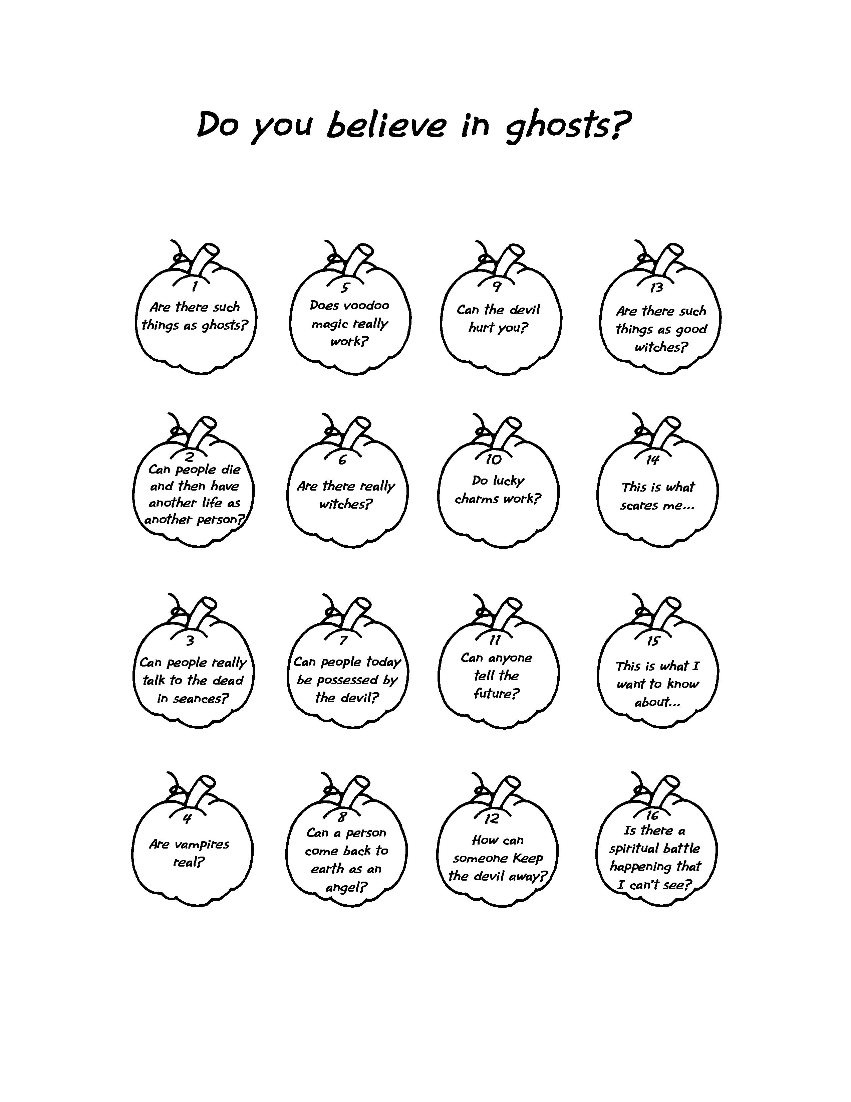
Game Sheet

Answer Sheet

“Do You Believe in Ghosts?”

Please keep answers brief so all kids can talk. Listen to their comments, and be praying for effective small group time at the end of today’s lesson to more fully prepare them with the truth. Tell the children that all these answers come from the Bible.
- No. The souls of people who have died do not stay around our world. But, there are spiritual beings created by God called angels and demons. Demons are angels who have “fallen” or turned away from God. But God is more powerful than they are because He made them. (Ephesians 6:12.)
- No. We only live once here on earth, but we do live forever, either in heaven or in hell. (Hebrews 9:27.)
- No. But they can make contact with the spirit world, talking to evil spirits who pretend to be other people who have lived before. (1 Samuel 28.)
- No. But people can get evil power from the devil.
- Yes. It can at times, but it does not work for good. Its power comes from the devil. (Exodus 7:22.)
- Yes. These are people who practice getting dark powers from the devil. (1 Samuel 28.)
- Yes. But usually for people to be controlled by the devil, they have to give him permission to take control of their lives. (Luke 11:14-26.)
- No. Angels are heavenly creatures who live in God’s presence and work for him. God sends them as messengers or to help us. (Psalm 91:11, Psalm 103:20, and Revelation 10:1.)
- Yes. But you can stand against the devil, and the devil will run away from you. (James 4:7.)
- No. But the devil would like us to trust in luck rather than trusting in God. (Exodus 20:4.)
- Yes. Sometimes God will let one of His special people prophesy about the future so that it helps people turn to Him. The devil doesn’t know the future. (Acts 21:10-11.)
- Call on the name of Jesus and tell the devil to “take a hike.” (Luke 10:18-20.)
- No. Some witches say they practice good magic. But God tells us that they are still going to the devil for their power and he might even disguise it to look like it’s good. (Deuteronomy 18:10-12, Acts 8:18-25, and 2 Corinthians 11:14.)
- Let the child answer.
- Let the child answer.
- Yes. And Jesus has won so you can win, too!
Large Group Presentation

Dao Dao Gets Spooked!

Puppet Presentation

Special props include a piece of garlic taped or strung to Dao Dao’s face. If a stone necklace is available, it could also be attached. Dao Dao should have a ridiculous look about him. Dao Dao will also need to have his head covered with a paper bag.

Teacher: Kids, should we see what Dao Dao is up to today?

Dao Dao: (Appears with bag over his head.) Is that you, Teacher?

Teacher: Dao Dao, what on earth is wrong with you?

Dao Dao: It smells terrible in here.

Teacher: No, I mean why do you have a paper sack over your head?

Dao Dao: Well, it’s that time of the year that really scares me. It’s Ghost Month. All those ghosts stuff scare me.

Teacher: So what’s with the paper bag?

Dao Dao: I figure that if I could just keep hidden then none of them would bother me. But it smells so bad in here.

Teacher: Let me see. (Lifts off the paper sack.) My goodness, Dao Dao. What is that on your nose?

Dao Dao: A piece of garlic.

Teacher: Why do you have a piece of garlic on your nose?

Dao Dao: To keep vampires away!

Teacher: Garlic doesn’t keep vampires away. It only makes things smell funny.

Dao Dao: That’s why it smells so bad. I thought I was keeping vampires away.

Teacher: No, you don’t have to worry about vampires. Vampires aren’t real. Although sometimes people pretend to be vampires and some of them might even follow the devil.

Dao Dao: Follow the devil?

Teacher: Yes, the devil will do anything he can to trick people and get them to turn away from God.

Dao Dao: Wow, that’s really spooky!

Teacher: It could be, Dao Dao, unless you know how to fight back.

Dao Dao: You mean I get to fight the devil?

Teacher: Actually, it’s Jesus who fights the devil. He has already beaten the devil. We just stand on conquered ground.

Dao Dao: Stand on conquered ground?

Teacher: Yes, we’ll explain that today. It is just like when an army fights for a territory, and when they are victorious, the territory becomes conquered ground. You can stand on Jesus’ conquered ground when you can claim his victory over the devil. You can tell the devil certain words that he can’t stand against.

Dao Dao: Are they secret words?

Teacher: No, they aren’t secret words. You’ll learn them today.

Dao Dao: Can I learn them now?

Teacher: Why don’t you listen to today’s lesson? See if you can learn the powerful words of spiritual warfare. Satan wants to trick us into staying on his side. He will use anything to get us. This is called spiritual warfare.

Dao Dao Gets Spooked
Dramatic Presentation

The large group leader selects one child from the audience who will be seated in the center of a large circle marked on the ground. There will be a large cross on a pole in the center. The child is standing on conquered ground.

An actor will play the role of Satan and will use his typical strategies to trick the child. Satan will try to get the child to forget the fact that he stands on conquered ground or not to use it. The leader then coaches the child (and all the kids) to stand on conquered ground by standing and saying *I belong to Jesus. Satan, take a hike.

Teacher: Does anyone else here feel like Dao Dao? Kind of scared of spooky things on Ghost Month? We want to help you know how you can fight Satan and his demons with the power of Jesus. (Put on an army hat, or something that helps you look like a soldier.)

Do you know there is a spiritual battle happening right now? It’s happening right here in our lives. You might not be able to see Satan or the demons, or you might not be able to see God and His angels but they are there. Let me show you how it works. (Call up a volunteer and have him sit on a chair in the circle with a cross in the middle of it.)

Do you know Jesus as your Savior and Lord? If you do, then you are standing with Jesus on conquered ground. The reason you are in this circle is to show that you live on conquered ground. Jesus already defeated His enemy and your enemy, Satan. He did that when He died on the cross for our sins. Jesus came back to life to give whoever trusts Him, the right to stand on His conquered ground. The war has been won. Jesus conquered Satan so Satan wouldn’t have power to keep us from God.

Introduce the volunteer to the group, finding out what hobbies he likes and some other personal information. You might even give him soldier’s gear.

Teacher: Do you know you’re going to heaven? Do you know God is with you wherever you go? Are your sins forgiven, even the really bad ones? When you believe this, you can stand on conquered ground. That means you can claim Jesus’ victory over Satan when he tries to scare or tempt you.

Satan doesn’t like this. When you trust Jesus as your Savior, the devil is really angry. He wants you to live on His ground, which is like living in a gooey, stinky pit that traps you and makes you a slave. If Satan can’t get you to live in this gooey, stinky pit,
he will try to come into your conquered ground and steal some of your good stuff like joy, peace, or freedom.
You have power over Satan through God’s Word. Jesus said in Luke 10:18-19, “I saw Satan falling like lighting from the sky. listen! I gave you power to walk on snakes and scorpions. I gave you more power than the Enemy has. Nothing will hurt you.”

You can tell Satan, *I belong to Jesus. Satan, take a hike. Practice this with me. Whenever you hear the cue “and everyone says…” you say *I belong to Jesus. Satan, take a hike.

Let me now introduce you to your enemy, Satan, sometimes called the Prince of Darkness or the devil.

The next part of this sketch takes imagination and drama from an actor portraying Satan. He will present four short monologues trying to convince us of the lies of who he is. (Option: Instead of an actor, have someone off-stage speak as the voice of Satan.)

The first monologue is one of Satan’s great lies: he really isn’t real or he’s merely a cute little character with a harmless pitchfork. Another aspect of this is that he is harmless and can be kind of friendly. The actor presents this in a monologue to the audience, but really goes at it with the child sitting on conquered ground.

The presenter then addresses the Satan character with the Bible verse:

Teacher: “Control yourselves and be careful! The devil is your enemy. And he goes around like a roaring lion looking for someone to eat.” (1 Peter 5:8). And everyone says…

Everyone: *I belong to Jesus. Satan, take a hike!

The Satan actor now goes to a different section of the stage. Here he puts on an evil black cape and horrible looking mask. He targets God’s child sitting on conquered ground. He speaks of his unstoppable powers. He tells how he was once an angel in heaven, but he wanted to be more powerful than God so he led a rebellion against God. He took a third of the angels with him, who are now his demons.

He will brag about being so horrible and mean that no one can stop him and his demons. He is like the monsters on television, except that he can’t be defeated. He will come and get every boy and girl because it’s his way of getting back against God. (There is some truth in much of this, but some lies as well. He is not all-powerful. As a matter of fact, Jesus has defeated him. When Jesus died on the cross, it broke the power of sin to separate us from God.)

Teacher: Jesus told his followers, “I have given you authority to overcome the power of the enemy!” Then everyone says…

Everyone: *I belong to Jesus. Satan, take a hike!

The presenter now exposes the truth. He comes over to Satan and pulls off the cape and gown. He shows that Satan usually comes to us in very ordinary everyday looking ways. Most of the time we don’t even realize his presence or influence. Sometimes he even comes to us disguised as something that sounds good or uses other tactics to invade our conquered ground.

Teacher: (With a sucker in hand.) Sometimes Satan will try to trap us with evil desires or things we want that are not God pleasing. An evil desire can be wanting something bad to happen to someone who has hurt you. It could also be something that we desire so much that we sin to get it. For example, is there anything wrong with this sucker in my hand? No of course not. But what if...

At this time, the Satan character takes the sucker, enters the circle, and begins to tempt. He extols the qualities of the sucker and then finally suggests that it would be worth it to climb up to the cabinet where the candy is kept at home and have one, even if you know you don’t have permission to do so.

Teacher: And everyone says…

Everyone: *I belong to Jesus. Satan, take a hike!

Teacher: Satan will also use worldly messages to tempt us.

The Satan character will use a well-known television commercial to tempt the child to believe the lie that if you just get more, then you will be happy. Or he can try and convince the child that he will be popular if he looks like a model or wears name brand clothing.

Teacher: You stand on conquered ground. And everyone says…

Everyone: *I belong to Jesus. Satan, take a hike!

Dao Dao: Teacher! Teacher! I think I’ve got it!

Teacher: What’s that, Dao Dao?

Dao Dao: I know the special words for spiritual warfare.

Teacher: What are they?

Dao Dao: I belong to Jesus…. (Rap style) so Satan, take a hike on your bike. I give you the psych, and take away your mic….
.
Teacher: Okay, Dao Dao, that’s enough. Just tell Satan to take a hike in Jesus’ name. We will say a closing prayer so the boys and girls can go back to their small groups?

Dao Dao: Sure!

Teacher: Dear God, thank You for Jesus defeating Satan on the cross. Thank You that I never have to be afraid of him. Thank You that I can resist Satan’s temptations because I can stand on the conquered ground that Jesus won for me. Help me to remember if ever I am scared or facing temptation to say… *I belong to Jesus. Satan, take a hike! Amen.

LESSON 23

Small Group Warm-Up:
- one game sheet for each group (see page 6)
- two sets of tokens, each a different color

Large Group:
- Dao Dao with a piece of garlic strung from or taped to his nose and a paper bag over his head
- stone necklace (if available)
- large circle marked on the floor
- chair
- cross on a pole
- army hat or fatigues for adult and child
- black cape and horrible looking mask
- sucker

Small Group Application:
- newspaper or table cloth for protecting work surface
- pencils, markers, or crayons
- paper plate for each child
- small rectangle sponge for each child
- pan or tray of washable red tempera paint for each group

Memory Verse L:earning:
- masking tape

