
Date: ____________________
Series: Pass the Promise (Sept-Nov)
Year 1, Lesson 25

Joseph’s
Brothers
In Egypt

Take Home Point: *God can make good from what seems bad.
*Repeat this phrase throughout the lesson.

Bible Event: Genesis 42-45
Key Verses: Jeremiah 29:11, “‘I know the plans that I have for you,’ declares the LORD…‘plans to give you a future filled with hope.’”
Genesis 50:20: “Even though you planned evil against me, God planned good to come out of it.”

We will help kids know:
- God works all things out for good in our lives.
- Joseph was faithful by forgiving his brothers and God forgave him.
- When we can’t see the whole picture, God is still there.

We will help kids feel:
- Confident that God is in control of what is happening in their lives.
- Hopeful when the picture of their life isn’t clear.

We will help kids do:
- Share their confidence with others when they are struggling with problems in their life.
- Pray for God’s peace in stressful times.

THIS LESSON’S ROADMAP

DESTINATION | PAGE # | DISCOVERIES ON YOUR JOURNEY | SUPPLIES NEEDED
Small Group Warm-Up   | 3-4 | Your group will try to assemble a puzzle without first seeing what it should look like. Sometimes it seems like the pieces of our life don’t fit together. But God knows what all the pieces look like when they are put together. | - one 25-50 piece puzzle for each group in a container other than the original puzzle box
Large Group   | 4  7-8  9-14 | Overview  Puppet Presentation: “Good Times, Bad Times”  Radio Drama: “Joseph’s Brothers in Egypt” | - Dao Dao  - various signs and sound effects  - football with a cross on it
Small Group Application   | 4-6  6-7 | Children will make a picture frame or refrigerator magnet to remind them that God knows their future and cares for them.  Memory Verse Learning:  “Memory Verse Puzzle”  Psalm 50:15 is recommended for lessons 24-25 to feel secure in the knowledge that God is with them even when a situation looks really bad. | Option 1:  - 2-4 x 6-inch rectangles of hard card for each child, one having a 2 x 3-inch center cut out  - Bible verse stickers  - glue  - puzzle pieces  Option 2:  - glue  - puzzle pieces  - Bible verse stickers  - 2 x 3-inch pieces of thick cardboard  - magnets  - two sets of Bible verse  puzzles for each group
Small Group Warm-Up: 15 minutes
Purpose: Get pointed in the right direction! Build relationships and help guests feel at ease. Do the learning readiness activity that will point your group in the right direction for the lesson.

Supplies needed: one 25-50 piece puzzle for each group in a container other than the original puzzle box

For this activity, use a 25 to 50-piece puzzle that is in a container other than the original box. The puzzle should not be in the original box because we do not want the children to see the picture. (If you are unable to find puzzles, cut pictures from magazines to make puzzles.)

I will give you the next three minutes to put this puzzle together.

There may be many complaints from the children due to the fact that they can’t see the whole picture. Stop the process after three minutes. (Be sensitive to younger children and stop the activity before it reaches a major frustration level.)

What made this so difficult? (The children were unable to see the whole picture to know where things went.)

We are going to compare our life to a puzzle today. Life may be very difficult at times because we just cannot see the whole picture.

Share a time in your life when you could not see the whole picture of what was happening but later God revealed it. It could be about a sickness or tragedy in the life of a family member or friend and how God worked in that circumstance.

Can you think of situations that seem unfair at times? Are things happening in your life that seem confusing? Can you think of something that hasn’t worked out the way you wanted it to? Would you share that with the group?

Let the kids talk about areas in their lives that seem really confusing. You may need to give children examples like “Are you having any problems with your friends or your parents?” “What about school?” “Do you know of some family going through a divorce or death of a loved one?” “What about the death of a pet?”

Imagine that your life is like this puzzle. Can you tell how it will finally end up looking? Not now, anyway. As a matter of fact, sometimes in our lives it seems that few things fit together, or sometimes it may seem that nothing fits together! But God sees the entire picture. He knows the future so he knows how it is going to be.

When we trust in God and what Jesus has done for us through His death on the cross, we know that all the pieces of the puzzle will fit together. In the Bible event today we will learn that *God can make good from what seems bad.

Large Group: 20-30 minutes
Purpose: Help kids observe what the Bible says. Present the Bible event in creative fashion. Help kids begin to interpret what it means.

Supplies needed: Dao Dao; various signs and sound effects; football with a cross on it

Overview:

Puppet Presentation: “Good Times, Bad Times”
Dao Dao tells about all the terrible things that happened to him this past week, but he learns that even in his life *God can make good from what seems bad.

Radio Drama: “Joseph’s Brothers in Egypt”
Joseph was reunited with his brothers and father when they came to Egypt for food during the famine. Even though his brothers had intended evil against him, it is clear that God planned good to come out of it.

Small Group Application: 20-25 minutes
Purpose: Help kids map out the meaning of the Bible event in their lives. Use the questions to stimulate discussion but don't feel tied to them. Allow the Holy Spirit to guide you. Include personal examples from your own faith journey. The example of Christ at work in your life will leave lasting impressions of how Christ can work in the children's lives.

Use your Bibles! Children need to learn how to look up references and follow along when scripture is read aloud. Allow for quality time of prayer at the close of the lesson.

Observation Questions: What happened?
The first time the brothers went to Egypt, Simeon was thrown in jail. Joseph told them they couldn’t come back without Benjamin. What do you think the brothers thought about that? What do you think they thought their father would say? Why didn’t Jacob want to let Benjamin go? (Genesis 42:36. He had already lost two sons, Joseph and Simeon. He was afraid he would lose a third son.)

When Joseph revealed himself to his brothers, what did he say? (Genesis 45:5-8. “Don’t be sad or angry with yourselves that you sold me. God sent me ahead of you to save lives…”)

Interpretation Questions: What does this mean?
How do you think the brothers felt when they found out who Joseph was? Do you think they were sorry for what they had done?

Why do you think Joseph didn’t tell his brothers right away who he was? (He was testing them to make sure they had really changed.)

Do you think it was difficult for Joseph to forgive his brothers? (It probably was at first, but Joseph knew God saw the big picture and only wanted what was best for him. He trusted God to take care of everything else.)

Read the key verse.

Joseph later said in Genesis 50:20, “You meant to hurt me. But God turned your evil into good.”

Application Questions: What does this mean to me?
Joseph had to go through many different changes in his life. What changes does God make in our lives? (He changes us from not being a part of His family to being His own children. He does this when we trust Jesus as our Savior. Our water baptism is a way God calls us His children.)

Read Jeremiah 29:11.

How does this verse make you feel about God? How does it make you feel about your future?

Let’s memorize a part of that verse. “‘I have good plans for you. I don’t plan to hurt you. I plan to give you hope and a good future.’”

What do you think this verse means?

Option: You could have kids write this part of the verse in their own words.

Application Activity:
As the children work on the following activity, use the time to talk to individual children about areas in their lives where it is difficult to see God’s plan. Share your knowledge of God’s love for you. Reassure them of God’s care. Help the children through the power of the Holy Spirit to learn to trust God’s heart.

Option 1: Picture Frame
Supplies needed: 2-4 x 6-inch rectangles of hard card for each child, one having a 2 x 3-inch center cut out; Bible verse stickers; glue; puzzle pieces

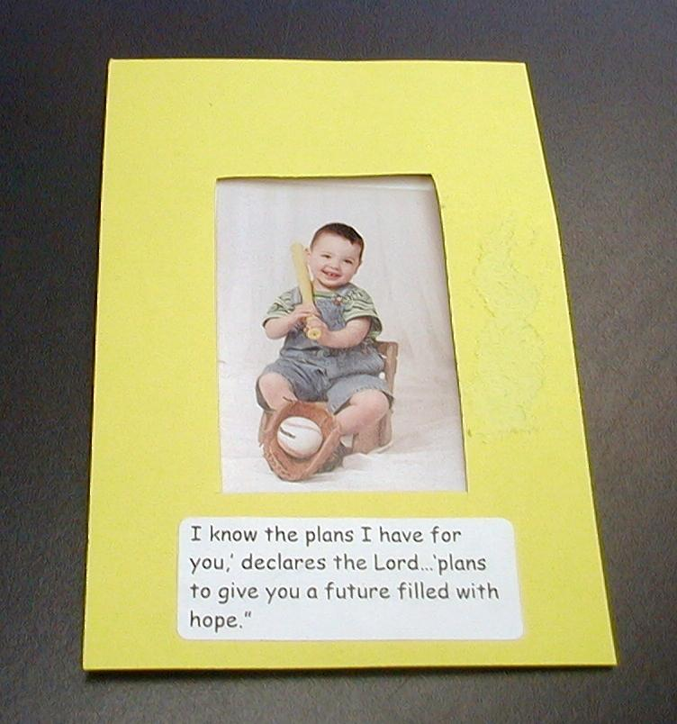
To make the frame, glue the two pieces of hard card together with a thin line of glue around two of the sides and along bottom. Leave the top open so when dry, a picture can be slid inside. Glue the puzzle pieces to the edge of the frame overlapping them.

Put a sticker on the bottom of the frame that reads, “‘I have good plans for you. I don’t plan to hurt you. I plan to give you hope and a good future.’”

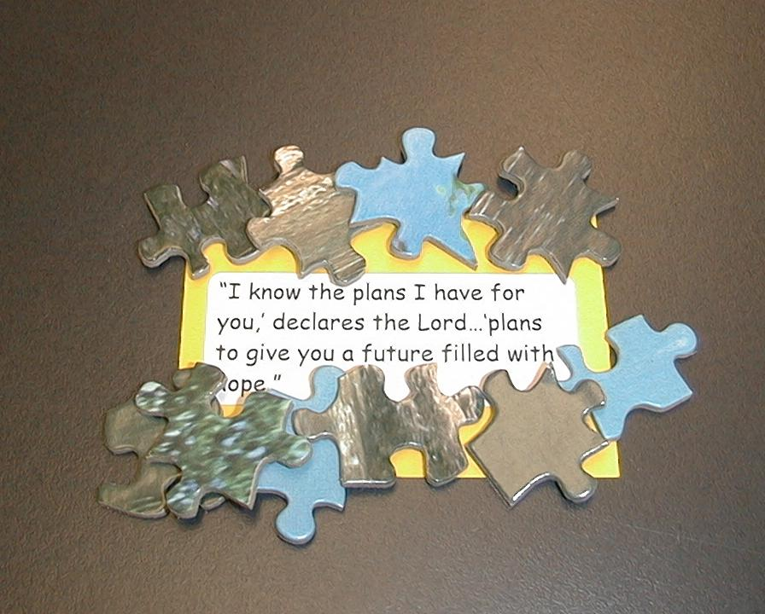
Option 2: Refrigerator Magnet
Supplies needed: glue; puzzle pieces; Bible verse stickers; 2 x 3-inch pieces of thick cardboard ; magnets

Attach the magnet to the back of cardboard or fun foam. Stick the Bible verse on one side of the cardboard or fun foam. Glue puzzle pieces in several layers to one side.

No matter how impossible things look and no matter how difficult it is to see the future, God knows your future and cares for you. *God can make good from what seems bad.

Memory Verse Learning: 5 minutes
Purpose: Help kids to memorize and keep scriptures at heart. Using creative ways to help kids enjoy learning the key verse and in small group setting.

Supplies needed: two sets of Bible verse puzzles for each group

Memory Verse: Psalm 50:15 ~ “Call to Me in times of trouble. I will save you, and you
will honor Me.”

MV Presentation: “Memory Verse Puzzle”
It is a puzzle challenge between two persons. As a review to the verse learnt last week, show the children a completed puzzle. Have the children say the verse a few times before setting them to challenge one another. The challenge is to see who can be the first among both of them to finish assembling the puzzle and say the verse a loud.

Prayer Time:
This lesson may bring up many personal concerns for the children. Spend plenty of time praying for these together as a group.

Good Times, Bad Times

Puppet Presentation

Dao Dao: I’ve had a terrible week! Pastor is never going to speak to me again.

Teacher: Dao Dao, tell me about it. What happened?

Dao Dao: Well, I got a brand new bicycle.

Teacher: That’s good.

Dao Dao: But as I was riding over to show Pastor, I ran into the back of his car and put a dent in his trunk.

Teacher: That’s bad.

Dao Dao: I fell off and skinned my knee. Pastor came out and took me into his house and put this really cool bandage on it.

Teacher: That’s good.

Dao Dao: When I came back outside, my tire had gone flat from hitting the car.

Teacher: That’s bad.

Dao Dao: Pastor helped me fix my tire so I could get home.

Teacher: That’s good.

Dao Dao: My dad said if I had another wreck, I would have to put the training wheels back on my bike.

Teacher: That’s bad.

Dao Dao: My mom invited Pastor and his family over for dinner that night.

Teacher: That’s good.

Dao Dao: I spilled my milk at the table and it all dumped on Pastor’s plate.

Teacher: That’s bad.

Dao Dao: Pastor said that he likes his mashed potatoes a little bit soggy. But my mom got him a new plate of food.

Teacher: That’s good.

Dao Dao: But I think Pastor must be getting scared to be around me. I don’t think he will ever want to speak to me again.

Teacher: Pastor and I had lunch together the other day and you know what he told me? He told me how glad he was that he got to spend time with you this week.

Dao Dao: You mean he didn’t say he hated me?

Teacher: No, Dao Dao, Pastor loves you. He gave me a message for you. He wants you to be on a ministry team that talks to kids who are going through hard times. Pastor says God has really wonderful plans for you even when things go bad!

Dao Dao: Wow! That is really good!

Teacher: Dao Dao, let’s listen to our radio drama and hear the last story about Joseph. He found the same truth you did. *God can make good from what seems bad.

Joseph’s Brothers In Egypt

Radio Drama

Cast and Voices:

- Host
- Sound Tech
- Jacob
- Joseph
- Reuben
- Simeon
- Brother 1
- Brother 2

The stage is set with a table and freestanding microphones for the host and actors. Any of the main characters can be costumed and sitting at the table according to the number of volunteers available. Hidden off stage or behind a screen are a table with props and microphones for other voices. Use the KLIF station signage from previous weeks. The host will remind the "studio audience" of their participation in making sound effects when cue signs are shown. The sound tech and the audience will then begin the countdown.

Sound: 5-4-3-2-1...

Sign: ON-THE-AIR

Host: Welcome to (the name of your Sunday school) radio station KLIF, 21.27 on your FM dial, the station that reports how God passes the promise to His people. (Holds up football with a cross on it.)

Sign: APPLAUSE

Host: Hi, I'm ________, and we are broadcasting live from________. Today is the final episode in our four-part series on Joseph. Last week's episode was "Joseph, a Ruler in Egypt." When we left, Joseph had been appointed by Pharaoh to oversee the storage of grain for the famine that was to come. The famine did come—and not just to Egypt. The famine had reached Canaan, and Jacob told his ten sons to load up the donkeys and head to Egypt.

Jacob: Okay! Reuben, Simeon, Levi, Judah Dan, Naphtali, Gad, Asher, Isaachar, and Zebulun out the door with you. Go down to Egypt and buy some food or we’ll all starve.

Sound: DONKEY SOUNDS and TRAVELING MUSIC

Host: Oh! There they are now. Let's catch up and find out what happens in Genesis 42-45 in today's episode "Joseph’s Brothers in Egypt.”

When the brothers arrived in Egypt and went to buy grain,
who should be standing there but Joseph!

Sign: OOH

Host: Now, many years had passed and even though Joseph recognized his brothers, they did not recognize him. The brothers went before Joseph and bowed down before him. (Sound familiar?)

Sound: ZITHER

Host: The dream! Remember the dream he told his brothers?

Sign: AAH

Host: Joseph decided not to tell his brothers who he was. He said to them harshly…

Joseph: Where do you come from?

Reuben: We come from the land of Canaan. We have come to buy food.

Host: Now Joseph wasn't quite ready to let his brothers know who he was. (I think he decided to have a little fun with them.)

Joseph: You're lying. You've come to spy on Egypt!

Brothers: No! No!

Brother 1: No my lord! The only reason we've come is to buy food.

Joseph: No way! You're spies!

Brother 2: No! Please listen. We are ten of 12 brothers from the land of Canaan. Our youngest brother is at home with our father and one brother is…

Sound: DUM DA DUM DUM

Brother 1: (Downcast.) …no longer with us.

Host: I guess they didn’t want to say that they sold him into slavery.

Joseph: I don't believe you!

Host: So Joseph had the brothers thrown in prison for three days.

Sound: SOMETHING THROWN, DOOR SLAMS, and KEYS JINGLE

Brothers: Hey! Not so rough!

Host: At the end of the three days, Joseph had the brothers brought to him and said…

Joseph: If you are honest, let one of your brothers stay here in prison while the rest of you go and take grain back to your home. But, you must bring your youngest brother back to me to prove you were telling the truth.

Reuben: Didn't I tell you not to sin against "you-know-who?" Now we're in trouble because of it!

Host: With that, Joseph had Simeon tied up and taken to prison.

SOUND: SOMETHING THROWN, DOOR SLAMS, and KEYS JINGLE

Simeon: Ow! Not so rough!

Host: And Joseph let the nine remaining brothers buy sacks of grain to take back to Canaan. When the brothers arrived back home, they told Jacob all that happened to them. They said the Egyptian ruler (Joseph) had imprisoned Simeon, and would not let him go until the brothers brought Benjamin to him.

Jacob: What?! Joseph is gone? Simeon is in prison? And now you want to take Benjamin? No! My son will not go! His brother is dead and he is the only one left.

Brother 2: Excuse me, Dad, but from my count you still have ten sons left.

Jacob: No! If anything would happen to Benjamin, I would die!

Host: But the famine continued and soon Jacob and his sons were out of food.

Jacob: You must go back to Egypt and buy more grain.

Brother 2: But, Father, remember what we told you. If we go back to Egypt without Benjamin, we'll all be killed!

Brother 1: Then you will only have one son left.

Sound: DUM DA DUM DUM

Host: Reluctantly, Jacob agreed to send Benjamin with them. He also sent gifts of honey, spices, nuts, and twice as much silver as they would need to pay for the grain. The ten brothers and Benjamin loaded up the donkeys and headed to Egypt.

Sound: DONKEY SOUNDS and TRAVELING MUSIC

Host: When Joseph saw the brothers had arrived, he had them brought to his house for dinner. The brothers bowed low before Joseph and gave him the gifts their father had sent.

Joseph: How is your father? Is he still living?

Reuben: He is alive and well.

Joseph: And this must be your little brother, Benjamin.

Host: When Joseph saw Benjamin he was overcome with joy and had to leave the room because he began to weep.

Sound: CRYING and NOSE BLOWING

Brother 1: Way to go, Reuben. What did you say?

Host: When Joseph returned, he brought back Simeon from prison.

Simeon: What took you guys so long?

Host: They sat down and had a meal together.

Brother 2: Pass the figs, please.

Brother 1: More bread?

Host: That night after dinner Joseph said to his servants…

Joseph: Fill each man's sack with grain and make sure you put the silver they brought back in the sack, too. Then, put my silver cup in the sack of the youngest, along with his silver money.

Host: The next morning all 11 brothers set off for home. They hadn't gone far when a group of Egyptian guards came charging after them.

Sound: HORSE HOOVES

Brother 1: Uh-oh.

Simeon: It's somebody else's turn to go to prison this time.

Host: The guards searched the brothers’ sacks and, sure enough, they found the silver cup in Benjamin's sack!

Sign: OOH

Host: The brothers were terrified!

Sound: TEETH CHATTER

Host: The guards took all 11 of them back to Egypt.

Sound: DONKEY SOUNDS and HORSES HOOVES

Host: When they arrived at Joseph's house, Joseph was waiting for them.

Reuben: Oh, Master! It must be a mistake.

Brother 2: We wouldn't steal anything from you.

Host: Joseph could keep his secret no longer.

Joseph: I am Joseph, the one you sold into Egypt!

Sound: DUM DA DUM DUM

Host: The brothers were terrified!

Sound: TEETH CHATTER

Joseph: Do not be afraid for even though you planned evil against me, God planned good to come out of it. If you hadn't sold me, many people would have died from the famine. Now hurry! Go back home and tell Father that I am alive and want him to bring all he owns and come to live with me here in Egypt!

Sign: YEA and APPLAUSE

Host: So Joseph settled his father and brothers in Egypt and gave them property in the best part of the land. And God blessed them with great prosperity (they became rich) and their numbers increased (they became a great nation).

Sign: APPLAUSE

Host: Wow! What an exciting story! Even though Joseph had been sold by his brothers and thrown in prison for crimes he didn't commit, he realized that *God can make good from what seems bad.

That does it for now. This is radio KLIF, the station that reports how God passes the promise to His people.

Sign: APPLAUSE and ON-THE-AIR come down

Teacher: Without Joseph, Jacob, and his family would have starved to death. But God had a plan and He wanted to Pass the Promise on to the next generation. God was faithful to Jacob and Joseph. Joseph believed God could turn anything bad that happened to him into greater good.

Genesis 50:20 says, “You meant to hurt me. But God turned your evil into good. It was to save the lives of many people.” We can trust God even when bad things happen in our lives. Let’s pray and ask God to give us an attitude of trust.

Dear Father, I am so glad You see the whole picture of my life. I am glad You would never mean to harm me. Thank You for only wanting what is the best for me. Help me trust You more when I can’t see the whole picture. Amen.

LESSON 25

Small Group Warm-Up:
- one 25-50 piece puzzle for each group in a container other than the original puzzle box

Large Group:
- Dao Dao
- various signs and sound effects
- football with a cross on it

Small Group Application:
Option 1:
- 2-4 x 6-inch rectangles of hard card for each child, one having a 2 x 3-inch center cut out
- Bible verse stickers
- glue
- puzzle pieces

Option 2:
- glue
- puzzle pieces
- Bible verse stickers
- 2 x 3-inch pieces of thick cardboard
- magnets

Memory Verse L:earning:
- two sets of Bible verse puzzles for each group. Find templates on page 17 & 18.

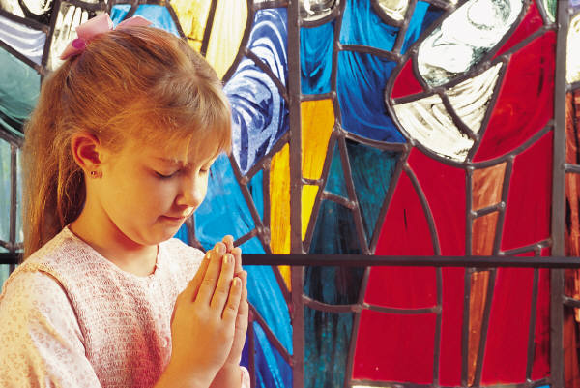

Psalm 50:15
Call to Me in times of trouble.
I will save you, and you will honor Me.”

Psalm 50:15
Call to Me in times of trouble.
I will save you, and you will
honor Me.”



