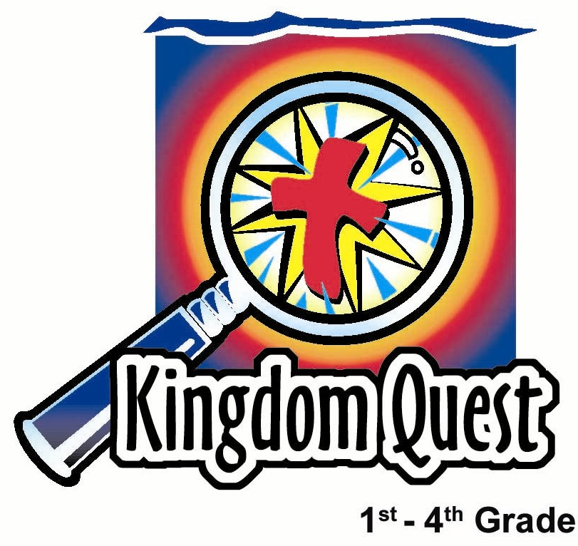
Date: ____________________
Series: Pass the Promise (Sept-Nov)
Year 1, Lesson 27

The Festival of Sukkot-Thanksgiving

Take Home Point: *God wants to bless us with joy. We are to say thank you back to him.
*Repeat this phrase throughout the lesson.

Bible Event: Leviticus 23:33-44, Deuteronomy 16:13-15, Nehemiah 8:13-18
Key Verse: Psalm 107:1, “Thank the Lord because He is good. His love continues forever.”

We will help kids know:
- The children will learn about the Festival of Sukkot and its significance to the Israelite people.
- God fills our lives with blessing. It is important to say “Thank You” back to Him.

We will help kids feel:
- Joyful for all the blessings God gives.
- Thankful!

We will help kids do:
- Build a sukkah.
- Pray with a thankful heart.
- Develop a family mission project.

THIS LESSON’S ROADMAP

DESTINATION | PAGE # | DISCOVERIES ON YOUR JOURNEY | SUPPLIES NEEDED
Small Group Warm-Up   | 4-5 | It is important to say thank you—especially to God. Ask a child to hand out candy as your group comes in. See how many thank you responses are given. | - bag of sweets for each group (approximately 20 pieces)  - mahjong paper (optional)  - colour pencils (optional)
Large Group   | 5  8-9  9-10 | Overview  Puppet Presentation:  “Dao Dao’s Cool New Fort”  Dramatic Presentation: “The Feast of Tabernacles” | - Dao Dao  - sukkah made for the stage (with the roof unfinished)  - adult Hebrew woman costume
Small Group Application   | 6-7 | Pretend you are Hebrews getting ready for the Festival of Sukkot and build a sukkah. As you do, everyone should say something they are thankful for.  (No memory verse learning for this lesson.) | - palm leaves  - colour paper strips to make paper chains  - paper leaves for each child to take home  - masking tape  - sheets or blankets may be needed for those shepherds who forgot to bring one from home  - chairs or dividers  - branches  - artificial fruits

Background Information on the Festival of Sukkot

The festival of Sukkot (sue-COAT) is a joyous festival of thankfulness, similar to our Thanksgiving. It was celebrated after the harvest was gathered in late September or early October. Sukkot is the Hebrew word for “booths.” The singular is sukkah (sue-KAH). This holiday celebrates God’s rich blessings in nature and His protection. God’s Word says in Deuteronomy 16:14 (NIV), “Be joyful at your Feast…” and in Nehemiah 8:17 (NIV), “And their joy was very great.”
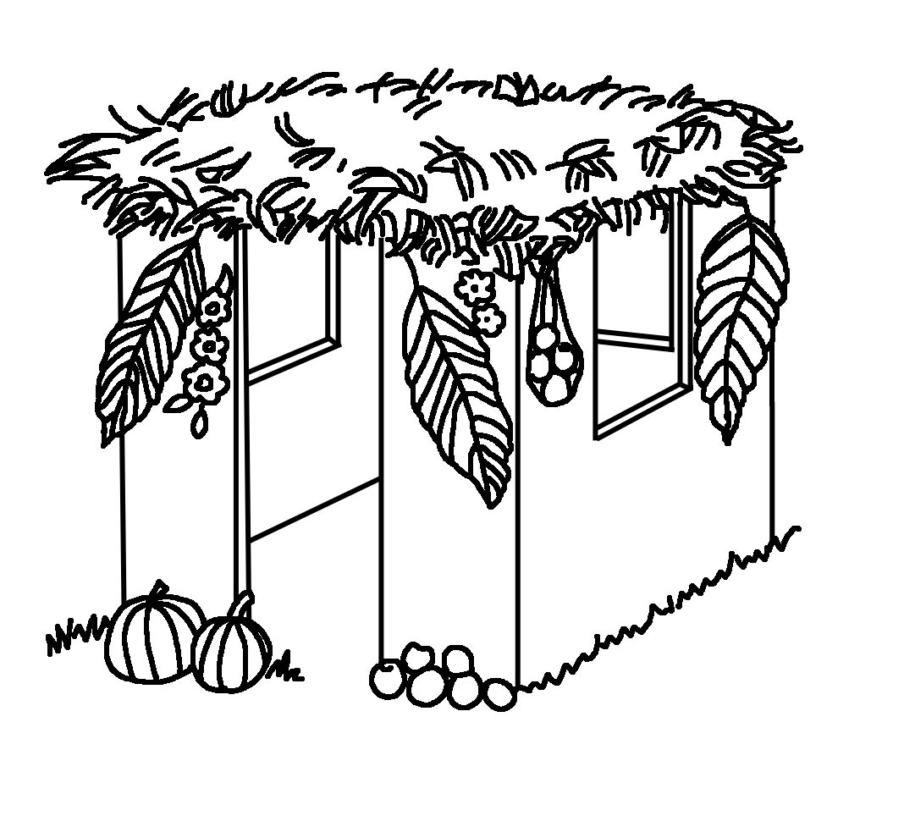
The booths, or tabernacles, remind the people of the booths the Israelites lived in as they traveled through the desert. Leviticus 23:34, 42-43 (NIV) says, “On the fifteenth day of the seventh month the Lord’s Feast of Tabernacles begins…All native-born Israelites are to live in booths so your descendants will know that I had the Israelites live in booths when I brought them out of Egypt.” The Festival of the Booths, the Feast of Tabernacles, and the Festival of Sukkot are all titles for the same festival, which lasts seven days.

The Old Testament Jewish family prepared for this festival by building a sukkah. It was a small hut with a roof made of leafy tree branches or wooden slats. It protected them from the sun and the heat during the day but allowed them to see the stars at night. They would decorate the outside of the sukkah with flowers, fruit, and paper chains. The families would eat and sleep there for seven days.

In your small group today, you will be building a sukkah. Please bring from home a sheet or blanket. To decorate your sukkah, you can also bring branches, leaves, fruit, autumn garland, or grape vines. You may join with one or two other groups close around you, if you wish.

Small Group Warm-Up: 15 minutes
Purpose: Get pointed in the right direction! Build relationships and help guests feel at ease. Do the learning readiness activity that will point your group in the right direction for the lesson.

Supplies needed: bag of sweets for each group (approximately 20 pieces); mahjong paper (optional); colour pencils (optional)

This activity is designed to remind the children of the importance of saying thank you. Pick an early arriving child to be your helper. Give him a bag of sweets that he will share with the other children. Explain to the helper that when he gives each child a piece of sweets and she says thank you, he gets a piece of sweets for himself. He gets sweets only if he gets a thank you response. Explain to the helper that this is a secret and not to say anything about it. If no one says thank you, have the helper give you a piece of sweets and you will model the appropriate response.

When finished handing out sweets, say:

Did you notice that (helper’s name) only got a piece of sweets sometimes? Were you observant enough to figure out when he got a piece of sweets?

If no one can answer, have the helper explain.

How do you think it made him feel if you forgot to say thank you? How do you think it would have made him feel if everyone said thank you?

What are some things in your life for which you are thankful? Who in our lives should we say thank you to? Do we always remember to thank God for everything he gives us?

Option: Have kids make a mural using newsprint paper and colour pencils. Title the mural, “Blessings we are thankful for…” Have kids draw pictures of all the things in their lives for which they can give thanks to God. This mural could be used to decorate their sukkah made later in the lesson.

Today we are going to learn about the Feast of Tabernacles or the Festival of Sukkot. God has commanded the children of Israel to celebrate this feast as a reminder that they had lived in tabernacles while they traveled in the desert. Then we will build a little hut or tabernacle called a sukkah.

Listen to what the Word of God says in Leviticus 23:39-43. Listen to how many times you hear the word “celebrate” and hold up a finger for each time you hear that word.
“However, on the fifteenth day of the seventh month, when you have gathered what the land produces, celebrate the LORD’s festival for seven days. The first and eighth days will be worship festivals. On the first day take the best fruits, palm branches, the branches of leafy trees and poplars, and celebrate in the presence of the LORD your God for seven days. It is the LORD’s festival. Celebrate it for seven days each year. This is a permanent law for generations to come. Celebrate this festival in the seventh month. Live in booths for seven days. Everyone born in Israel must live in booths so that generations to come may learn how I made the people of Israel live in booths when I brought them out of Egypt. I am the LORD your God.”

How many times did you hear the word “celebrate”? (Four.) When God says something three or more times in the Bible, that means it is very important.

What did God consider so important for His people to do? (Celebrate, have fun, be joyful.)

We will learn more about the Festival of Sukkot in large group. *God wants to bless us with joy. We are to say thank you back to Him.

Large Group: 20-30 minutes
Purpose: Help kids observe what the Bible says. Present the Bible event in creative fashion. Help kids begin to interpret what it means.

Supplies needed: Dao Dao; sukkah made for the stage (with the roof unfinished); adult Hebrew woman costume

Overview:

Puppet Presentation: “Dao Dao’s Cool New Fort”
Dao Dao learns what it means to be thankful.

Dramatic Presentation: “The Feast of Tabernacles”
Children will see a model of a sukkah and hear from a Hebrew woman about the Feast of Tabernacles.
Small Group Application: 20-25 minutes
Purpose: Help kids map out the meaning of the Bible event in their lives. Use the questions to stimulate discussion but don't feel tied to them. Allow the Holy Spirit to guide you. Include personal examples from your own faith journey. The example of Christ at work in your life will leave lasting impressions of how Christ can work in the children's lives.

Use your Bibles! Children need to learn how to look up references and follow along when scripture is read aloud. Allow for quality time of prayer at the close of the lesson.

Observation Questions: What happened?
How many days did the families live in the sukkah or tabernacle? (Seven.)

Why did God ask them to live in the sukkah? What was the purpose of this feast? (They were to be thankful for their rich harvest and remember how God had protected them when he brought them out of Egypt.)

Interpretation Questions: What does this mean?
How do you think the families felt at this feast? (Read Deuteronomy 16:14 and Nehemiah 8:17. Joyful.)

Why do you think the people were so joyful? (God had richly blessed them.)

Why do you think God asked the people to celebrate this festival? (It was important that the people give thanks to God for all he had done. God wanted His people to experience joy.)

Why do you think God told the people to build a special place in which they could celebrate their thanksgiving?

Application Questions: What does this mean to me?
Do you have things that you are thankful to God for?

What is God’s greatest blessing of all time for all people? (Jesus was sent to save us.)

What kind of offering of thanks can we give back to God?

Application Activity:

Supplies needed: palm leaves; colour paper strips to make paper chains; paper leaves for each child to take home; masking tape; sheets or blankets may be needed for those shepherds who forgot to bring one from home; chairs or dividers; branches; artificial fruits

“Building a Sukkah”
To make the structure for your hut you may use chairs or dividers to drape sheets and blankets over. Then have the children decorate it with paper leaves and paper chains.

We are going to pretend that we are Hebrew people getting ready for the Festival of Sukkot. We will build and decorate a sukkah. We want to do this with an attitude of reverence and worship for God. This is our act of thanksgiving to Him.

After the structure is built and you are ready to decorate, say:

As you put a decoration onto the sukkah, you can say something that you are thankful for. But this will be done a special way. You are to say, “Give thanks to the Lord because…” and say whatever you are thankful for. Everyone else responds with “His love continues forever.”

(This is modeling praises found in Psalm 136.)

Take enough time to build your sukkah but leave plenty of time to explain the activity that they will take home. Have the children sit in the sukkah and say:

Here is a special activity for you to do with your family. Each of you will take home a paper leaf. When you sit down to dinner, pass this leaf around the table. As each person receives the leaf, he is to share about one thing for which he is thankful.

But don’t just end there. God wants us to also show our thanks in our actions. See if you and your family can do a thanksgiving mission project. Come up with a way that shows God how much you appreciate what He has done by giving back to someone else. Maybe you can make a basket of food for someone who needs it. Do you know someone who might need some extra help around his house, like raking leaves? All of these are ways of saying thank you to God.

Write your family’s mission project on your leaf and bring it back next Sunday. We will put it on the sukkah that we had in large group today. This will be a special way we can all celebrate what we did to thank God.

Prayer Time: Close with a special time of prayers of thanksgiving.
Dao Dao’s Cool New Fort

Puppet Presentation

A sukkah will be assembled onstage.

Dao Dao: Hey,Teacher. Check this out! A cool new fort!

Teacher: Oh, you mean this. (Referring to the sukkah.)

Dao Dao: Yeah, a fort. I love to make forts. Then I pretend I’m the good guy beating out the bad guys.

Teacher: This isn’t a fort, Dao Dao. It’s a sukkah.

Dao Dao: Say what?

Teacher: Sukkah.

Dao Dao: Who are you calling sucker?

Teacher: No, it’s what the ancient Israelites built. They built a booth kind of like a fort, and the whole family camped in it. There they counted the blessings.

Dao Dao: No way! The whole family played in the fort?

Teacher: It wasn’t play. They camped there to remember how much God had blessed their ancestors when they were camping in the wilderness. They practiced being thankful to God.

Dao Dao: Oh. I think I’d rather play forts with the good guys on the inside and the bad guys on the outside.

Teacher: You still can. Today you can build a sukkah, climb in it, and count all the blessings you have.

Dao Dao: Blessings? Let me see…there’s my smarts, my good looks, my modesty…

Teacher: (In a correcting tone.) Dao Dao…

Dao Dao: Well, what blessings do I count?

Teacher: Today you need to think of some. Don’t forget the big blessings that are spiritual. Just like God provided for the Old Testament people throughout their wanderings, He provides for us through our lives.

Dao Dao: Like how?

Teacher: The biggest blessing is His Son, Jesus, who is alive and with us right now.

Dao Dao: Oh, I think I’m beginning to get it. When do we start?

Teacher: As soon as we hear from an expert on Sukkot.

Dao Dao: Okay. I’ll go back here and listen. See you later! And if you need any advice on how to build a fort for good guys and bad guys, just let me know.

Teacher: Okay, Dao Dao.

Dao Dao: Bye, kids!

Teacher: Bye, Dao Dao.

The Feast of Tabernacles

A sukkah, or tabernacle, with the roof unfinished sits on the stage. A woman comes out carrying several palm leaves and branches.

Aaron! We still need branches for the roof!

(Talking to self.) I don’t mind gazing at the heavens tonight, but our neighbors camped above us might not want to gaze on us!

(Looking to heaven.) Lord, every time I look at the heavens, the stars, and all the mystery of the universe, it reminds me of you. You have created it all and you are so wonderful.

(Noticing audience.) Oh, I’m sorry. I didn’t see you there. It’s been so busy with finishing the harvest and now preparing the sukkah, or tabernacle, for the feast. (Looking to side.) Excuse me.

Caleb! Jacob! Put the stones down and go help your father. Gather more branches for the sukkah. (Looking to heaven.) Lord, thank You for my sons that are strong and healthy. Thank You for my husband. Most of all, thank You for pouring so many blessings into our family.

(Back to audience.) I’m sorry for the interruption, but there’s so much to do. Today is the first day of the Feast of Tabernacles.

The Feast of Tabernacles is one of the special festivals that God instructed His people to hold each year. We have wonderful food and laughter. We tell stories of how God has loved us and chosen us to be His people. We tell stories about how God cared for His people when they left Egypt and traveled through the desert to Canaan with Moses.

(Looking to side.) Aaron! Wonderful! Come with the branches, my dear. I’m just chatting here with some of our neighbors.

The feast begins after the harvest, when all the fruits and grains have been gathered. Each family makes a sukkah or tabernacle, like this one here. For seven days we live in the sukkah celebrating and thanking God for all His goodness and blessing. It’s a wonderful time full of prayers of thanksgiving. We have wonderful meals together. We celebrate God’s goodness!

(Looking to side.) Oh! I must leave you now. Aaron and the boys will soon finish the roof. I must have our dinner feast ready. And to you, have a blessed Sukkot.

LESSON 27

Small Group Warm-Up:
- bag of sweets for each group (approximately 20 pieces)
- mahjong paper (optional)
- colour pencils (optional)

Large Group:
- Dao Dao
- sukkah made for the stage (with the roof unfinished)
      - adult Hebrew woman costume

Small Group Application:
- palm leaves
- colour paper strips to make paper chains
- paper leaves for each child to take home
- masking tape
- sheets or blankets may be needed for those shepherds who forgot to bring one
from home
- chairs or dividers
- branches
- artificial fruits

