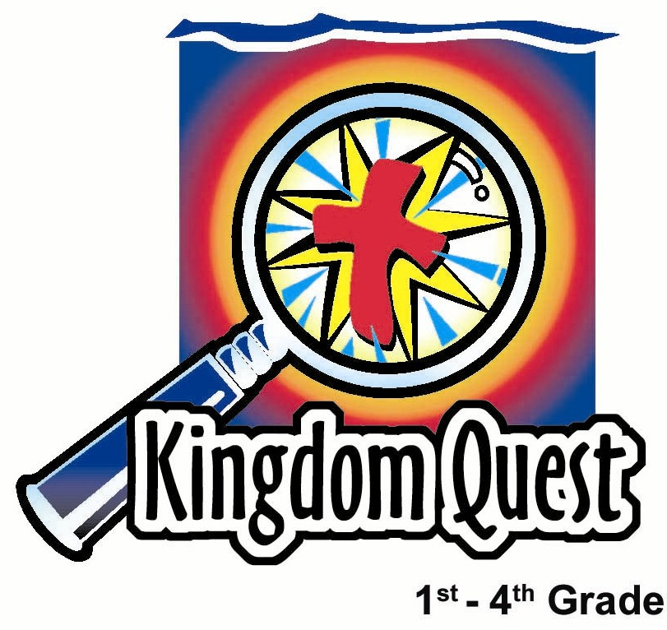
Date: ____________________
Series: The Early Church (Apr-May)
Year 1, Lesson 50

Sent by the King

Take Home Point: *Witnessing is showing and telling about our friendship with Jesus.
*Repeat this phrase throughout the lesson.

Bible Event: Acts 1:3-11 Jesus ascends to heaven.

Key Verse: Acts 1:8 “But the Holy Spirit will come to you. Then you will receive power. You will be my witnesses - in Jerusalem, in all Judea, in Samaria, and in every part of the world.”

We will help kids know:
- What it means to be a witness.
- The Holy Spirit will give them power.

We will help kids feel:
- Empowered to share the Gospel.
- Excited about sharing the good news.

We will help kids do:
- Make a witness tool.
- Identify those in their lives who are their witness targets.

THIS LESSON’S ROADMAP

DESTINATION | PAGE # | DISCOVERIES ON YOUR JOURNEY | SUPPLIES NEEDED
Small Group Warm-Up   | 3-4 | Kids are shown why a friendship is such a wonderful tool in “showing and telling” about Jesus. | - a paper bag  - a completed friendship bracelet and a card for each group. (see appendix)
Large Group   | 4  8-11 | Overview  Puppet Presentation: “Reporter Dao Dao and Eyewitness News” | - Dao Dao dressed as a news reporter (possibly with glasses and a tie)  - news desk  - banner reading, “News Center K-I-N-G”  - sign on news desk reads, “Passover Week 30 A.D. "  - large friendship bracelet needs to be made and displayed. Use construction paper strips of 12x3-inch in the colors of black, red, white, blue, green, and yellow. Option: use the life-sized bracelet from the application activity.  - target on an overhead  - video, The Visual Bible: Acts (1:3-11)
Small Group Application   | 5-7  12-14  6 | Questions and discussion will help kids understand the power and need for witnessing.  Appendices  Memory Verse Learning:  “Mike Test”  The power of God brought Jesus back to life and it is this same power that works in us to be God’s people. Acts 1:8 will be learnt for lesson 49, 50 and 51. | - Show and Tell target for each child (see appendix)  - one pencil for each child  - one friendship bracelet kit for each child  - copy the “Make a Friend for Life” page on the front and the “Directions for Tying Knots” on the back. One for each child.  - embroidery floss -black, red, white, blue, green, and gold  - tape for each group  - a microphone  - PA system or a karaoka

Small Group Warm-Up: 15 minutes
Purpose: Get pointed in the right direction! Build relationships and help guests feel at ease. Do the learning readiness activity that will point your group in the right direction for the lesson.

Supplies needed: a paper bag; a completed friendship bracelet and a card for each group. (see appendix)

You will need a completed friendship bracelet, an empty paper bag and a bit of imagination.

I loved show and tell when I was in school. Have you ever done show and tell? What was the most favorite item you ever took for show and tell? Today, I brought a show and tell bag. But it only works with your imagination. Let me show you. Here is something I think is cool in my house, and I’m going to take it out of the bag and “show and tell.”

Use your imagination to describe an object. Hold it, show it, and describe it. Then ask the kids:

Who else would like to use my show and tell bag and describe something cool that they have?

Let other children take turns and continue as time permits. When five minutes remain before large group, take the baggie with a friendship bracelet in it and pretend to pull it out of the show and tell bag. Say:

This is a friendship bracelet. It’s a way we can show and tell about our friendship with Jesus. That’s what *witnessing is…showing and telling about our friendship with Jesus. We will all make one of these friendship bracelets later.

Now let me use the bracelet to show and tell my friendship with Jesus. I’ll tell you what each color means. If you remember the colors, you might have a chance to win a prize in large group.

Talk about each color on the bracelet and how it connects with your relationship with Jesus. The capitalized words in the box below give you the key word for the children to remember.

Black: Reminds us of the darkness of our SINS.
Red: Reminds us of His BLOOD shed for our sins.
White: God FORGIVES our sins and we become white as snow.
Blue: Reminds us that FAITH is true blue. We can believe with confidence in what Jesus has done for us.
Green: Reminds us that we want to GROW in Him through studying His word.
Gold: Reminds us of the promise of HEAVEN.
I love to show and tell you about Jesus. He has done wonderful things in my life.

Look for more opportunities later in the lesson to share how Jesus has made a difference in your life.

Today we will learn that *witnessing is showing and telling about our friendship with Jesus.

Large Group: 20-30 minutes
Purpose: Help kids observe what the Bible says. Present the Bible Event in creative fashion. Help kids begin to interpret what it means.

Supplies Dao Dao dressed as a news reporter (possibly with glasses and a tie); news desk; banner reading, “News Center K-I-N-G”; sign on news desk reads, “Passover Week 30 A.D. "; large friendship bracelet needs to be made and displayed. Use con-struction paper strips of 12x3-inch in the colors of black, red, white, blue, green, and yellow. Option: use the life-sized bracelet from the application activity.;
target on an overhead; video, The Visual Bible: Acts (1:3-11)

Overview:

Puppet Presentation: “Reporter Dao Dao and Eyewitness News: Sent By the King”--- As the children come for large group today, someone will take the friendship paper chain or the friendship bracelet while the presenter is not present. The children are to witness the crime and tell what happened. This introduces the concept of witnessing, telling what you have seen or experienced. Teacher explains to Dao Dao how to be a witness for Jesus using the friendship bracelet.

Video: The Visual Bible: Acts (1:3-11) Jesus gives the disciples his last counsel before ascending into heaven.

Small Group Application: 20-25 minutes
Purpose: Help kids map out the meaning of the Bible event in their lives. Use the questions to stimulate discussion but don't feel tied to them. Allow the Holy Spirit to guide you. Include personal examples from your own faith journey. The example of Christ at work in your life will leave lasting impressions of how Christ can work in the children's lives.

Use your Bibles! Children need to learn how to look up references and follow along when scripture is read aloud. Allow for quality time of prayer at the close of the lesson.

Observation Questions: What happened?
When Jesus was getting ready to ascend into heaven, what did He promise His disciples? (Acts 1:8) They would receive power when the Holy Spirit came to them.

What did He tell them they would do? (Verse 8) They would be witnesses to tell others about Jesus.

Interpretation Questions: What does this mean?
What does it mean to witness or testify? (To show or tell others about something that happened.)

What kind of power did the Holy Spirit give the disciples? What kind of power do you think the Holy Spirit gives us?

Who were some of the people they were supposed to tell?
(To everyone, all the way to the ends of the earth.)

Application Questions: What does this mean to me?
Supplies needed: Show and Tell target, pencil, friendship bracelet kit with directions for tying knots, and “Make a Friend for Life” for each child

When Jesus said “witness to those in Jerusalem,” He meant those who are closest to you. Who are those people? (Family.)

Hand out a target to each child as you describe what the children are to write on their targets.

Take your target and write your family’s names in that circle on the target. You can include aunts, uncles, or cousins who do not know Jesus.

Jesus said witness to Judea. That was a little farther out but still pretty close to home. Who are some of your friends to whom you can witness. Write one or two of their names in the target area on the circle.

Jesus then said go to Samaria. That was a lot tougher. Those were people they really didn’t like very well at all. Do you have someone you don’t like? God would even want you to go to your enemy. Write the person’s name on the target whom you have trouble liking.

Let’s not stop there. Jesus said to go to the ends of the earth. When we give our offering to the China orphanage or go on a mission trip, we can witness to the ends of the earth. Write something in that ring on your target.

Memory Verse Learning: 5 minutes
Purpose: Help kids to memorize and keep scriptures at heart. Using creative ways to help kids enjoy learning the key verse and in small group setting.

Supplies needed: a microphone; PA system or a karaoka

Memory Verse: Acts 1:8a ~ “But the Holy Spirit will come to you. Then you will receive power...”

MV Presentation: “Mike Test”
Begin by asking whether anyone remember last week’s memory verse. After the show of hands, say...
Many times we have seen people set up the PA system and microphones for a programme. They must test the mikes to ensure that they are all transmitting properly. What would they say to test the mikes? (“Mike test; mike test; 1,2,3.”)

Many children also are interested to speak on the microphone. Today I will give you the chance. But the thing you can say on the mike is not “Mike test; mike test; 1, 2, 3.” You will only have the opportunity to say the memory verse in whatever tone of voice you desire. You can also try as much time as I can give you but I have only allocated 5 minutes for this “mike test.”. And we as a group will vote on the person who can say the memory verse in the clearest tone. So who is the first to be ready to try?

This is a quick fun way of review the memory verse before the group concerntrate in making a friendship bracelet.

Application Activity:
Is there one person in particular on your target that you want to aim for? That may be the person to whom God is calling you to witness. We are going to make a friendship bracelet so you can share it with your friend. We will probably only have time to start your bracelet but you can take it home and have someone there help you finish it.

It is more important that the children understand how to use the bracelet to talk to someone about Jesus than to actually make it in Sunday school today. They will have all the directions in their baggie to take home with them. (See the appendix for a copy of “Make a Friend for Life” included in the children’s baggie.)

Option: For younger children, make the friendship bracelet kit using different color beads and leather cord. You would need to show this completed example in the small warm up activity.

Have the children break into pairs and practice describing the colors and what they mean.

Prayer Time:
Have the children each pray for at least one person they would like to show and tell about their friendship with Jesus. You can also include the colors of the friendship bracelet as you pray like this.

Black: Dear God, we confess we have SINned.
Red: Thank You Jesus for the BLOOD You shed for me.
White: Thank You for the FORGIVEness of sin and washing me white as snow.
Blue: Help me to be true blue to You and to have FAITH in what Jesus has done for me.
Green: Help me to continue to GROW in You.
Gold: Thank You God for the sure promise of HEAVEN.

Large Group Presentation

“Reporter Dao Dao and Eyewitness News”
Puppet Presentation

Take Home Point: *Witnessing is showing and telling
about our friendship with Jesus.

A large type of friendship bracelet needs to be made and displayed someplace on the news set. We suggest you use construction paper strips of 12 x 3-inch in the colors of black, red, white, blue, green, and yellow to make a paper chain.

Another option is to use the smaller but life-sized friendship bracelet from the application activity for the day. In either case, right before the presentation begins, someone must come and take it without being obvious to the children. Hopefully someone will witness the event and be able to report it later.

Teacher: Dao Dao, are you ready to start Eyewitness News?

Dao Dao: You mean News Anchor, Eagle-Eyed Dao Dao? Are you kidding? Let’s role it. Action!

Teacher: Okay, here we go. Welcome to Eyewitness News, where you get the late breaking news first.

Dao Dao: Today we will be reporting how Jesus ascended right up into heaven. That means He just floated right up into the sky.

Teacher: But before He did He left something very important for His friends to do. It is the same thing His friends are to do today, and our news anchor Dao Dao is here to tell you all about it.

Dao Dao: I am? Oh, I mean I am. Yes, before Jesus ascended up into the clouds, He told us to…uh…He told us to…

Teacher: Yes, Dao Dao?

Dao Dao: He told us to make sure we clean up our room everyday?

Teacher: Not quite.

Dao Dao: He told us to eat our vegetables?

Teacher: Dao Dao.

Dao Dao: Well, I don’t know. I didn’t see the film clip yet.

Teacher: I’ll help, Dao Dao. Before Jesus went into heaven He told us we should be His witnesses.

Dao Dao: Cool, …uh, what’s a witness?

Teacher: To witness is doing something like show and tell. If you have seen something or experienced something, you tell someone else about it, just like you do for show and tell.

Dao Dao: I love show and tell. That’s easy. What does Jesus want me to show and tell about? I’ve got a real cool dog I could talk about.

Teacher: Jesus wants you to be able to talk about something even more cool than your dog. *Witnessing is showing and telling about our friendship with Jesus.

Dao Dao: What do we say?

Teacher: (Comment while looking around.) Well, I’ve got a friendship bracelet/paper chain here somewhere. And it will explain our friendship with Jesus. It’s a great way to witness. You give it to someone else and tell them it is a friendship bracelet because it tells the story of how you can be friends with God. Wait a minute. I know I had it here. Did you see what happened to it, Dao Dao?

Dao Dao: I didn’t see a thing. I’m just an eyewitness news anchor.

Teacher: But that’s what I need: someone who was an eyewitness to what happened to my friendship bracelet/ paper chain that I had up here. Did anyone see anything? (Ask for a volunteer from the audience who will describe how the bracelet was taken.)

Dao Dao: Oh, now I understand. This person witnessed what happened. Then they squeeled.

Teacher: You mean reported it.

Dao Dao: Yeah, reported it! Hey kid, do you want a job on the news team? Maybe you would like to be another eyewitness reporter? (The child hopefully says “yes.”) What do you say, Teacher, do you think we have room for another reporter?

Teacher: I think so. How about this? We need a reporter who can tell us what the different colors on the friendship bracelet stand for. Do you remember what your shepherd said about the colors and what they stand for? This is a great way to tell about your friendship with Jesus. Let’s go through the colors now and you witness to what the colors mean to you. (If the child gets stuck, let him choose a friend to help him.)

Both Dao Dao and Teacher can respond to the reporter’s accuracy in describing. As the child gives the one word the color represents, Dao Dao or Teacher can elaborate.
Black: Sin We have all sinned and broken the friendship we
need with God.

Red: Blood Jesus shed his blood on the cross to pay the price
for our forgiveness.

White: Forgiveness Because of Jesus, we can be forgiven and our sins are
washed white as snow.

Blue: Faith We receive God’s forgiveness through faith, trusting in
Jesus as our Savior.

Green: Growth We ask Jesus to lead our lives so we grow in our faith
and we follow Him every day.

Yellow: Heaven Jesus promised that He would take us to heaven to
live with Him there as His best friends.

Dao Dao: Teacher, I don’t know about you, but I’m impressed. This kid, (child’s name), is quite the eyewitness reporter! You better watch out, Teacher. You might be out of a job, soon!

Teacher: I wouldn’t care if it meant that more people were doing better jobs of being witnesses for Jesus! Now let’s go to today’s news event. Kids, when you witness the event and when you hear the word “witness,” I want you to raise your hand up quickly and then put it right back down.

The participant from the audience may be seated. Show the video, The Visual Bible: Acts. Begin at Acts 1:3 and end at 1:11.

Teacher: Did you hear Jesus telling the disciples and us that we will be witnesses? Does anyone remember where he told those disciples to be witnesses? Dao Dao, do you know?

Dao Dao: Something about Jerusalem and someplace else.

Teacher: Right, Dao Dao. Listen to Acts 1:8, because Jesus gave us very clear directions. He said, “But the Holy Spirit will come to you. Then you will receive power. You will be my witnesses - in Jerusalem, in all Judea, in Samaria, and in every part of the world”

Today in your small groups you will learn that Jesus is giving us a target as we witness about Him. First, He is telling us that we will be witnesses to those close to home like our family. Then we can witness to our friends. Then we can witness to those we don’t even like. Then we can witness to people who are far away, like in China, when we send our mission offerings to help them.

(Teacher shows the target for today’s lesson on an overhead. Make the connection between Jerusalem and your family, Judea and your friends, Samaria and your enemies, and the ends of the earth and those who are far away. Do not spend too much time on this as the children will work on individual targets in small group.)

Dao Dao: That’s cool! Now that we have a target, do we get dart guns to shoot?

Teacher: Dao Dao! All we have to do to hit the target is witness to these people. Remember, *witnessing is showing and telling about our friendship with Jesus. We will make friendship bracelets to share with some of the people that we witness to.

Dao Dao: Cool! Then let’s get to it! Folks, that’s all for Eyewitness News and the eagle-eyed news anchor Dao Dao.

Teacher: Except for a prayer. Let’s end with a word of prayer first.

Dao Dao: Yeah, Teacher please lead us in a prayer. Everyone, please bow your heads and pray in your hearts.

Teacher: Dear God, it sure is great being Your friend. Thank You for making that possible by giving us Your Son, Jesus. Help us to witness to others about Him. Help us to show and tell about our friendship with Jesus. In Jesus’ name we pray. Amen.

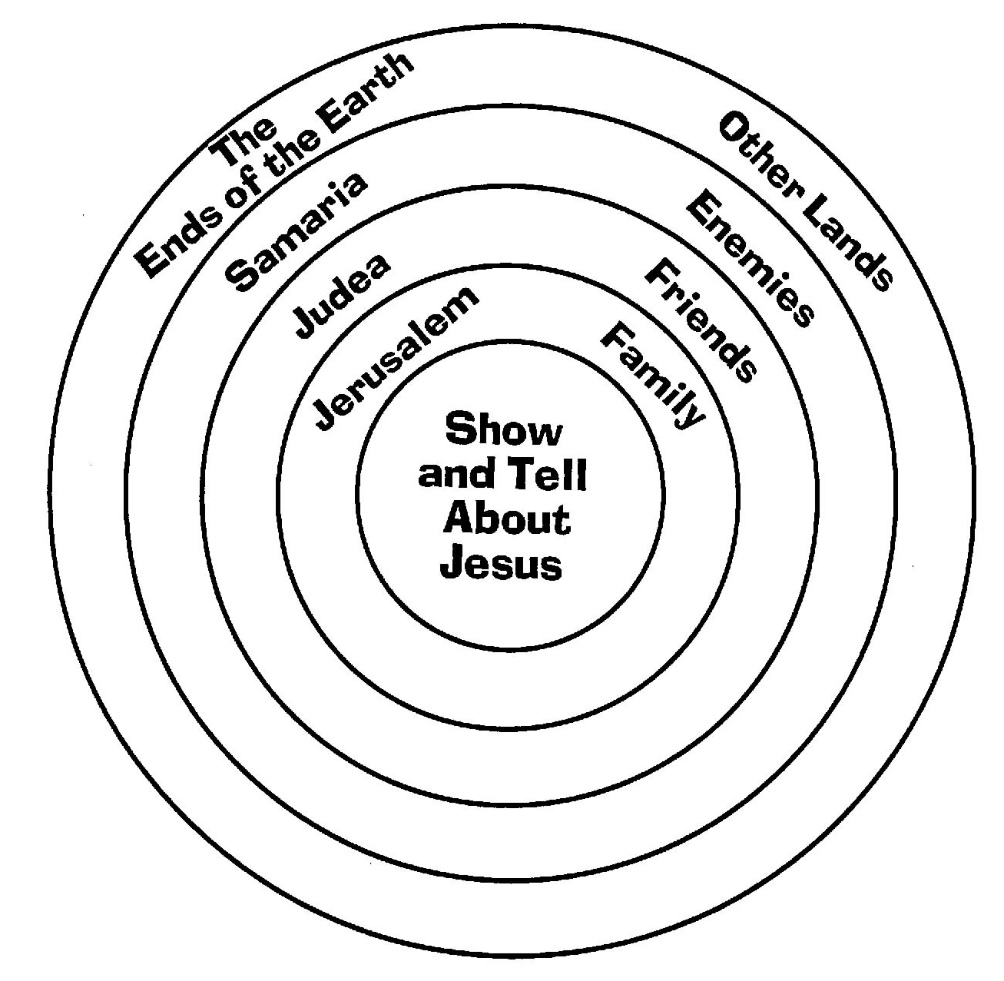
Make a FRIEND for LIFE
“The Friendship Bracelet

- Jesus wants to be your friend for life – even life after you die! Only by having a friendship with Him can we live forever!

- This friendship bracelet tells the story. You will make this friendship bracelet by tying knots. Follow the directions on the back of this page. When you make the knots, talk to Jesus by praying. Make the colors in the following order, praying for what the color means.

BLACK – Confess your SINS.
RED – Thank Jesus for His BLOOD shed for you.
WHITE – Ask God to FORGIVE your sins.
BLUE – True blue is FAITH. Believe Jesus has done
this for you.
GREEN – Ask Jesus to be Lord of all you do so you will GROW in Him.
GOLD – Thank God for His sure promise of
HEAVEN.

Tie the bracelet to your wrist using a big knot. It may be hard to untie, but it reminds you that YOU ARE JESUS’ FRIEND FOREVER!

- Give it away! Wear your bracelet until a friend asks about it. When they do, explain that it is a “Friendship with Jesus Bracelet.” You’ll give it to your friend or make your friend a new one. But you must tell him about what each color means. After telling him, ask if he would like to be Jesus’ friend forever. If so, pray with your friend through the colors just as you did when you made the bracelet.

DIRECTIONS for TYING KNOTS

- Tie the five strings together in a big knot. Tape the knotted end to the edge of a table.

- Hold the five strings together in one hand. Take the sixth string and drape it over the group of five strings.
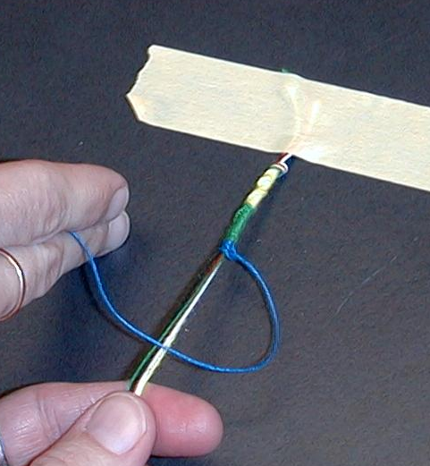

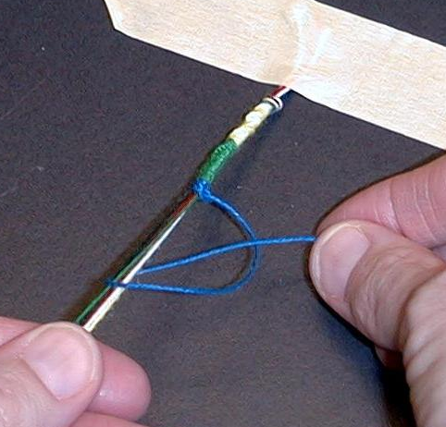
- Take the end of that string and feed it under the group of strings and through its own loop.

- Pull tight as the knot gets next to the others.

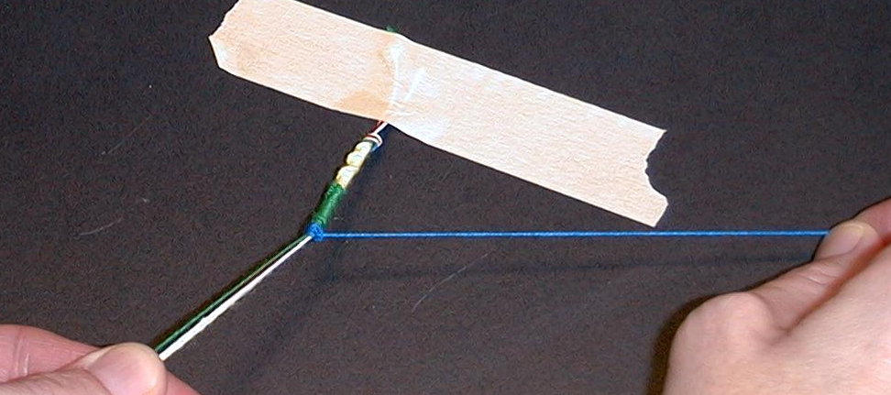

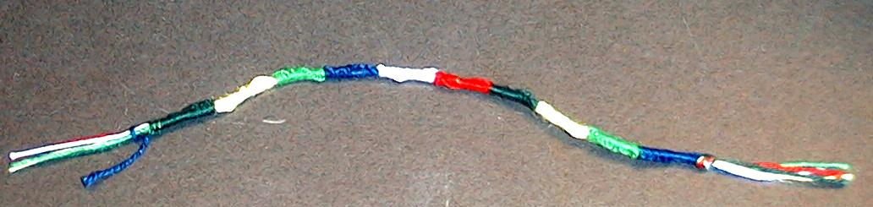
Tie twenty knots per color. Tie one big knot when you have finished.

Lesson 50
Small Group Warm-Up:
- a paper bag
- a completed friendship bracelet and a card for each group.

Large Group:
- Dao Dao dressed as a news reporter (possibly with glasses and a tie)
- news desk
- banner reading, “News Center K-I-N-G”
- sign on news desk reads, “Passover Week 30 A.D. "
- large friendship bracelet needs to be made and displayed. Use con-struction paper strips of 12x3-inch in the colors of black, red, white, blue, green, and yellow. Option: use the life-sized bracelet from the application activity.
- target on an overhead
- video, The Visual Bible: Acts (1:3-11)

Small Group Application:
- Show and Tell target for each child (see appendix)
- one pencil for each child
- one friendship bracelet kit for each child
- copy the “Make a Friend for Life” page on the front and the “Directions for Tying Knots” on the back. One for each child.
- embroidery floss -black, red, white, blue, green, and gold
- tape for each group

Memory Verse learning:
- a microphone
- PA system or a karaoka

