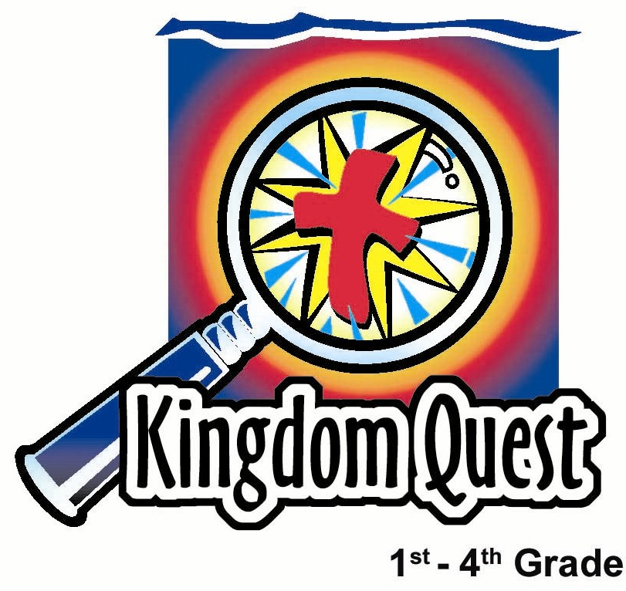
Date: ____________________
Series: God is Our Rescuer (Jun-Aug)
Year 2, Lesson 1

Merdeka Day—Remembering to be Thankful

Take Home Point: *A thankful heart is a happy heart. *Repeat this phrase throughout the lesson.

Bible Event: Psalm 103:2-5; Philippians 4:4.

Key Verse: Psalm 103:2: “My whole being, praise the Lord. Do not forget all His kindnesses.” (NCV)

We will help kids know:
- Filling our lives with more stuff doesn’t make us happy.
- Being thankful to God, who fills us with all good things, does bring us true joy.

We will help kids feel:
- Amused at the folly of collecting stuff to make one happy.
- Joyful as they count their blessings.

We will help kids do:
- Take an inventory of their blessings.
- Make a special craft reminding them that a heart filled with thankfulness is truly a happy heart.
THIS LESSON’S ROADMAP

DESTINATION | PAGE # | DISCOVERIES ON YOUR JOURNEY | SUPPLIES NEEDED
Small Group Warm-Up   | 3 | What makes a happy heart? Sometimes people have the wrong ideas and think they can only be happy if they get more stuff. | - scraps of colored paper  - scissors  - markers  - glue  - half sheet of manila card
Large Group   | 3  7  7 | Overview  Bible Reading: Psalm 103:1-5a and Philippians 4:4  Video: Madame Blueberry: Veggie Tales, Big Idea Productions, 1998 | - video, Veggie Tales: Madame Blueberry (Big Idea Productions, 1998)
Small Group Application   | 4-9 | Let’s remember our blessings. As we do, our heart will become thankful for what God has done.  Memory Verse Learning:  “Written on a Heart” | - six sheets of colored tissue paper for each child  - scissors  - glue  - copy of “A thankful heart is a happy heart!” page for each child (see attached)  - half-heart pattern for each child (see attached)  - a set of memory verse hearts  - whiteboard/wall; masking tape  - a small heart pattern for each child  - pencils  - stopwatch
Small Group Warm-Up: 15 minutes
Purpose: Get pointed in the right direction! Build relationships and help guests feel at ease. Do the learning readiness activity that will point your group in the right direction for the lesson.

This lesson is simple in that it has a longer large group time and the children spend most of the small group time working on crafts. The small group warm-up time may be cut short today since a movie will be shown in large group.

Supplies needed: scraps of colored paper; scissors; markers; glue; half sheet of manila card

Pass out scraps of colored paper, scissors, and markers. Ask the children the following:

What is one reason you are happy now?

After each child has discussed, let him cut a heart out of colored paper and paste it onto a group art project (of your own design) on a half sheet of manila card.

Each one of these hearts reminds you of something that you’re happy about. The question today is, “What is it that makes happy hearts?” Sometimes people have the wrong ideas and think they can only be happy if they get more stuff.

Have you ever thought you could be happy if you only got a special toy or possession? (Allow time to share.) The truth about happy hearts is that when we are truly thankful for the blessings God gives us, that’s when we’re happy.

Let’s count how many blessings we can put on this board right now. Each time you cut out a heart and paste it to the board, think of a blessing or special gift that you have. Remember that everything you have comes from God.

Large Group: 20-30 minutes
Purpose: Help kids observe what the Bible says. Present the Bible event in creative fashion. Help kids begin to interpret what it means

Supplies needed: video, Veggie Tales: Madame Blueberry (Big Idea Productions, 1998)

Overview:

Bible Reading: The large group presenter will ask five children to come forward to read a line from Psalm 103:1-5a and Philippians 4:4.

Video: Veggie Tales: Madame Blueberry, Big Idea Productions, 1998 - 35 minutes
This charming Veggie Tale video asks the question, "How much stuff does it take to be happy?” Madame Blueberry discovers that no amount of stuff can make a happy heart.

Small Group Application: 20-25 minutes
Purpose: Help kids map out the meaning of the Bible event in their lives. Use the questions to stimulate discussion but don't feel tied to them. Allow the Holy Spirit to guide you. Include personal examples from your own faith journey. The example of Christ at work in your life will leave lasting impressions of how Christ can work in the children's lives.

Use your Bibles! Children need to learn how to look up references and follow along when scripture is read aloud. Allow for quality time of prayer at the close of the lesson.

Supplies needed: six sheets of colored tissue paper for each child; scissors; glue; copy of “A thankful heart is a happy heart!” page for each child (see attached); half-heart pattern for each child (see attached)

The Bible says, “My whole being, praise the Lord. do not forget all His kindnesses.” Today let’s not forget the good God has done. Instead, let’s remember our blessings. As we do that, we become thankful and our hearts are filled with thankfulness to God. *A thankful heart is a happy heart

We are going to make a craft in which we cut sheets of tissue paper in the shape of hearts and glue them in a special way to make a full heart. While we do our craft, I would like all of us to talk about the things we are thankful for. When our craft is finished, we can remember that *a thankful heart is a happy heart.

The craft illustrates that the hearts are full (three-dimensional), and that is a picture of being filled with thankfulness.

Give each child six pieces of colored tissue paper. Have the children pile their sheets of tissue paper and then fold the pile in half. They will then trace and cut the half-heart pattern on the folded edge of the tissue paper. This should make six full-sized hearts.

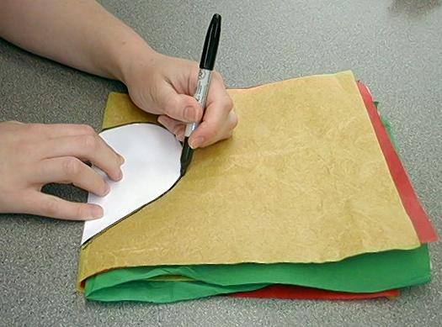
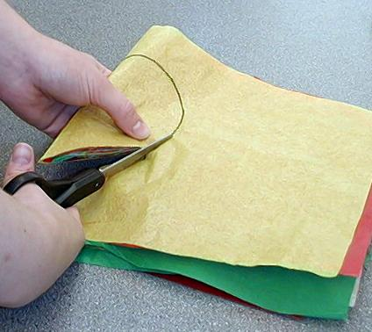

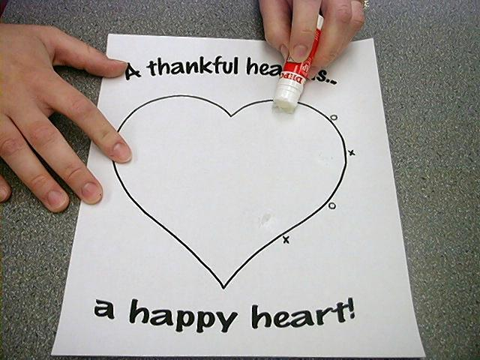
Give each child the page with the heart outline that reads “A thankful heart is a happy heart!” Have the children dab a small amount of glue on the area just inside the heart just below the three X’s.

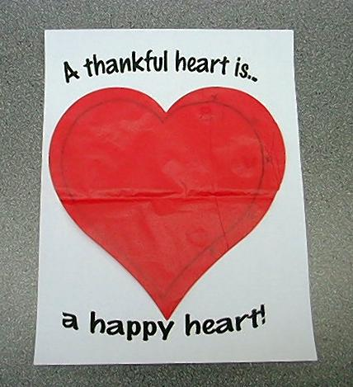

The children can then lay down their first tissue paper heart in the outline of the heart, gluing it to the page.

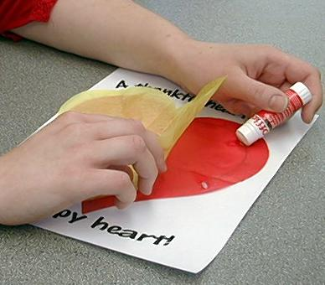

Next, have the children dab a small amount of glue on the area just inside the tissue paper heart below the two O’s. Then the children will lay down their second tissue paper heart, gluing it to the first tissue paper heart.

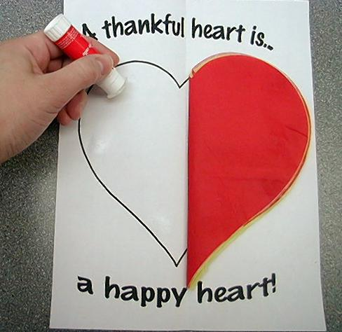

Alternate between X’s and O’s until all six tissue paper hearts have been glued to the right half of the heart. Then have the children continue gluing the left half of the tissue paper hearts on top of the right half of the tissue paper hearts.

Children should then dab glue on the opposite side of the heart, approximately in the area where the X’s would be.

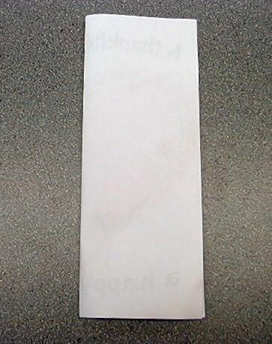

Fold the entire page in half vertically, pressing down firmly.

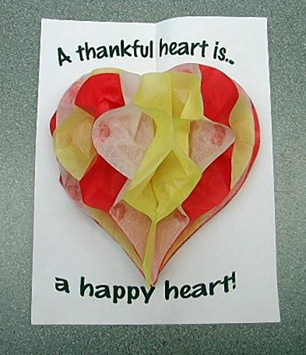

Unfold the page to reveal a heart full of thankfulness.

Memory Verse Learning: 5 minutes
Purpose: Help kids to memorize and keep scriptures at heart. Using creative ways to help kids enjoy learning the key verse and in small group setting.

Supplies needed: a set of memory verse hearts; whiteboard/wall; masking tape; a small heart pattern for each child; pencils; stopwatch

Memory Verse: Psalm 103:2 ~ “My whole being, praise the Lord. Do not forget all His kindnesses.”

MV Presentation: “Written on a Heart”
Psalm
103:2
My
the
Do
praise
kindnesses.
His
forget

all
not
Lord.
being,
whole
Before class, randomly paste the fourteen memory verse hearts all around the whiteboard or wall with masking tape. During class, recite the Bible verse by pointing the sequence as the children read. Pick up speed as you go. Then have two or four children challenge one another to see how fast they can recite the memory verse and also able to point correctly the sequence. Use a stopwatch to time the challenge. After that, have the children write the verse on the small piece of heart without looking at the board.

Prayer Time:
Encourage children to mention as many thanksgivings as possible during this prayer time.

Large Group Presentation

Take Home Point: *A thankful heart is a happy heart.

Bible Reading: The large group presenter will ask five children to come forward to read a line from Psalm 103:1-5a and Philippians 4:4.

Reader 1: “My whole being, praise the Lord!”

Reader 2: “All my being, praise His holy name.”

Reader 3: “My whole being, praise the Lord. Do not forget all His kindnesses.”

Reader 4: “The Lord forgives me for all my sins.”

Reader 5: “He heals all my disease”

Reader 1: “He saves my live from the grave.”

Reader 2: “He loads me with love and mercy.”

Reader 3: “He satisfies me with good things.”

Reader 4: “Be full of joy in the Lord always.”

Reader 5: “I will say again, be full of joy.”

Video: Veggie Tales: Madame Blueberry
This charming Veggie Tale video asks the question "How much stuff does it take to be happy?” Madame Blueberry discovers that no amount of stuff can make a happy heart. Instead, a thankful heart is a happy heart. She even learns a song to thank God for this day and for everything.

The video lasts approximately 35 minutes. Thirteen minutes into the story there is a silly song that lasts four minutes. If you would like to save time, you may fast forward through this song.

Closing Prayer:

Gracious Lord, thank You for giving us all that we need for this world. Many times we do get greedy and think a lot about wanting other people’s stuff. We think that if
we just had more stuff, then we would be happier. You have told us that is not the truth. Now help us really believe it. Show us how much we have to be thankful for and let us be thankful in every way to you. Thank You especially that You have given us the gift of Your Son, Jesus. Because of Him, we are filled with thankfulness instead of being filled with just wanting more stuff. In Jesus’ name. Amen.
Supplies:

Quantity ()

Small Group Warm-up
- scraps of colored paper
- scissors
- markers
- glue
- half sheet of manila card

Large Group
- video, Veggie Tales: Madame Blueberry (Big Idea Productions, 1998)

Small Group Application
- six sheets of colored tissue paper for each child (purchased from florist shops or Popular Bookshop)
- scissors
- glue
- copy of “A thankful heart is a happy heart!” page for each child (see attached)
- half-heart pattern for each child (see attached)

Memory Verse Learning
- a set of memory verse hearts
- whiteboard/wall; masking tape
- a small heart pattern for each child
- pencils
- stopwatch


Half-Heart Pattern

Photocopy and cut page in half. Each child gets one heart half to
cut out and use as a tracing pattern.
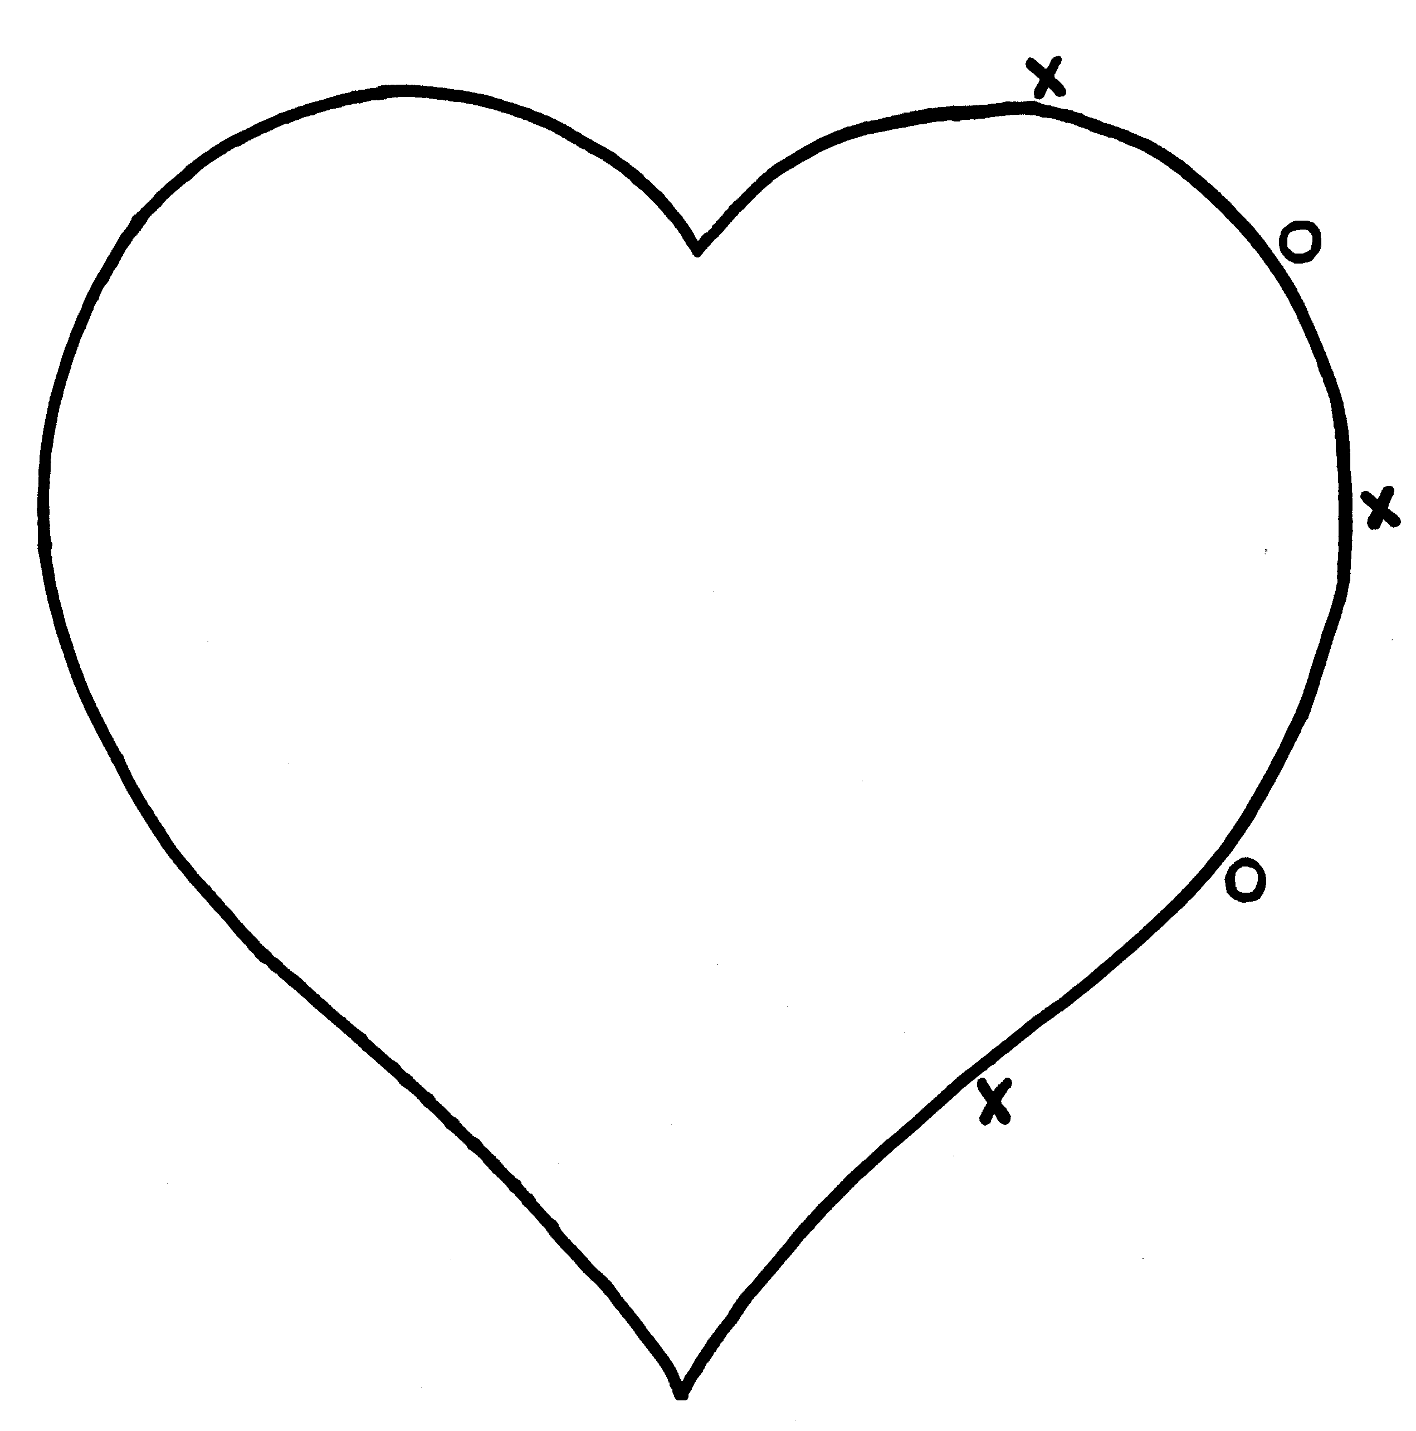
A thankful heart is...
a happy heart!

