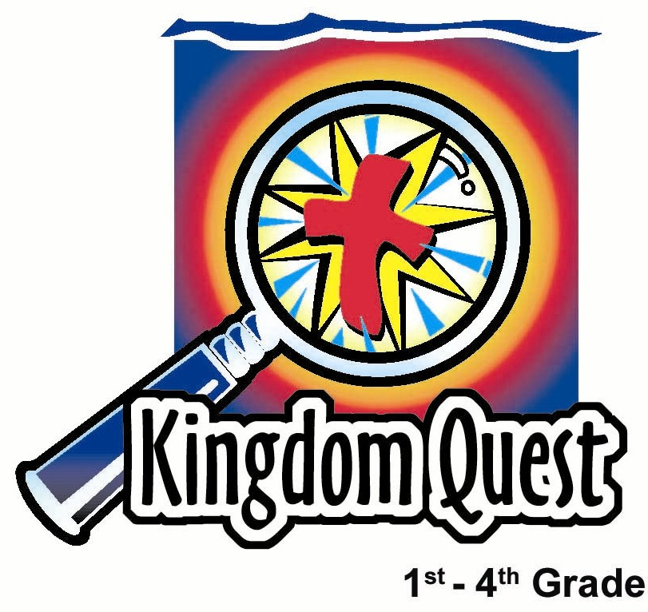
Date: ____________________
Series: God is Our Rescuer (Jun-Aug)
Year 2, Lesson 5

Never Forget
How God
Rescues You

Take Home Point: *Never forget. Can’t you see? Always remember. God rescues me.
*Repeat this phrase throughout the lesson.

Bible Event: Exodus 12:1-30.

Key Verse: Exodus 12:23b. “…He will not let the one who brings death come into your houses and kill you.” (NCV)

We will help kids know:
- The Passover event.
- They need to always remember how Jesus, as our Passover sacrifice, stopped the destroyer from getting us.

We will help kids feel:
- Amazed at the power of God and how He rescues His people.
- Passion for always remembering how God rescued us through Jesus.

We will help kids do:
- To vividly remember God’s history of rescue in the Passover and the cross.
- Explain how God helps rescue them even today.

THIS LESSON’S ROADMAP

DESTINATION | PAGE # | DISCOVERIES ON YOUR JOURNEY | SUPPLIES NEEDED
Small Group Warm-Up   | 3-4 | This name game will help us learn the value of repetition in memory. | - animal crackers
Large Group   | 4  7-8  8  9-11 | Overview  Puppet Presentation: “Dao Dao Remembers.” Dao Dao thinks he has a good memory but can’t remember the animal name Teacher had in small group.  Video: The Prince of Egypt—The Passover. An excerpt from this video begins 1 hour and 11 minutes after the opening title. Begin with Moses saying, “God has come to me again. Take a lamb and mark your doors…” The section ends after four minutes with the pharaoh saying, “You and your people have my permission to go. Leave me.”  Puppet Presentation: “Dao Dao Remembers” Conclusion.  Dao Dao learns how God gave Jesus, the Lamb of God, to rescue us from eternal death. | - two doors (see “Dao Dao Remembers” Conclusion)  - cross  - bowl of red poster paint  - large paintbrush attached to a branch  - plastic sheet for messes.  - actor wearing an angel of death costume (possibly a black cape or robe)  - pita bread or chappati  - video, The Prince of Egypt (DreamWorks Home Entertainment, 1999)
Small Group Application   | 5-6 | Review of the Bible event will help the kids remember that God rescued us by giving His son as a sacrifice for our sin.  Memory Verse Learning:  ”Keep Into Memory”  Exo. 14:14 will be emphasized for lessons 5-7 to instill in a child the courage in facing fears that attack them. | - one set of 20 cards for each group (see the attached sheets)  - a set of 20 cards per group
Small Group Warm-Up: 15 minutes
Purpose: Get pointed in the right direction! Build relationships and help guests feel at ease. Do the learning readiness activity that will point your group in the right direction for the lesson.

Gather the kids in a circle and explain:

We are going to play a memory game. I would like everyone to think of an animal. Let’s go around the circle and each person will say what animal he is thinking of. After everyone has said his animal, let’s see how many animal names you can remember.

Depending on the ages of the children and the size of the circle, the success will hopefully not be 100 percent. If this is not a challenge, go around the circle three times naming animals before asking how many can be remembered.That helps us move to the second game. This game reinforces the value of repetition in remembering.

The first person to my right begins by remembering my animal name(s) and then saying her own. Do that now.

The second person to my right repeats my animal name(s) and the animal name(s) of the person to my right, and then he adds his own animal name. The third person to my right repeats the process, beginning with my animal name.

The process continues until you have moved around the entire circle. By then, all will remember the animal names. (If you had each person name three animals, have them say their three and go to the next person who adds his three and so on.)

What did we do differently the second time to remember those names? We remembered them by saying them time and time again.

I have one other interesting way to remember animal names. Here are some animal crackers. Each of you can have an animal cracker. Before you eat it, look at the animal you have and see if you recognize what it is. Then you can eat your animal cracker. After you have eaten it, tell us what your new animal name is.

Is your new animal name easy to remember? Yes, because you just ate something that reminded you of that animal.

Today we are again discovering how God rescued His people, the Israelites, from slavery. He wanted them to never forget it, so He had them do something special every year. This special thing reminded the Israelites of God’s rescue. They had a special ceremony and a special meal. That ceremony and meal, called the Passover, was a way they always remembered how God had rescued them.
We will even find out how God gives us something special to eat in our church that reminds us today of His rescue.

We will remember our main point today as a rhyme. Here is how it goes. I’ll say it and then you repeat after me.

*Never forget. Can’t you see?
Always remember. God rescues me!

Large Group: 20-30 minutes
Purpose: Help kids observe what the Bible says. Present the Bible Event in creative fashion. Help kids begin to interpret what it means.

Supplies needed: two doors (see “Dao Dao Remembers” Conclusion); cross; bowl of red poster paint; large paintbrush attached to a branch; plastic sheet for messes; actor wearing an angel of death costume (possibly a black cape or robe); pita bread or chappati; video, The Prince of Egypt (DreamWorks Home Entertainment, 1999)

Overview

Puppet Presentation: “Dao Dao Remembers”
Dao Dao thinks he has a good memory but can’t remember the animal name Teacher had in small group. Teacher teaches Dao Dao how God used the visual reminder of the Passover to help the children of Israel remember how God rescued them (Exodus 12:1-30).

Video: The Prince of Egypt—The Passover
An excerpt from this video begins 1 hour and 11 minutes after the opening title. This section begins with Moses saying, “God has come to me again. Take a lamb and mark your doors…” The section ends after four minutes with the pharaoh saying, “You and your people have my permission to go. Leave me.”

Puppet Presentation: “Dao Dao Remembers” Conclusion
Dao Dao learns how God gave Jesus, the Lamb of God, to rescue us from eternal death. This is celebrated in the Lord’s Supper.

Small Group Application: 20-25 minutes
Purpose: Help kids map out the meaning of the Bible event in their lives. Use the questions to stimulate discussion but don't feel tied to them. Allow the Holy Spirit to guide you. Include personal examples from your own faith journey. The example of Christ at work in your life will leave lasting impressions of how Christ can work in the children's lives.
Use your Bibles! Children need to learn how to look up references and follow along when scripture is read aloud. Allow for quality time of prayer at the close of the lesson.

Supplies needed: one set of 20 cards for each group (see the attached sheets)

Observation Questions: What happened?

What plague was God going to send to Egypt? (Exodus 12:12. God would kill the firstborn male, both human and animal.)

What did God command the Israelites to do so that the angel of death would pass over their homes? (Exodus 12:1-11. They were to take a lamb that had no defects and use its blood to mark the top and sides of their doorframes. They were to roast and eat the lamb while being fully dressed so they would be ready to leave quickly.)

Why did God ask the Israelites to celebrate the Passover every year? (Exodus 12:26-28. To remember when the Lord passed over the houses of the Israelites in Egypt and spared their homes when He killed the Egyptians.)

Interpretation Questions: What does this mean?
To play this memory game, your group will be given a set of 20 cards. The cards are ten pairs of words from today’s Bible event.

Turn all cards face down. Take turns having each child turn over two cards at a time. If a child gets a match, he tells the group how this word fits into the Bible event. If he can relate the word to the Bible event, he may keep the match. The ten words will be:

LAMB EGYPTIANS
DOOR FRAME FIRSTBORN
BLOOD SLAVERY
DESTROYER CROSS
UNLEAVENED BREAD SACRIFICE

A fun way to play the game would be to divide into two teams. A team sends a representative forward to test his memory and find matching cards, he returns and has his team help him make the Bible event connection.

Application Questions: What does this mean to me?

Tell about a movie that you saw that reminded you of a spiritual destroyer. Did it scare you? How could God rescue you from something like that?
When you do something really bad what do you think God wants you to remember? (Even for the really bad things Jesus died on the cross so that your punishment would be taken away and the destroyer could not get you.)

How is the Passover like the Lord’s Supper? (They are both celebrations of a special way God rescued his people from death. He commanded his people to celebrate both. In both, God used the blood of the lamb: in the Old Testament the sacrificial animal, and in the New Testament, the blood of the Lamb of God, Jesus. In Exodus, God saved His people from the angel of death. The Lord’s Supper celebrates the death of Jesus who saves us from eternal death.)

Our key Bible verse from Exodus 12:23 says, “…He will not let the one who brings death come into your houses and kill you.” How has Jesus defeated the power of Satan in your life?

Let’s repeat the point we learned today: *Never forget. Can’t you see? Always remember. God rescues me!

Memory Verse Learning: 5 minutes
Purpose: Help kids to memorize and keep scriptures at heart. Using creative ways to help kids enjoy learning the key verse and in small group setting.

Supplies needed: a set of 20 cards per group

Memory Verse: Exodus 14:14 ~ “You will only need to remain calm. The Lord will fight for you.”

MV Presentation: “Keep Into Memory”
You will only be using half of the set where it makes up of the Bible verse. Keep the rest for next lesson. During class, have the children sit in a circle. Shuffle the cards and lay it before the children. Ask the children to help you open all the cards. Recite the verse while pointing at its sequence. Have the children recite with you next. Repeat the procedure – shuffle, recite while pointing to the cards. You can choose a certain child to be the pointer of the cards or to lead in the recitation. Before moving on to prayer, keep all the cards and the children recite the verse aloud.

Prayer Time:
Let the children thank God for times that He has rescued them and also for something special that God had done for them this last week. Rejoice that they are protected from the destroyer.

Large Group Presentation

“Dao Dao Remembers”
Puppet Presentation

Take Home Point: *Never forget. Can’t you see?
Always remember. God rescues me.

Throughout the series, “God Is Our Rescuer,” Teacher will wear a fireman’s hat labeled “God Rescues.”

Teacher: Good morning, kids! Welcome to Sunday school. We are exploring how God rescues. Today we will learn *Never forget. Can’t you see? Always remember. God rescues me!

To begin, we are talking about remembering.

Dao Dao: Yeah, I have a great memory.

Teacher: I know you do, Dao Dao. We just had a chance to play a memory game right before coming to large group.

Dao Dao: Yeah, and I remembered everyone in my group.

Teacher: I was in your group. Do you remember what my animal was?

Dao Dao: Of course I do.

Teacher: All right, Mr. Memory. What was it?

Dao Dao: A skunk?

Teacher: No. Whatever would make you think I would choose that for my animal?

Dao Dao: Well, it was just something that reminded me of…never mind!

Teacher: Do you remember my animal?

Dao Dao: Yeah, it was….a…pig!

Teacher: No, it wasn’t a pig.

Dao Dao: It wasn’t?

Teacher: You need help with your memory. My animal was a lamb.

Dao Dao: Wow! My memory isn’t so good.

Teacher: It’s okay to forget stuff like that. But God does want you to remember the important stuff.

Dao Dao: What do you mean?

Teacher: In today’s Bible event God rescues His people, the Israelites, from slavery in Egypt. He wanted them to always remember what He did.

Dao Dao: What did He do?

Teacher: He rescued them and used a special animal to do it.

Dao Dao: A special animal? Which one?

Teacher: Well, it was the animal I chose in the game.

Dao Dao: You mean a skunk?

Teacher: No, it was a lamb.

Dao Dao: Oh, that’s right! A lamb. How did God use a lamb?

Teacher: It was the tenth plague on Egypt. After each plague, Pharaoh’s heart was still hard. He would not let the Israelites go. But the final plague would be the death of all the firstborn males in Egypt. They would be killed unless the homes were marked with the blood of the lamb.

Dao Dao: Wow! That’s something I’d like to see!

Teacher: Let’s watch this part from The Prince of Egypt. After that, we’ll find out how God gave a special meal that would help the people always remember that He rescued them.

(Show an excerpt from the video The Prince of Egypt that begins 1 hour and 11 minutes after the opening title. This section begins with Moses saying, “God has come to me again. Take a lamb and mark your doors…” The section ends after four minutes with the pharaoh saying, “You and your people have my permission to go. Leave me.”)

“Dao Dao Remembers”
Conclusion

For the recap of the Bible event, some special staging is needed. Construct two doors out of refrigerator boxes or other cardboard in such a way that there are door frames and some type of door that one can enter. (Visible door frames are necessary.) Small free-standing dividers could be used if cardboard door frames were stapled to them. Brown paper or white mahjong paper would be a close enough effect for the door within the frame.
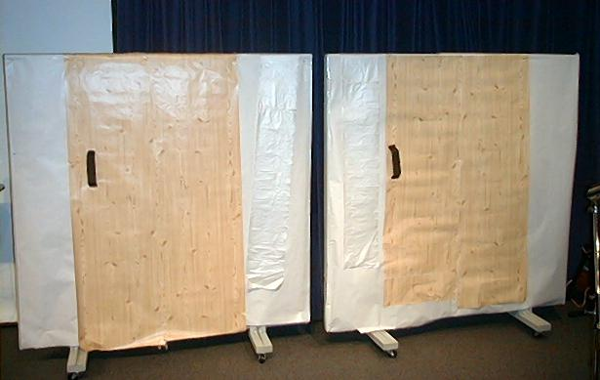

Behind one of the doors have a child holding a cross who can be seen when the door is opened. Behind the second door have a person who will not be visible but will give a frightful scream. An actor portraying the role of the angel of death needs to be wrapped in a black cape or gown.

Other props needed are a bowl of red poster paint, paint brush, a branch, and pita bread or chappati.

Dao Dao: Wow, Teacher! That was spooky how the angel of death moved through the land of Egypt.

Teacher: Yes, it was. But there were places that the angel of death passed over.

Dao Dao: Yeah…uh…What places were those?

Teacher: Don’t you remember?

Dao Dao: Well, I know he went to some doors and not others.

Teacher: Dao Dao, this is what happened. It’s written for us in Exodus 11 and 12. (Refers to his Bible.) Since Pharaoh would not let the people go, God sent the tenth and most terrible plague.

Dao Dao: That was with the angel of death, right?

Teacher: Yes. God promised to protect them from the angel of death. They were to take an unblemished lamb (that means a very perfect one) and kill him for food. They used a branch to wipe the lamb’s blood on the doorframes. Their houses were then marked with the blood of the lamb. (Use paint and paint brush to paint a stroke over the top of the door and the sides of the first door.)

Inside their houses, the Israelites were eating a special meal. God told them to eat this meal every year to remind them how He passed over their houses with the angel of death and freed them from slavery.

Dao Dao: What was in the special meal?

Teacher: They ate special bread that didn’t have yeast in it. It was called unleavened bread. (Hold up a pita bread or chappati.) They also had roasted lamb. They ate this meal at night while the angel of death passed over their houses and struck down the firstborn males in all the homes that were not marked with the blood of the lamb.

Let’s imagine what it was like as the angel of death came.

(The angel of death comes to the first door marked with blood. He cannot enter this door. He goes to the second door, which is not marked, and enters. A scream is heard from behind the door.)

Teacher: So God told His people to have a special meal called the Passover meal every year. This way they would always remember how God had rescued them from the land of slavery in Egypt. They ate unleavened bread and a Passover lamb.

Dao Dao: Do they still do that today?

Teacher: Yes, Jews still practice this today.

Dao Dao: What about us in our church? How do we remember that God rescues us?

Teacher: God doesn’t rescue us from slavery in Egypt. God rescues us from the slavery of sin. He did that with the blood of the Lamb.

Dao Dao: What do you mean?

Teacher: Jesus, the Lamb of God, died on the cross so our sins could be forgiven. Though we don’t actually see it, when we trust in Jesus as our Savior, it’s like having His blood protecting us. Watch this.

(At this point, the angel of death knocks on the first door covered by the blood. This time he opens each and shows everyone what is behind the door. Behind the door is someone holding a cross. The angel of death runs away terrified.)

Teacher: The cross is the sign that marks us as being covered by the blood of Jesus. The Destroyer cannot get us.

Dao Dao: Does that mean we’ll never die?

Teacher: No. That means that when we do die, we will live forever with God.

Dao Dao: That’s a pretty cool thing to remember.

Teacher: Yes, that’s why we take the Lord’s Supper.

Dao Dao: I know that it’s a special meal we have in church with the wine and the bread.

Teacher: That’s right. The Lord’s Supper is a way to remember that Jesus gave His body and blood so we would be rescued from eternal death and have our sins forgiven.

Dao Dao: Now that’s something even I could remember!

Teacher: I think it is. But let’s all practice it together. Let’s say our cheer.

We’re going to divide the room into four parts. Part One says, “Never forget!” Part Two says, “Can’t you see?” Part Three, “Always remember!” Part Four “God rescues me!”

(The children repeat the chant three times.)

Teacher: That’s great! Let’s close in prayer.

Dear God, we won’t forget. We will always remember that You rescue us. And just like the blood of the lamb caused the angel of death to pass over Your people in Egypt, thank You that the blood of Jesus causes the angel of death to pass over us. Since we believe in Jesus, we can live with You forever. Thank You, God! Amen.
Supplies:

Quantity ()

Small Group Warm-up
  - animal crackers

Large Group
  - two doors (see “Dao Dao Remembers” Conclusion)
  - cross
  - bowl of red poster paint
  - large paintbrush attached to a branch
  - plastic sheet for messes
  - actor wearing an angel of death costume (possibly a black cape or robe)
  - pita bread or chappati
  - video, The Prince of Egypt (DreamWorks Home Entertainment, 1999)

Small Group Application
- one set of 20 cards for each group (see the attached sheets)

Memory Verse Learning
- a set of 20 cards per group. The cards are ten pairs of words from Exodus 14:14.

Lamb

Door
Frame

Blood

Destroyer

Egyptians

Lamb

Door
Frame

Blood

Destroyer

Egyptians

Firstborn

Unleavened Bread

Slavery

Cross

Sacrifice

Firstborn

Unleavened Bread

Slavery

Cross

Sacrifice

