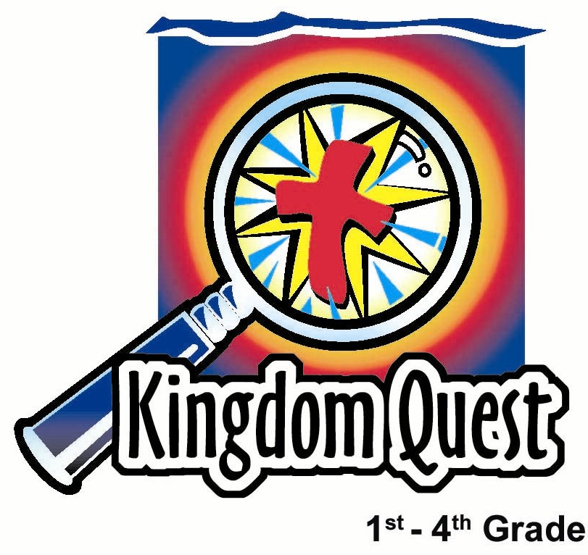
Date: ____________________
Series: God is Our Rescuer (Jun-Aug)
Year 2, Lesson 6

Stand Back
and Watch
the Rescue

Take Home Point: *In the middle of a fight when I have lost all my might, stand back and I will see that God will rescue me!
*Repeat this phrase throughout the lesson.

Bible Event: Exodus 13:20-15:21. The crossing of the Red Sea.

Key Verse: Exodus 14:14. “You will only need to remain calm. The Lord will fight for you.” (NCV)

We will help kids know:
- God wants us to trust Him, not to rely on our own strength.
- God miraculously rescued Israel through the crossing of the Red Sea and destroyed their enemies.
- Our promise in the waters of baptism is that God rescues us through Jesus.

We will help kids feel:
- Confidence in knowing God will rescue them through faith in Jesus.
- Courage as they face the fears that attack them.

We will help kids do:
- Recall the challenges in their life and how God can rescue them as they trust Him.
- Just as Israel had to be still and trust to walk through God’s parted sea, the kids need to walk in the path of trusting God’s promises by doing what He asks.

THIS LESSON’S ROADMAP

DESTINATION | PAGE # | DISCOVERIES ON YOUR JOURNEY | SUPPLIES NEEDED
Small Group Warm-Up   | 3 | This activity gives a picture of the crossing of the Red Sea. The “Chosen One” passes through with protection. The water cannot harm him. The need of the “Chosen One” to step out, trust, and walk is also illustrated | - two water shooters for each group  - masking tape
Large Group   | 3-4  7-8  8  10  9 | Overview  Puppet Presentation: “Dao Dao’s Protection.” Dao Dao learns how the Israelites passed through the Red Sea with God’s protection. We also can pass through the “waters” and receive the protection of God through Jesus.  Video: The Prince of Egypt  Interactive Drama (option): “Rescue at the Red Sea.” If you would prefer not to use the video, use this interactive drama.  Puppet Presentation: “Dao Dao’s Protection” Conclusion. | - two long pieces of blue plastic table cloth, drop cloth, or material  - banner pole with gray/ red/yellow crepe paper streamers hanging from it (see lesson)  - staff and headdress for Moses  - video, The Prince of Egypt (DreamWorks Home Entertainment, 1999). The video starts 1 hour, 21 minutes after the opening title. This scene is the sounding of the horn right before the chariots appear. Stop the video approximately six minutes later right before Pharaoh is seen
Small Group Application   | 4-6  6 | Today’s project and discussion reviews how God rescues us from sin through Jesus Christ.  Memory Verse Learning:  ”Memory Verse”  Exo. 14:14 will be emphasized for lessons 5-7 to instill in a child the courage in facing fears that attack them. | - two facial tissues for each child  - water-based markers  - pan or bowl of water (or use a nearby sink)  - a set of 20 cards
Small Group Warm-Up: 15 minutes
Purpose: Get pointed in the right direction! Build relationships and help guests feel at ease. Do the learning readiness activity that will point your group in the right direction for the lesson.

Supplies needed: two water shooters for each group; masking tape

Tape two parallel lines of masking tape on the floor, both 10 yards long and about 20 feet apart. The distance between these lines needs to be within the firing range of a water shooter. The space between the two lines is an imaginary river.

Pick one person to be the “Chosen One” and two others to be the water shooters. The two water shooters are to be outside of the masking tape, which is the border of the river. The object of the game is for the “Chosen One” to walk down the middle of this great sea without getting swept away with water.

Divide the rest of the kids into two groups of six to twenty-five. Their job is to form a protective corridor for the “Chosen One” so he can pass through without getting wet from water shooters. The children are to be protective shields. (Adapt the rules to fit whatever works best with your size of group.)

This activity gives a picture of the crossing of the Red Sea. The “Chosen One” passes through with protection. The water cannot harm him. The need of the “Chosen One” to step out, trust, and walk is also illustrated. Discuss these concepts with the children.

Then say:

Our point for today’s lesson goes like this:
*In the middle of a fight
when I’ve lost all my might,
stand back and I will see,
that God will rescue me!

Large Group: 20-30 minutes
Purpose: Help kids observe what the Bible says. Present the Bible Event in creative fashion. Help kids begin to interpret what it means.

Supplies needed: two long pieces of blue plastic table cloth, drop cloth, or material; banner pole with gray/ red/yellow crepe paper streamers hanging from it (see lesson); staff and headdress for Moses; video, The Prince of Egypt (DreamWorks Home Entertainment, 1999). The video starts 1 hour, 21 minutes after the opening title. This scene is the sounding of the horn right before the chariots appear. Stop the video approximately six minutes later right before Pharaoh is seen

Overview
Puppet Presentation: “Dao Dao’s Protection”
Dao Dao learns how the Israelites passed through the Red Sea with God’s protection. We also can pass through the “waters” and receive the protection of God through Jesus.

Video: The Prince of Egypt
Start the video 1 hour, 21 minutes after the opening title. This scene is the sounding of the horn right before the chariots appear. Stop the video approximately six minutes later right before Pharoah is seen.

Interactive Drama (option): “Rescue at the Red Sea”
If you would prefer not to use the video, use this interactive drama.

Puppet Presentation: “Dao Dao’s Protection” Conclusion

Small Group Application: 20-25 minutes
Purpose: Help kids map out the meaning of the Bible event in their lives. Use the questions to stimulate discussion but don't feel tied to them. Allow the Holy Spirit to guide you. Include personal examples from your own faith journey. The example of Christ at work in your life will leave lasting impressions of how Christ can work in the children's lives.

Use your Bibles! Children need to learn how to look up references and follow along when scripture is read aloud. Allow for quality time of prayer at the close of the lesson.

Supplies needed: two facial tissues for each child; water-based markers; pan or bowl of water (or use a nearby sink)

Observation Questions: What happened?

Where did God lead the Israelites after leaving Egypt? (Exodus 13:17-18. He didn’t lead them through the shortest route to the Promised Land because He knew what was best for them.)

How did God lead the people to the Red Sea? (Exodus 13:21-22. By day God was a cloud, or a column of smoke, and at night He was a pillar of fire.)

Why did God allow Pharaoh to come after the people? (Exodus 14:3-4. People would honor God and see Him as Lord because of what would happen.)

What did the Israelites do when they saw the Egyptians? (Exodus 14:11-12. They whined.)

How did God rescue them? (Exodus 14:13-31. He parted the Red Sea, let the Israelites cross safely, and destroyed the Egyptians.)
Interpretation Questions: What does this mean?

What do you think the Israelites were thinking after they were safe and they watched the Egyptian army get destroyed?

Application Questions: What does this mean to me?

We sometimes face problems and sometimes we feel like the Israelites because some bad things may be happening to us. For example, have you ever whined about anything?

Are these the kinds of things the Israelites were whining about?

Do you think it is because they couldn’t see God’s victory coming?

Our key verse for today says in Exodus 14:14, “You will only need to remain calm. The Lord will fight for you.” The Bible shows us the victories God has already won for His people. It gives us His promises to be our protection. We already know that Jesus defeated Satan with His death on a cross and the power of His resurrection.

Application Activity:
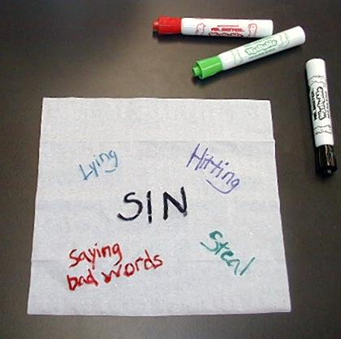
Pass out tissues and water-based markers to all the kids. Have them write the word “SIN” on their tissues. Then have the children think of specific sins and how Satan uses these sins to attack us and try to pull us away from God. Have some kids give examples. Then have them write down on the tissue other things that seem to attack them.

Is there a problem with a friend or a problem at home? Is there something that just doesn’t seem fair? Think of the things that you whine about. Does God want you to trust that He will rescue you? Remember today’s saying:

*In the middle of a fight
when I have lost all my might,
stand back and I will see,
that God will rescue me.

Let’s talk about how God rescues. He used the water to rescue the people in the Red Sea. When they passed through the water they were rescued, even though all the Egyptians drowned. Does God use water today to help rescue people?

Did you know that in a very special way He does? The way God rescues us is by giving Jesus to die on the cross and take away the punishment of our sin. And when we trust Jesus, He comes and lives in our lives.

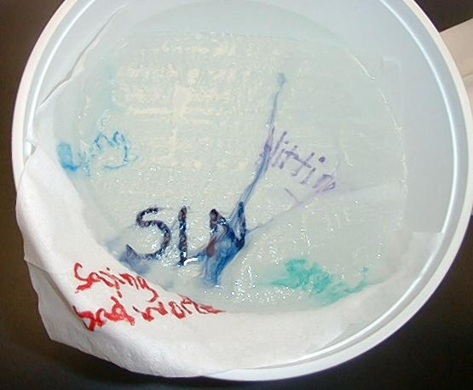
How is water part of that? When we are baptized, Jesus is making a guarantee to us that He will rescue us. We only need to be still and trust Him.

Use a pan of water or a nearby sink. Have children open their tissues and lay each flat across the top of the water in the pan of water or the filled sink. Watch the markings dissolve away. You may need to lightly touch the marker spots on the tissue.


That is just what God does for us when He rescues us. He takes our sin away and fights all of our other battles when we trust in Him.

Memory Verse Learning: 5 minutes
Purpose: Help kids to memorize and keep scriptures at heart. Using creative ways to help kids enjoy learning the key verse and in small group setting.

Supplies needed: a set of 20 cards

Memory Verse: Exodus 14:14 ~ “You will only need to remain calm. The Lord will fight for you.”

MV Presentation: “Memory Verse”
The memory verse learning is similar to the memory game of lesson 5. Each group will be given a set of 20 cards. The cards are ten pairs of words from today’s Bible verse. Turn all cards face down. Take turns having each child turn over two cards at a time. If a child gets a match, he recites to the group today’s Bible verse. If he recites it correctly, he can keep the match for his team. Shepherd divides the children into two teams. The winning team is the team that has the most matches.

Prayer Time:
Take a clean, dry tissue and pass it from person to person. When children receive the tissue it is their turn to pray. Encourage them to think about ways God rescues them as they pray.

Large Group Presentation

“Dao Dao’s Protection”

Puppet Presentation

Take Home Point: * In the middle of a fight, when I’ve lost all my might, stand back and I will see that God will rescue me!

Before Dao Dao appears, a squirt gun will appear from behind his stage area. Water will hit Teacher during his opening welcome. It should appear as if Dao Dao shot the water shooter.

Teacher: Hello, kids! Welcome to Sunday school. Today we are going to our take home point.

*In the middle of a fight
when I’ve lost all my might,
stand back and I will see
that God will rescue me!

I will say the first part and when I get to the last line, you say it with me. The last line is “…that God will rescue me!”

*In the middle of a fight
when I’ve lost all my might,
stand back and I will see….
(Kids shout)THAT GOD WILL RESCUE ME!

(Water squirted from Dao Daos stage area hits Teacher.)

Teacher: Hey! What’s that?

Dao Dao: (Appears.) This is cool, Teacher. I get to go to church and play with water shooters.

Teacher: But, Dao Dao, there’s a purpose in it.

Dao Dao: I know! The purpose is to get the guy behind you wet. (Squirts one more time while Teacher looks over his shoulder.)

Teacher: What guy? Hey, Dao Dao! Enough with the water. No, the purpose for our water shooter was to show that it was hard to get the “Chosen One” wet.

Dao Dao: Yeah, that’s because he had all those people to hide behind!

Teacher: Today we will learn that God wants to be our protection. When Moses crossed the Red Sea did he even get wet?

Dao Dao: No.
Teacher: Right. He didn’t get wet because he had God’s protection.

Dao Dao: He also had a staff. I saw The Prince of Egypt. Moses didn’t get wet because he put his staff in the water and all the water shot up. I wish I had a staff like that.

Teacher: It wasn’t the staff that did it. It was the Lord. The Lord was his protection. Here’s what happened in Exodus 14.

(Refers to his Bible.) Verse nine starts to talk about how all of the Egyptians and Pharaoh’s armies caught up to the Israelites who were camped by the sea. The Israelites were worried and afraid. But Moses told them, “You will only need to remain calm. The Lord will fight for you.” Let’s practice that now. Everyone be very still.

Then Moses raised his staff over the waters and God parted the sea. What do you think about that, Dao Dao?

(Dao Dao is locked in a frozen pause.)

Teacher: Dao Dao? (Pauses.) Dao Dao!

Dao Dao: Can I move yet?

Teacher: Yes, you can move.

Dao Dao: That’s pretty cool. “You will only need to remain calm. The Lord will fight for you.”

Teacher: That’s when the Lord parted the waters. Hey, would you like to see that part in the video?

Dao Dao: Yeah I would, but I don’t think these kids would like to.

(Kids will probably object. Show the video. If you are not showing the video, the above line should be “Hey, Teacher! Can we act that part out?”)

Teacher: Sure! Let’s do that now.

Option 1: Show the video, The Prince of Egypt. Start the video 1 hour, 21 minutes after the opening title. This scene is the sounding of the horn right before the chariots appear. Stop the video approximately six minutes later right before Pharoah is seen.

Option 2: See attached script for “Crossing of the Red Sea.”
“Dao Dao’s Protection”

Conclusion

Teacher: Come on, kids, let’s practice our special poem.

*In the middle of a fight
when I’ve lost all my might,
stand back and I will see
that God will rescue me!

Dao Dao: Teacher, that’s so cool how God rescued the people. But how can God rescue us today? After all, an army is not chasing us—unless, of course, we’re having a squirt gun war.

Teacher: But, Dao Dao, we do have an enemy and that is Satan. Satan wants to keep us from being close friends with God. When we sin or disobey, it’s just like we’re getting attacked.

Dao Dao: Attacked? How does God protect us?

Teacher: He gave us Jesus, his own son. Jesus took away the power of sin and the power of the devil when He died on the cross for us. If we trust in Jesus as our rescuer, then He is our protection. We are like the Israelites. We can pass through God’s protection and He will fight for us.

Dao Dao: Yeah, that really would have been cool to be there when God rescued them through the Red Sea. You could turn around and watch all the bad guys get washed away and know you were safe.

Teacher: It sure is. And remember this:
*In the middle of a fight
when I’ve lost all my might,
stand back and I will see
that God will rescue me!

Let us bow our heads for a closing prayer.

Lord, sometimes we feel attacked. Sometimes I feel that way when I do wrong things. Sometimes I feel that way when I have problems. You said you are fighting for me and I’m just to be still. I trust Jesus as my rescuer. Help me always remember: *In the middle of a fight when I’ve lost all my might, stand back and I will see that God will rescue me! In Jesus’ name. Amen.

“Rescue at the Red Sea”

Interactive Drama

This large group presentation will be an audience interactive retelling of God’s rescue at the Red Sea. The large group presenter will serve as the narrator telling the story while prompting kids who are pulled from the audience to act out various parts. The presenter will be assisted by someone who will interrupt the narrator by prompting the audience to make certain sounds. This prompter would best be played by the puppet, Dao Dao, but could be played by another adult as well.

Some props need to be gathered to tell the story. Two long pieces of blue plastic table cloth can be held at either end by kids and waved so that it gives the impression of water. These water sections can be held in such a way that, when a group of Israelites passes in between, they are shielded, but when a group of Egyptians passes they are flooded by the water.

A pillar of fire and a cloud can be constructed by taking a tall banner pole and having gray streamers on one side and yellow and red on the other. Moses should have a staff and headdress.

A group of children need to be selected to be the Israelites and another group to be Egyptians.

Caution: Do not let this drama drag. The narrator needs to move at a steady pace through the script while the prompter interjects responses.

Narrator: Welcome, one and all, as we retell the story, “Rescue at the Red Sea.” I need to prepare the actors and the stage.

First, I need four people to come forward and be the water. Next I need a Moses. (Hand this child the staff and headdress.) I also need some Israelites (choose an appropriate number of children) and some Egyptian soldiers with their Pharaoh. I need someone to be the pillar of cloud and fire.

I also need everyone in the audience to tell the story as well. Everything that our prompter says, you will repeat. Our prompter is (introduce Dao Dao or an adult prompter).

Let’s see how this works. Prompter, what do we repeat after you?

Prompter: *In the middle of a fight (Prompts audience to repeat.)
when I’ve lost all my might, (Audience repeat.)
stand back and I will see (Audience repeat.)
that God will rescue me! (Audience repeat.)

Narrator: Let’s begin!

After God won over the gods of Egypt and Pharaoh finally said that God’s people could go, the Israelites set out for their promised land. Though Moses and Aaron led them, they did not choose the way to go. God chose the way, and he chose not to go straight to the promised land. He wanted to take the people to a special place where He could teach them to trust Him.

Prompter: Ooh. (Audience repeat.) Aah. (Audience repeat.)

Narrator: God wanted to show His people that He was with them and it was He who was leading them.

Prompter: Lead on, Lord! (Audience repeat.)

Narrator: God wanted the Israelites to trust Him. By day, God was in a great cloud.

(Enter banner pole showing gray streamers.)

Prompter: Ooh. (Audience repeat.) Aah. (Audience repeat.)

Narrator: The cloud moved slowly before the people.

Prompter: Lead on, Lord! (Audience repeat.)

Narrator: At night the cloud became a pillar of fire.

(Turn pole around to show red and yellow streamers.)

Prompter: Ooh. (Audience repeat.) Aah. (Audience repeat.)

Narrator: By day or by night, the Israelites could look at the cloud or the pillar of fire and say…

Prompter: Lead on, Lord! (Audience repeat.)

Narrator: But God did not lead the people straight out of Egypt.

Prompter: Huh? (Audience repeat.) What? (Audience repeat.)

Narrator: He made it look like they were wandering around in confusion.

Prompter: Huh? (Audience repeat.) What? (Audience repeat.)

Narrator: God finally led them to the Red Sea. He knew that Pharaoh-Hard-Heart would regret his decision and would come chasing after them. Pharaoh with all of his chariots and men came after the people of Israel. They finally caught up to the Israelites when they were camped by the Red Sea. The people now saw they were trapped by the sea on one side and the Egyptian soldiers on the other side.

Prompter: Aaaah! (Audience repeat.) Eeeeh! (Audience repeat.) 911! (Audience repeat.) Panic! Panic! (Audience repeat.)

Narrator: The people broke out into a great panic and everyone was yelling. They felt trapped and they felt beaten. They let out a loud whine.

Prompter: Aaawww! (Children repeat.) Naaawwww! (Children repeat.)

Narrator: They cried to the Lord. They cried to Moses. “Why did you bring us all the way out to the desert to die? Why couldn’t you leave us alone so we could be slaves to the Egyptians?”

Prompter: We’re all going to die! (Audience repeat.)

Narrator: Moses cried to God for help. The Lord told Moses to speak to the people and say, “You will only need to remain calm. The Lord will fight for you. The Egyptians you see today you will never see again.”

The cloud moved from the front of the people to behind them. It stood between their camp and Pharaoh’s army.

Prompter: Ooh. (Audience repeat.) Aah. (Audience repeat.)

Narrator: All night long the cloud was there. On Israel’s side of the cloud, it was a pillar of fire and gave light.

Prompter: Ooh. (Audience repeat.) Aah. (Audience repeat.)

Narrator: On the Egyptians’ side, the cloud was all darkness. The people of Israel were about ready to see the rescue of the Lord.

Prompter: *In the middle of a fight (Audience repeat.)
when I have lost all my might, (Audience repeat.)
stand back and I will see (Audience repeat.)
that God will rescue me. (Audience repeat.)

Narrator: God told Moses to tell the people to start going towards the sea. “Lift your staff over the sea and divide it.” Moses obeyed and so did the people.

(Moses should lift his staff and the children who are the Israelites should walk between the waves of water.)

Narrator: God sent a strong wind and it swept a wide path through the waters and dried the ground. On each side of this path the water rose like a high wall until the thousands and thousands of Israelites and all their possessions crossed over to the other side.

Prompter: Yeah! (Audience repeat.) We’re safe! (Audience repeat.)

Narrator: All night long they walked under the light of God’s presence.

(The banner pole of red and yellow goes before the children.)

Prompter: Ooh. (Audience repeat.) Aah. (Audience repeat.)

Narrator: After the Israelites crossed over to the other side of the Red Sea, the cloud was lifted. Pharaoh-Hard-Heart and his army saw all the Israelites walking through the Sea on the dry path between the two walls of water. They rushed after them.

Prompter: Dum-da-dah! (Audience repeat.) Attack! (Audience repeat.)

Narrator: When Pharaoh’s army was far from shore the horses began to sink in the sand and the chariot wheels came off.

Prompter: So sorry! (Audience repeat.)

Narrator: While the Israelites escaped safely, Pharaoh’s army was bogged down.

Prompter: Too bad! (Audience repeat.)

Narrator: “Let’s go back!” the soldiers called. “Israel’s God is against us.” It was too late, though. They could not go back because now the walls of water came in on them and the whole army drowned in the Red Sea.

(The children who are playing the Egyptians should walk through the waves and it should cover them.)

Prompter: Glug, glug, glug. (Audience repeat.)

Narrator: The people of Israel learned that day how to trust. They learned that the Lord will fight for you, and you only need to be still.

Prompter: Yeah! (Audience repeat.)

Narrator: Even today, when kids imagine what it would be like to be there, you can hear them say…

Prompter: *In the middle of a fight (Audience repeat.)
when I have lost all my might, (Audience repeat.)
stand back and I will see (Audience repeat.)
that God will rescue me. (Audience repeat.)

Supplies:

Quantity ()

Small Group Warm-up
  - two water shooters for each group
  - masking tape

Large Group
- two long pieces of blue plastic table cloth, drop cloth, or material
- banner pole with gray/red/yellow crepe paper streamers hanging from it (see lesson)
- staff and headdress for Moses
- video, The Prince of Egypt (DreamWorks Home Entertainment, 1999). The video starts 1 hour, 21 minutes after the opening title. This scene is the sounding of the horn right before the chariots appear. Stop the video approximately six minutes later right before Pharaoh is seen.

Small Group Application
- two facial tissues for each child
- water-based markers
- pan or bowl of water (or use a nearby sink)

Memory Verse Learning
- a set of 20 cards

