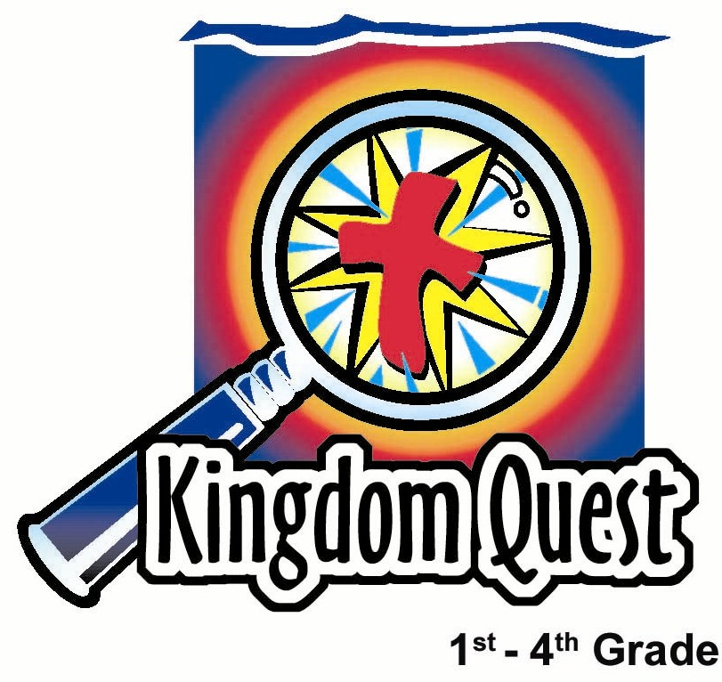
Date: ____________________
Series: God is Our Rescuer (Sept-Nov)
Year 2, Lesson 15

God’s Victory Breaks Down Walls

Take Home Point: *God helps us break down walls that keep Him away.
*Repeat this phrase throughout the lesson.

Bible Event: Joshua 5:13-6:27. Victory at Jericho

Key Verse: 1 Corinthians 15:57 “But we thank God! He gives us the victory through our Lord Jesus Christ.”

We will help kids know:
- The Bible event of the fall of Jericho and the rescue of Rahab and her family.
- Sometimes we can create invisible walls in our lives that keep God away. These are the walls of our own sin and selfishness.
- Through Jesus’ victory for us on the cross, God can break down the walls of sin in our life.

We will help kids feel:
- Conviction about the walls we put up in our life to keep God away.
- Excitement as they claim the victory God has won for them.

We will help kids do:
- Talk about those things that get in the way of our friendship with God.
- Claim God’s victory to knock down those walls and help us show others how God has a victory for them as well.
- Make a cross bookmark that reminds them that God won the victory for them.

THIS LESSON’S ROADMAP

DESTINATION | PAGE # | DISCOVERIES ON YOUR JOURNEY | SUPPLIES NEEDED
Small Group Warm-Up   | 3-4 | Building index card houses helps the kids think about walls that might keep God away. | - 3x5-inch lined index cards (five cards for each child)  - pencils or pens
Large Group   | 4  8-9  10-11  12-13 | Overview  Puppet Presentation: “Break Down the Walls” – Dao Dao puts up a wall between himself and. Teacher as he tries to ignore him.  Dramatic Presentation: “Korah’s Story: Knocking Down the Walls of Jericho” – The guest story teller is a priest from the days of Joshua to tell the Bible Event from Joshua 5 and 6.  Puppet Presentation: “Break Down the Walls” Conclusion | - Dao Dao with an index card taped to his head  - simple Old Testament costume for an adult  - shofar or ram’s horn (a long plastic blow horn or trumpet would work, as well)  - Ark of the Covenant (used in lesson 10, “Rescued People Meet Their Rescuer” or make a simple one, see picture for ideas)  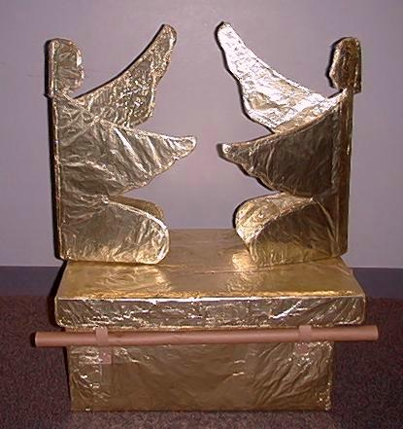
Small Group Application   | 4-7 | God wants us to knock down the walls in our life. Review of what Jesus did on the cross and other examples help the kids remember the take home point, *God helps us break down walls that keep Him away.  Memory Verse Learning:  “Help Me Teach”  1 Cor. 15:57 will be emphasized from lessons 15-18 to claim God’s victory for each of us. | - two index cards per child (used in small group warm-up)  - scissors  - glue  - red yarn  - hole punch for each group  - markers  - five crosses smiliar to Small Group Warm-Up with memory verse written  - pencils
Small Group Warm-Up: 15 minutes
Purpose: Get pointed in the right direction! Build relationships and help guests feel at ease. Do the learning readiness activity that will point your group in the right direction for the lesson.

Supplies needed: five 3x5-inch lined index cards for each child.

Using index cards, lean four cards against one another at right angles. A card on top of the four walls provides a roof. Demonstrate building a card house as you say the following.

Today we are going to build houses out of index cards like this. Before I pass these cards out to you, think about the walls in your home. Tell me at least one thing or one person that these walls might keep out. (Siblings out of your room, strangers out of your house, etc.)

After the children have shared, give them each five cards to build their houses. Then have them set their cards aside to discuss the following.

Now I want you to think about a different kind of wall. This is not a wall in a building, but it is an invisible wall. This is a wall that we build that might keep God away. This invisible wall is built with things we do that get between us and God, like not trusting in Him.

Write “not trusting God” on the lined portion of an index card. Hold the card up for the kids to see.

Sometimes we choose not to trust God when we have a problem. We want to worry about our problem and fix it ourselves.

Write “using God’s name in vain” on another index card.

Another example is when you use God’s name in the wrong way, like saying “Oh, my God…”

Ask the kids if they can think of things they sometimes do to make an invisible wall between them and God. Have them write their repsonses on a card.

Other examples of walls we build include:
- Not paying attention in worship to honor God.
- Watching bad TV shows that don’t have appropriate messages and ignore how God wants us to live.
- Not sharing Jesus with someone who needs to know about Jesus.
- Skipping Sunday school or Children’s Church.
- Rejecting Jesus’ ways in certain areas of your life.
- Making fun of others and hurting their feelings.
Today we are going to find out how God knocks down these walls. *God helps us break down walls that keep Him away.

When we go to large group we are going to see how God knocked down the walls of the city of Jericho. He gave the Israelites a great victory by doing this. God wants to give you and me a big victory by knocking down any walls we might have made to keep Him away from us.

Large Group: 20-30 minutes
Purpose: Help kids observe what the Bible says. Present the Bible event in creative fashion. Help kids begin to interpret what it means.

Supplies needed: Dao Dao with an index card taped to his head; simple Old Testament costume for an adult; shofar or ram’s horn (a long plastic blow horn or trumpet would work, as well); Ark of the Covenant (used in lesson 10, “Rescued People Meet Their Rescuer” or make a simple one, see picture for ideas)

Overview

Puppet Presentation: “Break Down the Walls” – Dao Dao puts up a wall between himself and Teacher as he tries to ignore him.

Dramatic Presentation: “Korah’s Story: Knocking Down the Walls of Jericho” – The guest story teller is a priest from the days of Joshua to tell the Bible Event from Joshua 5 and 6.

Puppet Presentation: “Break Down the Walls” Conclusion

Small Group Application: 20-25 minutes
Purpose: Help kids map out the meaning of the Bible event in their lives. Use the questions to stimulate discussion but don't feel tied to them. Allow the Holy Spirit to guide you. Include personal examples from your own faith journey. The example of Christ at work in your life will leave lasting impressions of how Christ can work in the children's lives.

Use your Bibles! Children need to learn how to look up references and follow along when scripture is read aloud. Allow for quality time of prayer at the close of the lesson.

Supplies needed: two index cards per child (used in small group warm-up); scissors;
glue; red yarn; hole punch for each group; markers

Observation Questions: What happened?
Have kids refer to Joshua 5:13-6:27 in their Bibles.

Who met Joshua to give him the battle orders? (Joshua 5:13-14. A man with a sword, the commander of the Lord’s army.)

The army was to march one full circle around the city for how many days? (Joshua 6:3. Six days.)

On the seventh day they were to march how many times? (Joshua 6:4. Seven times.)

What did the priests carry around the city? (Joshua 6:4. The Ark of the Covenant and trumpets or rams’ horns.)

What were the people to do on the seventh day when they heard all the trumpets? (Joshua 6:5. Shout.)

Who was saved from the city and how? (Joshua 6:22-23. Rahab and her family. Joshua 2:18. The scarlet cord.)

Interpretation Questions: What does this mean?

What do you think it meant to have the Ark of the Covenant march around the city? (The presence of God, the throne of God, God’s agreement to rescue.)

Rahab and her family were saved because of a scarlet cord that hung from her window and marked her house. What other rescues did God perform using the color red? (The blood on the doorposts during the Passover from Egypt, the blood of Jesus who rescues us.)

Application Questions: What does this mean to me?

God wants to knock down walls in our lives that might keep us from getting closer to Him. How many of you can remember some examples from small group warm-up of walls that try to keep God away? (Refer to that list. Encourage kids to come up with more of their own ideas.)

Let’s talk about how God gives us victory by breaking down those walls.

Take out a red piece of yarn.

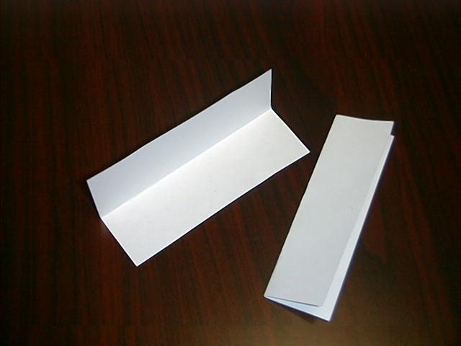
This red string might remind us of the blood of Jesus. He gave His life for us to give us forgiveness and to show us how much God loves us. We can trust that even if we build a wall, He can knock it down with His forgiveness.

Let’s make something that reminds us of that.

Application Activity:
Each child will need two index cards to fold in half lengthwise. The cards should be folded so the lines are on the inside, especially if phrases of the walls we build were written on those lines.
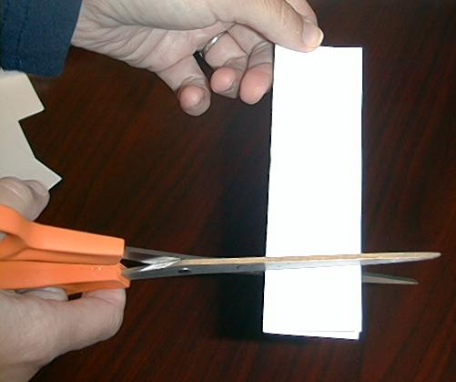

Have the children cut one inch off the end of one card.
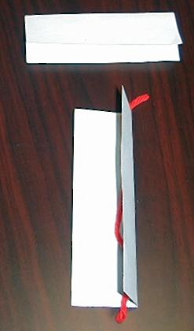

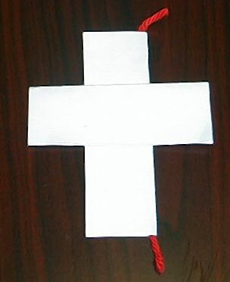
This will leave each child with two folded index cards that would form a cross when glued together. Before gluing shut the vertical piece of the cross, place a length of yarn along the inside center so it hangs out the top.

The horizontal piece of the cross can be glued shut and then glued to the vertical piece to make a cross.
Children can use this as a bookmark.
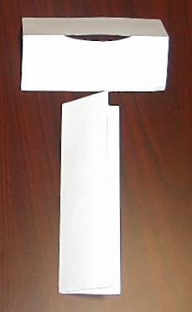

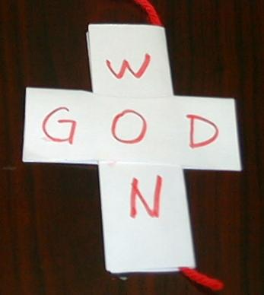
Older children may make their crosses fancier by cutting a slot in the middle of the horizontal piece of the cross and sliding it over the vertical piece before gluing.

On the cross write, “God Won.” This will remind the children how God won the victory over any
walls they might have put up in their lives. They
can use this bookmark in their Bibles or to
explain the lesson to their parents at home.

The key verse for today from 1 Corinthians 15:57 says, “But we thank God! He gives us the victory through our Lord Jesus Christ.” Remember, *God helps us break down walls that keep Him away.

Memory Verse Learning: 5 minutes
Purpose: Help kids to memorize and keep scriptures at heart. Using creative ways to help kids enjoy learning the key verse and in small group setting.

Supplies needed: five crosses smiliar to Small Group Warm-Up with memory verse written; pencils

Memory Verse: 1 Corinthians 15:57 ~ “But we thank God! He gives us the victory through our Lord Jesus Christ.”

Memory Verse Presentation: “Help Me Teach”

I Corinthian But we He gives the victory our Lord
15:57 thank God! us through Jesus Christ.

Pre-prepare fivecrosses out of index cards similar to Small Group Warm-Up. Write the memory verse like the diagram above. Have group sit in a circle and then lay out the crosses randomly before the group. Read the verse to the children by pointing the words in its squence. Do it two times before having volunteers be the “teacher.” After several rounds, put away the crosses and have the children write out the memory verse at the back of the bookmark that they had completed just earlier.

Prayer Time:
Close with a prayer that confesses the sin of the walls we put up. Thank God for breaking down those walls by giving us Jesus. Let each child also pray for any of his personal needs.
Large Group Presentation

Break Down the Walls

Puppet Presentation

Dao Dao will appear with an index card taped to the side of his head in such a way that it becomes a wall between him and Teacher.

Teacher: Kids, today we are talking about how *God helps us break down walls that keep Him away. I hear you made a few walls out of cards during your small group time.

Dao Dao: (Appears.) Hi, kids!

Teacher: Hi, Dao Dao.

Dao Dao: Hey, kids, I have a special game to play.

Teacher: What is it, Dao Dao?

Dao Dao: I’m not talking to you. I’m talking to them.

Teacher: Okay, Dao Dao.

Dao Dao: My special game is fun, and everyone can play it.

Teacher: Hey, Dao Dao, what’s with that silly card taped to your head?

(Dao Dao ignores Teacher.)

Dao Dao: Well, kids, my game is something that you can play here and at home.

Teacher: Dao Dao, what about this silly card? I can’t even see you.

Dao Dao: Kids, is there a strange noise in this room?

Teacher: Dao Dao, I’m talking to you.

Dao Dao: I thought I heard a strange noise, but it’s nothing.

Teacher: Dao Dao, it’s me! Aren’t you talking to me?

Dao Dao: By the way kids if you see Teacher, tell him I’m not talking to him. I’m ignoring him.
Teacher: Dao Dao, why are you ignoring me?

Dao Dao: Kids, do you want to play this new game with me? It’s called “Ignore Teacher.” Everybody stand up and turn around.

(Momentary chaos happens as Dao Dao encourages the kids to follow through on those directions. Dao Dao can ad-lib a line or two about this being a fun game to play.)

Teacher: Now, wait a minute, Dao Dao I don’t like this game. It makes me feel left out.

Dao Dao: Well, it’s my game, and we’re not playing with you!

Teacher: Now, wait a minute. Kids, turn around and sit back down.

Dao Dao: Hey! You’re ruining my game!

Teacher: Dao Dao, when you play that game it is just like putting a wall up between you and someone else. That’s not good. As a matter of fact, today we are learning that people can put up walls between themselves and God. If you ignored God like you ignored me, it would be just like putting up a wall between God and yourself.

Dao Dao: Oh…That would be bad.

Teacher: It sure would. But God is wonderful and *God helps us break down walls that keep Him away. Today we are going to discover the Bible event of how God knocked down the walls of Jericho. He promised a victory for His people by giving them the Promised Land. This is an exciting Bible event, and I have a special guest who was there and can tell us all about it.

Dao Dao: Cool!

Teacher: Kids, I would like to introduce to you Korah and his trumpet. Let’s welcome him.

Go to the dramatic presentation, “Korah’s Story: Knocking Down the Walls of Jericho.” If you choose not to use this presentation, you might have a storyteller tell the event in an animated fashion.

Korah’s Story: Knocking Down the Walls of Jericho

Dramatic Presentation

Korah, a fictitious character, was one of the Israelite trumpeters during the battle of Jericho. He appears as a costumed character with the prop of a trumpet. (It would be ideal to use a ram’s horn or shofar, however a long, plastic blow horn or a trumpet could be used as well.)

Also needed for this presentation is the Ark of the Covenant, which was used in Lesson 10, “Rescued People Meet Their Rescuer” or the ark can be made by referring to the picture in the Lesson Roadmap.

Korah: Enters with a blast from his trumpet. Excuse me. I hope I didn’t startle you. I love to blow this trumpet. I have never seen such an amazing thing as when we blew the trumpets and the walls came down. Oh! Wait a minute. Perhaps I’m getting ahead of myself. Would you like to hear the whole story of what happened?

My name is Korah, and this is what I do best. Blast trumpet. I am one of the hundreds of thousands of Israelites who crossed the Jordan River to take the Promised Land.

God told us to take the evil city of Jericho, but how could we ever do that? There was a great stone wall that surrounded the city. When the gate was locked, no one could get in or out.

We didn’t know what to do until our commander, Joshua, came and spoke to us. He told us he saw a strange man dressed like a soldier. He later discovered this strange man was an angel. He carried a bright sword and said he was captain of the Lord’s army.

Joshua asked the angel what the Lord wanted him to do. The angel said, “Gather seven priests who will carry seven horns.” (I got to be one of those guys.)

The priests led the march, and behind us was the Ark of the Covenant, which reminded us of the presence and the promise of God. All the warriors marched after them.

You would think that we would have attacked the city then, but we were told not to. Instead we quietly walked around the city. We did this one time on the first day. Then we did it again on the second day. And the third day. We did this for six days.

The people of Jericho wondered what kind of strange warfare this was. Why was this army just silently marching around their city? I must admit it felt very strange for me.

If time and logistics of your room work, you might have the children now follow the Ark of the Covenant in a processional around a section of the building. Do this so the children might experience what it was like to quietly march around the city of Jericho.

Korah: Finally on the seventh day, we marched around the city seven times. When we finished it was my turn. All seven priests did this. Blast horn.

All the people gave a great shout for we knew the Lord had given us the city. At that moment, the stone wall began to tremble. Then it shook. Then it fell flat! There was only one family to escape the destruction—the family of Rahab.

Rahab had helped our people spy on the city before we marched on it. Since she had helped us, we told her that she and her family would be spared. Before that could happen, she had to mark her window with a red, or scarlet, cord. After the walls had fallen there was one home still intact. Rahab’s home, along with the red cord attached to her window, still stood.

God knocked down great walls that day, and He gave us a mighty victory as we trusted and followed Him. *God helps us break down walls that keep Him away.

And that is my story. Blast horn and exit.

Break Down the Walls
Puppet Presentation Conclusion

Dao Dao: Wow! I guess when God wants to break down walls, He’s not messing around.

Teacher: Yes, and He’s not messing around when He breaks down walls in our lives.

Dao Dao: How does He do that?

Teacher: Well, I’m going to let you guess.

Dao Dao: Okay. Give me a hint.

Teacher: When Rahab was saved, what color was the cord that was hung from her window?

Dao Dao: I forgot. Kids, who will help me? (Chooses a volunteer.)

(Child offers the answer “red.”)

Dao Dao: Okay, the cord was red.

Teacher: And what does that remind you of?

Dao Dao: Oh, I know that one! That reminds us of the blood of Jesus when He gave His life for us on the cross.

Teacher: Right, Dao Dao!

Dao Dao: So is that how God helps to break down the walls?

Teacher: Of course it is! God’s power of forgiveness breaks down the walls that we might try to put up to keep Him away. He still loves us, and He will forgive us and help us change.

Dao Dao: Wow! I guess God really wants to be close to us.

Teacher: He sure does. Why don’t we close with prayer and thank Him for that.

Dao Dao: Okay!

Teacher: Dear God, thank You for wanting to be close to us. We’re sorry for the times we put up walls to keep You away. Please forgive us because of the blood of Jesus. Help to change us so we don’t want to put any walls up to keep You farther away. Help us want to be close to You because, God, You’re the best! In Jesus’ name. Amen.

Dao Dao: Thanks, Teacher. And, you know what? If I was trying to put up a wall between you and me, I was just teasing.

Teacher: I know, Dao Dao.

Dao Dao: No hard feelings?

Teacher: No, that’s okay.

Dao Dao Okay, let’s shake on it. (Pretends to want to shake hands and then pulls his hand away. He finally shakes Teacher’s hand.)

Teacher: Bye, Dao Dao!

Dao Dao: Bye, Teacher! Bye, kids!

LESSON 15

Small Group Warm-up
- 3x5-inch lined index cards (five cards for each child)
- pencils or pens

Large Group Presentation
- Dao Dao with an index card taped to his head
- simple Old Testament costume for an adult
- shofar or ram’s horn (a long, plastic blow horn or trumpet would work, as well)
- Ark of the Covenant (Either use Ark made in Lesson 10 or make one (see picture in Lesson Roadmap)

Small Group Application
- two index cards per child (used in small group warm-up)
- scissors
- glue
- red yarn
- hole punch for each group
- markers

Memory Verse Learning
- five crosses smiliar to Small Group Warm-Up with memory verse written
- pencils

I Corinthian But we He gives the victory our Lord
15:57 thank God! us through Jesus Christ.

