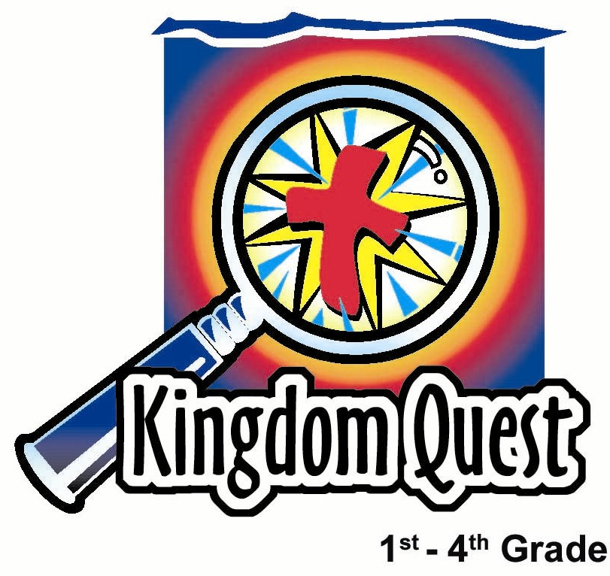
Date: _________________
Series: God is Our Rescuer (Sept-Nov)
Year 2, Lesson 18

A Rescuer Who Listens and Does Mighty Deeds

Take Home Point: *God listens to us and does mighty deeds.
*Repeat this phrase throughout the lesson.

Bible Event: Joshua 10. The sun and the moon stand still.

Key Verse: Zephaniah 3:17a (NIV) “The LORD your God is with you, he is mighty to save...”

We will help kids know:
- The Bible event of Joshua 10, God stopping the sun and the moon and providing victory for His people.
- We can call upon God and know He will listen to us and bring His victory in our lives.
- God’s power can penetrate our lives.

We will help kids feel:
- Awed by God’s power and love.
- Confident that God does hear our prayers and will provide His victory in wonderful ways.

We will help kids do:
- Identify situations in their lives where God wants to drive out His enemy, the devil, and apply those areas to prayer.
- Make an art project that reminds them the Lord listens to them.

THIS LESSON’S ROADMAP

DESTINATION | PAGE # | DISCOVERIES ON YOUR JOURNEY | SUPPLIES NEEDED
Small Group Warm-Up   | 3-4 | The object lesson compares strengths. Our strength is nothing in comparison to God’s. That’s why it’s so important to ask God for help. | - a brick, a large book, a bag of sand or flour, or something heavy for each group  - a pencil
Large Group   | 4  8-10  11-12  13 | Overview  Puppet Presentation: “God Gives Us a Hand” – Dao Dao asks for a hand clap and gets his wish in a mysterious way.  Dramatic Bible Reading: “The Sun and the Moon Stand Still.” – In this Bible event from Joshua 10, by God’s mighty hand Joshua defeats the five Amorite kings.  Puppet Presentation: “God Gives Us a Hand” Conclusion – Dao Dao learns that God sending Jesus for us was greater than stopping the sun in the sky. | - floodlight  - divider  - Dao Dao  - white gloves
Small Group Application   | 5-7 | Our battles are somewhat different than what the Israelites had to face with swords and spears. We have spiritual battles. We must decide on who we will call for help.  Memory Verse Learning:  “What Is The Missing Word”  1 Cor. 15:57  1 Cor. 15:57 will be emphasized from lessons 15-18 to claim God’s victory for each of us. | - a small, white, paper plate for each child  - scissors  - yellow cellophane or tissue paper to cover the center hole that will be in each plate  - lots of yellow construction paper (several per child.)  - glue or stapler  - markers  - sticker labels with phrases “The Lord your God is with you,” and “He is mighty to save.”  - 15 circles visual from lesson 16.
Small Group Warm-Up: 15 minutes
Purpose: Get pointed in the right direction! Build relationships and help guests feel at ease. Do the learning readiness activity that will point your group in the right direction for the lesson.

Supplies needed: a brick, a large book, a bag of sand or flour, or something heavy for each group; a pencil
Today’s warm-up activity involves a game of comparing strengths. Kids love to test their strength, comparing it with one another. The outcome of this game, however, is that every child would find that his strength is not enough. The twist at the end of the game is that one child will be able to accomplish a feat of strength because that child calls upon the shepherd for special help.

For this activity, you will need a brick or heavy object such as a large book and a pencil.

Begin by explaining the game.

Kids, today we are going to have a strength contest.

Show kids the brick or heavy object.

You will have a chance to test how long you can hold this brick with one hand.

Choose one child to demonstrate.

Kneel down on the floor so if you drop the brick, it won’t hit anyone else’s foot. Hold the brick out to the side of your body. If you want, you can bend your elbow and make your arm in the shape of an “L.” The rule is you must keep the top part of your arm straight out until you can’t anymore.

Have someone else hold a pencil horizonally just two inches underneath that child’s arm.

This is the line the brick cannot touch or go below. You can do anything you want to hold this brick as long as it doesn’t go below the line. As soon as the brick gets so heavy that your arm comes down and touches it, your turn is over. Try not to drop the brick. Let’s see who can hold it the longest, and while we are doing that let’s talk about what it means to be strong.

You might have the kids guess who they think will be the winner. As the game is being played, ask kids questions regarding their own strength. For example, as children are waiting their turn ask questions like:

If you were really strong, what would you like to do with your strength?
What is the hardest thing you have had to do?

As the kids progress through the test, secretly inform one child (or have another helper inform them) that when it’s his turn he can ask a shepherd to help him. When he asks for help, take your hand and put it underneath his. By doing so you would be holding the brick so the child could last for a very long time.

Of course, the kids will say this is cheating. Remind them that when you explained the rules, you said they could do anything they wanted to hold the brick. There was no rule against asking someone to help. In fact, this is the best thing to do.

Prepare for large group with the following:

Remember from last week how Joshua and the Israelites had to claim the promised land God had given them in order to go into it? By themselves they weren’t very strong, but with the Lord fighting for them, they were stronger than anyone else. The Lord is the one who wanted to rescue them from their enemies, so He listened carefully to their prayers for help.

In today’s event we will find that God listened to them in such a wonderful way that He even stopped the sun and moon so they could have complete victory. *God listens to us and does mighty deeds as well!

Large Group: 20-30 minutes
Purpose: Help kids observe what the Bible says. Present the Bible event in creative fashion. Help kids begin to interpret what it means.

Supplies needed: floodlight; divider; Dao Dao; white gloves

Overview

Puppet Presentation: “God Gives Us a Hand” – Dao Dao asks for a hand clap and gets his wish in a mysterious way.

Dramatic Bible Reading: “The Sun and the Moon Stand Still.” – In this Bible event from Joshua 10, by God’s mighty hand Joshua defeats the five Amorite kings.

Puppet Presentation: “God Gives Us a Hand” Conclusion – Dao Dao learns that God sending Jesus for us was an even greater act than stopping the sun in the sky.
Small Group Application: 20-25 minutes
Purpose: Help kids map out the meaning of the Bible event in their lives. Use the questions to stimulate discussion but don't feel tied to them. Allow the Holy Spirit to guide you. Include personal examples from your own faith journey. The example of Christ at work in your life will leave lasting impressions of how Christ can work in the children's lives.

Use your Bibles! Children need to learn how to look up references and follow along when scripture is read aloud. Allow for quality time of prayer at the close of the lesson.

Supplies needed: a small, white, paper plate for each child; scissors; yellow cellophane or tissue paper to cover the center hole that will be in each plate; lots of yellow ; construction paper (several per child.); glue or stapler; markers ; sticker labels with phrases “The Lord your God is with you,” and “He is mighty to save.”

Have kids look up the Bible event in Joshua 10.

Observation Questions: What happened?

What did God tell the Israelites to do with the cities of Canaan? Destroy them or drive the people out? (Destroy them. See Joshua 10:28,30,32-33.)

Why did He tell the Israelites to do this? (The Amorites were God’s enemies, and God did not want them to cause His people to follow their Canaanite false gods.)

What did the Israelites need to have happen so they could have complete victory? (Joshua 10:12. More daylight to chase away the other army.)

What did God do to give them complete victory? (Joshua 10:13. God caused the sun and moon to stay where they were to give them more time.)

Why did God do this? (Joshua 10:14. Because of the prayers of Joshua and the Israelites.)

Interpretation Questions: What does this mean?

How do you think the people felt when they saw God stop the sun and the moon and give them more daylight?

What do you think the bad kings and enemies of Israel thought when they heard about this mighty miracle?

Application Questions: What does this mean to me?

Today, we don’t face battles with swords and spears like the Israelites did years ago. Our battles are different. We can have spiritual battles. These are battles in which we struggle against sin or selfishness. An example of a battle might be when a parent asks us to do something, and we don’t want to. When we disobey, we feel like a battle is going on inside us, a battle between choosing to do wrong or choosing to do right. Or maybe we have a struggle being kind to a certain person at school. Maybe we struggle to get along with a sister or brother. When we have these battles it is important to remember *God listens to us and does mighty deeds. We need to tell Him about our struggles and ask that He would help.

Let me tell you about a battle I sometimes face… (Share a personal example.) Since I know Jesus as my Savior, He gives me the power of His forgiveness. He lives inside me to help me follow Him more every day. He helps me win that battle. When we think how mighty God is, it makes it easier to trust Him.

Today let’s make a craft that reminds us of God’s power when He held the sun in His hand to give victory to His people. It is His hand that holds ours and gives us a victory over the battles in our lives. Listen to what God tells us from His word in Zephaniah 3:17a: “The Lord your God is with you, He is mighty to save.”

Have kids repeat these words.

We can know for certain that every day *God listens to us and does mighty deeds.

Application Activity:
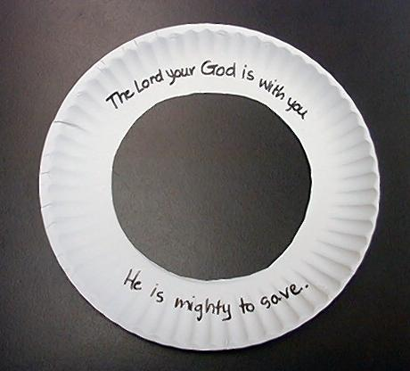
Kids will make a sun window ornament with today’s Bible verse to remind them of today’s lesson. Give each child a small white paper plate. Have them cut out the inside circle of the plate. Around the ring have the children copy the key verse. On the upper part of the remaining ring, have the kids write, “The Lord your God is with you,” and on the lower part write, “He is mighty to save.” (Especially with younger children it will be helpful to have these phrases written out for them to copy or show a sample craft. Print the phrases on labels that children can stick on to the paper ring.)

Replace the inside section of the circle with yellow cellophane or tissue paper glued to the back of the plate. (These can be square shaped.) For the rays of the sun, have the children trace their hands on yellow construction paper. Cut out these hands and staple or glue them around the paper plate to make sunrays.
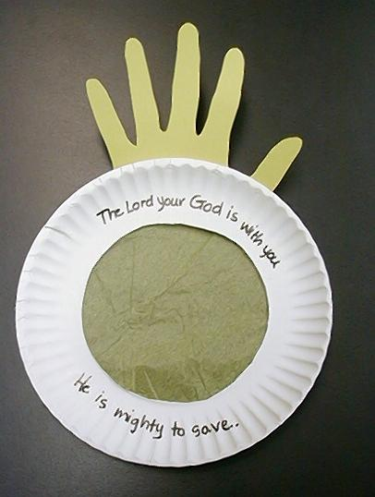
After you have given instructions for the craft, and while the kids are working, say:

I’d like you to think about some area in your life that might be a struggle or a battle to do what God wants you to do. While we do the craft, let’s listen to each person share some kind of struggle or battle in which they need God to do a mighty deed.

Even if the craft is not completed, stop to take time for closing prayer. This is one of the most important parts of the lesson—trusting God to listen to us. The children can always take the craft home to finish it. However, no one should leave without prayer.

Memory Verse Learning: 5 minutes
Purpose: Help kids to memorize and keep scriptures at heart. Using creative ways to help kids enjoy learning the key verse and in small group setting.

Supplies needed: 15 circles visual from lesson 16

Memory Verse: 1 Corinthians 15:57 ~ “But we thank God! He gives us the victory through our Lord Jesus Christ.”

Memory Verse Presentation: “What is the Missing Word?”
Have the children sit in a circle. Tell them that today’s match is Boys vs Girls. You as the shepherd lay out the words of 1 Cor. 15:57. But there is a missing word of the memory verse. The person who knows what the missing word is have to raise his hand, wait for the shepherd to call and then only give the answer. Before you proceed to the next round, have the children recite the verse with you.

Prayer Time:
Encourage the children to pray by asking God for victory and expecting that He will rescue them. Certainly if God can stop the sun, He can come into their lives and give them the victory. The victory is always ours through Jesus Christ, who strengthens us. Emphasize that by trusting in Jesus, who died on the cross to give us forgiveness, we have His power living in our lives, and we will become more like Him.

Large Group Presentation

God Gives Us a Hand
Puppet Presentation

IMPORTANT: Extra time is needed to complete the craft in small group. Please keep the large group presentation as succinct as possible.

This script requires an additional character behind the puppet stage with white-gloved hands. These white-gloved hands silently give gestures throughout the script as described.

Teacher: Boys and girls, today we are talking about how God is a rescue, and He gives us a hand in our lives so we can have a complete victory. So I wonder what Dao Daohas to say about this. Shall we call him?

(Kids chant, “Dao Dao! Dao Dao! Dao Dao!”)

Dao Dao: (Pops up, disappears, and re-emerges.) Hey, wait a minute! How come I have to come out every time you say, “Dao Dao, ”? Why don’t you give me a hand instead? Then I’ll come out. (Disappears.)

Teacher: Well, kids, what do you think? Let’s give Dao Dao a hand.

(Applause.)

Dao Dao: (Reappears.) Well, that’s better, but I don’t know if it’s good enough. Come on, kids! Can’t you really give me a hand? (Disappears.)

Teacher: I don’t know, Dao Dao. It seems like you’re asking a lot.

(Two gloved-hands appear on stage next to Dao Dao giving a soft applause. After a few seconds of this, Dao Dao appears staring in awe at the hands that are clapping for him.)

Dao Dao: Hey, what do you mean by this?

Teacher: Well, I guess you asked for a hand.

Dao Dao: Yeah, but I didn’t expect this. These really are hands! What are they doing here?

Teacher: It looks like they are clapping for you.

Dao Dao: Oh, pretty smart hands, huh?

Teacher: Well, I don’t think that makes them smart. It just might mean that these hands are listening to you.

Dao Dao: Hands that listen to me? Wow! Way cool. What are they about?

(With each of these comments, the hands need to be nodding or shaking sideways to show agreement or disagreement. Several different creative expressions can keep them an active part of the story.)

Teacher: Well, today we are talking about God’s hands.

Dao Dao: Does He have hands like this?

Teacher: No, not like that. When we say God has hands, we mean God can do mighty things just as if He had giant hands.

Dao Dao: Like what kind of mighty things?

Teacher: Like anything.

Dao Dao: Like grab the sun?

Teacher: Yes, like grab the sun.

Dao Dao: Like grab the moon?

Teacher: Yes, like grab the moon.

Dao Dao: No, way!

Teacher: In today’s story God took His hands, and He stopped the sun and the moon so He could give a victory to rescue His people.

Dao Dao: Why did He do that?

Teacher: Because He listened to the prayer of Joshua and His people.

Dao Dao: Wow! Would He give me a hand, too?

Teacher: I think He would.

Dao Dao: Go ahead, God. Clap for me.

Teacher: I don’t think that’s what God means. He will take His hands and put them in yours to help you do things that will bring His victory to challenges you face in life.

Dao Dao: Kind of like a high-five?

Teacher: Kind of. Watch God’s hands there grab you. (Hands wrap around Dao Dao.) He holds you. When you pray to God, His hands move in your life to help you have a victory.

Dao Dao: Wow! Way cool!

Teacher: It sure is. So, listen to today’s Bible event and imagine what it would be like if you were there. If God would stop the sun and the moon for the prayers of the people, then what kind of wonderful things would He do for you today?

Dao Dao: Let’s check it out!

The Sun and the Moon Stand Still

Joshua 10-12
Dramatic Bible Reading

While telling the Bible event, have a helper use a floodlight to show the setting of the sun. Darken the room and have the helper with the floodlight stand behind a divider. Move the floodlight slowly in the shape of an arc above the divider to show the rising and setting of the sun. When the Bible event reaches the point of Joshua’s prayer, the setting of the sun will stop or, perhaps, get a bit brighter.

As you remember from the last week, we have seen how the Israelites were at war with the people living in the promised land. God had ordered the Israelites to drive out the Amorites, the people living in the land that God had promised them. These people followed false gods and a religion that was at war with God. They even went as far as to sacrifice their own children to their gods. It was a very cruel religion, and Satan himself was behind it.

God did not want the Amorites to lead His people away from Him by following their false gods. This is why He wanted them driven out or destroyed. In a way, it was a battle between Satan and God. God judges sin and rebellion; His judgement is serious. At the same time, God rescues anyone who trusts Him as the true God and Savior.

Here is the account of how God listened to the Israelites and did mighty deeds for them.

News had traveled throughout the land that Joshua and the Israelites had been victorious in their battles. The Amorite kings were worried. One of them was the king of Jerusalem who gathered several of the neighboring kings with him and said, “Come, let’s go attack the city of Gibeon. They are the ones who made peace with the Israelites.”

So five kings gathered their armies and marched across the hills to the city of Gibeon. The Gibeonites knew they would soon be destroyed, but they had become friends with the Israelites and had agreed to serve them. They sent word to Joshua, “Come quickly! We are about to be attacked.”

Joshua and the whole Israeli army went to help. God had promised Joshua, “Do not be afraid for I will be with you. You will win over your enemies.”

All night long the Israelites traveled. They hoped to surprise all the soldiers attacking Gibeon. When they arrived, the enemy turned and ran away. The Israelites chased their enemies and scattered them. Hail fell from heaven. God killed more men in the hailstorm than even in the battle. Throughout the day, the Israelites chased down their enemies, but they ran out of time as night was approaching. The enemy soldiers would be able to hide in the woods to return and fight the next day.

Joshua knew that there wouldn’t be enough daylight to fight the enemy so he said, “Sun, stand still above Gibeon. Stay above the valley of Aijalon.” It was amazing, “The sun stopped in the middle of the sky, and for nearly a day, the sun was in no hurry.

“That has never happened at any time before that day or since. That was the day the Lord listened to a man. Truly the Lord was fighting for Israel!” Joshua 10:14.

The Israelites won a great victory. News of the battle soon reached the other cities. The people in these Amorite cities and everywhere were afraid of the Israelites. Just as God had commanded, Joshua defeated 31 kings and took their cities and the country where they ruled. Then the Israelites rested, for *God had listened to them and done mighty deeds.
God Gives A Hand

Puppet Presentation Conclusion

Teacher: Pretty cool story, hey, Dao Dao?

Dao Dao: It sure was, but does God ever do anything like that today?

Teacher: The Bible says God will never again lengthen a day like He did then. But God still does mighty things today.

Dao Dao: Like what?

Teacher: Well, the mightiest thing He did was giving His son, Jesus.

Dao Dao: Oh, yeah. Jesus gave His life for us. That was pretty cool, but I would still like to see the sun stop in the sky.

Teacher: Since Jesus gave His life for you, you can have the Son of God in your life. That’s better than watching the sun stop in the sky.

Dao Dao: I guess you’re right.

Teacher: Dao Dao, since you know Jesus, you know that *God listens to us and does mighty deeds. Why don’t we go back to small group and talk about the mighty deed He does for us? Let’s bow for prayer.

Dao Dao Okay.

Teacher: Dear God, thank You for listening to us and doing mighty deeds. You helped Joshua in the great battle. Sometimes when we face things that seem like a battle, we need You to help us win, also. Move Your mighty hand in our lives to help us. In Jesus’ name. Amen.

Dao Dao: Good-bye, Teacher! Good-bye, kids!

Teacher: Good-bye, Dao Dao and God bless you.

LESSON 18

Small Group Warm-up
- a brick, a large book, a bag of sand or flour, or something heavy for each group
- a pencil

Large Group Presentation
- floodlight
- divider
- Dao Dao
- white gloves

Small Group Application
- a small white paper plate for each child
- scissors
- yellow cellophane or tissue paper to cover the hole that will be cut out of the center of each plate
- lots of yellow construction paper (more than one sheet per child.)
- glue or stapler
- markers
- sticker labels with phrases “The Lord your God is with you,” and “He is mighty to save.”

Memory Verse Learning:
- 15 circles visual from lesson 16.

