
Date: __________________
Series: God is Our Rescuer (Sept-Nov)
Year 2, Lesson 24

Your Strength Comes from
the Lord

Take Home Point: *God arms me with strength.
*Repeat this phrase throughout the lesson.

Bible Event: Judges 13-16. The story of Samson

Key Verse: 2 Samuel 22:33a “God arms me with strength . . .” (GW)

We will help kids know:
- The events of Samson’s life. Samson received strength from the Lord yet allowed it to be taken from him.
- We, too, receive spiritual strength from the Lord. Let’s not be bound by listening to the lies of the enemy.

We will help kids feel:
- Amazed at Samson’s strength, yet more amazed that he could so easily lose his strength.
- Confident that, through Jesus, God arms us with strength.

We will help kids do:
- Identify special strengths the Lord has given them and how they might use these strengths for God.
- Identify that which might keep them from using their gifts and, thereby, bind up their strength.
- Make an artistic reminder that God arms us with strength through what Jesus has done.

THIS LESSON’S ROADMAP

DESTINATION | PAGE # | DISCOVERIES ON YOUR JOURNEY | SUPPLIES NEEDED
Small Group Warm-Up   | 3 | What you are good at might also be called your strength. Today we are going to meet someone whom God’s Spirit would come upon, and he would have supernatural strength. | - thin thread  - paper and pencils for each child
Large Group   | 4  8-9  10-11  12-13 | Overview  Puppet Presentation: “Dao Dao Uses What He’s Got”  Dramatic Monologue: “Interview With the Strong Man” – Teacher interviews Samson.  Puppet Presentation Con-clusion – Dao Dao learns how God gives us gifts to use for His glory. | - Dao Dao puppet  - Samson costume
Small Group Application   | 4-7 | Kids take a look at the strengths God has given them. By doing a craft and applying the discussion, the kids learn, *God arms me with strength.  Memory Verse Learning:  “Balloon Bust”  Through learning 2 Samuel 22:33a in lessons 24 & 25, the child will be confident that, through Jesus, God arms us with strength. | - extra sheet of questions cut into strips for each group (page 13)  - eight balloons per group  - permanent magic marker  - one sheet of light or white manila card each cild  - tempera paint  - 12" sections of thread for each child  - eye droppers or spoons  - picture with quote: God arms me with strength  - scissors  - glue  - flyer for next week’s lesson (see appendix- page 15)  - seven slips of paper per group  - marker per group  - seven balloons per group
Small Group Warm-Up: 15 minutes
Purpose: Get pointed in the right direction! Build relationships and help guests feel at ease. Do the learning readiness activity that will point your group in the right direction for the lesson.

Supplies needed: thin thread; paper and pencils for each child

Kids, what do you do that is better than most other people? Think about a special gift or talent God has given you that not everyone else has. Maybe you are good at drawing pictures. Maybe you are smart in school or good at sports. Maybe you are good at singing or telling jokes.
Sometimes quiet children feel reluctant to share who they are by using words. This simple
art project can make them feel more comfortable and may draw them out more.

Pass out white copy paper or light-colored construction paper.

Draw what you are good at on this piece of paper. After just two or three minutes I’m going to show everyone the pictures, and we’ll guess what your special gift is. Then you can tell us more about it.

Have kids share their picture and tell about their special gift.

What you are good at might also be called your strength. Today we are going to meet someone whom God’s Spirit would come upon, and he would have supernatural strength. Let me show you. I need a volunteer who will hold his hands together while I tie this thread around his wrist.

After you have wrapped one loop around the child’s wrist invite him to snap it free. This should be easily done. Then loop the thread seven times around the child’s wrist and challenge him to snap it. Be aware that the thin thread might dig into uncovered skin so advise the child not to struggle so much that he would hurt himself.

Today we are going to meet another judge who ruled over Israel. You’ve probably heard of him. He was known for his great strength. Who wants to guess his name? Yes, his name is Samson. Though Samson was tied up with many thick ropes, when the Spirit of the Lord came upon him he could break them like a single thread. Samson’s strength came from God, and he did miraculously strong things. But Samson let himself get tricked so he lost his strength. Even then, God helped him to be strong again. Maybe you will discover how God wants to work His strength in you today as well. We will learn today *God arms me with strength.

Large Group: 20-30 minutes
Purpose: Help kids observe what the Bible says. Present the Bible event in creative fashion. Help kids begin to interpret what it means.

Supplies needed: Dao Dao puppet; Samson costume

Overview

Puppet Presentation: “Dao Dao Uses What He’s Got” – Dao Dao uses his gift of rhyming to let Teacher know he does not want to meet the strong man, Samson.

Dramatic Monologue: “Interview With the Strong Man” – Teacher interviews Samson covering the details from Judges 13-16.

Puppet Presentation Conclusion – Dao Dao learns how God gives us gifts to use for His glory. God gives us the strength to use those gifts when we remain in Him.

Small Group Application: 20-25 minutes
Purpose: Help kids map out the meaning of the Bible event in their lives. Use the questions to stimulate discussion but don't feel tied to them. Allow the Holy Spirit to guide you. Include personal examples from your own faith journey. The example of Christ at work in your life will leave lasting impressions of how Christ can work in the children's lives.

Use your Bibles! Children need to learn how to look up references and follow along when scripture is read aloud. Allow for quality time of prayer at the close of the lesson.

Supplies needed: extra sheet of questions cut into strips for each group (page 13); eight balloons per group; permanent magic marker; one sheet of light or white manila card each child; tempera paint; 12" sections of thread for each child; eye droppers or spoons; picture with quote: God arms me with strength ; scissors; glue; flyer for next week’s lesson (see appendix- page 15)

Option 1: Game: “Balloon Bust”
Play the game “Balloon Bust.” Cut the observation and interpretation questions below into individual slips of paper. Have the children write the number of the question on the balloon with magic marker. Have them then roll up the paper strips and insert them each in the corresponding numbered balloon. Have kids blow up the balloons and tie them. You may need to help with the tying.

Have the children sit on the floor in a tight circle and tap balloon #1 in the air among each other. Do this as music is played. When the music stops or when the shepherd signals, everyone should put their hands in their lap and let the balloon fall. The person whom it lands closest to will become Samson and break the balloon with his bare hands. This person will read and answer the question. Repeat with the other balloons in order. If the balloon falls closest to the same person twice then have him hand it to someone who hasn’t had a chance. Continue until all the questions have been answered. For the application questions, do not use balloon popping, but simply discuss. You will not have time for the craft activity.

Option 2: Ask the following questions without playing the game. Do the craft project while discussing the application questions.

Observation Questions: What happened?

A Nazirite was someone dedicated to God in a special way. How did Samson’s parents raise Samson as a Nazirite?

(Judges 13:4-5. He had to follow strict rules like not drinking wine, not eating unclean food, and no haircuts.)

What are some of the ways Samson showed his strength?

(Judges 14-16. He killed a lion with his bare hands, picked up the gate of the city and walked off with it, broke new and wet ropes, killed 1000 men with the jawbone of a donkey, tied the foxes’ tails together, pulled down the pillars, etc.)

Where did his strength come from?

(Judges 14:19. He was strong when the Spirit of the Lord came upon him.)

After Samson lost his strength, what happened to him?

(Judges 16:21. The Philistines poked out his eyes and put him in jail.)

How did God still help him in prison?

(Judges 16:22. He started making his hair grow back.)

Interpretation Questions: What does this mean?

Do you think Samson was foolish to trust Delilah? Why?

What do you think Samson would have done differently if he could have lived his life over?

Last week we talked about Satan and how he wants to control us. What should we do when he tempts us?

(Resist or stand against temptation and Satan will flee.)

Application Questions: What does this mean to me?

Begin the craft project as you discuss the application questions. The supplies for the craft item include:
- a sheet of light or white manila card for each child
- tempera paint
- 12" sections of thread for each child (You might want to use twine for younger kids, as it is easier to control than a piece of thread.)
- eye droppers or spoons to drop paint on paper
- picture with quote: God arms me with strength (See appendix page 16)
- scissors
- glue

Give the children each a sheet of paper and a piece of thread. Put a drop of paint in the center of a piece of paper and say:

God is the source of our strength and gifts. He is like this drop in the center of the paper. Put a drop of paint on each child’s paper.

Then say: Take your thread and run it through the paint drop and see what designs you can make as you drag your thread around the page.

Before we went to large group we shared different gifts God has given each one of us. What might hold you back from using your gift to God’s glory? Let children give answers and then say:

Satan would want to keep us from using our gifts from God. God is the source of our gifts and strength just like the drop on the page. What happens as the string is moved along the page further and further from the drop?

How do we sometimes move further away from our source, God? (Like Samson, we may depend on our own strength. Let children discuss.)

Can you see how we need to always come back to God to restore our strength? That’s just like coming back to the paint drop to get more paint. We come back to God by reading the Bible, praying to Him, and doing what He wants. Did you also notice the farther you get away from the center drop the less of an impression you can make? The same was true for Samson. The farther he got from God, like when he was after Delilah, the easier his strength could be taken away from him.

After the kids have adequately doodled with their thread and paint, hand out the picture with the main point. Have them cut this out and paste it in the middle of the page and over the paint dot. Ask again:

Where does your special gift or ability come from? (God. It is through the merits of Jesus Christ and His life for us that we receive spiritual gifts to serve Him.)

Can you think of a way you can use your gift to share the good news of Jesus with others?

Tell kids to place the picture near something in their room that they do especially well. It can remind them to use that gift for the Lord.

Memory Verse Learning: 5 minutes
Purpose: Help kids to memorize and keep scriptures at heart. Using creative ways to help kids enjoy learning the key verse and in small group setting.

Supplies needed: seven slips of paper per group; marker per group; seven balloons per group

Memory Verse: 2 Samuel 22:33a “God arms me with strength . . .” (GW)

Memory Verse Learning: “Balloon Bust”
(This methodology is similar to option 1 of page 4.) Pre-write the memory verse on slips of paper, one word one piece. Display the slips of paper and have the children learn the Bible verse. Then have the children roll up the paper strips and insert them each in a balloon. Have kids blow up the balloons and tie them.

Have the children sit on the floor in a tight circle and tap balloon #1 in the air among each other. Do this as music is played. When the music stops or when the shepherd signals, everyone should put their hands in their lap and let the balloon fall. The person whom it lands closest to will become Samson and break the balloon with his bare hands. But before he can bust the balloon, he must recite the verse. If the balloon falls closest to the same person twice then have him hand it to someone who hasn’t had a chance. Continue until all have the chance to recite.

Prayer Time:
Have each child give thanks for His special gift or strength, and pray that they would be faithful to use it. As always, make sure there is thanksgiving for Jesus, who gave His life so we would have full access to God’s strength.
NOTE: Please reproduce and send the flyer at the back of this lesson home with the children today. Next week, there will be a carnival atmosphere to the lesson and small, junky, “nonsense” toys will be solicited for the games.
Large Group Presentation

Dao Dao Uses What He’s Got

Puppet Presentation

Teacher: Hi, boys and girls. Welcome to Sunday school today. We are going to meet one of the strongest men in the world…his name is Samson. Before we meet him, I wonder if Dao Dao would like to be a part of this. Shall we call Dao Dao?

(Kids Chant: Dao Dao, Dao Dao, Dao Dao.)

Dao Dao: (In a sing- song rhyme) Hi, kids. What’s the biz?

Teacher: Dao Dao, we are ready to meet Samson, a most very strong dude. He killed a lion with his bare hands. He did a bunch of other stuff, too.

Dao Dao: (In a sing- song rhyme) Well, I’m impressed, as you have guessed. But, I’m not hanging ‘round; I’m going back down. (Exits behind puppet stage.)

Teacher: Hmm… Boys and girls, that was strange. I wonder what is up with Dao Dao? Dao Dao, come out here a minute. Why don’t you want to hang around?

Dao Dao: (reappearing and continuing to rhyme) Samson’s strong, and it won’t take long to see that I’m weak, and he’ll call me a geek.

Teacher: Oh, I get it. You are just embarrassed because he is so strong and you are a small guy. Today’s lesson is about much more than just being strong.

Dao Dao: More than muscles? Who are you trying to hustle?

Teacher: What I mean, Dao Dao, is that the Spirit of the Lord came on Samson and gave him strength. That made him special. The Spirit of the Lord can come upon each one of us and give us special gifts as well.

Dao Dao: I don’t think I see what He could’ve given me.

Teacher: Dao Dao, look at the way you are talking. You are making everything rhyme.

Dao Dao: Why sure, I can rhyme on a dime.

Teacher: Yes, and you are good at making jokes.

Dao Dao: Teacher, that’s true ‘cause I make fun of you.

Teacher: Sometimes you even tell funny jokes, but anyway, God gave you a special gift and you can use it for Him. It is the same way He gave a special gift to Samson. It is just that Samson let someone take his special gift away. We do not want to make that mistake.

Dao Dao: Well, let’s show and go. Tell me what I gotta know.

Teacher: Here it is, Dao Dao. You sit back and listen as we have a chance to interview Samson, himself.

Dao Dao: Okay. See you in a while, alligator, I mean crocodile.

(Teacher goes directly into the introduction of Samson and the interview. Follow with puppet presentation conclusion.)

Interview With the Strong Man

Dramatic Monologue

This interview between the large group presenter and Samson can be performed live or it can be videotaped beforehand. The Samson character must have a firm knowledge of the Bible event and be able to tell it with animation and details. Caution! Be brief!

There are six key questions the interviewer will ask. These questions will give an outline to the interview. Samson’s possible responses to these questions are briefly given (see below). The main point to be delivered is: Samson’s strength came from the Lord, but the farther he got away from the Lord the more vulnerable he was. Samson might have ultimately thought he was invincible, as he was foolish enough to tell Delilah about his hair.

Comparisons can be drawn that just as Samson’s strength was robbed from him, Satan would want to rob us from the use of our gifts for God’s work. Just as Samson’s hair grew back and he became strong again, God will give us grace when we return to the Lord after failing. God supplies all the strength we need.

INTERVIEW QUESTIONS
Now I give to you one of the strongest men of history…the judge, Samson. Samson, tell me how you got to be so strong.

Judges 13 (The situation at Samson’s birth, Israel doing evil. Angel appears and promises a rescuer… Nazirite, no wine and no haircuts. As he grew, the Lord’s Spirit stirred in him. His strength was supernatural because God gave it to him. He wasn’t just an ordinary strong man.)

I also heard that you do riddles. Is that true?

Judges 14 (The story of Samson choosing a wife from the Philistines… Went to see her and killed a lion on the way… Later went back to marry her and saw a swarm of bees, honey, and the dead body… At the wedding party gave the Philistines a riddle -- from the eater . . . Wife tricked Samson to get the answer and told them… Paid the bet of thirty coats by killing thirty Philistines.)

Wow. I bet the Philistines were very angry, right?

Judges 15 (Left wife after the wedding, returned later but she had married another… Caught three hundred foxes, tied tails together, and fastened torches to their tails… Raced through the country burning the fields… When they tried to get even, Samson’s people handed him over… Snapped the ropes that bound me… Killed a thousand with donkey’s jawbone.)

It seemed that nothing could stop you. Is that true?

Judges 16 (That is not quite true. Samson’s strength came from the Lord. He was chosen especially for him… Remember no haircuts… The woman he liked took Samson’s strength. She made a deal with the Philistines to find his secret… Asked three times… First time, seven wet cords tie Samson up… Second time, new ropes tied his hair up… Finally, the truth; He was dedicated to God, and if his hair was shaved off his strength would leave… Captured, blinded, made to work…

You must have felt terrible. Did God forget you?

Judges 16 (No, God never did… In prison he let Samson’s hair grow out again . . . Philistines brought Samson to temple to make fun of him… He pushed over pillars and killed three thousand… Samson died, too.)

Any words for the kids today?

(Samson let his strength get tied up by being foolish and thinking he could make it on his own …we need to trust God. *God arms me with strength… God gives us power because He sent Jesus, who lived and died for us to give us God’s strength.)

Dao Dao Uses What He’s Got

Puppet Presentation Conclusion

Teacher: So Dao Dao, what did you think of Samson?

Dao Dao: (rhyming) Well, God made him strong, but he didn’t stay that way long.

Teacher: That’s the truth. He lost his strength because he let himself be fooled.

Dao Dao: Yeah, he was dumb, and Delilah was a bum.

Teacher: But what did you learn, Dao Dao?

Dao Dao: Don’t trust girls. They’ll cut your curls.

Teacher: Now Dao Dao, enough with the silly rhymes. Today we learned *God arms me with strength, and if I trust God, I can use whatever gifts He gives me to give glory to Him.

Dao Dao: Even if I’m a rhymin', a jukin', and a jimin'?

Teacher: Even that. Dao Dao, remember that God loved you so much He gave you Jesus, His own Son, and Jesus died on the cross to take away your sin so you will have strength from God. You will have the strength of His forgiveness.

Dao Dao: I’ll need that in a bind—for a rhyme I can’t find.

Teacher: Yes, we all need the power of God’s forgiveness through Jesus if we make a mistake. In this case, I don’t think it would be a mistake if you couldn’t find a rhyme. But Jesus does give you His power to use your special gift for Him.

Dao Dao: You mean my rhyme makes Him feel fine?

Teacher: Sure, when you use it for Him, but right now I’m getting sick of so much rhyming. Can you just talk normal for a minute?

Dao Dao: Okay, which way?

Teacher: Just let me close in prayer.

Dao Dao: All right.
Teacher: Dear God, first of all, thank You for Jesus. Thank You that He gave His life for us. Because of Him we are given strength. Help us to use our special gifts in a way that they bring glory to You. And please don’t let us fall for stupid traps like Samson did. In Jesus name, Amen.

See you later, Dao Dao.

Dao Dao: In a while, crocodile.

LESSON 24

Small Group Warm-up
- thin thread
- paper and pencils for each child

Large Group Presentation
- Dao Dao puppet
- Samson costume

Small Group Application
- extra sheet of questions cut into strips for each group (page 14 of lesson)
- eight balloons per group
- permanent magic marker
- one sheet of light or white manila card per child.
- tempera paint
- 12" sections of thread for each child
- eye droppers or spoons
- picture with quote: *God arms me with strength (see appendix page 19)
- scissors
- glue
- flyer to prepare for next week’s lesson – one for each child (see appendix page 15)

Memory Verse Learning
- seven slips of paper per group
- marker per group
- seven balloons per group

Observation and Interpretation Questions

- A Nazirite was someone dedicated to God in a special way. How did Samson’s parents raise Samson as a Nazirite?

- What are some of the ways Samson showed his strength?

- Where did his strength come from?

- After Samson lost his strength, what happened to him?

- How did God still help him in prison?

- Do you think Samson was foolish to trust Delilah? Why?

- What do you think Samson would have done differently if he could have lived his life over?

- Last week we talked about Satan and how he wants to control us. What

should we do when he tempts us?

(To save time you can also copy this image onto Avery #5163 labels.)

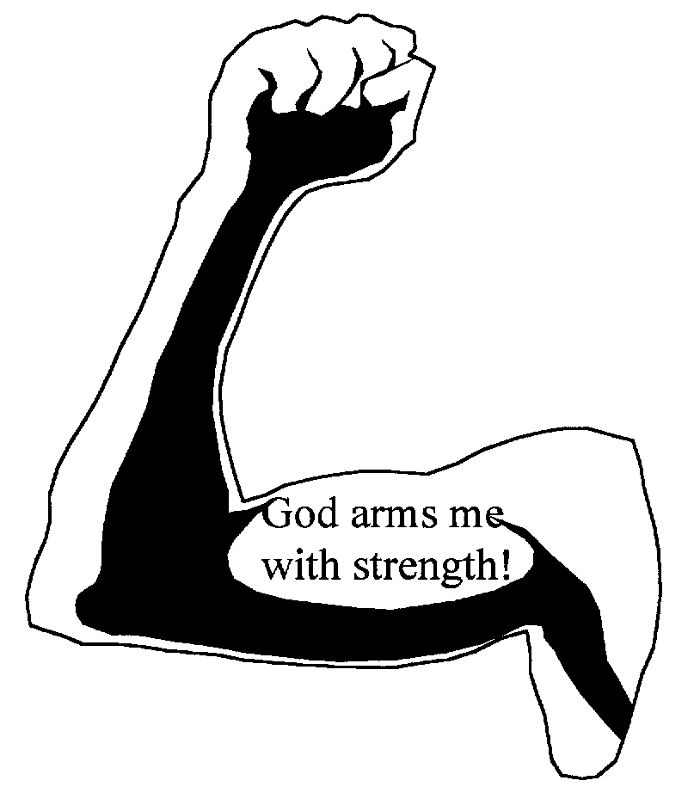

Hey, Kids,
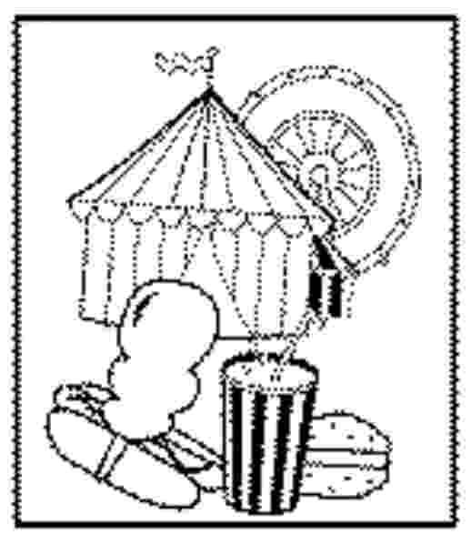

Next week, we’ll have a carnival at Sunday school. Please bring little used toys that can be given for prizes!

Thank You!

