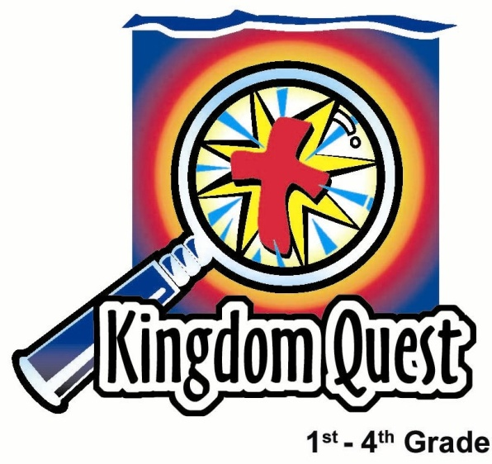
Date: __________________________
Series: Jesus is Lord of All (Apr-May)
Year 2, Lesson 50

Ascension

Take Home Point: *Jesus is Lord of heaven.
*Repeat this phrase throughout the lesson.

Bible Event: Acts 1:3-11. The ascension of Jesus.
Key Verse: Ephesians 1:20b; “God… raise Christ from death and put Him at His right side in heaven.”

We will help kids know:
- The Bible event of ascension. Jesus ascended to heaven and is Lord over all of heaven.
- Jesus will come back in the same way to bring all those who trust and follow Him to be with Him forever in heaven.
- Until Jesus comes back, our purpose is to lead more people to Him.

We will help kids feel:
- Excitement that Jesus is Lord over heaven and is coming back someday to get us.
- Thankfulness for shepherds on this appreciation Sunday. Shepherds help the kids trust in Jesus and lead others to Him.

We will help kids do:
- Make an invitation to others to get to know Jesus and launch it on a balloon.
- As a group, make a card of appreciation for the shepherds. The card will thank the shepherds for the ways they have helped them get ready for when Jesus returns.

THIS LESSON’S ROADMAP

DESTINATION | PAGE # | DISCOVERIES ON YOUR JOURNEY | SUPPLIES NEEDED
Small Group Warm-Up   | 3 | Kids relate vacation time with the Lord’s return to heaven. | - different colored sheets of copy paper  - pens or pencils  - scissors
Large Group   | 4  7  7  10 | Overview  Video Presentation: The Visual Bible: Acts 1:3-11 by Visual Bible International, Vol. 1, 1997.  Object Lesson: “Jesus Is Lord of Heaven.” The presenter uses a helium balloon as an object lesson of how Jesus rose into heaven. Handprints are tied onto the balloon, symbolic of believers that will rise to be with Jesus in heaven, too.  Puppet Presentation: “Give the Shepherds a Hand”—The Dao Dao puppet script will introduce Shepherd Appreciation Day. Instructions are given to the kids. | - a sign that reads “Jesus is Lord of All”  - helium balloon  - string or ribbon tied to the helium balloon  - paper crown  - several cutout hands that can be taped to the string or ribbon  - Dao Dao puppet  - sample of the appreciation card that will be made in Small Group Application  - video, Visual Bible: Acts 1:3-11
Small Group Application   | 4  12 | To imagine Jesus returning to heaven again with his followers, kids release a helium balloon with paper hands tied to it.  Appendices  Memory Verse Learning:  “Seed Verse”  John 11:25-26 will be the memory verse for lessons 49-51 to remind the children that Jesus is the Lord of life and we will live eternally if we believe in Him. | - hands cut out in Small Group Warm-up  - markers or crayons  - copies of the flower to create an appreciation card (see appendix)  - tape or glue  - helium balloon for each group (extra balloons should be available)  - string or ribbon tied to each balloon  - hole punch  - sticker with church’s name, address, and phone number typed on it  - flash cards from lesson 49

Small Group Warm-Up: 15 minutes
Purpose: Get pointed in the right direction! Build relationships and help guests feel at ease. Do the learning readiness activity that will point your group in the right direction for the lesson.

Supplies needed: different colored sheets of copy paper; pens or pencils; scissors

The children will have an activity to do with their hands while they discuss the following topic. Have kids trace both their hands (or one hand twice) on different colored copy paper. Then have them cut out the two handprints to use later in the small group application. (Shepherds also need to trace and cut out their hands for the small group application.)

Option: Have kids cut out two of the hands from the printed pattern found in the appendix.

As the children draw and cut, tie in the following discussion.

Let’s imagine that we could cut out an outline of your hands and mail it to a special vacation place. Wherever your hands were mailed, that would be the place where you could go on vacation. What place would you mail it? In other words, what place would you like to go for vacation?

Gather answers from the kids as they are cutting out their hands. Continue with the following questions.

Why did you choose this place? Was it because of the people there or something that you would like to do there? Or was it just because of the place itself?

Help the children listen to one another’s answers and compare each other’s vacation ideas.

Today in our Bible event, we are going to see how Jesus went to a special place. At that place right now, Jesus is ruler over everything. What place am I talking about? Yes, Jesus went to heaven. He is ruler, or Lord, over all of heaven.

What will it be like for us to go to heaven when we finish our life and God’s purposes for us here on earth? How will we get there? Do we want to go there because it is a great place? Do we want to go there because of who is there or because of what we will do there?

Today we will hear how *Jesus is Lord of heaven.
Large Group: 20-30 minutes
Purpose: Help kids observe what the Bible says. Present the Bible event in creative fashion. Help kids begin to interpret what it means.

Overview

Video Presentation: The Visual Bible: Acts 1:3-11 by Visual Bible International, Vol. 1, 1997.

Object Lesson: “Jesus Is Lord of Heaven.” The presenter uses a helium balloon as an object lesson of how Jesus rose into heaven. Handprints are tied onto the balloon, symbolic of believers that will rise to be with Jesus in heaven, too.

Puppet Presentation: “Give the Shepherds a Hand.” The Dao Dao puppet script will introduce Shepherd Appreciation Day. Instructions are given to the kids on how they can show their appreciation to their shepherds.

Small Group Application: 20-25 minutes
Purpose: Help kids map out the meaning of the Bible event in their lives. Use the questions to stimulate discussion but don't feel tied to them. Allow the Holy Spirit to guide you. Include personal examples from your own faith journey. The example of Christ at work in your life will leave lasting impressions of how Christ can work in the children's lives.

Use your Bibles! Children need to learn how to look up references and follow along when scripture is read aloud. Allow for quality time of prayer at the close of the lesson.

Observation Questions: What happened?
Have kids refer to Acts 1:3-11 in their Bibles.
How many days after Jesus’ death and resurrection did He show Himself to His followers? (Acts 1:3. For forty days He appeared to them and talked with them. )

Why did Jesus tell the disciples to wait in Jerusalem? (Acts 1:4-5. They were to wait to receive what the Father had promised, the Holy Spirit.)

What were the disciples to do after they received power from the Holy Spirit? (Acts 1:8. They were to be witnesses for Jesus to the ends of the earth.)

Describe how Jesus ascended into heaven. (Acts 1:9-10. He was taken to heaven as a cloud hid him. Two men in white clothes, and angels, appeared.)

How does this passage say Jesus will return someday? (Acts 1:11. The same way they saw Him go into heaven, appearing in the clouds.)

Interpretation Questions: What does this mean?
Have kids find the key verse from Ephesians 1:20b:

“God… raise Christ from death and put Him at His right side in heaven.”

Where is Jesus now? (In heaven) How do you know this? (God’s word says so in these passages.)

How does this make you feel knowing that *Jesus is Lord of heaven and He gives us the same power He gave His disciples? What are you to do with this power? (Testify or witness about Jesus just as Jesus commanded His disciples.)

Application Questions: What does this mean to me?
The two application activities have the children write on the hand cutouts from the warm-up.

Supplies needed:
- hands cut out in small group warm-up
- markers or crayons
- copies of the flower to create an appreciation card (see appendix)
- tape or glue
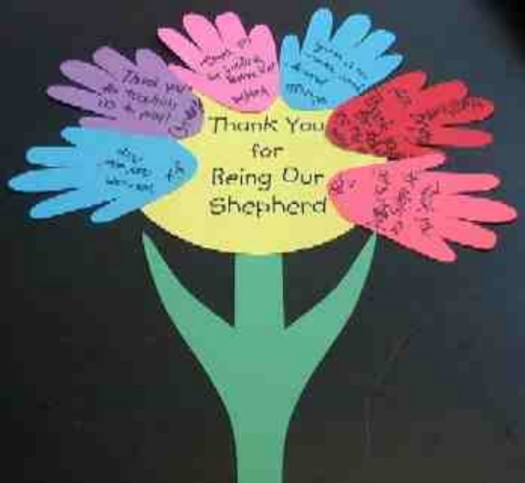
- helium balloon for each group (extra balloons should be available)
- string or ribbon tied to each balloon
- hole punch
- sticker with church’s name, address, and phone number typed on it

Let the kids create a group appreciation card for the shepherd first. The kids write their names on their hand cutout and complete the phrase, “Thank you for…”

After the kids have completed this, have them glue their paper hands to the face of the flower.

Shepherds, even though this card is for you, you may have to help the kids come up with some things they are thankful for in their learning experience with you.

Memory Verse Learning: 5 minutes
Purpose: Help kids to memorize and keep scriptures at heart. Using creative ways to help kids enjoy learning the key verse and in small group setting.

Supplies needed: flash cards from lessno 49

Memory Verse: John 11:25-26, “Jesus said…’I am the resurrection and the life. He who believes in Me will have life even if he dies. And he who lives and believes in Me will never die…do you believe this?’”

Memory Verse Presentation: “Seed Verse”
Ask if anyone can volunteer to recite John 11:25-26. Give the child a great cheer for reciting the verse. Now ask if anyone can arrange the flash cards. Give a cheer to this child as well. Have everyone recite the verse. Continue to ask for volunteers so as to reinforce this verse in their “hearts.” After most or all have volunteered, proceed to the second activity.

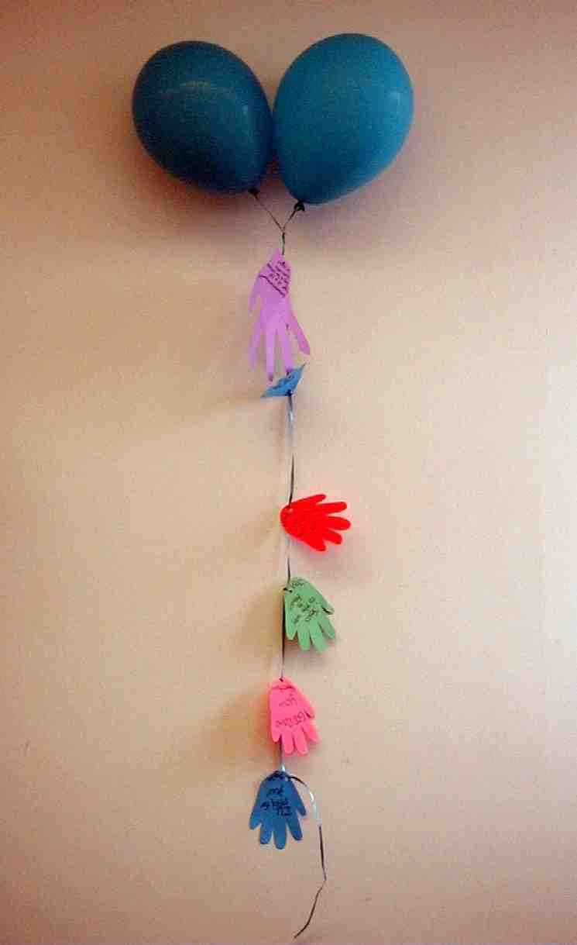
The second activity reviews the important Bible truth that Jesus asks us to be His witnesses until the time comes when He takes us to heaven. Have the children sign their names on their handprints. Then have each child write something he could say to someone else about Jesus. Examples could include “Jesus loves you,” “Jesus wants to be your friend,” “Get to know Him today,” etc.

Shepherds, place a sticker with your church’s name, address, and phone number on the hand you cut out. The information will help whoever finds the balloon contact your church if they are interested in visiting.

Punch holes in the paper hands and tie to the ribbon on the balloon. Be aware of the fact that too many hands tied to one balloon may weigh the balloon down. Extra balloons should be available.

Have your group go outside to release the balloon(s) after the closing prayer.

Prayer:
The closing prayer should include the children’s personal prayer requests for their friends and family who may not know Jesus. Also, the children might give thanks for learning experiences they have had in this group.

Special Note:

Shepherds, we truly appreciate all you do to love these kids and lead them to Jesus. May your day of appreciation be warmed by the fact that you are making a difference in the lives of children!

Large Group Presentation

Hold up a sign that reads “Jesus is Lord of All.” Then say:

We are in the series “Jesus is Lord of all.” Today we will see how He is Lord of heaven.

God says this in His word in Acts 1:3-11. (Read scripture portion.)

Video
Show the video, The Visual Bible: Acts 1:3-11. After the video, continue with the object lesson, “Jesus Is Lord of Heaven.” A Dao Dao puppet script follows introducing Shepherd Appreciation Day. Instructions are given to the kids on how they can show their appreciation to their shepherds.

Jesus Is Lord of Heaven
Object Lesson

Supplies needed:
        - helium balloon
- string or ribbon tied to the helium balloon
- several cutout hands that can be taped to the string or ribbon
- three or four paper hands from small group warm up
- felt tip pen

The large group presenter reads Ephesians 1:20b (GW):

“God… raise Christ from death and put Him at His right side in heaven.”

Hold the string with the balloon attached. Draw a crown on the balloon as you discuss the following.

When Jesus went to the cross to die for our sins, He completed the mission His Heavenly Father had given Him. Jesus rose from the dead to show people that He had won the victory for us. He showed Himself to many people so that they would know that He is alive. Now anyone who believes in Jesus will have everlasting life with Jesus and they will know Jesus as their King.

Forty days after Jesus rose from the dead on Easter, He ascended into heaven. He rose just like this balloon rises to the ceiling. Jesus floated up to the sky and out of sight.

Let balloon ascend to where you can still reach its string.

Where did He go? Jesus is in heaven. That is a different place than this world. Heaven is a place where millions of angels, heavenly creatures, and God live. Heaven is a place of perfect joy and fun. It is a place where everyone knows and likes each other. Every person has an important purpose there. In everything they do, they are giving thanks to God, who is at the very center of heaven. Everyone in heaven is thankful to Jesus who is King of heaven for going to earth and giving His life for us so that we could live in heaven. Heaven is more beautiful than anything we have seen on earth, and it is a more fun place than anywhere we have been on a vacation.

After Jesus ascended into heaven, two angels appeared to the disciples and told them that Jesus would return in the same way He left. From other Bible verses we find out that when Jesus does return, everyone will be able to see Him.

Pull down the balloon.

On the last day, Jesus, King of heaven, will come and take back to heaven all people who are alive and trust Him as their Savior. What about those people who have already died? They will be there, too. They will be come back with Jesus in new, perfect bodies. All the people who are living at that time will be changed and given perfect bodies, as well. No one will ever be sick or feel bad again in heaven. Instead, we will have a great time doing all the things we enjoy that give glory to God. All of this will happen in a place that is the new heaven and earth.
Use some of the hands made in Small Group Warm- up for the following:

I am tying the hands that represent each of you to the balloon that reminds us of Jesus. Jesus will come back from heaven and take us to heaven forever. We will follow Him into heaven. Won’t that be fun? If we die before He comes back, we will still be there with Him on the last day. We will come back with Him when He comes in the sky.

After a few hands are tied to the balloon’s string, release the balloon.

If heaven is so wonderful and we get to live face to face with God and see Jesus as King of heaven, why don’t we want to go there right now? Why wouldn’t God want to have us there right now?

God has a very important purpose for us here on Earth. God wants us to tell others about how much God loves them and wants to spend forever with them. He wants us to help others trust Jesus as their Savior. We want to stay here as long as we can to show God’s love to others and to help others trust in Jesus.

In small group today, you are going to make one of these balloons with your handprint tied to the string. As a group, you will go outside and release your balloon as you pray for people that do not know Jesus and His love. Each one of your handprints will have your name on it along with one thing you want others to know about Jesus. For example, you could say, “Jesus loves you,” “Jesus wants to be your friend,” or “Please call our church to tell us you found this balloon.”

Shepherds: Cut out your own hand and place on it a sticker with your church’s name, address, and phone number.

As you release the balloons and pray for people, it will remind your group of how Jesus went to heaven and will be coming back someday for us. We want to bring as many people as we can to meet Him.

Today we remember and want everyone to know: *Jesus is Lord of heaven.

Continue with the puppet script.

Give the Shepherds a Hand
Puppet Presentation

Teacher: Are there any questions?

Dao Dao: (enters) I have a question, Teacher.

Teacher: Hi, Dao Dao. What’s your question?

Dao Dao: What are you trying to do? Knock down airplanes?

Teacher: No, Dao Dao. I don’t think we will knock down any airplanes. These balloons remind us of Jesus going up to heaven. Until He comes back, we want to tell others about Him.

Dao Dao: By knocking down airplanes?

Teacher: No, forget the airplanes. Some of these balloons will land some place far away. Maybe someone will read about our witness to Jesus and they might even call us.

Dao Dao: You mean these kids could really help others get to know Jesus just by sending out balloons with their handprints?

Teacher: Who knows? It might help a little. I do know what helps a lot, though. It’s when we talk to our friends and the people who are close to us about how much God has helped our lives by giving His Son, Jesus, for us.

Dao Dao: Yeah, we all know that. Our shepherds are always helping us know how important it is to know Jesus and to invite others to know Him.

Teacher: Our shepherds are pretty amazing, aren’t they?

Dao Dao: Of course they are, because they have amazing kids like me! Isn’t that right, shepherds?

Teacher: Whatever you say, Dao Dao. Let’s do this. Let’s show the shepherds how much we appreciate them.

Dao Dao: What are we going to do? Tie balloons on the shepherds and let them go?

Teacher: There is another art project I would like you to do with the other hand that you cut out earlier. We have a special card for a shepherd in every group. The card is made in the shape of a flower using our own hands. (Show a sample of the card to the audience.)

Dao Dao: Wow! That looks neat.

Teacher: It sure is. We would like each one of you to write your name on your cutout hand. Then complete the phrase, “Thank you for…”

Dao Dao: What do you mean?

Teacher: For example, you would write “Dao Dao” on your hand. Then you might also write, “Thank you for teaching me about Jesus.”

Dao Dao: Could I write, “Thank you, Teacher, for giving me sweets”?

Teacher: Wait a minute. I haven’t given you sweets.

Dao Dao: Not yet, you haven’t. How about some sweets?

Teacher: Dao Dao, we’ll talk about that later. Kids, we want you to thank your shepherds for the ways they have helped you learn more about God. Younger kids might want to draw a picture instead of writing something.

After you write or draw on your paper hands, you will paste all of the hands around the card. The shepherds can then take the flower card home with them.

Dao Dao: We’re supposed to do that with our hand cutouts? I thought we were supposed to put our hands on a balloon and launch it into space to knock down airplanes.

Teacher: Each child has cut out two hands, remember? One is for the card for the shepherd and the other is to put on the balloon.

Dao Dao: That sounds great! We have a lot to do. Let’s go!

Teacher: Wait, Dao Dao. We should say a closing prayer.

Dao Dao: Sure.

Teacher: Dear God, thank You for sending Jesus to earth to die for our sins. Thank you that He rose from the dead and now *Jesus is Lord of heaven. Thank You, too, for our shepherds who have done so much to help us know more about Jesus. Help the kids do a good job in showing appreciation to them. In Jesus’ name, Amen.

Lesson 50

Small Group Warm-Up
- different colored sheets of copy paper
- pens or pencils
- scissors

Large Group
- a sign that reads “Jesus is Lord of All”
- helium balloon
- string or ribbon tied to the helium balloon
- paper crown
- several cutout hands that can be taped to the string or ribbon
- Dao Dao puppet
- sample of the appreciation card that will be made in Small Group Application
      - video, Visual Bible: Acts 1:3-11

Small Group Application
- hands cut out in Small Group Warm-Up
- markers or crayons
- copies of the flower to create an appreciation card (see appendix)
- tape or glue
- helium balloon for each group (extra balloons should be available)
- string or ribbon tied to each balloon
- hole punch
- sticker with church’s name, address, and phone number typed on it

Memory Verse Learning
- flash cards from lesson 49

Thank You
for
Being Our
Shepherd

