
Date: _________________
Series: Jesus is Our King (Dec-Mar)
Year 2, Lesson 31

Get Rappin’

Take Home Point: *We are the wrapping paper for the gift of Jesus to the world.
*Repeat this phrase throughout the lesson.

Bible Event: Luke 2:1-20 The shepherds proclaim the Christmas Gospel.

Key Verse: Luke 2:17, “When they saw the child, they repeated what had been told about Him.”

We will help kids know:
- The Christmas story: Jesus is God’s gift to the world for our salvation.
- We need to see ourselves like wrapping paper that makes the gift of Jesus appealing to the world as people experience our loving witness.

We will help kids feel:
- Excited about being the wrapping paper for God’s gift of Jesus to the world.
- Joyful because we can tell the Christmas Gospel in our own way (even by rapping).

We will help kids do:
- Identify a friend, relative, or acquaintance that may not know Jesus and for whom they will pray.
- Share with this person the Jesus candy cane. At the same time, do at least one act of loving witness for this person.
THIS LESSON’S ROADMAP

DESTINATION | PAGE # | DISCOVERIES ON YOUR JOURNEY | SUPPLIES NEEDED
Small Group Warm-Up   | 4-5 | Let everyone share what they are hoping to get for Christmas. | - one present wrapped in a very unattractive way. This could even be a paper sack wrapped around a box. Inside, put a single small piece of candy.  - one present wrapped in typical Christmas fashion with two small candy canes for each child in the group
Large Group   | 5-6  10-13  13-15  16-17 | Overview  Puppet Presentation: “Countdown To Christmas Blast Off: Get Rappin’”—Dao Dao, Ting Ting and Commander Wang review the countdown stages to Christmas blast off.  Large Group Presentation: “The Shepherd’s Rap”—A shepherd and sheep rap their testimony about the birth of the Savior, Jesus.  Puppet Presentation Conclusion: “Countdown To Christmas Blast Off: Get Rappin’”—Dao Dao and Ting Ting learn that the shepherds were like “wrapping paper,” attracting others to the gift of the Baby Jesus. We too, can be like “wrapping paper.” | - Dao Dao  - video of Ting Ting in her spacesuit  - Command Central setting  - an actor wearing a shepherd’s robe made from wrapping paper and a turban, carrying a shepherd’s staff. Option: a baseball cap worn backwards can be used as a turban  - four or five pairs of sheep ears made from the ends of old white socks and attached to something that will stay in place on top of the head (baseball cap) These don’t need to look very attractive. The more ridiculous the better.  - wrapping paper  - extra copies of “The Shepherd’s Rap”

Small Group Application   | 6-9 | Kids make a special wrapping invitation they can use to invite a friend or a neighbor to a Christmas worship service.  Memory Verse Learning:  “Layers of Surprises”  Acts 10:43 will be emphasized for lessons 28-31 to say that Jesus fit the puzzle of prophecies and so He is for real. | - easy-reading version of the Bible (For first and second grades, you might want to use an easy-to-read Bible storybook.)  - Jesus candy cane poem and invitation  - 10” square of wrapping paper for each child  - crayons or markers  - bows  - removable tape  - candy canes from Small Group Warm-Up  - lots of gift wrappers or newspaper  - small inexpensive gifts  - cellophane tape

Small Group Warm-Up: 15 minutes
Purpose: Get pointed in the right direction! Build relationships and help guests feel at ease. Do the learning readiness activity that will point your group in the right direction for the lesson.

Supplies needed: one present wrapped in a very unattractive way. This could even be a paper sack wrapped around a box. Inside, put a single small piece of candy; one present wrapped in typical Christmas fashion with two small candy canes for each child in the group

Each shepherd will have two wrapped presents. One present should be wrapped in a very unattractive way (such as in a paper sack). Inside this package should be a single small piece of candy. The other box should be wrapped in typical Christmas fashion and contain two small candy canes for all the kids in the group.

Boys and girls, how many of you have wrapped presents under your Christmas tree? Have you tried to guess what they might be? What presents would you like to receive this Christmas?

Let everyone share what they hope to get. Encourage conversation so you can better get to know your group and they can better know one another. Ask other questions that might be helpful for conversation, such as:

What do you think is best about Christmas? Giving presents or getting presents?

What gift are you excited about giving to someone else?

The following learning event will help set up the lesson for the day. It should take about five minutes, so please allow time for your group to accomplish this. Show the two packages and say:

As a group, decide which of these two presents you would like to receive. Please don’t touch them or shake them, just look at them and vote as a group. There is something for the group inside each package, but you will like one much more than the other.

Do not be surprised if they choose the poorly wrapped box. Kids will likely suspect that you are trying to trick them by putting the good present in an unbecoming box. If that is the case, they truly will be surprised when the best present is in the more attractively wrapped box.
If they choose the good present, say the following:

Congratulations, you all will get candy canes. Let’s set them aside and eat them when we come back from large group.

If they choose the plain wrapped gift, open it up and say:

It looks like you missed the good gift. The best present was in the good wrapping paper, but I will share the contents of the other gift after we return from large group.

Before going to Large Group, ask:

If Jesus is the gift that God gave to the world, then how are we like the wrapping paper around that gift? (For Jesus to be received by other people as a gift, God can use us to make people want to open the present and look inside. When we trust and follow Jesus, He is wrapped up inside of us. Hopefully, we will be like attractive wrapping paper that makes others want to experience the gift of Jesus as well.)

Today, we will think of ourselves as wrapping paper. When we go to large group, we will hear about another kind of rappin’. This isn’t the paper, this is the musical way of singing a song with rap. We will meet some rappin’ shepherds. When the shepherds met Jesus, they wanted to tell others about Him. They were like the nice wrapping paper around the gift of Jesus so others would want to find out about Him as well.

Today we will find out how *we are the wrapping paper for the gift of Jesus to the world, just like the shepherds.

Large Group: 20-30 minutes
Purpose: Help kids observe what the Bible says. Present the Bible event in creative fashion. Help kids begin to interpret what it means.

Overview

Puppet Presentation: “Countdown To Christmas Blast Off: Get Rappin’”—Dao Dao, Ting Ting and Commander Wang review the countdown stages to Christmas blast off.

Large Group Presentation: “The Shepherd’s Rap”—A shepherd and sheep rap their testimony about the birth of the Savior, Jesus.

Puppet Presentation Conclusion: “Countdown To Christmas Blast Off: Get Rappin’”—Dao Dao and Ting Ting learn that the shepherds were like “wrapping paper” attracting others to the gift of the Baby Jesus. We, too, can be like “wrapping paper” as our lives attract others to know about Jesus who is the greatest gift.

Small Group Application: 20-25 minutes
Purpose: Help kids map out the meaning of the Bible event in their lives. Use the questions to stimulate discussion but don't feel tied to them. Allow the Holy Spirit to guide you. Include personal examples from your own faith journey. The example of Christ at work in your life will leave lasting impressions of how Christ can work in the children's lives.

Use your Bibles! Children need to learn how to look up references and follow along when scripture is read aloud. Allow for quality time of prayer at the close of the lesson.

The children will need their own easy-reading version of the Bible to read the Christmas Gospel (Luke 2:1-20). For first and second grades, you might want to use an easy-reading Bible storybook.

Pass out candy canes as promised from Warm-Up so the kids can have them as snacks while discussing the lesson. Another candy cane will be used for the craft later.

Observation Questions: What happened?
Read Luke 2:8-18 in an easy-to-read version of the Bible.

When an angel appeared to the shepherds, what was their first reaction? (Luke 2:9. They were terrified.)

What good news did the angel tell them? (Luke 2:11. A Savior was born in the city of David.)

When many angels appeared, what did they say? (Luke 2:14, “Give glory to God in heaven, and on earth let there be peace to the people who please God.”)

After the angels left the shepherds, what did they decide to do? (Luke 2:15. Go to Bethlehem and find the Baby Jesus.)

Interpretation Questions: What does this mean?
After they saw the baby, they told others what had happened to them. How do you think their voices sounded? Were they excited or were they still scared? (It seems they were excited.)

What happened to the people who heard the shepherds’ story? (Luke 2:18. They were amazed. They might have wanted to find out more.)

Application Questions: What does this mean to me?
Luke 2:17 says, “And the shepherds saw the baby lying in a feeding box. Then they told what the angels said about this child.” How can we be like the shepherds? (We, too, can tell others about Jesus.)

In today’s lesson we learn that *We are the wrapping paper for the gift of Jesus to the world. What does this mean to you? (It is our loving actions and invitations that are like “wrapping paper” that make people eager to find out about the gift—Jesus.

Today we are going to make a wrapping invitation that you can use to invite a friend or a neighbor to one of our worship services on Christmas. We will make an envelope out of wrapping paper and we will put a special card inside that we can decorate and label with our worship service information. The card will also have a candy cane on it. We will even put a bow on the envelope so it looks like a present.

As we make our envelopes, let’s all talk about the person with whom we can share this invitation. We might even get ideas from each other that will help us know who to invite.

Supplies needed: easy-reading version of the Bible (For first and second grades, you might want to use an easy-to-read Bible storybook.); Jesus candy cane poem and invitation; 10” square of wrapping paper for each child; crayons or markers; bows;
removable tape; candy canes from Small Group Warm-Up


Craft Explanation:

- Begin with a 10” square of wrapping paper.



- Place in front of you with a corner towards you and make a mark 6” from the corner on both sides closest to you.

- Fold the bottom flap up at the marks.

- Fold each side over at least an inch at the base on each side.

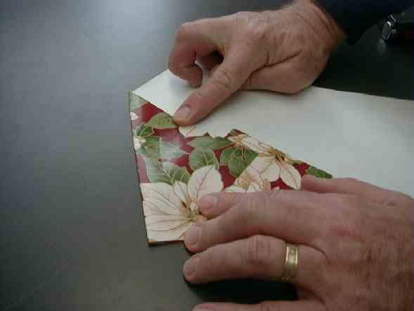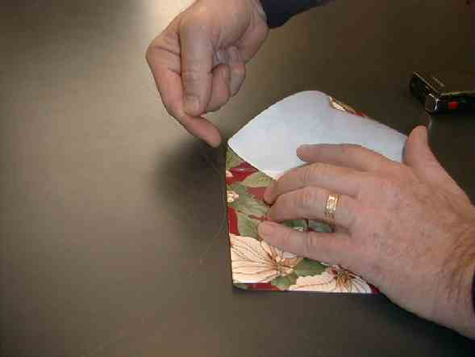

- When the two points meet in the middle, apply a small section of removable tape. (It needs to be removable tape so the envelope can be completely unwrapped if desired.)

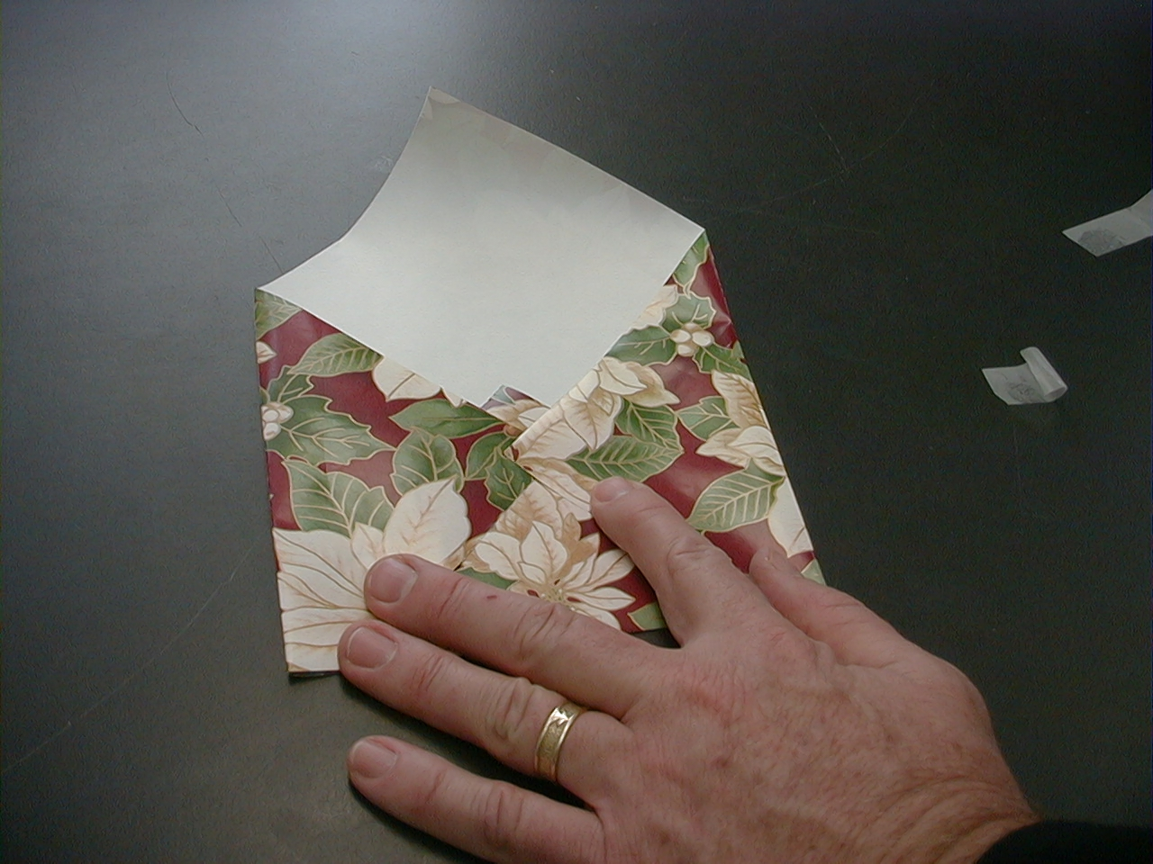

- Insert the card (see appendix) with the candy cane and fold over the top flap. Tape it with removable tape. (The card should be made on a half sheet of paper measuring 5 ½” x 8 ½”.)
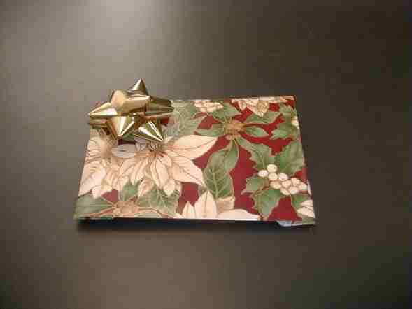

- Place a bow on the other side. Use ribbon if desired.

There are two options you may choose according to your time and the ability of the children:

Option 1: Younger kids may color the card with the poem as they put a sticker on it with the time, date, and location of the worship service.

Option2: Older kids may write the poem on the back side of the 10” square of wrapping paper that will be folded into an envelope.

To conclude the discussion and the craft activity, restate the take home point:
*We are the wrapping paper for the gift of Jesus to the world.

Memory Verse Learning: 5 minutes
Purpose: Help kids to memorize and keep scriptures at heart. Using creative ways to help kids enjoy learning the key verse and in small group setting.

Supplies needed: lots of gift wrappers or newspaper; small inexpensive gifts; cellophane tape

Memory Verse: Acts 10:43, “Everyone who believes in Jesus will be forgiven. God will forgive his sins through Jesus. All the prophets say this is true.”

Memory Verse Learning: “Layers of Surprises”
The aim is to encourage each child to say the memory verse and each time they get a gift if they say it absolutely correct. Before class, start out by wrapping a gift. Then add a gift over it and wrap it together. The idea is to have a gift in each layer as a person unwraps. Tell the children that today they can receive as many gifts as they can. But to qualify for a gift, one has to be able to recite the memory verse correctly and with no mistakes. A child can do as many times as he/she can but provided that there is available gifts.

Prayer Time:
Pray for courage and boldness to do acts of love and share the Christmas invitation. Pray that the invitations will be received and friends that normally don’t go to church will come to worship service on Christmas. Pray the visitors would be welcomed and they would meet Jesus as their Savior.
Large Group Presentation

Countdown to Christmas Blast Off: Get Rappin’
(Stage Four)

Puppet Presentation

(Ting Ting will appear in the cockpit still dressed in her aluminum foil space suit.)

Commander Wang: Boys and girls, welcome to Command Central where we are counting down to Christmas Blast Off. I wonder if today is the day we will blast off.

Dao Dao: Yes, I believe it is, Teacher.

Commander Wang: Teacher? Don’t you mean Commander Wang?

Dao Dao: Yes, I mean to command Teacher.

Commander Wang: Dao Dao!

Dao Dao: Well, that is why we have Command Central. If you haven’t caught on by now, I’m in command.

Commander Wang: Well, if you say so. I just want to see us get blasted off.

Dao Dao: Okay then, why don’t we get astronaut Ting Ting on the screen?

Commander Wang: Okay, Dao Dao. Our first stage to the Christmas Blast Off and our mission was to “Get Real.”

Dao Dao: The next step was “Get Right.”

Commander Wang: Last week, we “Got Ready.”

Dao Dao: Now that it is time to blast off, today we will “Get Rappin’.”

Commander Wang: Should we see if Ting Ting is in position and ready for blast off?

Dao Dao: Let’s do it. Command Central. This is Command calling Ting Ting. Are you there? Come in, please. Come in.

(Ting Ting appears in the cockpit ready for blast off.)
Ting Ting: This is Ting Ting here.

Dao Dao: Are you ready for blast off?

Ting Ting: Why, yes, but I don’t really want to blast off!

Commander Wang: What? You don’t want to blast off?

Ting Ting: You heard me right. There is no need for it.

Commander Wang: What do you mean there is no need for it? What about the mission?

Ting Ting: Well, the mission is to find God, right?

Commander Wang: Yes.

Ting Ting: Well, don’t you remember stage one?

Commander Wang: Yes, it was “Get Real.”

Ting Ting: Exactly. That means Jesus is the real answer to life’s puzzles and what the Old Testament prophets talked about.

Commander Wang: That’s right.

Ting Ting: Stage two was “Get Right.” By trusting Jesus as our Savior and having faith, we really do find God.

Commander Wang: Oh, I see. It’s like our mission to find God has already happened.

Ting Ting: Well, there was also stage three and that was “Get Ready.” We are supposed to be ready by following Jesus now. If we do that, we will be ready when He comes again.

Commander Wang: I think you’re right! We have already accomplished our mission of finding God because we have gone through these three stages.

Ting Ting: Yes. There’s no need to blast off.

Dao Dao: Well, there is a need to blast off!

Ting Ting: Why?

Dao Dao: Because I want to see a blast off! I want to see my sister blast off, right out of here!

Commander Wang: Well, I agree with you, Dao Dao.

Dao Dao: What? You do?

Commander Wang: I agree with you but for a different reason. We should blast off so we can tell others about Jesus.

Dao Dao: What do you mean?

Commander Wang: Kids, Jesus is the best present anyone could ever receive. He is a present that is not just for us, He is for others as well. Jesus is especially for people that do not know Him. Can you think of someone who does not know Jesus?

Dao Dao: Yeah, I have some friends who don’t go to church. I don’t think they know anything about Jesus.

Commander Wang: Well, today we are going to find that we can blast off by talking to them about Jesus.

Dao Dao: I don’t know if I can do that.

Commander Wang: I’ll bet you can. Think of it this way, if Jesus is the present that God gives the world at Christmas, then you are like the wrapping paper. By your witness and the kind things that you do in Jesus’ name, it makes other people want to find out more about Jesus.

Dao Dao: It seems so hard, Teacher.

Commander Wang: Let me introduce you to the first people who were Christmas wrapping paper. They told others about the birth of Jesus. Who were they? They were shepherds, and since we are talking about wrapping paper, why don’t we have them do a special shepherd’s rap? Can we have our rappin’ shepherds come out, please? Help us blast off, guys!
“The Shepherd’s Rap”

A specially costumed character comes on stage. This person will wear a shepherd’s robe that is made from wrapping paper. This person will also wear a turban and carry a shepherd’s staff. Since this shepherd will be rapping, perhaps a baseball cap turned backwards can be on top of the turban.

Behind the shepherd will be three or four volunteer sheep. These sheep will have little sheep ears made out of the ends of old white socks and attached to a baseball cap. The ears need not look very attractive. The more ridiculous the better. If some adult volunteers did this part it would make it more enjoyable.

“The Shepherd’s Rap”

Now sit up straight and lend me your ear
‘Cause I’ve got a story you just gotta hear.
I’m not gonna stand here and let my lips flap
Oh no, baby, gonna do the shepherd’s rap.

Do the shepherd’s rap. (Echo)
Do the shepherd’s rap. (Echo)

It happened one night to some shepherds and their sheep,
Camped on a hillside, tryin’ to get some sleep.
It was gettin’ real quiet then a light shone all around,
The shepherds saw an angel, ‘n then they hit the ground.

They’re a shakin’ now. (Echo)
They’re a shakin’ now. (Echo)

“Hey, dudes, fear not,” the angel did say,
“It’s powerful news that I bring to you today.
For God, from his mercy and love divine,
A Savior he sends for all mankind.”
A Savior comin’ down. (Echo)
A Savior comin’ down. (Echo)

“In the city of David, unto you is born,
True God, true man, Christ the Lord.
And this will be the sign so you will know,
A baby in a manger in swaddling clothes.”

Baby by ‘n by. (Echo)
Baby by ‘n by. (Echo)

The sky was filled with angels a praisin’,
Singing glory to God, ‘n peace most amazin’.
The shepherds said, “WOW! Let’s be on our way,
And see if it’s true what the angels did say.”

Get on down the road. (Echo)
Get on down the road. (Echo)

The shepherds ran FAST to Bethlehem town,
Racing through the hills, up hill and down.
Through the every gate and down through the street,
They found this baby with straw for a sheet.

Stable time now. (Echo)
Stable time now. (Echo)

And there in a manger like the angel had said,
Was a tiny little baby, swaddled up to his head.
Just took a look for the shepherds all knew,
This was the Savior, it really had come true.

Comin’ down true. (Echo)
Comin’ down true. (Echo)

The shepherds left the stable and ran through the streets.
Sharing good news with the people they’d meet.
That God sent a Savior to rescue you and me,
His name is Jesus ‘n he will set you free.

His promise was delivered. (Echo)
His promise was delivered. (Echo)

It be good news still true today,
Only thing’s left that’s to give it away.
God used shepherds and God will use you.
Just share Jesus you know what to do.

Do the shepherd’s rap now. (Echo)
Do the shepherd’s rap now. (Echo)
Do the shepherd’s rap now. (Echo softly)
Do the shepherd’s rap now. (Echo softly)

The large group presenter then wraps up the presentation by asking for a volunteer from the audience to come up front.

Do you know that Jesus came into the world to be your Savior? Do you trust in Jesus as your Savior?

If the answers to these questions are yes, then explain that the child is like wrapping paper. The presenter will take wrapping paper and quickly wrap the child in a loop or two.

Since (child’s name) has received the gift of Jesus, she can do actions of God’s love to others and it is like wrapping. Other people will want to find out about Jesus because they see something special about her life.

Close with prayer.

Dear God, thank You for giving us Jesus. He is the best gift we could ever have. He really is Your Son and He gave His life for us. Thank You that he lives in our lives because we trust him as our Savior.

Lord, we pray for other people that do not know the gift of Jesus. We ask that they would see Jesus living in our lives, and they would want Him to live in their lives, too. Help us to be like wrapping paper. Help us show others how wonderful it would be to know Jesus. Let us be like the shepherds who told others about Jesus so that other people were truly amazed. In Jesus’ name we pray. Amen.
Countdown to Christmas Blast Off: Get Rappin’
(Stage Four)

Puppet Presentation Conclusion

Ting Ting: I get it. We blast off, not to just find God, but to tell others about God’s gift of Jesus.

Commander Wang: Right! We are like the wrapping paper.

Dao Dao: If that’s the case, then I want to get rappin’ (Breaks into a rap-like chant.)

Stand back, Teacher, I’m ready to sing.
My foot’s a-tappin’ so I feel like rappin’.
I’m talkin’ about real and here’s my deal.
Just look at those prophets for they ain’t no Muppets.
They lookin’ at a picture of the puzzle
So they couldn’t hold a muzzle.

Jesus is the one, He is the real deal.
So get Him in your sight, He will help you get right,
Just take Him by faith and not by sight.
So if you’re listenin’ to me and your name is Freddy,
I’m tellin’ you, Freddy, that you better get ready.
Jesus is comin’ and He’s comin’ back soon.
Don’t be left and don’t be a goon!

So now that you know—Jesus stole the show,
When He came as a baby, He left no more maybe’s.
He gave His life for you and He gave His life for me,
If you want to blast off, He can set you free.
So Jesus is a gift, and you better be swift,
When you’re talkin’ to your neighbor,
Then you’re the wrappin’ paper.

Dao Dao and Teacher debate about the merits of the rap. They are interrupted by Ting Ting.

Commander Wang: Dao Dao, that was… well, at least it summed it all up.

Ting Ting: Excuse me, boys. I have to interrupt. I can’t take it anymore, I’m ready to blast off.

Commander Wang: Well, so are we, Ting Ting, but let’s send you off with a prayer.

Dear God, thank You for giving us Jesus. He’s the best gift we could ever have. Let him live in our lives so we trust Him every day. Help us to be the wrapping paper so others will see Jesus living in us, and they will want Jesus in their lives, too. Help us to be like the shepherds that told others the good news. And finally, Jesus, help us blast off. Amen.

Commander Wang: Okay, Ting Ting, permission to blast off. Count down with us, boys and girls. Five, Four, Three, Two, One, Blast Off!

( Option: Lighting some flash paper next to Ting Ting’s space shuttle would be effective.)

Dao Dao: Bye, boys and girls.

Commander Wang: Bye, boys and girls.

Lesson 31

Small Group Warm-up
- one present wrapped in a very unattractive way. This could even be a paper sack wrapped around a box. Inside, put a single small piece of candy.
- one present wrapped in typical Christmas fashion with two small candy canes for each child in the group

Large Group
- Dao Dao
- video of Ting Ting in her spacesuit
- Command Central setting
- an actor wearing a shepherd’s robe made from wrapping paper and a turban, carrying a shepherd’s staff. Option: a baseball cap worn backwards can be used as a turban
- four or five pairs of sheep ears made from the ends of old white socks and attached to something that will stay in place on top of the head (baseball cap). These don’t need to look very attractive. The more ridiculous the better.
- wrapping paper
- extra copies of “The Shepherd’s Rap”

Small Group Application
- easy-reading version of the Bible (For first and second grades, you might want to use an easy-to-read Bible storybook.)
- Jesus candy cane poem and invitation
- 10” square of wrapping paper for each child
- crayons or markers
- bows
- removable tape

candy canes from Small Group Warm-Up

Memory Verse Learning
- lots of gift wrappers or newspaper
- small inexpensive gifts
- cellophane tape

Lesson 31 – Shepherd’s Rap (2 pages)

“The Shepherd’s Rap”

Now sit up straight and lend me your ear
‘Cause I’ve got a story you just gotta hear.
I’m not gonna stand here and let my lips flap
Oh no, baby, gonna do the shepherd’s rap.

Do the shepherd’s rap. (Echo)
Do the shepherd’s rap. (Echo)

It happened one night to some shepherds and their sheep,
Camped on a hillside, tryin’ to get some sleep.
It was gettin’ real quiet then a light shone all around,
The shepherds saw an angel, ‘n then they hit the ground.

They’re a shakin’ now. (Echo)
They’re a shakin’ now. (Echo)

“Hey, dudes, fear not,” the angel did say,
“It’s powerful news that I bring to you today.
For God, from his mercy and love divine,
A Savior he sends for all mankind.”

A Savior comin’ down. (Echo)
A Savior comin’ down. (Echo)

“In the city of David, unto you is born,
True God, true man, Christ the Lord.
And this will be the sign so you will know,
A baby in a manger in swaddling clothes.”

Baby by ‘n by. (Echo)
Baby by ‘n by. (Echo)

The sky was filled with angels a praisin’,
Singing glory to God, ‘n peace most amazin’.
The shepherds said, “WOW! Let’s be on our way,
And see if it’s true what the angels did say.”

Get on down the road. (Echo)
Get on down the road. (Echo)

The shepherds ran FAST to Bethlehem town,
Racing through the hills, up hill and down.
Through the every gate and down through the street,
They found this baby with straw for a sheet.

Stable time now. (Echo)
Stable time now. (Echo)

And there in a manger like the angel had said,
Was a tiny little baby, swaddled up to his head.
Just took a look for the shepherds all knew,
This was the Savior, it really had come true.

Comin’ down true. (Echo)
Comin’ down true. (Echo)

The shepherds left the stable and ran through the streets.
Sharing good news with the people they’d meet.
That God sent a Savior to rescue you and me,
His name is Jesus ‘n he will set you free.

His promise was delivered. (Echo)
His promise was delivered. (Echo)

It be good news still true today,
Only thing’s left that’s to give it away.
God used shepherds and God will use you.
Just share Jesus you know what to do.

Do the shepherd’s rap now. (Echo)
Do the shepherd’s rap now. (Echo)
Do the shepherd’s rap now. (Echo softly)
Do the shepherd’s rap now. (Echo softly)

Here’s a candy cane,

Shaped like a Shepherd’s staff.

Reminding us that Shepherd’s came,
And found good news that lasts.

I wrap this invitation,
As I wish the same for you.
Please join us for a celebration,
Christmas Worship and good news!

TIME:
_____________

PLACE:
____________________________

(Make this card out of ½ sheet of paper, measuring 5 ½” x 8 ½”. )

