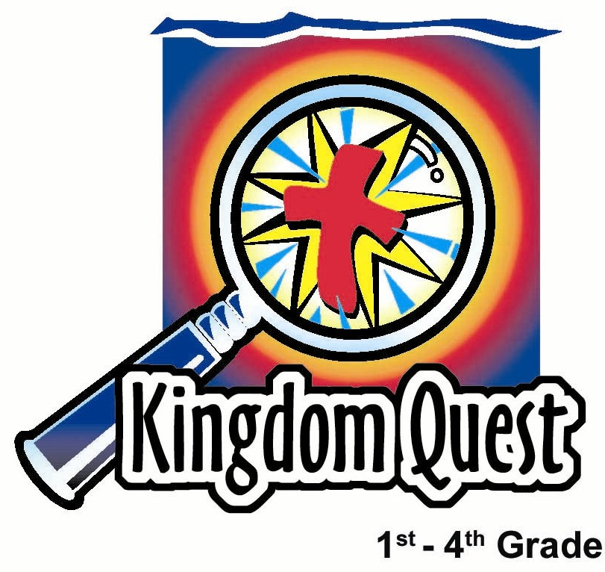
Date: _________________
Series: Meet Jesus the Sacrifice and… (Dec-Mar)
Year 2, Lesson 45

Get to be Sons and Daughters of God

Take Home Point: *Jesus gave us His life so we can be adopted as sons and daughters and have His inheritance.
*Repeat this phrase throughout the lesson.

Bible Event: Mark 14:32-42. Jesus in the garden of Gethsemane.

Key Verse: John 1:12, “But some people did accept Him. They believed in Him. To them He gave the right to become children of God.”

We will help kids know:
- The Bible event of Jesus in the garden of Gethsemane.
- Jesus agonized over Hs approaching sacrifice. He knew that when God would lay the sin of the world on Him, He would feel orphaned from God. This was His sacrifice.
- Because of Jesus’ sacrifice on the cross, we can become sons and daughters of God and have the inheritance of His kingdom.

We will help kids feel:
- Awed by the sacrifice of Jesus giving His life for us so we could be adopted sons and daughters of the king.
- Eagerness to live in the full riches of our inheritance in His kingdom.

We will help kids do:
- Use the Bible to discover treasures that are theirs because of their inheritance.
- Recall treasures from their Heavenly Father as they savor the taste of treasured candy.

THIS LESSON’S ROADMAP

DESTINATION | PAGE # | DISCOVERIES ON YOUR JOURNEY | SUPPLIES NEEDED
Small Group Warm-Up   | 4 | Kids pretend they are in an orphanage in another country waiting to be adopted as they discuss how Jesus felt when he was separated from his heavenly Father on the cross. | - marker  - poster board or section of mahjong paper
Large Group   | 4-6  8  8  9-10 | Overview  Audience Participation Game: “Meet Jesus the Sacrifice” Game Show – Kids will try to guess the words, “…get to be sons and daughters of God.”  Video: JESUS from the JESUS File Project – This section of the video shows Jesus praying in the Garden of Gethsemane.  Bible Reading: Mark 14:32-42  with Observation Questions | - video JESUS from the JESUS Film Project (Inspirational Films, 1979)  - treasure chest  - one sign decorated as “Meet Jesus the Sacrifice” Game Show  - one sign that reads “Meet Jesus the Sacrifice and Get…” and is attached to the treasure chest  - sign that reads “get to be ______ and _____ of _____.” Have it in the treasure chest.  - piece of paper titled “Adoption Papers” in the treasure chest (appendix)  - bowl of fish ball  - spoon  - egg timer or a timer with a bell  - Dao Dao, the puppet
Small Group Application   | 6-7 | As children disuss the three treasures of John 1:12, they use coins to understand their riches in Jesus Christ.  Memory Verse Learning:  “Slot and Learn”  Memorizing 1 Peter 2:16 in lesson 45 through 47 helps the children to feel secure as they find themselves freed through Jesus’ sacrifice for them. | - Bible  - three gold coins for the shepherd and three per child. Label the coins as follows:  - 1st coin: Galatians 4:6-7: WE BECOME HEIRS  - 2nd coin: John 3:16-17: WE RECEIVE ETERNAL LIFE  - 3rd coin: Luke 10:19- 20: WE HAVE VICTORY OVER SATAN  - chocolate gold coin for each child (optional)  - poster board with slots  - memory verse word strips

Small Group Warm-Up: 15 minutes
Purpose: Get pointed in the right direction! Build relationships and help guests feel at ease. Do the learning readiness activity that will point your group in the right direction for the lesson.

Supplies needed: marker; poster board or section of mahjong paper

Key warm-up question:

Let’s pretend you are in an orphanage in another country and you are waiting to be adopted. What kinds of things would you want in your new family? Let’s create the perfect parents for this adopted child. Let’s add to this picture all the things that you would like to give to the perfect parents!

With markers on a poster board or section of mahjong paper, draw stick pictures of a mom and dad. Or draw a more life-like picture if you’d like. Then list all the things the kids would ascribe to perfect parents. Let them exaggerate and have fun with this. Would these parents have eyes in the back of their heads to see what’s going on behind them? Would they have an extra set of arms for extra hugs?

In large group today, we are still learning about how Jesus is our sacrifice. We just talked about adoption. That’s when you are brought into a family where you have a new mom or dad. But just the opposite happened to Jesus when He went to the cross. While He was on the cross, Jesus felt what it was like to be separated from His Father. Because He did that for us, we have something really neat. I wonder if you will be able to guess what it is.

Encourage the children to bring their Bibles along to large group.

Large Group: 20-30 minutes
Purpose: Help kids observe what the Bible says. Present the Bible event in creative fashion. Help kids begin to interpret what it means.

Supplies needed: video JESUS from the JESUS Film Project (Inspirational Films, 1979); treasure chest; one sign decorated as “Meet Jesus the Sacrifice” Game Show; one sign that reads “Meet Jesus the Sacrifice and Get…” and is attached to the treasure chest; sign that reads “get to be ______ and _____ of _____.” Have it in the treasure chest.; piece of paper titled “Adoption Papers” in the treasure chest (appendix); bowl of fish ball; spoon; egg timer or a timer with a bell;
Dao Dao, the puppet
Overview

Audience Participation Game: “Meet Jesus the Sacrifice” Game Show – Kids will try to guess the words, “…get to be sons and daughters of God.”

Video: JESUS from the JESUS Film Project – The large group presenter introduces the film, JESUS. This section of the video shows Jesus praying in the Garden of Gethsemane.

Bible Reading: Mark 14:32-42 with Observation Questions

Meet Jesus the Sacrifice

Series Overview

This six-week series helps children understand that Jesus gave Himself as a sacrifice. This is a key concept. Jesus gave up something so we can get something. Each week we explore an aspect of how Jesus gave up His life for us so we can have a new life in Him.

Treasure Chest: A treasure chest will be used from week to week. Each week there will be a different object that illustrates what we might receive as we meet Jesus the Sacrifice. With the object is a sign that contains blanks where the audience will guess the main phrase. For an example, the first week we meet Jesus the Sacrifice and get “Jesus as Lord.” The object in the treasure chest is a heart and the sign will say, “Get _______ as _______.”

“Meet Jesus the Sacrifice” Game Show: This audience participation game show is a version of Charades. We recently played Meet the God/Man Game Show that involved kids up front. This game show involves shepherds up on stage trying to help the audience guess the blanks that fill in the special phrase for the day. Two shepherds try to be the first to have their respective half of the audience guess the mystery phrase for the week. The losing shepherd has to do something yucky like eat baby food or tow foo fa without a spoon.

Video: Each week the large group will see a short video clip from the video Jesus from the Jesus Film Project. Typically, the video clips are approximately two minutes each, except for the last two weeks when they are approximately 12 minutes each. Use a video imager or large screen TV, if possible.

Bible Observation: The Bible event will be read in large group while children follow along in their own Bibles. Kids should be reminded to bring their Bibles to large group. Simple observation questions will be asked during large group and kids can use their own Bibles to find the answers.

Week 1: Triumphant Entry (Video length: 2:05)
Meet Jesus the Sacrifice and…get Jesus as Lord.
*Jesus gave up His life so we can know Jesus as our Lord.

Week 2: Cleaning Up the Temple (Video length: 1:53)
Meet Jesus the Sacrifice and…get clean on the inside.
*Jesus helps us get clean on the inside.

Week 3: Widow’s Offering (Video length: 0:38)
Meet Jesus the Sacrifice and…get a giving heart.
*Jesus gave up His life so we can get a giving heart.

Week 4: Gethsemane (Video length: 2:14)
Meet Jesus the Sacrifice and…get to be sons and daughters of God.
*Jesus gave up His rights as Son of God so we can get a new status as sons and daughters of God.

Week 5: Arrest and Trial (Video length: 12:27)
Meet Jesus the Sacrifice and…get freedom.
*Jesus gave up His freedom so we can get true spiritual freedom.

Week 6: Crucifixion (Video length: 11:17)
Meet Jesus the Sacrifice and…get life forever.
*Jesus gave up His life so we can get life forever.

Small Group Application: 20-25 minutes
Purpose: Help kids map out the meaning of the Bible event in their lives. Use the questions to stimulate discussion but don't feel tied to them. Allow the Holy Spirit to guide you. Include personal examples from your own faith journey. The example of Christ at work in your life will leave lasting impressions of how Christ can work in the children's lives.

Use your Bibles! Children need to learn how to look up references and follow along when scripture is read aloud. Allow for quality time of prayer at the close of the lesson.

Supplies needed: Bible; three treasure coins for the shepherd and three per child. Label the coins as follows: 1st coin: Galatians 4:6-7: WE BECOME HEIRS, 2nd coin: John 3:16-17: WE RECEIVE ETERNAL LIFE, 3rd coin: Luke 10:19- 20: WE HAVE VICTORY OVER SATAN; chocolate gold coin for each child (optional)

Interpretation Questions: What does this mean?

The main point today is a very challenging concept to grasp, even for adults. That concept is Jesus becoming sin for us on the cross. As the sins of the world were laid on Jesus, He felt His Father’s rejection. Knowing what was going to happen made His prayer the night before in the garden so difficult.

In the garden, Jesus was praying about what He had to do the next day when He would go to the cross. What do you think was the worst thing He would experience and why would it be so difficult? (Jesus would experience separation from His Father because of sin. It would be hard to go through all He had to go through—especially by Himself. Jesus loved spending time with His father. Refer to Matthew 27:46 to read what Jesus said as He experienced His father’s abandonment, “My God, My God, why have You left Me alone?”)

Application Questions: What does this mean to me?
Three treasure coins will be labeled with the Bible references noted below. Place each coin in your Bible to mark the corresponding scripture reference. Ask a child to look up the first scripture passage and find the coin. Have him read the reference and share what the coin says. Continue in the same manner, having two other children find the next two Bible references.

John 1:12 says, “But some people did accept Him. They believed in Him. To them He gave the right to become children of God.” When we believe Jesus is the sacrifice for our sins, we become children of God. Then we become heirs to His kingdom and receive all spiritual treasures found there. Let’s find some of these treasures.

Treasure One: Galatians 4:6-7, WE BECOME HEIRS

What riches or privileges does Jesus have as God’s Son and we also get because we become His brothers and sisters?

Treasure Two: John 3:16-17. WE RECEIVE ETERNAL LIFE

What will it be like for us to live forever with God in heaven? Talk about how wonderful it is.

Treasure Three: Luke 10:19- 20, WE HAVE VICTORY OVER SATAN

Jesus defeated Satan when He died on the cross and rose again. When we believe in Jesus, we have His power to have victory over Satan. We have power to overcome Satan’s temptations.

Today we learned that *Jesus gave us His life so we can be adopted as sons and daughters and have His inheritance.

Give the children similar treasure coins. Invite the kids to mark their Bible with them or use them as a reminder of today’s lesson. It’s one way to explain to parents and others what they learned today.

Another option is to give the children chocolate gold coins for a snack. They can remember the sweetness of the treasure that God has given them.

Memory Verse Learning: 5 minutes
Purpose: Help kids to memorize and keep scriptures at heart. Using creative ways to help kids enjoy learning the key verse and in small group setting.

Supplies needed: poster board with slots; memory verse word strips

Memory Verse: 1 Peter 2:16, “Live as free men. But do not use your freedom as an excuse to do evil. Live as servants of God.”
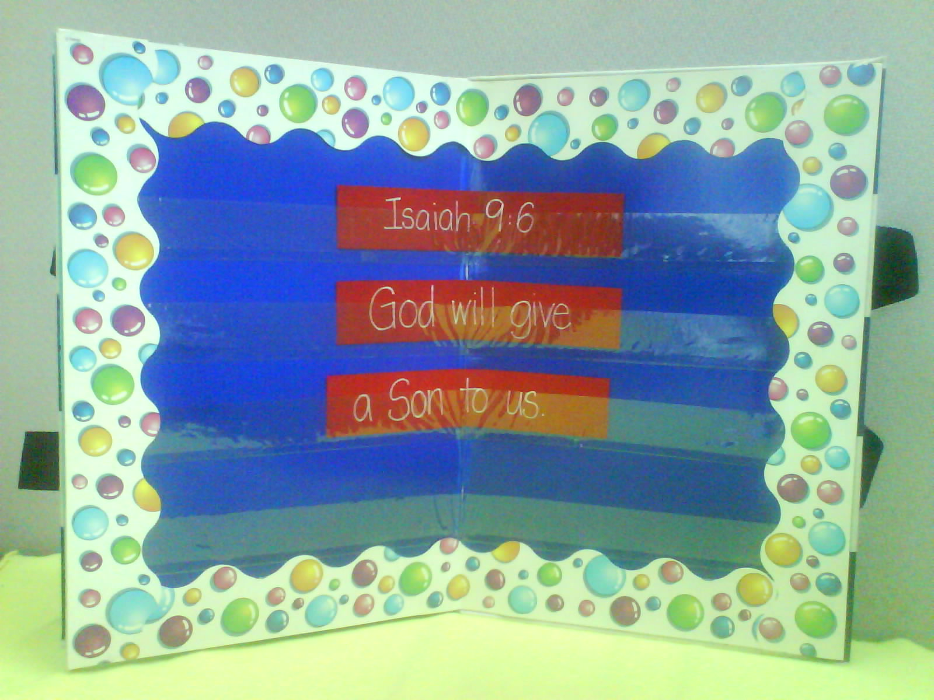

Memory Verse Learning: “Slot and Learn”
Teach the children 1 Peter 2:16 with poster board and
word strips. After the children are familiar with the verse
and have memorize, jumble the word strips and ask for
volunteers to rearrange the word strip onto the poster
board.

Prayer Time:
Give thanks for the benefits of being sons and daughters of God. Encourage each child to pray for one thing they are thankful for as children of the Heavenly Father.

Large Group Presentation

“Meet Jesus the Sacrifice” Game Show

Audience Participation Game

This audience participation game is a version of Charades. The game show host will invite two shepherds from the audience to come forward. The audience is divided in half with each half working with one of the two shepherd contestants.

A treasure chest with clues and signs will be needed each week. Two signs are needed throughout the series. One sign should be decorated and read “Meet Jesus as Sacrifice Game Show.” Another sign should read “Meet Jesus the Sacrifice and Get…” Place this sign above the treasure chest. Each week a new sign will be taken out of the treasure chest along with an object. This week's sign reads, “Get to be _____and _____ of _____.” The words to guess are “…“Get to be sons and daughters of God.” Along with this sign in the treasure chest is a piece of paper titled “Adoption Papers.”

The two shepherds compete with one another until a child guesses the phrase that is being acted out. The losing shepherd today will be required to eat fish ball without his hands.

Review a few of the standard signs. Holding up one finger signifies “first word.” Cupping one’s hand over an ear signifies “sounds like.” Making enthusiastic gestures of inviting someone to come closer signifies “getting closer to the word.”

Video
JESUS from the JESUS Film Project

Teacher: Right after we watch the video, we will play “Meet Jesus the Sacrifice” Game Show, which will ask questions about what happened when Jesus was praying in the Garden of Gethsemane. Jesus went to the garden right after He and the disciples celebrated the Last Supper. Jesus knew that the next day He would die for the sins of the world.

Watch this video carefully. Who did Jesus take with Him to pray? What did Jesus pray? Why was Jesus so troubled? And finally, what answer did Jesus receive?

Show the clip of Jesus praying in the Garden of Gethsemane from the JESUS video from the JESUS Film Project. This section lasts approximately two minutes.
Bible Reading: Mark 14:32-42

Read the Bible passage inviting the kids to follow along in their own Bibles. Kids need to remember to bring their Bibles from small group warm-up!

Observation Questions: What Happened?
Typically, observation questions are discussed in the small group. However, during this series, observation questions will be given in the large group as the children follow along in their Bibles. It will be important that the large group presenter moves through the crowd with a microphone or quickly calls on kids with answers so this portion of the lesson does not drag. He should also give the Bible references of where the answers are found. As the children answer, the large group presenter can read the Bible passage with the correct answer.

To help make this fun and interactive, the kids can compete with Dao Dao. He answers first and usually gives wrong answers which the children can gladly correct. (Comments marked in parentheses are Dao Dao’s.) This should help hold the children’s attention but, obviously, care needs to be taken so that Dao Dao does not upstage the message.

- Why did Jesus want to go to the Garden of Gethsemane in the middle of the night? (Mark14:32.)
To pray.

- Jesus took all of His disciples to the Garden of Gethsemane on this night He spent in prayer. He took three special disciples to be a little closer to Him. Who were those three? (Mark 14:33.)
(Errr . . .Ah Seng? Ah Ming? Ah Keong?)
Peter, James, and John. These are His three closest disciples.

3. Jesus went further into the garden. What did He want His disciples to do? (Mark 14:34.)
(Fix some roti canai because they were hungry.)
Stay awake and pray. Actually, prayer is hard work but it is very important. When someone is very troubled, he needs other people to pray for him, as well.

4. How many times did Jesus return to find them sleeping? (Mark14:41.)
(None. They were just doing their homework with their eyes closed.)
Three times. Jesus said that, even though they had good intentions, they were not spiritually strong enough to stay awake and pray.

- Jesus had anguish that was so great that He felt like what?
(Like He had a tummy ache.)

He felt like He was dying. He had real grief because He was thinking of the next day. He knew He would be a sacrifice for the sin of the world. Jesus knew He would have great pain as He was nailed to the cross.

There was something else, though, that was even more painful for Jesus. When He would be on the cross, God would lay the sin of the world on Him (2 Corinthians 5:21). Jesus would feel what it would be like if His Heavenly Father turned His back on Him. God cannot tolerate sin and Jesus had become sin for us. He would experience what it would be like not to be God’s Son. (Remember Jesus’ words on the cross, “My God, My God, why have You left Me alone?”) This is the worst thing He could imagine -- being away from God’s presence.

6. What did Jesus pray?
(Do I really have to do this?)
In a way that is right. (It is?) Jesus asked that God would make it so He would not have to do this. He also said, “Whatever You want, I will do.”

Teacher: Today, we meet Jesus the Sacrifice, who gave up His life so we might be adopted as sons and daughters of God. For that to happen, Jesus had to experience being cut off from God and what it would be like to not be in God’s family.

It is almost like a trade. Jesus took our sins outside of God’s family so we could come inside His family and be sons and daughters of God. When you go to your small groups today, you are going to find out just how wonderful it is to be a son or daughter of God.

Lesson 45

Small Group Warm-up
- marker
- poster board or section of mahjong paper

Large Group Presentation
- video JESUS from the JESUS Film Project (Inspirational Films, 1979)
- treasure chest
- one sign decorated as “Meet Jesus the Sacrifice” Game Show
- one sign that reads “Meet Jesus the Sacrifice and Get…” and is attached to the treasure chest
- sign that reads “get to be ______ and _____ of _____.” Have it in the treasure chest.
- piece of paper titled “Adoption Papers” in the treasure chest (appendix)
- bowl of fish ball
- spoon
- egg timer or a timer with a bell
- Dao Dao, the puppet

Small Group Application
- Bible
- three gold coins for the shepherd and three per child. Label the coins as follows:
    - 1st coin: Galatians 4:6-7: WE BECOME HEIRS
    - 2nd coin: John 3:16-17: WE RECEIVE ETERNAL LIFE
    - 3rd coin: Luke 10:19- 20: WE HAVE VICTORY OVER SATAN
- chocolate gold coin for each child (optional)

Memory Verse Learning
- poster board with slots (See diagram as how to make one.)
- memory verse word strips
Making of a poster board
- Cover a 60X45cm firm board or carton box with a plain colour construction paper.
- From thick clear plastic sheet, cut out seven 3X60cm strips.
- Affix double-sided tape at one end of the 60cm strips.
- Peel and stick them on to board at 3cm apart from each other.
- You will have seven rows to slip in word strips for teaching. (See photo.)

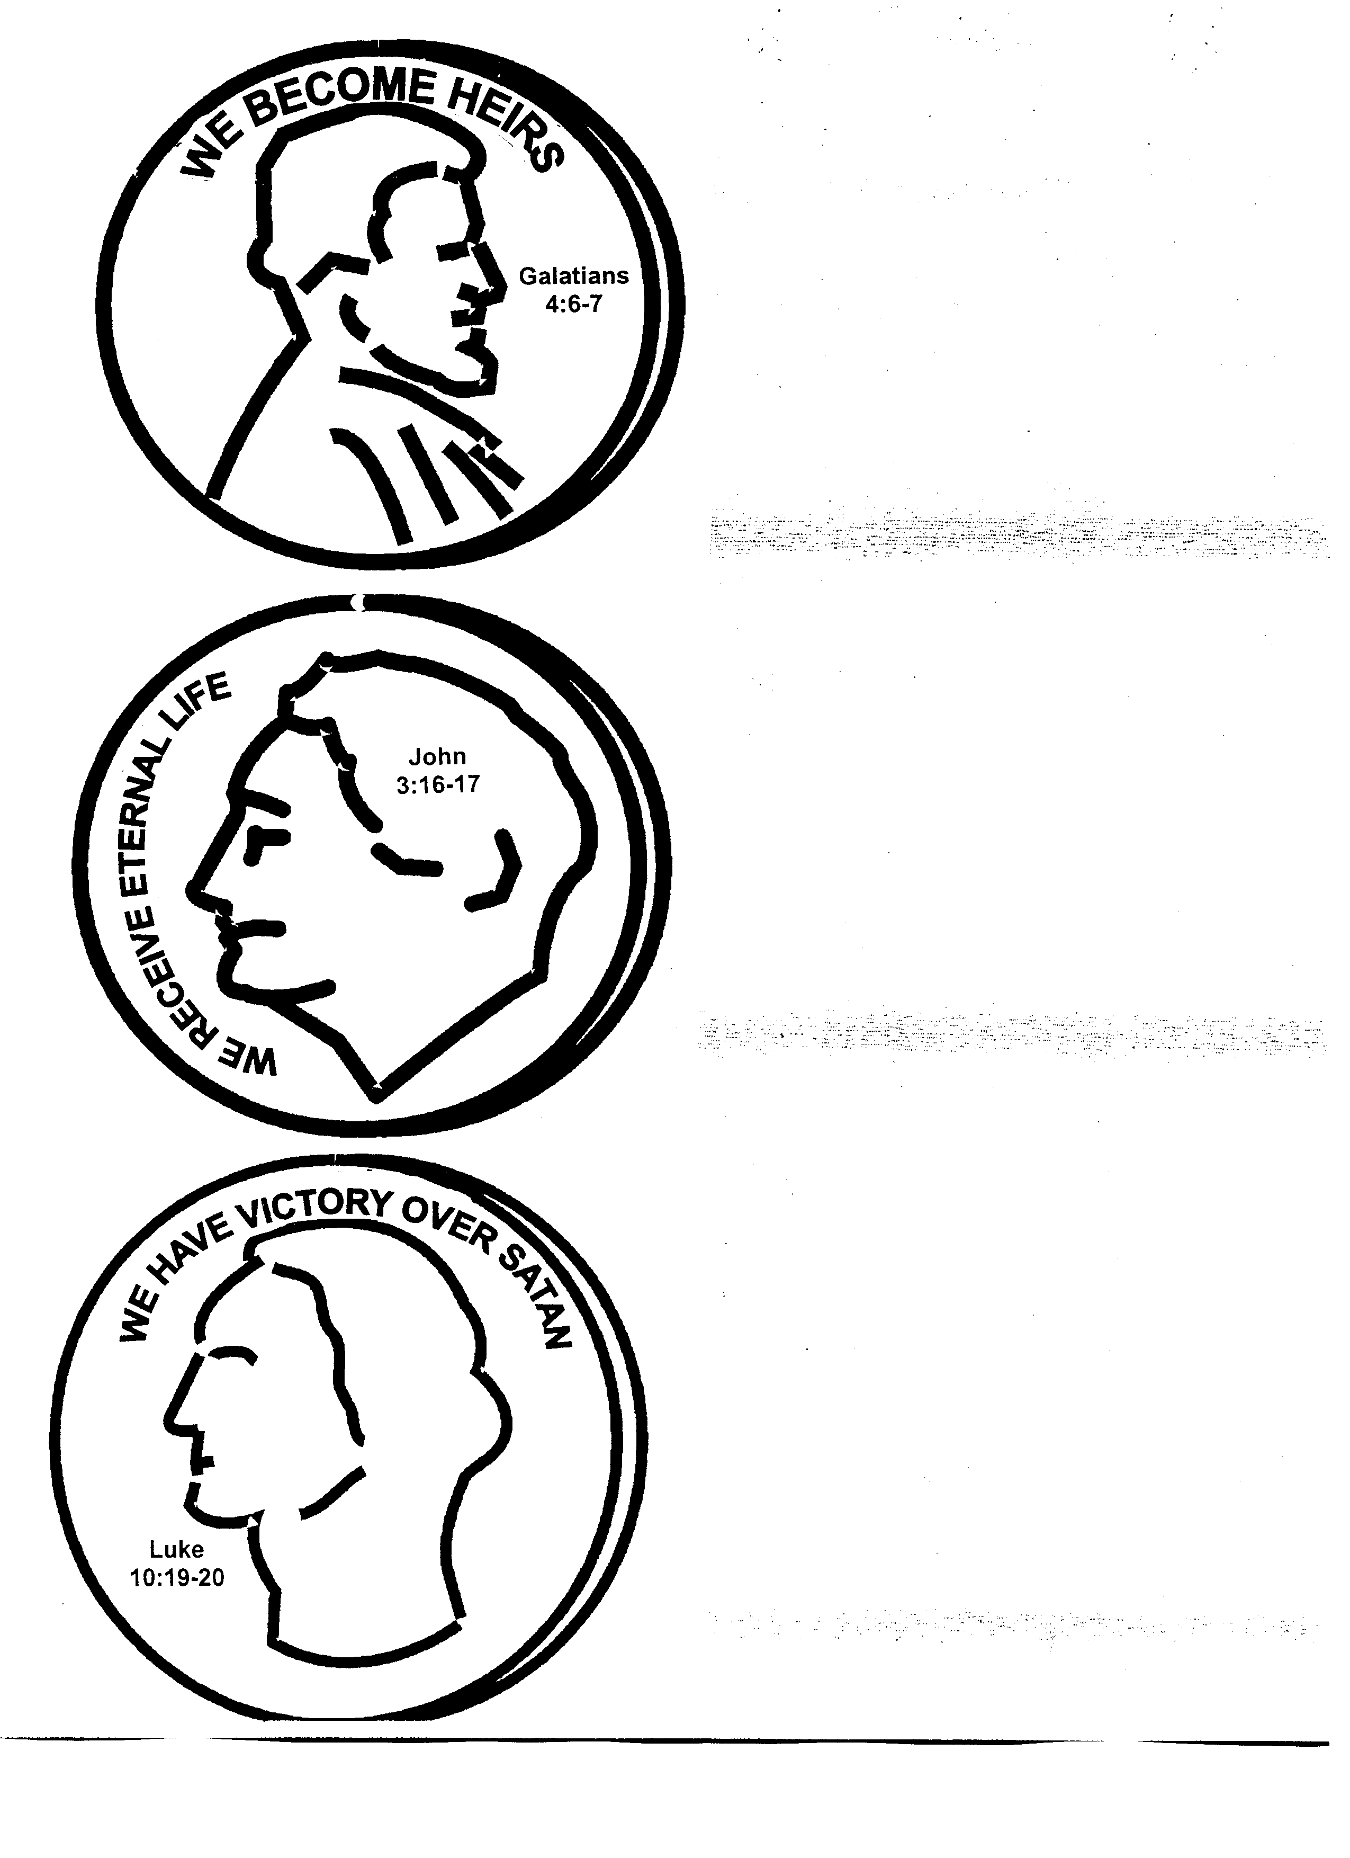

Adoption Papers

