
Date: __________________________
Series: Lookin’ for a Leader
Jun-Aug Year 3, Lesson 3

God Wants to Lead You

Take Home Point: *We can listen to God through His word.
*Repeat this phrase throughout the lesson.

Bible Event: 1 Samuel 2:22-3:21 The Lord calls Samuel.
Key Verse: 1 Samuel 3:10 (NIV), “Then Samuel said, ‘Speak, for your servant is listening.’”

We will help kids know:
- The Bible event of the Lord calling Samuel.
- God talks to us in His word, and we need to take time to listen to Him.

We will help kids feel:
- Not overwhelmed with the barrage of messages they can receive while finding direction for life.
- Peace and calm as they experience quiet time with the Lord.
- Challenged to develop a regular quiet time at home.

We will help kids do:
- Listen to God in their personal quiet time.
- Have three weekly quiet times per week for 12 weeks.

THIS LESSON’S ROADMAP

DESTINATION | PAGE # | DISCOVERIES ON YOUR JOURNEY | SUPPLIES NEEDED
Small Group Warm-Up   | 3 | Sometimes it is hard to hear clear directions. Wrong voices may get in the way of hearing what God wants of us. Play a game that demonstrates this. Children will learn they can be like Samuel and listen to what God is telling them. | - play area marked with a start line and a finish line, each 10 to 20 feet long (The distance between the two lines can be 20 to 40 feet.)
Large Group   | 4  8  9  11  12 | Overview  Pesta Game: Lookin’ for a Leader  Puppet Presentation: “Dao Dao’s Hearing Lesson”  Bible Event: 1 Samuel 2:22-3:21  Puppet Presentation: “Dao Dao’s Hearing Lesson” Conclusion | - pesta booth  - three garden hoses  - six funnels attached to the hoses, one on each end of the hose  - four-foot by eight-foot sheet of plywood (see page 9)  - small snack prize or big plastic ears  - Dao Dao  - earmuffs for Dao Dao  - sample Bible event reading calendar  - sample of prize that will be given for Bible event reading program
Small Group Application   | 4 | In what ways does God talk with us today? We can listen to God by reading the Bible. The children will have some quiet time listening to God through His word. They will be given a Bible reading calendar so they can spend time reading the Bible throughout the summer.  Memory Verse Learning:  “Listen & Write”  1 Cor. 6:19b-20 will be the memory verse for lessons 2-4 to help the children acknowledge the fact that Jesus paid the price so we might be owned by God. | - Bibles for each child to read in class  - Bible event reading calendars for each child (See page 8.)  - paper and pencils for each child  - poster board or mahjong paper  - two hoses with fannels from large group  - 3 X 5 cards with Bible verse prewrittern per group  - blank 3X5 cards  - a ballpen for each team
Small Group Warm-Up: 15 minutes
Purpose: Get pointed in the right direction! Build relationships and help guests feel at ease. Do the learning readiness activity that will point your group in the right direction for the lesson.

Supplies needed: play area marked with a start line and a finish line, each 10 to 20 feet long (The distance between the two lines can be 20 to 40 feet.)

The following active learning game is designed for larger groups from twelve to fifty. In some settings divide into large groups according to grade level. The object of the learning game is to create some confusion while participants try to listen for directions.

Mark the playing area with a start line and a finish line, each 10 to 20 feet long. The distance between the two lines can be 20 to 40 feet. (The game is quite flexible and can be adapted to whatever room size is available.)

Divide the children into teams of boys and girls (or however for equal numbers). One contestant from each team will begin at the starting line. Their task will be to walk backwards to the finish line without bumping into any of the stationary people called “bumpers.” If a contestant makes contact with a people bumper, he must go back to the starting line to begin again. Since the contestants cannot look backwards, they will likely run into the bumpers unless they have directions. To aid them in the race, the rest of their teammates are behind the finish line giving directions to the contestant.

Pick five kids from each team and place them in the path from start to finish line. They will be “bumpers” who stand silent and still as they watch for the contestants who are slowly walking backwards.

The probable outcome of this game may be that so many voices are shouting that it is hard for the contestants to discern what direction they need to take. It would be simpler if there was one voice giving direction, but do not share this with the children. Let them discover this on their own.

Make the game more challenging each round by adding more “bumpers” or changing the dimensions of the course to make it more compact.

After several children have experienced the different roles of being contestants, bumpers, and direction givers, ask the children to come together and sit in a large group.

What happened when you tried to find the finish line? (It was hard to hear clear directions because there were so many voices. We bumped into people and had to go back to the starting line.)

Wrong voices may get in the way of hearing what God wants of us. These wrong voices might tell us the wrong things to do. The voices could be some of the shows we see on television, some of the video games we play, or bad suggestions from our friends. Wrong voices tell us to do things that would not be pleasing to God.

God wants to tell us what is pleasing to Him. How do you think God tells us what we can best do for Him today? (Through God’s word, through the Bible, through parents and teachers who know what God’s will is.)

Today’s Bible event is about a 12-year-old boy. He heard God’s voice and listened to what God was telling him. We can be like this young boy and hear God’s voice. *We can listen to God through His word.

Large Group: 20-30 minutes
Purpose: Help kids observe what the Bible says. Present the Bible event in creative fashion. Help kids begin to interpret what it means.

Supplies needed: pesta booth; three garden hoses; six funnels attached to the hoses, one on each end of the hose; four-foot by eight-foot sheet of plywood (see page 9); small snack prize or big plastic ears; Dao Dao; earmuffs for Dao Dao; sample Bible event reading calendar; sample of prize that will be given for Bible event reading program

Overview

Pestal Event: The pesta game (an introduction to the Bible event) is a hearing game to try determining which “connection” is needed to hear the leader’s voice. Dao Dao, as is typical, has a hard time hearing the message.

Puppet Presentation: “Dao Dao’s Hearing Lesson”

Bible Event: 1 Samuel 2:22-3:21—The Bible event is about God calling Samuel by name and how Samuel learns to hear God’s voice and respond to Him.

Puppet Presentation: “Dao Dao’s Hearing Lesson” Conclusion

Small Group Application: 20-25 minutes
Purpose: Help kids map out the meaning of the Bible event in their lives. Use the questions to stimulate discussion but don't feel tied to them. Allow the Holy Spirit to guide you. Include personal examples from your own faith journey. The example of Christ at work in your life will leave lasting impressions of how Christ can work in the children's lives.

Use your Bibles! Children need to learn how to look up references and follow along when scripture is read aloud. Allow for quality time of prayer at the close of the lesson.

Supplies needed: Bibles for each child to read in class; Bible event reading calendars for each child (See page 8.); paper and pencils for each child; poster board or mahjong paper

Observation Questions: What happened?

When Samuel was a boy, where was he living? Who was he staying with? (1 Samuel 3:3. Samuel was living in the temple with Eli, the priest.)

When the Lord spoke to Samuel at night, what was the first thing Samuel said? (1 Samuel 3:4. “Here I am.”)

Who did Samuel think was calling him? (1 Samuel 3:5. Eli.)

How many times did this happen? (1 Samuel 3:5-9. Three times. Then Eli told Samuel to answer the Lord.)

When God called again, what did Samuel say? (1 Samuel 3:10. “Speak. I’m listening.”)

What did God tell Samuel? (1 Samuel 3:11-14. This is answered according to the details shared by the large group leader. It pertains to the bad news against Eli and his sons.)

Interpretation Questions: What does this mean?
How do you think Samuel felt being called in the middle of the night? How do you think he felt when Eli sent him back to bed so many times?

Application Questions: What does this mean to me?
Record the children’s answers to the next question on poster board or mahjong paper so they will be able to see and hear the answers. The more of their senses that are involved, the easier it will be for them to remember the main point.

How can we listen to God? What ways does He talk with us today? (The Bible, other Christians, pastors and teachers, Christian radio, etc.)

We listen to God not just by waiting for a voice in our heads. We listen to God by reading or listening to the Bible. In the Bible, God speaks to us and He has something special to say. We can also listen to our parents or teachers who are close to God. They can tell us about God.

Application Activity:

We are going to have quiet time today. “Quiet time” means that we are going to spend a few minutes listening to God through His word without any other distractions.

Anytime we study God’s word, it is important to pray that we would hear what God wants us to. We can pray like this:

Dear God, show me what You want to tell me today. Speak, Lord. Your servant is listening.

Explain to the children that after giving them a few short instructions, they will spread out and find a space somewhere in the room all by themselves. For older children, give these instructions:

When you are in your quiet place, read John 10:27-28. (Have them write the references on a piece of paper so they don’t forget.) After you read this scripture, think of one thing that God is telling you. Then pray to God and ask Him to show you how you can do that thing. Remember to pray in Jesus’ name because He is our Savior. Through Jesus, God hears all of our prayers and speaks to us. On your paper, draw or write about your conversation with the Lord.

For younger children who cannot read well or for those who do not have their own Bibles, read the verses to them and pray with them before they find their quiet place. The younger child can draw pictures of what they think of after hearing this passage.

Dismiss the children with Bible, pencil, and paper to quiet places in the room or outside. They cannot be next to any other child. You will tell them when time is up in three to five minutes. During this time, have the children write down what they are thinking about or what they think God wants them to do.

Gather the children back together as a group and discuss some of their responses.

Today we learned that *we can listen to God through His word.

Next, show the children the Bible event reading calendar. (See page 8.) They are to show this to their parents and get a parent’s signature each week. The children will receive a special prize (one option is to present kids with a new Bible) as a reward for completing ten of the 12 weeks of three quiet times and one Bible verse per week. Encourage the children to invite their parents to be a part of the devotion.

As a reminder or incentive to continue quiet times through the next weeks, show an example of the prize that will be given to the children who complete the summer reading program. Continue this each Sunday.

Memory Verse Learning: 5 minutes
Purpose: Help kids to memorize and keep scriptures at heart. Using creative ways to help kids enjoy learning the key verse and in small group setting.

Supplies needed: two hoses with fannels from large group; 3 X 5 cards with Bible verse prewrittern per group; blank 3X5 cards; a ballpen for each team

Memory Verse: 1 Corinthians 6:19b-20, “You do not own yourselves. You were bought by God for a price. So honour God with your bodies.”

Memory Verse Presentation: “Listen and Write”
Before class shuffle the 3X5 cards of each group to mix the order. During class, divide the children into two teams and set them into two lines at one end of the room. Pick a child to be “whisperer,” standing directly at the opposite end of the team with the 3X5 cards to read and a funnel-hose to speak through. Put some 3X5 cards and a ballpen in the middle of the track for each team. The procedure of the game is that they are to take turn to listen to the “whisperer’s” message by the funnel-hose, run to the middle to write the message, then runs and tag the next person. When everybody has received all the messages they have to arrange them into order. The first team to finish the arrangement and recites the verse as a team wins.

Prayer Time:
Have the children gather for prayer. Invite each child to pray about one thing he read in his Bible. The children may want to have their Bibles open while they pray. The children can also pray for any other needs they might have.

Safety and Security: Safety and security procedures are important for each church to carefully define and implement according to their unique needs. The security, safety, illness and accident procedures described in this curriculum are provided for example purposes only and may not be appropriate, applicable or adequate for every situation. Each church is responsible for determining whether any security, safety, illness and accident procedures contained in the curriculum are appropriate, applicable or adequate for its unique situation. The activities described in this curriculum require adult supervision and may not be suitable for each child and each situation. Each church is responsible for ensuring that adequate adult supervision is provided for all activities and for determining whether an activity is appropriate for each child and each situation. Kids Kount Publishing disclaims all liability for the implementation of any procedures or the performance of any activities described in this curriculum.


Week | Old Testament | Book of John | New Testament | I Did It!
 |  |  |  | (Please put a checkmark here.)
1 | 1 Samuel 2:22-3:18 | 1:1-18 | Romans 5:1-11
2 | 1 Samuel 7:15-8:22 | 2:1-11 | Romans 8:28-39
3 | 1 Samuel 9:1-10:16 | 3:1-21 | Romans 12:1-8
4 | 1 Samuel 14:47-15:35 | 4:1-26 | 1 Corinthians 12:12-31
5 | 1 Samuel 16:1-13 | 5:1-15 | 1 Corinthians 13:1-13
6 | 1 Samuel 17:1-54 | 6:1-14 | Galatians 3:26-4:7
7 | 1 Samuel 17:55-18:30 | 10:1-21 | Ephesians 6:10-20
8 | 1 Samuel 19 and 20 | 15:1-17 | Philippians 4:4-13
9 | 1 Samuel 23 and 24 | 18:1-18 | Colossians 12-25
10 | 1 Samuel 28 | 19:17-37 | 1 Thessalonians 4:13-5:11
11 | Psalm 23 | 20:1-18 | Hebrews 11:1-6
12 | Psalm 100 | 20:19-30 | Revelation 22:1-9
CHALLENGE:
Can you read the Bible three times a week and have a quiet time for 12 weeks?
You might want to do these for family devotions or with a parent.
Each week your parents will put a checkmark in the last column
after you have read all of the Bible events.
You also get two free checkmarks for weeks you might miss.

Large Group Presentation

Lookin’ for a Leader

Pesta Game

The current series, “Lookin’ For a Leader,” will use the theme of pesta games. Each week a new pesta game will be presented in which participants are invited to play. The large group leader will be a pestal booth attendant running the game.

Building the set for this can be simple, but the more detail and imagination given to it, the more entertaining it can be. A booth with a counter behind which the player stands would be necessary. Against the wall, various games or targets will be played. From week to week these games change. Within the games, the learning point will be revealed.

The pesta game is a good opportunity to use Dao Dao the puppet. He can be stationed somewhere within the booth as an assistant. Dao Dao can ask questions that set up the Bible event. If Dao Dao is not used, perhaps a live player could adapt the script so the setup dialog is presented.

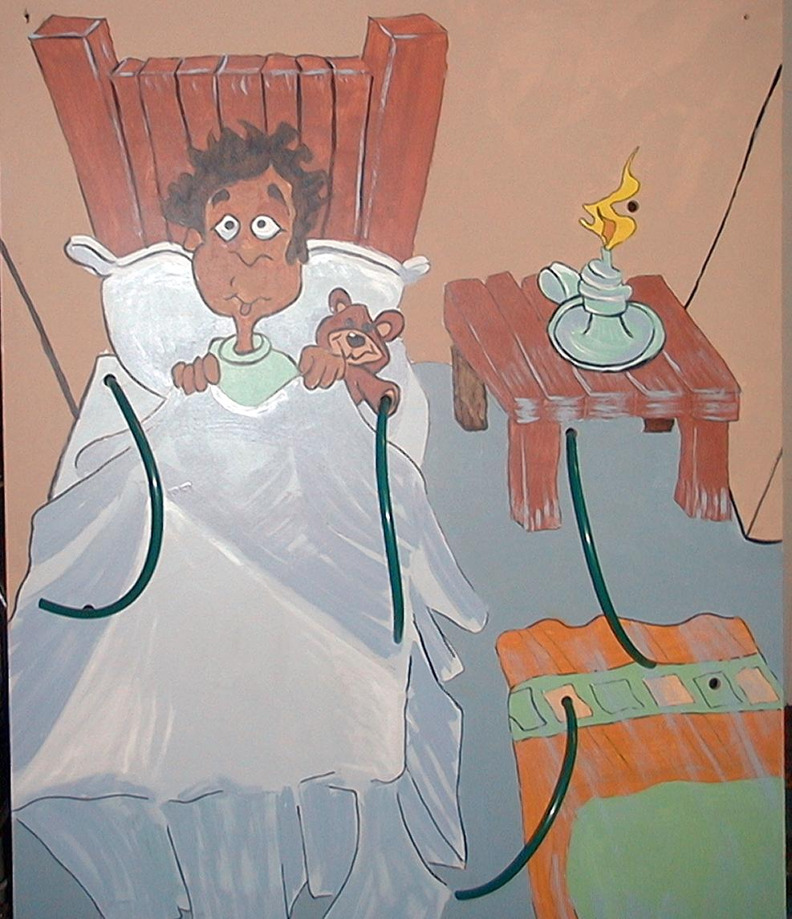
Today’s pesta event requires three garden hoses and six funnels (real or fabricated out of plastic). The funnels are attached to the ends of the garden hoses. The picture to the right is a painting of young Samuel in bed. This picture was done on a four-foot by eight-foot sheet of plywood. The board has holes drilled in it and the three hoses inserted. Then funnels are placed at both ends.

The large group leader (or better yet, another anonymous voice) will be whispering through a funnel behind the booth. A contestant will choose one of the three hoses at the front of the booth, put his ear to it, and listen for the message from the large group leader. If the contestant chooses the correct hose, he will be able to repeat to the group the message that was transmitted. It becomes even trickier when the hidden voice changes hoses after each wrong guess.

The following Bible verse will be whispered one phrase at a time. The “winning” child will repeat it to the group a phrase at a time.

Eli told Samuel, / “When he calls you / say, / ‘Speak, LORD. / I’m listening.’”/

The timing of the event should not drag. If too much time is taken, the event will upstage the real learning. The quicker the game moves along, the easier it is to keep children’s attention.

After the event, a small snack prize is awarded to participants. Invite them to share with the kids in the audience when they return to their place. Or a grand prize might be offered. This prize could be some big plastic ears from a novelty store or some other simple gift that fits the theme of hearing.

Dao Dao’s Hearing Lesson

Puppet Presentation

Dao Dao: (Appears wearing earmuffs.) Hey, Teacher?

Teacher: Hi, Dao Dao. What do you need?

Dao Dao: Teacher?

Teacher: Yes, Dao Dao. What?

Dao Dao: Hey, Teacher?

Teacher: I’m here. What do you want?

Dao Dao: Teacher? Are you there?

Teacher: Here I am. What do you want, Dao Dao?

Dao Dao: Teacher, are you listening?

Teacher: I’m right here, Dao Dao. What do you want?

Dao Dao: Teacher, I can’t hear you.

Teacher: (Shouting.) Dao Dao, cut it out! I’m right here. Can’t you hear me?

Dao Dao: Did you say something, Teacher?

Teacher: (Lifts Dao Dao’s earmuffs and shouts.) I’m here, Dao Dao! What do you want?

Dao Dao: Ouch! There’s no need to shout!

Teacher: But you weren’t listening, Dao Dao.

Dao Dao: No, you weren’t listening!

Teacher: I was listening. You just couldn’t hear me answer you because you had these earmuffs on. Why did you have these on?

Dao Dao: Because you were shouting at me!

Teacher: Oh, Dao Dao. I almost give up.

Dao Dao: Good. Give me back my earmuffs.

Teacher: On second thought, I’ll keep them. You need to listen. I need to listen, too. We need to listen to more than just each other. We need to listen to God.

Dao Dao: Does He talk to us?

Teacher: He sure does.

Dao Dao: Well, how come I don’t hear Him?

Teacher: It is more than earmuffs that get in the way of hearing God. Sometimes we don’t take the time to listen to Him. Today we’ll discover how He talks to us in His word. We need to take time for that. To help me show you this, I would like to read today’s Bible event. Will you listen?

Dao Dao: Sure, if you give me back my earmuffs.

Teacher: No. I’ll give them back to you after the Bible event.

Dao Dao: Okay. I’m listening.

Bible Event
1 Samuel 2:22-3:21

The large group Bible event is read in dramatic fashion using a Bible storybook or an easy-reading Bible. Adding a dramatic touch might involve a child coming forward to play the part of Samuel. The child can even speak Samuel’s parts as prompted by the narrator.

Teacher: The people of Israel were now living in the Promised Land. The tabernacle of God, the place where the people worshiped, was set up in the city of Shiloh.

It was Eli’s job as priest to make sure the sacrifices were carried out and that people could worship God. But Eli’s own sons showed great disrespect for God and His law. This led to the downfall of Eli and his family. This is what happened.
Eli’s sons, Hophni and Phinehas, did not have faith in the Lord. They would steal meat from that which was given to the Lord for sacrifice. They took advantage of some of the women who worked in the temple. They didn’t even care what God said about their wickedness.

Perhaps the worst thing of all was what their father, Eli, did. He did nothing. Eli warned Hophni and Phinehas, but he did not discipline them or stop them. They continued to sin.

Then a prophet came to Eli and told him what would happen. “God says to you: ‘You show no respect for the sacrifices brought to Me. You are honoring your sons more than Me by letting them steal from the sacrifices.’ Therefore, the Lord says: ‘Soon you and your family will no longer be priests or serve before Me in My presence. Your descendants will not live to old age but will die earlier in life. I will appoint a faithful priest to serve Me. He will do everything I tell him to do’.”

Late one night, Samuel was sleeping in his bed. He heard a voice calling him. Samuel ran to Eli in the middle of the night and said, “Here I am. You called me.”

Eli replied, “I didn’t call you. Go back to bed.”

Samuel went back and lay down. Then the Lord called again. “Samuel.”

Samuel got up again and went to Eli. “Here I am.”

Once more Eli said, “I didn’t call you. Go back to bed.”
Then the Lord called Samuel a third time. “Samuel.”

This time when Samuel got up and went to Eli, Eli realized that the Lord was calling Samuel. “Go, lie down. When He calls you say, ‘Speak, Lord. I’m listening.’”

So, Samuel lay down in his room. What do you think happened? Right. The Lord came and stood there. He called Samuel as He had before, “Samuel! Samuel!”

This time Samuel replied, “Speak. I’m listening.”

Then the Lord spoke to Samuel. He told Samuel that He was going to judge Eli and his family because they had not served God faithfully but had served sinfully instead. God told Samuel that Eli’s family would no longer be priests.

Samuel stayed in his bed all night. He must have thought much about what the Lord had said. He was afraid to tell Eli about what he heard.

In the morning, Eli called Samuel and asked, “What did the Lord tell you? Please don’t hide anything from me.”

So, Samuel told Eli everything. Eli replied, “He is the Lord. May He do what He thinks is right.”

As the years went by, everything that was foretold about Eli and his sons came true. Samuel continued to grow. The Lord was with him and spoke to him. Samuel spoke God’s words to all of Israel.

Dao Dao’s Hearing Lesson

Puppet Conclusion

Dao Dao: I guess Samuel did hear from the Lord.

Teacher: He did. God made Samuel a great leader and fulfilled all the promises he gave to Samuel.

Dao Dao: I wish God did that today.

Teacher: He does, Dao Dao. We just need to take time to listen to God. Today we are going to discover how to do that when we have quiet time and listen to God speak to us in His word. Right, Dao Dao?

Dao Dao: What did you say?

Teacher: Right, Dao Dao?

Dao Dao: What did you say?

Teacher: (Loudly.) Right, Dao Dao!

Dao Dao: I know I’m right, Teacher, but you don’t have to shout about it!

Teacher: Right, Dao Dao. Let’s close in prayer.

Dao Dao: No problem, Teacher.

Teacher: Dear God, thanks for talking to us through Your word. Sometimes we don’t listen too well. We need help with that. Will You help us take quiet time and listen to You when we read the Bible? Thank You that *we can listen to You through Your word. In Jesus’ name. Amen.

Kids, today we are discovering we need to take time to listen to God. Sometimes so many things fill our lives with other noises that we don’t take that time. These things might be television, a busy schedule, or the fact that we are always talking and doing.

In your small groups, we are going to help you learn to spend quiet time with God. You will receive a calendar. This calendar shows you how to have three Bible readings and a memory verse per week. If you do these and have your parents sign the sheet each week, you are going to win a prize. This is the prize. (Shows the prize deemed appropriate for the Bible event reading program. Some suggestions are: God’s Word for Boys and God’s Word for Girls Bibles, as published by God’s Word to the Nations.)

Lesson 3

Small Group Wrap-Up
- play area marked with a start line and a finish line, each 10 to 20 feet long (The distance between the two lines can be 20 to 40 feet.)

Large Group Presentation
- pesta booth
- three garden hoses
- six funnels attached to the hoses, one on each end of the hose
- four-foot by eight-foot sheet of plywood (see page 9)
- small snack prize or big plastic ears
- Dao Dao
- earmuffs for Dao Dao
- sample Bible event reading calendar
- sample of prize that will be given for Bible event reading program

Small Group Application
- Bibles for each child to read in class
- Bible event reading calendars for each child (See page 8.)
- paper and pencils for each child
- poster board or mahjong paper

Memory Verse Learning
- two hoses with fannels from large group
- 3 X 5 cards with Bible verse prewrittern per group
- blank 3X5 cards
- a ballpen for each team

