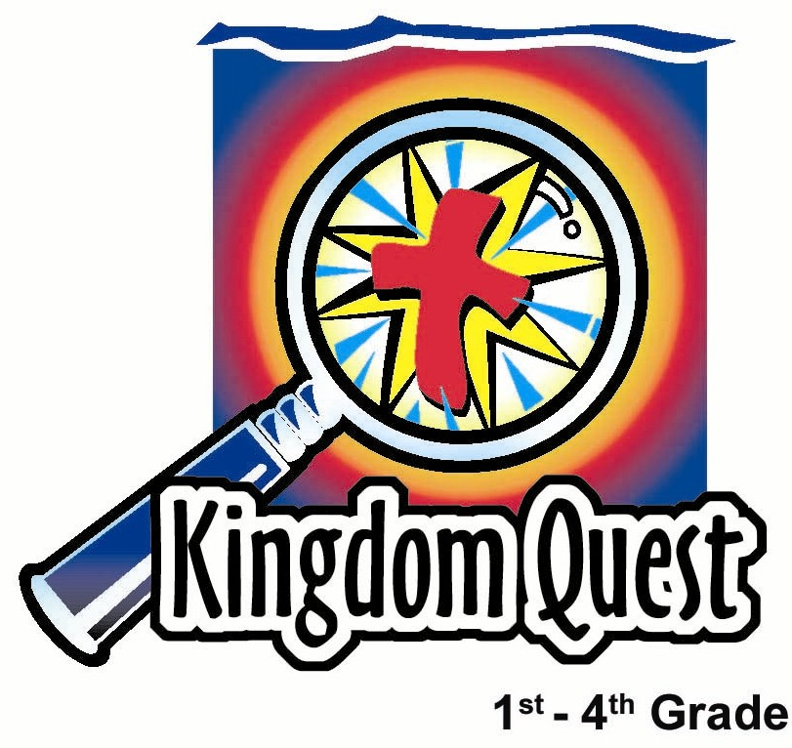
Date: __________________________
Series: Lookin’ for a Leader
Jun-Aug Year 3, Lesson 4

Father’s Day—God is a Faithful Father

Take Home Point: *Our Heavenly Father is faithful.
*Repeat this phrase throughout the lesson.

Bible Event: Luke 15:11-32 The prodigal son and faithful father.
Key Verse: John 1:12 (NCV), “But some people did accept Him. They believed in Him. To them He gave the right to become children of God.”

We will help kids know:
- The Bible event of the prodigal son.
- God gives us earthly fathers who can be faithful and love us.
- God always takes us back when we stray.

We will help kids feel:
- Thankfulness for their fathers or father figures.
- Comfort in knowing they can always rely on their Heavenly Father.

We will help kids do:
- Make a large display listing admired characteristics of their dads.
- Make Father’s Day cards for their Heavenly Father, remembering His faithful and loving kindness.

THIS LESSON’S ROADMAP

DESTINATION | PAGE # | DISCOVERIES ON YOUR JOURNEY | SUPPLIES NEEDED
Small Group Warm-Up   | 3 | What are some of the best things about dads? The children will write their answers on polka dots that will later be used to make a giant Father’s Day tie. | - five-inch circle of manila card for each child  - scissors  - pens, pencils, markers, or crayons
Large Group   | 4  7  7  7  8 | Overview  Build the Tie  Pesta Game and weight of a father.  Blessing and Prayer for All Dads  Puppet Presentation: “The Lost Son, Dao Dao” | - four-foot by eight-foot section of one inch insulation board wrapped in fabric  - sign that will fit in the knot of the tie that reads “A Father’s Love Ties Us Together”  - Velcro and/or tape  - Dao Dao  - carnival props  - plastic fruit  - small prizes
Small Group Application   | 5 | Make a giant Father’s Day card for their Heavenly Father. The children could list their thanksgivings in the card. Also talk about how our Heavenly Father is faithful like the father of the prodigal son.  Memory Verse Learning:  “Which is the Missing Card?”  1 Cor. 6:19b-20 will be the memory verse for lessons 2-4 to help the children acknowledge the fact that Jesus paid the price so we might be owned by God. | - one poster board folded in half. The front of the card reads,“Happy Father’s Day, God.” Inside, “Heavenly Dad, thank You, thank You, thank You!” Signed, “Your Children.”  - markers or crayons  - 3 X 5 cards with Bible verse prewrittern from lesson 3

Small Group Warm-Up: 15 minutes
Purpose: Get pointed in the right direction! Build relationships and help guests feel at ease. Do the learning readiness activity that will point your group in the right direction for the lesson.

Supplies needed: five-inch circle of manila card for each child; scissors; pens, pencils, markers, or crayons

The Small Group Warm-Up activity will help children think about their earthly fathers. Throughout the lesson, we want to be sensitive to children who do not have a father living at home or have a father who is not very faithful or loving. It would be very helpful for the children to talk about their situations in a safe environment. For those children who have positive father images, they also need to share their experiences.

Begin Small Group Warm-Up with the following.

Today we will be talking about dads. There are lots of different kinds of dads. Some dads live at home with their children. Some children have step-dads. Some children have always had the same dad. Some children don’t have dads at all. These children might have grandpas or other special men they look up to in their lives.

If you do not have a dad, I want you to think of a very special adult in your life. Think of that person when you answer this question: What is one thing you like about your father or father figure?

Tell the children they are going to make a giant tie with circles for all the dads. Hand out the five inch circles and tell the kids these will be the polka dots on the six-foot tie. On the circle they are to write about or draw a picture for what they are thankful about their father or father figure. You might have them start by writing, “I’m thankful for my dad because…” (The entire activity should not take more than ten minutes.)

As the children write on the circles and cut them out, discuss some of the children’s responses. Let the children talk freely. Those that are sensitive about their fathers may not wish to share much, which needs to be respected. Another question to help discussion:

What are some of the best things about dads? What is something you like to do with your father or father figure? (Remember that children often form their picture of what God is like based on their experiences with their earthly fathers. While admirable characteristics of their earthly fathers can be a point of comparison to their Heavenly Father, the truest example of a faithful father is our Heavenly Father.)

Have the kids take the completed circles to a common spot outside your small group area where the circles will be pasted on a mounting board or poster board section of the tie. We recommend each grade make a different section (or stripe) for the tie. The circles (polka dots) will be taped or glued to each section. This will be a completed super-sized Father’s Day tie.
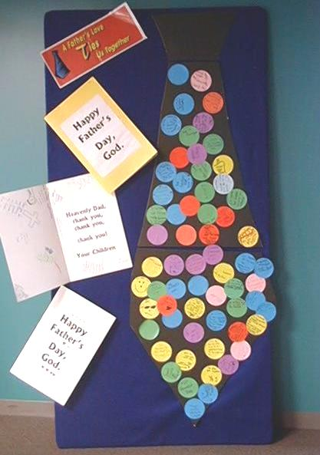
If there is any additional need for discussion with the children before large group, use the following question.

Can someone share about a time when you really needed your dad and he was there for you?

Before going to large group, say:

Today, we will learn how *our Heavenly Father is faithful.

Large Group: 20-30 minutes
Purpose: Help kids observe what the Bible says. Present the Bible event in creative fashion. Help kids begin to interpret what it means.

Supplies needed: four-foot by eight-foot section of one inch insulation board wrapped in fabric; sign that will fit in the knot of the tie that reads “A Father’s Love Ties Us Together”; Velcro and/or tape; Dao Dao; carnival props ; plastic fruit; small prizes

Overview

Build the Tie: During the carnival game, the tie will be assembled.

Carnival Game: The carnival game will be a contest to see who can guess the age and weight of a father.

Blessing and Prayer for All Dads

Puppet Presentation: “The Lost Son, Dao Dao” – The puppet script will transition into how our Heavenly Father is loving and faithful and such a blessing. Dao Dao will star as the main character in the Bible event.

Small Group Application: 20-25 minutes
Purpose: Help kids map out the meaning of the Bible event in their lives. Use the questions to stimulate discussion but don't feel tied to them. Allow the Holy Spirit to guide you. Include personal examples from your own faith journey. The example of Christ at work in your life will leave lasting impressions of how Christ can work in the children's lives.
Use your Bibles! Children need to learn how to look up references and follow along when scripture is read aloud. Allow for quality time of prayer at the close of the lesson.

Observation Questions: What happened?
How did the father show his love for the boy? (He welcomed him home, forgave him, and gave him back his status as son. It also was an act of love that he let his son go and did not force him to stay.)

Interpretation Questions: What does this mean?
How is God like the father in the story?

Is God ever sad when His children leave Him?

Do you think God would ever run to greet someone who came back to Him?

What other examples can you think of that show us God is like the father in the story?

Application Questions: What does this mean to me?
How are you like the lost son in the story? (We sin and are selfish. We may also run away from God at times.)

The key Bible verse for today is from John 1:12: “But some people did accept Him. They believed in Him. To them He gave the right to become children of God.” Thinking of the Bible event, what were privileges the son had over the servants?

What are some privileges we have as children of God that others don’t have?

How do we become God’s children? (You become God’s child through faith in Jesus Christ.) The Bible says, “Whoever believes and is baptized will be saved.”

Application Activity:
Supplies needed: one poster board folded in half; markers or crayons

Today’s activity will be to make a Father’s Day card for God. The entire group will work together on the project, using a large poster board folded in half.

Write on the front of the poster board card, “Happy Father’s Day, God.” Inside write, “Heavenly Dad, thank You, thank You, thank You!” Sign the card, “Your Children.” The cards will be placed with the tie display in the corridor of the church for all to see.
Have the children write inside the card things about their Heavenly Father they are thankful for. Help the kids see that out of all the gifts God has given them, the best gift is his Son, Jesus.

Through Jesus’ death and resurrection, though we were once lost, we are now found. God came after us to bring us home and welcome us back when He sent His Son. We’ve been brought back into God’s family.

Be sure this point is clear and have some children write that on the card.

The children could list many thanksgivings. Thank God for some of His characteristics as demonstrated in today’s parable: His faithfulness, His acceptance, His eagerness to have us home with Him, and His forgiveness. Also, consider the way God provides for us, leads us, and guides us.

You can help children find personal applications of these things in their lives by asking such questions as, How is God faithful to you?

As the children write these things, they are discussing all the many ways they can be thankful that God is such a wonderful Heavenly Father. Remind kids that no matter what they do or who else in their lives disappoints them, *Our Heavenly Father is faithful.

Look for any children who are not confident in knowing God as their Father through faith in Jesus. If they are ready, lead them in the following simple prayer to receive Christ.

Heavenly Father, I need to come home to You. I have done wrong things and I have not been perfect. I need Your forgiveness. Thank You for sending Jesus, who died on the cross for me. Thank You that He rose again and is alive right now. I receive Him as my Savior and invite Him into my life. Thank You that, because of Jesus, You can call me a son or daughter. I am an heir to Your kingdom. In Jesus’ name. Amen.

Memory Verse Learning: 5 minutes
Purpose: Help kids to memorize and keep scriptures at heart. Using creative ways to help kids enjoy learning the key verse and in small group setting.

Supplies needed: 3 X 5 cards with Bible verse prewrittern from lesson 3

Memory Verse: 1 Corinthians 6:19b-20, “You do not own yourselves. You were bought by God for a price. So honour God with your bodies.”

Memory Verse Presentation: “Which is the Missing Card?”
Use the flash cards to review the memory verse. Then tell the children that the boys are going to compete with the girls. You are going to quickly flash all the cards to them randomly but each round there is a missing card. The person who raises his/her hands first and can tell the missing phrase in the card scores 500 for their team. Give some time for the game then at the end have everyone recite the verse again.

Prayer Time:
Have children tell our Father in heaven how they are thankful for one thing about Him. They can include what they wrote on the Heavenly Father’s Day card.
Safety and Security: Safety and security procedures are important for each church to carefully define and implement according to their unique needs. The security, safety, illness and accident procedures described in this curriculum are provided for example purposes only and may not be appropriate, applicable or adequate for every situation. Each church is responsible for determining whether any security, safety, illness and accident procedures contained in the curriculum are appropriate, applicable or adequate for its unique situation. The activities described in this curriculum require adult supervision and may not be suitable for each child and each situation. Each church is responsible for ensuring that adequate adult supervision is provided for all activities and for determining whether an activity is appropriate for each child and each situation. Kids Kount Publishing disclaims all liability for the implementation of any procedures or the performance of any activities described in this curriculum.

Large Group Presentation

Beware of letting these activities drag.
Move through them with quick pacing so they keep children’s attention.

Build the Tie
While the pesta game is proceeding, have a couple of adults assemble the tie. Tape or Velcro the dots to the large fabric covered board in the shape of a tie.

Needed for this assembly:
- one, 4 x 8-foot, 1 inch thick piece of insulation board wrapped in fabric
- colored dots from the Small Group Warm-Up classes.
- sign that will fit in the knot of the tie that reads “A Father’s Love Ties Us Together”
- Velcro or tape for attaching dots to board.

Assemble the dots on the board, pointing out various attributes of fathers. The children, in prayers of thanksgiving of dads, will later mention some of the attributes.

Pesta Guessing Game
To further celebrate dads, ask a father to come forward. (Pick one who has a sense of humor and would be willing to share his age and weight.)

Have a contest with the children, inviting them to guess the father’s age and weight. Have two or three children come forward and guess his age and then award a prize to the child with the closest answer. You can replace the winner with another contestant and then have them guess his weight. A prize is awarded to the child whose guess is the closest. Have contestants return to their seats but have the father remain for the blessing. Do not let this event drag out too long!

Blessing and Prayer
Remind the kids that these last few weeks we’ve been “Lookin’ for a Leader.”

Teacher: A leader has been found. God has appointed leaders in our families—fathers. Some children may not have fathers living with them, but they can still have people in their lives that they look to for leadership. These men are called father figures.

(Ask three or four volunteers to come forward to pray a prayer of thanksgiving for fathers.)

Teacher: Think of some of the things we wrote about dads on the tie. Thank God for something about fathers.

After we have our prayers of thanksgiving, I would like to have a child bless all the dads in Jesus’ name. I would like the dad who participated in the pesta to remain seated onstage. One child will lay her hands on the shoulders of this dad and bless him as a representative of all dads as she reads this prayer. (Hand the child a card with this simple prayer to read.)

Child: I bless you and all dads in Jesus’ name. May our dads look to our Heavenly Father for guidance and direction as they guide and direct our families. May they never forget how much we love them and need them. In Jesus’ name. Amen.

The next part of large group deals with understanding God as our Heavenly Father. The main point is that our Heavenly Father is faithful. He gave Jesus to us so we could always be called his sons and daughters, living in his kingdom now and forever.

Teacher: Now that we have talked about our earthly fathers and have given thanks to God for them, let’s talk about our Heavenly Father. God asks that we would call Him “Father.” When Jesus gave us the Lord’s Prayer, how did He want us to begin? Right. We are to pray, “Our Father, who art in heaven.” God wants us to know Him as a Father who provides for us, guides and protects us, and loves us so much that He gave His only Son, Jesus. He wants us to be His sons and daughters, too.

The Lost Son, Dao Dao

Puppet Presentation

Teacher: Welcome to our special Father’s Day presentation. Today we tell you one of the best-loved stories in the Bible. This story is found in Luke 15:11-32.

You might know that Jesus was a wonderful storyteller. He told stories that had important truths for us to learn. Jesus told stories to people so they could know they have a Heavenly Father who loves them very much. No matter what they had done, God wanted them to come to Him for forgiveness and to be with Him forever. Let me tell you the story of the lost son and His faithful father—Dao Daoy-style.

Once there was an older brother and a younger brother…

Dao Dao: Smart younger brother! That’s me.

Teacher: The younger brother must have thought his dad was boring.

Dao Dao: He’s snoozin’ and losin’.

Teacher: He didn’t like doing anything his father said.

Dao Dao: Dad, I’m way too cool for you!

Teacher: He even wished he were no longer his dad’s son.

Dao Dao: Sorry, Dad, but drop dead.

Teacher: The son asked his dad to give him his portion of all of his inheritance. That was lots of money.

Dao Dao: Dad, give me the cash! I’m gonna make a dash! The whole world is beyond this door. Loosen up and don’t be a bore. Whew! I’m a poet and I didn’t even know it!

Teacher: The younger son thought he was so smart…

Dao Dao: And good looking!

Teacher: He went away to a foreign country…

Dao Dao: The farther the better.

Teacher: And began to party.

Dao Dao: (Singing) Disco, disco man!

Teacher: No, I mean he really began to party.

Dao Dao: (Loudly singing) Wow! I’m gettin’ down!

Teacher: He had lots of friends.

Dao Dao: Hey, guys! You want to have another party? I’m buyin’!

Teacher: His friends brought their friends.

Dao Dao: Oh, yeah! I’m so popular. Everybody loves me!

Teacher: Because he was spending his father’s inheritance on lots of bad stuff, he finally ran out of money.

Dao Dao: What?!

Teacher: He was broke.

Dao Dao: Okay, I still have my friends.

Teacher: His friends left him, too.

Dao Dao: What?! Well, at least I have some food in the frig. (Food appears, then disappears.)

Teacher: He ran out of food, too. Famine happened in the land.

Dao Dao: What?! Well, at least I can get a classy job.

Teacher: The only job that was available was working at a pig farm.

Dao Dao: Whew! It stinks here!

Teacher: For a Jewish boy, pigs were religiously yucky animals. He wasn’t even supposed to be near them. Pigs were disgusting.

Dao Dao: This is disgusting!

Teacher: And stinky.

Dao Dao: And stinky!

Teacher: But the son was so hungry he was ready to eat the pigs’ food.

Dao Dao: Now I know why they call it slop!

Teacher: He finally came to his senses.

Dao Dao: Duh!

Teacher: He remembered home. Even dad’s servants had it better. Certainly his dad wouldn’t take him back as a son, but maybe he would take him back as a servant.

Dao Dao: I’m hurtin’ for certain! How could Dad ever take me back? After all, I was so mean to him I told him to “drop dead.”

Teacher: As he started back, he thought about what he would say.

Dao Dao: What should I say? “Dad, I’ve sinned against heaven and you. I’m no longer worthy to be called your son. Just make me a lowly servant.”

Teacher: When he got home, the neatest thing happened. At a distance, he saw someone running towards him.

Dao Dao: Oh, no! A servant is coming to chase me away!

Teacher: It wasn’t a servant coming. It was his father. The father loved his son so much that he was always watching for him to come home. When he saw his son, he ran toward him, grabbed him, and hugged him.

Dao Dao: And I even smelled like pigs! Wow! My father still loves me. I’m so sorry I left and hurt him.

Teacher: The father took the son back—not as a servant, but as his son. The father gave his son back his position, put a wonderful ring on his finger, and said, “Welcome home!”

Dao Dao: My dad still loves me! He still wants me to be his son!

Teacher: The father gave his son a party. This showed that he was still the son.

Dao Dao: Yeah, but we aren’t going to sing, (sings) “Disco, Disco Man.”

Teacher: They had a great time together. He was a son of the father always.

Dao Dao: But this time, I really appreciate being his son.

Teacher: The end.

Dao Dao: Cool story! I’m going to chill with my dad. See you later!

Teacher: Whoa! Wait a minute, Dao Dao. Help us wrap up before you leave.

Dao Dao: What else is left to be said?

Teacher: How about this from the Bible? John 1:12 “But some people did accept Him (Jesus). They believed in Him. To them He gave the right to become children of God.” So Dao Dao, how is it that we become God’s children?

Dao Dao: By believing in Jesus, of course!

Teacher: And the main point today is …

Dao Dao: Don’t eat pig food.

Teacher: (Correction in his tone.) Dao Dao!

Dao Dao: Oh, I’m just kidding. It has to be something about how God is such a good Heavenly Father.

Teacher: Right! *Our Heavenly Father is faithful.

Dao Dao: He sure is.

Teacher: I’m going to lead you all in a closing prayer.

Dear God, thank You so much that You are a good Heavenly Father. Thank You that You are faithful even if we run away and have to hang out with the pigs. And if we come back, You take us back even if we are stinky. God, we just want to say thanks. And thanks for our earthly fathers, as well. In Jesus’ name. Amen.

Lesson 4

Small Group Wrap-Up
- five-inch circle of manila card for each child
- scissors
- pens, pencils, markers, or crayons

Large Group Presentation
- four-foot by eight-foot section of one inch insulation board wrapped in fabric
- sign that will fit in the knot of the tie that reads “A Father’s Love Ties Us Together”
- Velcro and/or tape
- Dao Dao
- carnival props
- plastic fruit
- small prizes

Small Group Application
- one poster board folded in half. The front of the card reads,“Happy Father’s Day, God.” Inside, “Heavenly Dad, thank You, thank You, thank You!” Signed, “Your Children.”
- markers or crayons

Memory Verse Learning
- 3 X 5 cards with Bible verse prewrittern from lesson 3

