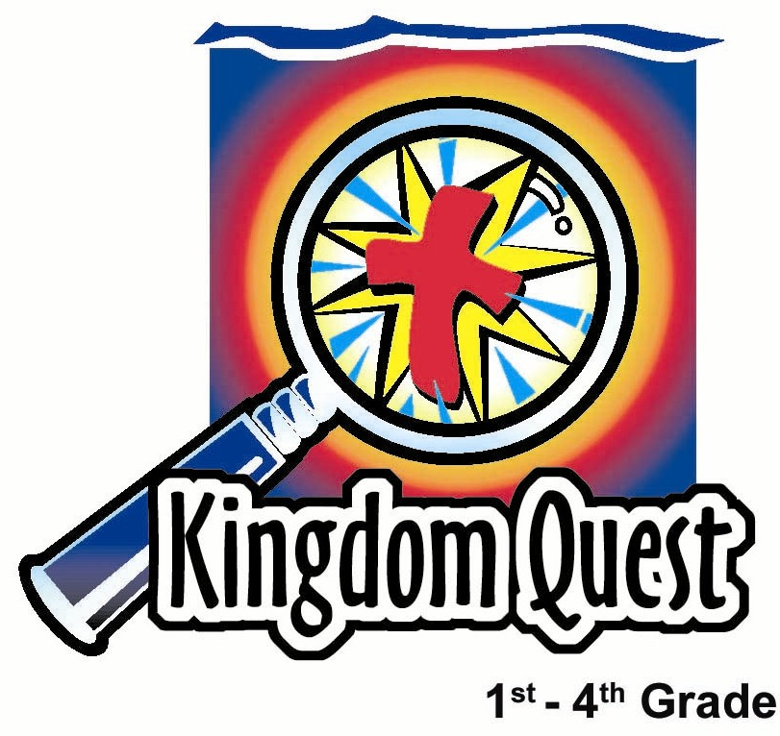
Date: __________________________
Series: Lookin’ for a Leader
Summer Year 3, Lesson 5

The Ark is Captured and Returned

Take Home Point: *God leads us; pay attention to Him!
*Repeat this phrase throughout the lesson.

Bible Event: 1 Samuel 4 through 7
Key Verse: Psalm 31:3b, “For the good of Your name, lead me and guide me.”

We will help kids know:
- The Bible event of how the ark of God was captured and then returned.
- God leads us, but sometimes we do not pay attention and do not follow His leading. Instead, we do things our way and try to get God to make things happen the way we want.
- He is the true and only God.
- We don’t have faith in mere religious objects. We have faith in God.

We will help kids feel:
- Amazement at the Bible event of how God was active in His people’s lives.
- Confident that, because we have a relationship with Jesus, we can follow God daily.

We will help kids do:
- Identify objects that might be wrongly used as a focus for faith.
- Identify and pray about one area in which God can lead them.

THIS LESSON’S ROADMAP

DESTINATION | PAGE # | DISCOVERIES ON YOUR JOURNEY | SUPPLIES NEEDED
Small Group Warm-Up   | 3 | Who is your leader? Play a game where the group has to follow a leader and a child has to guess who the leader is. Is it right to be our own leader, or should we follow God? | - no supplies are needed
Large Group   | 4  9  9  11 | Overview  Pesta Game: “Rolling Bowling Ball”  Puppet Presentation: “Dao Dao and His Good Luck Charm  Bible Event Presentation: “The Ark Is Captured and Returned” | - “The Rolling Bowling Ball” carnival or a small bowling ball set  - Dao Dao with a “magic” cross around his neck  - religious statues, pictures, or jewelry  - model of the ark of God  - golden rats  - golden tumors
Small Group Application   | 5 | The children will make a paper trick that will reveal a cross. Jesus showed us the way to God by dying on the cross. Jesus comes to us to show us how to follow God (and not ourselves).  Memory Verse Learning:  “Make Your Choice”  Psalm 118:8 will be the memory verse for lessons 5-7 to encourage the children to have security in God’s leadership over their lives. | - 8 ½ x 11-inch paper for everyone in the group  - scissors  - pencils  - markers or crayon  - four sets of arrow flash cards

Small Group Warm-Up: 15 minutes
Purpose: Get pointed in the right direction! Build relationships and help guests feel at ease. Do the learning readiness activity that will point your group in the right direction for the lesson.

Supplies needed: no supplies are needed

“Who’s the Leader?”
The object of the game is for one child, the guesser, to identify in three attempts the secret leader of the group. The job of the secret leader is to lead the group in doing some type of body action. The group follows the action of the leader as he changes from action to action. The trick is for the leader to do the action in a subtle way that makes it hard for the guesser to detect.

Pick a guesser who will leave the group after which the secret leader is chosen. When the secret leader is chosen, explain to the kids in the group to keep their eyes moving around the group and not stare at the leader. This will make it harder for the guesser to identify the leader.

The guesser returns to the group and stands in the middle. The secret leader tries three actions, attempting not to be identified by the guesser. The actions could be activities like tapping a foot, scratching one’s head, or holding one’s arm straight out. The more subtle the motion, the harder it will be to detect who the leader is. As the entire group mimics the activity the leader is doing, the guesser tries to identify the leader. The guesser gets three tries. Pick two more children to be the guesser and secret leader as the game repeats.

After the game has been played several times, offer the following questions:

Think of a person who leads you to make smart choices and do the right things. Who is that person?

What happens when you do something you know is wrong? Who do you think is your leader then? (Someone who was a bad influence.)

Have you ever thought of God as your leader? When you do what God wants, it means He is your leader.

Sometimes it might be hard to recognize who the leader is, just like it was hard to recognize the leader in this game. When we try to lead our own lives and don’t think about what God wants, we are trying to be the leaders instead of letting God lead us. If we follow someone who leads us to do things God does not want, we are following the wrong leader. Can you think of some wrong choices a kid might make? Discuss.

If we do whatever we want and make wrong choices, what do you think God would say? (Allow time for discussion.) What right choices might God want us to make?

If we think God would go along with us when we are doing something wrong, then that would be like thinking God would follow us. We would be trying to lead God. That is not the way God works. He knows what’s best for us and wants us to follow Him. *God leads us; pay attention to Him.

Large Group: 20-30 minutes
Purpose: Help kids observe what the Bible says. Present the Bible event in creative fashion. Help kids begin to interpret what it means.

Supplies needed: “The Rolling Bowling Ball” carnival or a small bowling ball set; Dao Dao with a “magic” cross around his neck; religious statues, pictures, or jewelry; model of the ark of God; golden rats; golden tumors

Overview

Carnival Game: “The Rolling Bowling Ball” – This is a difficult or almost impossible carnival game. The object of the contest is to roll the ball hard enough over the hump to stay in the valley but not so hard that it comes back over the hump.

Puppet Presentation: “Dao Dao and His Good Luck Charm” – During the carnival game, Dao Dao acts as the assistant. Dao Dao will offer a good luck charm to the contestant so she might accomplish the task.

Bible Event Presentation: “The Ark Is Captured and Returned” – After the contest, the announcer will give a story presentation of how the Israelites used the ark as a “sure bet” for military victory. They were using the ark almost like a good luck charm without truly seeking the Lord’s guidance in their lives. The results were devastating. However, when they did seek the Lord in prayer and repentance, God showed His power in victory.

Small Group Application: 20-25 minutes
Purpose: Help kids map out the meaning of the Bible event in their lives. Use the questions to stimulate discussion but don't feel tied to them. Allow the Holy Spirit to guide you. Include personal examples from your own faith journey. The example of Christ at work in your life will leave lasting impressions of how Christ can work in the children's lives.

Use your Bibles! Children need to learn how to look up references and follow along when scripture is read aloud. Allow for quality time of prayer at the close of the lesson.

Observation Questions: What happened?
Review the Bible event by asking the children some of the following questions.

When the Philistines won the battle, what did the Israelites think would help them? (1 Samuel 4:3. The ark of God as a secret weapon.)

What did the presence of the ark of God mean to the people? (1 Samuel 4:3. The presence of God was with them.)

What happened when they used the ark as a good luck charm? (1 Samuel 4:10-11. Because the Israelites took matters into their own hands and it was not God’s idea to have the ark present, the Philistines defeated Israel.)

What happened to Eli’s two sons? (1 Samuel 4:11. They were killed in battle.)

What happened to Eli? (1 Samuel 4:17-18. He was sad the ark had left Israel, the battle was lost, and his sons had died. He fell over and died, too.)

What happened to the temple of Dagon when the ark was placed there? (1 Samuel 5:1-4. The statue fell over and its head and hands broke.)

What happened to the people in the Philistine cities where the ark was kept? (1 Samuel 5:6-12. The people broke out with tumors and many died.)

How did the ark come back to Israel? (1 Samuel 6:10-12. It was placed on a cart and two cows pulled it to where the Israelites lived.)

How did the people of Israel finally follow God’s lead? (1 Samuel 7:1-6. They prayed for forgiveness and threw away their idols.)

What happened the next time the Philistine army attacked? (1 Samuel 7:7-11. God sent a thunderstorm and drove the Philistines away.)

Interpretation Questions: What does this mean?
What do you think the breaking apart of the statue of the god in the temple of Dagon signifies? (God is more powerful than any other god.)

Where did the power come from to make these things happen? Was it the ark or something or someone else? (It was the power of God.)

What is our main point for today? (*God leads us; pay attention to Him!)

Application Questions: What does this mean to me?
Supplies needed: 8 ½ x 11-inch paper for everyone in the group; scissors; pencils;

markers or crayon

Show the children the following paper trick. (It would be good to practice it once beforehand.)


Take an 8 ½ x 11-inch paper and fold it to two inches from the bottom.

Fold the paper in half with the “short” side on the inside.

With the “short” end at the inside bottom, fold the top corners to the centerfold. This will create a point.
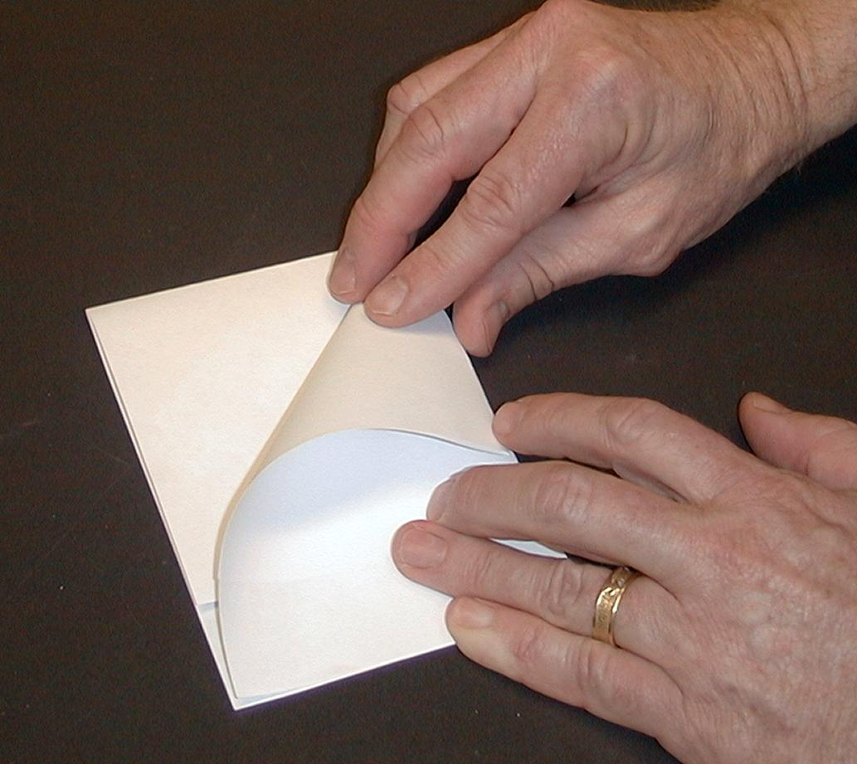




Unfold the paper at the centerfold, keeping the point together. Fold on the centerline so that the short side is now facing out.


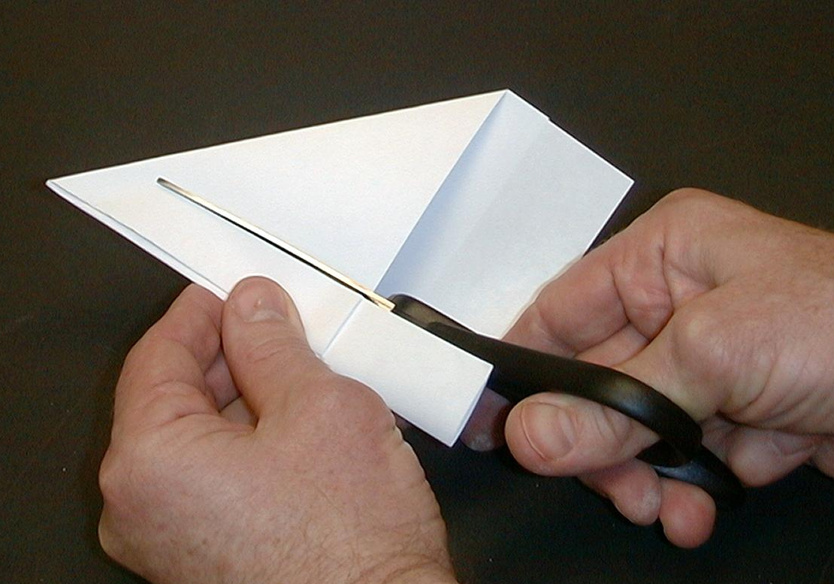
Use a scissors to cut approximately one inch from the folded edge. Cut until you are one-half inch from the top.

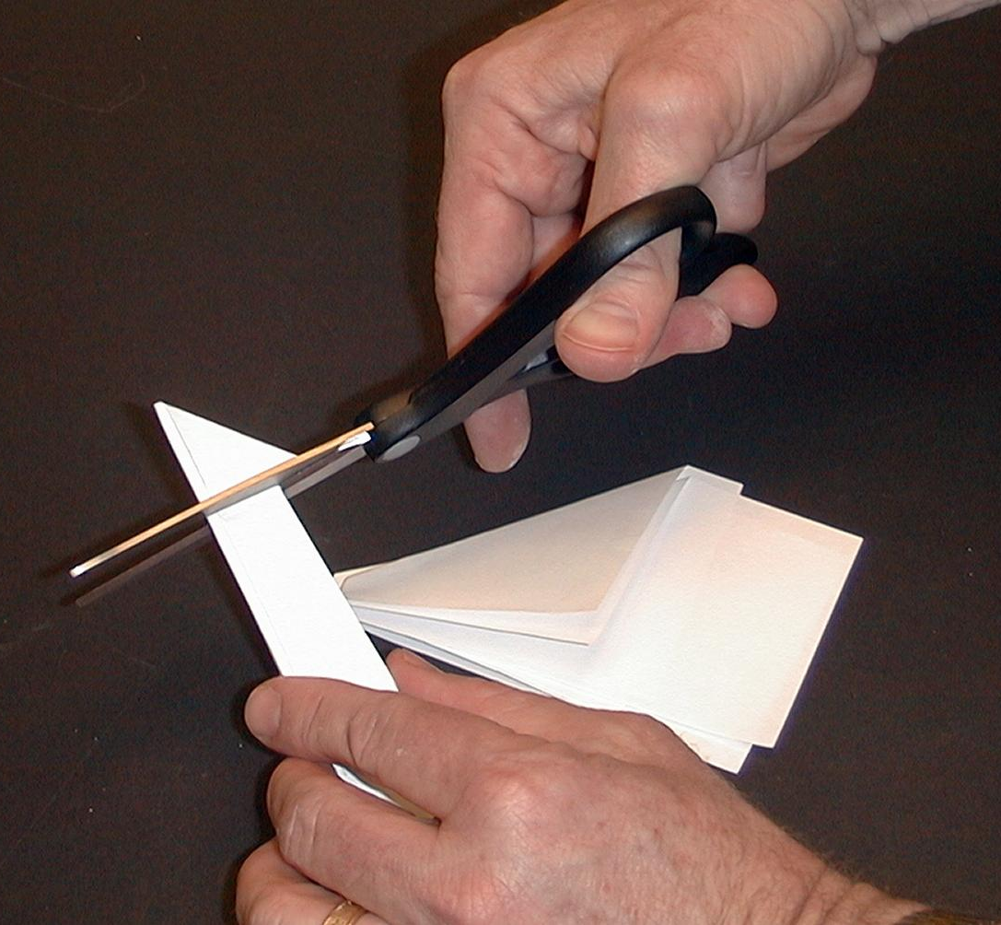

Next, cut from the “winged” edge to the cut made in the previous step. This will make the point of the arrow.



Unfold the paper only at the middle fold and show the children the arrow you just cut.

Sometimes I have important decisions to make, and I want God to follow along and do just what I want Him to do. But what I want may not be what is best for me. Instead, I need to seek what God wants and follow him. *God leads us; pay attention to Him!

Have the arrow point in one direction to yourself and in the other direction up to God.

Which way does it point? This arrow reminds us of the different directions we can follow. Are we only going to follow our own ways or are we going to follow God’s ways?

Now unfold the arrow to reveal a cross.

Jesus showed us the way to God. He made a way by giving His life for us. When He died on the cross, He paid the punishment for our sins. When He rose again, He said that He is alive and will be with anyone who follows Him. By His Holy Spirit, Jesus comes to us to show us how to follow God and not ourselves.

Discuss with the children ways they may follow the wrong people instead of God or ways people depend on good luck charms instead of God.

Next, the children can decorate their crosses with the Bible verse, “Lead me and guide me” (Psalm 31:3). Have the children take the crosses with them, not as good luck charms but as reminders. Just as the arrow points to God and turns into a cross, so it is in Jesus that we can follow Him.

Today we learned that *God leads us; we need to pay attention to Him.

Memory Verse Learning: 5 minutes
Purpose: Help kids to memorize and keep scriptures at heart. Using creative ways to help kids enjoy learning the key verse and in small group setting.

Supplies needed: four sets of arrow flash cards

Memory Verse: Psalm 118:8, “It is better to trust the Lord than to trust people.”

Memory Verse Presentation: “Make Your Choice”

It is better
to
trust
Psalm 118:8
the Lord
than
to
trust people.

Use the flash cards to teach the memory verse. Then play “Make Your Choice.” Mix the four sets of arrow cards and randomly lay it before the children who are sitting in a circle. Explain to the children that the aim of the game is to get all six cards of the memory verse as an individual. To get a turn to make a guess, one has to recite the verse before making a choice. If one already has the card, you have to leave that choice card where it is. Keep going until the first person wins.

Prayer Time:
Thank God that He sent Jesus to pay for the punishment of our sins, for the times we choose to follow our own wants or others. Thank Him for sending the Holy Spirit so that Jesus can come to us so we can follow Him. Ask God, by the power of the Holy Spirit, to lead us in all that we do.
Safety and Security: Safety and security procedures are important for each church to carefully define and implement according to their unique needs. The security, safety, illness and accident procedures described in this curriculum are provided for example purposes only and may not be appropriate, applicable or adequate for every situation. Each church is responsible for determining whether any security, safety, illness and accident procedures contained in the curriculum are appropriate, applicable or adequate for its unique situation. The activities described in this curriculum require adult supervision and may not be suitable for each child and each situation. Each church is responsible for ensuring that adequate adult supervision is provided for all activities and for determining whether an activity is appropriate for each child and each situation. Kids Kount Publishing disclaims all liability for the implementation of any procedures or the performance of any activities described in this curriculum.
Large Group Presentation

Pesta Game
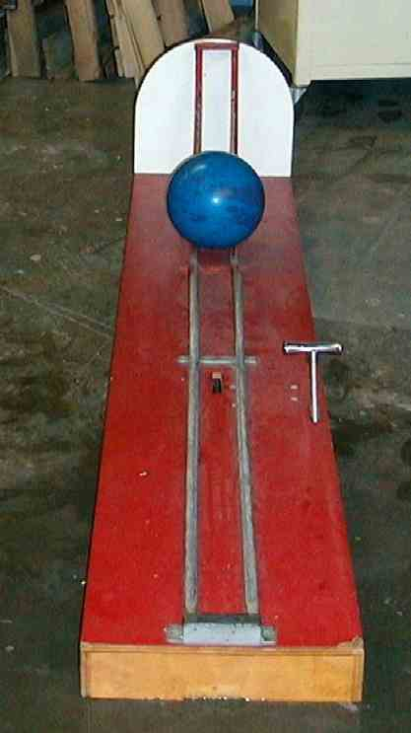
Use a difficult or almost impossible carnival game. For example, one church used “The Rolling Bowling Ball” as seen below. The object of the contest is to roll the ball hard enough over the hump to stay in the valley but not so hard that it comes back over the hump. Other game suggestions might be tossing soft balls into baskets that are at a steep pitch. Or, try to toss small rings onto the tops of bottles.

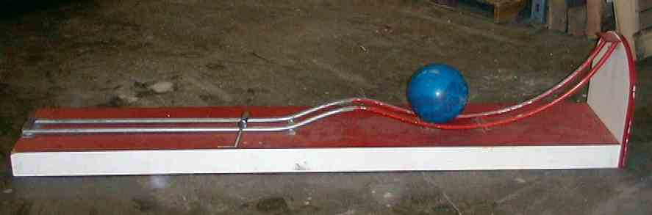

Dao Dao and His Good Luck Charm

Puppet Presentation

(As the announcer calls a contestant up and explains the rules of the pesta game, Dao Dao interacts. As the contestant tries the event, Dao Dao offers his help by suggesting the use of a “magic” cross. At that point, the following dialogue picks up.)

Dao Dao: Wait a minute! Wait a minute! Teacher, stop the show!

Teacher: What is it, Dao Dao?

Dao Dao: Our friend needs something extra to be able to win.

Teacher: What is that?

Dao Dao: Can’t you see? It’s obvious. He needs a “magic” cross.

Teacher: That’s obvious?

Dao Dao: Sure! Look around my neck. I have a magic cross. If you just hold this cross in your hand and wish really hard, whatever you want will come true.

Teacher: You mean God will do whatever you want?

Dao Dao: Sure! That’s why it’s a magic cross. (To the contestant.) Hey, kid, it can be yours for only $9.95.

Teacher: You mean he has to pay $9.95 for a magic cross?

Dao Dao: Yeah, but then he’ll win the carnival game. Let me take it off and give it to you. You’ll see.

Teacher: I don’t know. Boys and girls, do you think we ought to let him try?

(Teacher lets the child try the game while holding the magic cross.)

Teacher: Boys and girls, do you think the magic cross really helped?

(Kids answer, “No.”)

Dao Dao: Well, I think it did!

Teacher: Dao Dao, I don’t think it did.

Dao Dao: Wait a minute. I have some religious things he can use. (Shows objects like saint statues, pictures, or religious jewelry.)

Teacher: I don’t think those will help either. What do you think, boys and girls?

(Kids answer, “No.”)

Dao Dao: Why not?

Teacher: Because those things don’t have magical power. Those things might remind us of God, but the power to do things comes from God.

Dao Dao: How do we get God to do what we want Him to?

Teacher: That’s just the point, Dao Dao. God wants to lead us. We need to pay attention to what He wants, not just try to get Him to do what we want.

Dao Dao: I don’t know if I understand.

Teacher: Let’s ask our contestant to sit down. Then I’ll tell you about a Bible event that actually happened. It is about how God leads us and we don’t lead God.

The Ark Is Captured and Returned

Bible Event Presentation

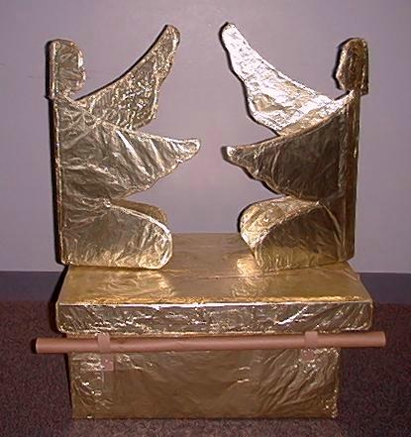
(Teacher opens his Bible to read from the following script. Objects that are useful in telling the story are a model of the Ark of the Covenant, golden rats, and golden tumors.)

Teacher: Today’s Bible event happens in the book of 1 Samuel, chapter four. Do you remember who Samuel was?

Dao Dao: Of course! He was a little boy who grew up in the temple.

Teacher: Right. And now I am reading here about when he has grown up and is a prophet and a priest. But still there is the old priest, Eli.

Dao Dao: Yeah, that was the guy who took care of Samuel. He was a good guy, wasn’t he?

Teacher: Yes, but he made a terrible mistake. He never disciplined his own sons. So when they grew up, they didn’t honor God at all. Even though they were priests and were supposed to lead God’s people in God’s ways, they actually worshiped other gods and did whatever they wanted.

Dao Dao: Wow! That will get them in trouble. So what happened?

Teacher: The Israelites were at war with the Philistines.

Dao Dao: Who’s winning the war?

Teacher: The Philistines just killed 4,000 Israelites and won a big battle.

Dao Dao: Bummer, dude!

Teacher: So all the Israelites got together to make a plan.

Dao Dao: Yeah, they went to get a big tank!

Teacher: No, they didn’t have tanks then. They went to get the Ark of the Covenant.

Dao Dao: Is that like a tank?

Teacher: (Points to the Ark of the Covenant.) The Ark of the Covenant reminded the people that the Lord God Almighty was their God and He was with them. They had carried the Ark of the Covenant into battle before when God had been directing them. But was God directing them to carry it into battle now?

Dao Dao: I don’t know. Was He?

Teacher: No, He wasn’t. Eli’s two wicked sons never prayed to God to find out what God wanted them to do. Instead, they were making up their own plan. They thought they could use the Ark of the Covenant like a good luck charm, and it would help them win the battle.

Dao Dao: Did it work?

Teacher: Kids, what do you think? Right, it did not work. God did not want them to use this symbol as a good luck charm. Instead, He wanted them to trust and follow Him.

Dao Dao: So what happened?

Teacher: The Israelites were defeated.

Dao Dao: Bummer!

Teacher: Eli’s sons were killed.

Dao Dao: Well, they probably had it coming.

Teacher: And the Ark of the Covenant was captured.

Dao Dao: Oh, no! That’s really bad news.

Teacher: It was bad news. As a matter of fact, when the news of all the bad things got back to poor, old, blind Eli, he fell back in his chair, broke his neck, and died.

Dao Dao: This story is depressing. With the Ark gone, did that mean God was no longer with His people?

Teacher: Some people thought that. They were afraid and discouraged, but God had other plans.

Dao Dao: Great! Bring in the tank!

Teacher: No, God has His own power. This is what happened:

The Philistines carried the Ark from the battlefield to their capital city and they placed it in the temple of Dagon, the fish god. The very next morning the worshipers went to the temple, and do you know what they found?

Dao Dao: Dead fish?

Teacher: No. The statue of Dagon had fallen over and was lying face down before the Ark. The Philistines set it back up. But do you know what they found the next morning?

Dao Dao: Dead fish.

Teacher: No, the idol had fallen over again. This time its head had broken off.

Dao Dao: Wow! I think God was trying to make a point.

Teacher: He sure was. He was telling everyone He was the true God. All other false gods were powerless before Him.

Dao Dao: And he didn’t even need a tank.

Teacher: More than that! Soon all the people in the city broke out in painful sores. They had huge, terrible tumors growing on their sick skin.

Dao Dao: Ouch!

Teacher: The people said, “Let’s not keep the Ark of the Lord any longer!” They sent it to the city of Gath.

Dao Dao: What happened there?

Teacher: The same thing. People in that city became covered with tumors and began to die.

Dao Dao: I’d really get rid of that thing if I were them.

Teacher: That’s what they thought, too, and so they sent the Ark to another city. Guess what happened there.

Dao Dao: More tumors and more people died?

Teacher: Right.

Dao Dao: Oh, God’s getting them good. So how did they get rid of the Ark?

Teacher They built a cart and put the Ark on it. Then they found two cows that had just given birth to baby calves to pull the cart. Cows who just have calves will not leave their babies. Normally, these cows would not have pulled the cart away at all. But when they turned the cows loose, guess what happened.

Dao Dao: They started pulling the cart.

Teacher: That’s right. They went in the opposite direction and started pulling the cart straight back to Israel.

Dao Dao: Awesome!

Teacher: Everyone knew God was powerful and was making the cows take the Ark of the Covenant back to His people.

Dao Dao: So the Philistines just let it go?

Teacher: Not only that, they put a special offering on the cart. They put five gold tumors and five gold mice on the cart to represent the Philistine rulers who suffered from the plague.

Dao Dao: That’s cool.

Teacher: It sure was. There were those cows taking the Ark of the Covenant with the gold tumors and mice back to Israel. Do you know what they said?

Dao Dao: “Moo! Moo! Moo-ve over! I’m coming through!”

Teacher: Not what the cows said. What everyone from Israel said. They knew God was the true God. They learned that the Ark of the Covenant was not a religious good luck charm. They were to follow God and not try to get God to follow them.

Dao Dao: Did they follow God?

Teacher: Sure they did. Their priest, Samuel, told everyone to throw away any false idols and follow God alone.

Dao Dao: And that’s what they did?

Teacher: They sure did.

Dao Dao: And they lived happily ever after and the Philistines never bothered them again, right?

Teacher: Not quite.

Dao Dao: You mean this is not the end of the story?

Teacher: Well, there is one last thing. The Philistines did bother the Israelites. They attacked them when the Israelites were gathered at a special place to thank God for bringing the Ark of the Covenant back to them. The only problem was the Israelites didn’t have any weapons and the Philistines came with all their armor, spears, and swords.

Dao Dao: Wow! Now they really needed a tank.

Teacher: No, they just needed God, and He was there for them. God sent a terrible thunderstorm. The Philistines became so frightened and confused that they dropped their weapons and ran away. Now everyone knew for sure that God was the true God and that they should follow Him.

Cool story, huh, Dao Dao?

Dao Dao: It sure is! I guess I need to get rid of this cross.

Teacher: You don’t need to get rid of the cross. You just can’t use it as a good luck charm. But it can help remind you of how God leads you.

Dao Dao: How is that?

Teacher: God gave us Jesus, His Son, to die on the cross. Because of Jesus, we can be forgiven and follow God in whatever He wants. He can lead us.

Dao Dao: I trust Jesus and He’s a great leader to follow.

Teacher: Great. Then let’s talk to our great leader.

Dear God, thank You for Jesus and how You lead us. Please help us pay attention and follow You so we don’t do stupid things like using religious good luck charms or following our own ways. Help us have victories by trusting You. In Jesus’ name. Amen.

Lesson 5

Small Group Wrap-Up
- no supplies are needed

Large Group Presentation
- “The Rolling Bowling Ball” carnival or a small bowling ball set
- Dao Dao with a “magic” cross around his neck
- religious statues, pictures, or jewelry
- model of the ark of God
- golden rats
- golden tumors

Small Group Application
- 8 ½ x 11-inch paper for everyone in the group
- scissors
- pencils
- markers or crayon

Memory Verse Learning
- four sets of arrow flash cards (see diagram below)

It is better
to
trust
Psalm 118:8
the Lord
than
to
trust people.

