
Date: _________________________
Series: Lookin’ for a Leader
Summer Year 3, Lesson 6

Israel Asks for a King

Take Home Point: *Follow God instead of following the crowd.
*Repeat this phrase throughout the lesson.

Bible Event: 1 Samuel 8 through 11: Israel asks for a king and God gives them Saul.
Key Verse: Psalm 118:8 (NCV), “It is better to trust the Lord than to trust people.”

We will help kids know:
- The Bible event of Israel asking for a king to be like other nations with kings.
- God appointed Saul as king but promised consequences.
- God still worked victory for His people, though they had sinned.
- Jesus comes as our ultimate King to rescue us.

We will help kids feel:
- Security in God’s leadership over their lives.
- Amazement at how God worked in the lives of His people in Israel.

We will help kids do:
- Identify ways they have gone along with the crowd.
- Identify ways to help others know God’s love for them.

THIS LESSON’S ROADMAP

DESTINATION | PAGE # | DISCOVERIES ON YOUR JOURNEY | SUPPLIES NEEDED
Small Group Warm-Up   | 3 | Have you ever made fun of someone or the way he looks just because everyone else was? Make some crazy teeth out of orange rinds and talk about how crazy it is for everyone to go along with the crowd when the crowd is doing something wrong. | - oranges cut into fourths or eighths (with peel remaining). Each child should have two slices. (Small oranges with thin, tough skins work best.)  - plastic knife with a serrated edge for each child
Large Group   | 4  7  9  12 | Overview  Pesta Game with Puppet Presentation: “Dao Dao Sees the Future”  Bible Event: “A Visit from Samuel”  Puppet Presentation: “Dao Dao Sees the Future” Conclusion | - Dao Dao with a mystical outfit and a turban around his head  - deck of playing cards  - Samuel costume with beard and walking cane  - Saul costume (optional)  - person offstage to read the part of God
Small Group Application   | 4 | Sometimes we might do something wrong just to please the crowd. Instead, we should do what God wants. He smiles over us because we are His children and we follow him. Have the children discuss things they can do this week to follow God.  Memory Verse Learning:  “Fish the Right Arrow”  Psalm 118:8 will be the memory verse for lessons 5-7 to encourage the children to have security in God’s leadership over their lives. | - orange for each group  - hand wipes  - For each team –  - a chair  - masking tape  - a fishing rod with magnet as hook  - one set of arrow flash cards from lesson 5

Small Group Warm-Up: 15 minutes
Purpose: Get pointed in the right direction! Build relationships and help guests feel at ease. Do the learning readiness activity that will point your group in the right direction for the lesson.

Supplies needed: oranges cut into fourths or eighths (with peel remaining). Each child should have two slices. (Small oranges with thin, tough skins work best.); plastic knife with a serrated edge for each child

“Crazy Teeth”
You will need two orange slices and a plastic knife for every child. To begin the activity, ask the following questions.

When did you do something just to be like everyone else? Have you ever done something wrong because everyone else was doing it?

While the kids are discussing this, pass out oranges slices that are cut into fourths leaving the peel. (Smaller pieces like eighths might work better depending on the size of the orange.) Ask another discussion question.

Have you ever made fun of someone and the way that person looks because other people were making fun of him?
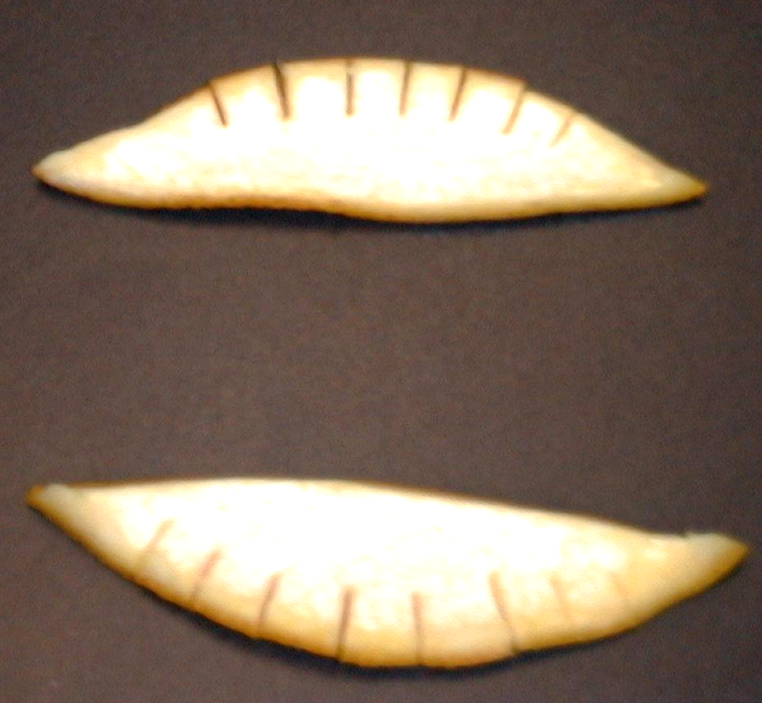
Discuss briefly as you make crazy teeth with your orange slice. Using a plastic knife with a serrated edge cut, half-inch slits into one edge of an orange peel about the width of large teeth.


Bend the orange peel in the opposite direction it is normally curved. Put the rind in the upper section of your mouth between your lips and gums. These new and somewhat white teeth should be visible and look quite ridiculous. If you stick your tongue out through the teeth, it looks even more real and crazy!

After kids have eaten their oranges, help them make their own crazy teeth. As they are doing so, talk about how crazy it is for everyone to go along with the crowd when the crowd is doing something wrong. For example:

Do you follow the crowd and make fun of the way a person looks because everyone else is doing it?

Continue by saying:

In today’s Bible event, we will find out how God’s people, the children of Israel, wanted to go along with all the other heathen nations. All those other nations had kings that ruled over them. Israel thought that if they could get a king, their king would make sure they would win battles. The king would help them stay together as a nation, too. The problem was that God was already their King.

By saying they wanted another king, they were saying no to God. There would be consequences for this. Today we will learn to *follow God instead of following the crowd.

Large Group: 20-30 minutes
Purpose: Help kids observe what the Bible says. Present the Bible event in creative fashion. Help kids begin to interpret what it means.

Supplies needed: Dao Dao with a mystical outfit and a turban around his head; deck of playing cards; Samuel costume with beard and walking cane;
Saul costume (optional); person offstage to read the part of God

Overview

Carnival Game with Puppet Presentation: “Dao Dao Sees the Future” – Dao Dao pretends to be a fortune-teller. (Of course, we will teach that fortune-telling is wrong and we should not do it.)

Bible Event: “A Visit from Samuel” – God’s prophets were able to see the future. Samuel, God’s prophet, tells how God gave Israel its first king.

Puppet Presentation: “Dao Dao Sees the Future” Conclusion

Small Group Application: 20-25 minutes
Purpose: Help kids map out the meaning of the Bible event in their lives. Use the questions to stimulate discussion but don't feel tied to them. Allow the Holy Spirit to guide you. Include personal examples from your own faith journey. The example of Christ at work in your life will leave lasting impressions of how Christ can work in the children's lives.

Use your Bibles! Children need to learn how to look up references and follow along when scripture is read aloud. Allow for quality time of prayer at the close of the lesson.

Observation Questions: What happened?
What was wrong with the people of Israel asking for a king? (They were rejecting God as their King and they wanted to be like the other nations around them who did not follow the true God.)

What happened when God gave them what they wanted? (They got a king, but also the consequences of having a king.)

What were the consequences of having a king? (1 Samuel 8:10-18. As we will find out later, some kings were very mean to their people. They took a lot of the people’s money and forced them to go to war. Some kings even led their people away from God.)

Do you think there would be any good kings after Saul? (Yes. David would be a good king. He was a shepherd and wanted to lead the people in the ways God wanted.)

Interpretation Questions: What does this mean?
Why do you think God let the people of Israel have their way? (He wanted to teach them a lesson.)

How did God use this situation to teach the Israelites a lesson? (He showed them there were consequences for not following Him. God knows what is best.)

How did God work victory for His people even though they had sinned? (1 Samuel 11. Saul led them to defeat the Ammonites.)

Application Questions: What does this mean to me?
What are some ways we are like the people of Israel who wanted to have a king just because all the other nations had a king? For example, do we ever want to have something we shouldn’t just because other people have it?

Do we ever want to do something just because others are doing it? Give examples. (Making fun of others, cheating, using bad words, using God’s name in vain, etc.)

How does God use situations in our lives for the good? (Give examples from your own life.)

Sometimes we want our own way, even though our parents know what is best for us. Sometimes they might let us have what we want so we learn a lesson. For example, we may not want to wear a coat when it’s cold outside, and our parents may let us get cold. Or we may not want to do our homework, so we go to school with it not finished and have to stay in at recess to do it. Even when we make mistakes, our parents still love us and try to help us work out things so they aren’t all bad.

How has God shown you that He loves you no matter what? (While we were still sinners, Christ died for us. In forgiveness, we can have another chance. Because of forgiveness, we can serve Jesus as our King. Emphasize the fact that God loves us no matter what we do. Even the biggest mistakes we make in our lives are not too awful for God to work out for us.)

Application Activity:
Supplies needed: orange for each group; hand wipes

For a final application point, peel an orange and give a section of orange to each child. Have them turn the ends of the orange section in such a way that it is shaped like a smile.

This orange section turned up looks like a smile. Sometimes we might do something wrong just to please the crowd, to make them smile. Instead, we should do what God wants. He smiles over us because we are His children and we follow Him. Think of one thing you will do this week to follow God.

Let kids share if they want to.

Today we learned it is better to *follow God instead of following the crowd. Our key Bible verse, Psalm 118:8 says, “It is better to trust the Lord than to trust people.”

Have the children repeat the verse a few times. Emphasize to the children that as they show God’s love to others, it shows that Jesus is the King of their lives.

Memory Verse Learning: 5 minutes
Purpose: Help kids to memorize and keep scriptures at heart. Using creative ways to help kids enjoy learning the key verse and in small group setting.

Supplies needed: For each team - a chair; masking tape; a fishing rod with magnet as hook; one set of arrow flash cards from lesson 5

Memory Verse: Psalm 118:8, “It is better to trust the Lord than to trust people.”

Memory Verse Presentation: “Fish the Right Arrow”
Before class, tape a starting line. At the opposite end about 12 feet away, put the chair and before it tape a square that is 3’X3’. Lay the set of arrow flash cards randomly within the square, words facing upwards. During the class, divide the children into two teams. Explain to the teams that the challenge is to get all the arrows to the team side at their fastest timing but in the correct memory verse order. Each member takes the fishing rod and run to stand on the chair. There he/she is to fish up the correct arrow, runs and give to the shepherd. When the shepherd indicates that it is the right one, he/she quickly runs and tag the next person. The first team to complete the verse wins.

Prayer Time:

Pray for specific ways this week that you can show Jesus’ love to others and bring a smile to their lives.
Safety and Security: Safety and security procedures are important for each church to carefully define and implement according to their unique needs. The security, safety, illness and accident procedures described in this curriculum are provided for example purposes only and may not be appropriate, applicable or adequate for every situation. Each church is responsible for determining whether any security, safety, illness and accident procedures contained in the curriculum are appropriate, applicable or adequate for its unique situation. The activities described in this curriculum require adult supervision and may not be suitable for each child and each situation. Each church is responsible for ensuring that adequate adult supervision is provided for all activities and for determining whether an activity is appropriate for each child and each situation. Kids Kount Publishing disclaims all liability for the implementation of any procedures or the performance of any activities described in this curriculum.
Large Group Presentation

Dao Dao Sees the Future

Puppet Presentation

(Dao Dao appears on the puppet stage with a mystical outfit and turban around his head. A regular deck of playing cards should be laying on the puppet stage.)

Teacher: Welcome, boys and girls, to Sunday school Pesta! Today we have another exciting booth for you.

Dao Dao: Wait a minute! I have an exciting booth for you!

Teacher: You do? What is that?

Dao Dao: I’m a fortune-teller.

Teacher: There is no such thing.

Dao Dao: Sure there is. I am one. Do you want to see?

Teacher: I don’t know, Dao Dao…

Dao Dao: Come on. I’ll show you how it works. Pick a card, any card.

(Teacher picks a card and holds it up for all to see.)

Dao Dao: Hmm… It says here that you are going to be the Raja of Malaysia someday.

Teacher: Oh! That’s a pretty good future. But I still don’t believe in fortune- telling.

Dao Dao: Wait a minute. I think I was reading that wrong. It was upside down. (Dao Dao turns the card the other direction.) Oh, here it is! (Heckling.) You will be a raja —Raja of the Donkey Club.

Teacher: The Donkey Club? I don’t know about that. But I do know that in today’s Bible event there was a future king who went out calling donkeys.

Dao Dao: Maybe that’s you!

Teacher: No, Dao Dao, it already happened. I’m talking about King Saul. And the only ones who could tell the future were God’s prophets.

Dao Dao: Well, let me take another try with a new contestant.

(A girl is chosen from the audience and draws a card from Dao Dao’s deck.)

Dao Dao: I can see in the future that you will have a boyfriend! Ooh!

Teacher: Can you see anything else?

Dao Dao: Yes. He’s very tall. Ooh!

Teacher: Is there anything else?

Dao Dao: Yes. You’ll find him hiding in a pile of suitcases.

Teacher: What?

Dao Dao: A pile of suitcases!

Teacher: Dao Dao, you must have been reading your Bible because something like that happens in our Bible event today. King Saul was tall and handsome. When it was time to be selected as king, he was hiding among all the bags that people used for their trips. I don’t think you can read the future. You’re just telling about today’s Bible event that happened thousands of years ago.

Dao Dao: Let me try one more.

(A boy comes up and draws a card.)

Dao Dao: I can see that you are going to be a big winner.

Teacher: He’s already a winner if he knows and trusts Jesus.

Dao Dao: No! A big winner in the World Series!

Teacher: I don’t know about that, but maybe it will happen. It is true in today’s Bible event that King Saul was a big winner in an important contest.

Dao Dao: A contest bigger than the World Series?

Teacher: Yes! In fact, he was a big winner in a battle against the Ammonites.

Dao Dao: Cool! Well, it was like I said.

Teacher: Like I said. Today we don’t listen to fortune-tellers. We know Satan often uses their messages. God had prophets that He had shown the future to.

Dao Dao: Yeah, well, I would like to meet one.

Teacher: Okay, you can! Today I would like to introduce you to the prophet Samuel. He will tell you the story of how the people of Israel insisted on having a king and they got one in a man named Saul.

A Visit from Samuel
Bible Event

The following script is a first person narration of Samuel from 1 Samuel 8-11.The actor for the Samuel character should be thoroughly acquainted with the Bible reading itself and delivers it in animated fashion. Costuming for Samuel can be a typical Old Testament period costume with beard and walking cane. Also needed is someone offstage narrating God’s voice.

Optional: This script can be placed inside of a Bible so that the actor can refer to the script as he tells his part. The opening paragraph sets up the situation in which Samuel can read from the Bible.

Introduction
Samuel: I am Samuel and you have read about me in your Bible. As a matter of fact, I wrote about what God did with His people. Can I tell you my story right here from the Bible? I would like to tell you how the people of Israel came about getting a king.

Now I am 65 years old. I helped rule over Israel but I was not a king. I was a judge. If people had disagreements with one another, they could come to me and I would settle the matter fairly. I would always point the people to God, for He is their true King.

Now that I am old, the people wonder who will rule when I’m gone. Would it be my two sons? No, I’m afraid my sons have disappointed me. They are not honest and have cheated people out of money.

The people have said, “Give us a king!”

“A king?” I asked.

“Yes,” they said, “we want a king so we can be like other nations.”

“That will mean trouble,” I thought. God alone was their King and Ruler. They want to put their trust in an earthly ruler instead of trusting in God as their King. They probably wanted to be like other heathen nations who had kings.

“What shall I do, God? Shall I give them a king?” I asked. God told me…

God’s voice: “Listen to them.”

Samuel: …and I did. I told them that if they had a king, the king would treat them like the other heathen kings treated their people. He would take portions of their money and their land. He would make them serve in his army and take the best of all they had. Their king would even take more than what the Lord required of them to give to him in their tithes and offerings.

I told the people they were rebelling against the Lord. Still they said, “We want to be like the other nations. Give us a king!”

The Lord said to me…

God’s voice: “They have not rejected you, Samuel, but they have rejected Me. Give them a king.”

Samuel: So I did. This is how it happened.

Finding Saul
Samuel: I was in my hometown when God spoke to me and said…

God’s voice: “Tomorrow about this time a man from the tribe of Benjamin will come to you. He is the one I am choosing to be king.”

Samuel: Sure enough, the next day a man came looking for me. He thought I might be able to help him because he was looking for his father’s donkeys. Sometimes God showed me special things, and maybe God would show me where his donkeys were.

As soon as I met this man, I knew this was the one God had chosen to be king. His name was Saul, and I told him, “You will be king.”

He didn’t believe me because he didn’t think he was very important or that his family was important. But I spent time with him, had a feast with him, and anointed him with oil. I said, “You will be king for God has chosen you to be leader over His people.”

“This is what will happen in the future so you know I am telling you the truth. On your way home, some people will meet you and say your donkeys have been found and your father is worried about you. After that, you will meet some men who will give you two loaves of bread to eat. When you get to the town of Gibeah, you will meet a group of prophets making music and proclaiming the Lord’s will. The Spirit of the Lord will come on you and you will join them in proclaiming the Lord’s will. You will be a changed person. After this, you will know it is God who is for you.”

Do you think it happened that way? Could I tell the future? By myself I could not, but God showed me. It was true.

When Saul was back with his family, he did not tell anyone else that I had anointed him as king. Now I had to call all of the people of Israel together to show them who God had chosen as king. The people gathered before me at Mizpah.

Publicly Anointing Saul
Samuel: I spoke the word of the Lord to the Israelites. “God says…”

God’s voice: I brought you up out of Egypt and delivered you from Egypt and all the other kingdoms attacking you. But now you have rejected Me who saves you, and you said that you would rather have a king. I will appoint you a king but someday you will understand. You will not like having such a king.’”

Samuel: After I told them that, I chose one tribe out of twelve. It was Saul’s tribe, Benjamin. Then I chose one family out of all the families of Benjamin. That was the family of Saul.

Saul was not there, though. No one knew where to find him, so we asked the Lord. The Lord told me…

God’s voice: “He has hidden himself among the baggage.”

Samuel: We ran and brought Saul out. The people shouted, “Long live the king!”

Saul Rescues the City of Jabesh
Samuel: Next, God showed that He would bless a king who followed Him. There was an evil group called the Ammonites that went to one of our cities, Jabesh. They said they would attack our city and kill everyone unless the city surrendered. To show that the city would surrender and serve them, they wanted to poke out the right eye of people there and disgrace them. Yuck!

The city of Jabesh did not know if all the people of Israel would unite together and come to help them. They sent a messenger to Saul for help.

When Saul heard about this, he became very bold. He cut pieces of an ox apart and sent them to all the different tribes of Israel. He said, “If you don’t come and help our brothers in Jabesh, this will happen to you.”

The fear of the Lord came upon all of the people, and they all know what they had to do. They formed an army of three hundred thousand. They went to the city of Jabesh, and there they found the Ammonites ready to take over the city. The people attacked the Ammonites and drove them away.

The people then confirmed that Saul was king. They sacrificed offerings to the Lord and had a great celebration.

Now my time as judge over Israel is through. I wonder what kind of king Saul will turn out to be. Will he follow the Lord with his whole heart and lead the people to follow God as their King? We will find out in the future. I must leave now. Thank you for hearing my story. And please don’t forget: *Follow God instead of following the crowd.

Dao Dao Sees the Future

Puppet Presentation Conclusion

Dao Dao: Well Teacher, those people finally got their king so they could be like everyone else. But I don’t think God was too happy with them.

Teacher: Right. That was because God wanted to be their King.

Dao Dao: Is God your King, Teacher?

Teacher: Sure. That’s because I trust in God’s Son, Jesus, as my Savior.

Dao Dao: I do, too! That means that God is my King, too!

Teacher: Great! Because Jesus is your King, you can *follow God instead of following the crowd. Let’s talk to our King in prayer.

Dear God, thank You that You are our King. Thank You for sending Your Son, Jesus, who gave His life for us. Now please help us follow You instead of following the crowd.

Lesson 6

Small Group Wrap-Up
- oranges cut into fourths or eighths (with peel remaining). Each child should have two slices. (Small oranges with thin, tough skins work best.)
- plastic knife with a serrated edge for each child

Large Group Presentation
- Dao Dao with a mystical outfit and a turban around his head
- deck of playing cards
- Samuel costume with beard and walking cane
- Saul costume (optional)
- person offstage to read the part of God

Small Group Application
- orange for each group
- hand wipes

Memory Verse Learning
- For each team –
  - a chair
  - masking tape
  - a fishing rod with magnet as hook
  - one set of arrow flash cards from lesson 5 (Attach a paperclip at the end of the arrow.)

