
Date: __________________________
Series: Lookin’ for a Leader
Summer Year 3, Lesson 8

God Rejects Saul and Chooses David

Take Home Point: *God wants us to follow Him with our whole hearts.
*Repeat this phrase throughout the lesson.

Bible Event: 1 Samuel 15 and 16
Key Verse: 1 Samuel 16:7b, “People look at the outside of a person, but the LORD looks at the heart.”

We will help kids know:
- The Bible event of Saul’s disobedience and how God chose David, a man after His own heart.
- God looks into our hearts and wants us to follow Him with our whole hearts.
- For those who trust Jesus, God looks at their hearts and sees Jesus and His righteousness for them.

We will help kids feel:
- Secure that God can see our hearts and our sin, but He loves us anyway.
- Awe that God expects obedience.

We will help kids do:
- Make simple optical illusions in which it appears they are looking through hearts.
- Become more concerned about what God sees on the inside rather than what people see on the outside.
- To help share Jesus with people who do not have Him in their hearts.

THIS LESSON’S ROADMAP

DESTINATION | PAGE # | DISCOVERIES ON YOUR JOURNEY | SUPPLIES NEEDED
Small Group Warm-Up   | 3 | God looks right through people to their hearts. What is that like? Make an optical illusion to see! | - A4 paper for each child  - tape
Large Group   | 4  7  12  13 | Overview  Pesta Game with Puppet Presentation: “Who Is the King of Your Heart?”  Bible Event Presentation: “Samuel’s Account of the Anointing of King David”  Puppet Presentation: “Who Is the King of Your Heart?” Conclusion | - Dao Dao in a fortune-teller costume  - “The Original King of Hearts” trick  - period costume for a 60-year-old Samuel
Small Group Application   | 4 | When God looks at our hearts, He can see the disobedient things we have done. But because of Jesus’ death on the cross for our disobedience, God can look right past those bad things. Make another optical illusion to see what that is like.  Memory Verse Learning:  “Learn By Heart”  1 Sam. 16:7b will be the memory verse for lessons 8-10 to enable children to know that God looks into our hearts and wants us to follow Him with our whole hearts. | - red sheets of paper  - scissors  - pens and pencils  - masking tape  - a set of heart flash cards per group

Small Group Warm-Up: 15 minutes
Purpose: Get pointed in the right direction! Build relationships and help guests feel at ease. Do the learning readiness activity that will point your group in the right direction for the lesson.

Supplies needed: A4 paper for each child; tape


Have each child make his own optical illusion tube. The illusion is done by taking an A4 paper and rolling it from short end to short end into a tube of approximately 1 ½ inch diameter by 8 ½ inch length. The tube can be taped so that it does not unravel.

Hold the tube with your right hand and bring it up to your right eye to look through the tube. Keep your left eye open. Place the left hand (with its palm facing you) next to the end of the tube with the side of your little finger touching the tube. To your surprise, you will discover a hole that apparently goes through the middle of the palm of your hand!

After the kids have had a chance to experiment, have them put down their tubes and continue discussion.

This is just like how God looks right through people to their hearts. In this case, the heart is not just a human organ that pumps blood. The Bible uses the heart to describe the center of our soul. It is the place where we have our thoughts and desires. God can look right inside of us to see our hearts.

Let’s ask some questions to see how hard it is to follow God with our whole heart and how it is easy to hide disobedience in one’s heart, hoping not to be found out.

What is the hardest thing to obey that your mom or dad has asked you to do? Have you ever not obeyed and no one has found out?

In today’s lesson we will find out how Saul tried to hide his disobedience, so God chose a king who would follow Him with his whole heart. We will learn that *God wants US to follow Him with our whole heart.

Large Group: 20-30 minutes
Purpose: Help kids observe what the Bible says. Present the Bible event in creative fashion. Help kids begin to interpret what it means.

Supplies needed: Dao Dao in a fortune-teller costume; “The Original King of Hearts” trick; period costume for a 60-year-old Samuel

Overview

Pesta Game with Puppet Presentation: “Who Is the King of Your Heart?” – Dao Dao helps with a gospel illusion presentation.

Bible Event Presentation: “Samuel’s Account of the Anointing of King David” – Samuel tells about King Saul’s disobedience and God choosing David to replace Saul as king.

Puppet Presentation: “Who Is the King of Your Heart?” Conclusion – Dao Dao learns that just as God could see into the hearts of Saul and David, He can see into our hearts. Jesus wants to be King of our hearts.

Small Group Application: 20-25 minutes
Purpose: Help kids map out the meaning of the Bible event in their lives. Use the questions to stimulate discussion but don't feel tied to them. Allow the Holy Spirit to guide you. Include personal examples from your own faith journey. The example of Christ at work in your life will leave lasting impressions of how Christ can work in the children's lives.

Use your Bibles! Children need to learn how to look up references and follow along when scripture is read aloud. Allow for quality time of prayer at the close of the lesson.

Observation Questions: What happened?
Have children refer to 1 Samuel 15-16 in their Bibles.

What order did God give Saul when they attacked the Amalekites?
(1 Samuel 15:3. Destroy everything.)

How did Saul disobey God? (1 Samuel 15:9. Saul saved some of the best things for himself.)

How did Saul answer Samuel when asked why he didn’t carry out the Lord’s instructions? (1 Samuel 15:15, 21. Saul tried to blame it on his soldiers. He also made the excuse that he would use the best animals for sacrifices.)

Since Saul did not follow God with his whole heart, what happened? (1 Samuel 15:26-28. God said Saul would no longer be king.)

Who was anointed to be the next king and where was this done?
(1 Samuel 16:10-13. David was anointed king in the city of Bethlehem. He was the youngest of Jesse’s sons.)

How did David help Saul? (1 Samuel 16:14-23. David played music for Saul when his spirit was troubled.)

Interpretation Questions: What does this mean?

Why didn’t Jesse bring David to the sacrifice when Samuel asked him to introduce all of his sons to him? (He probably thought since David was so young, he wasn’t as important. He may have thought God would surely not choose a boy to be king.)

Our key verse for today is from 1 Samuel 16:7, “People look at the outside of a person, but the LORD looks at the heart.” What do you think God saw in David’s heart that He would pick David instead of all his brothers to be king? (A heart devoted to and leaning on God.)

Application Questions: What does this mean to me?
If God looked in your heart, would God see obedience or disobedience to Him?

Are you ever like Saul and want to try and hide your disobedience? Have kids share some examples. What is the best way to respond when you make a mistake or are disobedient? (Confess your sin and repent. Turn away from that sin.)

Supplies needed: red sheets of paper; scissors; pens and pencils; masking tape

Pass out red sheets of paper to be cut into hearts. Have the kids write on their hearts some of the ways that they have disobeyed God. Then taking ¼-inch strips of masking tape, tape a cross over the end of the rolled tube made in small group warm-up. (Think of making it like crosshairs on a gun sight.)

Now take the peering tube again and hold the heart close to the tube end. See how the tube looks right through the heart and a cross is seen at the end of the tube.

When God looks at our hearts, He can see the disobedient things we have done. But because of Jesus’ death on the cross for our disobedience, God can look right past those bad things. He sees us through Jesus’ cross and loves us and accepts us as we are. God forgives our sin when He sees Jesus in our hearts. Because of that, we can serve God with our whole hearts.

Today we learned to be like David and not like Saul. *God wants us to follow Him with our whole hearts.

Memory Verse Learning: 5 minutes
Purpose: Help kids to memorize and keep scriptures at heart. Using creative ways to help kids enjoy learning the key verse and in small group setting.

Supplies needed: a set of heart flash cards per group

Memory Verse: 1 Samuel 16:7b, “People look at the outside of a person, but the LORD looks at the heart.”

Memory Verse Presentation: “Learn by Heart”
Use the heart flash cards to help the children memorize 1 Samuel 16:7b.

Prayer Time:
Pray to know Jesus as Savior so that when God looks at us He sees Jesus in our hearts. Thank God for looking past our sins and forgiving us when we know Jesus as our Savior! Pray for God’s help to follow Him with our whole hearts.

Safety and Security: Safety and security procedures are important for each church to carefully define and implement according to their unique needs. The security, safety, illness and accident procedures described in this curriculum are provided for example purposes only and may not be appropriate, applicable or adequate for every situation. Each church is responsible for determining whether any security, safety, illness and accident procedures contained in the curriculum are appropriate, applicable or adequate for its unique situation. The activities described in this curriculum require adult supervision and may not be suitable for each child and each situation. Each church is responsible for ensuring that adequate adult supervision is provided for all activities and for determining whether an activity is appropriate for each child and each situation. Kids Kount Publishing disclaims all liability for the implementation of any procedures or the performance of any activities described in this curriculum.
Large Group Presentation

Who Is King of Your Heart?

Puppet Presentation

(Dao Dao appears with his fortune-teller costume from last week. Obviously, we would not refer to Dao Dao as a fortuneteller, but we are using this type of costume to create a carnival character.)

Teacher: Hi, kids! Welcome to Sunday school Carnival! Today I have with me Dao Dao…

Dao Dao: Excuse me, Teacher. I’m not Dao Dao. I’m the Amazing Daody!

Teacher: Why is that?

Dao Dao: Because I can make things disappear.

Teacher: Make things disappear? Okay, Dao Dao, let’s see.

Dao Dao: Well, I can make your finger disappear.

Teacher: You can? Let’s see it.

Dao Dao: Okay! (Pauses as Teacher and the kids follow each of the instructions.) Cover your left eye with your right hand. Everybody can do this. Now look straight ahead with your right eye. Take your pointy finger on your left hand and touch it to your left ear. Start moving it around your head until you can barely see it. Stop right there as soon as you barely see it. Is it there? Okay, if it's there then hold it still. Stop looking straight ahead and look across your nose right at your finger. Aha! The finger disappeared, didn't it?

Teacher: Pretty amazing, Dao Dao.

Dao Dao: Of course! That’s because I’m the Amazing Daody!

Teacher: Well, I have an illusion too.

Dao Dao: What is that?

Teacher: It is called the “King of Hearts.” Watch this. I will need a contestant from the audience.

(In “The Original King of Hearts” trick, three cards are shown to the audience, one of which is the king of hearts. The king of hearts card is pulled out and laid flat on the table while the presenter describes why the king of hearts is his favorite card. That is because the king reminds him of Jesus, who is the King of all kings and gave His life for us so that He could become King of our hearts. When the king of hearts is turned over, it shows the face of Jesus.

“The Original King of Hearts” is available through www.gospelmagic.com.)

King of Hearts Gospel Illusion
Carnival Game

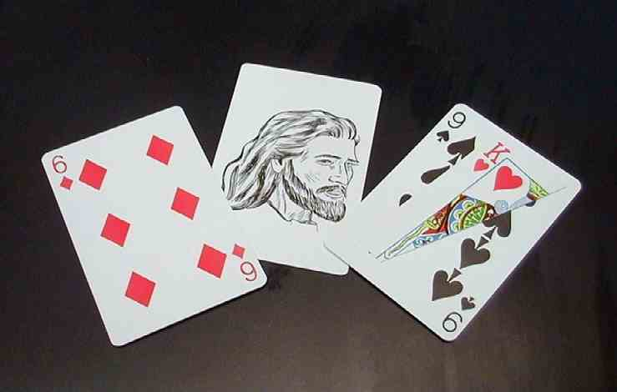
There are three playing cards involved in the “King of Hearts” gospel illusion – a six of diamonds, a nine of spades, and a card with Jesus’ picture (the King of Hearts). You will notice that the nine of spades has the corner of a king of hearts attached. The following description shows photos from the perspective of the presenter, not the audience.

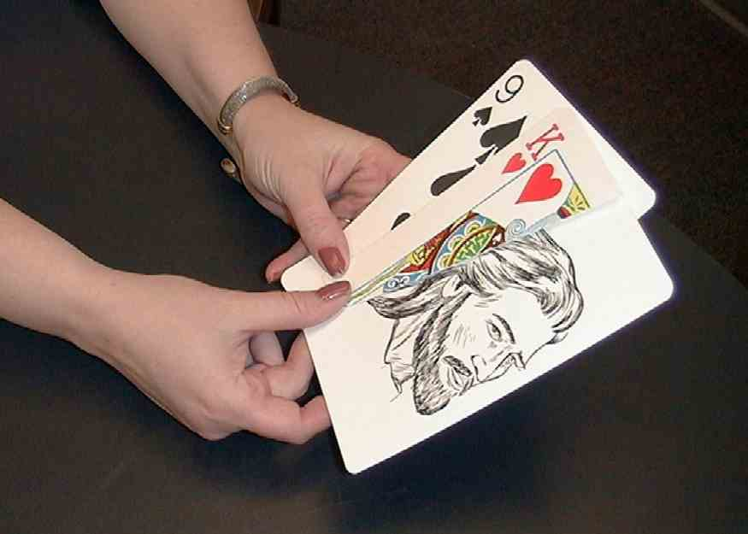

To load the trick, place the nine of spades on the bottom of the deck. Slide the King of Hearts card (Jesus card) under the flap of the king of hearts.

Next, place the six of diamonds on top of the deck. When the deck is fanned out, it will give the illusion of having a nine of spade, a king of hearts, and a six of diamonds.

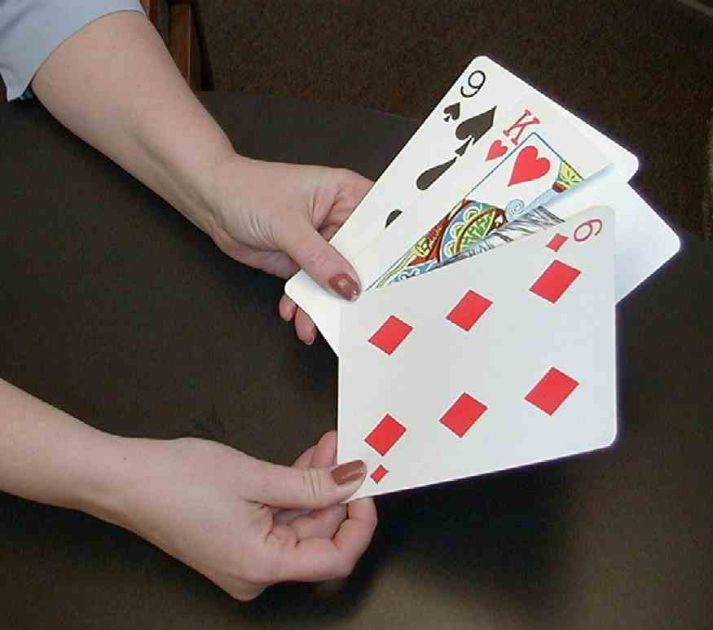
Teacher: As you can see, boys and girls, I have three cards in my hand. (Shows the cards in a fanfold of three.) Study these cards carefully and remember which cards they are.

Lay the cards face down on the table. Ask a child if he can recall and name the various cards. He is then invited to pull out the king of hearts card directly off the table. He should not look at the card!

Teacher: Pull out the card that you think is the King of Hearts. Don’t look at it, but leave it on the table.

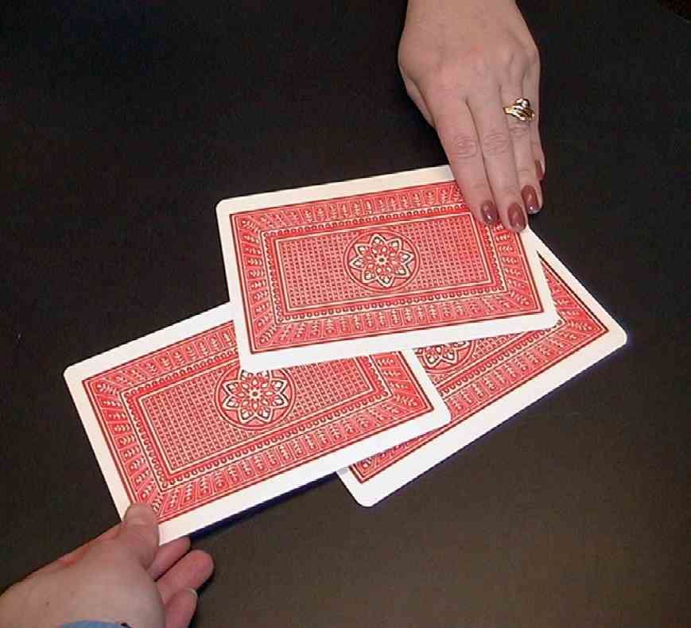
After he has done this, close the fan of three cards back to two. Show the audience that the child has picked the correct card, the middle card, the king of hearts.

Teacher: Kids, did he get the King of Hearts? I think so, as its not one of these two cards. So this card on the table must be the King of Hearts.

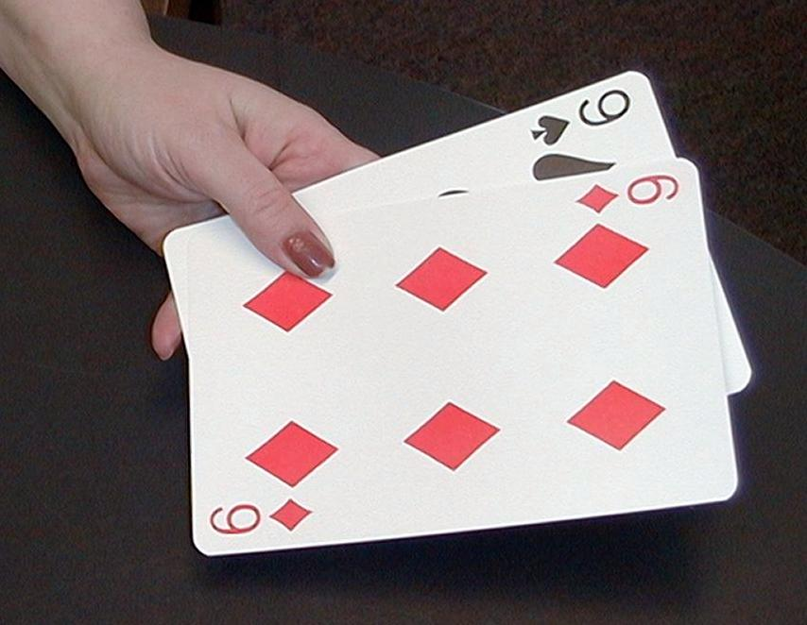
Teacher: Boys and girls, the king of hearts is my favorite card. Can you guess why? The king reminds me of the King of kings. The King over the whole universe is God’s Son, Jesus. He came as a person to our world. Even though He was the King of kings, He gave His life for us on the cross. When He died for our sin, He made it possible for us to come into His kingdom and live with Him forever. His death and then rising from the dead also made it possible for Him to come into our lives and live with us. That is why He can be King of our hearts. Who is the King of our hearts? Let’s just see. Will you show everyone the King of Hearts?

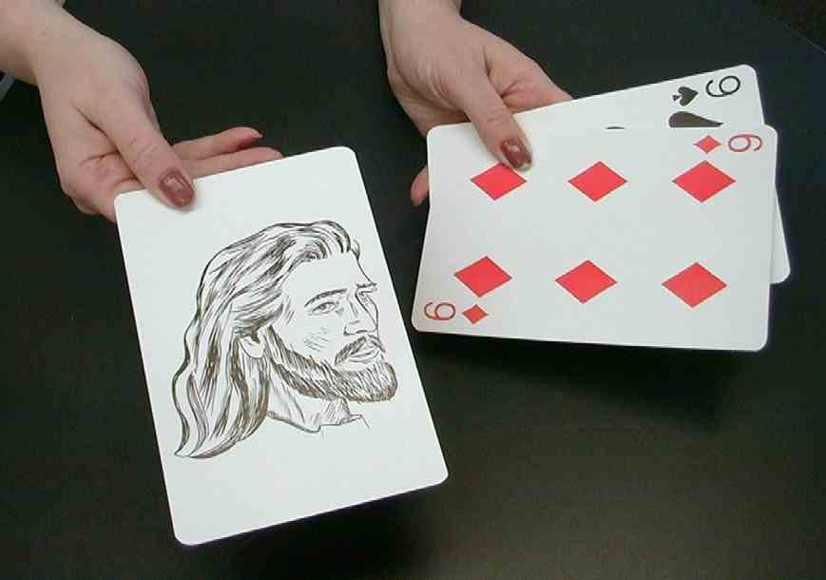
Ask the child to hold up the card on the table. Everyone will see a picture of Jesus—the King of Hearts.

Teacher: And there you have it. When you trust Jesus as your Savior, there He is the true King of your heart.

Be sure to not disclose to the audience how the trick was done. Do not repeat the trick—only do it once. This is part of the professional etiquette of illusionists and will take the fun out of it for the kids. The trick to making this illusion work well is practicing ahead of time and talking smoothly through the event.

Dao Dao: Wow! How did you do that?

Teacher: The point isn’t how I did the trick. The point is that Jesus can be the King of your heart.

Dao Dao: You mean that God can look right here in my heart and see that I trust Jesus as the King of my life?

Teacher: Of course. God can look into your heart and see whatever is there. In today’s Bible event, we will see that Saul tried to hide disobedience in his heart, thinking that God would not see it.

Dao Dao: Oops! I bet that didn’t work too well for him.

Teacher: Right. But God looked at David and saw that David loved God with his whole heart. And God chose David to be the new king instead of Saul. Here’s the whole story. Remember last week you heard from the prophet and judge Samuel? Well, here he is again to share with you what happened when God rejected Saul but chose David.

Samuel’s Account of the Anointing of King David
Bible Event Presentation

The following is simply a storyline for the monologue presentation by a costumed character of 60-year-old Samuel.

Samuel: I am the prophet Samuel and I spoke to you last week about King Saul. The people of Israel wanted a king and they got one. Was he a king who was fully devoted to God? Did he have a heart for God and doing things God’s way? I will let you decide as I tell you the story.

King Saul was powerful in war. Soldiers honored him as a brave leader. His forces grew stronger and stronger.

He chose his cousin, Abner, to be captain of his large army. He felt proud of his many victories. Perhaps that is where he went wrong. He began to think it was his power bringing victory. He began to think of his ways, instead of obeying God’s commands.

God told Saul that he should do battle against the Amalekites. God told him, “You must destroy everything in the city and not take anything you find there.”

Saul gathered an army of 210,000 men. It was an overwhelming number of soldiers. The battle was a great victory!

Do you think Saul obeyed God in every detail? Remember, God wanted everything sacrificed to Him. Do you think Saul kept some things back for himself? Right, he did. He took some things. He saved the best of the cattle and even took King Agag as a captive back to Israel.

The Lord spoke to me about this and said, “I am sorry that I ever made Saul a king. He does not follow My ways or obey My commandments.”

I was disappointed in Saul. All night long, I cried and prayed for the king. The next morning I went to meet Saul. When he saw me he said, “Look at this victory! I have done just what God commanded.”

“Just what God commanded?” I asked. “Then why do I hear the bleating of sheep and the mooing of cattle?”

Come on, kids. Can I hear some bleating of sheep? (Kids, “Baa. Baa.”) How about the mooing of cattle? (Kids, “Moo. Moo.”)

“What’s that I hear?” I asked Saul.

Saul explained, “I brought back the best of the sheep and the oxen because my men made me. We could sacrifice them to the Lord.”

I knew that Saul was just giving an excuse in trying to blame the soldiers for what he had done. I told him, “It is better to obey God than to offer sacrifices. Because you have rejected the word of the Lord, the Lord has rejected you as king. You may be tall, handsome, and a hero to the people, but God does not look on the outside like people do. God looks into the heart.”

At that, Saul grabbed my cloak and begged to come with me to worship the Lord. I think he just wanted everyone to see that we were together and that he still had God’s approval. But God looks at the inside.

My cloak tore and I showed him the rip. I said, “Just as this is torn, so your kingdom will be torn away from you.” I went and sacrificed to the Lord. That was the last I saw of Saul.

God was now looking for someone after His own heart and who would follow Him with his whole heart. Do you know whom He found? It was a small boy. This is how it happened.

The Lord told me to fill my horn with oil and go to the town of Bethlehem. There I would anoint a man to be a new king. He told me to make a feast. Among the guests, I was to invite Jesse and his sons. One of Jesse’s sons would be Israel’s next king.

One by one, Jesse’s sons were introduced to me. After all the sons Jesse showed me, I knew that God had not chosen any of them. “Jesse, do you have another son?” I asked.

“Just one more,” replied Jesse, “but I did not bring him. He is the youngest. Right now he is the field caring for the sheep.”

“Send for him at once!” I said. “We will not eat until he comes.”

The messenger found the son in the field. Do you know the name of this son? It was David. David came to the feast a rosy-cheeked, bright-eyed shepherd. I anointed him with oil in front of his family and God’s Spirit was upon him.

Saul did not know that this young boy was anointed to be king. He was troubled with an evil spirit and he needed someone to soothe him with music. David was assigned to King Saul and he played his harp to soothe Saul’s troubled soul. David began to learn by watching Saul what the life of a king would be like. David’s heart was different. David was a man after God’s own heart.

Remember, God does not look at the outward appearances, but He looks to the heart!

Who Is King of Your Heart?

Puppet Presentation Conclusion

Dao Dao: Wow! I guess Saul really didn’t follow God with his whole heart.

Teacher: That’s right, Dao Dao. Because of that, Saul would lose his kingdom.

Dao Dao: But then it would be given to David, even though he was a small kid.

Teacher: More than that, God looked at the inside and saw that David had a heart to follow Him.

Dao Dao: Can God see my heart?

Teacher: Sure.

Dao Dao: And yours?

Teacher: Yes.

Dao Dao: Well, what does He see?

Teacher: Dao Dao, let me ask you a question and that should give you the answer.

Dao Dao: Okay, what?

Teacher: Who is the King of your heart?

Dao Dao: Jesus is. Just like that trick you did.

Teacher: And how did Jesus get to be King of your heart?

Dao Dao: Well, He gave His life for me when He died on the cross, and I trust Him as my Savior. I want to follow Him and do what He says.

Teacher: Did you know that when God looks at your heart this is what He sees? (Hold up card with picture of Jesus.)

Dao Dao: You mean He sees a card?

Teacher: No, he sees the King of your heart, Jesus.

Dao Dao: Oh, yeah! Sure!

Teacher: Because of that, God forgives your sins and sees that you are following Him with your whole heart.

Dao Dao: Wow! God kinda has x-ray vision, doesn’t He?

Teacher: Well, like it says in the Bible, “People look at the outside of a person, but the LORD looks at the heart.”

Why don’t we close in prayer now.

Dear God, we know that You want us to follow You with our whole heart. Help us not to be like Saul and disobey You and then try to hide it. Help us to be like David, who followed You with his whole heart. Thank You for giving us Jesus so we can do that. In Jesus’ name. Amen.

Lesson 8

Small Group Wrap-Up
- A4 paper for each child
- tape

Large Group Presentation
- Dao Dao in a fortune-teller costume
- “The Original King of Hearts” trick available through www.gospelmagic.com.
period costume for a 60-year-old Samuel

Small Group Application
- red sheets of paper
- scissors
- pens and pencils
- masking tape

Memory Verse Learning
- a set of heart flash cards per group (See diagrams below.)
1 Samuel 16:7b
a person,
People
look
at the
outside
of
but the
LORD
looks
at the
heart.

