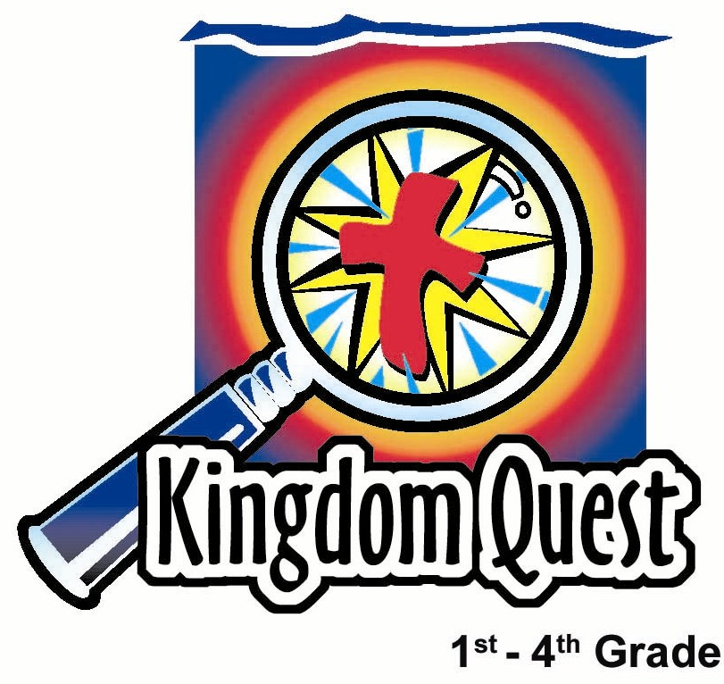
Date: __________________________
Series: Lookin’ for a Leader
Summer Year 3, Lesson 9

David, The Giant Slayer

Take Home Point: *Trust God with your problems, both little and big.
*Repeat this phrase throughout the lesson.

Bible Event: 1 Samuel 17
Key Verse: 1 Samuel 17:37 (NCV), “[David added,] ‘The LORD saved me from a lion and a bear. He will also save me from this Philistine.’”

We will help kids know:
- The Bible event of David’s ability to slay Goliath because of the Lord’s power.
- Like David, we need to trust God for life’s little victories so we will be confident that He can give us the big victories.
- Life’s biggest victory is over sin, death, and the power of the devil through Jesus, His death, and His resurrection for us.

We will help kids feel:
- Confidence to trust God for both little and big victories.
- Excited to claim the personal victory of Jesus over sin, death, and the power of the devil.

We will help kids do:
- Use a little rubber band to illustrate knocking down the big problems of life with God’s help.
- Have victory over problems in life because the Holy Spirit is with us.

THIS LESSON’S ROADMAP

DESTINATION | PAGE # | DISCOVERIES ON YOUR JOURNEY | SUPPLIES NEEDED
Small Group Warm-Up   | 3 | The last time you were worried or scared, would you call it a big or a small problem? Shoot a rubber band at a picture of a lion. In today’s Bible event, David trusted God to help him defeat a lion and a bear. We are shooting a rubber band at a lion picture to show that, with God’s help, we can defeat our problems, too. | - lion picture (see page 18)  - rubber bands
Large Group   | 4  8  10  10  14 | Overview  Puppet Presentation: “Knocking Down the Big Problem”  Pesta Game: “Rubber Band Shoot Out”  Interactive Bible Presentation: “David the Giant Slayer”  Puppet Presentation: “Knocking Down the Big Problem” Conclusion | - Dao Dao  - rubber bands  - ping pong ball placed approximately ten feet from the floor on the wall or on a poster board with a drawing of Goliath’s face  - red dot sticker  - ladder  - Bible  - actor dressed as Goliath with armor fashioned from cardboard  - slingshot made of two sections of three-foot rope tied to a pouch
Small Group Application   | 4 | Discuss challenges the kids face. Write these on a poster board. Then let kids shoot rubber bands against the poster board that cannot be knocked down. When we are confident Jesus is with us in our challenges, we can have confidence in Him to give us His power in working through these problems.  Memory Verse Learning:  “Hearts Search”  1 Sam. 16:7b will be the memory verse for lessons 8-10 to enable children to know that God looks into our hearts and wants us to follow Him with our whole hearts. | - rubber bands  - manila card  - half sheets of paper  - markers or crayons  - For each team –  - a box of shredded paper  - a set of heart flash cards  - masking tape

Small Group Warm-Up: 15 minutes
Purpose: Get pointed in the right direction! Build relationships and help guests feel at ease. Do the learning readiness activity that will point your group in the right direction for the lesson.

Supplies needed: lion picture (see page 16); rubber bands

Today, we will be talking about things in life that challenge us or make us afraid. Sometimes these are things like being afraid in a storm or being worried about getting a bad grade in school. Sometimes we might feel challenged when others are mean to us or a friend turns against us. Sometimes our challenges are big, like being worried about dying or having someone we love die. Some people might even feel God does not care about them or listen to them.

Each of you will have a chance to answer a question as you shoot a rubber band at this picture of a lion. Later, I will tell you what the lion represents. It has to do with our Bible event about David.

Set up the picture of the lion (see page 16), folding back the two flaps on each side. When the flaps are folded back, the piece of paper should stand on its side. A rubber band can be shot at the paper by launching it from one’s index finger. Allow each child to shoot down the picture of the lion after he answers the following questions.

When was the last time you were worried or scared? Would you call it a big problem or a small problem? How did you handle it?

After all children have had a chance to shoot down the lion, explain the significance of this picture.

In our Bible event today, David trusted God to help him defeat the lion and the bear. We were shooting a rubber band at the lion picture, to show that with God’s help we can defeat our problems, too.

David gained trust and confidence in God through the smaller victories against fierce animals, so he was confident that God would help him through the bigger challenge with the giant, Goliath.
Going Deeper (for older children):
Have children look up 1 Peter 5:8. Talk about how Satan is described as a prowling lion and God can help us defeat this enemy, too.

Today we will learn to *trust God with your problems, both little and big.
Large Group: 20-30 minutes
Purpose: Help kids observe what the Bible says. Present the Bible event in creative fashion. Help kids begin to interpret what it means.

Supplies needed: Dao Dao; rubber bands; ping pong ball placed approximately ten feet from the floor on the wall or on a poster board with a drawing of Goliath’s face; red dot sticker; ladder; Bible; actor dressed as Goliath with armor fashioned from cardboard; slingshot made of two sections of three-foot rope tied to a pouch

Overview

Puppet Presentation: “Knocking Down the Big Problem”– Dao Dao’s solution to his problem is to shoot it with a rubber band.

Carnival Game: “Rubber Band Shoot Out” – Rubber bands are used to knock a ping-pong ball off its ten-foot high perch (the height of Goliath).

Interactive Bible Presentation: “David, the Giant Slayer” – Kids are actively involved in telling the Bible event of David and Goliath.

Puppet Presentation: “Knocking Down the Big Problem” Conclusion – Dao Dao learns that David depended on God for victory in defeating the giant just like we can depend on God for victories to our problems, both little and big.

Small Group Application: 20-25 minutes
Purpose: Help kids map out the meaning of the Bible event in their lives. Use the questions to stimulate discussion but don't feel tied to them. Allow the Holy Spirit to guide you. Include personal examples from your own faith journey. The example of Christ at work in your life will leave lasting impressions of how Christ can work in the children's lives.

Use your Bibles! Children need to learn how to look up references and follow along when scripture is read aloud. Allow for quality time of prayer at the close of the lesson.

Observation Questions: What happened?
What were some of the things that made Goliath so scary? (1 Samuel 17:4-7. He was ten feet tall, and he had heavy bronze armor and weapons. His spear was huge!)

How did Saul and his army respond to the challenge? (1 Samuel 17:11. They were gripped with fear.)

Where did David come from when he arrived at the battle? (1 Samuel 17:20. He had come from home with food for his brothers.)

What experience did David have in fighting? (1 Samuel 17:34-37. He had defended his sheep from lions and bears.)

Interpretation Questions: What does this mean?
Why was David so brave? (1 Samuel 16:13 reminds us that David was filled with God’s Spirit. 1 Samuel 17:36 shows that David knew Goliath had defied the Living God. Verse 47 indicates his confidence in the Lord to win the battle.)

Application Questions: What does this mean to me?

Application Activity:
Supplies needed: rubber bands; manila card; half sheets of paper; markers or crayons

This learning activity is designed to help kids visualize the application point as they play the game.

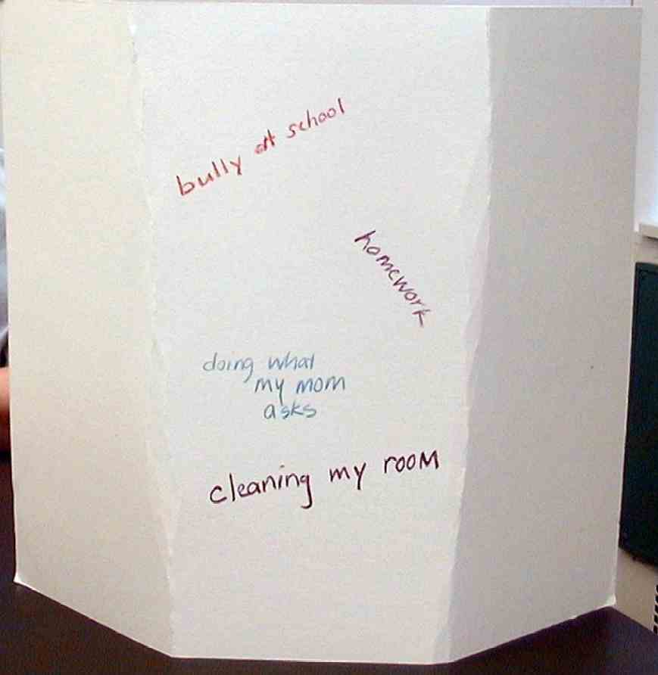
Fold both sides of the manila card to the middle and create two creases about seven inches from both edges, so the outside wings are bent in, and the manila card is freestanding. Face the poster board with the outside wings bent away from you.

Have the kids discuss challenges they face. Write these in the middle section while discussing. Ask kids if these challenges or problems seem little or big.

Following the discussion, let kids shoot rubber bands against the manila card. The manila card should not be knocked over because the wings keep it from falling.

In order to help the children identify some of the big challenges of their lives, read “The Big Problem with Buster.” You may choose to read this to help the kids identify areas in their lives that might be big problems. Once again, the teaching point is that as we trust God with little challenges, we can trust Him with big challenges. In both cases, we need to know that Jesus, who gave His life for us, is there to help us. Even the biggest challenges of all from sin, death, or the power of the devil are defeated in Jesus.

“The Big Problem with Buster”

Kok Seng was a bully. Jian Song was not too worried about him because Kok Seng always picked on kids weaker than he, and Jian Song was big.

Jian Song’s friend, Aaron, was not very big. Aaron was small and it seemed that Kok Seng always loved to pick on him. At recess, Kok Seng would push Aaron down, he would break Aaron’s pencils in the classroom, and he would shove Aaron as he stood in line.

When Aaron and Jian Song were walking home from school, Aaron talked about his problem—Kok Seng the Bully. “What do you do when you have problems?” Aaron asked Jian Song.

Jian Song thought for a moment. “I try to work out an answer. Sometimes I get advice from other people. Oh, yeah, I also pray that God would help me.”

“Does God answer your prayers?” asked Aaron.

“Sure he does! The small problems and the big ones. As a matter of fact, I’ll pray that you figure out how to deal with Kok Seng.”

The next day at school, Aaron came up to Jian Song and asked him, “Did you?”

“Did I what?”

“Did you pray for me?”

“Oh sure,” said Jian Song. “I’m sure God will help you.”

“Good,” said Aaron as he ran off for recess.

At the time, this did not seem like a big deal to Jian Song. He always prayed. He knew God could help in the small things and the big things.

Soon a big thing happened. Kok Seng came running across the grass and pushed Jian Song. “What’s the big idea?” said Kok Seng. “Aaron said you’re praying about me. Well, let’s just see if your prayers can take care of this!” With that, he pushed Jian Song down. Jian Song was stunned as he got up and shook off the dust.

“What should I do?” he thought to himself. Quickly he prayed, “God, this seems to be a big problem. I need your help. Please take care of it.” With that he turned to Kok Seng and said…
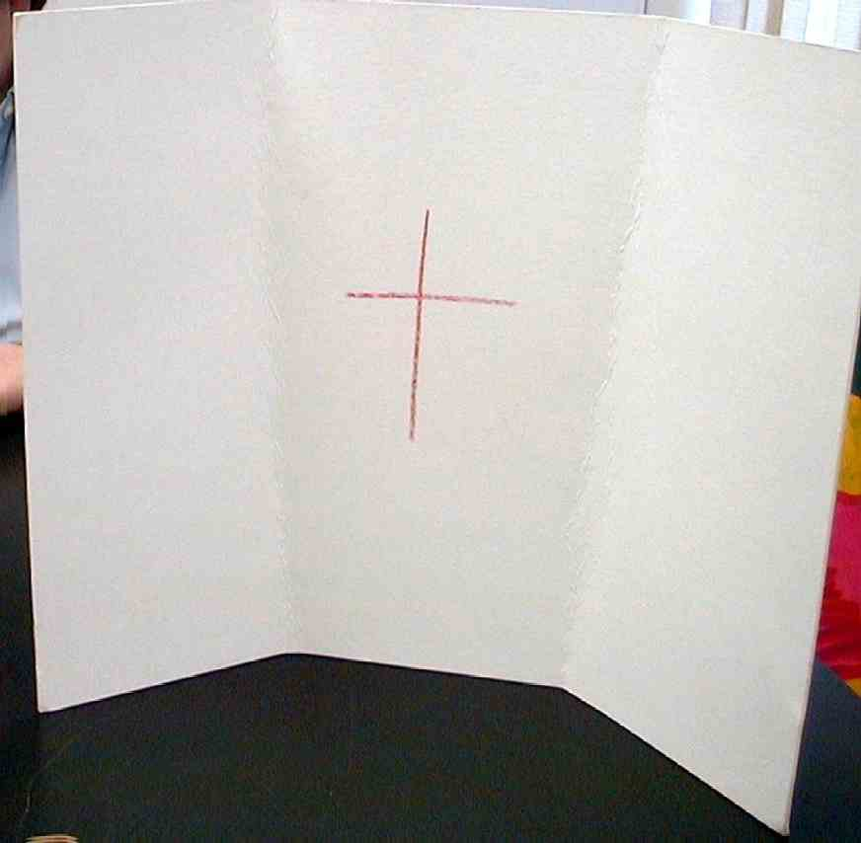
At this point, have the kids finish the story. They can make up whatever ending they like. Help them find endings that emphasize the learning point that we can trust God for the little victories and the big victories. Now draw a cross on the reverse side of the poster board (the side with the wings folded in). Then say:

Jesus defeated sin, death, and the power of the devil when He died on the cross and rose again. Nothing is more powerful than God. We have Jesus’ resurrection power when we believe in Him as our Lord and Savior.

When we are confident Jesus is with us in our challenges, we can have confidence in Him to give us His power in working through these problems. This activity can show us what this is like.

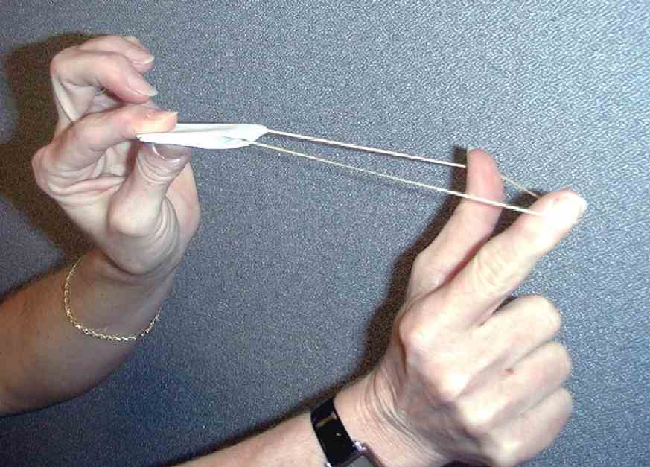
Have the kids take their rubber bands and load them with a “paper missile.” Paper missiles are made by folding a half sheet of paper until it is finally a strip of thick paper approximately a half-inch wide and three inches long. When this strip of thick paper is folded in half, it can be placed in the rubber band held between the thumb and index finger. By pulling the rubber band back, the missile is launched against the manila card. The weight of the paper and its force should knock the manila card over.

Talk about how these rubber bands are like David’s slingshot and stones.

In 1 Samuel 17:37 “[David added,] ‘The LORD saved me from a lion and a bear. He will also save me from this Philistine.’” God showed David victory over the smaller challenges, which gave David faith that God would bring him victory over the bigger challenges (like Goliath). Just like David trusted in God to bring him victory in his challenges both little and big, we can*trust God with our problems, both little and big.

Memory Verse Learning: 5 minutes
Purpose: Help kids to memorize and keep scriptures at heart. Using creative ways to help kids enjoy learning the key verse and in small group setting.

Supplies needed: For each team - a box of shredded paper; a set of heart flash cards; masking tape

Memory Verse: 1 Samuel 16:7b, “People look at the outside of a person, but the LORD looks at the heart.”

Memory Verse Presentation: “Hearts Search”
Before class, throw the flash cards into the box and mix them with the shredded paper.
During class, recite several times of 1 Samuel 16:7b with the children. Explain to them that today’s challenge between teams is to find all the hearts found in the boxes. The rule is that one person at a time comes to the box to search. But one cannot cause shredded paper to fall out of the box if not there will be disqualifying points on the team. When they have fully obtained all eight hearts, they have to arrange them in order and then recite the verse to complete the race. The first team that can do that in the fastest time wins.

Prayer Time:
Closing prayer may include the kids praying for one another’s challenges or their own challenges.
Safety and Security: Safety and security procedures are important for each church to carefully define and implement according to their unique needs. The security, safety, illness and accident procedures described in this curriculum are provided for example purposes only and may not be appropriate, applicable or adequate for every situation. Each church is responsible for determining whether any security, safety, illness and accident procedures contained in the curriculum are appropriate, applicable or adequate for its unique situation. The activities described in this curriculum require adult supervision and may not be suitable for each child and each situation. Each church is responsible for ensuring that adequate adult supervision is provided for all activities and for determining whether an activity is appropriate for each child and each situation. Kids Kount Publishing disclaims all liability for the implementation of any procedures or the performance of any activities described in this curriculum.
Large Group Presentation

Knocking Down the Big Problem

Puppet Presentation

(A red dot sticker will be needed as a prop along with some rubber bands for shooting.)

Teacher: Good morning, kids! Welcome to Sunday school Pesta. I’m here to introduce to you our special booth called “Knocking Down the Big Problem.” Here to help me is…

Dao Dao: Me, Dao Dao!

Teacher: Dao Dao, let’s explain how it is that we play “Knocking Down the Big Problem.”

Dao Dao: First, you take this red dot…

Teacher: Red dot? I don’t remember anything about a red dot.

Dao Dao: Sure! I’ll show you. Take the red dot.

Teacher: Okay.

Dao Dao: Then put the red dot right between the eyes of Teacher.

Teacher: Right between my eyes? Now wait a minute. Are you sure this is how this game is supposed to work?

Dao Dao: Of course. Would I ever trick you? Don’t answer that!

Teacher: Okay, I have placed the dot between my eyes.

Dao Dao: Now take the rubber band and give it to a kid in the audience.

Teacher: (Handing the rubber band to a child.) I don’t know if I like this.

Dao Dao: (To the child.) Now your job is to knock down the big problem. Blast Teacher right between the eyes!

Teacher: Wait a minute! That would hurt!

Dao Dao: Yeah.

Teacher: Why would anyone want to do that?

Dao Dao: Isn’t the name of the game “Knock Down the Big Problem?”

Teacher: Dao Dao, stop teasing. I’m not the big problem. Here, let me see that rubber band. The object of the game will be to knock the ping-pong ball off the place where it is resting almost ten feet above the ground. That is just about where it would have been if it were between the eyes of the giant Goliath.

Dao Dao: Wow! That’s way up there! That could be a problem.

Teacher: Yes, that could be a big problem.

Dao Dao: Do you think anyone could do it?

Teacher: In today’s lesson, we are going to find out that David did it because he relied on the strength of the Lord.

Dao Dao: He knocked down a big problem?

Teacher: He knocked down a giant problem called Goliath.

Dao Dao: How did he do it?

Teacher: Let me show you. David first had confidence because of this. (Take the red dot and place it on Dao Dao. Prepare to shoot.)

Dao Dao: Hey! What are you doing?

Teacher: I am just showing you that David first practiced trusting God and having victory with smaller problems, like defending his sheep against lions and bears.

Dao Dao: Oh, my! Why do you have the red dot on me?

Teacher: It would be kind of like practicing on a small problem like you, Dao Dao, before I tackle a big problem like Goliath. I need to be able to trust God with small things and big things.

Dao Dao: Are you going to shoot me?

Teacher: What do you think, boys and girls? Should I shoot him? (Take responses from the audience.) No, Dao Dao, I won’t shoot you. I will now ask some of the kids to come up so we can give them rubber bands. I will place this dot right over here so they can practice hitting it. (Place the dot on some kind of cardboard target.) After some practice shooting at the dot, we will see if they can knock the ping-pong ball down from between Goliath’s eyes.

Rubber Band Shoot Out

Pesta Game
Practice with kids in advance to determine the size of rubber bands and distance needed so kids can be successful.
The large group presenter continues with the pesta activity. Invite several children to shoot rubber bands at the ping-pong ball to “knock out” Goliath, allowing only one or two minutes to play the game. If needed, the large group presenter can even lift kids closer to Goliath’s ping-pong ball. This could demonstrate how God helps us have a victory!

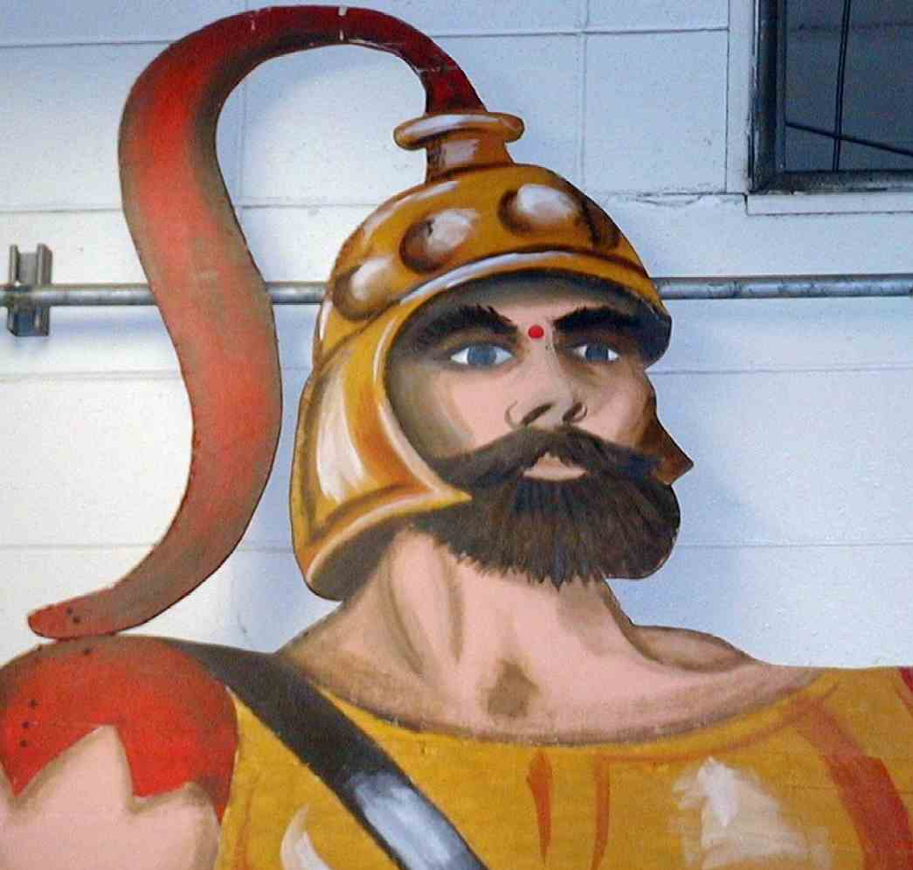
The setup for this game is simple enough, but requires imagination. The target of a ping-pong ball needs to be placed high on the wall. This will be symbolic of the area between Goliath’s eyes. An even better presentation would be if Goliath’s head (or even better, his entire body) were outlined or drawn on a poster board and placed high on the wall. In whatever scenario, a ping-pong ball needs to be mounted somehow between the eyes of Goliath in such a way that, when hit with a rubber band, it easily falls off its perch. For example, two small nails could make a simple perch.

After the pesta game, introduce the interactive Bible Presentation, “David, the Giant Slayer.”

Teacher: And now for today’s Bible event, “David, the Giant Slayer.” I need your help in telling this event, boys and girls. This is what I’d like you to do…

David the Giant Slayer

Interactive Bible Presentation

The following narrative is not designed to be read. Rather, it is designed to help the large group presenter tell the story of David and Goliath while involving the audience with roles of participation. The key is to get the audience involved.

The large group presenter needs to practice the cues that invite the audience to participate. He can be free to adapt the entire narrative to his own personal storytelling style.

The Bible event is divided into four sections so that it might be easier to remember and tell. We recommend that the storyteller place this outline inside a Bible to communicate that this was a real event recorded in the Bible.

SECTION 1: The Setting
Divide the room of kids in half down the middle. One half of the kids are Philistines while the other half are Israelites. Separate the kids to symbolize a valley between the two armies—the Philistines on one side and the Israelites on the other. Have the Philistines practice a war chant in unison with deep voices: “Thump, bump, Goliath! Thump, bump, Goliath!” Have the Israelites respond with screams of terror and sitting down to pretend to bite their nails.

An additional visual aid might be having a large adult stand on a stepladder the height of Goliath. Armor could be fashioned from cardboard.

Teacher: The Philistines gather their armies to fight King Saul. They gathered on one mountain while the armies of Israel gathered on a mountain facing them. In between them was a valley.

From the armies of the Philistines came a giant man. He was so tall that his head would have bumped against a basketball rim. He was almost ten feet tall. The giant was so big that his armor weighed 125 pounds. He had bronze shin guards, and on his back he had a bronze javelin. The wood for his spear was so thick that you could not get your hand around it. The tip of the spear was made with 15 pounds of iron. He was the champion of the Philistines.

As the giant walked down to the valley, you could hear the Philistines cheer. (Prompt the Philistines.)

Philistines: “Thump, bump, Goliath! Thump, bump, Goliath!”

Teacher: From the valley, he shouted up to the Israelites, “Why should both of our whole armies go to battle. I am the champion of the Philistines. Send your champion and we will fight together. Whoever wins in the fight of the champions will be the winner of the whole battle. He will be served by the other army.”

When the Israelites saw the size of Goliath and how big his weapons were, they all became scared. They said, (prompt the Israelites)…

Israelites: “Eye-eee. . .”

Teacher: …while they sat down and bit their nails.

Day after day, Goliath made the challenge. He insulted Saul and all the armies of Israel. Worst of all, he insulted the God of Israel. He said the Philistine god was more powerful than the God of Israel.

Goliath: Hey, Saul. Yo momma ain’t nothin’. Yo daddy ain’t nothin’. Yo dawg ain’t nothin’. And yo God ain’t nothin’, you big sissy.

SECTION 2: Here Comes David
Teacher: For 40 days, Goliath insulted the army of Israel. Then a young boy named David came from his father’s pastures where he was tending sheep. His job was to bring food for his three older brothers in the army.

When David heard the insults of Goliath…

Philistines: “Thump, bump, Goliath! Thump, bump, Goliath!”

Israelites: “Eye-eee. . .”

Teacher: …he said, “Wait a minute! Who is this obnoxious pagan Philistine that would dare mock the armies of the living God?”

When others heard this they said, “Oooohhh.” (Prompt all the kids.)

All Kids: Oooohhh.

Teacher: David’s brothers told him to go home and mind his sheep. Instead, David went to Saul and said he would fight Goliath. (Prompt all the kids.)

All Kids: Aaaaahhh.

Teacher: Saul asked him, “How can you? You are just a boy.” David replied, “First of all, I know the Lord will save me. You see, when I am a shepherd tending my flock, sometimes a lion or bear will come.”

All Kids: Oooohhh.

Teacher: When that happens the Lord gives me strength to take my sling and fire a rock to kill the lion or bear.

All Kids: Aaaaahhh.

Teacher: I trust the Lord when challenged by a lion or bear. Certainly, I can trust the Lord to defend me against Goliath.

All Kids: Oooohhh.

Teacher: Furthermore, Goliath has insulted the Lord Most High. The Lord will bring His judgment.”

All Kids: Aaaaahhh.

SECTION 3: Saul’s Suggestion
Teacher: When Saul heard this, he said to David, “Go ahead and may the Lord be with you, but what you are wearing won’t do. You need my armor.”

So, Saul had his armor brought and put on David, but it did not fit at all. The armor also did not fit God’s plan. You see, Saul thought the solution to the problem would be to fight according to human strength and use swords and spears. David saw that he would fight in the strength of the Lord. He would use the weapons of a shepherd. Instead of Saul’s armor, David took what he used as a shepherd—his staff and sling with five stones. By the way, the size of the stones were about the size of a baseball, and David was a deadeye shot. (For special effect, show a slingshot made of two sections of three-foot rope tied to a pouch. One end of the rope is tied to a wrist and the other is held in the same hand. It is swung overhead then released.)

SECTION 4: The Battle
Teacher: The champion of the Philistines came forward. Let’s have the armies chant while Goliath comes forth.

Philistines: “Thump, bump, Goliath! Thump, bump, Goliath!”

Israelites: “Eye-eee. . .”

Teacher: From the Israelites comes the shepherd boy, David. Goliath was surprised when he saw David without a weapon. Were the Israelites making fun of him by sending a boy?

Goliath: Am I like a dog that you come to fight me with a stick? I will tear you to pieces and give your body to the birds.

Teacher: David did not turn back. Instead he called out, “You come to me with a sword, spear, and shield. But I come to you in the name of the true God, Yahweh. He is God of all the armies of heaven and you have defied Him. Today the Lord will deliver you into my hand. Then everyone will know there is a Lord God in Israel. Everyone who watches will know that the Lord can save without the sword or the spear because He determines the outcome of the battle. He will hand all of you over to us.”

With that, Goliath moved closer in order to attack. David ran quickly toward him. With a rock in his sling, he spun his sling and let the rock fly. On the first shot, the rock hit Goliath right between the eyes. Goliath was dead before he hit the ground.

Then David took the sword of Goliath, cut off Goliath’s head…

All Kids: Oooohhh.

Teacher: …and held it high.

All Kids: Aaaaahhh.

Teacher: With that all the Philistines knew that God was against them. They said, “Eye-eee,” turned, and ran. The Israelites chased after them and drove them out of the land.

Knocking Down the Big Problem

Puppet Presentation Conclusion

Teacher: Dao Dao, what did you think?

Dao Dao: I know what Goliath thought when that big ol’ rock hit him right between the eyes.

Teacher: You do? What did he think?

Dao Dao: Well, he must have said to himself, “Hmm…Nothing like that ever entered my mind before.” (Laughs.) It’s a joke, Teacher. I’ll explain it to you later.

Teacher: Dao Dao, what we are to remember is that David learned to trust God for little victories.

Dao Dao: Yeah, like when he was protecting his sheep.

Teacher: That’s right. He knew God would help him in the little things. So when he faced a big battle, he know he could trust God even more. It says in 1 Samuel 17:37, “[David added,] ‘The LORD saved me from a lion and a bear. He will also save me from this Philistine.’”

Dao Dao: I guess you can always count on God.

Teacher: For the little victories and for the big ones. Dao Dao, do you know what’s the biggest victory God could ever give you?

Dao Dao: I’m not sure, but I bet it has to do with Jesus.

Teacher: You’re right. The biggest victory would be over the power of sin, death, and the devil.

Dao Dao: Jesus took care of that when He died on the cross for us.

Teacher: Of course He did. We can always trust God for that. If God took care of that by giving us Jesus, how much more will He also help us with the little challenges we face. That’s what we’ll talk about in our small groups—the little challenges and the big challenges we face and how God gives us a victory.

Let’sprayer.

Dear God, thank You that we can trust You for the little victories and the big victories. Help us understand that all of our challenges and problems that we face can come tumbling down just like big ol’ Goliath came tumbling down. Most of all, thank You for Jesus, who gives us a victory that will last forever. He made it possible for us to be in heaven with You forever. In Jesus’ name. Amen.

Lesson 9

Small Group Wrap-Up
- lion picture (see page 16)
rubber bands

Large Group Presentation
- Dao Dao
- rubber bands
- ping pong ball placed approximately ten feet from the floor on the wall or on a poster board with a drawing of Goliath’s face
- red dot sticker
- ladder
- Bible
- actor dressed as Goliath with armor fashioned from cardboard
slingshot made of two sections of three-foot rope tied to a pouch

Small Group Application
- rubber bands
- manila card
- half sheets of paper
- markers or crayons

Memory Verse Learning
- For each team –
  - a box of shredded paper
  - a set of heart flash cards
  - masking tape

