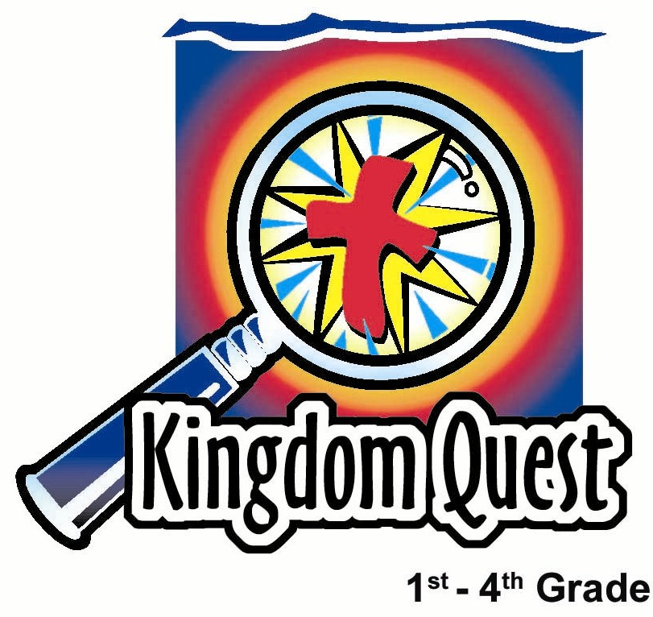
Date: __________________________
Series: Lookin’ for a Leader
Jun-Aug Year 3, Lesson 11

Jonathan
and David’s Friendship

Take Home Point: *Friendship is loving others as you love yourself.
*Repeat this phrase throughout the lesson.

Bible Event: 1 Samuel 20
Key Verse: Mark 12:31, “The second most important commandment is this: ‘Love your neighbor as you love yourself.’”

We will help kids know:
- The Bible event of Jonathan warning his friend, David.
- Just as Jonathan loved David as he loved himself, so we can love our friends as we love ourselves.
- God loves us as He loves Himself by giving Jesus as our Savior.

We will help kids feel:
- The joy of having friends they can count on.
- The security of knowing Jesus as their friend.

We will help kids do:
- Identify qualities of friendship.
- Identify ways they can be better friends to others.

THIS LESSON’S ROADMAP

DESTINATION | PAGE # | DISCOVERIES ON YOUR JOURNEY | SUPPLIES NEEDED
Small Group Warm-Up   | 3 | Draw the outline of a child. Have your group write on the outline some of the different qualities they like in a friend. | - five foot length of mahjong paper or newspapers taped together  - markers
Large Group   | 3  7  8  10  12 | Overview  Puppet Presentation: “Dao Dao Discovers True Friendship”  Pesta Game: “The Secret of Friendship”  Bible Event: “Prince Jonathan’s Servant”  Puppet Conclusion: “Dao Dao Discovers True Friendship” Conclusion | - Dao Dao  - Nerf arrows or something that resembles a bow and arrow  - targets will be five 8 ½ x 11 inch sheets of paper that are taped to something that lets them stand up on their side (This could even be another 8 ½ x 11 inch sheet of cardstock taped to the top edge of the paper.) On the back of these freestanding targets needs to be the words that are the lesson point for the day: “LOVING,” “OTHERS,” “AS YOU,” “LOVE,” and “YOURSELF“  - three prizes  - Jonathan’s servant’s costume: a simple tunic and three arrows
Small Group Application   | 4 | Draw a large red dot on the hands and feet of the outline you made earlier. The marks on Jesus’ hands and feet were marks of a friendship that Jesus paid for very dearly. Now challenge the kids to think of someone who needs a special friend.  Memory Verse Learning:  “Sign the Verse”  1 Sam. 26:23 will be the memory verse for lessons 11-13 so that the children knows that God calls us to be faithful and seek Him for guidance. | - “I can be a better friend by…” arrows (page 13)  - red marker  - pencils  - outlined figure from Small Group Warm-Up  - none needed

Small Group Warm-Up: 15 minutes
Purpose: Get pointed in the right direction! Build relationships and help guests feel at ease. Do the learning readiness activity that will point your group in the right direction for the lesson.

Supplies needed: five foot length of mahjong paper or newspapers taped together; markers

Spread the mahjong paper or newspaper on the floor and ask a child to lie down on it. Outline him using a black marker. Be aware of permanent markers seeping through the paper!

As you ask the following question of the kids, have them write the different qualities of friends they have mentioned on the outlined figure. You will be making a group picture of what a good friend is. Ask:

Describe a fun time you had with a friend. What are some qualities you like in a friend? (Some younger children will not understand the word “qualities.” You can help them understand by giving them examples of things you like about a friend. Examples of good qualities in friends are: laughs with you, faithful when others are mean, or interested in what you are interested in.)

Conclude with:

Today we are going to hear about two people in the Bible who were good friends. We will learn that *friendship is loving others as you love yourself.

Large Group: 20-30 minutes
Purpose: Help kids observe what the Bible says. Present the Bible event in creative fashion. Help kids begin to interpret what it means.

Overview

Puppet Presentation: “Dao Dao Discovers True Friendship” – Dao Dao thinks he should be chosen as the friend to play the carnival game.

Pesta Game: “The Secret of Friendship” – Kids shoot at targets that have words on the back. As the targets are hit, the words revealed complete the phrase, “God’s idea of true friendship is…”

Bible Event: “Prince Jonathan’s Servant” – The story of Jonathan and David’s friendship as found in 1 Samuel 20.

Puppet Conclusion: “Dao Dao Discovers True Friendship” Conclusion – Dao Dao learns how Jonathan risked his life for his friend, David, but our greatest friend and lifesaver is Jesus.

Small Group Application: 20-25 minutes
Purpose: Help kids map out the meaning of the Bible event in their lives. Use the questions to stimulate discussion but don't feel tied to them. Allow the Holy Spirit to guide you. Include personal examples from your own faith journey. The example of Christ at work in your life will leave lasting impressions of how Christ can work in the children's lives.

Use your Bibles! Children need to learn how to look up references and follow along when scripture is read aloud. Allow for quality time of prayer at the close of the lesson.

Supplies needed: “I can be a better friend by…” arrows (page 13); red marker; pencils;
outlined figure from Small Group Warm-Up

Observation Questions: What happened?
Have kids refer to 1 Samuel 20 for the following questions.

Did Jonathan know that his father, Saul, wanted to kill David? (1 Samuel 20:1-2, 9. No. He thought it was unthinkable. )

What plan did Jonathan and David make to let David know if Saul was angry and was trying to kill him? (1 Samuel 20:17-23. David would hide in the wilderness behind some rocks instead of going to the festival with Jonathan and Saul. Jonathan would go out to the wilderness and shoot three arrows. When Jonathan’s servant went to retrieve the arrows, Jonathan would give a secret message. If Jonathan said to the servant, “Look the arrows are next to you; get them,” David was safe. If Jonathan said to the servant, “The arrows are next to you,” then David should flee because Saul was angry and wanted to kill him.)

At the festival, what did Saul do to show Jonathan he wanted David dead? (1 Samuel 20:30-33. He got so angry Jonathan would not tell him where David was, he threatened him with his spear.)

How did David and Jonathan show their love for each other before David ran away? (1 Samuel 20:41-42. They showed strong emotion. They promised they would protect each other’s families.)

Interpretation Questions: What does this mean?
Jonathan risked dying when Saul threatened to kill him for not revealing where David was hiding. How would you feel if you were Jonathan?
How do you think Jonathan and David felt knowing they would never see each other again?

Can you tell about a friendship you have that is as strong as Jonathan and David’s friendship? Would you risk your life for your friend?

Application Questions: What does this mean to me?
True friendship means loving others as you love yourself. How does God show He wants to truly be our friend? (God loves us so much that He died for us. Jesus died on the cross for our sin, and He is alive to be our friend right now.)
Going Deeper: Excellent scripture for the children to look up is John 15:12-14. These verses tell us that we are to love each other as Jesus has loved us.

Take a red marker and draw a large red dot on the hands and feet of the outlined picture of a friend. Talk about how God showed His friendship by giving us Jesus.

The marks on Jesus’ hands and feet were marks of a friendship that Jesus paid for very dearly.

If any of the children do not know Jesus as their friend or trust Him as their Savior, explain that they can do so very simply. They need to recognize their sin separates them from God’s friendship. But God gave them Jesus, so if they trust in Him and what He has done for them, their sin is forgiven and they can be friends forever with God.

Jesus demonstrated what He commanded in Mark 12:31, “The second most important commandment is this: ‘Love your neighbor as you love yourself.’” *Friendship is loving others as you love yourself.

The rest of the small group application challenges the children to think of another person who needs a special friend. We can be a friend just like Jesus was a friend to us.

Think of a person who needs a friend. This might be a person who is lonely or does not have many friends. Maybe it is someone who does not know what a great friend Jesus can be. You can show this person the kind of love Jesus gives us. You can be a friend to him by showing the kind of love Jonathan and David had—loving someone else as you love yourself.

Give each child an arrow (see page 13) for the following application discussion.

Take your arrow and point to one of the qualities of friendship that we have written down on the paper friend outline. This can be something you can do to show your friendship to that special person you are thinking of.

After everyone has pointed to a quality, have each child tell a little bit about what he has chosen and why. We should treat others the way we want to be treated ourselves.

*Friendship is loving others as you love yourself.

After the group discussion, have children write down some other characteristics on their arrow that would help them be a good friend to the person they are thinking of.

Have the kids take their arrows home with them and place them in their Bibles as a bookmark. This will remind them of the secret of friendship—*loving others as we love ourselves.

Memory Verse Learning: 5 minutes
Purpose: Help kids to memorize and keep scriptures at heart. Using creative ways to help kids enjoy learning the key verse and in small group setting.

Supplies needed: none needed

Memory Verse: 1 Samuel 26:23, “The LORD rewards every man for things he does right and for his loyalty to Him.”

Memory Verse Presentation: “Sign the Verse”
See page 7 for the sign language for 1 Samuel 26:23. Use them to teach and impress the verse into the hearts of the children.

Prayer Time:
Using the arrows, have kids pray that they can show those qualities to the special person they want to show friendship. Have all children give thanks to God for His friendship. If this is a new experience for any of the children, tell them being a Christian is accepting God’s friendship that He gives us in Jesus.

Safety and Security: Safety and security procedures are important for each church to carefully define and implement according to their unique needs. The security, safety, illness and accident procedures described in this curriculum are provided for example purposes only and may not be appropriate, applicable or adequate for every situation. Each church is responsible for determining whether any security, safety, illness and accident procedures contained in the curriculum are appropriate, applicable or adequate for its unique situation. The activities described in this curriculum require adult supervision and may not be suitable for each child and each situation. Each church is responsible for ensuring that adequate adult supervision is provided for all activities and for determining whether an activity is appropriate for each child and each situation. Kids Kount Publishing disclaims all liability for the implementation of any procedures or the performance of any activities described in this curriculum.

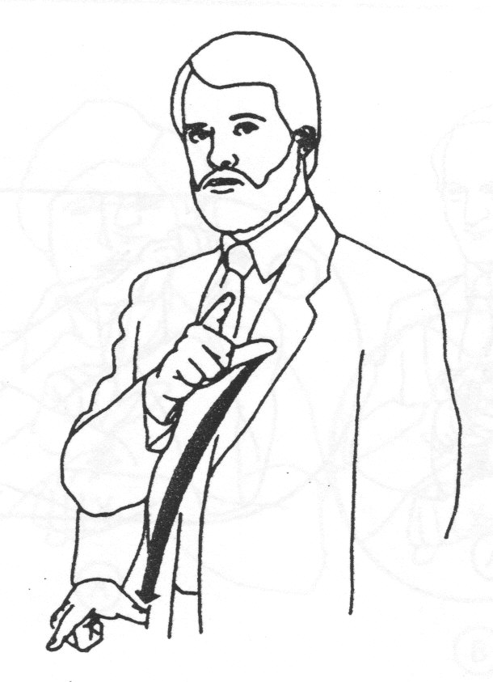THE LORD | 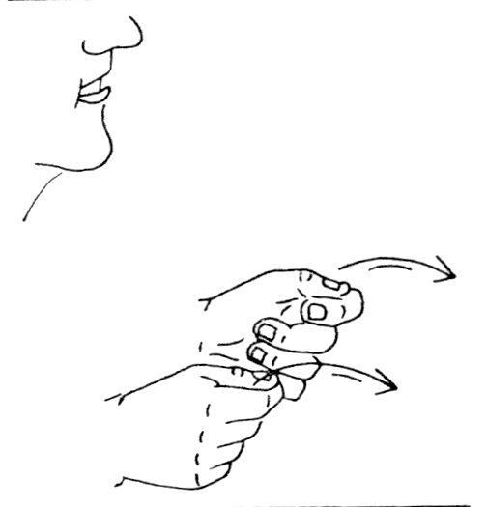  REWARDS
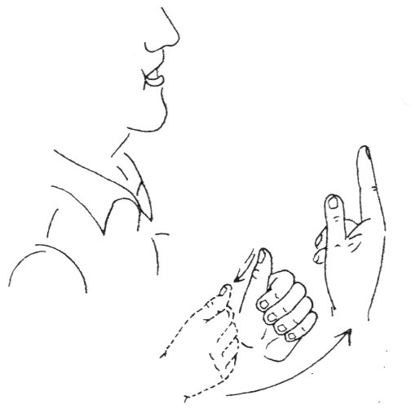  EVERYONE | 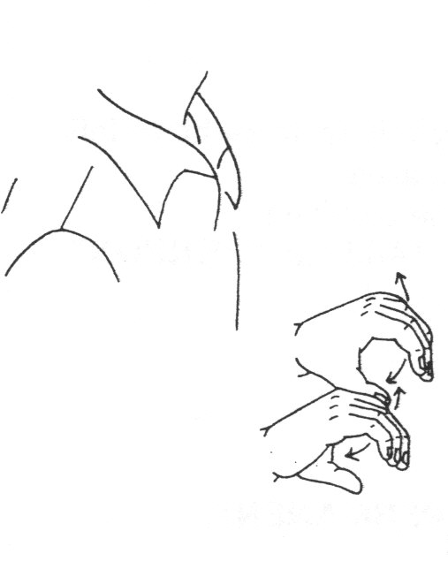  ACTIVITIES
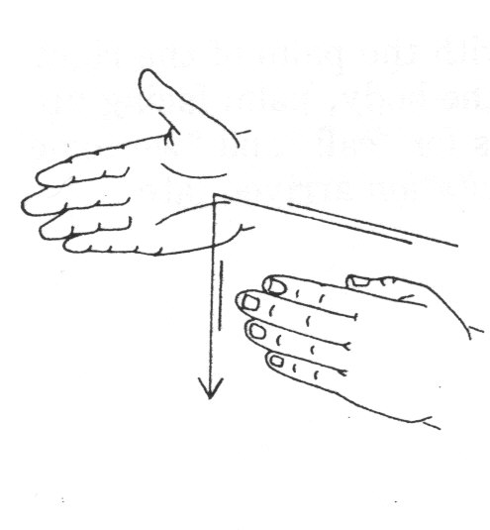  HE DOES | 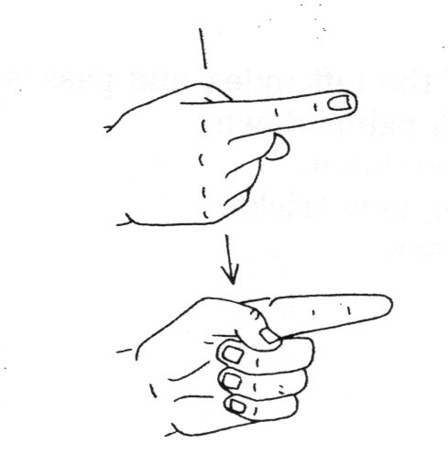  RIGHT
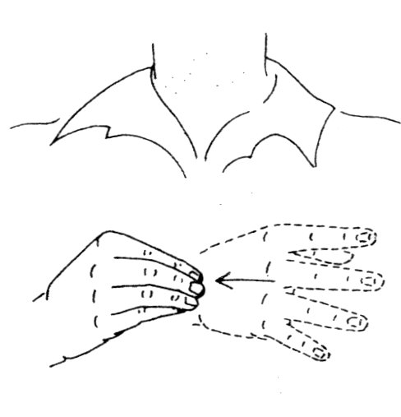  AND | 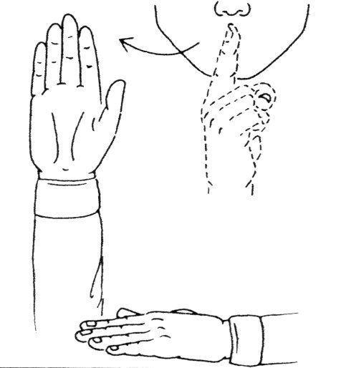  LOYAL
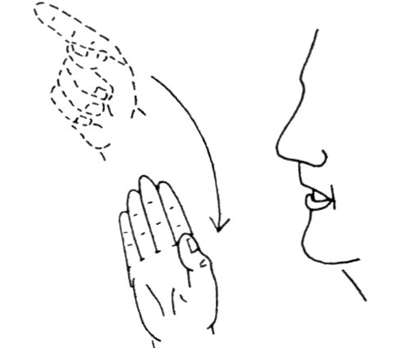  GOD | 1 Samuel 26:23/The LORD/rewards /every man/ for things/ he does right/and/ for his loyalty/to Him.  When signing, we sign the meaning and not the word.
Large Group Presentation

Dao Dao Discovers True Friendship

Puppet Presentation

Teacher: Hello, kids! Welcome to Pesta Sunday school. I am Teacher _____________.

Dao Dao: And I’m Dao Dao!

Teaher: We’re here to invite you to our new booth.

Dao Dao: Yes, it’s called “The Secret of Friendship.”

Teacher: And to play it I would like to invite a contestant to come forward AND bring a friend with you! (Selects a contestant who comes forward along with a friend.)

Dao Dao: Wait a minute! Wait a minute!

Teacher: What’s wrong, Dao Dao?

Dao Dao: She didn’t choose me. (Speaking to the child pulled from the audience.) Aren’t I your friend?

Teacher: Dao Dao, she can’t choose everyone.

Dao Dao: But she could choose me!

Teacher: Dao Dao, I need you to help me with the carnival booth. I would like to be your friend.

Dao Dao: Yeah! You need all the friends you can get!

Teacher: It’s not that, Dao Dao. Sure, I need friends. We all need friends. I would like to be your friend because I like you and I think you’re a pretty cool guy.

Dao Dao: Now wait a minute. You want to be my friend even though sometimes I make jokes about you?

Teacher: Yes, even if you make jokes about me. I would like to be a true friend. Today we are going to find out what a true friend is.

Dao Dao: Well, I already know. A true friend is someone who always gives his friend prizes. That is what really makes a true friend. So, where’s my prize?

Teacher: Dao Dao, I don’t have a prize. But if I did, I would share it with you.

Dao Dao: Well, I want someone who has a prize to be my true friend! Who here has a prize and wants to be my friend?

Teacher: Dao Dao, friendship is more important than prizes. God tells us what He thinks a true friend is.

Dao Dao: Does it have to do with prizes?

Teacher: It does have to do with sharing and giving of yourself, but it takes more than prizes.

Dao Dao: What does it take?

Teacher: Today’s contestants will have a chance to find out at “The Secret of Friendship” Pesta Booth. This is how the game works. Each contestant has three shots to hit any of the five targets. Each time they knock down a target, we will turn over the target and read the word on the backside. The final phrase of all the words together will finish the sentence, “God’s idea of true friendship is...” Let’s see how they do.

The Secret of Friendship

Pesta Game

The pesta game today has two children shooting at a series of five targets. Since the lesson deals with bow and arrows, have the children shoot Nerf arrows or something that resembles a bow and arrow.

The targets are five 8 ½ x 11-inch sheets of paper taped to something that allows them to stand on their side. (This could even be an 8 ½ x 11-inch sheet of cardstock taped to the top edge of the paper.) On the back of these targets are the words for the lesson point of the day: ”LOVING,” “OTHERS,” “AS YOU,” “LOVE,” and “YOURSELF.” If the targets are not made to be freestanding on a table or carnival booth, tape the targets to the wall with the blank side facing out. The targets can then be turned if they are successfully hit. (See picture below.)

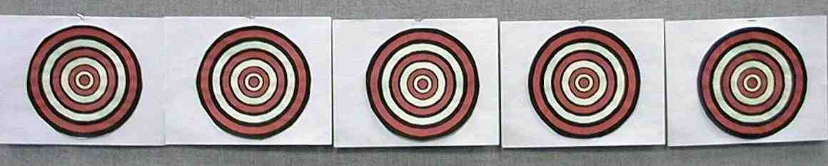

The phrase fills in the rest of the sentence, “God’s idea of true friendship is…” The audience should not be able to see the phrase on the back of the targets. It will be a secret that is revealed one word at a time. As the contestants successfully hit one of the targets, it is then turned around to give a clue as to what the final phrase is.



Ask kids to finish the phrase, “God’s idea of true friendship is…” Then have two contestants alternate shooting. After each attempt, the contestant will have an opportunity to guess the phrase or answer to the question. Each contestant gets three arrows (the number of arrows Jonathan shot). If the contestants do not hit the targets, they have fewer clues to work with.

While contestants are shooting, Dao Dao and Teacher are free to make comments. After each shot, Teacher can ask the contestant if they have an answer to finish the phrase: “God’s idea of true friendship is…” The game does not need to be competitive between the two contestants. The two can help each other guess. If the children do not hit enough targets to finally get it right, Teacher can give them a little help in finding the answer: “…loving others as you love yourself.”

As a reward for the contest, Teacher gives each child a prize.

Dao Dao: Hey, wait a minute. I thought you didn’t have any prizes.

Teacher: I said I didn’t have prizes, but I do have gifts. Today’s Bible event is about Jonathan and David’s friendship. Jonathan loved David as much as he loved himself. Because of his love, Jonathan was a real gift.

Dao Dao: And the story of how Teacher loves Dao Dao as he loves himself so that he even gives a gift to Dao Dao?

Teacher: You got it! I’ll be a true friend. Here’s a gift for you, Dao Dao. Now listen to today’s Bible event. It will be told by a servant boy who was assigned to Prince Jonathan, the son of King Saul. Jonathan showed David that he was a true friend. Listen to his story.

A Monologue by Prince Jonathan’s Servant

Bible Event

The following sample monologue is from the perspective of the servant assigned to Prince Jonathan. He had to retrieve the arrows, which were Jonathan’s secret signal to David. (He can be dressed in a simple tunic with three arrows in his hand.)

The story is simple, so it ought to be told from memory. The actor is encouraged to read 1 Samuel 20 for himself to gather more details. A key phrase that needs to be highlighted is, “True friendship is loving others as you love yourself.”

Servant: Hello. My name is not important but who I worked for is. I was assigned as the personal guard and servant of Prince Jonathan, the son of King Saul of Israel. I would like to tell you the story of what happened between Prince Jonathan and his best friend, David. I was a part of Jonathan’s secret message and that is why I have three arrows in my hand.

As you have already heard, King Saul had grown to despise young David. I suppose he was simply jealous of David because everyone loved David. David was a great military leader, and we could see that the Lord was with him.

No one loved David more than my master, Prince Jonathan. Jonathan had made an oath of friendship to David. He had given David his princely robe, his sword, and his bow. With these gifts, Jonathan promised to always be David’s friend.

My master, Jonathan, was deeply sorry for the actions of his father, King Saul. He was ashamed that the king could be so angry against David. David was worried for his life and Jonathan did all he could to protect him. Jonathan told David that his father did not do anything without first consulting him. King Saul always talked his plans over with Jonathan.

Jonathan told David, “Don’t worry. If he has plans to harm you, I will certainly tell you first.”

David still did not feel safe. He suggested a plan to Jonathan. “There is a feast starting and Saul will expect me to be at his table. Instead of attending, I will hide. If Saul becomes angry because I am not there, then you will know that he intends to take my life. But if he speaks well of me, you can tell me. I will then know that it is safe for me to return.” Jonathan promised to let David know.

When the feast began, David’s seat was empty. The first day of the feast Saul did not say anything about David’s absence. But by the second day, Saul let everyone see his anger. Jonathan stood up and said, “Father, David is loyal to you. Why are you so angry? Why do you want to hurt him? What has he done to deserve death?”

That is when I saw something so terrible I could not believe my eyes. Saul’s face turned red. He shouted at Jonathan in anger, “As long as David lives, you will never be king! You must bring him to me now because he must die!”

When Jonathan refused to do this, Saul picked up his spear and threw it at him. Jonathan ducked in the nick of time and the spear missed him.

Jonathan and I went out to the field the next morning. I did not know David was hiding up in the rocks and that Jonathan and he had planned a secret meeting.

Jonathan shot three arrows and told me to run and gather them. When I got to the area where I thought the arrows were, Jonathan hollered at me, “Isn’t the arrow beyond you? Hurry! Go quickly! Don’t stop!”

I looked for the arrows and found them. I brought them back to Jonathan and he told me to leave. I did not know that when he hollered at me, it was a secret message that he was really giving to David. He was telling David that it was not safe around Saul and that he should leave. Jonathan and David had worked this secret message out beforehand. Jonathan was even ready to tell David if it would be safe with Saul. If it would have been safe, Jonathan would have instead hollered, “The arrows are on this side of you! Bring them back!”

I left the field but later found out Jonathan and David had met. They both knew David would have to run away to save his life and this made them so sad they cried. Jonathan said, “I promise I will always be a friend in the name of the Lord. I will always watch out for you, and you will always watch out for me.”

Jonathan loved David even as he loved himself. That is true friendship.

Dao Dao Discovers True Friendship

Puppet Presentation Conclusion

Teacher: Dao Dao, what do you think of Jonathan and David’s friendship?

Dao Dao: Wow! It was almost as if Jonathan risked his life for his friend, David.

Teacher: I think that’s true.

Dao Dao: Yeah, a friend like that can be a real gift.

Teacher: Dao Dao, you know you have a gift from a friend, too.

Dao Dao: Well, I know that I got a gift from my friend. You gave me one just a while ago.

Teacher: No, I mean this. Listen to what Jesus said in John 15:13: “The greatest love a person can show is to die for his friends.” Dao Dao, you know that Jesus gave His life for you.

Dao Dao: I guess that makes me His friend, doesn’t it?

Teacher: It sure does! Do you know what He tells you because of that?

Dao Dao: What?

Teacher: He says this in Mark 12:31: “The second most important commandment is this: ‘Love your neighbor as you love yourself.’”

Dao Dao: Kind of like Jonathan did, huh?

Teacher: Yes, and that’s what we can do today. Let me pray for that as we close large group.

Dear God, thank You that Jesus gave His life for us. He really is a true friend. We need help being friends, too, so we can love others as we love ourselves, just like Jonathan and David. And thanks for giving us lots of great friends to be with here. In Jesus’ name. Amen.

LESSON 11

Small Group Warm-Up
- five foot length of mahjong paper or newspapers taped together
- markers

Large Group
      - Dao Dao
      - Nerf arrows or something that resembles a bow and arrow
      - targets will be five 8 ½ x 11 inch sheets of paper that are taped to something that lets them stand up on their side (This could even be another 8 ½ x 11 inch sheet of manila card taped to the top edge of the paper.’) On the back of these freestanding targets needs to be the words that are the lesson point for the day: “LOVING,” “OTHERS,” “AS YOU,” “LOVE,” and “YOURSELF.”
- Jonathan’s servant’s costume: a simple tunic and three arrows
- three prizes

Small Group Application
- I can be a better friend by…” arrows
- red marker
- pencils
- outlined figure from Small Group Warm-Up

Memory Verse Learning
- none needed



LOVING

OTHERS

AS YOU

LOVE

YOURSELF


