
Date: __________________________
Series: Lookin’ for a Leader
Jun-Aug Year 3, Lesson 12

Saul Seeks the Witch of Endor

Take Home Point: *Seek God for the answers.
*Repeat this phrase throughout the lesson.

Bible Event: 1 Samuel 28 and 31
Key Verse: 1 Samuel 26:23, “The LORD rewards every man for things he does right and for his loyalty to Him.”

We will help kids know:
- The Bible event of the witch of Endor contacting Samuel and the subsequent death of Saul.
- The dangers of the occult and seeking fortunetellers.
- God calls us to be faithful and seek Him for guidance.

We will help kids feel:
- Cautious in dealing with games and practices of fortune-telling or the occult.
- Security in trusting Jesus.

We will help kids do:
- Speak about their opinions of ghosts and the supernatural.
- Remember to seek Jesus for answers.

THIS LESSON’S ROADMAP

DESTINATION | PAGE # | DISCOVERIES ON YOUR JOURNEY | SUPPLIES NEEDED
Small Group Warm-Up   | 3 | Do you believe in ghosts or witches? Today we will find out about a witch and a ghost. From this Bible event we will learn not to mess around with fortunetellers, witchcraft, or people trying to contact ghosts. Instead, we’ll learn about being faithful to God. | - two tissues for each group  - rubber band for each group
Large Group   | 4  9  11  15 | Overview  Puppet Presentation with Pesta Event: “Daody the Magnifico, the Finger Reader”  Dramatic Presentation of the Bible Event: “God’s Ghostbuster”  Puppet Conclusion: “Daody the Magnifico, The Finger Reader” Conclusion | - Dao Dao dressed in a “fortuneteller costume”  - Magic 8 Ball (optional)  - game box marked “Ouija board” (optional)  - red marker  - God’s Ghostbuster costume (An idea would include a decorated backpack with a vacuum hose coming out of it and a cross taped to the end. Across the chest of God’s Ghostbuster should be the word “faith.”)
Small Group Application   | 5 | Kids will look at an optical illusion to remind them that when we know Jesus as our Savior, He will be right with us to lead us into our future. Faith will point us in the direction God wants.  Memory Verse Learning:  “Who Can Sign?”  1 Sam. 26:23 will be the memory verse for lessons 11-13 so that the children knows that God calls us to be faithful and seek Him for guidance. | - copy of “What Do You See?” (page 9)  - pens or pencils  - none needed
Small Group Warm-Up: 15 minutes
Purpose: Get pointed in the right direction! Build relationships and help guests feel at ease. Do the learning readiness activity that will point your group in the right direction for the lesson.

Supplies needed: two tissues for each group; rubber band for each group

CAUTION: Today’s lesson contains sensitive material

Today’s lesson requires sensitivity for children, especially the younger ones. It will be important that the children are not unduly frightened because of the conversations about ghosts, witches, or spiritual mediums. Nor should children be held by an intense fascination with spiritually dark forces. Rather, the children need a clear Biblical understanding of these things.

The Bible says plainly, “People die once, and after that they are judged.” (Hebrews 9:27). People’s ghosts do not roam the earth. Yet, demonic beings are very real and have spiritual influence in our world. “…even Satan disguises himself as an angel of light” (2 Corinthians 11:14). Spiritual beings can be seen and sensed upon occasion, but these occurrences must be interpreted through the lens of Biblical truth.

Occult practices of today and of times past can make connections with demons and demonic forces. These forces seek to turn us away from our faith in God. Through television, movies, and children’s literature, kids are saturated with stories of ghosts, mediums, and the occult. This is part of the post-modern world in which they will grow up. Kids need to talk about these matters at church where they can formulate their world-view from the Bible rather than from Saturday morning cartoons.


On another note, consider the younger elementary aged child who may have difficulty differentiating between fantasy and reality. There still may be a “monster” that lives in the closet. This child needs extra clear explanations and adults who listen to him when he describes his view of such things.

Begin discussion while making a paper ghost out of a tissue wadded up and stuffed in another tissue wrapped by a rubber band. Ask the kids:

How many of you believe there are such things as ghosts? Tell me what you think about them.

Let kids talk. Do they believe there are ghosts like Casper, the friendly ghost? Or are ghosts people who once lived? Don’t try to teach yet. Just listen.

How many believe there are witches? Why or why not? Discuss without answering many questions.

In today’s Bible event, we will find out about a witch and a ghost. This is a true event that really happened in the Bible. It is a story of someone who was unfaithful to God. This person was a leader chosen by God. We have been studying him quite a bit lately. Do you know who it is? Right, it is Saul.

From this event we will learn not to mess around with fortunetellers, witchcraft, or people trying to contact ghosts. Instead, we can be like David who was a leader after God’s own heart. David said, “The Lord will reward any person who is righteous and faithful.”

Let’s learn about what it means to be faithful to God instead of messing around with fortune-telling and witchcraft. God wants us to know we can *seek God for the answers.

Large Group: 20-30 minutes
Purpose: Help kids observe what the Bible says. Present the Bible event in creative fashion. Help kids begin to interpret what it means.

Supplies needed: Dao Dao dressed in a “fortuneteller costume” ; Magic 8 Ball (optional); game box marked “Ouija board” (optional); red marker; God’s Ghostbuster costume (An idea would include a decorated backpack with a vacuum hose coming out of it and a cross taped to the end. Across the chest of God’s Ghostbuster should be the word “faith.”)

Overview

Puppet Presentation with Carnival Event: “Daody the Magnifico, the Finger Reader” – Dao Dao dresses up like a fortuneteller to predict the future.

Dramatic Presentation of the Bible Event: “God’s Ghostbuster” – a character dressed like a “ghostbuster” tells the events from 1 Samuel 28 and 31, about Saul seeking the advice from the witch of Endor. We learn that God is the true “ghostbuster” and we should only *seek God for the answers.

Puppet Conclusion: “Daody the Magnifico, The Finger Reader” – Dao Dao learns that to know our eternal future we can look at the palms of Jesus’ hands and see the cost Jesus paid for us to live with Him forever.

Small Group Application: 20-25 minutes
Purpose: Help kids map out the meaning of the Bible event in their lives. Use the questions to stimulate discussion but don't feel tied to them. Allow the Holy Spirit to guide you. Include personal examples from your own faith journey. The example of Christ at work in your life will leave lasting impressions of how Christ can work in the children's lives.

Use your Bibles! Children need to learn how to look up references and follow along when scripture is read aloud. Allow for quality time of prayer at the close of the lesson.

Supplies needed: copy of “What Do You See?” (page 9); pens or pencils

Do you have any questions or comments about what we just learned in large group?

Help clarify any misperceptions.

Observation Questions: What happened?
Why did Saul want advice from a woman who conjured up the dead? (1 Samuel 28:5, 6, 11. Saul was afraid of the Philistine army. The Lord did not answer him. He wanted the woman to conjure up the dead prophet Samuel for advice.)

What did the ghost tell Saul about his future? (1 Samuel 28:18-19. The Philistine army would conquer the Israelite army and Saul and his sons would be killed. 1 Samuel 31 tells of Saul’s death.)

Interpretation Questions: What does this mean?
Why did Saul disguise himself (1 Samuel 28:8-9) to meet with a woman who conjured up the dead? (He had made a law against witchcraft and he didn’t want the witch to refuse to tell him the future. Maybe Saul felt guilty disobeying his own and God’s law.)

Do you think the ghost had the power to predict the future? (If this ghost was an evil spirit, then we know this: Satan cannot predict the future. But he knows very well and remembers God’s words. The Lord had told Samuel while he was alive that Saul would lose his kingship to David, 1 Samuel 15:26-29.)
Going Deeper:
Read 1 Chronicles 10:13-14 about the reason for Saul’s death. Read Deuteronomy 18:10-13, Leviticus 19:26 & 31, Galatians 5:19-21 for God’s warnings against witchcraft and sorcery.

Application Questions: What does this mean to me?
We need to see that we can always *seek God for the answers. When we know Jesus as our Savior, He will be right with us to lead us into our future.

To make this very real to the children, pass the handout marked “What Do You See?”

Concentrate on the four dots in the middle of the picture for about 30 seconds. Then, close your eyes and tilt your head back. You will see a circle of light. Continue looking at the circle. What do you see?

Children should see the image of Jesus as their eyes are closed.

On the backside of the picture, have each child trace his hand. At the tip of the fingers and thumb, they should write the letters F-A-I-T-H.

Faith will point us in the direction God wants. Each one of the letters in the word “faith” can stand for a word you will write on that finger or thumb. For each letter, write the following words:

F -Future
A -Answers

I - Ideas
T - Truth
H - Heaven

This hand of faith is what we get when we trust and follow Jesus. The following Bible verses help explain this.

For some children, reading these Bible verses would be appropriate. For other groups, it might be easier for you to read the verses. In either case, discuss how our faith in God takes care of all we need to know about the future. Use simple questions like, “What does this verse say to you that helps you feel better?”

Future - Jeremiah 29:11, “I say this because I know what I have planned for you,” says the Lord. “I have good plans for you. I don’t plan to hurt you. I plan to give you hope and a good future.”

Answers - Psalm 91:15, “They will call to Me, and I will answer them. I will be with them in trouble.”

Ideas - John 14:26, But the Helper will teach you everything. He will cause you to remember all the things I told you.”

Truth - John 17:17, “(God’s) teaching is truth.”

Heaven - John 14:3, “After I go and prepare a place for you, I will come back. Then I will take you to be with Me so that you may be where I am.”
Memory Verse Learning: 5 minutes
Purpose: Help kids to memorize and keep scriptures at heart. Using creative ways to help kids enjoy learning the key verse and in small group setting.

Supplies needed: none needed

Memory Verse: 1 Samuel 26:23, “The LORD rewards every man for things he does right and for his loyalty to Him.”

Memory Verse Presentation: “Who Can Sign?”
Review 1 Samuel 26:23 by using the sign language learnt in lesson 11. Then ask for volunteers to come forward and sign to the group. Try to have everyone come forward to sign.

Prayer Time:
Give thanks that our futures are secure with God forever.
Safety and Security: Safety and security procedures are important for each church to carefully define and implement according to their unique needs. The security, safety, illness and accident procedures described in this curriculum are provided for example purposes only and may not be appropriate, applicable or adequate for every situation. Each church is responsible for determining whether any security, safety, illness and accident procedures contained in the curriculum are appropriate, applicable or adequate for its unique situation. The activities described in this curriculum require adult supervision and may not be suitable for each child and each situation. Each church is responsible for ensuring that adequate adult supervision is provided for all activities and for determining whether an activity is appropriate for each child and each situation. Kids Kount Publishing disclaims all liability for the implementation of any procedures or the performance of any activities described in this curriculum.

  THE LORD | 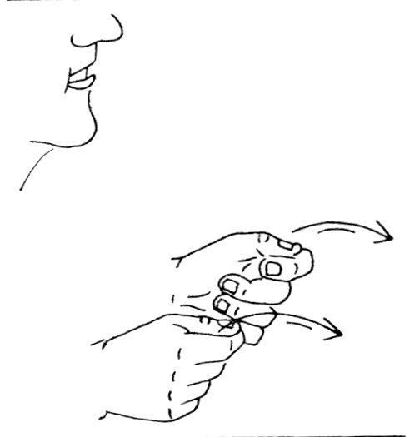  REWARDS | 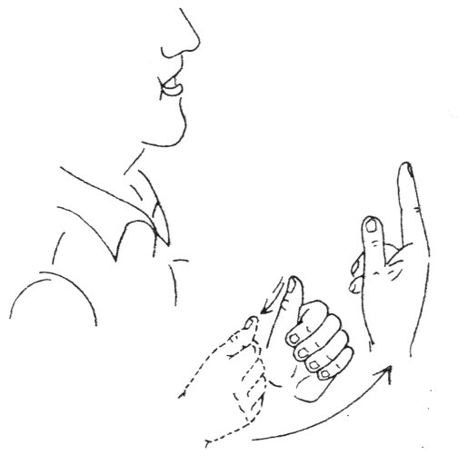  EVERYONE
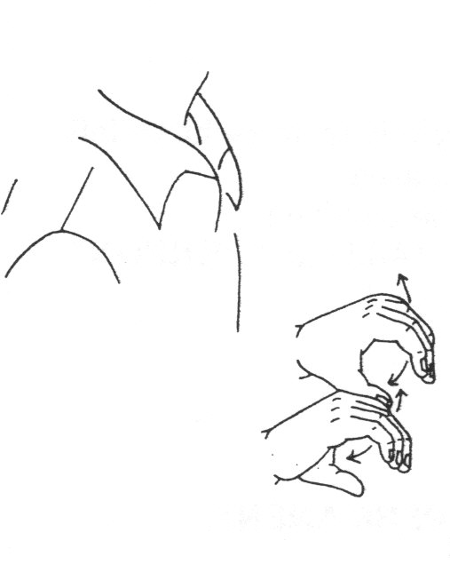  ACTIVITIES | 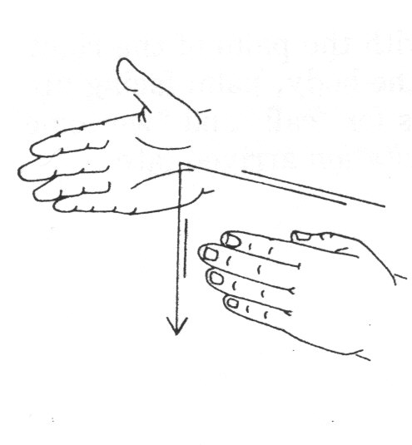  HE DOES | 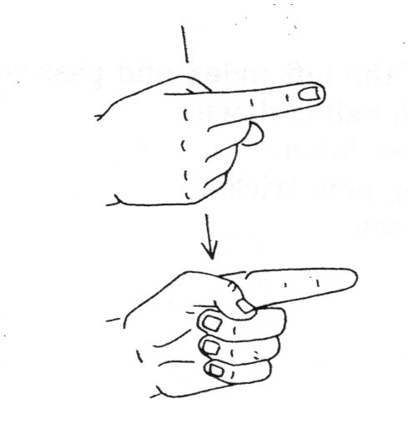  RIGHT
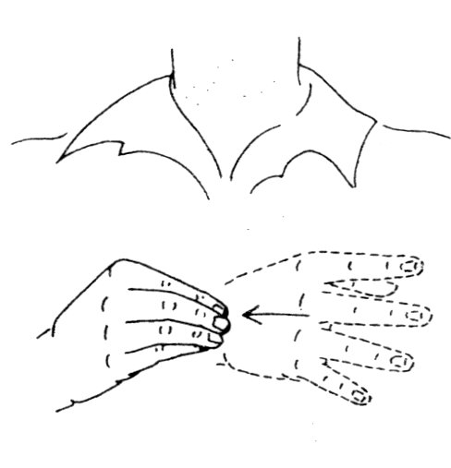  AND | 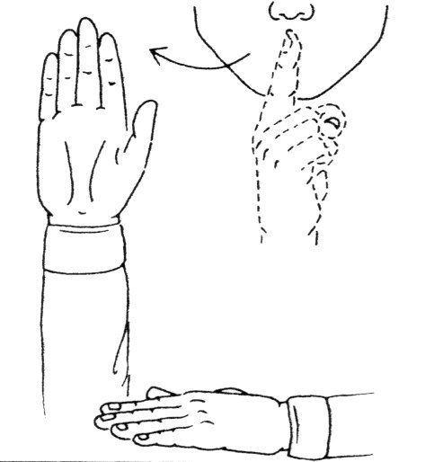  LOYAL | 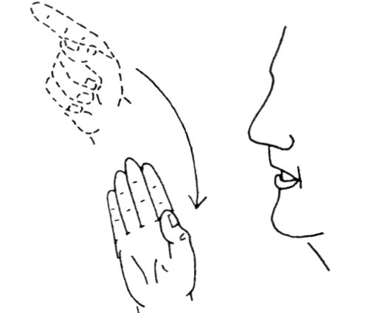  GOD

“What Do You See?”

Large Group Presentation

Daody the Magnifico, the Finger Reader

Puppet Presentation

Dao Dao is dressed in a fortuneteller costume. Additional props are optional: a Magic 8 Ball and a game box marked “Ouija board.”

Teacher: Hello, kids! Welcome to the Sunday school Carnival where we are still lookin’ for a leader. Right now I am looking for my assistant, Dao Dao. Dao Dao, are you there?

Dao Dao: (Appears in costume.) No, he’s not. But I’m here. I’m Daody the Magnifico.

Teacher: Daody the Magnifico? What does that mean?

Dao Dao: That means I’m Daody the Magnificent!

Teacher: Magnificent what?

Dao Dao: Magnificent Finger Reader!

Teacher: Finger reader? You mean palm reader?

Dao Dao: That’s right. You read my mind. Are you a fortune-teller, too?

Teacher: No, I didn’t read your mind. I’m not a fortuneteller.

Dao Dao: Well, I am!

Teacher: No, you’re not, Dao Dao.

Dao Dao: Excuse me, that’s Daody to you. And I am a fortuneteller. I’ll tell you your fortune. You will be in the presence of someone magnificent very soon… in five seconds! Close your eyes. One, two, three, four, five! Now open your eyes.

Teacher: So what?

Dao Dao: Ta-da! Here you are in the presence of Daody the Magnifico! See? I told you so. You are in the presence of someone great!

Teacher: Dao Dao, there is something important for you to learn today.

Dao Dao: My future?

Teacher: No, not your future. There is only one who is truly magnificent and He is God. He holds the future in His hand, and He commanded that we would not try to read fortunes or go to fortunetellers.

Dao Dao: What?! Then what about my fortune telling stuff? Like my crystal ball?

Teacher: God is against it.

Dao Dao: My Magic 8 Ball?

Teacher: Nope.

Dao Dao: My Ouija board?

Teacher: Especially no to that. God is against trying to read the future.

Dao Dao: Oh, come on! Everyone knows I’m just kidding around.

Teacher: Well, you’re not to kid around with trying to read the future or contact different spirits. It is very serious.

Dao Dao: But what if I pretend to be… let me see now… how about a ghostbuster? You know, ”Who ya gonna call? Ghostbusters!”

Teacher: Okay, that was just a “for fun” movie. Think about this, though. Many kids come to believe whatever the movies tell them about ghosts or witches or fortune-telling. And sometimes the movies are just trying to be funny or sometimes scary, but they hardly ever tell you what the Bible says.

Dao Dao: So what does the Bible say about this?

Teacher: In today’s Bible event, we are going to find out how Saul did not turn to God and trust Him. Instead, Saul tried to find out his fortune by going to a witch who was going to bring back the ghost of Samuel.

Dao Dao: Wow! That’s weird. You mean there was a real witch and a real ghost?

Teacher: Yes. There is a real witch talked about in the Bible. And there was a ghost that was seen.

Dao Dao: Wow! I never knew that was in the Bible! Did they have someone who was a ghostbuster, too?

Teacher: No, Dao Dao. But why don’t we just imagine that we do have a ghostbuster who would tell us about what's really true. Let me introduce you to our special guest that will tell us more about Saul and the witch of Endor. Let’s meet him now. Let’s give a big hand for “God’s Ghostbuster.”

God’s Ghostbuster
Dramatic Presentation of Saul and the Witch of Endor

The Bible event of Saul, his consultation with the witch of Endor, and his ultimate demise will be told by a costumed character, God’s Ghostbuster. This character is obviously a takeoff from the movie, Ghostbusters. A costume for the character can be creatively made. Some ideas would include coveralls with a backpack that has a vacuum hose coming out of it with a cross taped to the end. Across the chest of God’s Ghostbuster should be written “FAITH.” Think of imaginative things that could be done with special lighting effects and a fog machine. How about music for entrance and exit?

Though this character is fictional and a bit comical, he can begin with the kids’ frame of reference when it comes to ghosts and the supernatural. Kids see ghosts often portrayed in comical ways. The truth is there is a very present spiritual reality of Satan and his legions of demons that would want us to dabble with attempting mystical contact. This is why God strictly forbade it and why its consequences are so severe. As lighthearted as this character might appear, he is delivering a very serious message: “The LORD rewards every man for things he does right and for his loyalty to Him.”
(1 Samuel 26:23). It is an act of unfaithfulness to consult with any spiritual mediums or attempt to have our futures told.

The script for God’s Ghostbuster is not written out. It has been divided into key thoughts so the main ideas can be more easily memorized and told in storytelling fashion.

Introduction
Hi, kids! Who do I remind you of? Ghostbusters? Okay. How many of you believe there are ghosts like there were in the movie Ghostbusters? How many believe we can vacuum them up with our ghostbuster machine? Nawww. I didn’t think so.

But did you know there is a time when a ghost was seen in the Bible? There was also a witch. And there was someone who was trying to find a fortuneteller. Let me tell you the truth about ghosts and witches and fortunetellers.

Kids, do you believe in fortunetellers? The truth is that there are people who claim to be able to tell fortunes. The power they think they have does not come from God. It actually comes from the devil. That’s why God was so strict and clear about not visiting fortunetellers.

Do you believe in witches? The truth is that there are witches who try to call upon the forces of darkness so they would have special power. God says we should never practice witchcraft or spells.

Do you believe in ghosts? The truth is that when we die our spirits don’t live here on earth. We go to heaven if we know Jesus as our Savior. If we reject Jesus, we go to hell. Yet, there are spiritual forces and demons that can make themselves like ghosts or spirits. We have no reason to be afraid of them, though. God defeated Satan when He gave us Jesus. When we trust in Jesus as our Savior and Lord, we can call upon Him because He is the Ghostbuster!

Now let me tell you a story about a man who went to a witch so he could meet a ghost.

David Was Faithful, Saul Was Not
As you remember from last week, Saul was pursuing David to kill him. Saul was no longer following God’s ways. He was trying by his own power to hang onto his position as king. Even though David had opportunities to kill Saul, he did not take matters into his own hands. He trusted that God would take care of him. He said, “The LORD rewards every man for things he does right and for his loyalty to Him.The LORD put you into my power today. But I wouldn’t harm the LORD’s appointed king.” (1 Samuel 26:23). David was faithful to God. When David was worried about his future, he trusted God to take care of him.

- Saul Visits the Witch
Meanwhile, the prophet Samuel died. Saul had killed many priests. King Saul was looking for someone who could tell him God’s will, but he found no one. Saul was worried because the Philistines were gathering against him in battle. Though he had a large army, Saul had no courage. He did not have faith to trust in God and do things God’s way. As a result, he did not know what would happen in the battle.

Saul decided to visit a witch. Witches were people who called upon the forces of darkness. They tried to contact the dead, find out people’s futures, or cast evil spells. The power they seek comes not from God but from Satan and his demons. God said in His Word very clearly to never cast evil spells or consult fortunetellers or witches (Leviticus 19:26).

Saul was so desperate, though, that he went to see a witch that lived in Endor. Perhaps she could tell him what to do to win the battle.

Saul disguised himself by taking off his kingly clothes. He asked the witch, “Please consult a dead person for me. Conjure up the person I request.”

The woman told him, “You know that King Saul gave the order to rid the land of mediums and physics. Are you trying to trap me?”

Saul took an oath in the Lord’s name. “I swear you will not be harmed if you do this.”

The Witch Agrees to Help Saul
The witch agreed to help Saul. “Whom do you want me to conjure up?” she asked.

“Conjure up Samuel the prophet,” he answered.

The witch did this for him. When she saw Samuel she cried out loudly, “Why did you deceive me? You are Saul!”

The king said, “Don’t be afraid. Just tell me what you see.”

She said, “I see a spiritual being rising from the ground.”

“What does he look like?” Saul asked.

“It is an old man coming up and he is wearing a robe,” the witch answered.

Samuel’s Ghost Appears
Saul knew the ghost was Samuel. He said to the ghost of Samuel, “Tell me what to do. The Philistines are at war with me.”

The ghost of Samuel answered, “The Lord has done to you just what He promised. Your kingdom is being torn from you and given to David. The Lord is doing this because you did not listen to Him or obey Him. For this reason, the Lord will hand you and your army over to the Philistines. You and your sons will be killed.”

Saul Is Killed
The next day the battle began. The Philistines overpowered the Israelites and many were killed. They killed Saul’s three sons, including Jonathan. When the archers got close to Saul, they shot him with an arrow. He was badly wounded. Since he did not want to be captured, he fell on his own sword and died. The Philistines went throughout the territory telling the people that Saul and his sons were dead and the Israelite army had been defeated.

- What Can We Learn?
Could Saul have avoided this tragic end? Did he have to listen to the witch and talk to the ghost of Samuel? No, he could have had faith in God and trusted Him. He could have waited for God to show him what to do. He could have done things God’s way. Saul needed faith. There is one thing that busts up the power of evil forces and that is faith and trust in God. As we rely on Him, He will deliver us.

Was It Really a Ghost?
Was it really the ghost of Samuel that talked to Saul? It is true that God could do anything. If God wanted to speak to Saul by having the ghost of Samuel reappear, God could do that. Probably what happened, though, was that the witch of Endor called up a demonic spirit. These evil spirits can make themselves look like the ghosts of someone who has lived before. Even then, this ghost knew God said that the kingdom would be torn away from Saul and given to David because of Saul’s disobedience.

Saul had lost all hope. If only he had never turned to the witch. He should have kept turning to God and seeking to do what God wanted. If we do that, it is never too late to find hope.

Boys and girls, remember not to goof around with fortune-telling, psychics, or calling upon spiritual forces of darkness. Instead, do what David did and do what it says right here on my chest—have faith! Believe in God. He has won the victory over all the forces of darkness by giving his Son Jesus for us. Let’s just have faith to believe and *Seek God for the answers.

Daody the Magnifico, the Finger Reader

Puppet Presentation Conclusion

Dao Dao: Wow! No more pretend palm reading for me. What could you read from a palm anyway?

Teacher: Let me show you this. (Takes a red marker and puts a dot in the middle of his own palm.) This is all you need to know about your future.

Dao Dao: That you have a red dot on your hand?

Teacher: This red dot on my hand reminds me that Jesus was nailed to the cross for my future. Jesus gave His life so I could be forgiven and live with Him forever. That is what God wants me to know about my future.

Dao Dao: That’s a good future. That’s a lot better to think about than all this other ghost stuff. That kind of gives me the “chilly willies,” if you know what I mean.

Teacher: I know what you mean. I also know there is one more thing you can do to help get rid of those “chilly willies.”

Dao Dao: I know what that is. I need to pray.

Teacher: And I would like to prayer for you.

Dao Dao: Thank you, Teacher.

Teacher: Dear God, we love You so much. Thank You that we don’t have to worry about our future because You already took care of that. You gave Your own Son, Jesus. His palms have holes in them so our sins would be forgiven and we could live with You forever. That’s cool. It’s the most important thing to know about our future. Help us not to goof around with fortunetellers or witches or ghosts or stuff. In Jesus’ name. Amen.

LESSON 12

Small Group Warm-Up
- two tissues for each group
- rubber band for each group

Large Group
- Dao Dao dressed in a “fortune-teller costume”
- Magic 8 Ball (optional)
- game box marked “Ouija board” (optional)
- red marker
- God’s Ghostbuster costume (An idea would include a decorated backpack with a vacuum hose coming out of it and a cross taped to the end. Across the chest of God’s Ghostbuster should be the word “faith.”)

Small Group Application
- copy of “What Do You See?” template
- pens or pencils

Memory Verse Learning
- none needed

