
Date: __________________________
Series: Lookin’ for a Leader
Jun-Aug Year 3, Lesson 14

A Man After God’s Own Heart

Home Point: *God is looking for someone after His own heart. *Repeat this phrase throughout the lesson.

Bible Event: Review of Lessons 1-13
Key Verse: Acts 13:22, “(God) said… ‘I have found that David, son of Jesse, is a man after My own heart. He will do everything I want him to do.’”

We will help kids know:
- A review of the Bible events from the birth of Samuel through the death of Saul.
- What God looks for in a leader is someone who has a heart like His, someone who would do what God would want him to do.

We will help kids feel:
- Convicted of the times our hearts disobey God or are hardened against Him.
- Comforted that God forgives us in Jesus and gives us the power to follow Him as our leader.

We will help kids do:
- Work together to review the lessons.
- Make a heart sculpture out of paper mache.
- Pray they would become someone “after God’s own heart.”

THIS LESSON’S ROADMAP

DESTINATION | PAGE # | DISCOVERIES ON YOUR JOURNEY | SUPPLIES NEEDED
Small Group Warm-Up   | 3 | What kind of leader is God looking for? The kids will play a game in which they will lasso a heart-shaped balloon to find out the answer that God is looking for in a leader after his own heart. | - inflated heart-shaped balloon or regular balloon with a heart drawn on it  - large (four to six inches) rubber band  - six, four-feet long pieces of yarn or string  - paper marked “Acts 13:22” on the front and, “God removed Saul and made David their king. God spoke favorably about David. He said, “I have found that David, son of Jesse, is a man after my own heart. He will do everything I want him to do” on the back.
Large Group   | 4  6 | Overview  Review Question List  Pesta Game with Puppet Presentation: “Dao Dao Helps Review What God Is Lookin’ for in a Leader” | - board or piece of cardboard with various balloons taped to it. At the center of these balloons should be a heart-shaped balloon.  - darts  - Dao Dao  - a jug of Ribena  - paper cups
Small Group Application   | 4 | Use observation questions to review the Bible events studied in this series. Then help the kids make a personal application of today’s point, *God is looking for someone after His own heart. | - one foot strips of crepe paper (in various colors)  - corn starch glue  - heart-shaped balloon for each group  - review questions for each group (pages 6-8)

Small Group Warm-Up: 15 minutes
Purpose: Get pointed in the right direction! Build relationships and help guests feel at ease. Do the learning readiness activity that will point your group in the right direction for the lesson.

Supplies needed: inflated heart-shaped balloon or regular balloon with a heart drawn on it; large (four to six inches) rubber band; six, four-feet long pieces of yarn or string
paper marked “Acts 13:22” on the front and, “God removed Saul and made David their king. God spoke favorably about David. He said, “I have found that David, son of Jesse, is a man after My own heart. He will do everything I want him to do” on the back.

Today we will review the first 12 lessons of this series, from the birth of Samuel to the death of Saul. The theme tying it together answers the question,

What kind of leader is God looking for?

Pose this question to the children. They will have a hint to the answer by playing the following group initiative game.
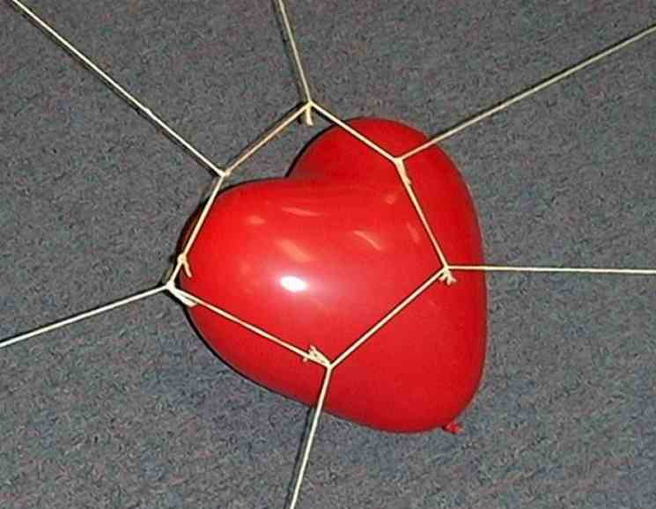
For the game you will need an inflated heart-shaped balloon and a large rubber band that is four to six-inches long when it is unstretched. You will also need six pieces of yarn or string that are each approximately four-feet long. One end of each of these strings needs to be tied at even intervals around the rubber band.

Have six children take an end of each string and pull, stretching the rubber band to expand in diameter so it can be slipped over the balloon.

As those holding the string loosen the tightness of the rubber band, it should lasso the balloon and pick it up. This can only be done as a group project.
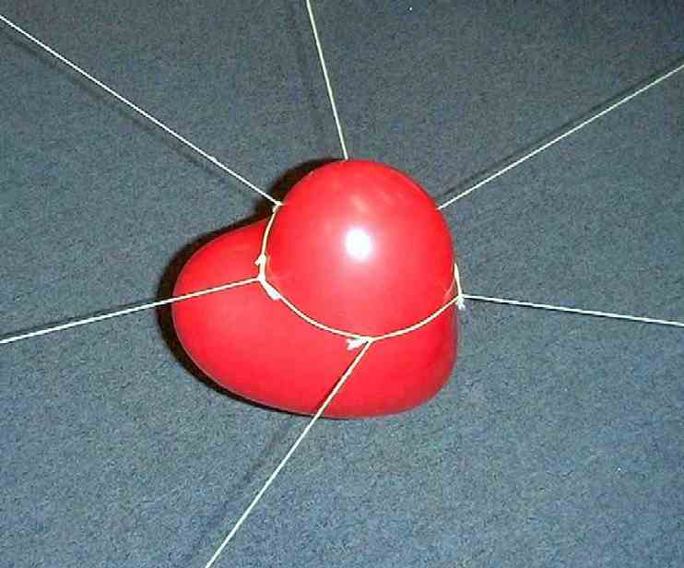

Six children can participate in the game at one time. If your group is larger, divide into two smaller groups and have them compete against each other as to how fast they can lasso the balloon and raise it off the ground. You may even have them carry the balloon and see if they can drop it on a piece of paper marked “Acts 13:22.” In this verse is the answer to the above question.

“God removed Saul and made David their king. God spoke favorably about David. He said, I have found that David, son of Jesse, is a man after My own heart. He will do everything I want him to do.”

The children can look up this verse in the Bible or it can be printed on the backside of the paper. After reading this verse, say:

The kind of leader God is looking for is a man after God’s own heart. These leaders have the desire to do the things that God desires. They desire to be obedient to Him and to love Him. This is also the kind of person we can be.

Today we will review some of the lessons we have learned this summer and will remember *God is looking for someone after His own heart.

Large Group: 20-30 minutes
Purpose: Help kids observe what the Bible says. Present the Bible event in creative fashion. Help kids begin to interpret what it means.

Supplies needed: board or piece of cardboard with various balloons taped to it. At the center of these balloons should be a heart-shaped balloon.; darts; Dao Dao; a jug of Ribena; paper cups

Overview

Carnival Game with Puppet Presentation: “Dao Dao Helps Review What God Is Lookin’ for in a Leader” – Kids get the opportunity to answer review questions when they hit a balloon with a dart.

Small Group Application: 20-25 minutes
Purpose: Help kids map out the meaning of the Bible event in their lives. Use the questions to stimulate discussion but don't feel tied to them. Allow the Holy Spirit to guide you. Include personal examples from your own faith journey. The example of Christ at work in your life will leave lasting impressions of how Christ can work in the children's lives.

Use your Bibles! Children need to learn how to look up references and follow along when scripture is read aloud. Allow for quality time of prayer at the close of the lesson.

Supplies needed: one foot strips of crepe paper (in various colors); corn starch glue; heart-shaped balloon for each group; review questions for each group (pages 6-8)

Observation Questions: What happened?
Small group application time will primarily be used to ask observation questions reviewing the content of the Bible events through the summer. See pages six through eight for the review questions.

To encourage kids in their Bible skills, references are given so that children can look up answers in their Bibles.

To reinforce the main point for the day, *God is looking for someone after His own heart, the group gets a one-foot strip of crepe paper for each question they answer correctly. They will dip the crepe paper in corn starch glue and wrap it around an inflated heart balloon. The finished product should be a paper mache heart.

Application Questions: What does this mean to me?

The central theme of this lesson is that God was looking for someone who had a heart after His heart. He found such a person in David. Help the children make personal application of this point in their own lives.

After the review questions, continue with the following questions for discussion. Feel free to include application from your own life, as well.

When has your heart not been “after God’s heart?” (When we disobey or don’t care about what God wants.)

How does God help us get our hearts right again? (When we trust in Jesus as our Savior, God gives us forgiveness and the desire to have hearts after His own heart.)

How do you think you can have a heart after God’s heart this week? (Come up with your own personal application.)

Prayer Time:
Use the prayer time to recap the conviction of confession and the comfort of forgiveness in Jesus. Let all children think of something they can pray for that demonstrates they have a heart after God’s own heart.

Large Group Presentation

“Lookin’ For a Leader,” Lessons 1-13

Question List

- Hannah was a woman who came to the tabernacle to worship every year. Every year she was sad and cried out to the Lord to answer a special prayer for her. What did she want from the Lord? (1 Samuel 1:10-11. A baby.)

- Hannah promised God that if she were to be given a baby, she would do something special with that baby. What would she do? (1 Samuel 1:11. Dedicate him to the Lord’s service.)

- What was the name of Hannah’s baby? (1 Samuel 1:20. Samuel.)

- When Samuel was growing up in the temple, he heard a voice call to him one night. Whose voice did he first think it was? (1 Samuel 3:4. Eli, the priest.)

- After hearing this voice three times, Eli told Samuel what to say if he heard the voice again. What was he to say? (1 Samuel 3:9. Samuel was to say, “Speak, for your servant is listening.”)

- Who was it that was speaking to Samuel? (1 Samuel 3:8. God.)

- Were Eli’s sons good leaders or bad leaders? (1 Samuel 2:12. Bad leaders.)

- When the Israelites were fighting against the Philistines, they decided to use a secret weapon. By using this secret weapon they thought they could bring the presence of God and make Him win the battle for them. What was their secret weapon? (1 Samuel 4:3-5. The Ark of the Covenant.)

- Did the Israelites win or lose the battle? (1 Samuel 4:10-11. They lost the battle. Eli’s two sons were killed and the ark was captured.)

- The Philistines took the ark and put it in the temple of their god, Dagon. What happened to the statue of Dagon when they placed the ark there? (1 Samuel 5:1-5. The statue fell over and its head and hands broke off.)

- What happened to the people in the Philistine cities where the ark was kept? Did good things happen to them while they held the Ark of the Covenant or did people break out in sores and die? (1 Samuel 5:6. They broke out in sores and died.)

- How did the Philistines send the ark back to Israel? (1 Samuel 6:8. It was placed on a cart and two cows pulled it to where the Israelites lived.)

- Samuel was now a grown man and a prophet for the Israelites. He led them by showing them God’s plan. The people asked for a king. Was God happy they asked for a king? (1 Samuel 8:6-8, 1 Samuel 10:19. No. The Israelites asked for a king because they wanted to be like the other nations around them who did not follow the true God.)

- What did Samuel say would happen to them if they were to have a king? (1 Samuel 8:11-20. The kings would take the people’s money and force them to go to war. Some kings would even lead them away from God.)

- Did God still let them have a king? (1 Samuel 8:22. Yes. Some of these kings were good and wanted to serve God.)

- Who did God choose as the first king? (1 Samuel 9:17. Saul.)

- Was Saul tall, good-looking, and popular with the people or was he skinny and weak? (1 Samuel 9:2. Saul was tall, good-looking, and popular.)

- When it was time to announce Saul as king, he was hiding. Where was he hiding? (1 Samuel 10:22. In the baggage or luggage.)

- Saul led the people to fight against the Philistines. Before they were to fight, Saul was supposed to wait for the prophet Samuel to come and offer a sacrifice. When Samuel did not come, what did Saul decide to do? (1 Samuel 13:8-9. Make his own sacrifice. Saul was taking things into his own hands and not trusting the Lord to take care of it.)

- Saul again disobeyed God when God told Saul to attack and destroy the Amalekites. Saul was not supposed to save anything. What did Saul do? (1 Samuel 15:8-9. He saved some of the best things for himself and his men. He later tried to blame it on his soldiers. He made excuses that these things would be used for sacrifice.)

- Since Saul did not follow God with his whole heart, whom did God choose to be the next king? (1 Samuel 16:12-13. David, youngest son of Jesse from Bethlehem.)

- King David was the youngest of the eight sons of Jesse. When the prophet, Samuel was having dinner with Jesse and his sons, David was not there, even though he was the one to be anointed as king. Where was he? (1 Samuel 16:11. In the fields taking care of sheep.)

- Sometimes King Saul would act crazy and David would help him relax. What did David do to soothe Saul? (1 Samuel 16:23. Play music.)

- What was the name of the giant that David killed? (1 Samuel 17:4. Goliath.)
- Why was David confident that he could kill Goliath? (1 Samuel 17:37. Because he knew God was on his side and had already helped him kill the lion and the bear.)

- Saul was so jealous of David he tried to kill him. What did he throw at him? (1 Samuel 18:10-11. A spear.)

- When Saul was tracking after David one time, he went to rest in a cave. Who else was in that cave? (1 Samuel 24:3-7. David and his men. David did not harm Saul even then.)

- One time David could have killed Saul when he snuck into Saul’s camp at night when he was asleep. Instead of killing Saul, David took two things. What did he take? (1 Samuel 26:7-11. A spear and his water bottle.)

- What was the name of King Saul’s son who was David’s best friend? (1 Samuel 18:1-3. Jonathan.)

- Jonathan promised to watch out for David. He did this by sending David a secret message that David should keep running away from King Saul. What did Jonathan shoot in the air? What did he tell his servant boy? (1 Samuel 20:36-38. Jonathan shot three arrows and he told his servant boy to go further as he looked for the arrows. David heard this and knew he was to go further himself.)

- Saul finally contacted a witch to find his future. Who did he ask the witch to bring back to life? (1 Samuel 28:11. Samuel the prophet.)

- What did the ghost of Samuel tell King Saul? (1 Samuel 28:18-19. He would die along with his sons in the upcoming battle. It happened just that way.)

“Dao Dao Helps Review - What God Is Lookin’ for In a Leader”

Puppet Presentation

Today’s carnival game is a board or piece of cardboard with various balloons taped to it. At the center of these balloons should be a heart-shaped balloon. The object of the game will be to throw darts and hit the center heart-shaped balloon. If the center balloon is hit, kids can win the game by correctly answering the question, “What kind of leader is God looking for?” (Answer: “A person after God’s own heart.”) If the first child fails to answer correctly, the next contestant can have an opportunity to answer for the win.

Select five boys and five girls to come forward and sit on the floor until he/she has a turn at throwing darts. The boys are one team and the girls are another. Each child gets to throw one dart. Not every child may have a turn because the game might end as soon as someone hits the center balloon. However, if a child hits one of the balloons surrounding the center balloon, he is given a question. If the child answers the question correctly, he is given another turn at trying to hit the center balloon. If he misses a balloon, a child from other team takes a turn.

The large group presenter may permit a child to ask the other teammates for help with the answer. The questions used for this game are found in the appendix. All of the questions should not be asked because the remaining questions will be asked in the small group time. This large group game should whet the kids’ appetite for individually answering these review questions in their small groups.

Introduce the game:

Teacher: Hi, boys and girls. Welcome to Pesta Sunday school. I’m Teacher _____________.

Dao Dao: And I’m Dao Dao!

Teacher: I’m looking for five boys and five girls. As I point to you, I will number you off one through five. I’ll ask that you come forward and sit on the floor. Boys will sit on one side and girls will sit on the other side.

Dao Dao: And where do I sit?

Teacher: You’re fine right there.

Dao Dao: What are we going to do, Teacher?

Teacher: Today we are trying to answer the question, “What kind of leader is God lookin’ for?”

Dao Dao: We've been talking about that these three months.

Teacher: We sure have. We have been studying the prophet Samuel, King Saul, and now the new king, David.

Dao Dao: So what kind of leader is God lookin' for?

Teacher: Well, it is going to be the kids’ job to answer that question. They can't answer it now. First, they have to hit the center balloon.

Dao Dao: The one shaped like a heart?

Teacher: Yes.

Dao Dao: What happens when they do?

Teacher: I’ll ask them the question, “What kind of leader is God lookin’ for?” Hopefully, they will remember what they heard in warm-up to answer the question.

Dao Dao: Then what do they get?

Teacher: How about a jug of Ribena?

Dao Dao: Cool! What if they hit one of those other balloons?

Teacher: If they hit one of the other balloons, I will ask them one of the review questions. If they get a review question right, I will give them another dart to throw at the center balloon.

Dao Dao: What if they miss that?

Teacher: Then the turn goes to the other team.

Dao Dao: Then the other team has a chance and then it goes back to the next person in line on the first team.

Teacher: I think you understand it, Dao Dao. How about you, boys and girls? Any questions?

Okay. Let’s begin.

(Dao Dao ad-libs as children throw darts and are asked questions accordingly. After the heart-shaped balloon is hit and the children arrive at the answer “a person after God’s own heart,” Dao Dao’s script continues.)

Dao Dao: Hey, wait a minute! What does it mean to be a person after God’s own heart?

Teacher: It means that your heart’s desire is to do what God’s heart desires.

Dao Dao: Well, what does God want?

Teacher: God wants all people to know how much He loves them and to know Jesus whom He sent for them.

Dao Dao: If my heart were after God’s own heart, I would want people to know Jesus, too.

Teacher: You bet you would.

Dao Dao: And I’d be willing to do whatever God wants me to do.

Teacher: You bet.

Dao Dao: Like winning a jug of Ribena for getting the right answer.

Teacher: That’s right, but you didn’t get the right answer.

Dao Dao: Wait a minute. I think you didn’t have the right answer.

Teacher: I sure did. God says He chose David because He was a man after God’s own heart.

Dao Dao: Yeah, but God can choose me because I’m a kid after God’s own heart. Get it?

Teacher: Oh! I guess I do get it. Well, you are right. You can be a kid after God’s own heart and He will use you to help lead others to Him.

Dao Dao: So where’s my jug of Ribena?

Teacher: Here’s a jug for you. Now that you’re a kid after God’s own heart, you would probably do what God would do.

Dao Dao: What’s that?

Teacher: You would share the Ribena just like God shared his Son, Jesus.

Dao Dao: Oh, no!

Teacher: Oh, yeah.

Dao Dao: Okay, here it is. Teacher, please help me serve the children some Ribena. Well, that’s okay. It’s worth being a kid after God’s own heart.

Teacher: It sure is, Dao Dao. Thank you for showing us that. Boys and girls, after we pray, you will go back to your small group and review questions from our lessons this summer. These lessons show how God was lookin’ for a leader. Sometimes He didn’t find very good ones, but He can find them right here this morning. He can find kids willing to follow after God’s own heart.

Let me close us with prayer.

Dear God, we know You’re looking for someone to follow after Your own heart. You want people who will love You and do what You want. You want people who will help others get to know You also. Help all of us to be kids after Your heart. Bless us this time as we think about some of the stuff we’ve learned this summer from the Bible. In Jesus’ name. Amen.

Lesson 14

Small Group Warm-Up:
- inflated heart-shaped balloon or regular balloon with a heart drawn on it
- large (four to six inches) rubber band
- six, four-feet long pieces of yarn or string
- paper marked “Acts 13:22” on the front and, “God removed Saul and made David their king. God spoke favorably about David. He said, “I have found that David, son of Jesse, is a man after my own heart. He will do everything I want him to do” on the back.

Large Group
- board or piece of cardboard with various balloons taped to it. At the center of these balloons should be a heart-shaped balloon.
- darts
- Dao Dao
- a jug of Ribena
- paper cups

Small Group Application:
- one foot strips of crepe paper (in various colors)
- corn starch glue
- heart-shaped balloon for each group
- review questions for each group (pages 6-8)

