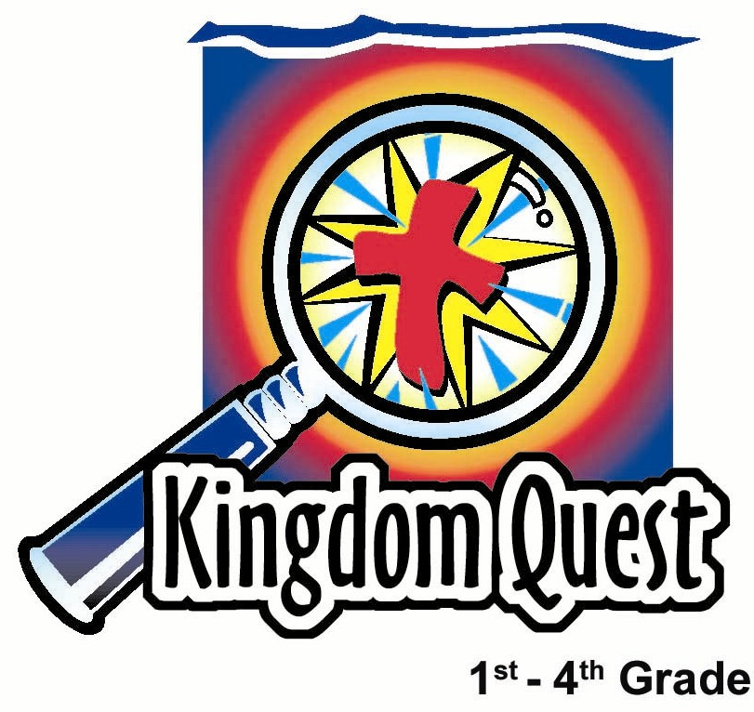
Date: ______________________
Series: Lookin’ for a Leader
Sep-Nov Year 3, Lesson 18

David Repents

Take Home Point: *Confess sin and bring your broken heart to God. *Repeat this phrase throughout the lesson.
Bible Event: Psalm 51 and 2 Samuel 12
Key Verse: Psalm 51:17, “The sacrifice God wants is a willing spirit. God, You will not reject a heart that is broken and sorry for its sin.” (NCV)

We will help kids know:
- The Bible event of David hiding his sin with Bathsheba and Nathan’s confrontation of that sin.
- We should not hide our sin but confess it and bring our broken heart to God.
- Through His death and resurrection for us, Jesus lifts our punishment of sin and gives us His forgiveness.

We will help kids feel:
- Confident in approaching God and receiving His forgiveness.
- Caution in the danger of hiding sin or covering it up.

We will help kids do:
- Identify times in their lives when they have done something wrong and tried to cover it up.
- Talk about how making excuses is covering up sin.
- Pray from the heart about issues in their lives for which they need to confess their sins and receive God’s forgiveness.

THIS LESSON’S ROADMAP

DESTINATION | PAGE # | DISCOVERIES ON YOUR JOURNEY | SUPPLIES NEEDED
Small Group Warm-Up   | 3 | What do we do after we have done something wrong? Most of the time we want to hide it. Play a game in which hiding is involved to get the kids to start thinking about how we sometimes want to hide our sin. | - full-size marshmallows
Large Group   | 4  8  11  14 | Overview  Carnival Game with Puppet Presentation: “Dao Dao and the Smooshed Marshmallow”  Bible Event Presentation: “Storyteller’s Version of David and Nathan”  Puppet Conclusion: “Dao Dao and the Smooshed Marshmallow” Conclusion | - three cups  - table or smooth surface  - six large marshmallows  - Dao Dao  - large marshmallow for Dao Dao  - marshmallow man made with marshmallows and toothpicks (see small group application)  - marshmallow sheep  - mousetrap  - paper towel or cloth
Small Group Application   | 4 | David had been caught in the trap of his sin. Covering up his sin did not fix his brokenness. Jesus took our sin and punishment when He died on the cross. God does not want us to hide our sin, but we should give it to Him by repenting.  Memory Verse Learning:  “Say It With Your Mouth Full”  Psalm 51:17 emphasize in lessons 15-18 encourages a child to pray from the heart about issues in their lives for which they need to confess their sins and receive God’s forgiveness. | - two large marshmallows and six small marshmallows for each group  - four toothpicks for each group  - mousetrap for each group  - paper towel  - marshmallow cross for each group  - marshmallows
Small Group Warm-Up: 15 minutes
Purpose: Get pointed in the right direction! Build relationships and help guests feel at ease. Do the learning readiness activity that will point your group in the right direction for the lesson.

Supplies needed: full-size marshmallows

The warm-up game will require full-size marshmallows and poker faces. Begin with the following warm-up question.

Every one of us has done things that are wrong from time to time. Today’s question is, “What do we do after we have done something wrong?” Most of the time, we want to hide it or cover it up.

Can you remember a time when you did something wrong and wanted to hide? Have you ever done something wrong and you wanted to cover it up? If you can think of a time like this and tell us about it, you will be the first one to be “it” in the game we are playing.

After a child shares his story, he is “it.” He turns from the rest of the group while one marshmallow is passed out to the other kids. One child will place a marshmallow in her mouth, and she will be the mystery person. The child who is “it” will turn around and look at all the kids’ faces to determine which one has a marshmallow in her mouth. The child tries until he guesses correctly. The person with the marshmallow then becomes “it” and is invited to answer the same question.

Play the game a few times. Then say:

When we go into large group today, I want you to think about David. He was a good king who followed God, but last week we saw how he made a terrible mistake. David sinned with Bathsheba. What do you think he did next? Did David try to hide it or did he give it to God? We will find out the answer in large group.

Today we will learn how important it is to *confess sin and bring our broken hearts to God.

Large Group Overview: 20-30 minutes
Purpose: Help kids observe what the Bible says. Present the Bible event in creative fashion. Help kids begin to interpret what it means.

Supplies needed: three cups; table or smooth surface; six large marshmallows; Dao Dao; large marshmallow for Dao Dao; marshmallow man made with marshmallows and toothpicks (see small group application); marshmallow sheep; mousetrap; paper towel or cloth

Carnival Game with Puppet Presentation: “Dao Dao and the Smooshed Marshmallow” –Teacher does the three-cup carnival trick with smooshed marshmallows to make the point that we often try to hide our sin from God.

Bible Event Presentation: “Storyteller’s Version of David and Nathan” –The events in 2 Samuel 12 are covered, as well as David’s words of confession found in Psalm 51.

Puppet Conclusion: “Dao Dao and the Smooshed Marshmallow”

Small Group Application: 20-25 minutes
Purpose: Help kids map out the meaning of the Bible event in their lives. Use the questions to stimulate discussion but don't feel tied to them. Allow the Holy Spirit to guide you. Include personal examples from your own faith journey. The example of Christ at work in your life will leave lasting impressions of how Christ can work in the children's lives.

Use your Bibles! Children need to learn how to look up references and follow along when scripture is read aloud. Allow for quality time of prayer at the close of the lesson.

Supplies needed: two large marshmallows and six small marshmallows for each group;
four toothpicks for each group; mousetrap for each group; paper towel; marshmallow cross for each group

Allow for a large amount of time to be spent during this small group session helping kids have a clear understanding of how to respond to his own sin.

We can learn from King David and his mistake that we should not cover up sin, make excuses for it, or try to hide it from God. We should tell God about our sins right away and ask for forgiveness through Jesus. We should remember that Jesus took the punishment of our sins upon Himself when He died on the cross. That does not mean we will not have consequences for our sin, but it does mean that sin cannot separate us from having a friendship with God.

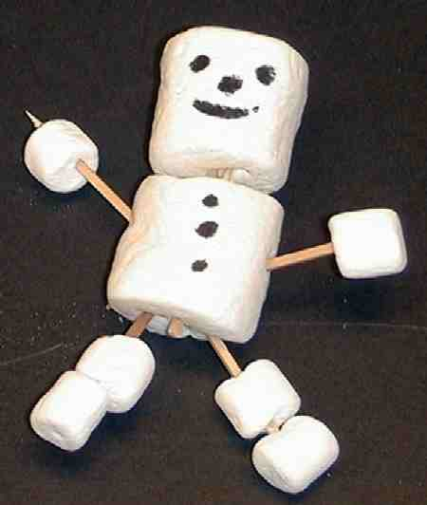
While the questions below are reviewed, invite the children to help assemble one marshmallow man that will remind them of David. Each child who answers a question can put a marshmallow on a toothpick.

Observation Questions: What happened?
What was the name of the woman David wanted to have as his wife? (2 Samuel 11:3. Bathsheba.)

What was Bathsheba’s husband's name? (2 Samuel 11:3. Uriah.)

What did David do to Uriah to cover up his sin of being with Bathsheba? (2 Samuel 11:14-15. David had Uriah killed in battle.)

Did David think he got away without anyone knowing about his sin? (Yes.)

Who knew about David’s sin? (God.)

What was the name of God’s prophet who talked to David? (2 Samuel 12:1. Nathan.)

Nathan told a story about two men. One man was very rich and the other man was what? (2 Samuel 12:1. Very poor.)

The poor man had a special pet. What kind of animal was it? (2 Samuel 12:3. A female sheep.)

A terrible thing happened to the sheep. What was it? (2 Samuel 12:4. The rich man stole it and made a meal out of it for his guest.)

Interpretation Questions: What does this mean?
Which one of these men was David like? (2 Samuel 12:5-7. The rich man who stole the sheep.)

When David finally had his sin uncovered, was he sorry for what he did? (2 Samuel 12:13. Yes, very much.)

Application Questions: What does this mean to me?
Read some verses from Psalm 51. Set a mousetrap and have it spring to damage the David marshmallow man. Cover the David figure with a paper towel or serviette and note how merely covering up sin up did not help David.

David had been caught in the trap of his sin. Covering up his sin did not fix his brokenness. Let’s see what did fix his brokenness.

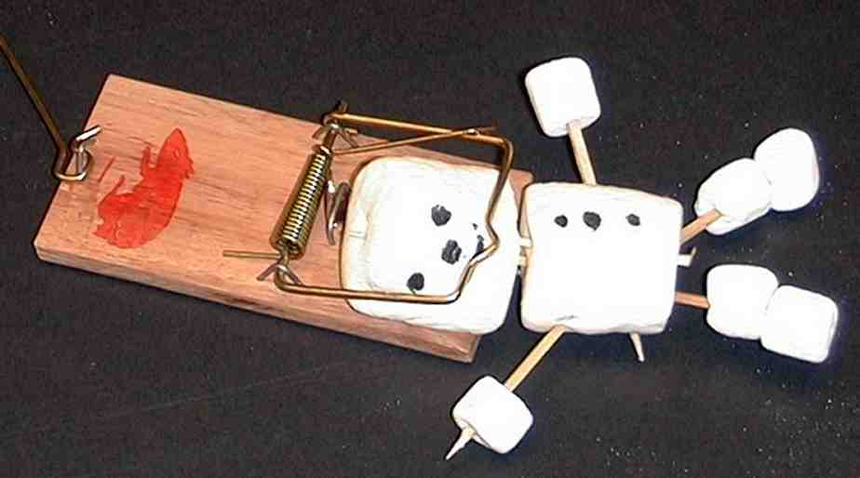

Read 2 Corinthians 5:21.

“God had Christ, who was sinless, take our sin so that we might receive God’s approval through Him.”

Jesus took our sin and our punishment when He died on the cross.

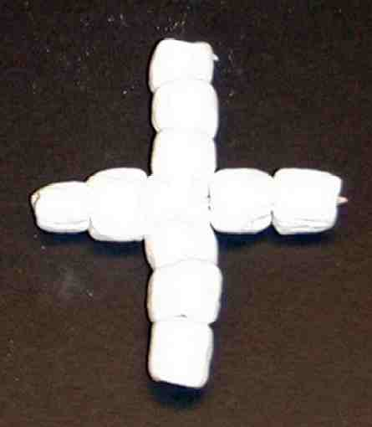
To demonstrate this, remove the smooshed marshmallows from the entrapped David figure and set them aside. Repair the David figure with new marshmallows to form a marshmallow cross. (The cross can be made from toothpicks and marshmallows.)

See the exchange? Jesus’ perfection was given to us. He took our punishment and brokenness. God says He does not want us to hide our sin, but we should give it to Him by repenting. After all, God knows about our sins anyway. God tells us in Psalm 51:17:

“The sacrifice God wants is a willing spirit. God, You will not reject a
heart that is broken and sorry for its sin.”

Conclude the discussion with the general topic of bringing to God a broken spirit and contrite heart. Let children have a toothpick and pick up a marshmallow to eat after they share an example from their own lives. These sample questions will help stimulate conversation.

Making excuses for our bad behavior is often the same as trying to cover up our sin and not face it. What are some common excuses that you say or hear others in your family say? Take answers. What should we say instead? Take answers.

Some people may think there are things they do that are so bad they can never tell God about them. What do you think some of those things could be? What would you tell that person?

Look again at the verses from Psalm 51. Let the children pick out one verse or some words that they really like. Have them explain why they like those verses.

Memory Verse Learning: 5 minutes
Purpose: Help kids to memorize and keep scriptures at heart. Using creative ways to help kids enjoy learning the key verse and in small group setting.

Supplies needed: marshmallows

Memory Verse: Psalm 51:17, “The sacrifice God wants is a willing spirit. God, You will not reject a heart that is broken and sorry for its sin.”

Memory Verse Presentation: “Say It With Your Mouth Full”
Review Psalm 51:17 several times with the children then ask for a volunteer to recite the verse. When the volunteer come before the shepherd, he tells the child not to begin until three or four marshmallows has been put into his mouth. The child cannot eat or swallow the marshmallows until he had complete recitation. Continue the same with more volunteers. (If the shepherd does not desire marshmallows, one can use biscuits instead. But be prepared for a lot of crumbs flying out of the mouths.)

Prayer Time:
Coach the children not to hide sin but to give it to God by being sorry for it. Then ask God to forgive them because of Jesus, and ask Him to change us to be more like Jesus.

Help kids find an authentic way to confess their sins and receive complete forgiveness. You might encourage them to have a quiet prayer time or you might encourage group participation by asking every child to pray for one thing they often get in trouble for.
Safety and Security: Safety and security procedures are important for each church to carefully define and implement according to their unique needs. The security, safety, illness and accident procedures described in this curriculum are provided for example purposes only and may not be appropriate, applicable or adequate for every situation. Each church is responsible for determining whether any security, safety, illness and accident procedures contained in the curriculum are appropriate, applicable or adequate for its unique situation. The activities described in this curriculum require adult supervision and may not be suitable for each child and each situation. Each church is responsible for ensuring that adequate adult supervision is provided for all activities and for determining whether an activity is appropriate for each child and each situation. Kids Kount Publishing disclaims all liability for the implementation of any procedures or the performance of any activities described in this curriculum.

Large Group Presentation

Dao Dao and the Smooshed Marshmallow

Puppet Presentation

The carnival game is a familiar game in which three cups are turned over on a table or smooth surface. One cup is concealing an object the contestant is challenged to find after the cups have been moved.

Three marshmallows will be used in this game. Two of these marshmallows should be smooshed by pinching in the sides, and one should be left in good form. The contestant will be shown all three marshmallows as the three cups are being placed over them. With some practice, the large group presenter can make the movement of the cups deceptive. A key to doing this is moving two cups at a time and keeping a steady, fast pace. Even so, most children ought to be able to identify the cup holding the unsmooshed marshmallow.

The trick in this game is that the large group presenter smooshes the marshmallow in his hand as he reaches for the marshmallow beneath the cup. Because of this, the child will always guess the wrong cup. Eventually, the children should realize the game is rigged and the large group presenter has cheated.

Teacher: Hi, boys and girls. I’m Teacher ___________.

Dao Dao: And I’m Dao Dao! Welcome to Pesta Kingdom Quest!

Teacher: We are looking for some really slick kids. I need a volunteer right now.

Dao Dao: I think I see one there. There’s a slick kid.

Teacher: Okay, you can come up for today’s pesta game. (Invites a child onstage.)

(Dao Dao ducks off stage and fills his mouth with a marshmallow that he conceals by squishing his mouth shut.)

Teacher: As you can see, boys and girls, I have three cups here. I am going to turn these upside down over three marshmallows. I have my three marshmallows right here. (Only two are present.)

Hey, wait a minute! The marshmallows are supposed to be right here. Dao Dao, have you seen my third marshmallow?

Dao Dao: (Marshmallow falls out of his mouth.) No, I sure haven’t.

Teacher: Yuck! What is that goop coming out of your mouth?

Dao Dao: What goop?

Teacher: That goop.

Dao Dao: I don’t see any goop.

Teacher: It looks like a smooshed marshmallow. How did it get there?

Dao Dao: I don’t see any smooshed marshmallow. (Teacher holds it in front of Dao
Dao.) Oh! You mean that smooshed marshmallow. Well, I . . . uh . . .

Teacher: Dao Dao, we are going to talk about hiding our sin by covering it up.

Dao Dao: What sin?

Teacher: Well, like that smooshed marshmallow. Let me get another marshmallow and let’s get on with our game.

As you can see, boys and girls, I have two smooshed marshmallows and one marshmallow that is unsmooshed. Now, contestant, please keep your eye on the cup with the unsmooshed marshmallow.

(Teacher takes several seconds to move the cups around. At the same time, Teacher is bantering with contestant.)

Teacher: I can see you have made your choice. Let’s look underneath.

(If the child has made the right choice, Teacher smooshes the marshmallow and pretends to be innocent.)

Teacher: What do you mean I smooshed the marshmallow? I didn’t cheat. You can’t prove it.

Dao Dao: Oh yes, we can, Teacher.

Teacher: How?

Dao Dao: Look under the other two cups.

Teacher: (Looks under other two cups.) Oh! I guess you’re right. How did all three of these get smooshed? Oh, but maybe that’s the point.

Dao Dao: Smooshed marshmallows?

Teacher: No. The point is that when we cheat or do wrong, we often try to cover it up or hide it from God. Our hidden smooshed up marshmallows represent the sin and brokenness in our lives that we often try to hide from God. God wants to take our “smooshedness” (the Bible calls it brokenness) and help it get better.

Dao Dao: How do we do that?

Teacher: We can do that by confessing our sin to God and claiming what Jesus has done for us so that we would be forgiven. Let’s find out more about that. Thank you very much, contestant.

Jesus takes our smooshed brokenness and trades it for the perfect life He lived for us. Let’s find out more about that as we listen to David’s story.

I need the storyteller to come up now. Let’s find out more about how God is lookin’ for a leader and found one in King David (even though he made some serious mistakes).

Storyteller’s Version of David and Nathan
Bible Event Presentation

A storyteller will present the story of Nathan, his parable, and David’s repentance with some of his words from Psalm 51. The storyteller will use marshmallows, as well, to talk about David and Nathan.

The storyteller comes onstage with his props. If he has practiced and is somewhat talented, he can create the marshmallow props as he speaks. Doing so would captivate the children.

The best option for telling this story is to speak it from memory while referring to the Bible. The following story is but a simple narrative that can be placed in your Bible to help you tell the story and illustrate it with the props. Storytellers need to practice using gestures, various inflections, and vivid facial expressions.

SECTION 1: Reviewing Last Week’s Story
(During the telling of this part of the story, use the marshmallow man to symbolize David. David can be constructed while telling the story. When David is trapped by sin, place a section of the marshmallow man into the mousetrap. Let the mousetrap snap and break part of the marshmallow man. Lay him on the table while still caught in the mousetrap. Take the paper towel or cloth and cover him before continuing.)

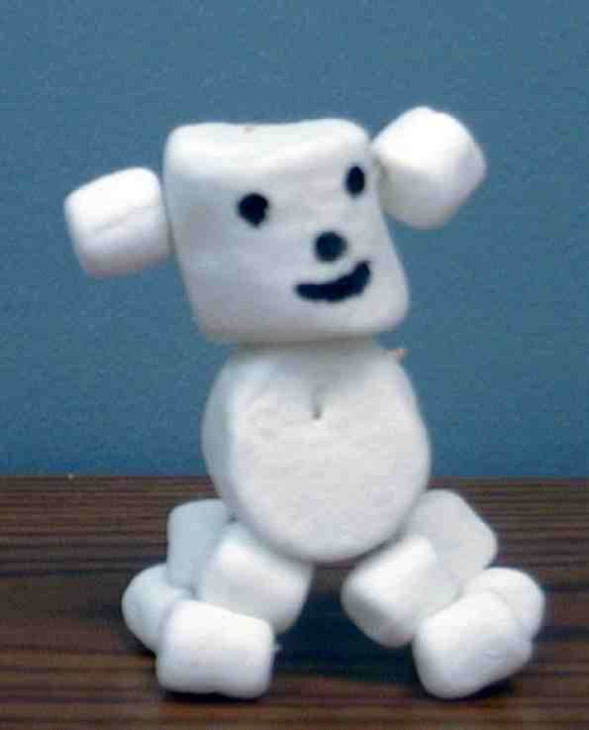
Remember last week when we heard how David was trapped in sin? That event is written in 2 Samuel 11. Do you remember what happened? Let me see here. David was on the roof of his palace and he noticed a beautiful woman who was the wife of one of his soldiers, Uriah. He shouldn’t have wanted her as his own wife but he kept thinking about her and wanting her as his wife. Finally, he took her as his wife while her husband was away fighting in the wars. David then gave orders to his soldiers to let Uriah get killed in battle. He had committed one sin, stealing Bathsheba as his wife, but tried to cover it up with another sin, killing Uriah, her husband.

SECTION 2: God Uncovered David’s Sin
(For this section, allude to or construct a marshmallow sheep while telling this part of the story from 2 Samuel 12.)

In the next chapter, 2 Samuel 12, we read how God uncovered David’s sin. The Lord sent Nathan, His prophet, to see David. Nathan told him this story.

There was a very rich man and a poor man who were neighbors. The rich man had many sheep and great wealth. The poor man only had one lamb, which was a family pet. This lamb was treated like one of his own children. It even ate at the dinner table with the family.

It so happened, that one day the rich man had a guest, and he needed some food to serve his guest. Though the rich man had hundreds of sheep to choose from, he stole the poor man’s pet lamb and cooked it for the traveler. (Peel off some of the marshmallows from the sheep and eat them.)

Nathan asked David, “What should happen to this rich man?” David’s response was quick, “The man who did this deserves to die.”

“You are that man,” Nathan replied. Nathan explained that David was the one who had done wrong in stealing Bathsheba and having her husband put to death. The truth cannot be hidden from God.

David admitted his wrong and uncovered his sin, but David would still have consequences for his sin. From then on, David would have trouble with his children and the child he had with Bathsheba would die.

So, what did David do then? He turned to the Lord to admit his sin and ask for forgiveness. Here are some of the things he wrote in one of his psalms.

“The sacrifice God wants is a willing spirit. God, You will not reject a heart that is broken and sorry for its sin.” (Psalm 51:17)

“Wash away all my guilt and make me clean again. I know about my wrongs. I can’t forget my sin. You are the one I have sinned against. I have done what You say is wrong. So You are right when You speak. You are fair when You judge me.” (Psalm 51:2-4)

“Create in me a pure heart, God. Make my spirit right again. Do not send me away from You. Do not take Your Holy Spirit away from me. Give me back the joy that comes when You save me. Keep me strong by giving me a willing spirit.” (Psalm 51:10-12)

Did God forgive David? What do you think? (This question will be answered in the puppet conclusion. The storyteller exits.)

Dao Dao and the Smooshed Marshmallow

Puppet Conclusion

Dao Dao: So, Teacher, did God forgive David?

Teacher: What do you think?

Dao Dao: I think he did.

Teacher: You’re right. Remember more than anything else, God wants to take away the sin that blocks our relationship with Him.

Dao Dao: Yeah, that’s why He sent Jesus, isn’t it?

Teacher: Exactly! Because Jesus gave His life for us, we can all have forgiveness. David received forgiveness. He trusted God, he was sorry for his sin, and he didn’t try to hide it from God. David admitted his sin to God.

Dao Dao: But he still got punished, didn’t he?

Teacher: Yes, David still had consequences. Because of his sin, the baby he and Bathsheba had would die. God still can make good things happen, though.

Dao Dao: Like what?

Teacher: Well, they had another baby. Do you know what his name was?

Dao Dao: What?

Teacher: Solomon.

Dao Dao: Oh, I’ve heard of him before.

Teacher: Yes, we’ll hear about him more in the next few weeks. King David learned it is better to *confess sin and bring your broken heart to God. Now let us close in prayer.

Dear God, thank You for sending Jesus to be our Savior. And Lord, sometimes we do bad stuff and want to hide our sin instead of telling You. Please forgive us. Help us *confess sin and bring our broken hearts to You. In Jesus' name. Amen.

Lesson 18

Small Group Warm-Up:
- full-size marshmallows

Large Group:
- three cups
- table or smooth surface
- six large marshmallows
- Dao Dao
- large marshmallow for Dao Dao
- marshmallow man made with marshmallows and toothpicks (see small group application)
- marshmallow sheep
- mousetrap
- paper towel or cloth

Small Group Application:
- two large marshmallows and six small marshmallows for each group
- four toothpicks for each group
- mouse trap for each group
- paper towel
- marshmallow cross for each group

Memory Verse Learning:
- marshmallows

