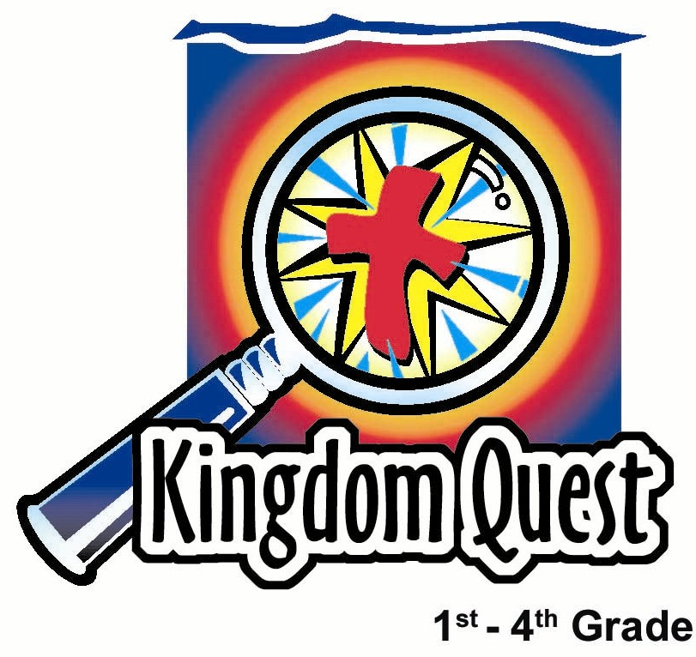
Date: ______________________
Series: Lookin’ for a Leader
Sep-Nov Year 3, Lesson 20

Solomon’s Wisdom

Take Home Point: *The smart way is God’s way.
*Repeat this phrase throughout the lesson.

Bible Event: 1 Kings 3:4-28
Solomon asks for wisdom in guiding his people. God grants him wisdom and much more. Solomon writes Proverbs, which has as its theme, “The fear of the Lord is the beginning of knowledge.”
Key Verse: Proverbs 2:6, “Only the LORD gives wisdom. Knowledge and understanding come from Him.” (NCV)

We will help kids know:
- The Bible event of Solomon asking and receiving wisdom in ruling his people.
- The world teaches multiple truths, each person making his own. God teaches His way is the only truth.
- Jesus followed God’s way by giving His life for us on the cross.

We will help kids feel:
- Delight in learning the wisdom of following God’s way.
- Commitment to think first of what would be God’s way.

We will help kids do:
- Identify what they would wish for if they could have anything.
- Discuss applications of God’s wisdom to everyday situations.
- Leave their golden rock of wisdom under a pillow to remind them of God’s wisdom.
THIS LESSON’S ROADMAP

DESTINATION | PAGE # | DISCOVERIES ON YOUR JOURNEY | SUPPLIES NEEDED
Small Group Warm-Up   | 3 | If you could squeeze a golden rock, wish for anything, and know your wish would come true, what would you wish for? Let kids respond to this question. Our golden rock is false gold. Sometimes there is false gold in thinking that if we just had more things, we would be happier. | - small rock that has been spray painted gold for each group
Large Group   | 3  7  10  11 | Overview  Puppet Presentation with Pesta Game: “Dao Dao Gets Smart”  Drama: “Solomon’s Wise Judgment”  Puppet Conclusion: “Dao Dao Gets Smart” | - Dao Dao wearing a graduation cap or something that makes him appear smart  - four plastic apples painted gold  - four signs to be taped to the backside of the apples:  - The fear  - of the LORD  - is the beginning  - of knowledge  - Nerf gun  - costumes for King Solomon, two women, and a court attendant  - baby doll  - sword
Small Group Application   | 4 | Kids will answer discussion questions designed to contrast a falsehood with God’s truth. The falsehood will be implied in the question, and the kids will make their own application of wisdom. “What would God want you to do in this situation?” The discussion question wrapped around a gold rock symbolizes God’s wisdom is true riches more precious than gold.  Memory Verse Learning:  “Who Has the Golden Rock?”  Prov. 14:34 is emphasized in lessons 19-22 that each child is aware that sin brings a person down but obedience to God brings success. | - small golden rock for each child wrapped with a discussion question from page 13  - a rock for each child minus one  - one golden rock from Small Group Wrap-Up  - a pouch
Small Group Warm-Up: 15 minutes
Purpose: Get pointed in the right direction! Build relationships and help guests feel at ease. Do the learning readiness activity that will point your group in the right direction for the lesson.

Supplies needed: small rock that has been spray painted gold for each group

Show kids a small rock that has been spray-painted gold and introduce it as a golden rock. Then ask the following questions to elicit conversation. Both of these questions will provide insight into kids’ lives, as well as help the group learn to listen to one another.

If you could squeeze this rock, wish for anything, and know your wish would come true, what would you wish for?

How long do you think what you wished for will make you happy?

Pass the golden rock to the first person ready to respond to the question. The speaker would then pass the rock to the next person who wants to answer.

Refer to the golden rock again.

How many think this is real gold? Our golden rock is false gold. Sometimes there is false gold in thinking that if we just had more things, we would be happier. Sometimes that is the most common lie Satan uses to trick people. Thinking we need more things does not make us happier.

In today’s Bible event, we’ll meet Solomon, David’s son, who became king after David. God appeared to Solomon in a dream and asked him, “What do you want? You can have anything.” I wonder what Solomon asked for.

Today we will learn *the smart way is God’s way.

Large Group Overview: 20-30 minutes
Purpose: Help kids observe what the Bible says. Present the Bible event in creative fashion. Help kids begin to interpret what it means.

Supplies needed: Dao Dao wearing a graduation cap or something that makes him appear smart; four plastic apples painted gold; four signs to be taped to the backside of the apples: The fear, of the LORD, is the beginning, of knowledge; Nerf gun; costumes for King Solomon, two women, and a court attendant;
baby doll; sword

Puppet Presentation with Pesta Game: “Dao Dao Gets Smart”–Dao Dao wants to appear extra smart. Teacher teaches him that wisdom is found in God’s truth. In the pesta game, contestants use a Nerf gun to knock over four golden apples.

Drama: “Solomon’s Wise Judgment” –The Bible event found in 1 Kings 3:16-28 is acted out.

Puppet Conclusion: “Dao Dao Gets Smart”– Jesus will show us what to do when we trust in Him.

Small Group Application: 20-25 minutes
Purpose: Help kids map out the meaning of the Bible event in their lives. Use the questions to stimulate discussion but don't feel tied to them. Allow the Holy Spirit to guide you. Include personal examples from your own faith journey. The example of Christ at work in your life will leave lasting impressions of how Christ can work in the children's lives.

Use your Bibles! Children need to learn how to look up references and follow along when scripture is read aloud. Allow for quality time of prayer at the close of the lesson.

Observation Questions: What happened?
Have kids refer to 1 Kings 3:4-28 in their Bibles for the following questions.

For what did King Solomon ask? (1 Kings 3:9, 12. A wise and understanding heart.)

Since God was pleased with his request, what else did He give Solomon? (1 Kings 3:13. Riches and honor.)

If Solomon followed and obeyed God, what else would he also receive? (1 Kings 3:14. A long life.)

How did Solomon show his wisdom in judging the two women who were fighting about whose baby was alive? (1 Kings 3:16-27. He said to divide the live baby in two knowing that the real mother would rather see the other woman have him than for him to be killed.)

What did all of Israel think about King Solomon after he made this decision? (1 Kings 3:28. “…they respected him very much. They saw he had wisdom from God to make the right decisions.”)

Interpretation Questions: What does this mean?
What does Solomon’s request for wisdom rather than riches and fame tell about his heart?

What can we learn about God when we see that He not only honored Solomon’s request but also gave him more? (God blesses those who seek to do His will.)

Application Questions: What does this mean to me?
The smartest thing we could ever do is follow God. The only way we can follow Him is to trust in Jesus as our Savior. This is a gift He gives us so we can be friends with God. Because of Jesus, we can fear (respect) God and know it is the beginning of wisdom.

Supplies needed: small golden rock for each child wrapped with a discussion question from page 13

Eight discussion questions are on page 13. The questions are designed to contrast a falsehood with God’s truth. The falsehood will be implied in the question, and the child will make his own application of wisdom. The shepherd can coach the response by using a phrase like:

“What do you think God would want you to do in this situation? Respecting what God wants is the beginning of wisdom.”

The discussion question wrapped around a gold rock symbolizes God’s wisdom is true riches more precious than gold.

Have the children hold their rocks as they discuss their responses. After class, challenge the children to take their rocks home and place them under their pillows for a week.

Proverbs 2:6 says “Only the LORD gives wisdom. Knowledge and understanding come from Him.”

Let this rock remind you that you can pray for wisdom and learn the fear of the Lord is the beginning of wisdom for making all of your decisions. *The smart way is God’s way.

Memory Verse Learning: 5 minutes
Purpose: Help kids to memorize and keep scriptures at heart. Using creative ways to help kids enjoy learning the key verse and in small group setting.

Supplies needed: a rock for each child minus one; one golden rock from Small Group Wrap-Up; a pouch

Memory Verse: Proverbs 14:34, “Doing what is right makes a nation great. But sin will bring disgrace to any people.” (NCV)

Memory Verse Presentation: “Who Has the Golden Rock?”
Have the children sit in a circle. Hand a rock each to a child but one of them will have a golden rock. Tell them that it is not that the person is special but this help you to begin a fun way of learning the memory verse together. Now have each person drop their stone into the pouch. Give the rocks a good mix in the pouch. Recite Prov. 14:34 several times with the children then tell them that you would like each person to put their hand into the pouch and pick up a rock. But they are to hide the rock with their fist. When everyone is ready, they must ask the question together – Who has the golden rock? When they uncover their pick, the child that has the golden rock must recite the verse. Do as many rounds as time permits.

Prayer Time:
Have the children hang onto their rock of wisdom while they pray for specific requests for which they need God’s knowledge. Encourage the children to ask themselves what wisdom they need to make smart choices.

Safety and Security: Safety and security procedures are important for each church to carefully define and implement according to their unique needs. The security, safety, illness and accident procedures described in this curriculum are provided for example purposes only and may not be appropriate, applicable or adequate for every situation. Each church is responsible for determining whether any security, safety, illness and accident procedures contained in the curriculum are appropriate, applicable or adequate for its unique situation. The activities described in this curriculum require adult supervision and may not be suitable for each child and each situation. Each church is responsible for ensuring that adequate adult supervision is provided for all activities and for determining whether an activity is appropriate for each child and each situation. Kids Kount Publishing disclaims all liability for the implementation of any procedures or the performance of any activities described in this curriculum.

Large Group Presentation

Dao Dao Gets Smart
Puppet Presentation

Dao Dao appears wearing a graduation cap or some type of prop that makes him appear smart. The carnival event is shooting Nerf arrows (or some other projectile) at four plastic gold-painted apples. On the back side of the apples needs to be taped various phrases from today’s Bible verse:

- The fear
- of the LORD
- is the beginning
- of knowledge.

By shooting all apples, the contestant will be able to assemble them in the correct order and read the Bible verse of the day.

Teacher: Hi, boys and girls. Welcome to Kingdom Quest Pesta. I’m Teacher ___________ and this is Dao Dao.

Dao Dao: (Appears wearing a graduation cap.) Excuse me, it is Professor Dao Dao to you.

Teacher: Oh, excuse me. What’s up with the special smart person’s hat?

Dao Dao: Well, I’m a smart guy and want to get smarter.

Teacher: You’re a smart guy, huh?

Dao Dao: Sure! I’m so smart they call me wise.

Teacher: They do?

Dao Dao: Sure. I’m a smart guy and a wise guy! Hee, hee.

Teacher: I believe it! Maybe you can show me an example of being smart as we play today’s pesta game. As you know, our pesta game often lets us learn an important truth. In today’s carnival game, someone shoots these four golden apples with this Nerf gun. What do you think these four golden apples represent?

Dao Dao: Four apples, hey? Apples remind me of getting in good with the teacher. Smart guys use apples to do that. Since there are four apples and I know we are talking about God, how about this? There are at least four different ways we can get to God.

Teacher: What do you mean, Dao Dao?

Dao Dao: There are so many different religions like Hindu, Islam, and whatever you want to believe. So there must be many different ways to get to God.

Teacher: How do you know which one is true?

Dao Dao: There’s not just one that’s true. All of them are true. You have to decide which one is best for you.

Teacher: Boys and girls, Dao Dao thinks there are many truths about how we get to God. Each person is supposed to make up his own way. If you think he is right, raise your hand. (Pauses for response.) Uh-oh, Dao Dao I think most don’t agree with you.

Dao Dao: That’s okay. Everybody has to decide for himself what is his own truth.

Teacher: Dao Dao, I don’t think God agrees with you.

Dao Dao: What?!

Teacher: Even though many people today believe that each person can make his own truth of how we get together with God, God says that there is only one way.

Dao Dao: What’s that?

Teacher: Jesus said, “I am the way, the truth, and the life. No one comes to God but through Me.”

Dao Dao: Only Him?

Teacher: Only Him.

Dao Dao: Not many different religions?

Teacher: Just Jesus. Through His death on the cross and coming to life again, we are saved when we trust in Him.

Dao Dao: What about those golden apples?

Teacher: These golden apples remind us of King Solomon who was one of the smartest guys ever. He wrote the book of Proverbs. In Proverbs he talked about wisdom, or smart things. Proverbs 2:6 says, “Only the LORD gives wisdom. Knowledge and understanding come from Him.”

Dao Dao: What did he say about apples?

Teacher: He said in Proverbs 25:11, “The right word spoken at the right time is as beautiful as gold apples in a silver bowl.”

Dao Dao: Saying the right thing at the right time is like a golden apple?

Teacher: Yes, saying the right thing at the right time is pretty valuable.

Why don’t we bring some contestants up and see who will be able to knock over the golden apples to uncover the Bible verse of the day.

(The contestants each take a shot at the apples with the Nerf gun. If they knock down the apples, they can take a look at the message on the backside of the apples. Then, they try to reconstruct the Bible verse: “The fear of the LORD is the beginning of knowledge.”

While the kids are shooting, Teacher will tell the Bible event of how Solomon got his wisdom (1 Kings 3:4-15). It might seem that the carnival game will distract from telling of the Bible event, but the two can actually tie in together and this saves time. Dao Dao can ad-lib with Teacher during the story if he so chooses.)

Teacher: Boys and girls, last week we talked about King David. After King David ruled 40 years, his son Solomon came to the throne. It says here in I Kings 3:5 that God came to him in a dream and said, “What can I give you? Ask for whatever you want.”

If God asked you that question, would you ask for golden apples like these worth millions of dollars? Would you ask to be a famous sports hero or president of a country?

This is what Solomon asked God for: “a hearing heart.” In other words, he asked for wisdom. He wanted to listen to the people he was to rule and tell the difference between good and evil.

That was the real golden apple in God’s eyes: wisdom, not money, or riches. So God answered him, “Since you have not asked for money, or power, or success, and instead wisdom to govern my people, I will give you what you haven’t asked for: riches and honor. And that’s what God did. Solomon became a very rich and powerful king. But most of all he was known for his wisdom in ruling the people.

Now let’s see what the back of the apples say. It’s a verse from Proverbs that Solomon wrote: “The fear of the LORD is the beginning of knowledge.” (Proverbs 1:7)

Go to the drama and finish with the puppet conclusion.

Solomon’s Wise Judgment

Drama

Cast: King Solomon
Woman 1
Woman 2
Court Attendant(s)
Narrator

King and attendants enter and take their places.

Narrator: Once when King Solomon was sitting upon his throne judging cases for the people, two women came and stood before him.

Women enter and stand before the king. Woman 2 is carrying a baby.

King: What seems to be the problem?

Narrator: These two women lived in the same house and each of them had a baby son. One sad night, one of the baby boys died. The mother took her dead son and switched him for the other woman’s live baby. Now each woman said the live baby was hers. King Solomon had to decide who was telling the truth.

Woman 1: He’s my son.

Woman 2: No, he’s my baby.

King Solomon looks thoughtful.

Narrator: The king thought and thought, then he finally said…

King: Bring me a sword.

An attendant brings a sword.

Narrator: The king told his attendant to cut the child in two pieces and give each mother half of him.

Attendant places baby on a table and raises sword.

Woman 1: (Screams.) Let her have him! Please don’t kill him!

Attendant lowers sword and looks confused.

Woman 2: Oh, come on. We’ll both have half a baby.
Attendant, looking confused, raises sword again.

King: Wait! Give the baby to the first woman. She is his mother.

Narrator: In his wisdom, King Solomon knew the boy’s real mother would rather give her son to the other woman than let him be killed.

Narrator moves to center stage to address audience.

Narrator: When all Israel heard the verdict the king had given, they respected the king. They saw he had wisdom from God to administer justice.

Dao Dao Gets Smart

Puppet Conclusion

Dao Dao: Wow, Teacher. Solomon really was smart to figure out how to get the baby back to the real mom.

Teacher: Right, Dao Dao. But remember *the smart way is God’s way.

Dao Dao: Is that what it means to be wise…to do things God’s way?

Teacher: Yes. And wisdom comes from God. He will show you what to do when you trust Him.

Dao Dao: What do you think He wants me to do?

Teacher: He wants you to trust Him.

Dao Dao: You mean, like, trust Jesus as my Savior?

Teacher: Exactly. And then trust Jesus to lead you every day. Pray to Him and ask Him to help you make wise choices.

Dao Dao: I can do that! Then I’ll be a wise guy!

Teacher: Okay, Mr. Wise Guy. I would like to close us in prayer right now.

Dear Heavenly Father, You are so good to us. Thank You. Thanks for the wisdom You give us, even if we aren’t as wise as Solomon. But maybe You could help us be wise and trust Jesus as our Savior and also let Him lead us. In Jesus’ name. Amen.

Lesson 20

Small Group Warm-Up:
- small rock that has been spray painted gold for each group

Large Group:
- Dao Dao wearing a graduation cap or something that makes him appear smart
- four plastic apples painted gold
- four signs to be taped to the backside of the apples:
- The fear
- of the LORD
- is the beginning
- of knowledge
- Nerf gun
- costumes for King Solomon, two women, and a court attendant
- baby doll
- sword

Small Group Application:
- small golden rock for each child wrapped with a discussion question from page 13

Memory Verse Learning:
- a rock for each child minus one
- one golden rock from Small Group Wrap-Up
- a pouch
Discussion Questions
Wrapped Around Golden Rocks

Your friend asks you if she can copy your homework. She says that no one will ever know. What do you do or say?

Your friend says, “God doesn’t care about anyone. Give me one example of how He cares.” What do you say?

Your friend says that if he could just get one more special toy, like a ________, then he would be happy and wouldn’t want anything else. What would you say?

Your friend says, “Everybody goes to heaven just by being good.” What do you say?
While over at a friend’s house, you find some very bad pictures on the Internet. Your friend suggests that you look at some more. What do you say?
One of your friends says she will only be your friend if you gang up with her against someone she doesn’t like. You have to call this other person a loser. What do you say?
You hear at school that science proves God did not make people. Instead, you hear people came from monkeys. What do you say?

Some people say there are many ways to get right with God and that all religions are the same. What do you say?

