
Date: ________________________
Series: Lookin’ for a Leader
Sep-Nov Year 3, Lesson 22

Solomon Follows False Gods

Take Home Point: *Keep God on top.
*Repeat this phrase throughout the lesson.

Bible Event: 1 Kings 11:1-13, 29-40
Key Verse: Exodus 23:13b, “Never mention the names of other gods or let them be heard on your lips.”

We will help kids know:
- The Bible event of Solomon pulling away from God by serving the gods of his foreign wives.
- We should have no other gods before the true God. We should keep God on top.
- When we trust in things or people to be most important in our lives, they can become like idols or false gods.

We will help kids feel:
- Disgust at Solomon’s falling into idolatry.
- Inspired to keep God on top and to let their lights shine.

We will help kids do:
- Identify ways they can keep God on top and trust in Him with their whole heart.
- Make a small lamp to remind them of God’s light shining.

THIS LESSON’S ROADMAP

DESTINATION | PAGE # | DISCOVERIES ON YOUR JOURNEY | SUPPLIES NEEDED
Small Group Warm-Up   | 3 | Kids share things they enjoy doing or having. | - a bowl of water  - coarse pepper  - cardboard matches  - bowl of dishwashing soap
Large Group   | 4  10  14  17 | Overview  Puppet Presentation – “Dao Dao Tries to Stay on Top”  Dramatic Presentation – “Solomon Saddens God”  Puppet Conclusion—“Dao Dao Tries to Stay on Top” | - Dao Dao with a baseball cap on  - a plastic baseball bat  - headpieces or costumes for Ahija and Jeroboam  - crown for Solomon
Small Group Application   | 5 | The kids discuss how to keep God first in their lives and how the result would be like “a light on a hill.”  Memory Verse Learning:  “You Missed, You Say”  Prov. 14:34 is emphasized in lessons 19-22 that each child is aware that sin brings a person down but obedience to God brings success. | - baby food jar with lid for each child  - vegetable oil or lamp oil  - food coloring  - water  - gold glitter  - a plastic baseball bat

Small Group Warm-Up: 15 minutes
Purpose: Get pointed in the right direction! Build relationships and help guests feel at ease. Do the learning readiness activity that will point your group in the right direction for the lesson.


Supplies needed: a bowl of water; coarse pepper; cardboard matches; bowl of dishwashing soap

This warm-up involves a science experiment.

Sprinkle coarse ground pepper into a bowl of water.
The pepper will float on the surface tension of the water.
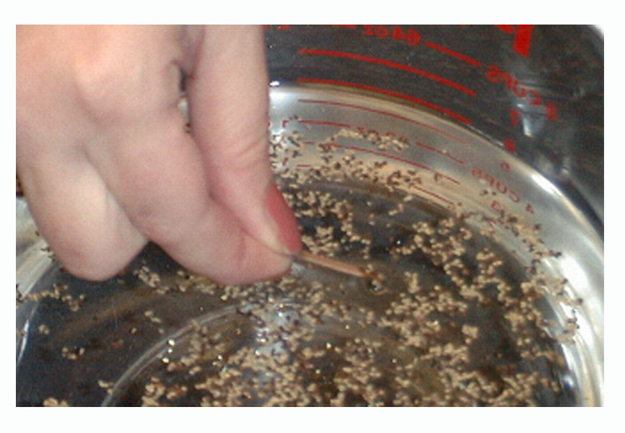

Give children a paper match. Using the cardboard side of the match, have the kids touch flakes of pepper to see if they can “capture” pepper on the ends of their matches.

The following discussion takes place during the science experiment.

Today we are going to talk about our favorite toys or favorite things to do. I am going to pass you a match. Dip the cardboard end of that match into the water that is sprinkled with pepper. Try to grab one of the pieces of pepper with the end of your match. Then you can tell everyone what is your favorite toy or favorite thing to do.

Is it possible to ever like a toy or a special activity too much? Could it ever become like a god?

Be considerate in discussing these questions. Toys or fun activities are not evil. They can be wonderful blessings from God. Anything we look to with trust and confidence that it will provide the entire fulfillment we need in life, though, becomes like an idol or a false god. Examples can be made. “If I like basketball so much that I stay home from church every Sunday to play, basketball might be more important than spending time with God.” Other false gods or idols that can be easily identified are money, power, fame, or following false spiritual forces (crystals, séances, fortune-telling).

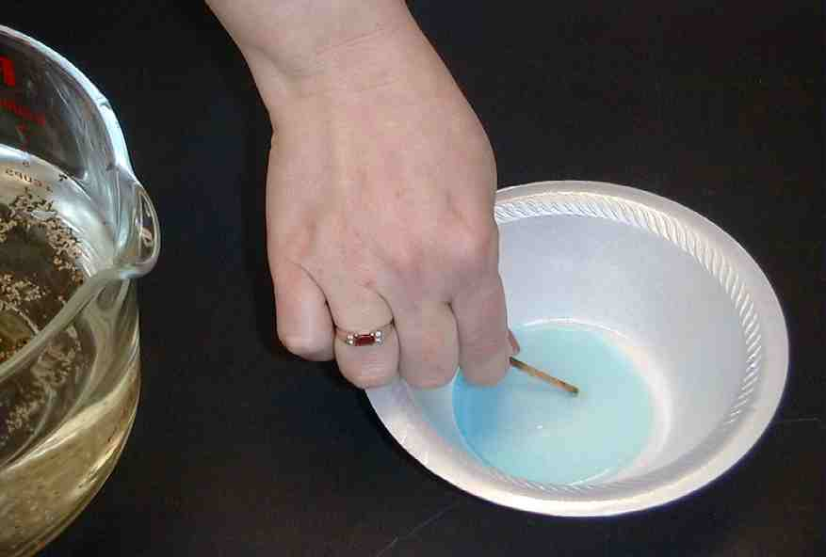

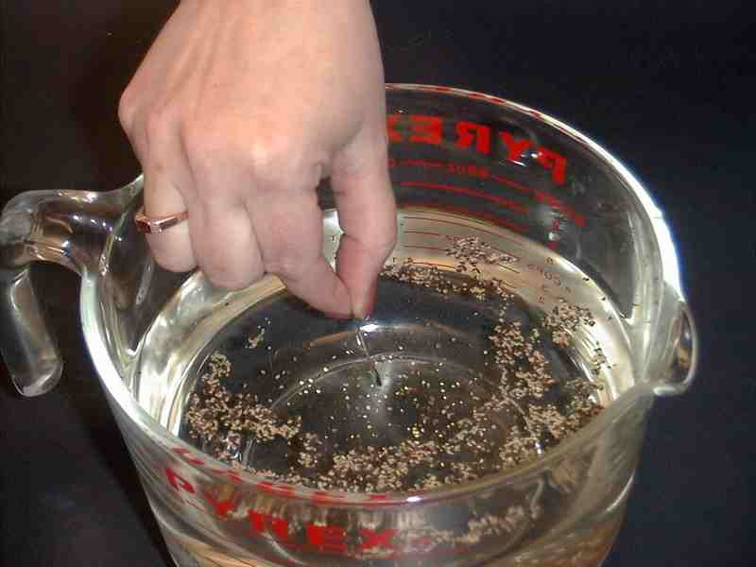
The final “wow” event is done by dipping the cardboard tip of one match into a bowl of dishwashing soap.

Put the match back into the bowl of water with the ground pepper. As soon as the match touches the water, all of the pepper will “fly.”

Say: This is very much like how God wants to be on top in our lives. He wants us to have no other gods. Though we can have things that are important to us, He wants us to trust Him more than we trust things or people to make us happy. When we know and trust in Jesus, who gave His life for us, God helps us scatter all the other false gods.

Today we will learn to *keep God on top.

Large Group Overview: 20-30 minutes
Purpose: Help kids observe what the Bible says. Present the Bible event in creative fashion. Help kids begin to interpret what it means.

Supplies needed: Dao Dao with a baseball cap on; a plastic baseball bat;
headpieces or costumes for Ahija and Jeroboam; crown for Solomon

Pesta Game with Puppet Presentation: “Dao Dao Tries to Stay on Top”—Dao Dao thinks he is the biggest, baddest, best football player in the world until he realizes he might be making football his god.

Dramatic Presentation: “Solomon Saddens God”— Events from 1 Kings 11 are acted out.

Puppet Conclusion: “Dao Dao Tries to Stay on Top”

Small Group Application: 20-25 minutes
Purpose: Help kids map out the meaning of the Bible event in their lives. Use the questions to stimulate discussion but don't feel tied to them. Allow the Holy Spirit to guide you. Include personal examples from your own faith journey. The example of Christ at work in your life will leave lasting impressions of how Christ can work in the children's lives.

Use your Bibles! Children need to learn how to look up references and follow along when scripture is read aloud. Allow for quality time of prayer at the close of the lesson.

Observation Questions: What happened?
Turn to 1 Kings 11:1-13, 29-40. Using the Bible, review some observation questions about today’s Bible event. It might be worth noting that a concubine is just like a wife except she does not have as many rights under the law.

How many wives did Solomon have that were princesses? (1Kings11:3 Seven hundred)

How many of Solomon’s wives were concubines? (1 Kings 11:3. Three hundred.)

What did Solomon’s wives tempt him to do? (1 Kings 11:4. Follow other gods.)

How did Solomon respond to these temptations? (1Kings 11:6-7. He did not follow wholeheartedly the Lord, as his father David had done. He even built an illegal worship site.)

What was God’s reaction to Solomon? (1 Kings 11:9. God became angry.)

What did God decide to do? (1 Kings 11:11. God said He would tear away part of the kingdom from Solomon and give it to one of His servants. Solomon’s son would have one tribe for the sake of David, Solomon’s father.)

What is the First Commandment? (Exodus 20:3. Never have any other god.)

Interpretation Questions:
Why do you think Solomon gave in to the temptations of his wives?

How did God keep His promises to David and Solomon? (God promised that Solomon could be king as long as he was faithful to God. God did not take away Solomon’s kingdom in his lifetime because of his father David. God would not tear the whole kingdom away from the hands of Solomon’s son. He would still rule over one tribe.)

Application Questions:
Today we are talking about how we can *keep God on top. To help us remember this, we will make a special craft.

Supplies needed: baby food jar with lid for each child; vegetable oil or lamp oil; food coloring; water ; gold glitter

Demonstrate making the craft. Fill a baby food jar three-fourths full of water. Fill the jar one-fourth with oil. Next, put in a drop of food coloring, close the lid, and shake it up.

What do you think will happen to the water and oil? The oil rises to the top. This is a reminder to always *keep God on top. The memory verse today is, “Have no other god’s before Me.” Let’s see how we can do that.

John 1:18 says, “No man has ever seen God. But God the only Son is very close to the Father. And the Son has shown us what God is like.” What does this mean? Jesus came into the world so He could make known God’s heart. God showed us how much He loves us by giving up His Son to die on the cross for us.

Jesus told us he would be a light that lights up our lives. Read John 1:4: “In Him there was life. That life was light for the people of the world.”

Also read Matthew 5:14-16, which describes how we will be lights—lights shining for him.

“You are the light that gives light to the world. A city that is built on a hill cannot be hidden. And people don’t hide a light under a bowl. They put the light on a lampstand. Then the light shines for all the people in the house. In the same way, you should be a light for other people. Live so that they will see the good things you do. Live so that they will praise your Father in heaven.”

One of the most important ways we can always keep God on top is to trust Jesus as our Savior and to let His light shine through us. To remind us of that, we are going to make a craft.

Give each child a baby food jar. Let kids fill the jars (¾ full with water and ¼ with oil). Add a couple drops of food coloring. Have the children sprinkle a small amount of gold glitter into their baby food jars. After the children have tightly screwed the lids onto their jars, they can shake the jars. Holding the jars up to the light, the kids can see the light reflect off of the glitter in the liquid. Remind them that this is how Jesus is the light of the world and they are lights that reflect Jesus to the world, also. The oil on the top is a reminder to *keep God on top.

Encourage the children to talk at home about what they have learned in Sunday school using their light jars.

Read the following story for further discussion.

“A Light On The Hill”

At school, Jeremy loved recess. His favorite game above all was King of the Mountain. A mound of dirt had been left on the playground from workers building nearby. Jeremy and his friends loved to play King of the Mountain there. The goal of the game was to stay on top of the mountain as long as possible without getting pushed off.

Jeremy was the best at the game. He was not only big but he was quick. When his friends would come to push him down, Jeremy could quickly dodge out of the way. His friends would lose their balance and go rolling down the hill.

One day all of the boys started to play before Jeremy arrived. Each boy pretended to be a superhero with super powers. One would charge up the hill and say, “Batman rules,” and attempt to push off the boy on the top. If this boy won, he would give a dance and scream, “Batman rules!” Before he could scream it a second time, he would be pushed by another boy yelling, “Superman rules!”

On the game went. Various superheroes would all have a short time of victory and ruling as king of the mountain.

Then Jeremy came to play. His friends were eager to see him, and Jeremy was ready to play. Along with Jeremy was his friend, David. It seemed that David was the smallest boy in the class. He wasn’t very strong and he was made fun of so often that he was used to the mean comments he heard from the boys playing King of the Mountain.

“Come on, Jeremy! Come up and play! What superhero are you going to be?” his friends asked.

“Is Superman taken?” asked Jeremy.
“Yeah, I have Superman. Think of another one.”

“Okay,” said Jeremy, “but let David play, too.”

“Sure,” his friends said. “David can be Wimp Man.”

“Yeah. How about Geek Man?” another friend joked, while all of the boys laughed.

“How about Fly Man?” said another. “One little thump and he’ll go flying away.”

Jeremy was saddened at the way the other boys teased David. David pretended like he didn’t mind. He just stuck his hands in his pockets and shrugged his shoulders.

“I don’t want to play a stupid King of the Mountain game anyway,” David said.

“That’s okay,” Jeremy said. “I know who rules this hill.” At that, Jeremy bolted up the hill. He was quick to knock off Superman. He dodged Batman. Spiderman lost his grip. All of the X-Men couldn’t budge Jeremy. All tried to move Jeremy off the top of the mound but they couldn’t. They just sat down in a pile to rest at the bottom of the hill.

“So, who rules?” the boys shouted up at Jeremy. “What hero are you?”

“I’ll tell you in a minute,” said Jeremy. “Hey, David. Come up here. Take a shot at me.”

The other boys snickered, “Yeah, sure. Wimp Man is going to take out Jeremy. That’s a laugh!”

David, however, did not hesitate. He charged up the hill with a big smile on his face and gave Jeremy a push. To everyone’s surprise, Jeremy fell backwards.

“Whoa!” Jeremy said. “David pushed me off! David rules!”

“What?!” his friends shrieked. “That’s not possible.”

“Sure, it is,” Jeremy said, just as the recess bell was ringing. “David rules, and he’s the winner.”

As the boys were walking in together, David asked Jeremy, “You were up on top of that hill for a long time and you never said which superhero you were. Who were you?”

Jeremy thought to himself and then he put his fist in the air. He said, “The best super hero of all. Jesus rules!”

Do you think Jeremy let David win?

What do you think Jeremy meant by saying “Jesus rules!” Refer to Matthew 5:16.

How did Jeremy let his light shine in front of people?

Do you think anyone praised God in heaven for what Jeremy did? Who might have given thanks to God in this story?

Think of a way you can let your light shine before others at your school. How is this like keeping God on top?

Memory Verse Learning: 5 minutes
Purpose: Help kids to memorize and keep scriptures at heart. Using creative ways to help kids enjoy learning the key verse and in small group setting.

Supplies needed: a plastic baseball bat

Memory Verse: Proverbs 14:34, “Doing what is right makes a nation great. But sin will bring disgrace to any people.” (NCV)

Memory Verse Presentation: “You Missed, You Say”
Select four volunteers and play the same carnival game. But end it this way, the player immediately to the winner’s right is to recite Prov. 14:34. Add another player and the game repeats in the same manner until everyone has the chance to recite.

Prayer:
Pray for specific ways in which the kids can *keep God on top and let their lights shine.

Safety and Security: Safety and security procedures are important for each church to carefully define and implement according to their unique needs. The security, safety, illness and accident procedures described in this curriculum are provided for example purposes only and may not be appropriate, applicable or adequate for every situation. Each church is responsible for determining whether any security, safety, illness and accident procedures contained in the curriculum are appropriate, applicable or adequate for its unique situation. The activities described in this curriculum require adult supervision and may not be suitable for each child and each situation. Each church is responsible for ensuring that adequate adult supervision is provided for all activities and for determining whether an activity is appropriate for each child and each situation. Kids Kount Publishing disclaims all liability for the implementation of any procedures or the performance of any activities described in this curriculum.

Large Group Presentation

Dao Dao Tries To Stay On Top

Dao Dao Puppet Script

The puppet script introduces the carnival contest that is played with a plastic baseball bat.

Contest: Four contestants are brought forward. The large group presenter tosses the bat to one of the contestants so he catches it, holding it vertically with one hand. The person to the catcher’s right grabs the bat directly above the catcher’s fist. The next person grabs the bat above the previous one. The fourth person continues in the same manner. The catcher can then grab the bat with his other hand, and so on with the rest of the contestants.

The winner of the game is the one who can put the last fist on the bat so the following person has no bat to grab. The game continues as the person to the right of the winner drops out. The game is then repeated. Each round a person is lost until one wins.

The game illustrates trying to stay on top. God says that He wants to be on top in our lives and we should have no other gods before Him. When we put anything on top of God (even ourselves), that is idolatry and following false gods.

All of this sets up the drama that presents the Bible event of Solomon not keeping God on top. Solomon followed after the idols of his foreign wives.

(Dao Dao appears onstage with a baseball cap. A baseball bat is leaning against the puppet stage.)

Teacher: Hi, boys and girls. Welcome to Pesta Kingdom Quest where we play some great games.

Dao Dao: You bet! Batter up!

Teacher: Batter up? This is a pesta not a football game.

Dao Dao: Well, it’s about time we played football at this pesta.

Teacher: Why is that?

Dao Dao: Because I’m the best football player in the world!

Teacher: The best in the whole world?

Dao Dao: Let me put it another way. The biggest, best in the whole world!

Teacher: The biggest best?

Dao Dao: The most important, biggest, best football player in the whole world!

Teacher: And you think that’s you?

Dao Dao: Well, I think I’m the most important, biggest, baddest, best in the whole world.

Teacher: Dao Dao, I can tell that football is pretty important to you.

Dao Dao: Shouldn’t it be if I’m the most important, biggest, baddest, best football player in the whole world?

Teacher: Well, I suppose. I think you’re getting a bit carried away, though.

Dao Dao: I’m not carried away. I’m just number one, on top! Football is everything to me.

Teacher: Dao Dao, it’s beginning to sound like football is like a god to you.

Dao Dao: Well, I guess I’m kind of a football god.

Teacher: No, I mean you might be worshiping football or trusting in it more than you are trusting in God.

Dao Dao: Oh, I didn’t know that I could do that.

Teacher: It could happen.

Dao Dao: Are you saying that football is bad?

Teacher: No, football isn’t bad. When football becomes your idol or something that you put more trust in than God, then it is bad.

Dao Dao: But I am the biggest, baddest, best football player in the whole world.

Teacher: Dao Dao, if you serve football like a god, I promise you that you will be disappointed.

Dao Dao: No way!

Teacher: Yes way. What happens when you lose a game?

Dao Dao: Lose?! I’ve never lost a game!

Teacher: That’s amazing. How many games have you won?

Dao Dao: Oh, I don’t know. Lots.

Teacher: Twenty?

Dao Dao: Not quite.

Teacher; Ten?

Dao Dao: No.

Teacher: Five?

Dao Dao: Not quite.

Teacher: Three?

Dao Dao: No.

Teacher: Two?

Dao Dao: Well . . .

Teacher: One?

Dao Dao: Yeah.

Teacher: You mean, you have just won one game and you think you are the biggest, baddest, best football player in the whole world?

Dao Dao: Of course.

Teacher: Dao Dao, learn something today. It’s okay to have fun playing football, just don’t make it your god. Don’t make anything your god other than God, Himself. God said, “Have no other gods before me.” In other words, keep God on top.

Dao Dao: Oh, I think I can do that.

Teacher: Here, let’s watch a game. We’re going to play a game of “Who’s on Top” with a football bat. After that we will hear about how Solomon put something else on top of God’s place in his life. Then, Dao Dao, would you come back and tell us what you think?

Dao Dao: Sure.

Teacher: Okay then. Let’s go to our contest. I need four contestants.

Select four contestants from the audience. Toss the bat vertically to one player so he catches it. The player to the right of the catcher should grab the bat just over the catcher’s fist. The next person grabs the bat above the previous one. The fourth person continues in the same manner. The game continues until a player places his fist on the very top. The player with his fist on top at the very end is the winner of the round. The player immediately to the winner’s right is out of the game. The game repeats in the same manner until there is one winner left.

During this time, Dao Dao can make comments about being on top and being the best. At the conclusion, Teacher introduces the drama.)

Teacher: We have seen in today’s carnival contest that no matter how often you try to be on top, sometimes you cannot stay there. God says that He wants to be on top in our lives. He wants to be most important so we don’t serve any other gods. A god can be anything so important that we trust in that thing or person to give us our meaning and purpose in life.

Today we are learning about King Solomon who started out as a very wise king. He asked God to show him how to choose right and wrong for the people he ruled over. Surprisingly, at the very end of his life, Solomon made some very bad choices. He couldn’t even choose right from wrong for himself. Here’s what happened.

Solomon Saddens God
Dramatic Characterization

Cast:
Solomon
Some of Solomon’s wives
Jeroboam

Ahijah, the prophet

The drama is narrated by an adult and acted out by children. The characters listen to the narration and act out accordingly. Dress the child actors in period costumes or headpieces. Practice in advance.

Props:
- Ark of the Covenant, if available, or something that reminds the children of the temple
- Idols (a trophy, a puppet, or a clay statue)
Narrator: Solomon was known for wisdom in ruling his people. He asked God to help him know what was the best way to rule right and wrong for his subjects.

(Solomon points to his head and looks very smart.)

Narrator: Solomon was known for his great wisdom. Later in his life, Solomon step by step . . .

(Solomon walks on tiptoes.)

Narrator: …moved farther and farther away from God…

(In the center stage should be something depicting God, such as the Ark of the Covenant. Solomon continues to move away from this symbol of God.)

Narrator: …and this is how it happened.

Solomon made agreements with other kings. The kings gave their daughters to Solomon to be his wives.

(One girl comes over to Solomon.)

Narrator: But there was more than one wife. There were many. There were twenty, then fifty, then a hundred, then three hundred, then finally seven hundred wives.

(The other girls come on stage.)

Narrator: This is when Solomon got in trouble. He did something that saddened God and pulled him farther away from God. You see, when a wife from a foreign country came, she brought her own idol or god with her.

(One of the girls holds up an idol represented by a trophy, puppet, or clay statue.)

Narrator: Solomon allowed his wives to keep their gods with them. He even let them build temples to their gods.

(The girl puts her idol in a special place in the room, bows down to it, and pulls Solomon over to where the idol is.)

Narrator: Instead of learning to worship and serve the true God, the wives worshiped their idols. Solomon loved his wives and tried to do what they asked. When they asked if he would come to the temples with them, he said yes.

(The girl drags Solomon to the temple.)

Narrator: Before long, many of his wives were pulling him farther and farther away from God.

(At this point, several of the girls show Solomon their idols. The girls tug at Solomon and confuse him as they drag him around.)

Narrator: How could it be that a man who was once so wise in ruling over his people was now making such terrible choices for his own spiritual life? Solomon visited other temples and even bowed before other gods.

Didn’t Solomon remember what God had promised him when he dedicated the temple? God said there would always be a descendant of David on the throne as long as they were faithful to God. Didn’t Solomon understand that he was not being faithful to God as he bowed down to other idols?

(The girls continue to pull Solomon in different directions.)

Narrator: So it happened. By the end of his forty years of ruling, Solomon was only serving God half-heartedly. He was trying to please his wives too much by serving their gods as well.

(The commotion stops and everyone listens for God’s voice.)

Narrator: God said, “Solomon, because this is your attitude and you have no respect for my promises, I will tear the kingdom away from you. I will give the kingdom to one of your servants, but I won’t do it in your time. I will tear it away from the hands of your son. I will also not tear the whole kingdom away, but I will give your son one tribe for David’s sake and for the sake of Jerusalem.”

(Solomon and the girls move offstage. Jeroboam and the prophet, Ahijah, enter.)

Narrator: Among Solomon’s servants was young Jeroboam.

(Jeroboam bows to recognize who he is.)

Narrator: He was such a good worker…

(Jeroboam points to himself.)

Narrator: … that Solomon made him foreman in building his big project. One day, God sent the prophet, Ahijah, to speak to the young man. (Ahijah bows.) He took off his robe and tore it into twelve pieces. He gave ten pieces to Jeroboam and said, “Take these. The Lord will take the kingdom away from Solomon and give you ten tribes. Solomon’s son will have one tribe because David obeyed the Lord as long as he lived.”

When Solomon heard this, he tried to kill Jeroboam. Jeroboam ran to Egypt and stayed there safely until Solomon was dead.

Solomon ended his life in a sad way. He wasn’t keeping God on top.

Dao Dao Tries To Stay On Top

Puppet Conclusion

Teacher: So there you have it, Dao Dao. Solomon did not keep God on top so he didn’t finish his life very well, did he?

Dao Dao: You can say that again. How silly! Seven hundred wives? Wow, think of what it would cost! I can just see him at a curry puff stand by the roadside. “I’ll buy seven hundred curry puffs for my wives here.”

Teacher: But Dao Dao, that’s not the worst thing. It’s getting pulled away from God.

Dao Dao: Oh, I see. That kinda might even be like me if I let football be on top and my football ball as an idol. Well, I sure hope that never happens to me.

Teacher: I hope so, too. But is there something you can do about it?

Dao Dao: Not marry seven hundred wives?

Teacher: Of course that…but most important is to remember what God has done for you so that you can keep Him on top in your life. Do you know what God did for you?

Dao Dao: I know that God sent His Son, Jesus, for me.

Teacher: That’s it! You know how God sent His Son who gave His life for you on the cross. He paid the price of forgiveness for any of the times you let other things become like an idol to you. And Jesus is there to fill you with His love to help you keep God on top!

Dao Dao: That’s for me!

Teacher: Great. It’s a good time here to close in prayer.

Dear God. thank You for being a good God. You actually like us and want us to belong to You. Thank You for giving us Jesus and forgiving us for the times we don’t put You on top. Please help us keep You on top. Also help us not to be dumb and marry seven hundred wives… but I don’t think I’d like to do that anyway. In Jesus’ name, we pray. Amen.

Lesson 22

Small Group Warm-Up:
- a bowl of water
- coarse pepper
- cardboard matches
- bowl of dishwashing soap

Large Group:
- Dao Dao with a baseball cap on
- a plastic baseball bat
- headpieces or costumes for Ahija and Jeroboam
- crown for Solomon

Small Group Application:
- baby foot jar with lid for each child
- vegetable oil or lamp oil
- food coloring
- water
- gold glitter

Memory Verse Learning:
- a plastic baseball bat

