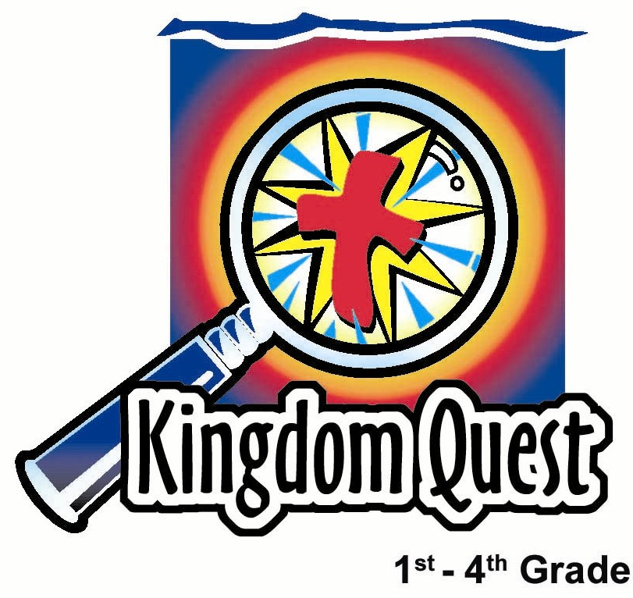
Date: ______________________
Series: Lookin’ for a Leader
Sep-Nov Year 3, Lesson 24

Too Big for Your
Trousers

Take Home Point: *Listen to God and His advice.
*Repeat this phrase throughout the lesson.

Bible Event: 1 Kings 12:1-24, 14:21-30. Rehoboam listens to bad advice.
Key Verses: Proverbs 22:17, 19, “Pay attention and listen to what wise people say. Remember what I am teaching you… so that you will put your trust in the Lord.” (NCV)

We will help kids know:
- The Bible event of Rehoboam listening to bad advice and the people revolting against him.
- The importance of seeking godly advice as well as listening to God.
- The Bible is God’s truth and it gives us great advice as we meet Jesus, our Savior, in God’s word.

We will help kids feel:
- Conviction when puffed up with pride.
- Sensitive to discerning what is good advice and what is bad advice.

We will help kids do:
- Imagine themselves in positions of great power where they might become “too big for their trousers.”
- Apply God’s word to real life situations for themselves and their friends.

THIS LESSON’S ROADMAP

DESTINATION | PAGE # | DISCOVERIES ON YOUR JOURNEY | SUPPLIES NEEDED
Small Group Warm-Up   | 3 | Are you too big for your trousers? An object lesson illustrates the meaning of the phrase. | - markers  - large balloons  - cellophane tape
Large Group   | 4  9  12  14 | Overview  Puppet Presentation: “Dao Dao is Too Big for His Trousers” –Dao Dao thinks he’s “too cool” and doesn’t need anyone’s advice.  Dramatic Storytelling: “Wise Advice Not Taken” –King Rehoboam listens to wrong advice.  Puppet Conclusion: “Dao Dao is Too Big for His Trousers” | - large, long trousers  - balloons  - straight pin  - costume for an old, wise counselor (possibly with a beard)  - whip  - Dao Dao looking “cool” - may wear sunglasses or a hat  - two light inflated balloons taped to each of Dao Dao’s biceps
Small Group Application   | 4 | The objective is for the children to become sensitive to their own skills of listening and seeing their need of godly advice.  Memory Verse Learning:  “Balloon Burst”  As the child learn Proverbs 22:17,19 in lessons 24 and 25, he will remember the importance of seeking godly advice as well as listening to God. | - tape to be placed on the balloon person  - straight pin for each group  - friendship bracelet supplies (beads and leather or elastic bands 8”-10” long)  - copy of the colors explanation used in the friendship bracelets for each child (page 16)  - balloons  - masking tape  - straight pin

Small Group Warm-Up: 15 minutes
Purpose: Get pointed in the right direction! Build relationships and help guests feel at ease. Do the learning readiness activity that will point your group in the right direction for the lesson.
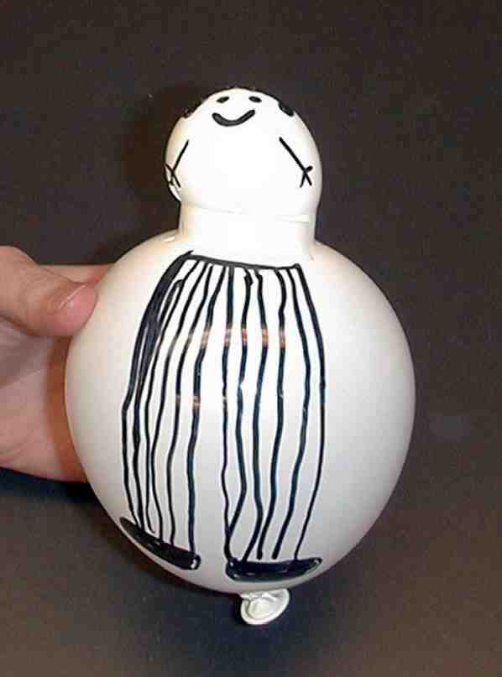
Supplies needed: markers; large balloons; cellophane tape

For an attention grabber, make the silhouette of a person on an unusually shaped balloon. First, inflate a large balloon about one-half full and wrap a strip of Scotch tape around the middle of the balloon’s circumference. Continue inflating the balloon and you will have a balloon that is constricted by the tape.

Imagining that the tape is the belt of a man, draw pants and feet beneath it. Add a torso, arms, and a head above the belt. Ask:

Can you guess what the balloon character symbolizes? (The answer is someone who is too big for his trousers.) I will explain the meaning of the phrase “too big for his trousers” at the end of the Warm-Up time.

We are going to pass this balloon to someone who wants to be very important. Let’s pretend to give this person an important job, perhaps the principal of a school. Who would like to be principal? You can hold the balloon man.

Pass the balloon to the child.

I would like for everyone to give our principal suggestions of what he should do in his role. What are some recommendations?

Typical recommendations might include: “let school out,” “give free candy,” and “fire the teachers.” Accept these kinds of “bad” advice scenarios. They will be discussed later.

Pass the balloon figure to someone else and promote him/her to mayor or boss of the city. Finally, promote someone to be President or boss of the whole country.

Our balloon figure is someone who is “too big for his trousers.” Being too big for your trousers means being so filled with your own pride that you do not listen to others or to good advice.

Do you think it would be easy if you had an important job to feel so important that you would not listen to advice, or that it might be easy to listen to the wrong advice?

Today’s Bible event is about a young prince who was too big for his trousers. He split the kingdom of Israel in half because he took the wrong advice. We will learn to *listen to God and His advice. Listen carefully because if you answer all the questions correctly, when we get back, I’ll let you pop him with a pin.

Large Group Overview: 20-30 minutes
Purpose: Help kids observe what the Bible says. Present the Bible event in creative fashion. Help kids begin to interpret what it means.

Supplies needed: large, long trousers; balloons; straight pin; costume for an old, wise counselor (possibly with a beard); whip; Dao Dao looking “cool” - may wear sunglasses or a hat; two light inflated balloons taped to each of Dao Dao’s biceps

Pesta Game with Puppet Presentation: “Dao Dao Is Too Big for His Trousers”—Dao Dao thinks he is too cool for school and doesn’t need anyone’s advice. The pesta contest is a game demonstrating what it can look like to get too big for your trousers.

Dramatic Storytelling of Bible Event: “Wise Advice Not Taken”—One of King Solomon’s old advisers recounts the Bible event from 1 Kings 12 about King Rehoboam listening to the wrong advice.

Pesta Game with Puppet Conclusion: “Dao Dao Is Too Big for His Trousers”

Small Group Application: 20-25 minutes
Purpose: Help kids map out the meaning of the Bible event in their lives. Use the questions to stimulate discussion but don't feel tied to them. Allow the Holy Spirit to guide you. Include personal examples from your own faith journey. The example of Christ at work in your life will leave lasting impressions of how Christ can work in the children's lives.

Use your Bibles! Children need to learn how to look up references and follow along when scripture is read aloud. Allow for quality time of prayer at the close of the lesson.

The main theme of today’s lesson is to listen to godly advice and, more specifically, to listen to God’s advice. The objective is for the children to become sensitive to their own skills of listening and see their need to listen to godly advice. Beyond that, the children themselves can be a source of godly advice to their peers.

For the things that Rehoboam did wrong, a straight pin is poked through the tape (so the balloon will not burst) on the balloon person created earlier. Poking holes is a neat way to show how someone gets “deflated” when he is too big for his trousers.

Observation Questions: What happened?
Have kids look in 1 Kings 11:43-12:19 for the following questions.

What was the name of Solomon’s son who was to become king?
(1 Kings 11:43. Rehoboam.)

The ten tribes of northern Israel had been taxed by Rehoboam’s father, King Solomon, and had worked very hard for him. When Rehoboam wanted to rule over the northern ten tribes of Israel, what did they ask of him? (1 Kings 12: 3-4. The people asked Rehoboam if he would ease their burden.)

Rehoboam needed advice to answer the people of Israel. What did the older leaders who had served Solomon say? (1 Kings 12:7. They advised Rehoboam to ease the burden of the people.)

What did the young rich friends advise? (1 Kings 12:10-11. They advised Rehoboam to increase the people’s burden and make them afraid.)

What did Rehoboam do? (1 Kings 12:13-14. He ignored the advice of the older leaders and increased the people’s burden.)

What wicked thing did Rehoboam do that his mother also did? (1 Kings 14:21-24. He worshiped idols.)

What did God do to Rehoboam because he worshiped idols? (1 Kings 14:25-28. He sent the king of Egypt to attack Rehoboam’s land.)

Interpretation Questions: What does this mean?
Do you think Rehoboam was a wise or foolish king? Why?

If Rehoboam had accepted godly advice, how might his life and kingship been different?

Application
Supplies needed: tape to be placed on the balloon person; straight pin for each group;
friendship bracelet supplies (beads and leather or elastic bands 8”-10” long); copy of the colors explanation used in the friendship bracelets for each child (page 16)

The application portion of the lesson will be assembling friendship bracelets. The six colors used in making the bracelets remind the kids of six truths about God that they can give as advice to people. The attached handout will help the children remember the meaning of each bead as they share the bracelets with their friends and witness to them.

*If the friendship bracelet is too complicated as an option, consider making a “Book without Words.” Use construction paper in the six colors listed below, cutting them into small square shapes 2x2 inches. Then staple them together as a book.

The friendship bracelets will be made while the children are asked to give their advice on various topics. During this time, you should emphasize the importance of listening to others for better understanding. (Hopefully, tying the friendship bracelets will not be a distraction to the conversation but a way to keep the kids in active discussion.)

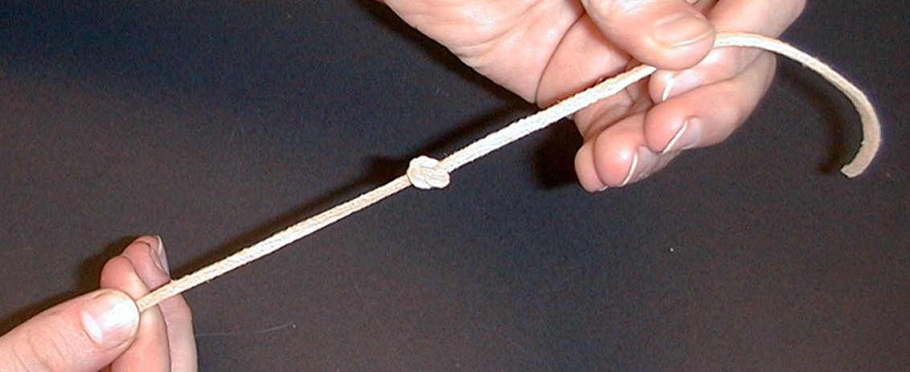
Give each child a leather band, a bead of each color, and a copy of the handout. Leaving enough room to tie the bracelet around the wrist, tie a knot in the leather band.

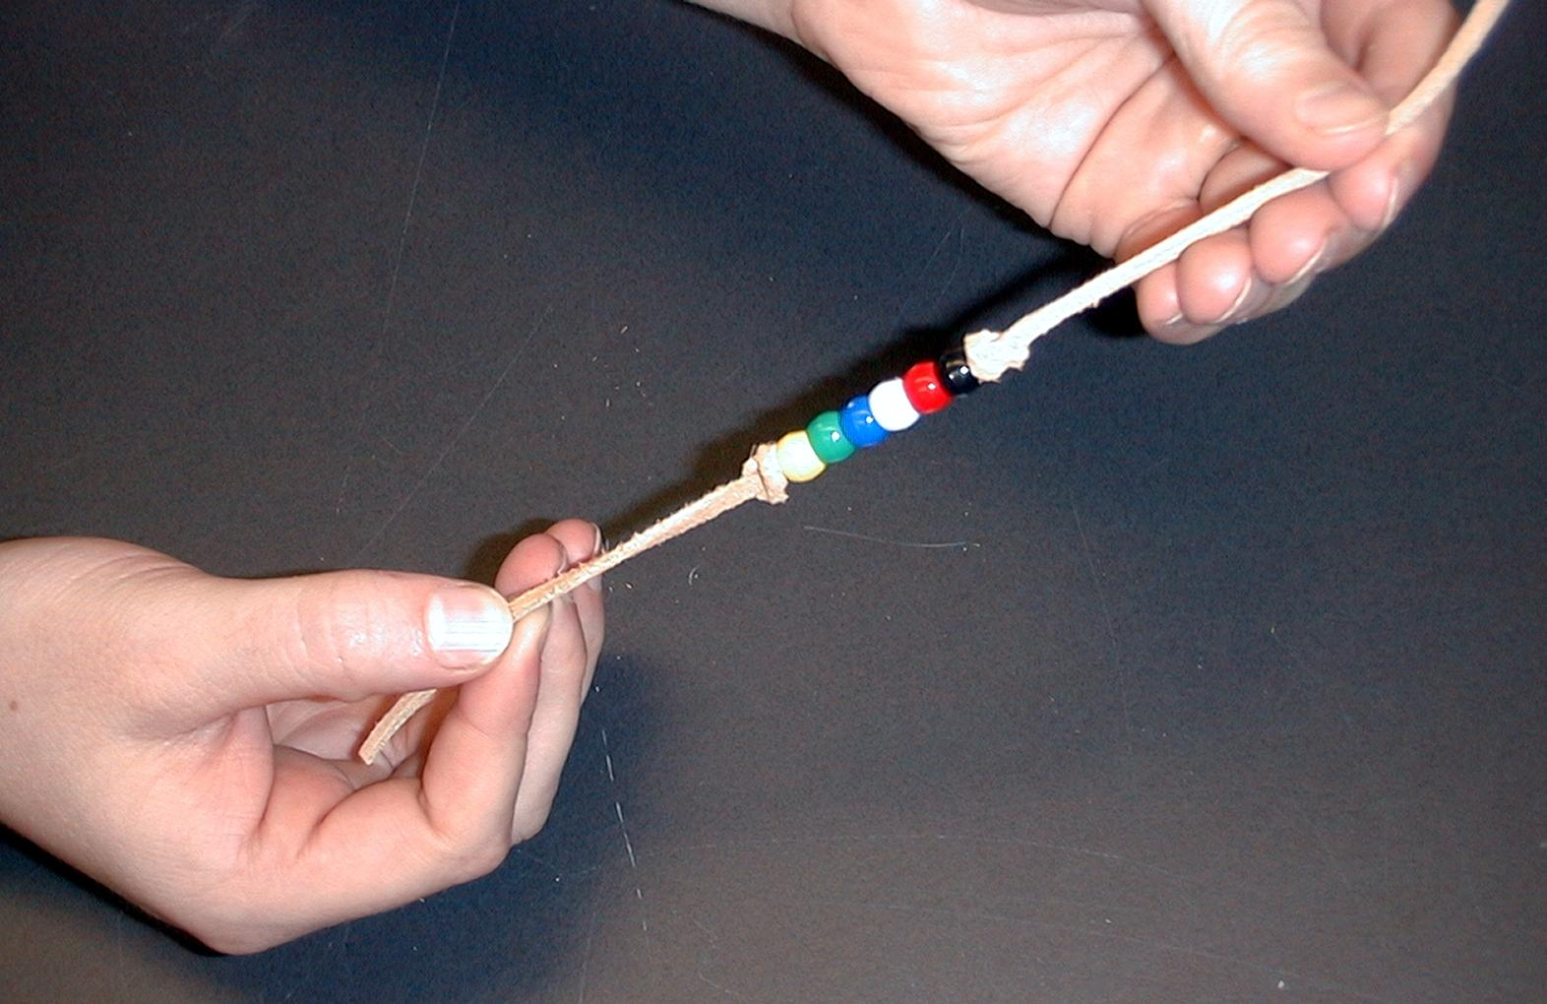

After each bead is added in the following order, another knot is made to keep the beads in the center of the bracelet.

The kids can then help each other tie the bracelets around their wrists.

Have kids thread the beads in the following order as you explain each color’s meaning and ask your group the accompanying questions. Noted scripture references may be helpful.

The BLACK bead reminds us of God’s truth that ALL ARE SINFUL.

You are discussing church with a friend who does not go to church. She says, “I don’t really need to go to church because I have never done anything bad enough to keep me out of heaven.” What advice would you give her?

Refer to Romans 3:12, “All have turned away. Together, everyone has become evil. None of them does anything good.”

The RED bead reminds us of the BLOOD OF JESUS.

One of your friends notices that you are wearing a cross necklace. She admires it and says it is cool. You ask her if she knows what the cross stands for. She says it has something to do with Jesus but she does not know what. What does the cross have to do with Jesus?

Refer to Ephesians 2:13, “Yes, at one time you were far away from God. But now in Christ Jesus you are brought near to God through the blood of Christ’s death.”

The WHITE bead reminds us of FORGIVENESS.

Your friend was caught cheating at school. He even got sent home early and his mom and dad had to pick him up. That night he called you because he was so worried about what he had done wrong. He said God would probably never forgive him. What do you tell him?

Refer to 1 John 1:9, “But if we confess our sins, He will forgive our sins. We can trust God. He does what is right. He will make us clean from all the wrongs we have done.”

The BLUE bead reminds us of FAITH.

Your friend has heard you tell him about how Jesus paid the price for his sins and offers forgiveness. Now he wants to receive that forgiveness. He asks you how to pray to receive it. What do you tell him?

Refer to Romans 3:22 (NIV), “This righteousness from God comes through faith in Jesus Christ to all who believe.”

The GREEN bead reminds us of GROWTH IN FAITH.

One of your friends is ready to steal candy at the store. He asks if you want a piece. You say, “No, that’s not right.” Your friend goes to church with you and should know better. He says, “It’s okay. We can always ask God to forgive us.” What do you tell him?

Refer to Ephesians 5:1 and 10: “So try to be like God… Try to learn what pleases the Lord.”

The YELLOW bead reminds us of EVERLASTING LIFE.

Your grandmother died and everyone in your family is sad. You know that she loved Jesus and trusted in Him as her Savior. Your little brother does not understand where Grandma is right now. What would you tell him?

Refer to John 3:16, “For God loved the world so much that He gave His only Son. God gave His Son so that whoever believes in Him may not be lost, but have eternal life.”

Today we have learned to *listen to God and His advice. How do you look for godly advice when you need it? If you can’t find an answer clearly in the Bible, you can go to older leaders (the ones Rehoboam chose not to listen to), like Christian adults or friends.

The Bible says in Proverbs 22:17, 19, “Pay attention and listen to what wise people say. Remember what I am teaching you… so that you will put your trust in the Lord.”

Memory Verse Learning: 5 minutes
Purpose: Help kids to memorize and keep scriptures at heart. Using creative ways to help kids enjoy learning the key verse and in small group setting.

Supplies needed: balloons; masking tape; straight pin

Memory Verse: Proverbs 22:17, 19, “Pay attention and listen to what wise people say. Remember what I am teaching you… so that you will put your trust in the Lord.”

Memory Verse Presentation: “Balloon Burst”
Before class, break up the verse and write them on the amount of balloons you desire. Line and stick them up on a wall with the masking tape. During class, learn the verse with the children by reciting. After two rounds, burst a balloon and continue to burst one after each round the verse is recited.

Prayer:
Encourage the children to listen to godly advice and advice from God’s word. Have them pray about the advice they will give to others.

Safety and Security: Safety and security procedures are important for each church to carefully define and implement according to their unique needs. The security, safety, illness and accident procedures described in this curriculum are provided for example purposes only and may not be appropriate, applicable or adequate for every situation. Each church is responsible for determining whether any security, safety, illness and accident procedures contained in the curriculum are appropriate, applicable or adequate for its unique situation. The activities described in this curriculum require adult supervision and may not be suitable for each child and each situation. Each church is responsible for ensuring that adequate adult supervision is provided for all activities and for determining whether an activity is appropriate for each child and each situation. Kids Kount Publishing disclaims all liability for the implementation of any procedures or the performance of any activities described in this curriculum.

Large Group Presentation

Dao Dao Is Too Big for His Trousers

Puppet Presentation

Today’s pesta game is a humorous illustration of someone too big for his/her trousers. The game can be done either as a contest between two groups or as a single group game.

A contestant (or two contestants from two groups) will slip on some extra large, long trousers over his/her pants. The rest of the group will stuff as many inflated balloons into the underwear as they can. The object of the contest is to see which team can stuff the most balloons. It is fun to take a straight pin and pop the balloons through the fabric as all the kids count how many balloons were stuffed.

The contest version of the game would have the girls blowing up balloons, tying them, and passing them to stuffers who are stuffing the long underwear of their female representative. At the same time, the boys would be blowing up and stuffing their representative’s long trousers.

The biggest concern with the game is the amount of time that it may take. The game should not upstage the message. It is best to give this game a restriction of two minutes to see how many balloons can be inflated and stuffed. All of this needs to be considered when you decide if you will do this as a contest between two teams or with just one person.

The key learning point is that we are to listen to God and to godly wisdom. When we become “full” of ourselves, we become too big for our trousers. Rehoboam had this problem and he ended up worshiping idols.

Add some accessories to Dao Dao to give him a contrived “cool” look. The accessories could include sunglasses and a hat. In addition, tape a lightly inflated balloon to each of his biceps so that it would look like Dao Dao was trying to pad himself for the appearance of extra muscles.

Teacher: Hi, boys and girls. I’m Teacher __________. Welcome to Pesta Kingdom Quest featuring my assistant, Dao Dao.

Dao Dao: Way-Too-Cool Dao Dao to you.

Teacher: What do you mean “Way-Too-Cool?”

Dao Dao: Just what I said. Also, we need to get rid of this assistant business. Instead, you should be my assistant!

Teacher: Why?

Dao Dao: Because I’m the coolest one.

Teacher: What makes you so cool?

Dao Dao: Check out the outfit.

Teacher: Yes, I can see it. What are those things on your arms?

Dao Dao: Well, these are my extra muscles. I’m looking like a bad dude!

Teacher: A bad dude? What do you mean?

Dao Dao: A way cool bad dude!

Teacher: Oh, I see. You think all of these things make you hot stuff.

Dao Dao: Yeah. A way cool bad dude that’s hot stuff. That’s me!

Teacher: Dao Dao, do you want my advice?

Dao Dao: No.

Teacher: Maybe I will give it to you anyway.

Dao Dao: I said I don’t want it!

Teacher: You are trying to be way cool and you don’t want my advice, is that it?

Dao Dao: That’s it. After all, what do you know about being way cool?

Teacher: Well, I know that you don’t become cool by stuffing your arms with balloons to make it look like you have bigger muscles.

Dao Dao: Or, if you do, just wear long sleeved shirts to cover them up.

Teacher: No, Dao Dao, there is more to it than that. In today’s Bible event, we will meet someone who thought he was too cool.

Dao Dao: Too cool for school?

Teacher: Well, too cool to take anyone’s advice. His name was Prince Rehoboam and he was too big for his trousers.

Dao Dao: What does that mean?

Teacher: That means he took no one’s advice except the advice he wanted to hear, and he ended up being too big for his trousers. As a matter of fact, we have a special game to help us picture what it is like to be too big for our trousers.

Dao Dao: Cool! How does it work?

Teacher: I am going to ask for a boy and a girl volunteer to come forward. Each of you will put on these extra large long trousers over your pants. I will pass out balloons to a group of girls and a group of boys. While remaining in their seats, each team will have two minutes to blow up as many balloons as they can, pass them to the front, and have two volunteers stuff them into the long trousers on our contestants. Let’s see which team can get the most balloons stuffed in the pants in two minutes.

(Dao Dao and Teacher ad-lib while the game is played.)

Teacher: It looks like these people are too big for their trousers. That means they are full of too much hot air and they really don’t listen to good advice. Let’s count the balloons. Everyone count them as I pop them with this pin through the pants.

After the counting and the contestants are dismissed, continue with:

Teacher: Now let’s hear about the son of King Solomon who was not so wise. As a matter of fact, he ended up as the prince who was too big for his trousers.

Wise Advice Not Taken
A storytelling from a wise counselor
whose advice was not heeded by Rehoboam

A character in period costume, perhaps showing age or sporting a beard, enters to give an account of the Bible event from 1 Kings 12. His prop is a whip that can be a tube with several pieces of rope attached to it.

Hi, kids. Would you like some advice from an older man who knows what he is talking about? Well, would ya? Okay, here it is. Take your hands and put them over your ears to shut out all other noises. Now say, “La, la, la, la, la” so you can’t hear anything! Try that for five seconds and see if you can hear me.

After kids have repeated the “not listening” demonstration, continue with:

Some of you might have done something like that when you refused to listen to someone else. Here’s my advice. Don’t do it. Do you hear me? Don’t cut out listening to wise advice from godly people and most definitely don’t cut out wise advice from God. How do I know this? Let me tell you a story.

I was an advisor to the great King Solomon, one of the wisest kings of all times. However, Solomon was not so wise in choosing the women he married or in raising his children. You see, Prince Rehoboam was raised mostly by his mother who worshiped idols and performed horrible practices. Rehoboam had grown up in the midst of royal wealth and splendor. He was spoiled and did not understand the common people.

When Rehoboam was forty-one years old, Solomon died and Rehoboam was to be crowned king. At this time, God’s people were divided into tribes. There were twelve tribes—ten of those lived in the north and two in the south. Rehoboam lived in the south and his father had always treated the people in the south, the tribe of Judah, with special favor. The other ten tribes known as Israel had to do extra heavy work and pay high taxes. Rehoboam wanted to be like his father and rule both Judah in the south and Israel in the north.

When it came time to crown Rehoboam king, the people of Israel made a special request to their leader, Jeroboam. They wanted him to say to Rehoboam, “Your father forced us to do heavy work and pay high taxes. If you will lighten our load, we will serve you.”

Rehoboam needed to think about this and took three days to give an answer. He needed some advice so he called me and the other wise advisors who had given counsel to his father, Solomon.

I told Rehoboam, “You should give the people what they request. Give them a break! Treat them kindly and then they will serve you forever. Otherwise, the people will reject you.”

Rehoboam didn’t like that answer. It was almost like he did this. Places hands over ears and say, La, la, la, la, la, la. I can’t hear you.

Rehoboam was not listening to wise and godly advice. Instead, he called on his rich young friends and asked their advice. They told Rehoboam to say, “My little finger is heavier than my whole father’s body. If my father put a heavy burden on you, I will add to it. If my father punished you with whips, I will punish you with scorpions.”

“There!” Rehoboam thought to himself. “If I show no weakness and I am extra mean, that certainly will cause the people to fear me and do what I say.”

Kids, what do you think happened? Do you think Rehoboam became the king of Israel and his own people in Judah? Right! The tribes of Israel rejected him as king.

Rehoboam tried to send people to Israel to collect taxes for him, but they got killed. He was even going to send soldiers, but God sent a prophet who said, “Don’t do it.”

After three years as king, Rehoboam turned to idol worship. Though his father, Solomon, had built a great temple where people could worship the true God, Rehoboam had altars built on every high hill and under every green tree He worshiped false gods like his mother had done.

Do you think Rehoboam was listening to God’s word that says not to do this? Right. He was not doing this. Place hands over ears and say, La, la, la, la, la, la. I can’t hear you!

God was displeased and sent great trouble for Rehoboam. He sent Shishak, king of Egypt, with twelve hundred chariots and sixty thousand horsemen. They captured the cities and were about to capture Jerusalem and Rehoboam. But Rehoboam took all the treasures he could find, even the golden shields that belonged to his father, and sent them as a payment to the Egyptians. The Egyptians, in turn, did not destroy them.

After seventeen years as king, Rehoboam died. He was constantly at war with the ten tribes to the north called Israel. God was displeased with Rehoboam because he would not take godly advice or listen to God.

Dao Dao Is Too Big for His Trousers

Dao Dao Puppet Script Conclusion

Teacher: So Dao Dao, what do you think about Rehoboam?

Dao Dao: Well, he kind of got his balloon popped, didn’t he?

Teacher: Yeah, he was too big for his trousers wasn’t he? That’s an important lesson. I hope I don’t get too big for my trousers. How about you, Dao Dao?

Dao Dao: Gulp. Well, I think you made your point.

Teacher: What do you mean?

Dao Dao: I can see now that I was too big for my trousers.

Teacher: What do you think you should do about it?

Dao Dao: I need to tell God that I’m sorry, don’t I?

Teacher: Yep.

Dao Dao: And then what?

Teacher: You know that Jesus gave His life for you, don’t you?

Dao Dao: Sure, He died on the cross for my sins.

Teacher: Right, Dao Dao. Think about that. Even though Jesus was God’s own Son, He did not think of Himself as too big for His trousers. He listened to God and took His advice. He obeyed and went to the cross because He loves us so.

Dao Dao: Wow. I never thought of it that way.

Teacher: Sure, Jesus wasn’t too big for His trousers. He gave His life for you so that you could be forgiven. Because of that, now you can have His power not to get too big for your trousers.

Dao Dao: That really is cool!

Teacher: Yeah. It’s even more cool than us. So now, we will close in prayer and ask that God’s power of forgiveness would help us not get too big for our trousers!

Dear God, sometimes we get too big for our trousers. I’m sorry. Thank You for Jesus and how He gave His life for us. Please forgive us and help us not to try to act too cool. Help us listen to You and Your advice. In Jesus’ name. Amen.

Lesson 24

Small Group Warm-Up:
- markers
- large balloons
- cellophane tape

Large Group:
- large, long trousers
- balloons
- straight pin
- costume for an old, wise counselor (possibly with a beard)
- whip
- Dao Dao looking “cool” - may wear sunglasses or a hat
- two light inflated balloons taped to each of Dao Dao’s biceps

Small Group Application:
- tape to be placed on the balloon person
- straight pin for each group
- friendship bracelet supplies (beads and leather or elastic bands 8”-10” long)
- copy of the attached explanation of the colors used in the friendship
- bracelets for each child (page 18)

Memory Verse Learning:
- balloons
- masking tape
- straight pin
Friendship Bracelet

BLACK bead – SIN (All people are sinful.)

“All have turned away. Together, everyone has become evil. None of them does anything good.”

Romans 3:12

RED bead – BLOOD (Jesus’ blood is the payment.)

“Yes, at one time you were far away from God. But now in Christ Jesus you are brought near to God through the blood of Christ’s death.”
Ephesians 2:13

WHITE bead – FORGIVENESS (Forgiveness is offered through Jesus.)

“But if we confess our sins, He will forgive our sins. We can trust God. He does what is right. He will make us clean from all the wrongs we have done.”
1 John 1:9

BLUE bead – FAITH (We receive forgiveness by faith.)

“This righteousness from God comes through faith in Jesus Christ to all who believe.”

Romans 3:22 (NIV)

GREEN bead – GROWTH (Growth in faith.)

“So try to be like God… Try to learn what pleases the Lord.”
Ephesians 5:1, 10

YELLOW bead – HEAVEN (We know heaven is our home.)

“For God loved the world so much that He gave His only Son. God gave His Son so that whoever believes in Him may not be lost, but have eternal life.”
John 3:16

