
Date: ________________________
Series: Meet the Amazing Jesus
Dec-Mar Year 3, Lesson 34

Grow Close to God

Take Home Point: *Spend time with God and grow close to Him. *Repeat this phrase throughout the lesson.

Bible Event: Luke 2:41-52 Jesus’ boyhood trip to the temple.
Key Verse: James 4:8 “Come near to God, and God will come near to you.” (NCV)

We will help kids know:
- The Bible event of Jesus’ boyhood trip to the temple.
- Jesus, though He was true God, spent time learning from scripture and teachers.
- Jesus loved being in His Father’s house and learning from scripture. So can we.
- Through Jesus’ perfect life for us, we can be close to God and spend time with Him at church and at home.

We will help kids feel:
- A desire to get closer to God.
- Confident that they can learn from the Bible at home and at church.

We will help kids do:
- Identify favorite family vacations and feelings of closeness.
- Identify ways we can get closer to God, especially through Bible reading and church attendance.
- Practice family or personal devotions. Take home a sample of devotions and practice them.

THIS LESSON’S ROADMAP

DESTINATION | PAGE # | DISCOVERIES ON YOUR JOURNEY | SUPPLIES NEEDED
  Small Group Warm-Up | 3 | The kids share and talk about how their trips helped them feel closer to their families. | - a five-inch round balloon  - five to six Styrofoam packing peanuts
Large Group   | 3  7  12 | Overview  Object Lesson: “Jesus’ Boyhood Trip to the Temple.” The presenter uses yarn and a static charged balloon to tell the story of Jesus visiting the temple (Luke 2:41-52). It illustrates Jesus’ desire to stay close to God the Father and teaches how we, too, can grow close to God.  Review: Dao Dao helps review the Bible event. | - large sign that reads “Meet the Amazing Jesus”  - smaller signs, each with the word “amazing” printed on it  - the animated video “The Miracle Maker,” produced by Family Home Entertainment, Inc.—order from www.booksofthebible.com  - Dao Dao puppet  - 5” balloon  - glue  - 12” piece of yarn  - three Styrofoam packing peanuts  - scissors  - various yarn segments
Small Group Application   | 4 | Help the kids identify times of learning from God’s Word, prayer, worship, and talking with others about their faith.  Memory Verse Learning:  “Come Nearer to Read”  James 4:8 will be emphasized in lessons 34-36 so that each child desire to get closer to God. | - balloon for each group  - yarn for each group  - scissors  - three Styrofoam packing peanuts  - glue  - memory verse in very small  print on paper (4pt.)  - magnify glass
Small Group Warm-Up: 15 minutes
Purpose: Get pointed in the right direction! Build relationships and help guests feel at ease. Do the learning readiness activity that will point your group in the right direction for the lesson.

Supplies needed: a five-inch round balloon and five to six Styrofoam packing peanuts.
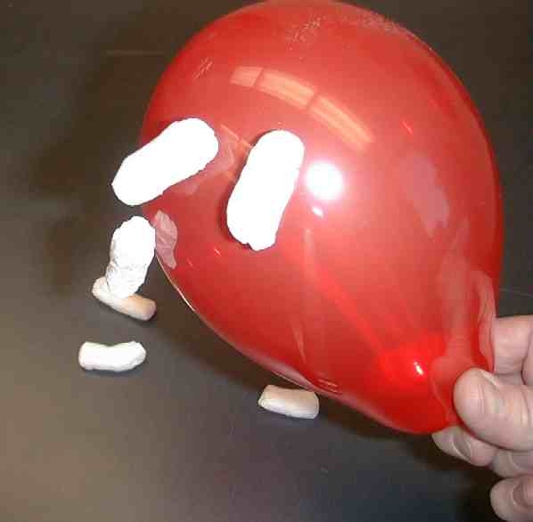
Have the balloon inflated and tied when asking the first warm-up question. Charge the balloon by rubbing it on someone’s clothing made of wool, polyester, or a similar type of fabric until the balloon gathers an electrical charge. Hold the balloon over the foam packing peanuts and watch them cling to the balloon. Let kids take turns charging the balloon as they answer the following.

What was your best family trip? How did this help you feel closer to your family?

Let each child collect on the balloon the number of packing peanuts that correspond to the number of family members that went on his/her trip.

This activity can illustrate how the family might have felt closer after they had taken the trip. It is a good idea for you to demonstrate this activity first and share your best family trip.

After all of the kids have shared and have talked about how their trips helped them feel closer to their families, introduce the large group presentation with the following.

Today we are going to learn about Jesus who was simply amazing. As a 12-year-old boy, Jesus went with His family on a trip. On the trip, Jesus showed us how important it was for Him to be close to His Heavenly Father. We can learn from Jesus that we, too, can be close to our Heavenly Father.

We will learn that like Jesus, we can *spend time with God and grow close to Him.

Large Group Overview: 20-30 minutes
Purpose: Help kids observe what the Bible says. Present the Bible event in creative fashion. Help kids begin to interpret what it means.

Object Lesson: “Jesus’ Boyhood Trip to the Temple” The presenter uses yarn and a static charged balloon to tell the story of Jesus visiting the temple (Luke 2:41-52). It illustrates Jesus’ desire to stay close to God the Father and teaches how we, too, can grow close to God.

Video: The Miracle Maker, Family Home Entertainment, 1999

Review: Dao Dao helps review the Bible event.

Small Group Application: 20-25 minutes
Purpose: Help kids map out the meaning of the Bible event in their lives. Use the questions to stimulate discussion but don't feel tied to them. Allow the Holy Spirit to guide you. Include personal examples from your own faith journey. The example of Christ at work in your life will leave lasting impressions of how Christ can work in the children's lives.

Use your Bibles! Children need to learn how to look up references and follow along when scripture is read aloud. Allow for quality time of prayer at the close of the lesson.

Observation Questions: What happened?
Read aloud Luke 2:41-52. Then ask the following questions.

How old was Jesus when He stayed behind in Jerusalem after the Passover festival? (Luke 2:42. He was twelve.)

Where did Mary and Joseph find Jesus? (Luke 2:46. In the temple courtyard.)

How long had Jesus been at the temple in Jerusalem? (Luke 2:46. At least three days.)

What did Jesus do at the temple that was so amazing? (Luke 2:47. “
All who heard Him were amazed at His understanding and wise answers.”)

What was Jesus’ answer to His parents when they asked him why he had done this? (Luke 2:49. “Why did you have to look for Me? You should have known that I must be where My Father’s work is!”)

Interpretation Questions: What does this mean?
What do you think was so amazing about Jesus wanting to stay at the temple? (He was so young to have so much knowledge or to want to be at the temple instead of playing.)

How do you think He acquired so much knowledge and understanding? (He spent time praying and studying scripture.)
Luke 2:50 said Jesus’ parents didn’t understand what He meant when He said He had to be in His Father’s house. How do you think it made Mary and Joseph feel?

What does Jesus’ answer tell us about what He thought was important? (Even though Jesus loved His earthly parents, He wanted to get even closer to His heavenly Father.)

Application Questions: What does this mean to me?
Read Luke 2:52.

Why do you think Jesus grew in wisdom and maturity and gained favor from God and people?

How old should we be to want to get close to God?

Application activity:
Supplies needed: balloon for each group; yarn for each group; scissors; three Styrofoam packing peanuts; glue

Charge the balloon by rubbing it on wool, polyester, or similar type fabric. Hold the balloon over the yarn and watch the yarn reach up towards the balloon. Let kids do this as they share their response to the following question.

Talk about a time you felt close to God at church or at home.

Help the kids identify times of learning from God’s word, prayer, worship, and talking with others about their faith. Read today’s key verse:

James 4:8 says, “ Come near to God, and God will come near to you.” Notice how the yarn is drawn close to the balloon.

Continue with the next question after cutting the yarn into two pieces, and then make a cross on the balloon.

Are you close enough with God right now that you know for sure you would be with Him forever in heaven after you die? What makes you near with God?

Using the pieces of yarn to make the shape of a cross on the balloon, talk about how Jesus did just what the Father wanted by giving His life for us.

Jesus died on the cross for our sins. When we have faith in Him, God says that we are near to Him because our sins have been forgiven. We can then live with Him forever. We receive this by simply trusting Jesus as our Savior.
The activity can be concluded as the group makes a happy face on the balloon with foam packing peanuts, glue, and yarn. Talk about any personal experiences of joy from feeling closer to God.

How can you, like Jesus, come nearer to God?

Ask the kids if they ever read the Bible on their own. When and how do they pray? When you discuss this, share with them what you have learned about keeping your own time set aside for prayer and Bible reading.

Option: To give kids incentive and accountability, make a monthly chart kids can mark with a check or a sticker on the dates that they are faithful to have a personal time with God.

Review the take home point: *Spend time with God and grow close to Him.

Memory Verse Learning: 5 minutes
Purpose: Help kids to memorize and keep scriptures at heart. Using creative ways to help kids enjoy learning the key verse and in small group setting.

Supplies needed: memory verse in very small print on paper (4pt.); magnify glass

Memory Verse: James 4:8 “Come near to God, and God will come near to you.”

Memory Verse Presentation: “Come Nearer to Read”
Ask for a volunteer to read the memory verse. What the volunteer will get is a very fine print. Say that the volunteer truly need to go very near to the paper in order to read the verse but hand a magnify glass to help volunteer. After the volunteer reads, have the group repeat. Have a few more volunteers to help children learn up the verse.

Prayer Time:
Thank Jesus that He made a way for us to be closer to God through His death and resurrection. Thank Him for His example of wanting to get close to God through prayer and scripture reading. Pray for the Holy Spirit to help all spend daily time with God.
Note: In the weeks to come, various illusions will be used in the series, “Meet the Amazing Jesus.” If your large group is over 40 kids, you may find it helpful to have a video camera to project the illusion on a large screen. A volunteer operator will be needed if you decide on this method of sharing the illusion.
Safety and Security: Safety and security procedures are important for each church to carefully define and implement according to their unique needs. The security, safety, illness and accident procedures described in this curriculum are provided for example purposes only and may not be appropriate, applicable or adequate for every situation. Each church is responsible for determining whether any security, safety, illness and accident procedures contained in the curriculum are appropriate, applicable or adequate for its unique situation. The activities described in this curriculum require adult supervision and may not be suitable for each child and each situation. Each church is responsible for ensuring that adequate adult supervision is provided for all activities and for determining whether an activity is appropriate for each child and each situation. Kids Kount Publishing disclaims all liability for the implementation of any procedures or the performance of any activities described in this curriculum.
Large Group Presentation

An Object Lesson Telling of
Jesus’ Boyhood Trip to the Temple
Luke 2:41-52

Take Home Point: *Spend time with God and grow close to Him.

Supplies needed: large sign that reads “Meet the Amazing Jesus;” smaller signs, each with the word “amazing” printed on it; the animated video The Miracle Maker, produced by Family Home Entertainment, Inc. (order from www.amazon.com or www.RoadtoGlory.com ); Dao Dao puppet; 5” balloon; glue k; 12” piece of yarn; three Styrofoam packing peanuts; scissors; various yarn segments

Prompt kids to say, “Simply amaaaazing,” when the presenter points up and says, “And THAT is…,” A sweeping arm gesture by the large group presenter as the kids say, “simply amaaaa-a-azing” will add effect and emphasis. Use this technique as an attention grabber when presenting the main points.

Video

Show short clip of video the Miracle Maker produced by Family Home Entertainment, 1999. Start when Jesus and Mary are remembering the time He was found at the temple. End when Mary says, “After that day I knew you would be …”

Object Lesson
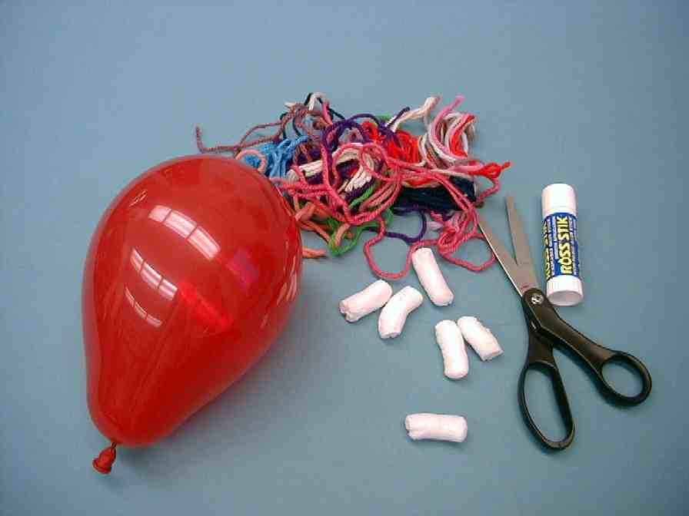

Illustrations and script for the presenter

Supplies Needed:

- 5” balloon
- glue stick
- 12” piece of yarn
- 3 foam packing peanuts
- scissors
- various yarn segments
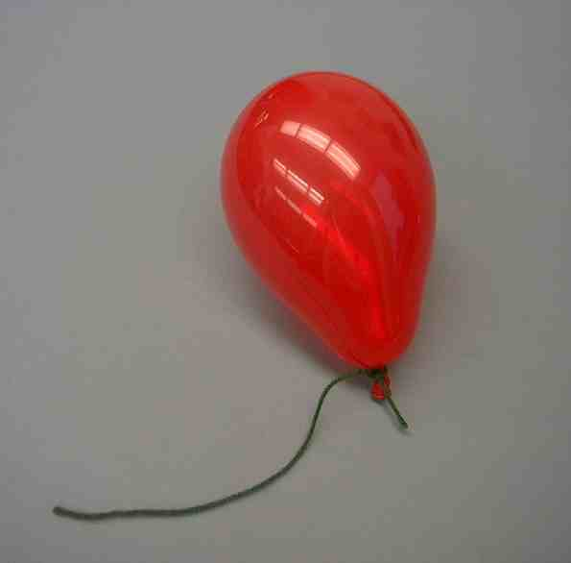

Let this yarn remind us of Jesus. The balloon will remind us of God the Father. Even before the creation of the world, Jesus was with God the Father. They were connected together. Jesus was God the Son, and the Father was God the Father. With them also was God the Holy Spirit. They were very close, just like this yarn is tied to the balloon.
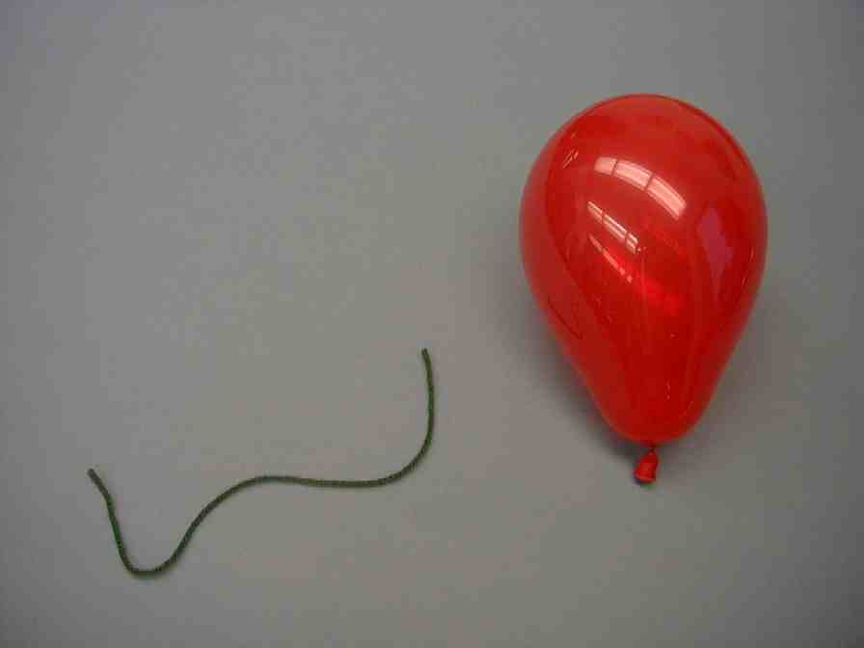

When Jesus was born in Bethlehem, He left God the Father and became a human being. Even though Jesus was God, He was also a person like you or me. Jesus started as a baby and grew up to be a little boy and then a man. He grew just like any other boy.


There was something special about Jesus. Because He was the Son of God, He was perfect. He had a mission here on earth to give His life for us so that we could get put back together with God. You see, our sin separates us from God, the Holy One.

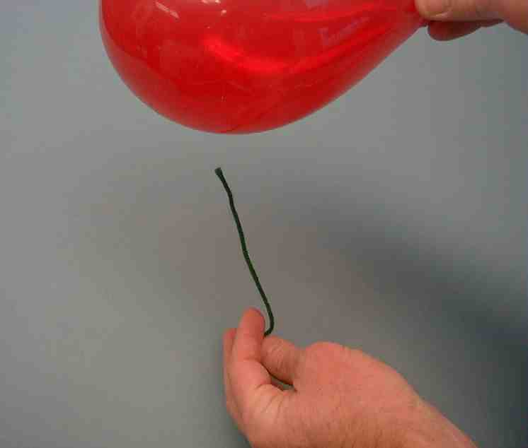
Every year Jesus’ parents would go to Jerusalem for the Passover festival. When
He was twelve years old, Jesus went as usual. To the Jews at this time, a twelve years old boy was just one year away from becoming an adult. It was an important year
for Jesus.

At this time, charge the balloon by rubbing it against clothing. Hold the yarn beneath the balloon. The charge will draw the tip of the yarn toward the balloon.

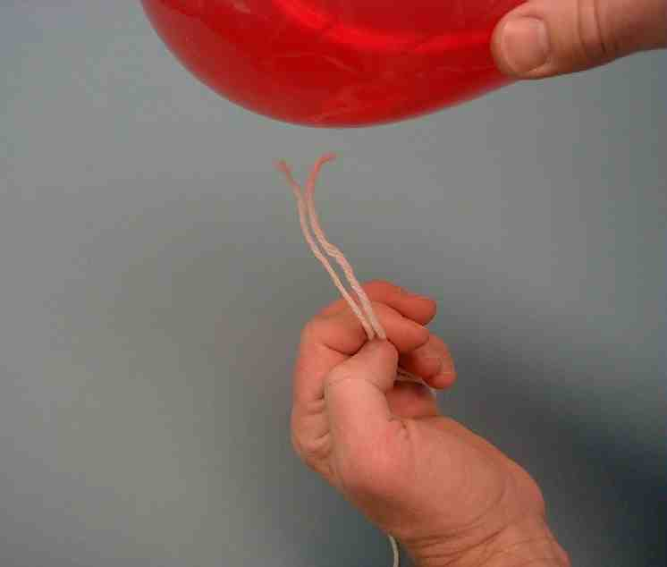
When Jesus was in Jerusalem, He spent time in the temple. There He asked questions and listened to the teachers of scripture. He also understood it and gave answers that surprised everyone. What excited Jesus was that, while at the temple discussing scripture, He was learning and growing closer to God.

Charge the balloon. Use two pieces of yarn to represent the teachers at the temple drawn closer to God.


The teachers were amazed at Jesus’ learning and understanding. As Jesus asked questions and gave answers, they could tell that He had wisdom from God. They, too, wanted to grow closer to God.

Jesus’ family had left to go back to Nazareth. They had a long walk! After traveling for a whole day, Mary and Joseph started to look for Jesus among all of their relatives and friends. When they did not find Jesus, they were worried and went back to Jerusalem to look for Him.


Mary and Joseph looked all over Jerusalem for three days. You can imagine how worried they were! Finally, they found Jesus in the temple courtyard. He was sitting among the teachers, listening and asking questions. When Mary and Joseph saw Jesus, Mary said, “Son, why have you done this to us? Your father and I have been worried sick looking for you.”

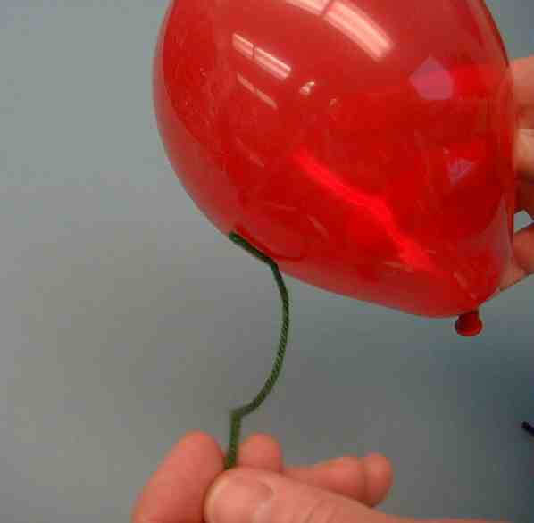
Charge the balloon. Have the “Jesus yarn” reach towards the balloon.

Jesus seemed to be surprised. “Why did you have to look for Me?” he asked. “You should have known that I must be where My Father’s work is!?”
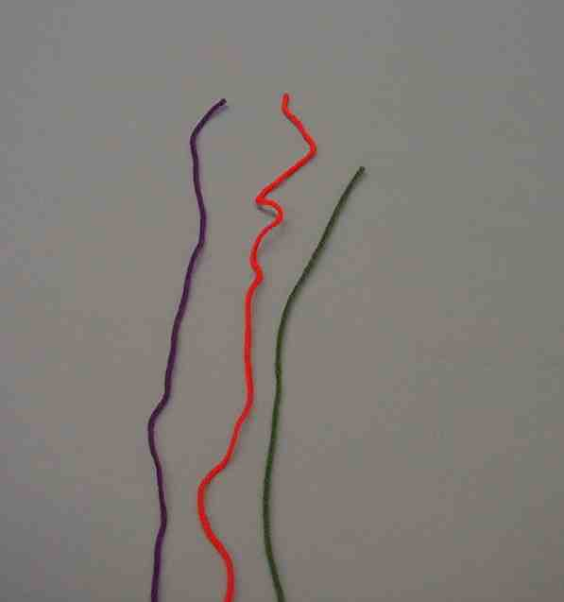

For Jesus, it was very important to learn, discuss, and teach the Bible in the temple. Jesus was also doing those things that helped Him grow close to His heavenly Father.

Jesus returned with Mary and Joseph to Nazareth and He was obedient to them. He must have realized that it was not yet time for Him to start His public ministry. Jesus would learn and grow with His family in Nazareth until He was 30 years old. Then He would leave home to start His ministry.

Cut the “Jesus yarn” in approximately two-thirds. Charge the balloon and place the two sections of yarn in the shape of a cross.
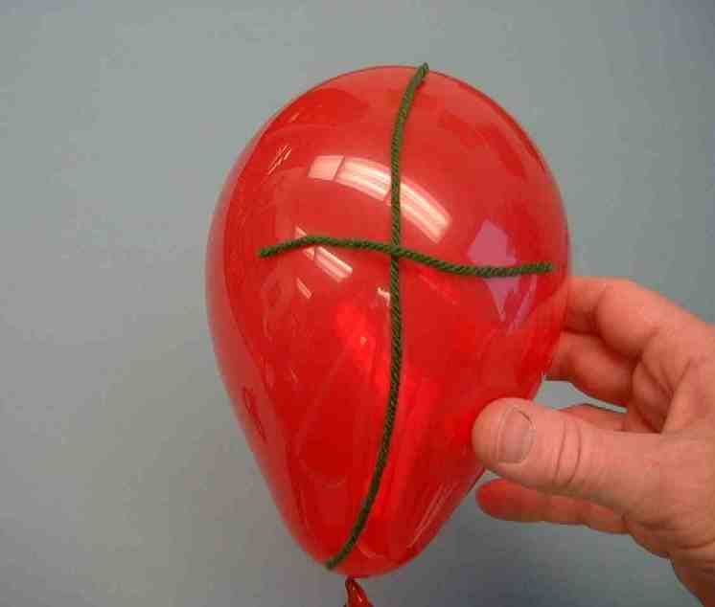
This Bible event demonstrates that Jesus wanted to be close to His Father during his life here on earth. He also made a way possible for us to be close to God the Father by giving his life on the cross for us. If anyone believes in Jesus as Savior, he can be close to God just like this yarn sticks to the balloon.

Let me show you something else.

Cut more sections of yarn to make eyebrows, mouth, and hair. Use a glue stick and foam packing peanuts to make the eyes and nose of a happy face. As you are making the face, continue with the dialogue.
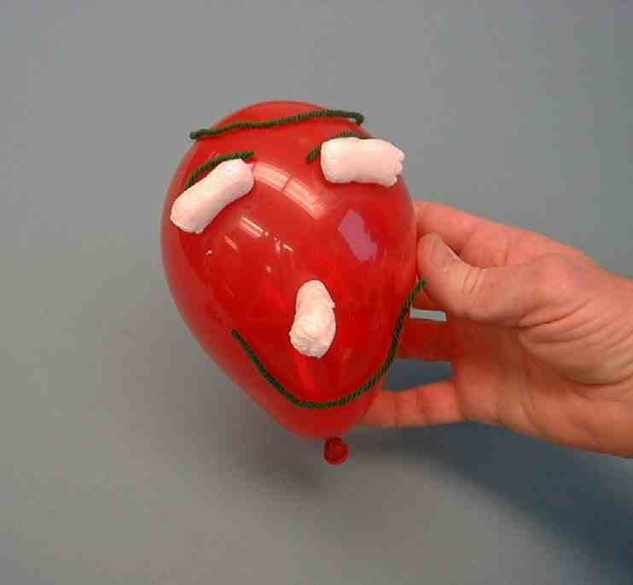
There is something very important that God wants us to know. He very much wants us to be close to Him. He wants us to spend time with Him just like friends want to spend time together. We spend time with God when we worship and pray. Then we tell God that we love Him and recognize that He is our God. When we listen to God’s word and understand how He wants to be part of our lives every day, we can be filled with His presence.

Jesus Himself can live in our lives. We can be very close to God. This does not only happen at church – it also happens at home. When we read the Bible and talk about God at home, we can grow closer to God there, as well.

Why do we want to grow closer to God at church and at home? Because … Show the happy face balloon to the children. God has designed us and created us to be close to Him. When we are close to Him, we will be truly happy.

Today, we are learning to *spend time with God and grow close to Him.
Dao Dao’s Review Questions
“Jesus’ Boyhood Visit to the Temple”

The following questions can be used for review of today’s Bible event. This will be a contest between Dao Dao and the kids. Dao Dao assigns a scoring value to each question before that question is read. That number is in parenthesis at the beginnning of the question. What makes it fun is that Dao Dao finally gets one correct at the end and that number helps him make a dramatic comeback. The kids typically win, but it might be interesting if, from time, to time, Dao Dao wins. Adjust to your preference. One thing is important and will be vital to this script: move through your material quickly. By this time, the kids’ attention spans are short. You may even want to delete some of the questions if it is feeling a bit long.

After each question, the first parenthetical remark is Dao Dao’s response. The second parenthetical remark is the correct answer from a child.

Kids might even bring their Bibles to large group to search for answers as they listen to the following questions.

- (1 point) How is Jesus the same as the kids here?
(Goofy.)
(He was a person, a human.)

- (2 points) How is Jesus different from the kids here?
(He could fly.)
(He was God.)

- (3 points) How old was Jesus when He visited the temple in today’s Bible event?
(Eight.)
(Twelve.)

- (4 points) What feast was at this time?
(Fourth of July.)
(Passover.)

- (5 points) Jesus’ parents left and travelled a whole day without Him. Why didn’t they miss Him?
(He was playing hide and seek.)
(They thought He was with relatives.)

- (6 points) Jesus’ parents went back and looked for Him. How long were they searching?
(Twenty minutes.)
(Three days.)

- (7 points) Where was Jesus?
(At the video arcade.)
(At the temple.)

- (8 points) What did Jesus say when Mary and Joseph found Him?
(“Uh oh, am I in trouble now!”)
(“Didn’t you realize that I had to be in My Father’s house?”)

- (9 points) Why was the temple a special place for Jesus?
(It was a great place to play hide and seek.)
(He felt closer to God. He could learn and teach there.)

- (10 points) Did Jesus obey His parents?
(Only when He had to.)
(Yes. He returned and grew in favor with God and people. He stayed there until He was 30.)

- (11 points) Can we get closer to God? How?
(Yes. Take an airplane.)
(Yes. Learn about Him in the Bible, at church, and at home.)

Teacher: I know you know better, Dao Dao. Next time we get together how about getting one question right. Can you handle that?

Dao Dao: Sure, Teacher. I know this stuff is serious, but I really enjoy having fun.

Teacher: Well, can we close us in prayer then?

Dao Dao: Of course.

Teacher: Dear heavenly Father, we thank You so much for Jesus. Thank You for sending Him to pay for our sins. Help us be like Jesus. Help us to come close to You, to learn about You and to be obedient to You. We love You. In Jesus’ name. Amen.

Lesson 34

Small Group Warm-up
  - a five-inch round balloon
  - five to six Styrofoam packing peanuts

Large Group Presentation
- large sign that reads “Meet the Amazing Jesus”
- smaller signs, each with the word “amazing” printed on it
- the animated video “The Miracle Maker,” produced by Family Home Entertainment, Inc.—order from www.booksofthebible.com
- Dao Dao puppet
- 5” balloon
- glue
- 12” piece of yarn
- three Styrofoam packing peanuts
- scissors
      - various yarn segments

Small Group Application
- balloon for each group
- yarn for each group
- scissors
- three Styrofoam packing peanuts
- glue

Memory Verse Learning
- memory verse in very small
print on paper (4pt.)
- magnify glass

