
Date: ________________________
Series: Meet the Amazing Jesus
Dec-Mar Year 3, Lesson 37

Mary and Martha

Take Home Point: *Spend time with Jesus.
*Repeat this phrase throughout the lesson.

Bible Event: Luke 10:38-42 Mary and Martha
Key Verse: Luke 10:42, “There is only one thing you need. Mary has made the right choice, and that one thing will not be taken away from her.” (NCV)

We will help kids know:
- The Bible event of Mary and Martha entertaining Jesus at their home.
- Jesus wants us to spend time with Him in prayer and in His word.
- God knows our thoughts.
- God wants to be close to us.

We will help kids feel:
- Amazed that God would want to spend time with us as we spend time with Him in prayer and devotion.
- A sense of calm in quiet times of prayer and Bible reading.

We will help kids do:
- Identify a special time and place they can spend talking to God and listening to Him in His word.
- Consider what it is like to have God know and desire them to share their deepest thoughts.
THIS LESSON’S ROADMAP

DESTINATION | PAGE # | DISCOVERIES ON YOUR JOURNEY | SUPPLIES NEEDED
  Small Group Warm-Up | 3 | One kid acts as a “mind reader” to set up the teaching that God can read our minds but wants us to spend time telling him our deepest thoughts. | - pens  - aluminum foil  - string
Large Group   | 4  9  10  13  15 | Overview  Video: “The Miracle Maker,” by Family Home Entertainment, Inc., 1999—show Mary and Martha entertaining Jesus.  Object Lesson: “An Object Lesson—A Time with Jesus” – Teacher uses the “Disobedient Heart” illusion to teach the Bible event of Mary and Martha found in Luke 2:38-42.  Dao Dao’s Review Questions: Jesus visits Mary and Martha –Dao Dao tries to remember the facts of the Bible event but needs help from the kids.  Appendices | - video: “The Miracle Maker”  - “The Disobedient Heart” gospel illusion trick—contact Dock Haley Gospel Magic Co. at www.booksofthebible.com  - copies of the three sheets in the appendix that list the busy activities that Martha was doing as well as the center section designated “Spend Time With Jesus”—mount on poster board or tape to a wall so that the presenter can hold the gospel illusion trick next to it
Small Group Application   | 5 | Kids discuss the importance of spending time with God and make a plan for a set time and place to have daily quiet time. The illusion from large group is duplicated to make the point.  Memory Verse Learning:  “Read Where the Heart Goes”  Rm. 3:22 will be emphasized in lessons 37-39 so each child know that faith is trusting in Jesus as God’s Son, our Savior. | - aluminium ball trick from Warm Up  - a paper heart  - tape  - three sheets of paper  - pencils  - “Spending Time with Jesus” worksheets  - aluminium ball trick from Warm-Up  - a paper heart  - 41X15cm piece of paper  - Marker  - masking tape
Small Group Warm-Up: 15 minutes
Purpose: Get pointed in the right direction! Build relationships and help guests feel at ease. Do the learning readiness activity that will point your group in the right direction for the lesson.


Supplies needed: pens, aluminium foil, string

In advance, prepare a “trick” aluminium foil ball. To make this, crumple a sheet of aluminium foil about twelve inches long into a ball. Jab a pen into the ball at the “north pole” and the “south pole.” Both of these jabs should penetrate at an angle and connect to each other.

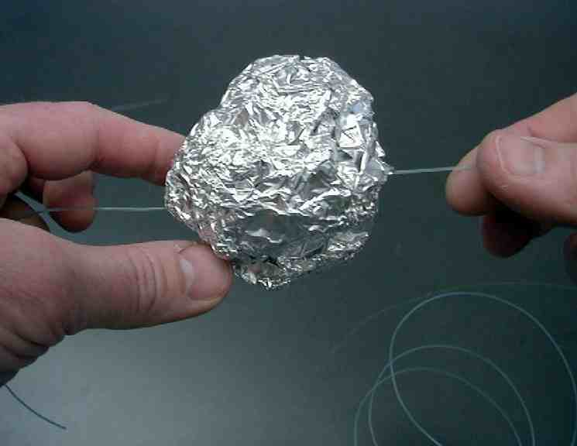

Thread a string or fishing line through the hole so that the ball can easily slide back and forth along the string.

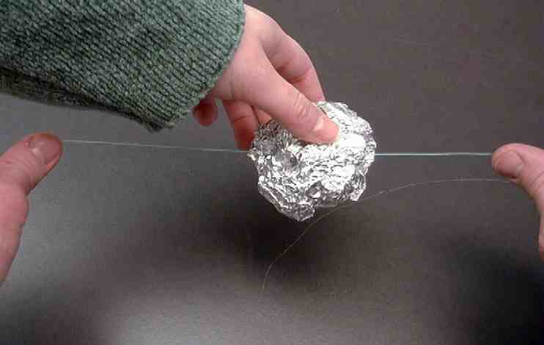
While holding the string horizontally in both hands, a child
ought to be able to move the
aluminum ball easily back and
forth along the string.

It may be a challenge to pull one child aside and explain the following so that rest of the group does not know that you have a secret plan. Even if the children do find out you have a secret, they will have a hard time discovering what that secret is.

Pull a child aside and say:

Let’s play a trick on the rest of the group, making it appear that you can read people’s minds. You will have your eyes closed and you will actually not see where one of the kids touches this string. However, you will claim to be able to read that person’s mind and know where he touched the string. This is how you will know.

I will hold the string for you. You will start the aluminium ball on the far edge of the string. As you slowly move the ball across the string from the left to the right, look down at my shoe. When you see my toes wiggle up, then you will know that is the place to stop the aluminum ball on the string. It will seem to everyone that you could read the mind of the person that touched the string.

After several kids have had a turn to touch the string and the “mind reader” has placed the aluminum ball exactly on each point, ask the following question.

Can anyone really read minds? No, of course not. We will now tell you how we did this trick.

Explain the trick to the kids.

In Psalm 139:2b David says to God, “You know my thoughts before I think them.” Can God read our thoughts? How does that make you feel? If God can read our thoughts, then why should we pray? (Because He told us to. Because He desires that we would want to talk with Him about our deepest thoughts.)

Just like there was a special place on this string where the aluminum ball was placed, today we will find out how God wants all of us to have a special place to meet and visit with Him.

Where might you find a favorite place to spend time, sharing your thoughts with God? Discuss.

We will learn today that one of the most important things you can ever do is every day *spend time with Jesus.

Large Group Overview: 20-30 minutes
Purpose: Help kids observe what the Bible says. Present the Bible event in creative fashion. Help kids begin to interpret what it means.

Video: “The Miracle Maker,” by Family Home Entertainment, Inc. Show the portion where Mary and Martha entertain Jesus.

Object Lesson: “An Object Lesson—A Time with Jesus” – Teacher uses the “Disobedient Heart” illusion to teach the Bible Event of Mary and Martha found in Luke 2:38-42.

Dao Dao’s Review Questions: Jesus visits Mary and Martha – Dao Dao tries to remember the facts of the Bible event but needs help from the kids.

Small Group Application: 20-25 minutes
Purpose: Help kids map out the meaning of the Bible event in their lives. Use the questions to stimulate discussion but don't feel tied to them. Allow the Holy Spirit to guide you. Include personal examples from your own faith journey. The example of Christ at work in your life will leave lasting impressions of how Christ can work in the children's lives.

Use your Bibles! Children need to learn how to look up references and follow along when scripture is read aloud. Allow for quality time of prayer at the close of the lesson.

Observation Questions: What happened?
Read Luke 10:38-42.

Jesus went to stay at the home of two sisters. What were their names? (Luke 10:38-39. Mary and Martha.)

How did Mary spend her time? (Luke 10:39. She sat at Jesus’ feet and listened to Him talk.)

How did Martha spend her time? (Luke 10:40. She was upset about all the work she had to do.)

Interpretation Questions: What does this mean?
What did Jesus say was the most important way to spend time?

Read Luke 10:42 out loud:

“Only one thing is important. Mary has chosen the right thing, and it will never be taken away from her.”

Martha probably thought she was doing the best she could to make Jesus’ time in her home special. She was hospitable and serving. But what was her attitude like? Why do you think so?

In this Bible event, what does Jesus say He wants most from us? (He wants us to spend time with Him more than serve Him.)

Application Questions: What does this mean to me?
Use the following questions to stimulate discussion. Don’t feel tied to these questions. As a shepherd, allow the Holy Spirit to guide you to include and share your own faith walk. Your role model as a living, breathing example of Christ at work in your life will mean more to them as they work to model Christ in you.

Supplies needed: aluminum ball trick from Warm-Up, a paper heart, tape, three sheets of paper and pencils, “Spending Time with Jesus” worksheets

Using the ball of tin foil on the string, you will now be able to duplicate the illustration you saw in large group. You will also need to have a heart cut out and fastened to the aluminum ball with tape.

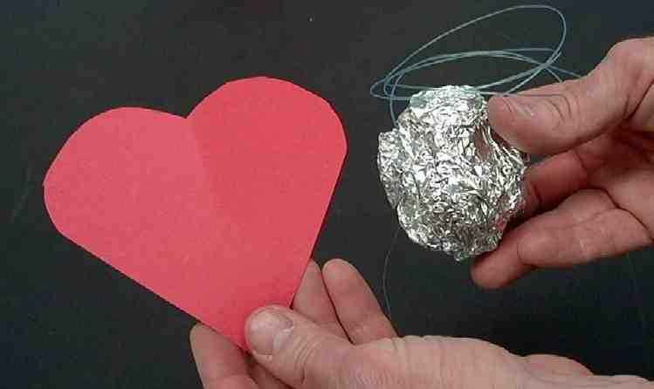

Have kids record on paper some of the busy activities in which they are involved. Two sheets of paper are needed, just as were used in large group. Both sheets can be filled with the kind of things the children are busy doing.

Boys and girls, think of some of the things that you are busy doing and take a lot of your time. These things are not necessarily bad things. They can be very good things. Sometimes we can feel too busy, though. Let’s name some things we do.

The two sheets of paper are passed around the room to the children that have ideas. They can write their ideas on the paper. (If it is more convenient, one person may write the ideas as they are mentioned.) The point of this is to get the children to see how busy their lives can be. They may begin to realize that some of the things they are doing are not as important as taking time every day to spend with God.

A third sheet of paper needs to be labeled “Spending Time With Jesus.” Line the sheets of paper on the wall vertically so that a list of activities is at the top and at the bottom of the column. Place the “Spending Time With Jesus” sheet in between the two activity lists. Hold the string vertically with the aluminum foil ball. The ball should be covered with a paper heart. Hold the ball next to the sheets of paper that are taped to the wall.

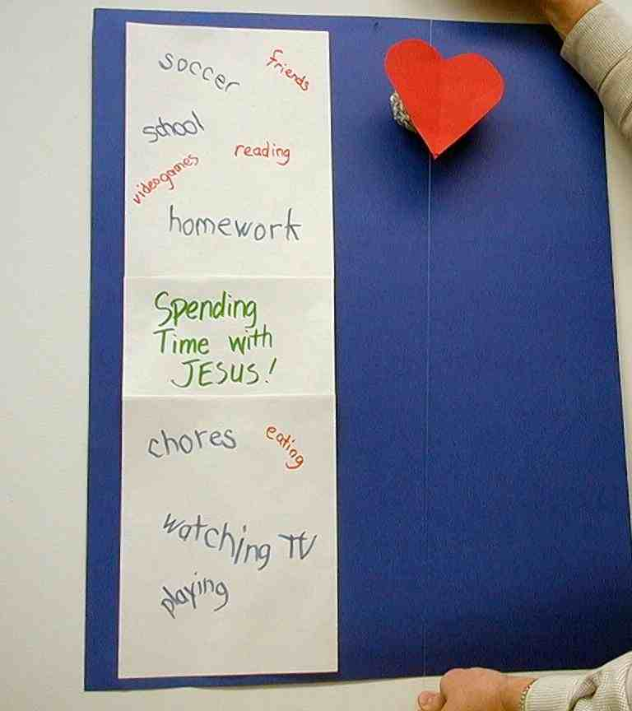

Duplicate the trick that was done in large group that shows how our hearts and lives can race over so many busy things.

Have one of the children “place a kiss” on the string by kissing her finger and touching the string. The kiss should be placed at the point that is parallel to the “Spending Time With Jesus” sheet.

Pull the string taut at the point when the heart reaches the kissed spot. The trick demonstrates how God wants us to spend time with Him.

The children will be amazed at how the heart stopped at just the right spot. You might then disclose the secret of the trick to the kids which lies in the tension on the string. Some of the kids might even practice the trick themselves for a moment.

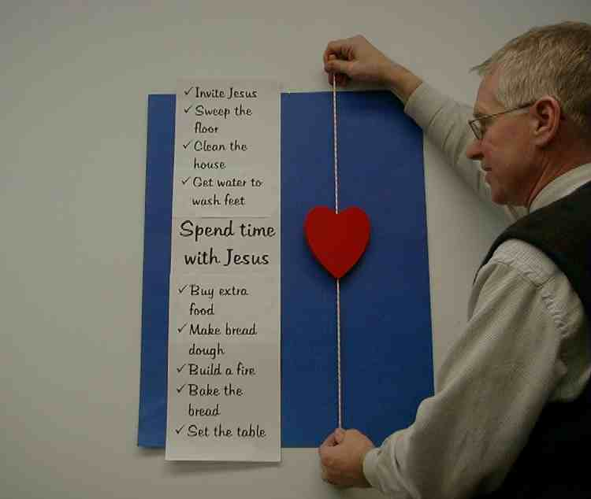

Have the kids talk about spending time with God. Pass out to each child the “Spending Time With Jesus” worksheets in the appendix. Have the children fold the worksheet into quarters to make a small booklet.

Invite the children to fill out this booklet for themselves as they contemplate how they might spend time with God this week. While kids are thinking, read some verses from the Bible that help the kids realize how God knows them so well and wants to spend time with them.

Then summarize with:

Let’s make our goal this week to *spend more time with Jesus.

Memory Verse Learning: 5 minutes
Purpose: Help kids to memorize and keep scriptures at heart. Using creative ways to help kids enjoy learning the key verse and in small group setting.

Supplies needed: aluminium ball trick from Warm-Up; a paper heart; 41X15cm piece of paper; marker; masking tape

Memory Verse: Romans 3:22, “God makes people right with Himself through their faith in Jesus Christ.”
Romans 3:22
God makes
people
right with
Himself
through
their
faith in
Jesus Christ
Memory Verse Learning: “Read Where The Heart Goes”
Duplicate the trick that was done in large group that shows how a heart can race over things. Write the memory verse on a piece of paper (see diagram). Bring out the verse by reading and moving the heart down the string parallel to the word in its sequence. Do it a few rounds. Tell children that next week you would ask for volunteers to recite the verse by moving the hearts in the verse correct sequence.

Prayer:

Close with prayer time. Invite the children to be quiet and think about spending time with God. Then ask the Holy Spirit to show where our hectic schedules cause us to miss spending time with Jesus. Ask for help to be like Mary, who was willing to find time for God.
Safety and Security: Safety and security procedures are important for each church to carefully define and implement according to their unique needs. The security, safety, illness and accident procedures described in this curriculum are provided for example purposes only and may not be appropriate, applicable or adequate for every situation. Each church is responsible for determining whether any security, safety, illness and accident procedures contained in the curriculum are appropriate, applicable or adequate for its unique situation. The activities described in this curriculum require adult supervision and may not be suitable for each child and each situation. Each church is responsible for ensuring that adequate adult supervision is provided for all activities and for determining whether an activity is appropriate for each child and each situation. Kids Kount Publishing disclaims all liability for the implementation of any procedures or the performance of any activities described in this curriculum.
Large Group Presentation

A Time With Jesus

Illustrations and Script for the Presenter

Take Home Point: *Spend time with Jesus.

Set design and props needed for this series will include a large sign that reads, “Meet the Amazing Jesus.” In addition to this sign, hang smaller signs in the front of the room with the word “Amazing” printed on each one.

Prompt kids to say “simply amaaaazing” when the presenter points up and says, “And THAT is…,” A sweeping arm gesture by the large group presenter as the kids say, “simply amaaaa-a-azing” will add effect and emphasis. Use this technique as an attention grabber when presenting the main points.

There are three sections to today’s large group presentation. The first section is a video presentation of the Bible event. The second section is a retelling of the event using an amazing object lesson. In the third section, Dao Dao, the puppet, helps kids review.

Adapt this lesson to use one or all of the following parts depending on availability of videos and/or illusion tricks.

Part One:
Begin with the animated video “The Miracle Maker” by Family Home Entertainment, Inc. Show the clip of Mary and Martha entertaining Jesus.

Next, call Dao Dao out and ask that he would come back after the lesson has been taught. Dao Dao will help with the review questions. Ad-libbing these conversations is most effective, as long as it is kept brief.

Part Two:
Re-tell the story with the object lesson as follows.

Part Three
Dao Dao is invited to answer review questions along with the children.

PART ONE
Begin with the animated video “The Miracle Maker” by Family Home Entertainment, Inc. Show the clip of Mary and Martha entertaining Jesus.

PART TWO

A Time With Jesus
Object lesson: Mary and Martha serving Jesus

Supplies needed:
- “The Disobedient Heart” gospel illusion trick (purchase at Dock Haley Gospel Magic Co.- www.gospelmagic.com)
- copies of appendix pages that list the busy activities that Martha was doing as well as the center section designated “Spend Time With Jesus” mounted on poster board or taped to a wall so that the presenter can hold the gospel illusion trick next to it. (See illustration below.)

Presenter:
As you read each of Martha’s activities getting ready for Jesus’ arrival, move the heart down the string parallel to the activity described.

Jesus was coming to the town of Bethany, where there lived two of His very good friends, Mary and Martha. They were sisters who also had a brother named Lazarus.

Martha was very excited that Jesus was coming to the village and staying at her house. There were so many things that needed to be done. First, she needed to invite Him. Then she had to clean the house and sweep the floors. She also had to get water to wash Jesus’ feet. She had to buy extra food and make the bread dough. Then she had to build a fire and bake the bread. Finally, she had to set the table for them to eat.

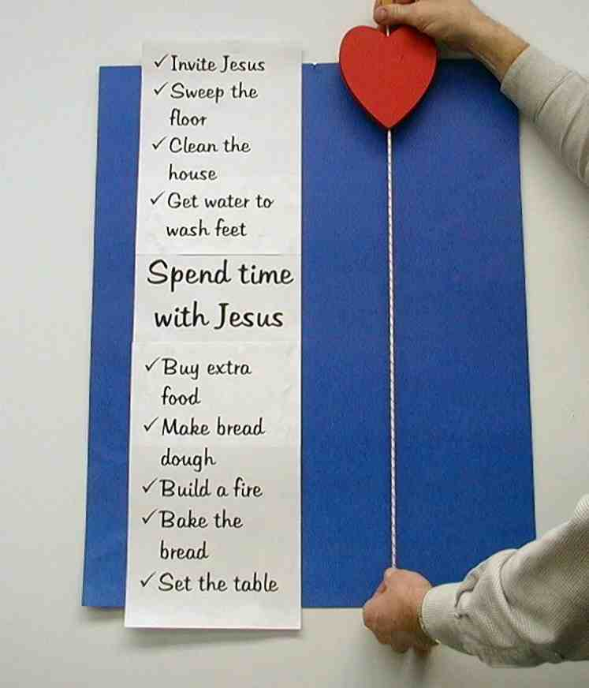

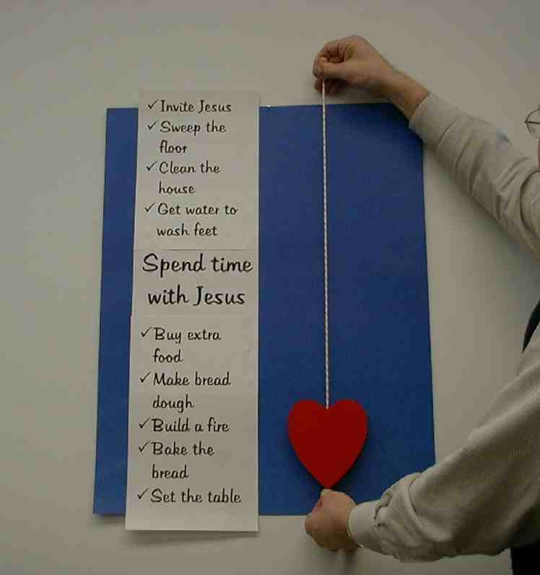

Martha became so busy that all she could think about was getting everything ready for Jesus.

Hold the heart and string so the heart is turned upside down. Move the heart to the top of the list and allow it to slowly fall to the bottom.

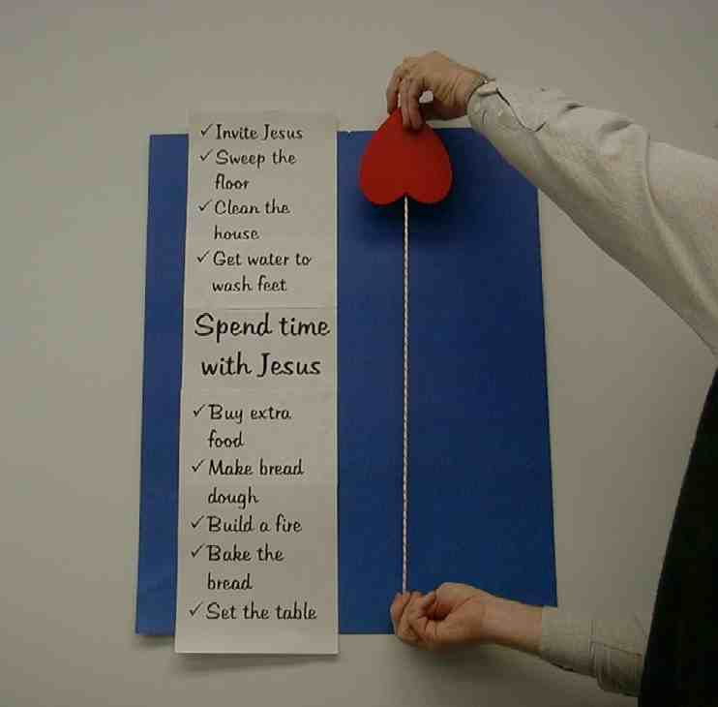

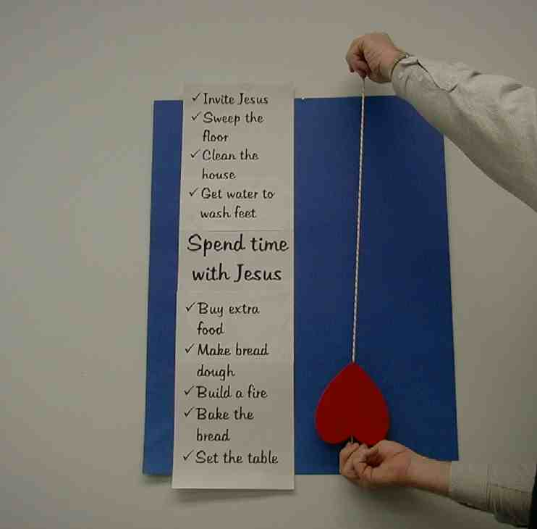

During the time that Martha was busy doing all of these things, Mary sat at Jesus’ feet and enjoyed listening to Him and sharing her thoughts with Him. Mary realized that Jesus was the promised Son of God.

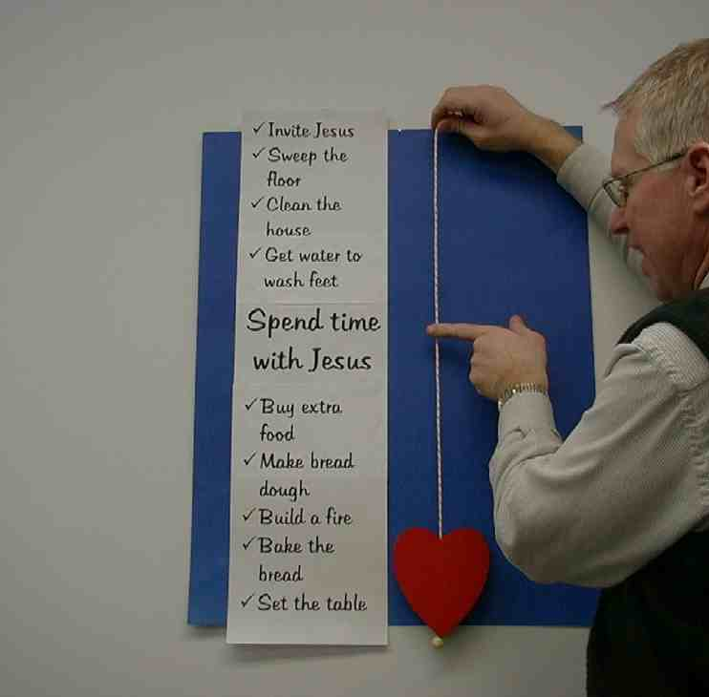
Lightly kiss your finger and touch that finger to the very center of the string opposite the sign reading “spend time with Jesus.”

Move the heart back to the top of the string and let the heart slowly drop until it stops right at the point that was touched. As you do this, cue the audience to reply with the “amaaazing” slogan: “Simply amaaazing!”

The truly amazing thing is that Jesus loves to spend time listening and talking to us. He does this even today when we set aside a special time and place to pray and read the Bible.

Remember Martha? How do you think she felt about all of this? She was upset about all the work she had to do. She asked Jesus, “Lord, don’t you care that my sister has left me alone to do all the work? Tell her to help me!”

Jesus said, “Martha! Martha! You worry and fuss about a lot of things. There is only one thing you need. Mary has made the right choice, and that one thing will not be taken away from her.”

Place the heart at the top of the string. Place another kiss on the middle of the string with your finger. Allow the heart to slowly come down until it is next to “Spend time with Jesus.”

Boys and girls, do you have a time and a place that you spend time with God? Do you have a time and place where you can talk to God in your prayers and He can talk to you through the Bible? You can be like Mary and have the one thing that you really need – time with Jesus.

Demonstrate the heart dropping to the middle again.

PART THREE

Dao Dao’s Review Questions
Jesus visits Mary and Martha

The following questions can be used for review of today’s Bible event. This will be a contest between Dao Dao and the kids. Dao Dao assigns a scoring value to each question before that question is read. That number is in parentheses at the beginnning of the question. What makes it fun is that Dao Dao finally gets one correct at the end and that number helps him make a dramatic comeback. The kids typically win, but it might be interesting if, from time to time, Dao Dao wins. Adjust to your preference. One thing is important and will be vital to this script: move through your material quickly. By this time, the kids’ attention spans are short You may even want to delete some of the questions if it is feeling a bit long.

After each question, the first parenthetical remark is Dao Dao’s response. The second parenthetical remark is the correct answer from a child.

Option: Kids could bring their Bibles to large group to search for answers as they listen to the following questions.(Luke 10:38-42)

- (5 points) How were Mary and Martha related?
(They were twins – joined at the feet.)
(Sisters.)

- (10 points) What were some of the things Martha was busy doing?
(Homework.)
(Making preparations for Jesus’ visit.)

- (15 points) What was Mary busy doing?
(Curling her hair… doing her makeup.)
(Spending time with Jesus.)

- (20 points) Who was it that complained?
(I don’t know who complained but, if I were Martha, I would have complained! She was doing all the work.)
(It was Martha who complained. Sometimes it’s not good to be so busy you forget to spend time with Jesus.)

- (25 points) What did Jesus say to Martha?
(I don’t know.)
(“Mary made the right choice.”)

Teacher: Dao Dao, you didn’t get many of those answers right. Were you just goof’n off, or did you not listen very closely to the Bible event?

Dao Dao: Sorry, Teacher, I was kind of goof’n off, I guess. Sometimes my mind wanders and I get goofy. Jesus must get mad at me sometimes, because I’m not too good at spending time with Him.

Teacher: Dao Dao, Jesus gave His life for you so your sins and failures would be forgiven and erased.

Dao Dao: He’s pretty patient with me, isn’t He?

Teacher: With all of us, Dao Dao. That’s because He loves us and He wants us to spend time with Him. We need to get to know Him better. We’ll talk about that in small group today and learn to *spend time with Jesus. That’s what’s important.

Dao Dao: I think I’d like that.

Teacher: Great, Dao Dao. I am going to close this time with prayer.

Dao Dao: Okay.

Teacher: Dear God, thank You for sending Jesus. And Jesus, thank You for paying the price for our forgiveness. We really do want to get to know You better. Help us *spend time with You. That’s really important. We really do like it when we get to know You better and trust You more and more for answers in everything. Jesus, in Your name we pray. Amen.

Lesson 37

Small Group Warm-up
- pens
- aluminum foil
- string

Large Group Application
- video: “The Miracle Maker”
- “The Disobedient Heart” gospel illusion trick—contact Dock Haley Gospel Magic Co. at www.booksofthebible.com
- copies of the three sheets in the appendix that list the busy activities that Martha was doing as well as the center section designated “Spend Time With Jesus”—mount on poster board or tape to a wall so that the presenter can hold the gospel illusion trick next to it

Small Group Application
      - aluminum ball trick from Warm Up
      - a paper heart
      - tape
      - three sheets of paper
      - pencils
      - “Spending Time with Jesus” worksheets

Memory Verse Learning
      - aluminum ball trick from Warm-Up
      - a paper heart
      - 41X15cm piece of paper
      - Marker
      - masking tape
- Invite Jesus

- Sweep the
floor

- Clean the
house

- Get water
to wash feet

- Buy extra
food

- Make bread
dough

- Build a fire

- Bake the
Bread

- Set the
table

Spend time
With
Jesus
________________________
________________________
________________________
________________________
________________________
________________________
________________________
________________________
________________________
________________________
________________________
________________________
________________________
________________________
________________________
________________________

Spending time with
Jesus worksheet

