
Date: _________________________
Series: Meet the Amazing Jesus
Dec-Mar Year 3, Lesson 39

Have Faith that Follows Him

Take Home Point: *Faith is trusting Jesus as God’s Son, our Savior. *Repeat this phrase throughout the lesson.

Bible Event: Luke 5:1-11. Jesus’ miraculous catch of fish
Key Verse: Romans 3:22, “God makes people right with Himself through their faith in Jesus Christ.” (NCV)

We will help kids know:
- The Bible event Luke 5:1-11 of Jesus’ miraculous catch of fish.
- Faith is trusting in Jesus as God’s Son, our Savior.
- God does miracles but we must believe and obey Him if we want to be a part of them.

We will help kids feel:
- Amazed that God does miracles, especially the miracle of salvation.
- Excited to share their faith with others.

We will help kids do:
- Share the Bible story of faith by making their own trick bag.
- Understand the ichthus fish and symbol.

THIS LESSON’S ROADMAP

DESTINATION | PAGE # | DISCOVERIES ON YOUR JOURNEY | SUPPLIES NEEDED
  Small Group Warm-Up | 3 | Kids talk about and demonstrate different handshakes. Then kids learn the secret code the early Christians used to signal they were followers of Jesus. | - paper for each child  - pens or pencils
Large Group   | 4  10  11  14 | Overview  Video: “The Miracle Maker,” by Family Home Entertainment, Inc., 1999—cue the video clip of Peter’s catch of fish and Jesus’ call to follow him.  Object Lesson: Jesus’ Miraculous Catch of Fish—The presenter uses a trick bag to demonstrate how Peter’s fishing nets were filled after Jesus told him to go to deeper water to catch fish. With Jesus, we can become fishers of people just like Peter and Jesus’ disciples.  Dao Dao’s Review Questions: Dao Dao helps kids review the main points in the Bible event. | - large sign that reads “Meet the Amazing Jesus”  - smaller signs hung in the front of the room, each with the word “amazing” printed on it  - Dao Dao  - the animated video “The Miracle Maker ,” by Family Home Entertainment, Inc.  Cue the video to start at Peter’s catch of fish and his call.  - two large paper sacks  - fish crackers  - sheets of paper or bowls to hand out the fish crackers
Small Group Application   | 5 | Kids will review the Bible event and then learn how to share the Bible story of faith with friends using their own trick bag.  Memory Verse Learning:  “Look For the Right Fishes”  Rm. 3:22 will be emphasized in lessons 37-39 so each child know that faith is trusting in Jesus as God’s Son, our Saviour. | - copies of ichthus fish  - scissors  - two small paper sacks  - tape  - a bag of 25 fishes per team. (Use 14 to write a word of the memory verse on it.)
Small Group Warm-Up: 15 minutes
Purpose: Get pointed in the right direction! Build relationships and help guests feel at ease. Do the learning readiness activity that will point your group in the right direction for the lesson.

Supplies needed: paper and pens or pencils for each child

Ask the kids if they have ever had any secret handshake or signal that they shared with other friends. The kids can show examples of these handshakes or signals. Some of these might be quite funny. Another great discussion question is:

Have you ever been part of a special club of friends?

After you have had some fun with this, transition to the following:

People in the early Christian church used a secret signal to find out if someone else was Christian. They had to do this because many Christians were persecuted for their faith at that time. If they were found to be Christians, they were killed.

Let me show you their secret signal. Let’s pretend two people are facing each other. One person is a Christian. This person would make an ark in the sand with his toe or sandal like this:

Draw the following on a piece of paper.



If the other person were a Christian, he would make another ark in the sand underneath the first ark. The two arks formed a fish.



The reason the fish was a sign of the early Christian is that Jesus said He would make us fishers of men. Also, the word “fish” in Greek is spelled “ichthus.” (English letters are used here, not Greek).

Greek is a different language than what we speak today. In Jesus’ day, most of the books were written in this language. The New Testament was even written in the Greek language. We use different letters in English than are used in Greek. Here are the Greek letters that spell ichthus, the Greek word for fish. Let me show you the Greek letters. (The following are upper case Greek letters.)

Write on paper:
ICqYS

Let’s practice saying “ichthus” (pronounced “ICK-thoos”). Now you have said the Greek word for fish: “ichthus.” But the early Christians had another special secret about this word.

Each one of those letters stood for a word that began with that letter. For example the first letter is “iota” and this is the first letter of the word “iaesus” (ee aye sus). That’s their word for Jesus. Put all the words together that begin with these letters and you have the phrase: “Jesus Christ, God’s Son, Savior.”

Give each child a sheet of paper and a pencil. Have kids copy the strange looking word and then draw a simple fish around them by making two arks.

You have just written and illustrated the word for fish. Can you remember what each one of those letters stands for?

Today we are going to learn about fishing and the miracle of faith when we follow Jesus. We will see how Jesus makes miracles in our lives.

We will learn that *faith is trusting in Jesus as God’s Son, our Savior.

Large Group Overview: 20-30 minutes
Purpose: Help kids observe what the Bible says. Present the Bible event in creative fashion. Help kids begin to interpret what it means.

Video: “The Miracle Maker,” by Family Home Entertainment, Inc. Cue the video clip of Peter’s catch of fish and Jesus’ call to follow Him.

Object Lesson: Jesus’ Miraculous Catch of Fish—The presenter uses a trick bag to demonstrate how Peter’s fishing nets were filled after Jesus told him to go to deeper water to catch fish. With Jesus, we can become fishers of people just like Peter and Jesus’ disciples.

Dao Dao’s Review Questions: Dao Dao helps kids review the main points in the Bible event.

Small Group Application: 20-25 minutes
Purpose: Help kids map out the meaning of the Bible event in their lives. Use the questions to stimulate discussion but don't feel tied to them. Allow the Holy Spirit to guide you. Include personal examples from your own faith journey. The example of Christ at work in your life will leave lasting impressions of how Christ can work in the children's lives.

Use your Bibles! Children need to learn how to look up references and follow along when scripture is read aloud. Allow for quality time of prayer at the close of the lesson.

Observation Questions: What happened?
Have kids find Luke 5:1-11 in their Bibles.

What did Jesus tell Simon Peter to do? (Luke 5:4. “Take the boat into deep water, and lower your nets to catch some fish.”)

How did Peter respond to Jesus? (Luke 5:5. He said that they had worked hard all night and had caught nothing, but he would do so since Jesus said to do so.)

What happened when Peter obeyed Jesus? (Luke 5:6-7. They caught so many fish that the nets began to tear and both boats were so full they nearly sank.)

What did Jesus tell Peter he would now catch? (Luke 5:10. Peter would now catch people instead of fish.)

What did Simon Peter and his partners do next? (Luke 5:11. They left everything and followed Jesus.)

Interpretation Questions: What does this mean?
Why do you think that now Peter’s partners also followed Jesus?

How did Peter show faith? (He did what Jesus told him even though it did not make sense to him.) Does God ever ask us to do things for Him that don’t make sense? Can you give an example?

What do you think might have happened if Peter had not gone back out to the deep water and let down his net? Do you think Jesus might have been testing Peter?

Because Peter was faithful, Jesus gave him greater responsibility: to now catch people for Jesus. How does Jesus sometimes test us? (He may give us lesser opportunities to prove our faithfulness and when we are obedient, He may give us bigger opportunities.)

*Faith is trusting in Jesus as God’s Son, our Savior.

Application Questions: What does this mean to me?
Activity:
Supplies needed: copies of ichthus fish (see appendix), scissors, 2 small paper sacks per child, tape

Give each child a copy of ichthus fish. Review the meaning of the ichthus fish to the early Christians and that the letters spelling ichthus stood for the phrase, “Jesus Christ, God’s Son, Savior.” (Younger children would do well to just have the picture remind them that it stands for Jesus, and Jesus asks us to become fishers of men.)

Invite the children to start cutting out their fish. As the children work, talk about what it means to have faith.

Peter had faith. Even though it did not make sense to Peter when Jesus told him to take the boat back to the deep water to catch fish, he simply believed Jesus. He took the boat back out to the deep water and threw his nets out to catch fish.

What do you have faith in God about? What will you do about it?

God wants you to have faith in His Son, Jesus, as your Savior. He wants you to simply believe in Jesus and to follow Him.

The Bible says it this way in Romans 3:22, “Everyone who believes has God’s approval through faith in Jesus Christ.”

Encourage the children to talk about their faith in Jesus Christ, Son of God, our Savior.

After everyone has finished cutting out their fish, ask them if they believe Jesus is asking them to go fishing. (Some will catch on to the fact that Jesus is asking them to be fishers of men.) Jesus makes us fishers of men. We use His power as we share Jesus’ love with the world.

To help us talk to friends about Jesus, we are going to use these fish and a special trick. The trick is similar to the one we saw in large group. We will use the ichthus fish instead of fish crackers. This is how we will do it.

Give each child two lunch size paper sacks. Have them cut out the bottom of one bag, leaving a small lip approximately one-half inch in size on the short side.



Instruct the children to fold the lip down and tape it to the inside of the other paper bag.

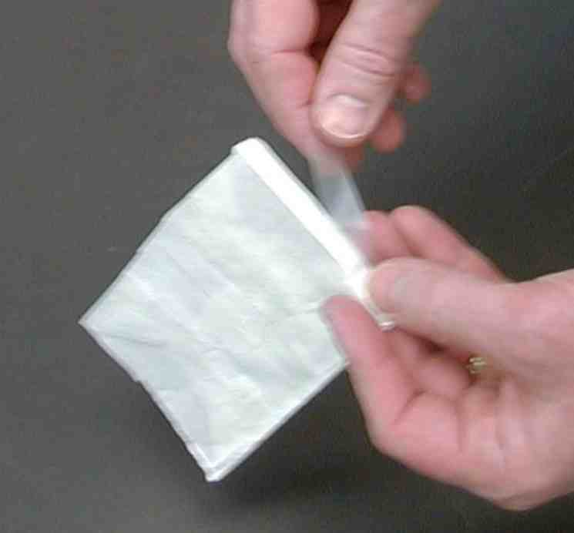

This will create a false bottom.



The children can then lay their ichthus fish underneath the false bottom of their bags.

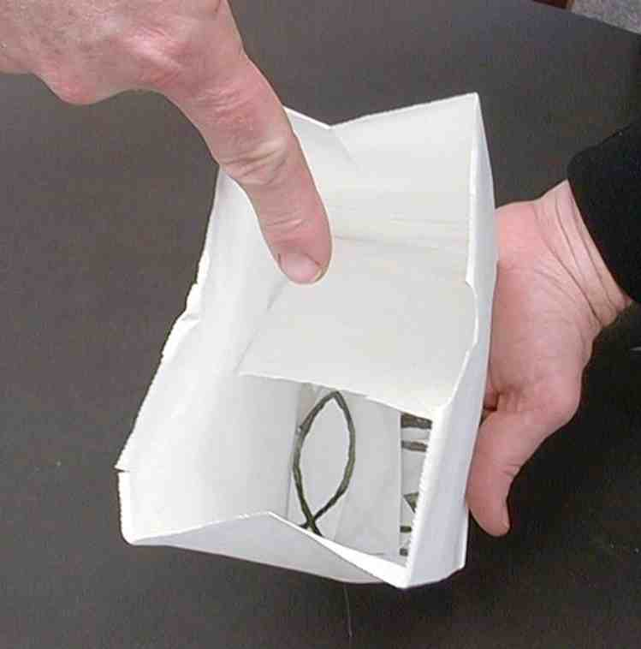

You can use these bags with your friends. Just ask them if they would like to go fishing. Then tell them you have just what they need. It is not a hook or a string, but it is this empty paper bag. They will think that a paper bag is not a good thing to go fishing with!

You can tell your friends the story about Jesus asking His friends to go fishing after they had not caught anything all night. Talk about how Jesus’ friends thought it was a terrible idea to try fishing again, but that they trusted Jesus and did what He said. When they put their nets down into the deep water, they caught tons of fish!

You can then show your friends the empty bag and turn it upside down and shake it. Tell your friends how God sometimes wants to shake us up so that we will believe Him. Jesus wants us to go fishing just like His friends did. But He wants us to catch this… Then open your bags and let some of the ichthus fish fall out.



Tell your friends that this is what we are fishing for. Explain how in Greek the word “Ichthus” means fish and how each letter of this word is the first letter in “Jesus Christ, Son of God, Savior.”

The most amazing thing is that God wants to give us the gift of Jesus Christ, God’s Son, our Savior. He wants to go fishing with us and let us catch the biggest fish of all! Your friends can then keep one of the Ichthus fish to remind them that God wants to give them Jesus Christ, Son of God, Savior. *Faith is trusting in Jesus as God’s Son, our Savior.

Have the kids practice the illusion with one another.

Memory Verse Learning: 5 minutes
Purpose: Help kids to memorize and keep scriptures at heart. Using creative ways to help kids enjoy learning the key verse and in small group setting.

Supplies needed: a bag of 25 fishes per team. (Use 14 to write a word of the memory verse on it.)

Memory Verse: Romans 3:22, “God makes people right with Himself through their faith in Jesus Christ.”

Memory Verse Learning: “Look For the Right Fish”
Divide the children into two teams and give each team a bag. Tell the teams that at your indication, they are to pour out the fishes and look for the ones that have words written on them. Then arrange them according to the memory verse. The first team to complete wins.

Prayer:
Have the children pray for people that they would like to witness to using their fishing bags. Remind them that they are fishers of men since Jesus has caught them.
Safety and Security: Safety and security procedures are important for each church to carefully define and implement according to their unique needs. The security, safety, illness and accident procedures described in this curriculum are provided for example purposes only and may not be appropriate, applicable or adequate for every situation. Each church is responsible for determining whether any security, safety, illness and accident procedures contained in the curriculum are appropriate, applicable or adequate for its unique situation. The activities described in this curriculum require adult supervision and may not be suitable for each child and each situation. Each church is responsible for ensuring that adequate adult supervision is provided for all activities and for determining whether an activity is appropriate for each child and each situation. Kids Kount Publishing disclaims all liability for the implementation of any procedures or the performance of any activities described in this curriculum.
Large Group Presentation

Take Home Point: *Faith is trusting Jesus as
God’s Son, our Savior.

Set design and props needed for this series will include a large sign that reads, “Meet the Amazing Jesus.” In addition to this sign, hang smaller signs in the front of the room with the word “Amazing” printed on each one.

Prompt kids to say, “Simply amaaaazing,” when the presenter points up and says, “And THAT is…,” A sweeping arm gesture by the large group presenter as the kids say “simply amaaaa-a-azing” will add effect and emphasis. Use this technique as an attention grabber when presenting the main points.
.

There are three sections to today’s large group presentation. The first section is a video presentation of the Bible event. The second section is a retelling of the event using an amazing object lesson. In the third section, Dao Dao, the puppet, helps kids review.

Adapt this lesson to use one or all of the following parts depending on availability of videos and/or illusion tricks.

Part One:
Begin with the animated video, “The Miracle Maker,” by Family Home Entertainment, Inc., 1999. Cue the video clip of Peter’s catch of fish and Jesus’ call to follow Him.

Next, call Dao Dao out and ask that he would come back after the lesson has been taught. Dao Dao will help with the review questions. Ad-libbing these conversations is most effective, as long as it is kept brief.

Part Two:
Retell the story with the object lesson as follows.

Part Three
Dao Dao is invited to answer review questions along with the children.

PART ONE

Show the video “The Miracle Maker,” by Family Home Entertainment, Inc. Cue the video clip of Peter’s catch of fish and Jesus’ call to follow Him.

PART TWO

Object Lesson

Jesus’ Miraculous Catch of Fish
Illustrations and Script for the Large Group Leader

In advance, create the prop for today’s illusion using two large paper sacks from a grocery store.

Cut the bottom from the second paper sack on the creases except for one edge. On this edge leave one inch extra from the side of the bag.

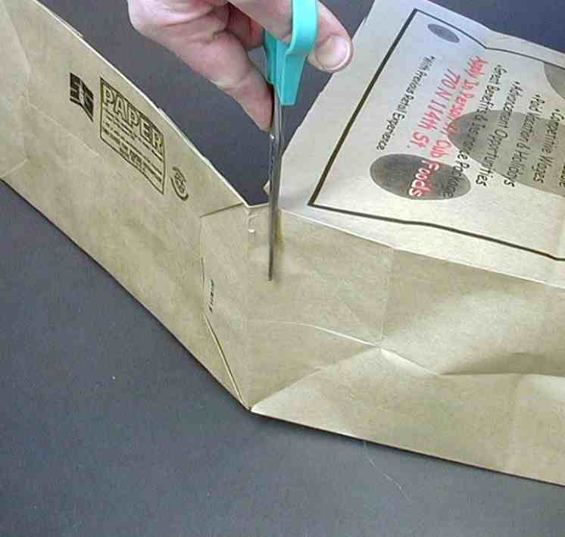

The one-inch flap is then folded down and taped to the inside of the first grocery bag so it has a false bottom.

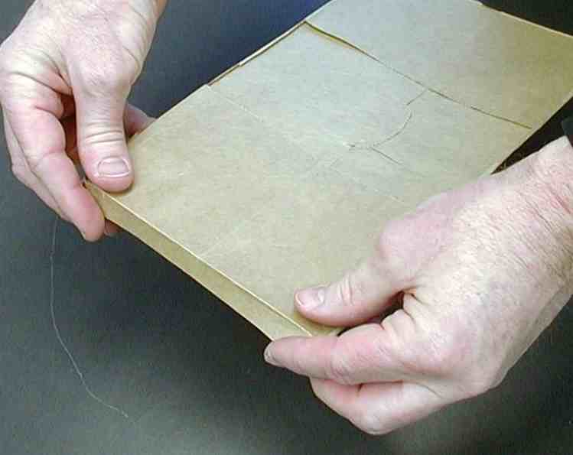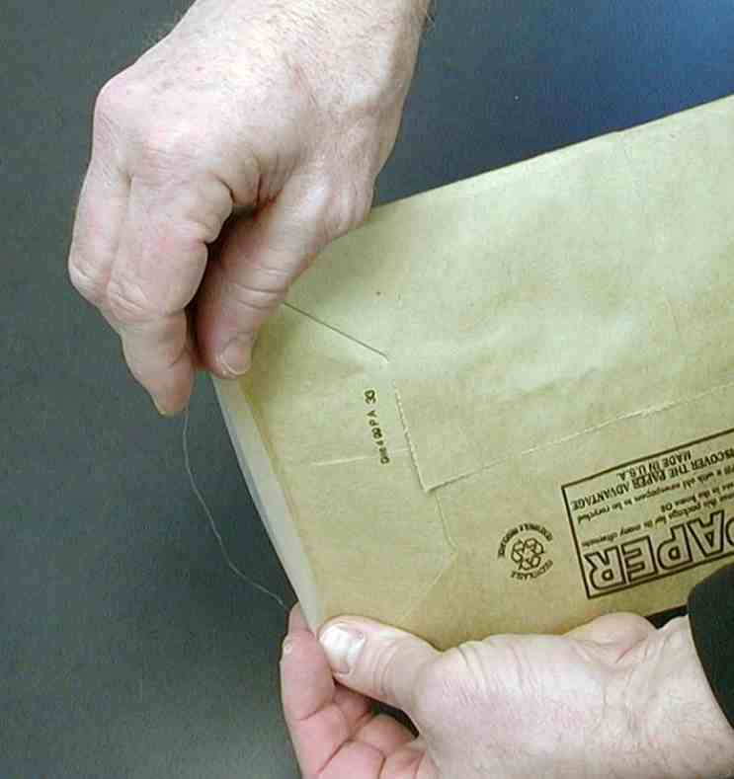

The false bottom is a flap that looks like the bottom of an ordinary paper sack when it lies flat.



When the bag is tilted, handfuls of fish crackers beneath the false bottom can be poured out from the side that is not taped down.

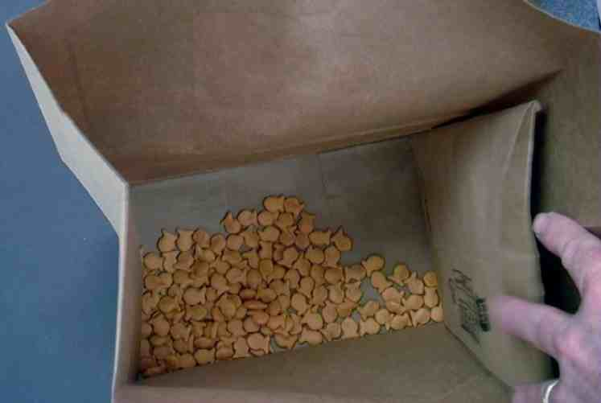

Presentation:

Have a volunteer come forward to play the role of Simon Peter while you read Luke 5:1-11. Read Luke 5: 1-5 and have the child repeat Simon’s words:

“ Master, we worked hard all night trying to catch fish, but we caught nothing. But You say to put the nets in the water; so I will.”

Say: Peter was acting on faith even though what they were doing did not seem to make sense. He did what Jesus asked because he trusted Jesus. As a result, Peter was part of a miracle.

Show the empty bag to Peter (the volunteer) and to the other children.

(This will take practice because tipping the bag at certain angles can expose the trick.)

Read verse six as follows:

“The fishermen did as Jesus told them…”

After the bag has been shown to be “empty,” set it down on the floor and swoosh your hands over the bag as if you were pulling a net through the water.

(The biggest challenge to this trick is the sound of the fish in the bag. Therefore, try not to rustle the bag with any large motions.)

Then pour the fish from the bag into a basket or bowl and continue:

“…they caught so many fish that the nets began to break. They called to their friends in the other boat to come and help them. The friends came, and both boats were filled so full that they were almost sinking.”

Call other children forward and give each of them a bowl to catch fish crackers. Then read:

“When Simon Peter saw what had happened, he bowed down before Jesus and said, “Go away from me, Lord I am a sinful man!”

Explain this as follows:
Peter realized that Jesus had miraculous power and did not feel worthy to be near Jesus. It is true that the closer we get to God, the more we realize our own unworthiness or sinfulness. God wants us to be close to Him, though. He gives us forgiveness and acceptance so we don’t have to feel unworthy.

The Bible says it this way in Romans 3:22, “God makes people right with Himself through their faith in Jesus Christ.”

Read the rest of the passage.

“Simon and everyone who was with him was amazed…

Point to an “amazing” sign and prompt kids to say, “Simply amaaaazing.”

to see the large number of fish they had caught. James and John, who were Zebedee’s sons and Simon’s partners, were also amazed.”

Point to an “amazing” sign and prompt kids to say, “Simply amaaaazing.”

“Jesus told Simon, ‘Don’t be afraid. From now on you will catch people instead of fish’.” Simon and his partners brought the boats to shore, left everything, and followed Jesus.”

Let the volunteers pass out the fish to the rest of the kids.

Why did Jesus say Simon Peter would catch people instead of fish? As a fisherman, Peter wanted to catch as many fish as possible. As a disciple of Jesus, his goal became telling as many people as possible how to receive God’s approval and enter heaven.

Even though Peter had fished all night and was unsuccessful in his own efforts, he was successful with Jesus’ help and caught more fish than he could handle. This is also true as a fisher of people. We are much more successful with Jesus’ help than working in our own strength. *Faith is trusting in Jesus as God’s Son, our Savior.

PART THREE

Dao Dao’s Review Questions
Jesus’ miraculous catch of fish

The following questions can be used for review of today’s Bible event. This will be a contest between Dao Dao and the kids. Dao Dao assigns a scoring value to each question before that question is read. That number is in parentheses at the beginnning of the question. What makes it fun is that Dao Dao finally gets one correct at the end and that number helps him make a dramatic come back. The kids typically win, but it might be interesting if, from time to time, Dao Dao wins. Adjust to your preference. One thing is important and will be vital to this script: move through your material quickly. By this time, the kids’ attention spans are short. You may even want to delete some of the questions if it is feeling a bit long.

After each question, the first parenthetical remark is Dao Dao’s response. The second parenthetical remark is the correct answer from a child.

Kids might even bring their Bibles to large group to search for answers as they listen to the following questions.

- (11 points) What job did Simon Peter have?
(He as preacher.)
(He was a fisherman.)

- (18 points) What was Jesus doing in the boats while the other fishermen were cleaning their nets?
(He was trying to splash the other people near the shore.)
(He was teaching the people from the boat.)

- (16 points) After He was through teaching, Jesus told Simon to take the boats into deep water. What did Simon say?
(“That sounds like a good place to go fishing.”)
(“We tried all night and had no luck. There would be no fish there now.”)

- (20 points) Even though Peter did not think it was a good idea, what did he do?
(He hid so he could get out of doing chores.)
(He did exactly what Jesus asked.)

- (15 points) After the miraculous catch of fish, Peter realized something about Jesus. What did he say to Jesus then?
(“You’re good luck! I’d like to take you fishing more.”)
(“Go away from me! I’m a sinner!” He said this because he
realized Jesus was the Son of God.)

- (35 points) What was it that Peter had that made him trust Jesus even though what Jesus said did not make sense to him? Clue: It is a word that starts with “F.”
(Fun!)
(Faith.)

- (385 points) What do you think God’s greatest miracle is for us today?
(Helping me pass my spelling tests.)
(Giving us the gift of salvation when we trust in Jesus as our Savior.)

(500 points total! Yippee!)

Continue with puppet script:

Teacher: Dao Dao, enough joking around. Did you get the point of today’s lesson?

Dao Dao: Yep, Teacher. Jesus said, “Follow me and I will make…

Teacher: (pause) Yes, Dao Dao? “Follow me and I will make… what?

Dao Dao: Make some fish crackers for you!

Teacher: Dao Dao!

Dao Dao: I’m just kidding, Teacher. This is easy. Jesus said, “I will make you fishers of people.”

Teacher: This is important, Dao Dao! Are you a fisher of people?

Dao Dao: Sure, Teacher. I mean, I try to find ways that I can tell other people about Jesus.

Teacher: What do you tell them?

Dao Dao: I tell them what we learned today. They can have faith in Jesus. *Faith is trusting Jesus as God’s Son, our Saviour.

Teacher: Cool! Then you really are a fisher of people, Dao Dao. I’m proud of you. Now we will pray and we’ll all go back to small groups where the kids will make their own special illusion trick.

Dear God, thank You for sending Jesus and then inviting us to follow Him. Help us be fishers of people, just like all followers of Jesus. But best of all, thank You for Jesus and what He’s done for us. If there is anyone here who doesn’t know Jesus as his or her Savior, help them have faith and trust Him. We all want faith, which is trusting Jesus as God’s Son, our Savior. Amen.

Lesson 39

Small Group Warm-up
- paper for each child
- pens or pencils

Large Group Presentation
- large sign that reads “Meet the Amazing Jesus”
- smaller signs hung in the front of the room, each with the word “amazing” printed on it
- Dao Dao
- the animated video “The Miracle Maker ,” by Family Home Entertainment, Inc.
Cue the video to start at Peter’s catch of fish and his call.
- two large paper sacks
- fish crackers
- sheets of paper or bowls to hand out the fish crackers

Small Group Application
- copies of ichthus fish
- scissors
- two small paper sacks
- tape

Memory Verse Learning
- a bag of 25 fishes per team. (Use 14 to write a word of the memory verse on it.) Romans 3:22, “God makes people right with Himself through their faith in Jesus Christ.”

