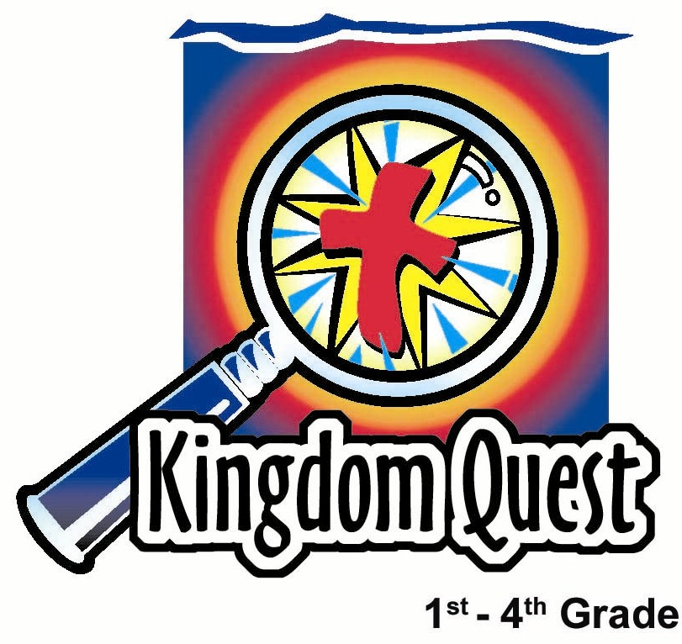
Date: ______________________
Series: Meet the Amazing Jesus
Dec-Mar Year 3, Lesson 40

Bring a Friend with You

Take Home Point: *Friends bring friends to Jesus.
*Repeat this phrase throughout the lesson.

Bible Event: Luke 5:17-26. Jesus heals the paralytic and forgives his sin
Key Verse: Luke 5:20, “Jesus saw that these men believed. So he said to the sick man, “Friend, your sins are forgiven.’” (NCV)

We will help kids know:
- The Bible event of Jesus healing the paralytic man and forgiving his sins.
- Their faith makes a difference when they pray for others or bring them to Jesus.
- The greatest power God uses to help us is the power of forgiveness.

We will help kids feel:
- Amazed at the power of God’s forgiveness.
- Encouraged that they, too, can bring friends to meet Jesus.

We will help kids do:
- Receive the power of God’s forgiveness of them in Jesus.
- Give the message of God’s forgiveness to others in their group.
- Pray for friends and invite them to church or Sunday school.

THIS LESSON’S ROADMAP

DESTINATION | PAGE # | DISCOVERIES ON YOUR JOURNEY | SUPPLIES NEEDED
  Small Group Warm-Up | 3 | Kids discuss times of friends encouraging them and lifting them up as they work on an “amaaazing” activity. | - a three ply tissue paper for each child  - two water-based markers  - cup of water
Large Group   | 4  10  11  14 | Overview  Video: “The Miracle Maker,” by Family Home Entertainment, Inc. Show Luke 5:17-26. www.booksorthebible.com  Object Lesson: The presenter draws and paints a diagram to retell the Bible event and teach kids that *friends bring friends to Jesus.  Dao Dao’s Review Questions: Jesus Heals the Paralytic and Forgives His Sin—Dao Dao helps kids review the main points in the Bible event. | - large sign that reads “Meet the Amazing Jesus”  - smaller signs hung in the front of the room, each with the word “amazing” printed on it  - Dao Dao  - the animated video “The Miracle Maker,” by Family Home Entertainment, Inc., 1999—cue the video to start at the scene where people are gathering at the house where Jesus is  - easel  - poster board  - tempera paints or water colors  - white candle to draw the picture in the appendix on the poster board before class  - black marker
Small Group Application   | 5 | Kids discuss the Bible event and make a craft project to illustrate that *friends bring friends to Jesus.  Memory Verse Learning:  “Fill in the Blanks”  John 15:16 will be emphasized in lessons 40-42 that each child know God chooses us to make a difference in His Kingdom. | - three ply tissue paper for each child  - various colors of water-based markers (Make sure you have red.)  - crayons  - paper plate for each child  - straw for each child  - cup of water  - whiteboard and marker  - worksheet from page 17
Small Group Warm-Up: 15 minutes
Purpose: Get pointed in the right direction! Build relationships and help guests feel at ease. Do the learning readiness activity that will point your group in the right direction for the lesson.

Supplies needed: a three ply tissue paper for each child; two water-based markers; cup of water

Begin with this thought provoker:

Think of a time when a friend gave you a lift. In other words, you needed a friend to help you, to encourage you, or to lift you up. Tell about a friend who did that and why it was important to you.

As the children are considering their responses, have them work on the following activity.

Give each student a three ply tissue paper and two water-based markers. Have the children write their initials in the corner of the tissue. Above their initials, have them write the name of the person who gave them a lift, as shown in the illustration.

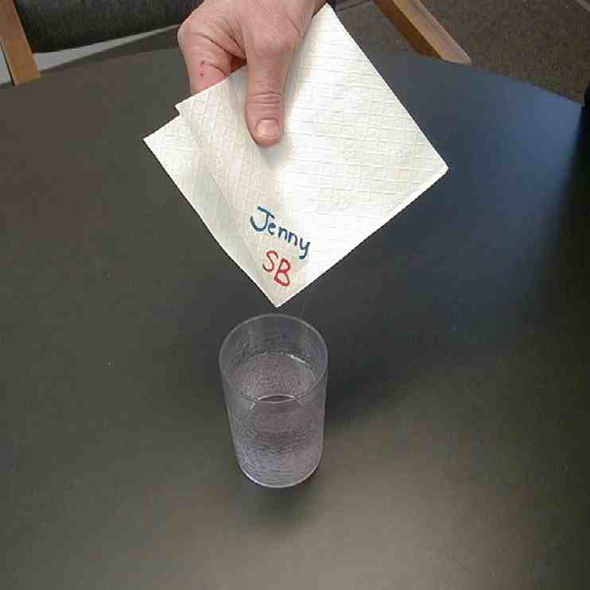

Let them dip the tip of the tissue into a cup of water. The water will absorb into the tissue and, as it does, it carries the colors with it. The colors will blend to produce an effect the kids will enjoy.

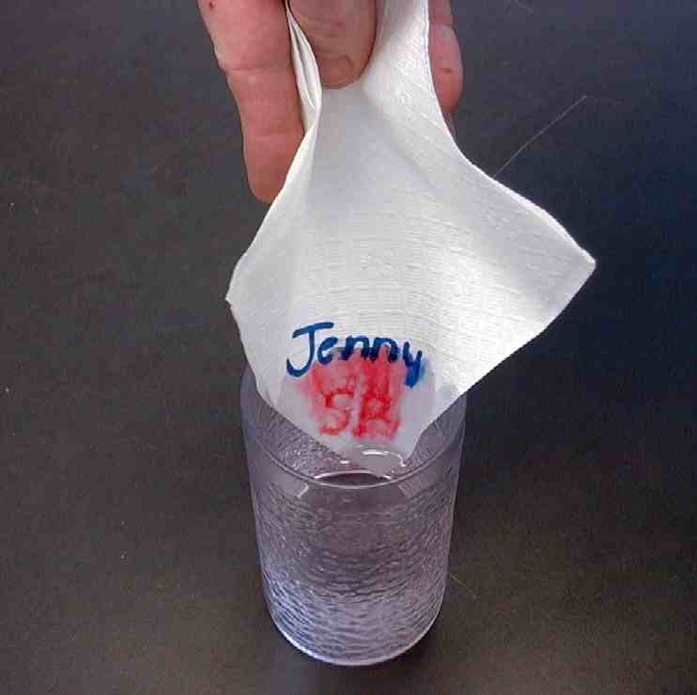

Then say:
Today we are going to hear about some men who gave their friend a lift by bringing him to Jesus. When they did this, it changed their friend’s life. We will learn that *friends bring friends to Jesus.

Large Group Overview: 20-30 minutes
Purpose: Help kids observe what the Bible says. Present the Bible event in creative fashion. Help kids begin to interpret what it means.

Video: “The Miracle Maker,” by Family Home Entertainment, Inc., 1999. Show Luke 5:17-26.

Object Lesson: The presenter draws and paints a diagram to retell the Bible event and teach kids that *friends bring friends to Jesus.

Dao Dao’s Review Questions: Jesus Heals the Paralytic and Forgives His Sin--- Dao Dao helps kids review the main points in the Bible event.

Small Group Application: 20-25 minutes
Purpose: Help kids map out the meaning of the Bible event in their lives. Use the questions to stimulate discussion but don't feel tied to them. Allow the Holy Spirit to guide you. Include personal examples from your own faith journey. The example of Christ at work in your life will leave lasting impressions of how Christ can work in the children's lives.

Use your Bibles! Children need to learn how to look up references and follow along when scripture is read aloud. Allow for quality time of prayer at the close of the lesson.

Observation Questions: What happened?
Why were people coming to Jesus? (Luke 5:17. Jesus had the power of the Lord to heal.)

Why couldn’t the friends of the paralyzed man get him into the house where Jesus was? (Luke 5:19. There was such a crowd.)

How did they finally get him before Jesus? (Luke 5:19. They went up on the roof and made an opening in the tiles and let the man down on his stretcher in front of Jesus.)

Why did the Pharisees think Jesus was dishonoring God? (Luke 5:20. Jesus told the man his sins were forgiven. This offended the Pharisees because they believed only God had the power to forgive sins.)

How did the crowd respond when they witnessed this miracle? (Luke 5:26. They were amazed and praised God. )

Interpretation Questions: What does this mean?
Why do you think the people were so amazed? Weren’t they bringing people before Jesus to be healed?

How did Jesus prove he really was God’s Son in this event? (Luke 5:22-24. Jesus could read the thoughts of the Pharisees. He told the man his sins were forgiven, which only God can do, and He showed He had the authority to forgive sins by showing His power in healing the man.)

How did these friends show faith in Jesus? (They would stop at nothing because they knew Jesus could help their friend.)

Application Questions: What does this mean to me?
Which do you think is the bigger miracle – for God to forgive sins or to tell someone to stand up and walk? (Both of these miracles can only be done by the power of God. Let the children answer and give explanations. Doing so allows them to interpret the meaning of the Bible event. )

Asking the next question may clarify for the kids the correct answer to the previous question.

What did it cost God to be able to perform these miracles? (He had to speak the word for the paralyzed man to walk, but He had to die on the cross to forgive our sins. Also, one miracle heals for only this lifetime. The other miracle allows us to live forever.)

Jesus has done such a wonderful miracle of giving His whole life for us by suffering and dying on the cross for our sins. Since Jesus is our friend, we want to bring other people to meet Him as their friend also.

Activity:
Supplies needed: three ply tissue paper for each child, various colors of water-based markers (Make sure you have red), crayons, paper plate and straw for each child, a cup of water

Pass out a tissue, water-based markers, and crayons to each child.

We are going to think of friends that we could talk to about Jesus. After all, *friends bring friends to Jesus. We need to pray for people and bring them to meet Jesus.

I want you to imagine your tissue is a card. It is folded so that there is an outside cover and an inside cover. Using a crayon, draw a cross in the center of the cover of your tissue paper.

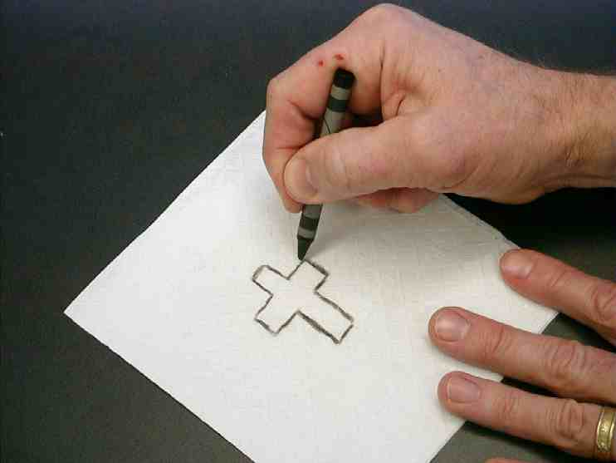

Then color the cross in with a light-colored marker.

Make sure a water-based marker is used.

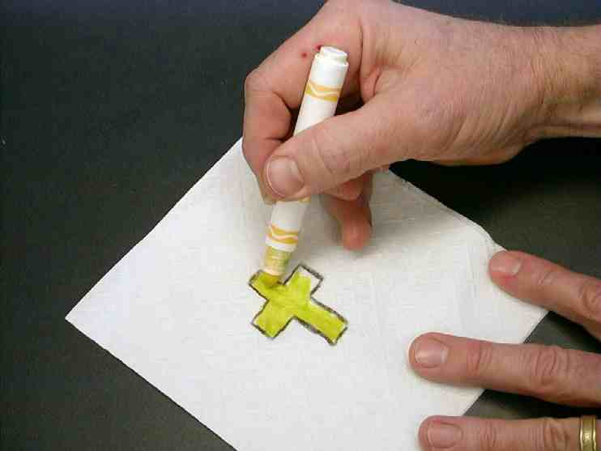

Open up your tissue “card.” Using different colored markers, I would like you to draw four different faces on the inside of your tissue paper. Don’t draw the faces too close to the middle, but don’t draw them too close to the corners either. When you draw these faces, I want you to think of four different kinds of people.

First, I want you to think about your best friend. You can draw that person in the upper left hand corner. Give a short amount of time to do this.

Next, I want you to think of someone who is hard to like as a friend. Draw this person in the upper right hand corner. Pause while kids draw.

In the bottom left-hand corner, draw someone in your family who might need to be brought to Jesus. Pause. In the lower right-hand corner draw someone who you are almost sure does not know Jesus and needs to know Him as her friend.

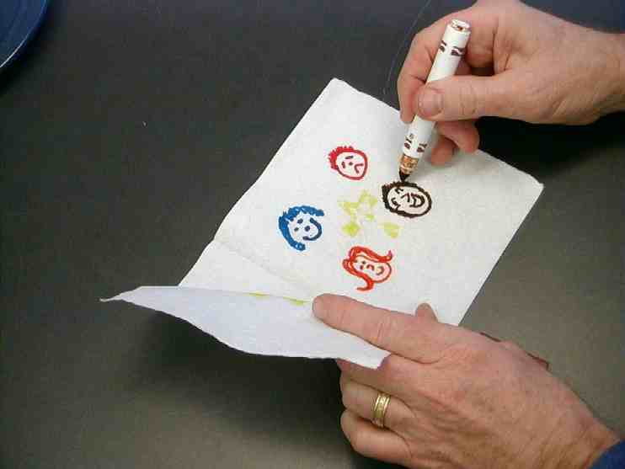

After all the kids have done this, talk to them about how Jesus is alive right now.

The color in the cross reminds us that Jesus is alive. More than anything else, Jesus wants to have His life become part of ours. He becomes a part of our lives when we know Him as our Savior and follow Him. We want our friends to be drawn to Him as well. Let’s see a picture of that.

Have each of the children place his tissue on a paper plate. Then each child can dip a straw into a cup of water, place his finger over the top of the straw, and “grab” some water out of the cup. They can drop the water onto the middle of the tissue by taking their fingers off the tops of the straws.

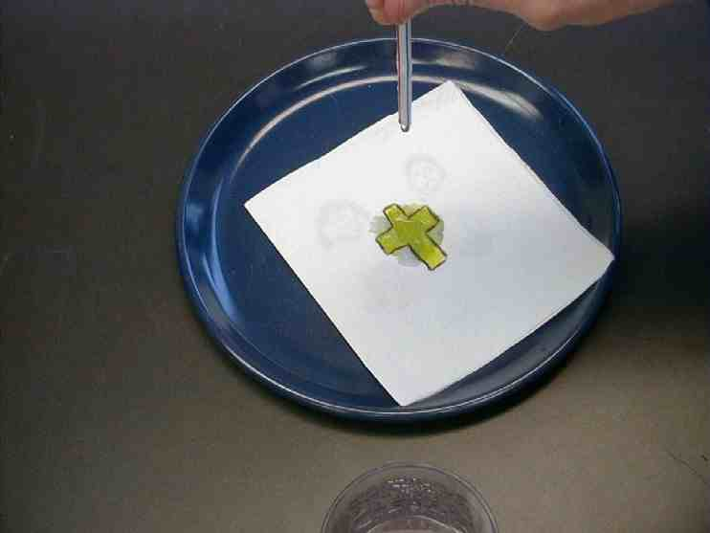

The water will dissipate the light color in the cross. The color will reach out in a circle.

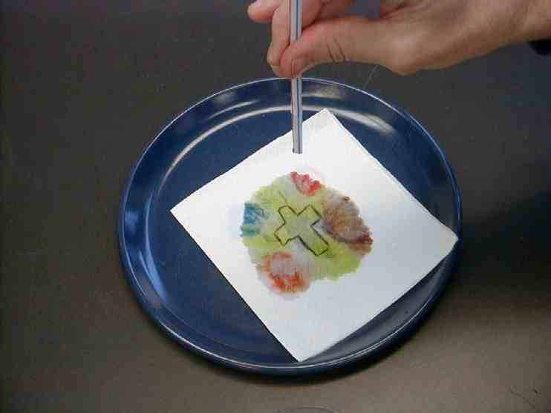

Eventually, the light color will reach the faces that the children drew. The colors in the faces will blend with the light color of the cross. It will look as though the faces are being drawn to the cross.

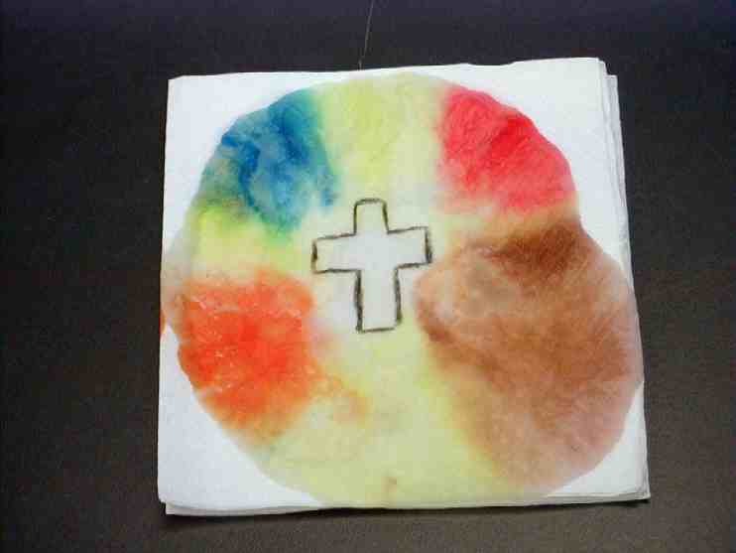

Remember *friends bring friends to Jesus.

Memory Verse Learning: 5 minutes
Purpose: Help kids to memorize and keep scriptures at heart. Using creative ways to help kids enjoy learning the key verse and in small group setting.

Supplies needed: whiteboard and marker; worksheet from page 17

Memory Verse: John 15:16, “You did not choose Me; I chose you. And I gave you this work, to go and produce fruit. I want you to produce fruit that will last…”

Memory Verse Learning: “Fill in the Blank”
Write the memory verse on the white board. Recite it several times with the children. After that rub off the board and hand the worksheet to the children. Tell them to fill in the blanks. Give a sticker or gift for the completed worksheet.

John 15:___, “You did not _________ Me; I ________ you. And I gave you this ______, to go and ________ fruit. I want you to _________ fruit that will ______…”

Prayer:
Take time to pray for each kind of person the children drew. Pray that the children can bring them as friends to meet Jesus.
Safety and Security: Safety and security procedures are important for each church to carefully define and implement according to their unique needs. The security, safety, illness and accident procedures described in this curriculum are provided for example purposes only and may not be appropriate, applicable or adequate for every situation. Each church is responsible for determining whether any security, safety, illness and accident procedures contained in the curriculum are appropriate, applicable or adequate for its unique situation. The activities described in this curriculum require adult supervision and may not be suitable for each child and each situation. Each church is responsible for ensuring that adequate adult supervision is provided for all activities and for determining whether an activity is appropriate for each child and each situation. Kids Kount Publishing disclaims all liability for the implementation of any procedures or the performance of any activities described in this curriculum.

Large Group Presentation

Take Home Point: *Friends bring friends to Jesus.

Set design and props needed for this series will include a large sign that reads “Meet the Amazing Jesus.” In addition to this sign, hang smaller signs in the front of the room with the word “Amazing” printed on each one.

Prompt kids to say, “Simply amaaaazing,” when the presenter points up and says, “And THAT is…,” A sweeping arm gesture by the large group presenter as the kids say “simply amaaaa-a-azing” will add effect and emphasis. Use this technique as an attention grabber when presenting the main points.

There are three sections to today’s large group presentation. The first section is a video presentation of the Bible event. The second section is a retelling of the event using an amazing object lesson. In the third section, Dao Dao, the puppet, helps kids review.

Adapt this lesson to use one or all of the following parts depending on availability of videos and/or illusion tricks.

Part One:
Begin with the animated video, The Miracle Maker by Family Home Entertainment, Inc. Cue the video to start at the scene where people are gathering at the house where Jesus is.

Next, call Dao Dao out and ask that he would come back after the lesson has been taught. Dao Dao will help with the review questions. Ad-libbing these conversations is most effective, as long as it is kept brief.

Part Two:
Retell the story with the object lesson as follows.

Part Three
Dao Dao is invited to answer review questions along with the children.

PART ONE

Show the video, The Miracle Maker by Family Home Entertainment, Inc. Cue the video to start at the scene where people are gathering at the house where Jesus is. Show the story where the friends of the paralyzed man let him down through the roof.

PART TWO

Object Lesson

Friends Bring Friends to Jesus

Script Accompanying Drawing

NOTE: Scripture quotes will be paraphrased.

For today’s object lesson the presenter draws a picture on an easel or poster board. Two different colors of tempera paints or water colors should be used. In advance, use a white candle to leave a wax imprint on the paper. When tempera paint or water colors are applied to the imprint during large group, the wax should repel the paint to show a special message. The drawing made with the candle is attached in the appendix. The painting should be so simple that anyone can do it. It might be helpful to lightly etch the outlines of the picture in pencil before class.

Direction: Write the words “to Jesus” with a black marker on the board.

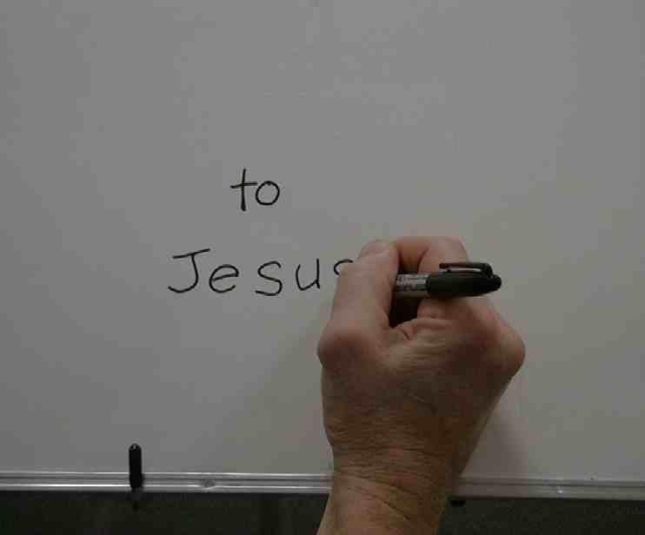

Say: People from all of Galilee, Judea, and Jerusalem were bringing sick people to Jesus. Jesus had the power of the Lord to heal.

Direction: Draw sour face expressions.

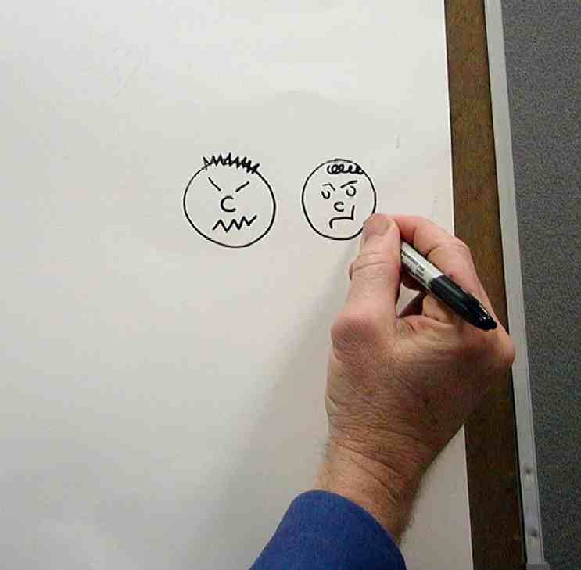

Say: Not everyone came to watch Jesus heal. Some Pharisees and religious experts were jealous of Jesus and all the attention he was receiving. They doubted that Jesus was truly the Son of God.

Direction: Draw four hands with lines attached.

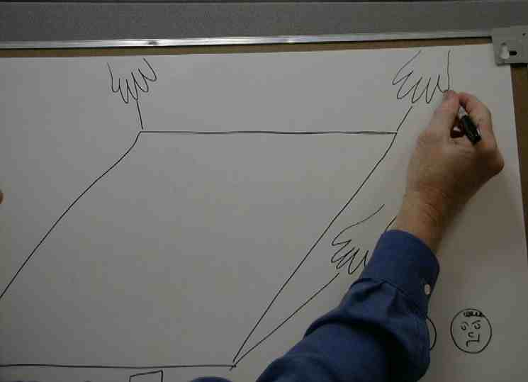

Say: There were some men who had a friend that was paralyzed. The paralyzed man’s friends thought Jesus could help because they had faith in Him. It was so crowded in the house where Jesus was that the friends could not find a way to get the paralyzed man into the house.

The friends carried the man up onto the roof. They made an opening in the roof and lowered the paralyzed man down on a stretcher.

Direction: Draw the cross around the words “to Jesus.”

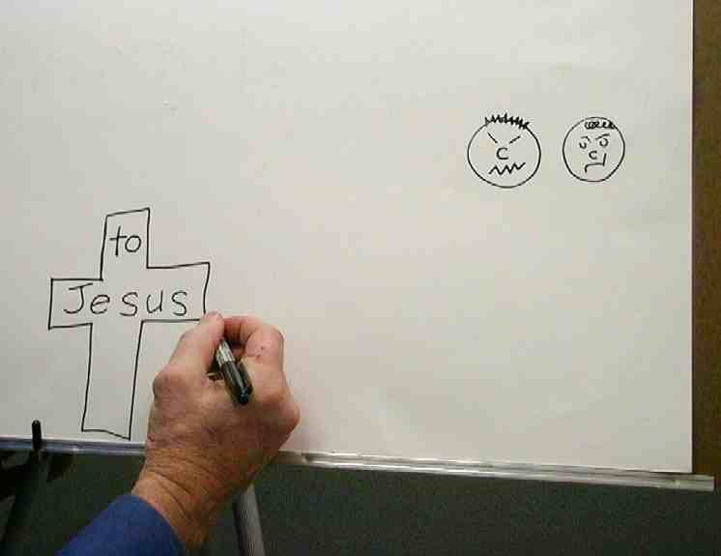

Say: When Jesus saw the friends’ faith He said, “Friend, your sins are forgiven.” The Pharisees and religious experts said, “How can you say that? He is dishonoring God because God alone can forgive sins.”

Jesus knew what they were thinking. So he said to them, “Which is easier: to tell this paralyzed man, ‘Your sins are forgiven,’ or to tell him ‘Stand up and walk’?” Jesus knew that neither could be done without God’s power.

Direction: Start painting in the mat. As the mat is painted, “Friends bring friends to Jesus” should appear.

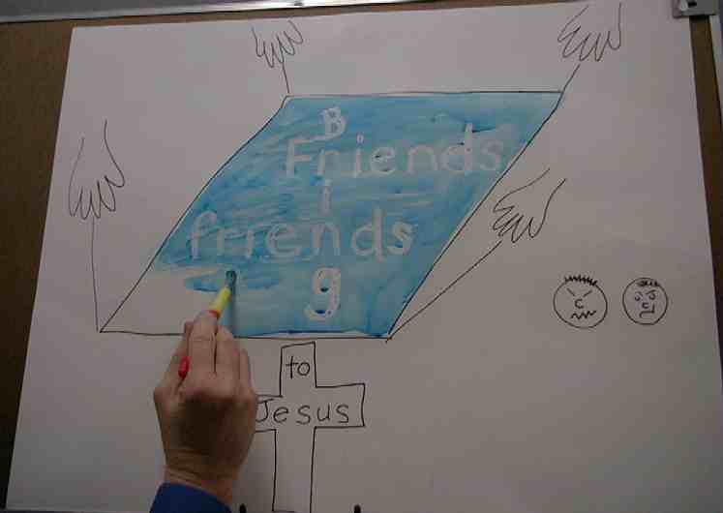

Say: Jesus said to the paralyzed man, “Just so that you would know that I, the Son of Man, have the authority to forgive sins, pick up your stretcher and go home.”

Direction: Start painting in the cross with red paint.

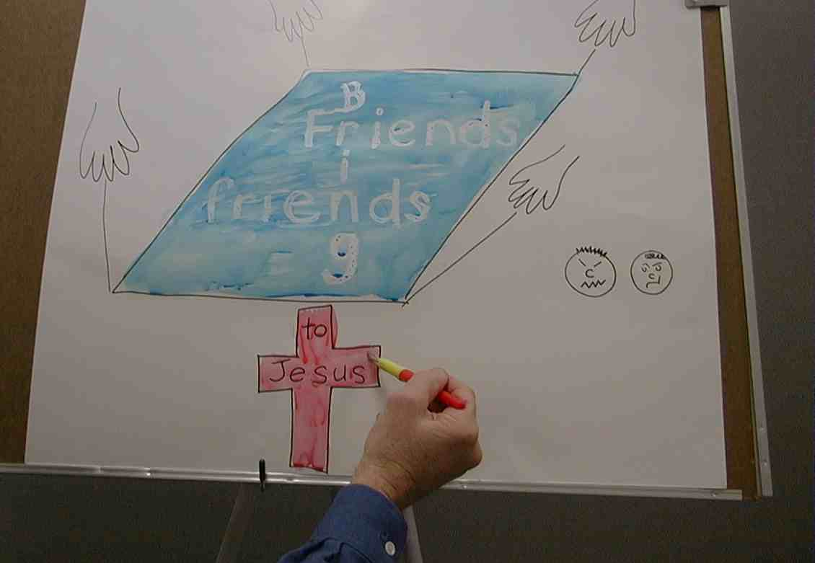

Say: The paralyzed man stood up and picked up his stretcher. Praising God, the paralyzed man walked home.

It was amazing! Was it more amazing that the paralyzed man was healed and could walk or that his sins were forgiven?

The man’s friends might have said, “This is simply amazing. We brought our friend here so he could receive healing but he left with forgiveness.” Everyone was filled with awe and said, “We’ve seen things we can hardly believe. It’s amaaaazing!”

PART THREE

Dao Dao’s Review Questions
Jesus Heals the Paralytic and Forgives His Sin

The following questions can be used for review of today’s Bible event. This will be a contest between Dao Dao and the kids. Dao Dao assigns a scoring value to each question before that question is read. That number is in parentheses at the beginnning of the question. What makes it fun is that Dao Dao finally gets one correct at the end and that number helps him make a dramatic comeback. The kids typically win, but it might be interesting if, from time to time, Dao Dao wins. Adjust to your preference. One thing is important and will be vital to this script: move through your material quickly. By this time, the kids’ attention spans are short. You may even want to delete some of the questions if it is feeling a bit long.

After each question, the first parenthetical remark is Dao Dao’s response. The second parenthetical remark is the correct answer from a child.

Kids might even bring their Bibles to large group to search for answers as they listen to the following questions.

- (3 points) Where were the people that Jesus was healing coming from?
(From the hospitals.)
(From the surrounding area – Galilee, Judea, and Jerusalem.)

- (17 points) Why were they coming to Jesus?
(To get His autograph.)
(Because God had given Jesus the power to heal.)

- (14 points) How did the friends get the paralyzed man through the crowds to see Jesus?
(They had someone saving a place in line so they could cut in.)
(They lowered him through the roof of the house.)

- (8 points) Whose faith did Jesus see when the paralyzed man was brought before him?
(The faith of the paralyzed man.)
(The faith of the paralyzed man’s friends.)

- (26 points) What did Jesus say to the paralyzed man?
(“Whoa, dude! Where’d you come from?)
(“Your sins are forgiven.”)

- (31 points) Since the Pharisees were thinking that only God could forgive sin, Jesus asked them, “Is it easier to say your sins are forgiven or to say ________ ?”
(To say “supercalifragilisticexpialidocious.”)
(“Get up and walk.”)

THIS SHOULD GIVE THE KIDS 99 POINTS!

- (99 points) Jesus proved He had the authority to forgive sins by doing a miracle. What was the miracle?
(He told the man to get up and walk and he did!)
(The paralyzed man got up and walked.)

- (1 point) The friends of the paralyzed man made a big difference in his life by bringing him to Jesus. What should we learn from this?
(We should choose our friends carefully.)
(We should bring our friends to Jesus, too.)

Teacher: Congratulations on a close contest. But the last point is pretty important.

Dao Dao: Even though it was just worth a point!?

Teacher: It meant the difference of winning or losing didn’t it?

Dao Dao: It sure did.

Teacher: And it’s important to our friends. It makes a difference for them to either win or lose when it comes to having a friendship with God. It’s our job to help bring our friends to Jesus!

Dao Dao: I guess you’re right. Friends bring friends to Jesus.

Teacher: Leet me close us with a prayer.

Dao Dao: Okay.

Teacher: Dear God, thank You for all the great friends here. And thank You Jesus for being such a good friend by giving Your life for us for the forgiveness of our sins. Wow! That’s a great friend. Now help us bring friends to meet You, Jesus and receive Your forgiveness, too! In Jesus’ name. Amen.

Lesson 40

Small Group Warm-uo
- a three ply tissue paper for each child
- two water-based markers
- cup of water

Large Group Presentation
- large sign that reads “Meet the Amazing Jesus”
- smaller signs hung in the front of the room, each with the word “amazing” printed on it
- Dao Dao
- the animated video “The Miracle Maker,” by Family Home Entertainment, Inc., 1999—cue the video to start at the scene where people are gathering at the house where Jesus is
- easel
- poster board
- tempera paints or water colors
- white candle to draw the picture in the appendix on the poster board before class
- black marker

Small Group Application
- three ply tissue paper for each child
- various colors of water-based markers (Make sure you have red.)
- crayons
- paper plate for each child
- straw for each child
- cup of water

Memory Verse Learning
- whiteboard and marker
worksheet from page 17

John 15:___, “You did not _________ Me; I ________ you. And I gave you this ______, to go and ________ fruit. I want you to _________ fruit that will ______…”

John 15:___, “You did not _________ Me; I ________ you. And I gave you this ______, to go and ________ fruit. I want you to _________ fruit that will ______…”

