
Date: ________________________
Series: Meet the Amazing Jesus
Dec-Mar Year 3, Lesson 41

Be Chosen to Make a Difference

Take Home Point: *Jesus chooses us to make a difference for Him. *Repeat this phrase throughout the lesson.

Bible Event: Luke 6:12-16. Jesus appoints the twelve apostles
Key Verse: John 15:16, “You did not choose Me; I chose you. And I gave you this work, to go and produce fruit. I want you to produce fruit that will last. Then the Father will give you anything you ask for in My name.” (NCV)

We will help kids know:
- The Bible event of Jesus choosing the twelve apostles.
- God chooses ordinary people and does extraordinary things through them as they put their trust and confidence in Him.
- God chooses us to make a difference in His Kingdom.

We will help kids feel:
- Secure in the fact that God chose them because of their faith and confidence in Jesus as their Savior.
- Inspired to make a difference for Him.

We will help kids do:
- Identify ways they can serve others to make a difference in God’s Kingdom and list those things on a giant mural.
- Identify and pray for one or two specific tasks that they will do for God’s Kingdom this week.

THIS LESSON’S ROADMAP

DESTINATION | PAGE # | DISCOVERIES ON YOUR JOURNEY | SUPPLIES NEEDED
  Small Group Warm-Up | 3 | Shepherds perform an illusion to show that God can do extraordinary things through ordinary people. God puts his warm touch on us. | - card trick, “Feeling the Card That Has Been Touched” (pages 7-11)  - deck of cards per group  - table cloth or blanket per group
Large Group   | 3  12  13  17 | Overview  Video: “The Miracle Maker,” by Family Home Entertainment, Inc. – This video presents the Bible event of Jesus choosing the twelve disciples as found in Luke 6:12-16.  An Object Lesson: Illustration of the Chosen Twelve – The presenter does an amazing card illusion to teach how amazing it is that God would choose ordinary people.  Dao Dao’s Review Questions: Jesus Appoints the Twelve Apostles—Dao Dao helps kids review the main points in the Bible event. | - large sign that reads “Meet the Amazing Jesus”  - smaller signs hung in the front of the room, each with “amazing” on it  - Dao Dao  - the video “The Miracle Maker” by Word Entertainment, Inc. www.booksofthebible.com, 1999—cue start right after Jesus heals the demon-possessed woman  - twelve name tags, each with an apostle’s name  - red or black marker  - deck of cards
Small Group Application   | 4 | Kids will identify ways they can serve others to make a difference in God’s Kingdom and list those things on a giant mural. They will pray for one or two specific tasks that they will do for God’s Kingdom this week.  Memory Verse Learning:  “Choose a Card”  John 15:16 will be emphasized in lessons 40-42 that each child know God chooses us to make a difference in His Kingdom. | - spell out “Jesus” and “us to make a difference,” one letter per group  - 8 ½” x 11” sheet of construction paper per group  - markers  - glue  - manila card or mahjong paper—spell out “chose” on the mural with playing cards that have been pasted face up  - playing cards to border the mural  - half a stack of play cards with some having the missing words of the memory verse pasted on it with masking tape  - template on page 18
Small Group Warm-Up: 15 minutes
Purpose: Get pointed in the right direction! Build relationships and help guests feel at ease. Do the learning readiness activity that will point your group in the right direction for the lesson.

Supplies needed: card trick, “Feeling the Card That Has Been Touched” (pages 7-11); deck of cards per group; table cloth or blanket per group

The warm-up time begins with the shepherds performing a card trick. See the appendix, “Feeling the Card That Has Been Touched.” Following the directions, each shepherd should be able to perform this simple trick. A tablecloth or blanket is needed to place the cards under while the shepherd “feels” for a card that is “warm to the touch.”

After performing the trick, explain that this was a trick but you are not allowed to give away the secret.

If you think this is amazing, wait until you hear the most amazing news we have today. That news is that God puts His warm touch on you and chooses you.

Imagine that you are chosen for a special team or chosen to do something very special. For example, you could be chosen to play on a special football team. You might be chosen to be part of a special group of friends. What do you think it would be like to be chosen as an astronaut or the President of the United States? For what would you like to be chosen?

After the kids have discussed this, ask them if they are qualified for such a role or are they too “ordinary” for such a special selection.

Today we are going to meet the amazing Jesus who would actually choose us to make a big difference for Him. He gave His life for us so that He might choose us to be on His team. When we trust Him, we will be friends with Him forever.

God chooses ordinary people to do extraordinary things. *Jesus chooses us to make a difference for Him.

Large Group Overview: 20-30 minutes
Purpose: Help kids observe what the Bible says. Present the Bible event in creative fashion. Help kids begin to interpret what it means.

Video: “The Miracle Maker,” by Family Home Entertainment, Inc. Cue start right after Jesus heals the demon-possessed woman. This video presents the Bible event of Jesus choosing the twelve disciples as found in Luke 6:12-16.
An Object Lesson Illustration of the Chosen Twelve – The presenter does an amazing card illusion to teach how amazing it is that God would choose ordinary people like His apostles and us to do amazing things for Him.

Dao Dao’s Review Questions: Jesus Appoints the Twelve Apostles—Dao Dao helps kids review the main points in the Bible event.

Small Group Application: 20-25 minutes
Purpose: Help kids map out the meaning of the Bible event in their lives. Use the questions to stimulate discussion but don't feel tied to them. Allow the Holy Spirit to guide you. Include personal examples from your own faith journey. The example of Christ at work in your life will leave lasting impressions of how Christ can work in the children's lives.

Use your Bibles! Children need to learn how to look up references and follow along when scripture is read aloud. Allow for quality time of prayer at the close of the lesson.

The key message to be communicated during small group application is that Jesus chose us to make a difference. A mural will be made out of cards that spell out this phrase. Around the mural will be written children’s specific examples of things they can do to make a difference. Before the mural is done, however, make sure the following three questions (application questions) are discussed and the children have an understanding of how they are chosen.

Observation Questions: What happened?
Look up Luke 6:12-16.

How long did Jesus spend in prayer before calling His disciples? (Luke 6:12. The whole night.)

What is another name for disciple? Or what did Jesus call His disciples? (Luke 6:13. Apostles.)

How many of the twelve can you name without looking? (Luke 6:14-16. Simon Peter, Andrew, James, John, Philip, Bartholomew, Matthew, Thomas, James (son of Alphaeus), Simon the Zealot, Judas (son of James), and Judas Iscariot.)

Interpretation Questions: What does this mean?
How are we like the twelve apostles? (We are ordinary people; God chose us to be His followers and to go out in the world to share the good news of Jesus and what He has done for us.)

Application Questions: What does this mean to me?
Supplies needed: spell out “Jesus” and “us to make a difference” (one letter per group), 8 ½” x 11” sheet of construction paper per group, markers, glue, manila card or mahjong paper—spell out “chose” on the mural with playing cards that have been pasted face up, playing cards to border the mural

What did Jesus do for us so that we can be His followers? (He died on the cross and rose again.)

When we are baptized, everyone can see that we belong to God. God is touching us and saying, “I choose you to be My child.” How many of you have been baptized?

While touching each child on the head or shoulder, say:

I am touching you just like God touched you in baptism.

When you trust in Jesus as your Savior, He wants to be leader in your life. Let’s think of wonderful things to be chosen for. How would these things compare to being chosen by Jesus to be one of His followers?

After discussing these questions, show the kids the pre-cut letters they will use to make the mural. Say:

By the time all of the groups put their letters together, the phrase “Jesus chose us to make a difference” will be spelled out.

For the kids to take part in making the mural, each group will have one or more pre-cut letters. The letters will spell out the words “Jesus” and “us to make a difference.” On the letter, every child in the group will write his name. As children write their names on the letter say:

God chose you by name to be part of His team.

Then paste the letter to a 8 ½” x 11” piece of colored construction paper.

Jesus says in John 15:16, “You did not choose Me; I chose you. And I gave you this work, to go and produce fruit. I want you to produce fruit that will last. Then the Father will give you anything you ask for in My name.”

What do you think it means to “produce fruit that will last?” (Doing things for God that will make a difference in people’s lives which make a difference for eternity.)

Ask the children to write on the construction paper some of the things that they can do to make a difference in God’s Kingdom. For example, they could pray for others, sing in the worship team, give offerings to Cambodia, or be kind to the bully at school.

The letters will be brought to the center of the room to be pasted on the manila card or mahjong paper mural. The word “chose” will already be spelled out on the mural with playing cards that have been pasted down.

The mural will be trimmed with various playing cards. The mural reminds the kids that they have been chosen by Jesus as ordinary kids, but He can do extraordinary things through His great power working through them because of their faith in Jesus.

Review the take home point: *Jesus chooses us to make a difference for Him.

Memory Verse Learning: 5 minutes
Purpose: Help kids to memorize and keep scriptures at heart. Using creative ways to help kids enjoy learning the key verse and in small group setting.

Supplies needed: half a stack of play cards with some having the missing words of the memory verse pasted on it with masking tape; template on page 18

Memory Verse: John 15:16, “You did not choose Me; I chose you. And I gave you this work, to go and produce fruit. I want you to produce fruit that will last…”

Memory Verse Learning: “Choose a Card”
Review the memory verse with the children. Then tell them that they are to fill in blank with the right card. They are to choose a play card but it need to be one that has the missing word pasted on it. Getting the word they are to paste it on the template – on the right blank. But to be able to choose, one must be able to recite John 15:16. Fan out the cards for them to choose.

Closing Prayer:
Thank God that He chose us when He died on the cross to take away the consequence for our sins. Thank Him that He chooses us ordinary people to do extraordinary things for Him. Have kids pray for one or two specific tasks that they will do for God’s Kingdom this week.
Safety and Security: Safety and security procedures are important for each church to carefully define and implement according to their unique needs. The security, safety, illness and accident procedures described in this curriculum are provided for example purposes only and may not be appropriate, applicable or adequate for every situation. Each church is responsible for determining whether any security, safety, illness and accident procedures contained in the curriculum are appropriate, applicable or adequate for its unique situation. The activities described in this curriculum require adult supervision and may not be suitable for each child and each situation. Each church is responsible for ensuring that adequate adult supervision is provided for all activities and for determining whether an activity is appropriate for each child and each situation. Kids Kount Publishing disclaims all liability for the implementation of any procedures or the performance of any activities described in this curriculum.

Feeling the Card That Has Been Touched
A Card Trick for Small Group Warm-Up

Supplies needed:
- card trick, “Feeling the Card That Has Been Touched” (pages 7-11)
- deck of cards per group
table cloth or blanket per group

Shepherd: Boys and girls, did you know that in each one of your fingers is warmth? It’s true. Something that you probably did not know is that I can feel the warmth of your touch that is left on a card. Do you believe me? Let’s see.

I am going to ask you to touch a card. Then I will put the cards under the table (or cloth) and feel which one you have touched.

Here is an ordinary deck of playing cards.

Show the children the deck of cards that has been specially prepared beforehand. The card on the bottom of the deck has been flipped face up while the other cards are face down. It is important that the kids do not see that the card is any different from the other cards.

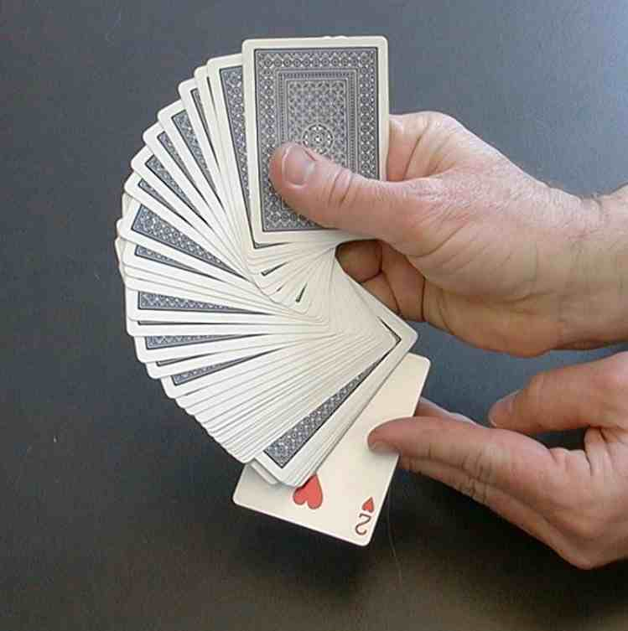

Fan out the deck in front of a child. Turn your head and ask a child to pull out a card as you are fanning the cards. Make sure a card is pulled out before you fan the cards out too far and the bottom card is revealed.
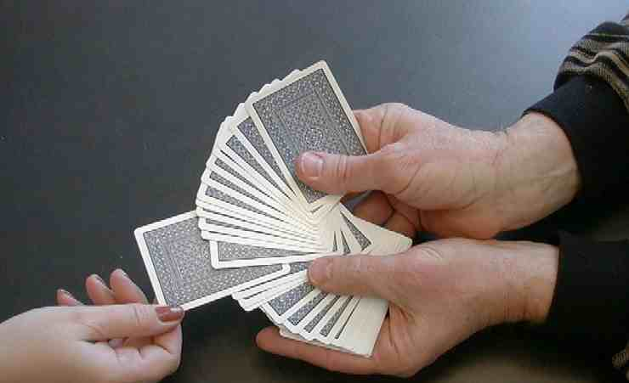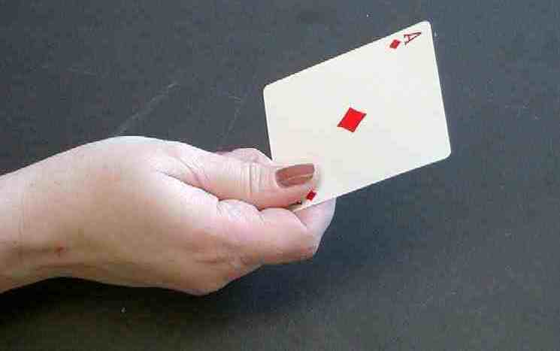

I am not looking at your card. I need you to put your touch really hard on that card so some of your warmth will seep into the card. Are you touching it and making it warm?

Ask the child to hold the card tightly between her hands.

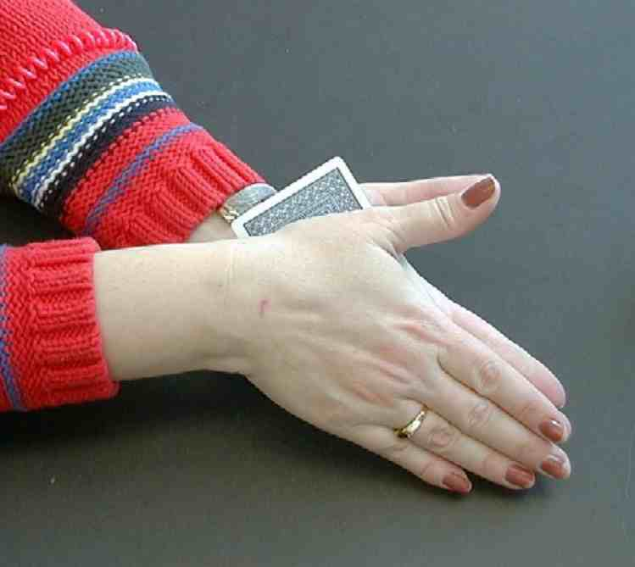

While the child is concentrating, flip the neatly stacked deck over and place it on the table. Remember the one reversed card is now on the top so the whole deck looks like it is face down.

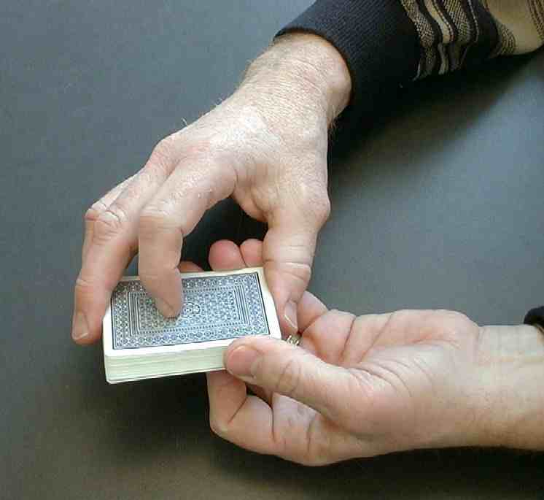
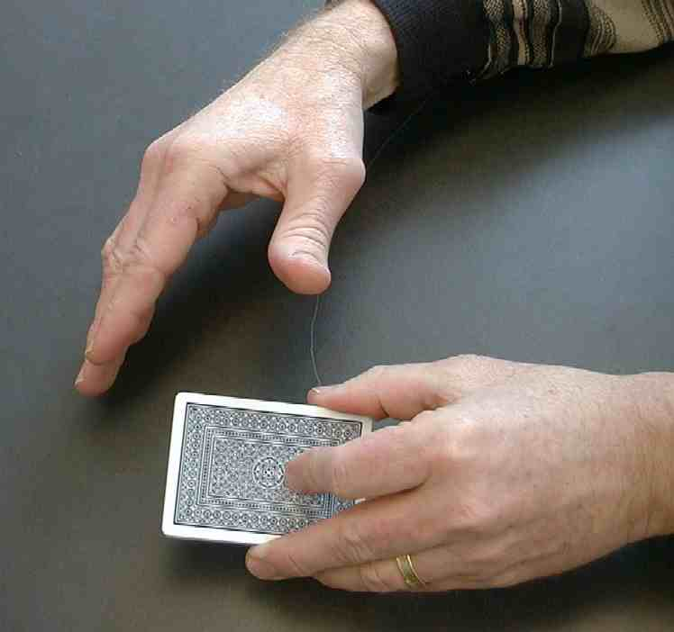

Please put your card back into the deck.

Have the child slide the card back into the middle of the deck. Caution! Help the child insert the card so that the deck is not separated and they can see that all the cards are face up.
.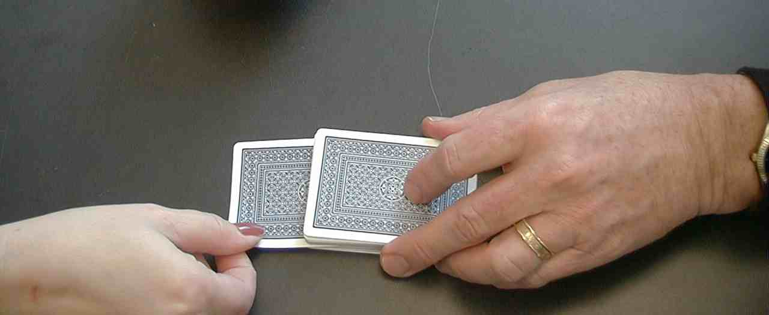

At this point, the deck is all face up except for the top card which is face down. The deck should appear as though it is entirely face down. Take the deck in your hand and hold it under the table (or cloth). Don’t look at the cards.

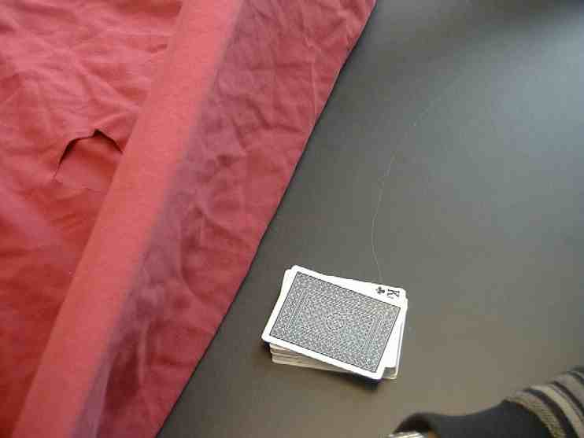

While holding the deck underneath the table (or cloth) and not looking at the deck, flip the deck and turn the bottom card face down like the rest. The only card turned up will be the one touched by the child.
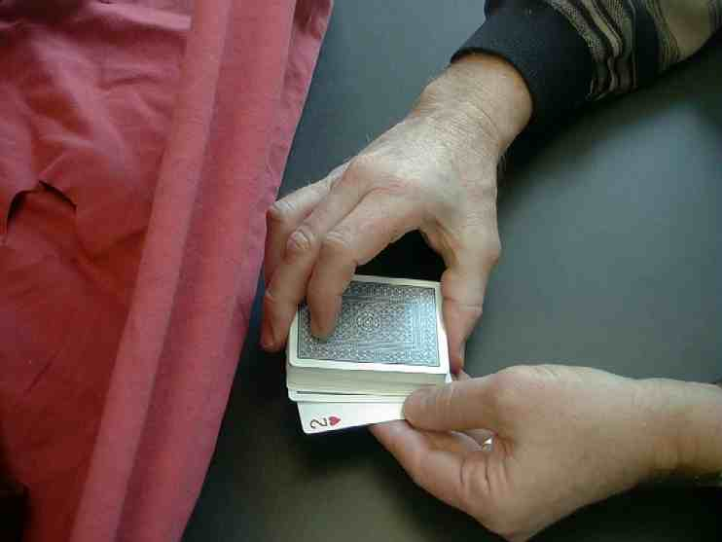

Now I am feeling through the cards to find the warmest card. There it is! Let me feel it again. Yes. Here is the card that must have been warmed up by your touch. Let me see if I can pull it out and turn it over. Get ready… Here it is!

Let me fan the cards out on the table. Make sure the card I pulled out is the one you touched.

Fan the cards out for the child to see.

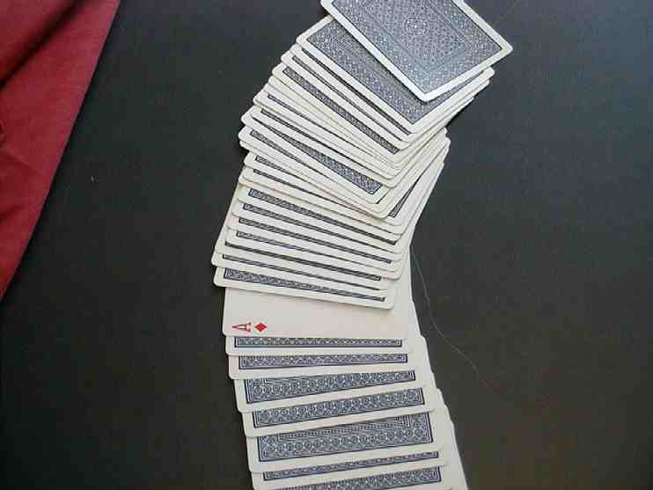

Go back to lesson plan.

Large Group Presentation

Take Home Point: *Jesus chooses us to make a difference for Him.

Set design and props needed for this series will include a large sign that reads, “Meet the Amazing Jesus.” In addition to this sign, hang smaller signs in the front of the room with the word “Amazing” printed on each one.

Prompt kids to say, “Simply amaaaazing,” when the presenter points up and says, “And THAT is….,” A sweeping arm gesture by the large group presenter as the kids say “simply amaaaa-a-azing” will add effect and emphasis. Use this technique as an attention grabber when presenting the main points.

There are three sections to today’s large group presentation. The first section is a video presentation of the Bible event. The second section is a retelling of the event using an amazing object lesson. In the third section, Dao Dao, the puppet helps kids review.

Adapt this lesson to use one or all of the following parts depending on availability of videos and/or illusion tricks.

Part One:
Begin with the animated video, “The Miracle Maker,” by Family Home Entertainment, Inc. Cue start right after Jesus heals the demon-possessed woman. Show story of Jesus calling the twelve disciples.

Part Two:
Retell the story with the object lesson as follows.

Part Three
Dao Dao is invited to answer review questions along with the children.

PART ONE

Begin with the animated video, “The Miracle Maker,” by Family Home Entertainment, Inc. Cue start right after Jesus heals the demon-possessed woman. Show story of Jesus calling the twelve disciples.

PART TWO

An Object Lesson Illustration of the Chosen Twelve
Illustrations and Script

Four children will be chosen to come forward as participants. Each one will represent one of the chosen apostles. All twelve names are available on name tags. They may choose any name which will then be taped to their shirt. (Time may prevent all twelve names from being taped to twelve children, though some churches might try this.) A fifth apostle will be the presenter.

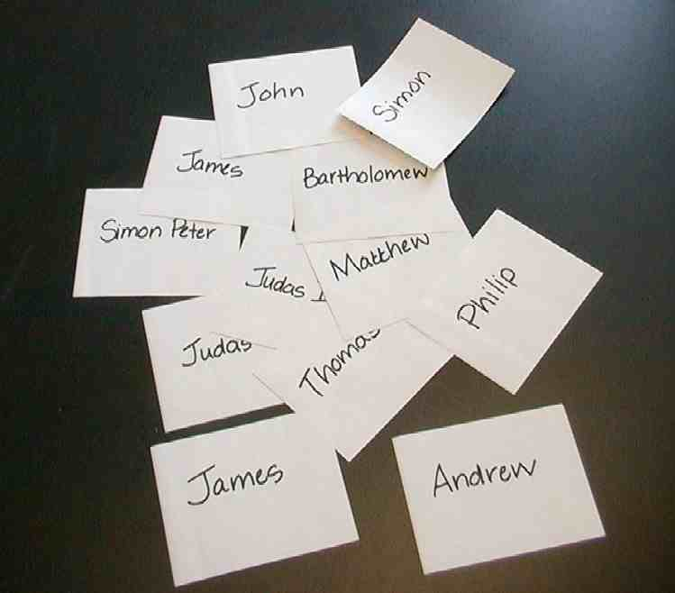

Meet the ama-a-azing Jesus and be chosen to make a difference. Today we will discover how Jesus chooses us to make a difference for Him. And THAT is… make a sweeping gesture to get the kids to respond… “Simply amaaa-azing.” The Bible event is Luke 6:12-16. Listen to how Jesus chose from among His followers some very ordinary men, fishermen, tax collectors and common workers. People who would make a big difference for Him. They would end up changing the world.

Read Luke 6:12-16.

Just like these common people, I need some volunteers from the audience who will be chosen. As common ordinary people, they will help us demonstrate that when they are chosen, something special happens. May I have four volunteers?

As you come up, you’ll see that I have a whole list of tags with the names of the first twelve disciples. Let’s pretend that you were one of these men chosen by Jesus.

Tag four of them and one for yourself. Line the students onstage.

Now I’d say these are ordinary people, but can you imagine what it’s like when Jesus, God’s own Son, would choose you to make a difference for Him? Why, it would make the ordinary extraordinary and …THAT is…..give a wide gesture and have the audience reply… “simply amaaa-a-azing!”

Let me give you an example of how the ordinary is chosen and becomes extraordinary. First disciple, please come here. I’d like you to point to a card here in this deck and choose one. But don’t just choose any card, choose the ten of diamonds. Now, let me look at it. My goodness, THAT is… gesture and audience responds with… ”simply amazing.” How did you know? I’ll set it on the table and show you later, but let’s write “10” in red on your name tag. You chose the card that I asked for. That is pretty special, isn’t it?

Now let’s have the next disciple step up. I’d like you to choose (name the card the previous student chose.) Wow, how did you do that? I can’t show you now, but let’s go ahead and write it on your name tag.

Continue this through the four students and finally as the last disciple chooses the same card, for example our ten of diamonds. The trick is then to place that card on the bottom of the chosen card. Now when they are peeled up, one at a time, they will be in order.

Okay, now let’s see how we did. These disciples were just choosing an ordinary card, but because they chose it without looking, it became very special. Let’s see, the first disciple was asked to choose (check their name tag) a red ten. Here it is. The next one was asked to choose a black three. The next disciple chose a …. And so forth. And THAT is… gesture and get audience response… “simply amaaa-a-azing.” The amazing thing is that Jesus chose twelve apostles to make a difference and He chooses us to make a difference, as well.

Now, kids, listen to this. This is very important. Jesus gave His life for you when He died on the cross. But it wasn’t just to forgive your sins; it was also to give you power to live for Him. He is choosing you, even though you’re just an ordinary person like me, to make a big difference, for Him. And THAT is… gesture and receive response… “simply amaa-a-azing.”

The Trick

Fan out the cards so that all can see that it is an ordinary deck. As you do this, take note of the bottom card. (For the sake of this description, we will assume that the bottom card is the ten of diamonds.)

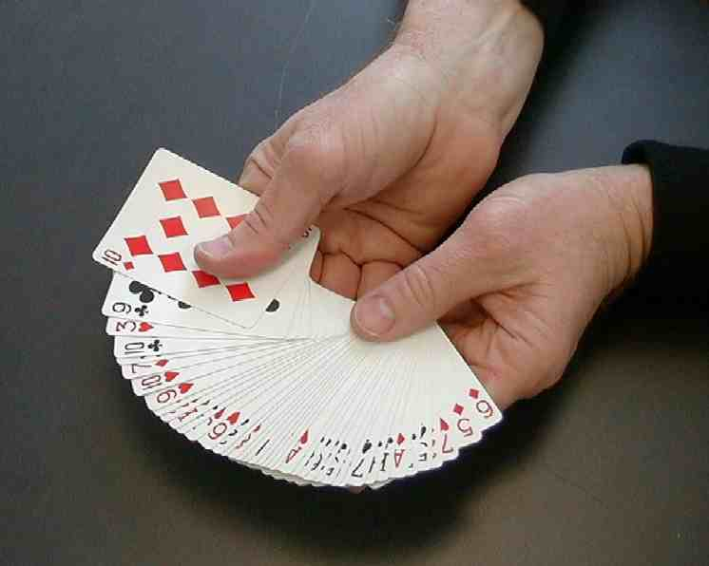

Return the deck to a pile. Spread the deck out in several circular motions so that many cards are spread on the table. The bottom card should be left at the very bottom so that a child would not pick it. The bottom card can be retrieved when it is needed at the end of the trick.

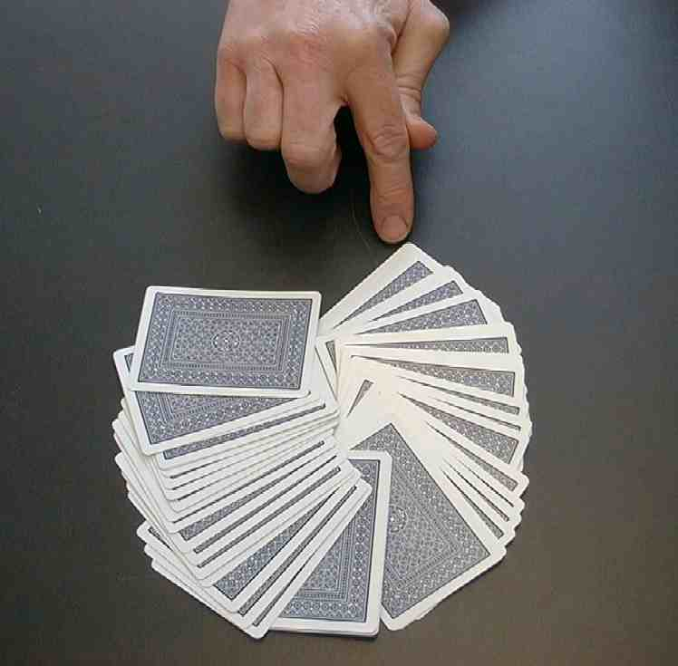

Begin with the apostle of your choosing. Ask the apostle to touch a card without looking at it. This is the card you would like them to select. (For our example, you would ask the first child to select a red ten.)

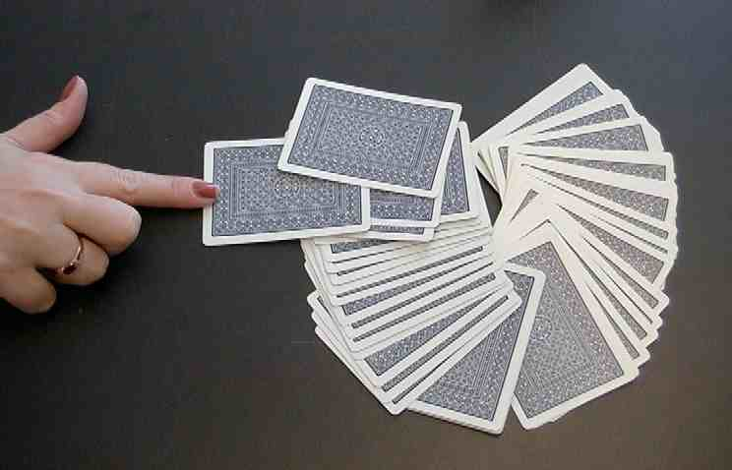

Have an assistant write the card that you are requesting, number ten (10) in red ink on the contestant’s name tag. You pick up the card and peek at it. Make sure the child does not look at the card at any time. Make some surprising gestures that the card selected is a good choice. Hold this card and the following in your hand.

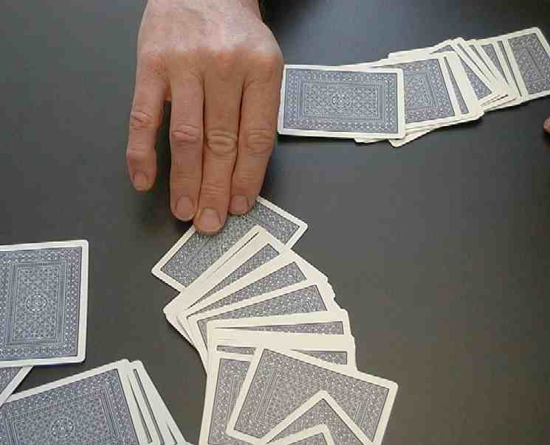
Ask the next apostle to choose a card. The card you ask them to touch is a black three (in our illustration) because the previous child pulled it from the deck. Label this child’s name tag “3” in black. You are holding another card in your hand. It is, for example, a red king. That again will be the next card you ask a child to select.

For the final card, say you are going to pull out whatever the card was the last child touched and then pull out the bottom card. It will be the red ten which you first had requested. You have four ordinary cards in your hand matching what you requested the kids to touch.

See how these ordinary cards seem so special because they were chosen? The same is true of us. Jesus chooses ordinary kids like us to make a difference for Him!

The trick needs to move quickly. The smoother the talk and the more it seems these cards are randomly pulled from the imagination of the presenter, the more effective the trick becomes.

Just as amazing as this trick, it is amazing that God would choose ordinary people like you and me to know Jesus as our Savior. As we follow God in all that we do, He will use us to make a big difference in His Kingdom. We will help more people get to know God and be friends with Him forever.

PART THREE

Dao Dao’s Review Questions
Jesus Appoints the Twelve Apostles

The following questions can be used for review of today’s Bible event. This will be a contest between Dao Dao and the kids. Dao Dao assigns a scoring value to each question before that question is read. That number is in parentheses at the beginnning of the question What makes it fun is that Dao Dao finally gets one correct at the end and that number helps him make a dramatic comeback. The kids typically win, but it might be interesting if, from time to time, Dao Dao wins. Adjust to your preference. One thing is important and will be vital to this script: move through your material quickly. By this time, the kids’ attention spans are short. You may even want to delete some of the questions if it is feeling a bit long.

After each question, the first parenthetical remark is Dao Dao’s response. The second parenthetical remark is the correct answer from a child.

Kids might even bring their Bibles to large group to search for answers as they listen to the following questions.

- (3 points) What did Jesus do just before choosing the twelve apostles?
  - (He played cards.)
  - (He spent the whole night in prayer.)

Three points for the kids!

- (27 points) Name three of the apostles.
  - (Herman, Oscar, and Alfred.)
  - (Choose three from: Simon, Andrew, James, John, Philip, Bartholomew, Matthew, Thomas, James, Simon, Judas, and Judas Iscariot)

Thirty points for the kids!

- (142 points) Name three more apostles.
  - (Moses, Elijah, and Abraham.)
  - (See answer to question two.)

That’s 172 points for the kids!

- (171 points) Did Jesus choose the apostles because they were ordinary people or was there something extraordinary about them?
  - (They were the ordinary, just like me! Wow, I got it right…score 172 points for the kids, 171 for Dao Dao!)
  - (They were ordinary people.)

- (2 points) What was it that made the apostles so special?
  - (God chose them. Dao Dao got another one! Score: ME 173; You 172!)

- (1,712 points…last question) How do you know God chooses you to be His follower?
  - (If you can guess the right card God is thinking of.)
  - (If you trust Jesus as your Savior, you know God has chosen you to be His follower.)

Teacher: Sorry, Dao Dao. It looks like the kids made a big comeback and won by quite a bit!

Dao Dao: Okay. I don’t mind. Just a game!

Teacher: What! You’re taking that quite well for you, Dao Dao!

Dao Dao You’ve got to understand, Teacher. I have something a bit more important. Even if I lose the dumb game, I’m still chosen by God! You see I trust in Jesus as my Savior.

Teacher: Well, Dao Dao, you’ve got it! I’m proud of you. You really did get the message today!

Dao Dao: Sure, Teacher. *Jesus chooses me. And because of that, I’ll make a difference for Him. Who knows, I might do great things for God someday!

Teacher: Dao Dao, why wait!? You can do great things for God today! You can tell others what Jesus has done for them, pray, bring a friend to church, help mom and dad around the house. As a matter of fact, I think you already have. It’s good for us to pray now.

Dao Dao: Thanks, Teacher. Ya! Let’s pray.

Teacher: Dear God, You are really cool. Thank You for sending Jesus who gave His life for us. Jesus, thank You for choosing us to follow and make a difference. Wherever we go this week, help us remember that we can make a difference for You because we follow You. In Jesus’ name. Amen.

Lesson 41

Small Group Warm-up
- card trick, “Feeling the Card That Has Been Touched” (pages 7-11)
- deck of cards per group
- table cloth or blanket per group

Large Group Presentation
- large sign that reads “Meet the Amazing Jesus”
- smaller signs hung in the front of the room, each with “amazing” on it
- Dao Dao
- the video “The Miracle Maker” by Word Entertainment, Inc. www.booksofthebible.com, 1999—cue start right after Jesus heals the demon-possessed woman
- twelve name tags, each with an apostle’s name
- red or black marker
- deck of cards

Small Group Application
- spell out “Jesus” and “us to make a difference,” one letter per group
- 8 ½” x 11” sheet of construction paper per group
- markers
- glue
- manila card or mahjong paper—spell out “chose” on the mural with playing cards that have been pasted face up
- playing cards to border the mural

Memory Verse Learning
- half a stack of play cards with some having the missing words of the memory verse pasted on it with masking tape
- template on page 18

John 15:___
“You did not _________ Me; I ________ you. And I gave you this ______, to go and __________ fruit. I want you to __________ fruit that will ______…”

